Promise Questions – Scenario also

1. Promise Execution Order
console.log('1');
const promise = new Promise((resolve) => {
console.log('2');
resolve('3');
});
promise.then(console.log);
console.log('4');

Solution – output – 1,2,4,3
Reason –
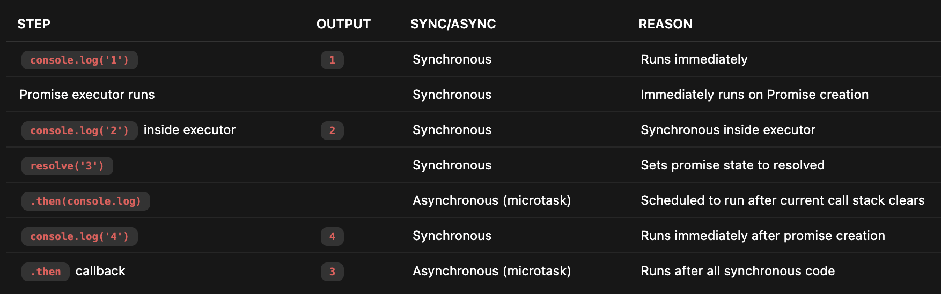
Promise executors run right away, .then() callbacks run later as microtasks, so their logs happen after all synchronous code.

2. Chaining Promises
Promise.resolve(1)
.then(x => x + 1)
.then(x => { throw new Error('fail') })
.catch(() => 2)
.then(x => x + 1)
.then(console.log);

Output – 3
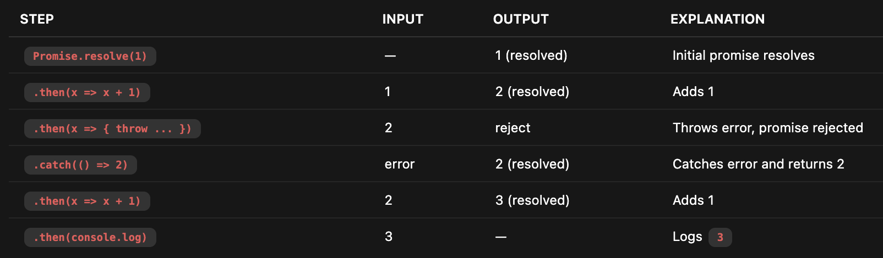
Why chain moves forward after .catch()?
• .catch() handles and "recovers" the error, returning a resolved value (2).
• This resolved value continues down the chain as normal.
• So .then(x => x + 1) receives 2 and adds 1, resulting in 3.

3. Promise.all vs Promise.race
const p1 = new Promise(resolve => setTimeout(() => resolve('1'), 1000));
const p2 = new Promise(resolve => setTimeout(() => resolve('2'), 2000));
const p3 = new Promise((_, reject) => setTimeout(() => reject('3'), 500));

// What happens with Promise.all([p1, p2, p3])?
// What happens with Promise.race([p1, p2, p3])?

• Promise.all([p1, p2, p3]):
Rejects with '3' at ~500ms because p3 rejects first, and Promise.all rejects as soon as any promise rejects.
• Promise.race([p1, p2, p3]):
Rejects with '3' at ~500ms because p3 settles (rejects) before others resolve, and Promise.race settles with the first settled promise whether resolve or reject.

4. Return Value in .then()
Promise.resolve(1)
.then(x => {
return x + 1;
})
.then(x => {
console.log(x); // ?
});

Promise.resolve(1)
.then(x => {
x + 1; // no return
})
.then(x => {
console.log(x); // ?
});

If you don’t return anything explicitly in a .then callback, the returned promise resolves with undefined.

5. Nested Promises
Promise.resolve('outer')
.then(result => {
console.log(result);
return Promise.resolve('inner');
})
.then(result => {
console.log(result);
});

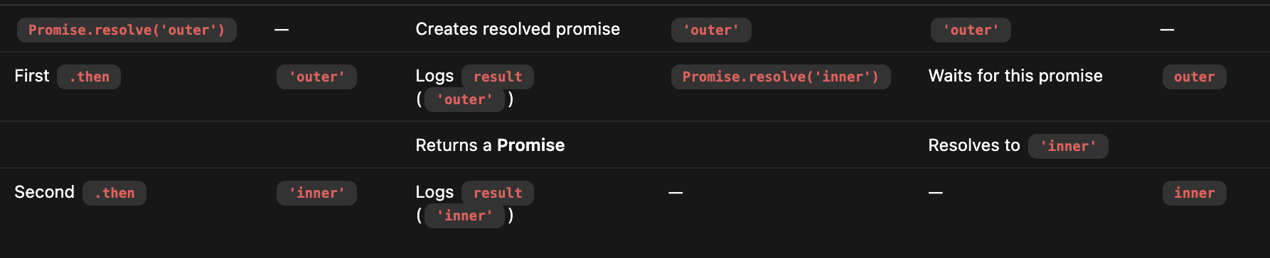

Returning a promise from a .then() callback unwraps it, meaning the next .then() in the chain waits for it to settle and receives its resolved value.

6. Error Handling
Promise.reject('error1')
.catch(err => {
console.log(err);
throw 'error2';
})
.catch(err => {
console.log(err);
})
.then(() => {
console.log('done');
});

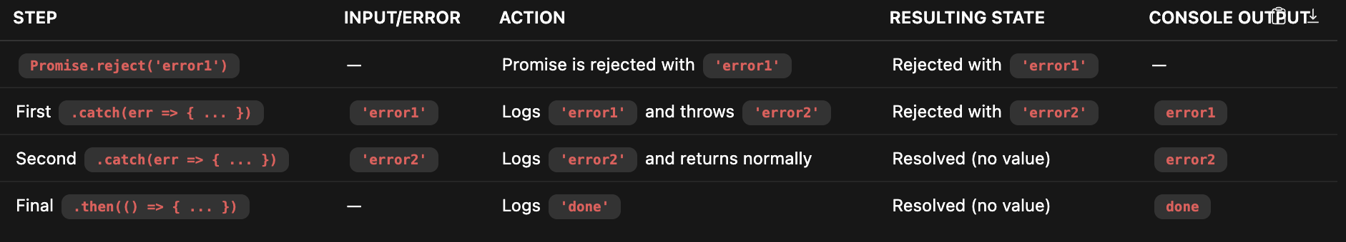

• Initial rejection with 'error1'.
• First .catch() handles it, logs 'error1', then throws 'error2', returning a rejected promise.
• Second .catch() catches 'error2', logs it, returns normally (i.e., a resolved promise).
• The final .then() runs because the error has been handled, logging 'done'.

7. Async/Await Error Handling
async function test() {
try {
const result = await Promise.reject('error');
console.log(result);
} catch (err) {
console.log(err);
return 'caught';
}
}

test().then(console.log);

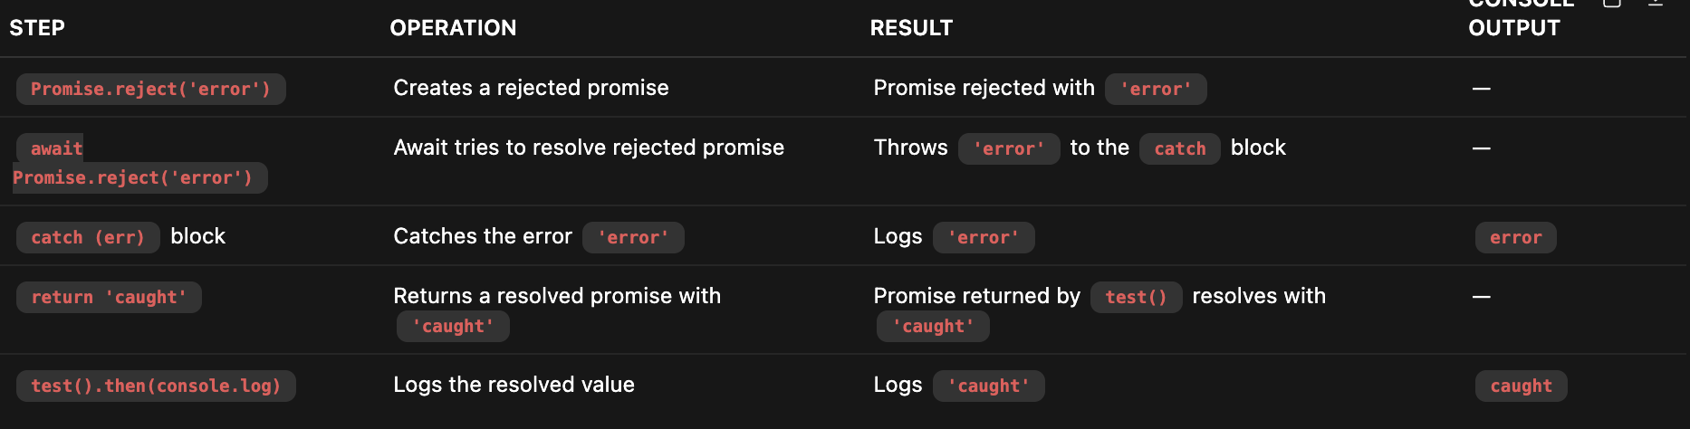

• The await on a rejected promise throws an error which is caught by the try...catch.
• The error message 'error' is logged.
• Then 'caught' is returned from the async function as an async function always returns a Promise.
• Finally, the .then(console.log) logs 'caught'.

8. Promise.all with Rejection
const promises = [
Promise.resolve(1),
Promise.reject('error'),
Promise.resolve(3)
];

Promise.all(promises)
.then(console.log)
.catch(console.log);
// What gets logged and when?

What happens:
- Promise.all() waits for all promises to fulfill.
- However, if any promise rejects, it immediately rejects with that reason.
- In your array, the second promise Promise.reject('error') rejects immediately.
Thus:
- The .catch(console.log) handler is called with 'error'.
- The .then(console.log) handler never runs because the overall promise is rejected.

When does this happen?
- All promises are already settled because Promise.resolve() and Promise.reject() create immediately settled promises.
- So, the rejection happens synchronously (actually asynchronously but immediately queued), and the catch logs 'error'.

Example ->

const promises = [
new Promise(resolve => setTimeout(() => resolve(1), 1000)),
new Promise((_, reject) => setTimeout(() => reject('error'), 500)),
new Promise(resolve => setTimeout(() => resolve(3), 1500)),
];

Promise.all(promises)
.then(console.log)
.catch(console.log);

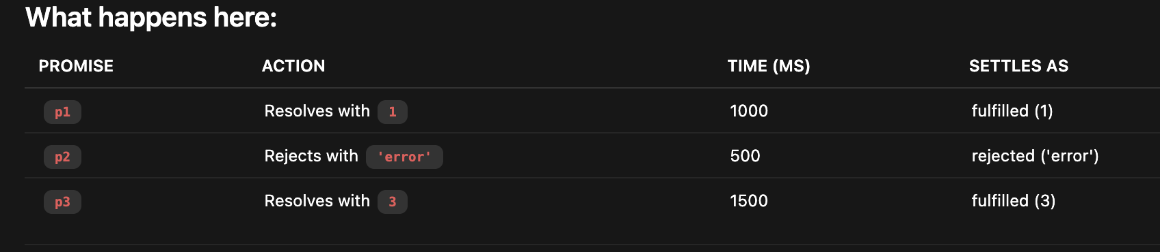

Question -> why p1 and p3 are fulfilled they would run post p2 na their timer is more it should have rejected earlier only?

Core concept:
- Promises (and their timers) run independently of each other once created.
- Promise.all reacts to the state changes (resolve/reject) but does not cancel or stop other promises.
- Timers (setTimeout) inside promises still fire regardless of whether some other promise rejects earlier.

9. Parallel vs Sequential Execution
// Scenario 1: Sequential
async function sequential() {
const r1 = await fetch('url1');
const r2 = await fetch('url2');
return [r1, r2];
}

// Scenario 2: Parallel
async function parallel() {
const [r1, r2] = await Promise.all([
fetch('url1'),
fetch('url2')
]);
return [r1, r2];
}
// Which is faster and why?

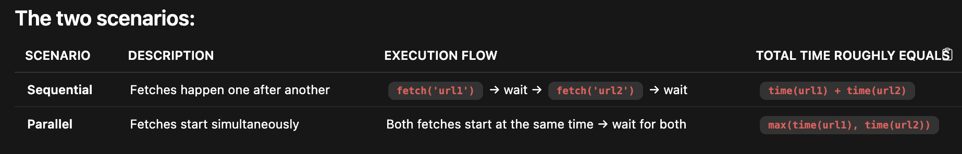

Why is Parallel faster?
- In Sequential, the second fetch starts only after the first completes.
- In Parallel, both fetches start together—they run concurrently.
- Therefore, the total waiting time is just the longer of the two fetch durations, not their sum.

10. Promise Constructor Pitfall
const promise = new Promise((resolve) => {
resolve(1);
resolve(2);
console.log(3);
});

promise.then(console.log);
// What gets logged?

What actually happens:
- Inside the Promise constructor callback:
  - resolve(1) is called — this settles the promise once with value 1.
  - resolve(2) is called — but ignored because the promise is already settled.
  - console.log(3) runs synchronously and logs 3 immediately.

Important notes:
- A promise can only be resolved or rejected once; subsequent calls to resolve or reject are ignored.
- The executor runs synchronously, so console.log(3) happens right away.

Practical Implementation Questions

11 – Implement Promise.all

12 – Implement Promise.race

13 – Retry Failed Promise

function retry(fn, maxAttempts) {
// Implement function that retries a promise-returning function
}

14 – Promise with timeout

function promiseWithTimeout(promise, timeout) {
// Implement promise that rejects if not resolved within timeout
}

15 – Debounce with Promises

function debouncePromise(fn, delay) {
// Implement debounced version of promise-returning function
}

Advanced Promise Scenarios

- Microtask v/s Macrotask Queue

console.log('1');

setTimeout(() => console.log('2'), 0);

Promise.resolve()
.then(() => console.log('3'))
.then(() => console.log('4'));

console.log('5');

setTimeout(() => console.log('6'), 0);

Promise.resolve().then(() => console.log('7'));

console.log('8');

// What's the output order and why?

- Promise Memory Leak

function createMemoryLeak() {
const data = new Array(1000000).fill('leak');

return new Promise((resolve) => {
setTimeout(() => {
console.log(data.length);
resolve('done');
}, 1000);
});
}

// Is there a memory leak? Why or why not?
// How would you fix it?

- Promise Chain with Conditional Branching

function processUser(userId) {
return fetchUser(userId)
.then(user => {
if (user.isPremium) {
return fetchPremiumData(user.id)
.then(premiumData => ({ ...user, premiumData }));
}
return user;
})
.then(user => {
if (user.age < 18) {
throw new Error('Underage user');
}
return user;
})
.catch(err => {
if (err.message === 'Underage user') {
return { ...user, restricted: true };
}
throw err;
});
}

// What's wrong with this code?
// How would you refactor it?

- Concurrency Limit for Promises

// Implement a function that runs promises with concurrency limit
async function promiseAllWithLimit(promises, limit) {
// Example: limit = 2, only 2 promises run at a time
// Your implementation here
}

// Usage:
const urls = Array.from({ length: 100 }, (_, i) => `url${i}`);
const promises = urls.map(url => () => fetch(url));
await promiseAllWithLimit(promises, 5);

- Promise Cancellation Pattern

function cancellablePromise(promiseFn) {
// Implement cancellation for a promise
// Return { promise, cancel }
}

// Usage:
const { promise, cancel } = cancellablePromise(
() => fetch('https://api.example.com/data')
);

setTimeout(() => cancel(), 1000);

promise
.then(data => console.log(data))
.catch(err => console.log('Cancelled:', err));

- Race Condition in Async Operations

let cache = null;

async function fetchData() {
if (cache) {
return cache;
}

const data = await fetch('/api/data').then(r => r.json());
cache = data;
return data;
}

// User clicks button multiple times rapidly
button.addEventListener('click', async () => {
const data = await fetchData();
render(data);
});

// What's the problem?
// How do you fix it?

- Promise.allSettled vs Promise.all

const promises = [
fetch('/api/user'),
fetch('/api/posts'),
fetch('/api/comments')
];

// Scenario 1: One API is down
// Which should you use and why?

async function handleAPIs() {
// Implement proper error handling
}

- Async Iterator with Promises

async function* asyncGenerator() {
yield Promise.resolve(1);
yield Promise.resolve(2);
yield Promise.reject('error');
yield Promise.resolve(4);
}

// How do you consume this?
// How do you handle errors?
// What's the difference between:
for await (const value of asyncGenerator()) {
console.log(value);
}

// vs

const gen = asyncGenerator();
for (const promise of gen) {
promise.then(console.log);
}

- Deadlock with Async/Await

async function deadlock() {
const promise1 = new Promise(async (resolve) => {
const result = await promise2;
resolve(result + 1);
});

const promise2 = new Promise(async (resolve) => {
const result = await promise1;
resolve(result + 1);
});

return Promise.all([promise1, promise2]);
}

// What happens?
// How do you detect and fix this?

- Promise.any with error handling

const promises = [
fetch('/api/primary'),
fetch('/api/secondary'),
fetch('/api/tertiary')
];

Promise.any(promises)
.then(response => console.log('First successful:', response))
.catch(error => {
console.log('All failed:', error);
// What type is error?
// How do you access individual errors?
});

- Implementing promisify

// Implement a generic promisify function
function promisify(fn) {
// Convert callback-based function to promise-based
}

// Usage:
const fs = require('fs');
const readFileAsync = promisify(fs.readFile);

readFileAsync('file.txt', 'utf8')
.then(console.log)
.catch(console.error);

// Edge cases to handle:
// 1. Multiple callbacks
// 2. Error-first callback pattern
// 3. This binding

- Promise Chain v/s Async/Await Performance

// Scenario 1: Promise chain
function promiseChain() {
return fetch('/api/user')
.then(user => fetch(`/api/posts/${user.id}`))
.then(posts => fetch(`/api/comments/${posts[0].id}`))
.then(comments => processComments(comments));
}

// Scenario 2: Async/await
async function asyncAwait() {
const user = await fetch('/api/user');
const posts = await fetch(`/api/posts/${user.id}`);
const comments = await fetch(`/api/comments/${posts[0].id}`);
return processComments(comments);
}

// Which is better and why?
// How can you optimize the async/await version?

- Handling Parallel API calls with dependencies

// You need to:
// 1. Fetch user
// 2. Fetch user's posts and user's friends (parallel)
// 3. Fetch comments for all posts (parallel)
// 4. Fetch friend details for all friends (parallel)

async function fetchAllData(userId) {
// Implement the most efficient solution
}

- Promise Memoization with Cache Invalidation
- function memoizeAsync(fn, ttl = 60000) {
- // Implement async memoization with:
- // 1. Cache based on arguments
- // 2. TTL (time to live)
- // 3. Handle pending promises (don't call twice)
- // 4. Error handling (should errors be cached?)
- }

- // Usage:
- const fetchUser = memoizeAsync(
- (id) => fetch(`/api/users/${id}`).then(r => r.json()),
- 30000
- );

15. Retry with Exponential Backoff

async function retryWithBackoff(fn, options = {}) {
const {
maxRetries = 3,
initialDelay = 1000,
maxDelay = 10000,
multiplier = 2,
shouldRetry = () => true
} = options;

// Implement retry logic with exponential backoff
// Add jitter to prevent thundering herd
}

// Usage:
await retryWithBackoff(
() => fetch('/api/flaky-endpoint'),
{
maxRetries: 5,
shouldRetry: (error) => error.status === 503
}
);

16. Promise pipeline/waterfall
// Execute promises in sequence, each receiving
// the result of the previous one

async function pipeline(initialValue, ...fns) {
// Implement promise pipeline
}

// Usage:
const result = await pipeline(
5,
x => Promise.resolve(x * 2),
x => Promise.resolve(x + 3),
x => Promise.resolve(x / 2)
);
// result should be 6.5

17. Detecting Unhandled Promise Rejections
// In Node.js
process.on('unhandledRejection', (reason, promise) => {
console.log('Unhandled Rejection at:', promise, 'reason:', reason);
});

// Scenario: Why does this trigger unhandledRejection?
async function test() {
const promise = Promise.reject('error');
await new Promise(resolve => setTimeout(resolve, 100));
await promise; // Handled after 100ms
}

test();

18. Promise Queue with Priority
class PromiseQueue {
constructor(concurrency = 1) {
this.concurrency = concurrency;
this.queue = [];
this.running = 0;
}

add(promiseFn, priority = 0) {
// Add with priority support
// Higher priority runs first
}

async run() {
// Implement queue execution
}
}

// Usage:
const queue = new PromiseQueue(2);
queue.add(() => fetch('/low-priority'), 1);
queue.add(() => fetch('/high-priority'), 10);
queue.add(() => fetch('/medium-priority'), 5);

1

19. Circular Promise Resolution
const obj = {};

obj.promise = new Promise((resolve) => {
resolve(obj.promise);
});

obj.promise.then(console.log);

// What happens and why?
// How does the spec handle this?

20. AbortController with Multiple Promises
async function fetchMultipleWithAbort(urls, signal) {
// Implement fetch for multiple URLs
// All should be abortable with one signal
// Handle partial completion
}

// Usage:
const controller = new AbortController();
const promise = fetchMultipleWithAbort(
['url1', 'url2', 'url3'],
controller.signal
);

setTimeout(() => controller.abort(), 2000);

promise
.then(results => console.log('Completed:', results))
.catch(err => console.log('Aborted:', err));

COMMON INTERVIEW QUESTIONS

Behavioral/Scenario:
- "How would you handle a scenario where third-party API is rate-limited?"
- "Design a file upload system for files up to 5GB"
- "How do you prevent duplicate API calls in React?"
- "Explain how you'd implement optimistic UI updates"
- "Design a resilient payment processing system"

Technical Deep-Dive:
- "Explain difference between Promise.all, Promise.race, Promise.allSettled, Promise.any"
- "How do you prevent memory leaks with promises?"
- "What's the microtask queue and how does it affect promise execution?"
- "How would you implement request deduplication?"
- "Explain the circuit breaker pattern"

Trade-offs Discussion:
- "Sequential vs parallel API calls - when to use which?"
- "Caching strategies and their trade-offs"
- "Retry vs fail-fast - how to decide?"
- "Client-side vs server-side rate limiting"

Common Pitfalls:
- Unhandled promise rejections
- Memory leaks from never-resolving promises
- Race conditions with multiple async operations
- Not cleaning up on cancellation
- Improper error handling in chains
- Over-aggressive retries causing cascading failures

