ABSTRACT CONCEPTS

1 ->
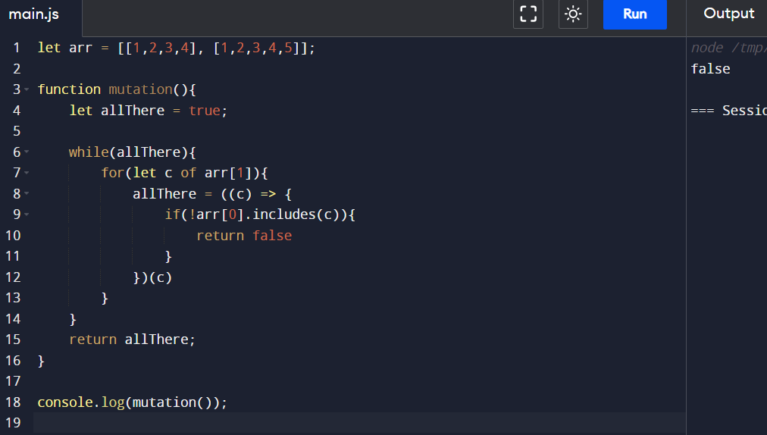
See, in the above code, we have an allThere variable initially assigned with true value, and then line number 8, we are invoking an arrow function wrapped inside an IIFE, that’s the concept we need to study
If we don’t use the IIFE, then we allThere will not be assigned with the false value, instead it will assigned with the function, but if we want to assign the false value, we need to invoke the function, hence we have made use of IIFE

