Floating Point Imprecision

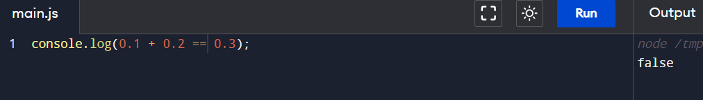
Shocked na? hahah
Let’s see why?
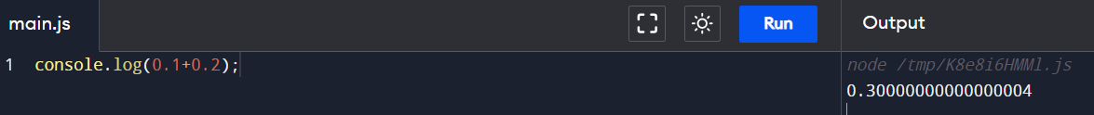
Because of this, 0.1 + 0.2 amounts to 0.30000000..4 , rather than simply 0.3
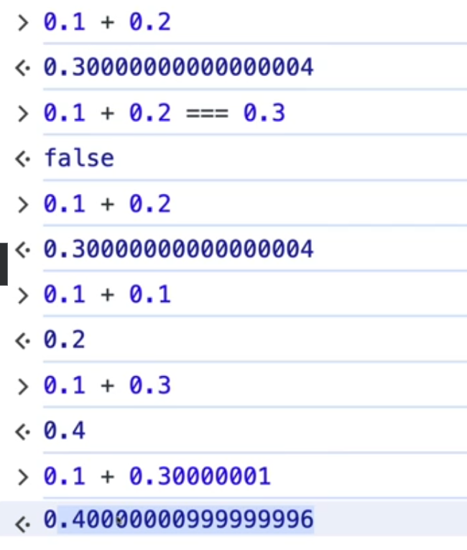
In some case, its normal, but in some case imprecise
JS may not be the best language to use if you are working with really small floats
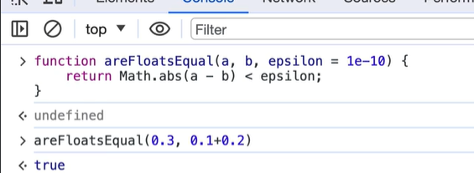
We have used a helper function to get the desired results

#BigInt() and Really large Numbers
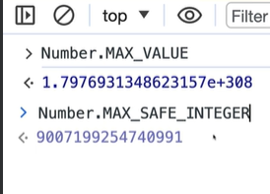
Number.MAX_SAFE_INTEGER, is the largest value upto which we can safely perfom maths
So, there is a recent addition in JavaScript BigInt to help in these exact situation to help with very large numbers
Adding n at last to a number indicates that is is BigInt
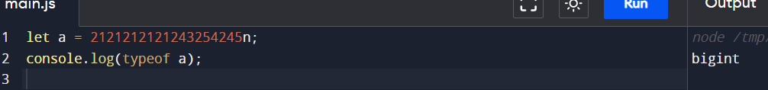
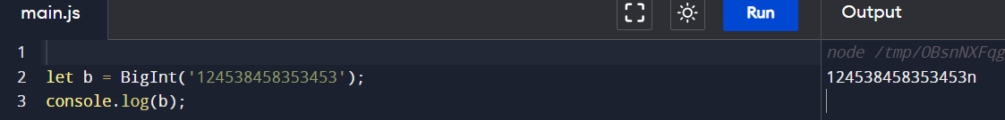
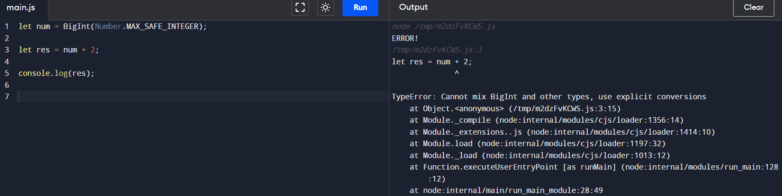
See, in the last example, we tried to add 2 with num i.e BigInt but it does not allow it cause the other number i.e 2 must be also of type BigInt
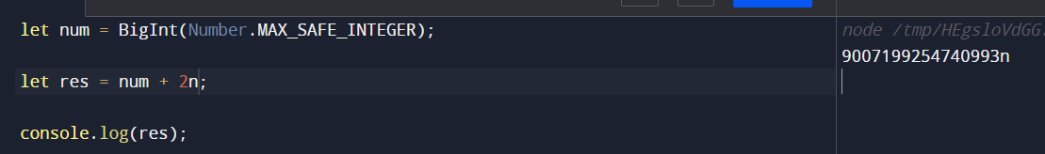
See, now it worked
BigInt cannot be used with floating numbers, also Math.sqrt does not work on BigInt
#isNaN vs Number.isNaN
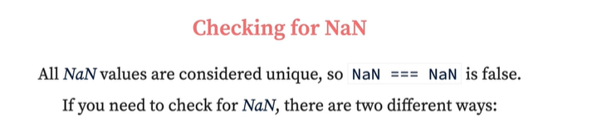
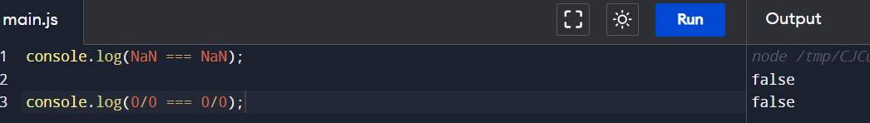
The way to check not a number is to use isNaN()
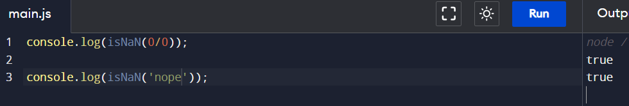
isNaN(n) returns true if n is NaN or is a value that cannot be coerced into a number
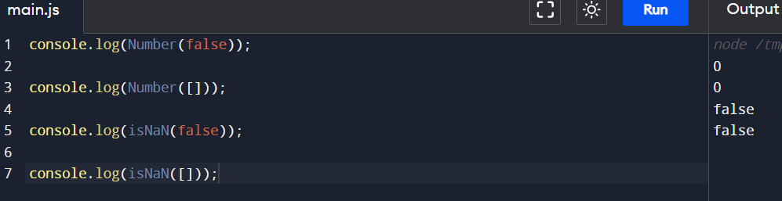
See, above false and [ ] (empty array) can be coerced into a number, hence isNaN returned false
Whereas Number.isNaN(n) returns true only if n is isNaN – everything else returns false
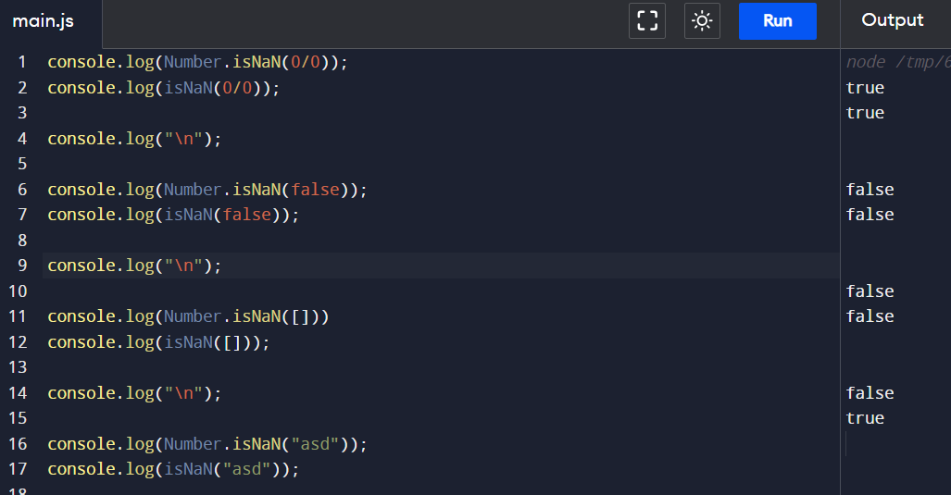

#Post increment (x++) vs Pre increment (++x)
In the post increment the value is used in the expression first and then is incremented,
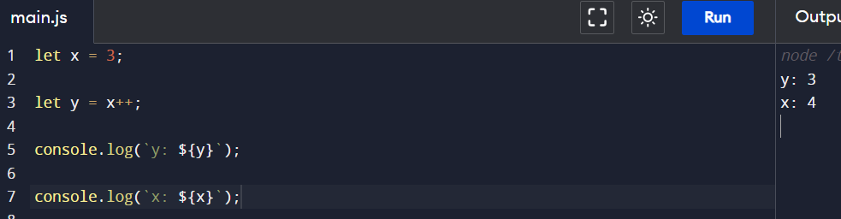
See, y is still 3 and x is 4, cause initial value of x i.e 3 is first assigned to y, then is incremented
# Automatic Semicolon (;) Insertion (ASI)
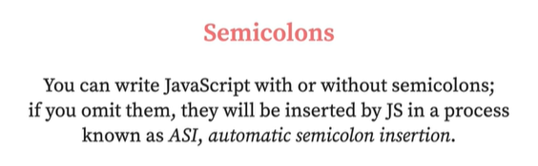

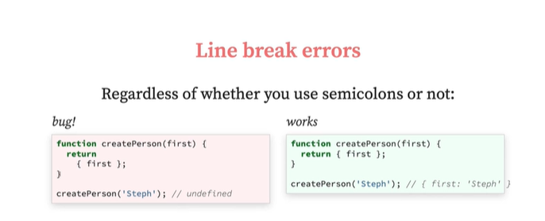

#Generator Functions
Generator functions are functions that can pause their execution and then resume their execution, they also produce sequence of values on demand
We use function decoration (function*) and within the function we use the keyword yield
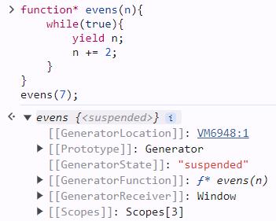
See we have created a simple Generator function evens, and called it below, it returned us a Generator object, rather than giving a number back
And that object has a method called next,
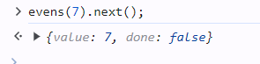
And when we called the next on the returned Generator object, we got the value
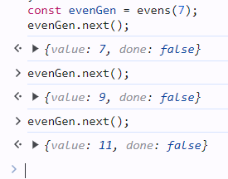
See, everytime we call the next method on the object, it returns us a new value because of the logic that we have stated in our Generator function i.e n+= 2
Let’s see another simple example of Generator function ->
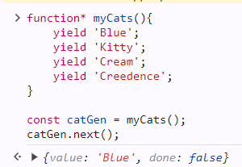
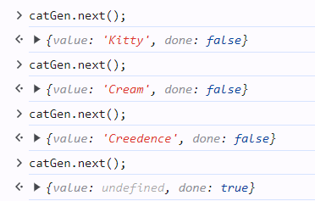
See, in the last call, it gave undefined as we were out of values, and we can see the done property set to true
Let’s write a Generator function called Fibonacci
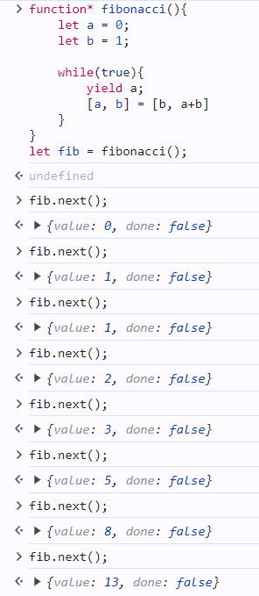
Why do we use Generators?
Suppose we have a large batch of image urls with us,
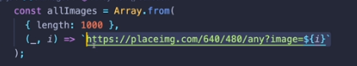
And if we don’t want to display all thousand at once, rather we wanna display 10 at a time, then next 10, then next 10, and so on…
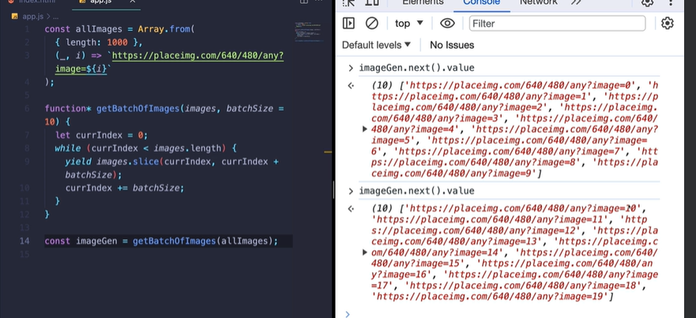
#Array.from
Generates new array from some sort of initial non-array, we’ll pass in anything that is iterable like
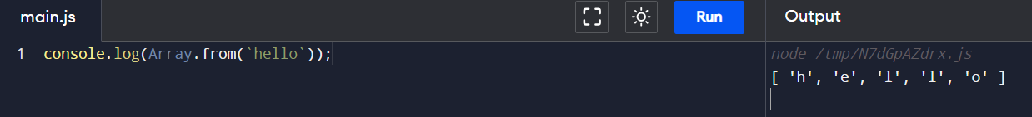
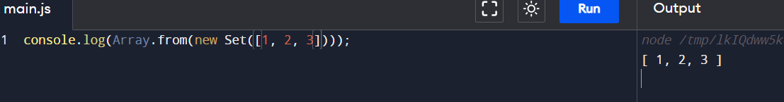
One of the most useful place to use Array.from is when you are working with DOM Nodelist
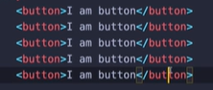
Suppose we have five buttons in the body, and we want to select them all,
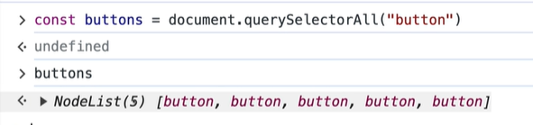
We used querySelectorAll to select those buttons, but querySelectorAll returned a NodeList that looks like an array but is not one, and it we try to perform operations on it, we will get error
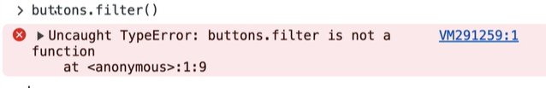
Therefore we need to turn it to an array, and we will do that using Array.from
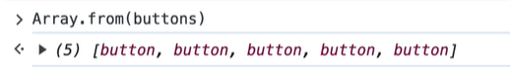
Now, there is a second argument to Array.from, a mapping function
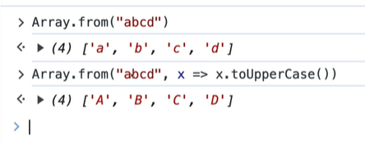
See, in the above example, for the first time we simply used Array.from and we got the ‘abcd’ alphabets in an array,
But what if we need those alphabets in Uppercase, that we did second time, by passing a mapping function to Array.from and updated each item using toUpperCase() method
Now, with Array.from we can also generate an array of a specific length ->
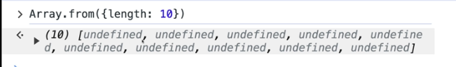
Now all the elements are undefined, we can define them at the time of creation only by using the mapping function ->
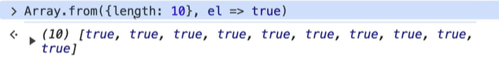
If we want to generate numbers from 0 to 99
