CURRYING
Suppose humare pas ek function hai multiplier which takes two arguments namely x and y
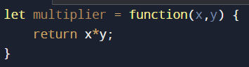
But, suppose our requirement is like, ki humko ek argument fix karna hai, matlab jese ek function hai usme hum wo bhi argument dede wo 2 se multiply hoke result de, mtlb sidhe sidhe multiplier ka ek argument 2 fix karna hai, ek trika to h ki 2 hardcode krdo, but hmko harcode nahi krna hai, then the other way is multiplier ke ek argument ko 2 se bind kardo
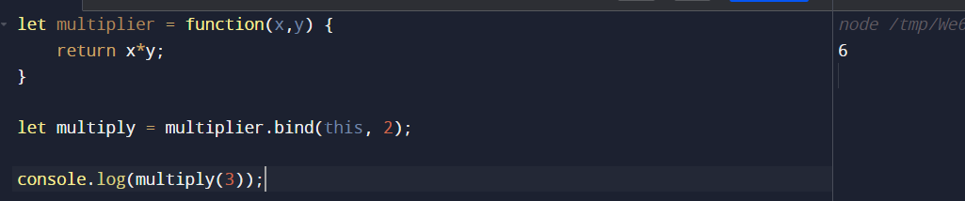
Uper jo humne kia is function currying using bind method, and this was one way to do currying.
One more way to achieve currying is by use of closures
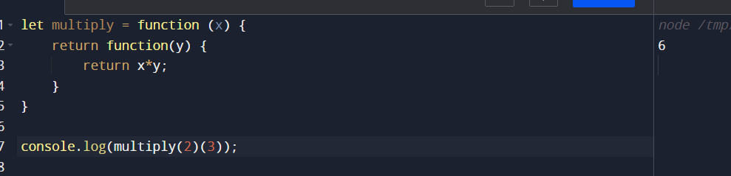
And if we want to fix 2 then follow below code:
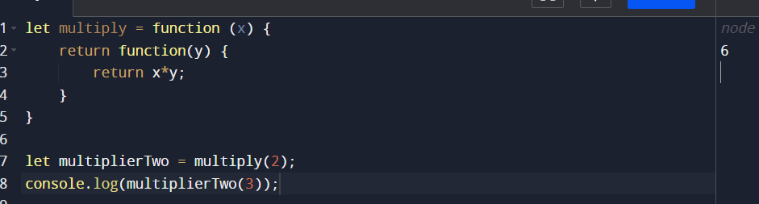

Why should currying be used?
Following are the reasons why currying is good :
✅ It makes a function pure which makes it expose to less errors and side effects.
✅ It helps in avoiding the same variable again and again.
✅ It is a checking method that checks if you have all the things before you proceed.
✅ It divides one function into multiple functions so that one handles one set of responsibility.

QUESTIONS
- Implement infinite currying -> Basically, this is a function that could sum n numbers.
Sum(1)(2)(3)…….(n)

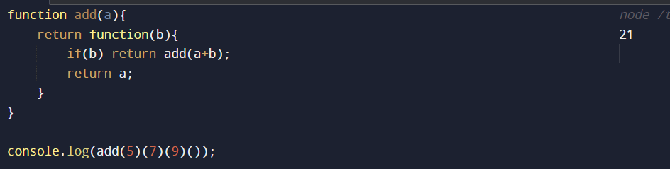

- Currying v/s Partial Application
Partial application transforms a function into another function with small arity(the number of arguments that the function has)

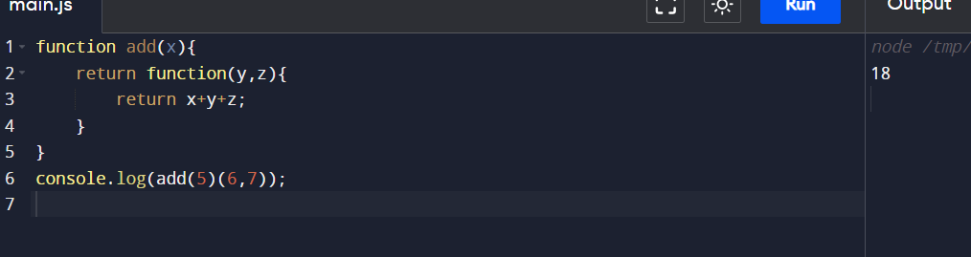

We have three arguments but we are returning only two functions, hence this is the case of partial application

- Real-World Example of Currying – DOM Manipulation

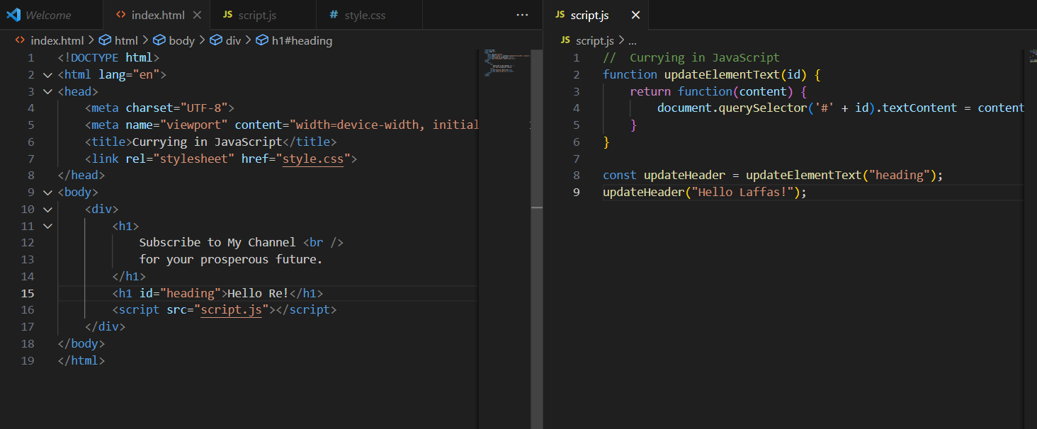


- CURRY IMPLEMENTATION ( MOST IMPORTANT )

