Constructor Function
A constructor function, gets an object out of thin air assigned to this, then optionally initializes it, and finally implicitly returns that object
Constructor defines characteristics and behaviour of each the objects constructed from it — or better to say, instantiated from it.
we'll use the fact that a constructor in JavaScript is quite similar to the idea of a class from the OOP universe
Let us create a constructor function Point
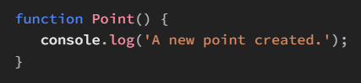
Let’s go on and create a Point object,
Creating an object using a constructor is accomplished by invoking the constructor via new, as we already know
A constructor's invocation expression (with new) creates and returns a new instance of the constructor. The overall process of creating the instance is called instantiation.
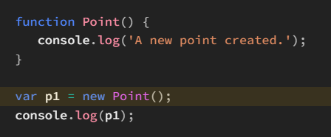
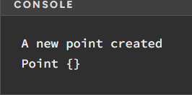
Well, p1 is an object, right? objects could be assigned new properties at any time just by a simple assignment syntax together with bracket notation or dot notation.
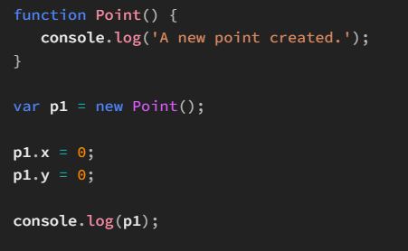
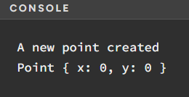

Initializing the Instance
Assuming that when a point is created, it's placed on the origin, i.e. (0, 0), we could configure our Point() constructor to do this automatically for us:
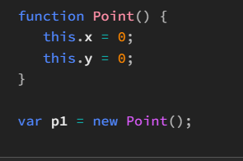
When Point() is called in line 6, as a constructor, it's quite obvious what's happening in its body i.e. the properties x and y are being assigned on the this object, but what's not that obvious is the value that this resolves to
It turns out that this holds the real potential of OOP in JavaScript:
- It's what makes it possible to initialize an object upon construction inside the constructor function.
- it's what provides a method's body, defined on the prototype, with the instance object calling it.

When a constructor function is called (i.e. with new), internally a new empty object is created and then that object is assigned to this, which can then be accessed inside the function.
Assigning properties to an instance from within the constructor is commonly known as initialization.

While describing the code above, it won't be wrong to say that a constructor is a template-kind-of thing that defines what a Point object looks like. We use this template to create two Point instances p1 and p2 in our code, each having their own x and y properties set to 0.
In other words, we don't have to manually go on and create each object using the same new literal syntax, merely copied and pasted again and again.

Internals of a Constructor
When a function is called in the context of a constructor, i.e. with the new keyword, the internal [[Construct]] method of the function object is called, if it exists
Given a function F, the expression new F() executes the internal [[Construct]] method on F that performs the following steps:
- A new empty object is created.
- The prototype of this object is set to F.prototype.
- The [[Call]] internal method of the function is executed with its this set to the object created in step 1.
- The object created in step 1 is returned.

We could set up the Point() constructor to accept the x and y coordinates of the point to-be-created as arguments.
Consider the code below:
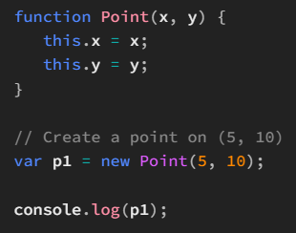
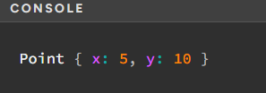
Currently, if we want to create a bunch of points pointing to the origin, we have to manually pass in the arguments 0 and 0 to the constructor's invocation, i.e. new Point(0, 0). Given the fact that the origin is a common location, we could simplify this a bit.
That is, we could allow the arguments x and y to be omitted, and in that case assumed to be 0. In other words, we could make the parameters x and y optional and default them to 0, if omitted.
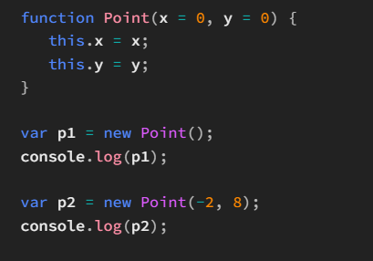
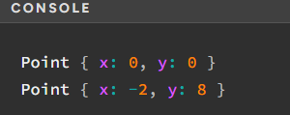
When called without any arguments, it creates a Point object situated at the origin. Otherwise, it creates a Point object situated at the given set of coordinates (provided as arguments).
However, even with this parameterized Point() constructor, one thing is still not addressed. That is when we want to change the coordinates of a given point after it has been created.
For example, suppose that we create a new point object via the expression new Point(0, 2) and then save the returned instance in the variable p1. Now what if we want to change this point to (1, 5)?
Well, given the setup we have right now, there's only one way to do this, as shown below:

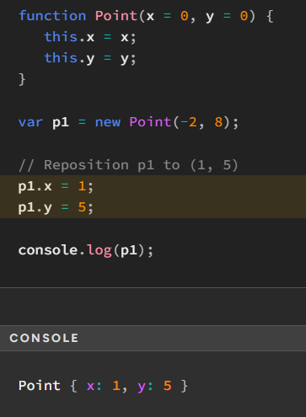
As can be seen, we have to manually change the respective properties one-by-one.
Once again, this manual work is tiring. The good news is that it could be prevented as well.

Well, recall the fact that inside a constructor, we initialize the instance being created by adding properties to it. Methods are simply special cases of properties so we could add them to the instance as well and thus describe its behavior.
In our case, we could define a method that serves to reposition a point to another set of coordinates. It would take in two args x and y, and then assign them to the x and y properties of the Point object, respectively.
Let's call this method setTo(). With this method, we would no longer need to manually write assignment statements to change the x and y properties of a given Point.

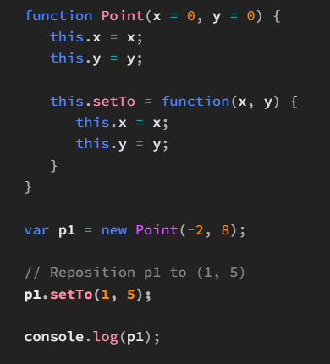
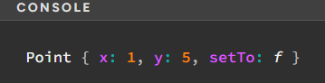
Problem with constructors
Any code that is written inside a constructor's body is executed for each instantiated object. In the case of mere properties, that anyways have to be maintained for each instance, this isn't a problem.
After all, each instance usually has distinct properties. But behavior is typically not local to instances.
For instance, there might be tons of different Tesla Model S cars on Earth right now, each with different properties, such as the name of the owner, the body color, etc, but they all have the same internal mechanism of braking, right?
In simple words, adding methods to instances from within the constructor in the way we add properties is usually not a good idea, since for each instance there is a separate method, yet every single one of them performs the same action.
Consider the latest definition of Point() from the last code snippet shown above:
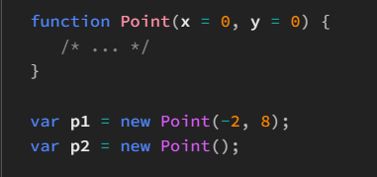
Quite trivially, as can be seen here, both instances p1 and p2 have a setTo property available that points to a function.
Now, let's go on and compare the setTo() method of p1 with that of p2 to see whether they both are the same:
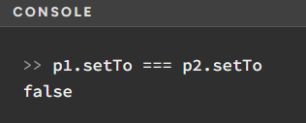
p1 has its own setTo() method while p2 has its own setTo() method. Both these methods perform exactly the same task, yet they ain't the same.
Our code is not DRY (Don’t Repeat Yourself!)
To be more precise, the code is creating a separate setTo() method for each instance
This separate method for each instance comes at a cost:
- Storing these different function objects assigned to setTo obviously consumes memory.
- Storing keys on an object consumes memory as well. Here, we are referring to the key 'setTo'.
- Storing references (i.e. addresses) to function objects also takes up memory. Here, we are referring to the actual value stored inside a property.
Constructors, generally speaking, shouldn't be used to define instance methods.
One obvious remedy to this is to create the function objects in the global scope and then create methods on the instance by means of passing a reference to these global functions.
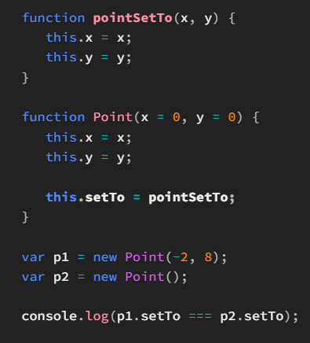
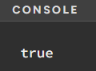
We have taken the definition of the function assigned to setTo outside the Point() constructor. In this way, it's not re-created each time Point() is called. The log made also shows that both p1.setTo and p2.setTo point to the same function object.
But, nonetheless, this still doesn't solve all of our problems...
Firsly, we are still defining setTo on each instance, even though there is no need to. Ideally, stuff defined separately for each instance of a constructor should define traits of the instance (that are usually different for each instance) and in this way define its state. So that's problem number one.
Secondly, we have effectively lost encapsulation of the stuff related to a Point object within the Point() constructor.
. That is, we are now filling up the global scope with stuff that ideally should've been somehow defined as part of the Point class only, and not anywhere else
Now, someone could go on and argue that to prevent global namespace pollution, we could wrap an IIFE around the whole code defining the Point() constructor and its related functions
This is possible, but much more headache than a solution
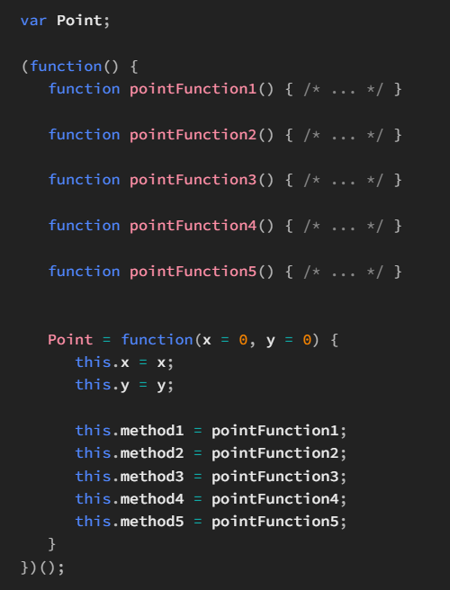
First of all, we have to make sure that Point is declared outside the IIFE (line 1) in order to be accessible in the global scope.
Secondly, we have to change the Point function declaration to a function expression (line 15) and assign that to the variable Point.
Moreover, we also have to increase the indentation of the code inside the IIFE
But still, we are creating separate properties method1, method2, ..., on each Point instance, even though they all point to the exact same function objects internally.
Overall, the code looks extremely ugly and unmaintainable. We are creating IIFE overheads (putting them in memory, maintaining lexical environments, calling them) in our application completely unnecessarily.
So an IIFE is clearly not a solution to our global-scope-pollution problem.

So what is the way then?
There's one and only one answer to this — prototypes
So what exactly is a prototype in JavaScript?
JavaScript, as we know, is a prototype-based OOP language
In classical OOP languages, classes inherit data from other classes. Instance objects created out of these classes essentially don't inherit data from other objects.
In prototype-based languages, objects inherit data from objects.
This leads us to the simplest definition of what a prototype is:
For a given object o, the object from which o inherits properties is called the prototype of o.
Suppose that p is this prototype object. Then any properties defined on p would be available on o as well, since they are inherited by o.
Let's say we have two objects a and b as shown below:
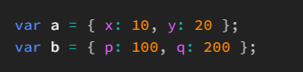
If we assume that a is the prototype of b, which isn't explicitly shown in this code snippet in any way (i.e. it's just a supposition), then here's what would happen when we access a couple of properties on b
- b.p would simply be 100.
- b.q would be 200.
- b.x would be... Hmm. What do you think? Well, b.x would be 10 and you might have already been able to see where this value is coming from — it's being inherited from a.
- b.y would be 20, once again thanks to inheritance.
At the very foundation, this is just what prototypes are all about — that is, inheritance. One object has access to all the properties of its prototype by means of inheritance.

The [[Prototype]] attribute
So far, we've learnt that an object in JavaScript inherits data from another object called its prototype
But how does it know of its prototype in the first place? In other words, how does any given object know that it will be inherting properties from another given object?
every single object (yes that's right, every single object) has an internal attribute called [[Prototype]] that simply holds a reference to the prototype of that object.
In simpler words, all objects in the language inherit properties from their [[Prototype]] attribute, which simply points to their prototype object.
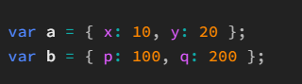
where b's prototype is a, the object b would internally look something like this:
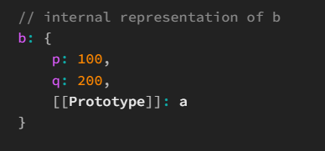
Mark, this words, that it is merely an internal representation
Let's consider an example:
When we create an object via the object literal syntax, or equivalently via the Object() constructor, JavaScript creates an Object instance whose prototype is automatically set to Object.prototype:
Hence, given the code below:

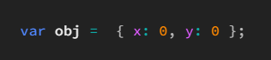
its internal representation would be something as follows:
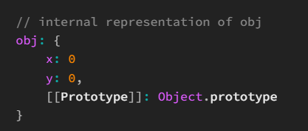
Now sometimes it might be the case that an object doesn't want to inherit any properties from another object. In other words, it might be the case that the object doesn't want to have a prototype.
Well, the solution quite straightforward — the object has its prototype as null
The prototype is effectively still there on the object, i.e. its [[Prototype]] attribute has a value at the end of the day, but it's null, signaling that the object doesn't inherit any properties.
In JavaScript, there is only one predefined object that has a null prototype and that is Object.prototype.
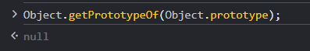
The Object.create() method
The static Object.create() method was introduced in ECMAScript 5 as a way to create a new object with a given prototype.
First, let's consider the object a that has to be made the prototype of b:
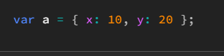
Now, let's consider the object b:
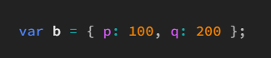
Stating it once more, a has to be made the prototype of b. Currently there is nothing implementing this in the code.
So how do you think could this be done using Object.create()?

Well, one thing that has to be realized over here is that we want to change the prototype of an existing object (b in this case). However, Object.create() only enables us to create a new object with a given prototype.
Hence, we couldn't just take b and magically set a as its prototype using Object.create(). There is just no way to do so, at least using Object.create().

Instead, we have to first create an empty object using Object.create() whose prototype is configured to a, save that object in b, and then add the properties of b as specified in the code above one-by-one using the dot notation (or bracket notation) property assignment syntax.
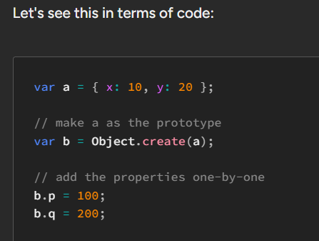
Object.create() could be called with null as an arg as well.
In that case, a new object is created (and returned) whose prototype is null. That is, this object does not inherit any properties since it doesn't have a prototype.
Consider the following code:
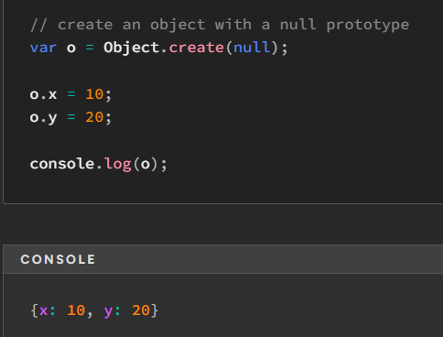

Prototype Chains
For a given object o, its prototype chain is simply a list of prototypes whose first item is the prototype of o, and any subsequent item is the prototype of the previous item, and the last item is simply null.
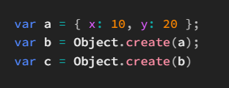

With this code in place, we'd write the prototype chain of c as follows:

This means that c inherits data from b which in turn inherits data from a. Note how the arrow start at b and points to a. This just follows from the fact that b contains a [[Prototype]] internal attribute that points to a.
As we stated before, when we create an object using the object literal syntax, its prototype is automatically set to Object.prototype. Hence, in our case, a inherits from Object.prototype, which in turn has a null prototype.
Thus, the complete prototype chain of c would look like this:
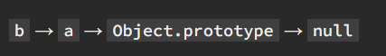
If a given property exists directly on an object, it takes precedence over the same property somewhere in the object's prototype chain, when accessed on the object.
A property that is accessible on an object could be its own property or an inherited property

The hasOwnProperty() method of objects helps us determine whether a given property is an object's own property.
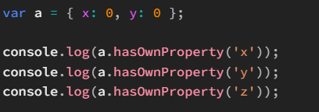
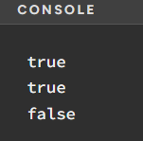
in operator
in simply tells us whether a given property is accessible on an object.
This means that starting from the object itself, it effectively traverses the whole prototype chain of that objet in search of the property, until it's found.
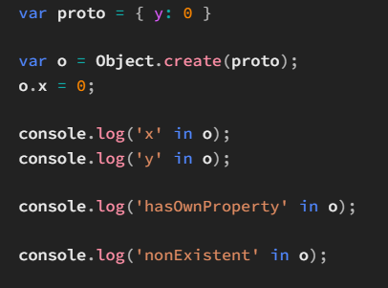
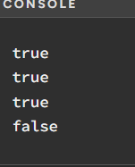
The third log might be counter-intuitive — we've not defined any hasOwnProperty on o, or its prototype proto, yet we have access to it as determined by the in operator.
this hasOwnProperty property is coming from Object.prototype

The prototype property
When a given function F is called as new F(), then as we already know, we get back a new object returned — or better to say, an instance of F().
This instance has its prototype set to F.prototype i.e. to the prototype property of F, automatically during the instantiation process.
Well, as one might think at the first glance (even as I did initially when learning JavaScript), F.prototype seems to take us to the prototype of F (remember that F is a function object).
That's completely wrong!
The term 'F.prototype' seems to be confusing and misleading
Let's now see what F.prototype is.
F.prototype is just a convenient (and frankly speaking, a clever) way to denote the prototype of any instance of the constructor F()
Consider the simple Point() constructor below, without the setTo() method's definition inside it:

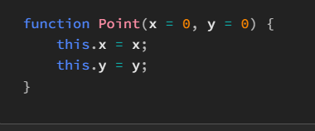

From all the discussion we've had so far, we know that Point.prototype points to an object that is the prototype of every Point instance. That is, a Point instance inherits properties from Point.prototype
Thus, if we define the setTo() method on the object Point.prototype, then every Point instance would have access to it. In other words, we'd be able to do something like p1.setTo() if we assume that p1 is a Point instance.
Voila!
We have solved our method definition problem.

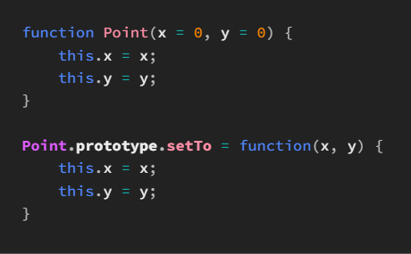
The setTo() method is defined on the Point.prototype object. As a result, it's available to all Point instances.
Let's see the benefits of using Point.prototype to define setTo():
- We aren't creating a new setTo() function for each new Point instance. The function is defined once and saved under Point.prototype.
- We aren't creating a new setTo() property for every single Point instance. The property is defined exactly once on the object Point.prototype and from there ultimately finds its way in the resolution of setTo as accessed on any Point instance.
- We aren't filling up the global scope in any way — all Point-related functionality is nicely within the Point function object.

The instanceof operator as the name suggests tells us whether a given object is an instance of a given constructor
When an instance is created using a constructor, there is a constructor property available on the instance. This points to the constructor function used to create the object.
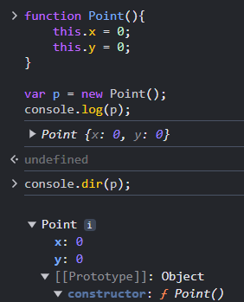

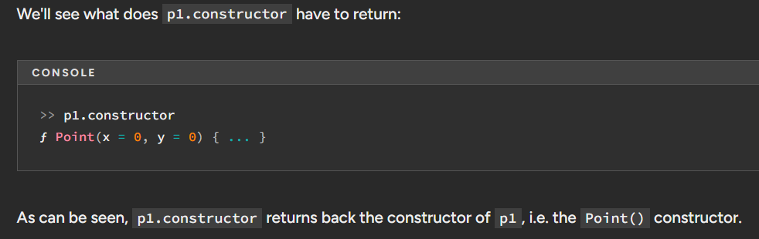
how do we check whether a constructor is called as a normal function or vice versa?
There are mainly two ways to accomplish this:
- Use the ES6-style expression new.target
- Use the instanceof operator
Let’s check instanceof ->
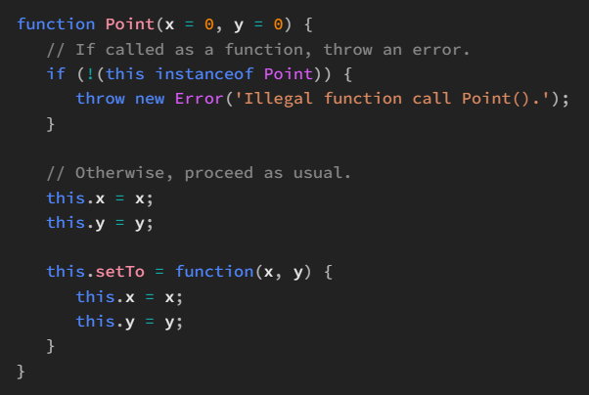
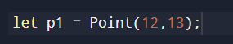
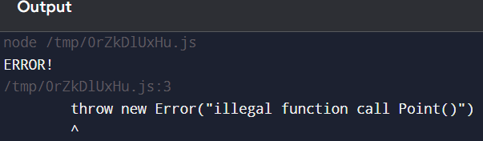
Note that instead of throwing an error, we could also configure Point() to make the correct call itself. That is, when we call Point() as a function, the function could call itself as new Point().
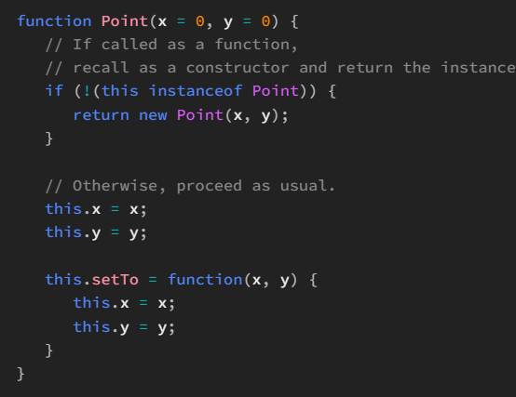
#Constructor Stealing
In JavaScript, this idea of calling the parent class' constructor from within the constructor of the subclass is possible, but not as straightforward as it might seem, now classes are there but we are talking before that
Consider the task of creating a shape drawing application in JavaScript
Let's assume that each shape is denoted by the Shape class. A Shape could have a fill color given as a hexadecimal value (including the hash symbol), and a position on the canvas (the main drawing area) given as two properties x and y representing the x and y coordinates on the canvas, respectively (in addition to numerous other properties).
The most abstracted Shape constructor would look something like this:
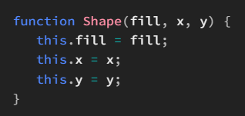
Since there can be multiple kinds of shapes, it seems sensible to create subclasses of Shape to represent these shapes in the application.
The subclass we'll construct right now is Rect to denote rectangles.
Rect could have a length property and a height property to determine the area spanned by the rectangle
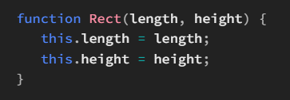
Now, as we said before, Rect is a subclass of Shape. This simply means that every Rect is a Shape as well. Consequently, every Rect object must have all the properties a Shape object has.
So how do we get all properties of Shape in Rect, should we again declare them in Rect?
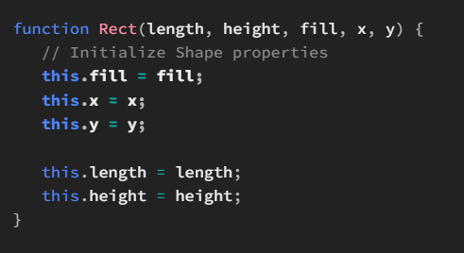
But hey, wait. Isn't this repetition of code? We are redefining assignment statements for a Shape object again inside the Rect() constructor.
One straightforward solution that might come in the mind of the novice developer is to call the Shape() constructor from within the Rect() constructor as new Shape().
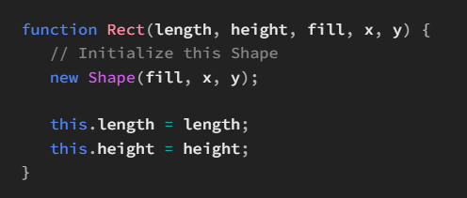
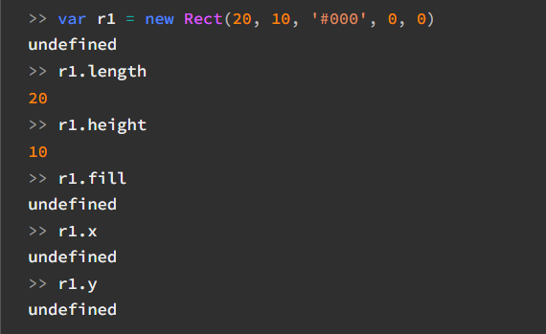
Can you see the problem here?
The object doesn't seem to have any of the properties x, y or fill
when we call new Shape(), a new object is created and the properties fill, x and y added to that object. This is just the problem.
The Shape() constructor's invocation as a constructor simply creates a new binding for this, that is a new Shape instance. This instance is what receives all the initialization code of Shape()
Even if we were to assign Shape to this.parent inside Rect() and then go like new this.parent(), there would be absolutely no difference in the final result — the properties fill, x and y would be undefined on the Rect instance.
This can be seen as follows:

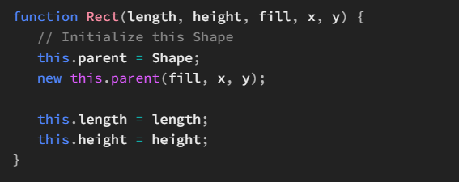
Any solution?
define a method on the instance inside Rect() and point it to the Shape() constructor, and then call this method, without using new
This would automatically set this of the Shape() function to the calling object, i.e. the Rect instance
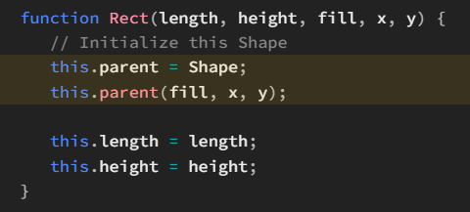
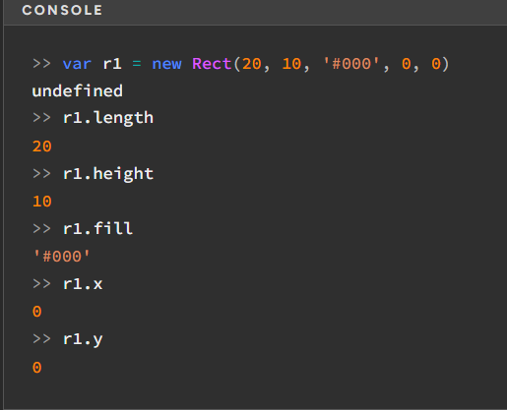
Yeah, it works!
Another solution is to use the power of the call method, to configure this for constructor function
This is much better than the previous way, as we don't have to create a new property (parent in the case above) on the instance to hold the parent constructor.
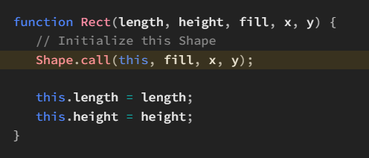
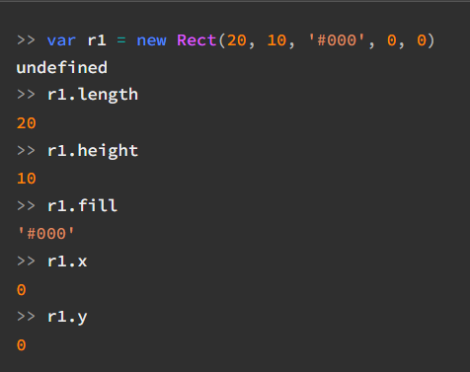
You'll find this second way used very frequently out there — this is because it's the simplest way to emulate parent class constructor invocation in JavaScript.
This technique is commonly referred to as constructor stealing, or constructor borrowing, following from the fact that we merely steal the constructor's code to be used in the context of another constructor.

