EVENTS

Every event in JavaScript is denoted by a name.
In JavaScript, the click action is referred to as the click event.
The click of the mouse's right button is referred to as the contextmenu event
Event’s target
Apart from name, every single event has an underlying target
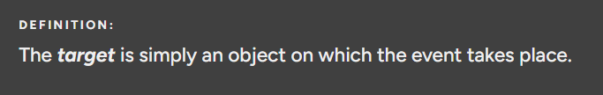
For instance, if we click on a <div> element, then the target of the click event would be that <div> element
There can never be an event without a target.
Event’s Handler
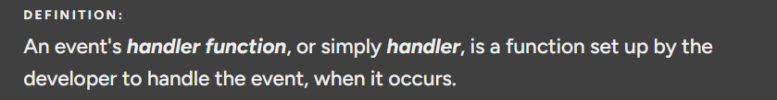
Sometimes, the handler is also called the event's listener function, or simply listener.
Event handlers are automatically invoked by the JavaScript engine when their underlying event occurs.
And when that does happen, they even get provided with an argument object. This argument is commonly known as the event object and serves to host a plethora of properties and methods to allow the developer to inspect details of the occurred event.

Event Handling Properties
In JavaScript, there are essentially three ways to setup event handlers:
- Use event-handling properties
- Use the EventTarget interface
- Use event-handling HTML attributes
- Many interfaces in JavaScript are extended by these so-called event-handling properties. They begin with the word 'on' followed by the name of an event, all in lowercase, and simply serve one purpose — to hold a handler for the given event.
- For instance, taking the click event as an example, its corresponding event-handling property is onclick. This property is available on all objects that can potentially receive a mouse click on a web page. To be precise, onclick is defined on the HTMLElement interface.

As a quick example, if we wish to handle the click event on the following <button> element,
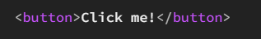
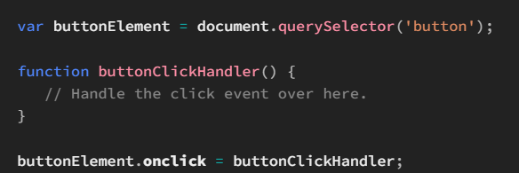
Note that we don't have to call the function buttonClickHandler(); just pass its reference to the onclick property, which will then automatically be called by the JavaScript engine on the occurence of a click.

EventTarget Interface
The property-based approach above to set up event handlers works well in all but some complex cases. These complex cases are when we want to use more than one event handler.
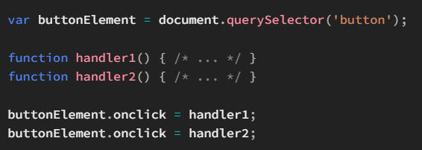
We wish to set up two click event handlers here on the <button> element that should both execute when the button is clicked.
However, we can't assign them one after another to the <button>'s onclick property, since the second assignment, to handler2, overrides the first one.

With the onclick approach, the only way to use multiple handling functions is by manually calling them inside one single function and then using this function as the handler function, as shown below:
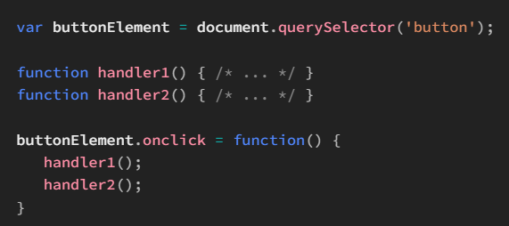
# addEventListener()
the addEventListener() method is used to add an event listener for the target object it's called on
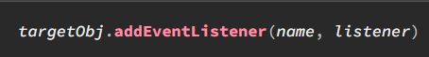
targetObject is an instance of EventTarget on which we wish to handle a given event, name is a string representing the name of the event (a.k.a. its type), and listener is the listener function (a.k.a. the handler function) for the event.

#removeEventListener()
As with the event-handling property approach that we saw above, it's possible to remove an event handler set up via addEventListener(). That is by using removeEventListener().
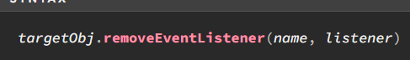
The first argument is the name of the event whose handler we wish to remove from targetObj while the second argument is a reference to the handler function, provided at the time of calling addEventListener(), that we wish to remove.
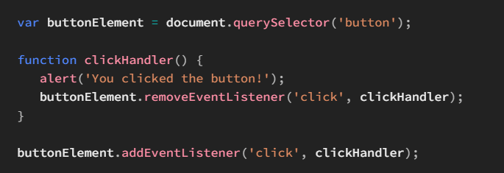
After the button is click ed for the very first time, removeEventListener() is used to remove its click handler and thereby prevent any further alerts from being made upon its click.
Notice that in both the calls, i.e. to addEventListener() and to removeEventListener(), we pass the same function in the second argument. This is not just a nice thing, but also a requirement.
Event handler's this binding
when JavaScript calls an event handler, it sets its this value to the object on which the event handler was set up, initially.
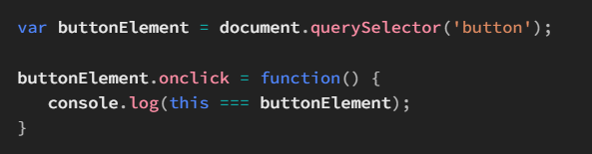
Normally, we'd expect the this inside onclick() to resolve to the buttonElement object, as onclick() is a method of buttonElement. Fortunately, this is the actually the case. 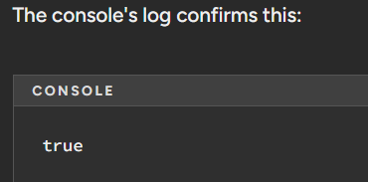
# Event Object
An event object refers to the argument sent into an event handler function.
It contains contextual information regarding the event that caused a given handler to be invoked.
in the case of event-handling HTML attributes, since they don't hold a function, there's no point of even talking about parameters — that's because there ain't any!
Instead what happens in this case is that the event object is available via a local variable called event that's automatically created by the JavaScript engine when execution enters the context of an event-handling HTML attribute.

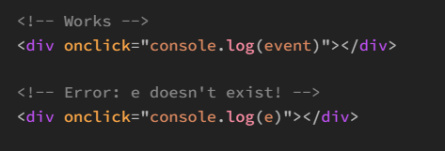
The Event Interface
It defines those features that are common to all events, no matter what their type. This includes things such as the event's name, its target, the time at which is occurred, and so on.
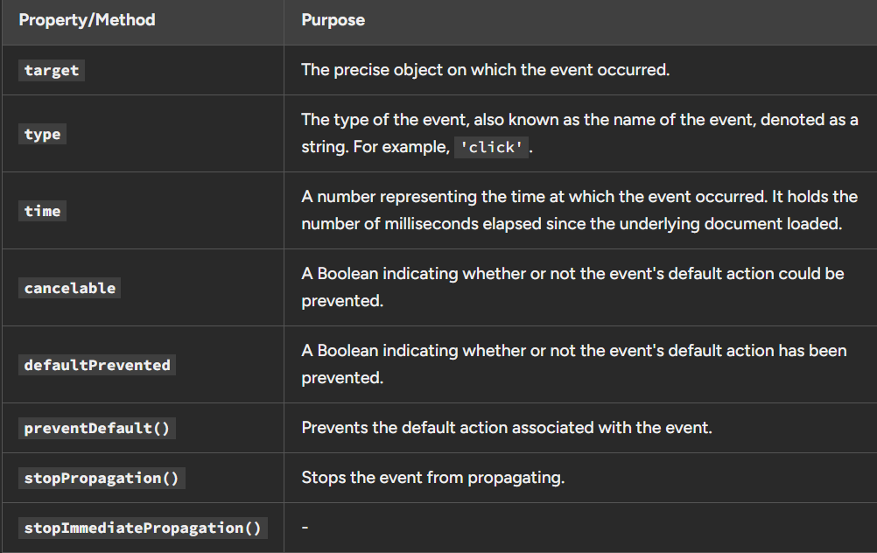
Now clearly, since every single event couldn't sensibly be represented to its entirety by just one single interface, i.e. Event, there are some specialized interfaces extending Event that represent specific sets of events.
For example, many events in JavaScript could be grouped under the category of mouse events, by virtue of being initiated by the mouse. They share common information and functionality, such as denoting the x and y coordinates of the mouse pointer. Likewise, in JavaScript, the MouseEvent interface is made to specifically represent these mouse events.
MouseEvent extends UIEvent, which is yet another interface meant to represent events initiated inside or by the user interface. UIEvent extends Event, which we've already discussed about.
Handler's this vs. event object's target
Given that an event handler's this hasn't been configured by virtue of a bind() call on it, it points to the object on which it was set.
For example, if we log this in the handler shown in the code above, it'll be equal to window, simply because we set up the handler on window:
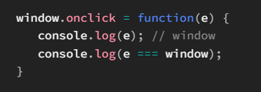
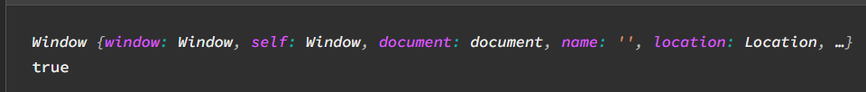
However, as you just saw above, e.target isn't the same as this inside the handler.
e.target returned the element node that received the click event. In contrary, this always returned the window object.
Knowing about this distinction between an event handler's this binding and its corresponding event's target is absolutely critical when writing programs. It can sometimes lead to unexpected behavior, or even fatal exceptions.
To help illustrate this fact better, we've put together the following example:
What we want to do over here is to simply change the background color of the button to yellow the moment we click on it.
On first glance, the task seems quite straightforward.
In the code below, we try accomplishing it, using the event's target property:

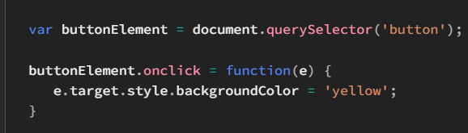
Surprisingly, there's a weird issue (actually, it's not weird at all!).
When we click anywhere inside the button where the <span> element doesn't exist, we get the expected outcome. However, when we click inside the <span>, instead of the button's background changing, the <span>'s background changes.
So what's causing this issue?
Well, the reason that we're facing this bug is because we're using the event's target property where we could've otherwise used this.
When we set up an event handler on the <button> element directly, we could've easily accessed it using this. Using e.target, we refer to the precise element that triggered the click on the button — which might turn out to be the <span> element nested inside the button.
Hence, when we clicked on <span>, e.target resolved down to that <span> node and therefore, ultimately, got its background changed.
So whether one needs to use this or e.target depends totally on the situation at hand. Sometimes, an event handler's this might be bound to some other object, in which case we might have to work our way around e.target.
PreventDefault Property
No argument needs to be provided to the method. Conventionally, it's called right at the start of the handler function, but there's no such necessity — you could even make it the last statement of your function body, or put it simply anywhere in between.
Moving on, we could easily inspect whether preventDefault() has been invoked upon an event object previously or not by referring to its defaultPrevented Boolean property.
defaultPrevented indicates whether or not an event's default action has been prevented.
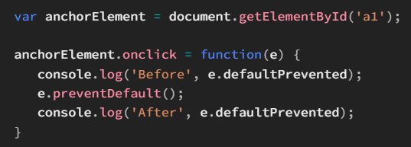
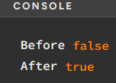

Cancelable Property
The cancelable property of the Event interface simply tells whether or not a given event is cancelable.
In other words, it states whether calling preventDefault() on an event would have any effect or not.
The cancelable property of the click event is true. Hence, applications could invoke preventDefault() on a click event and then expect it to have an effect.
Events whose cancelable property is false, calling preventDefault() has absolutely no effect on them. An example would be the blur event.
