EVENT Propagation
Event propagation is the process of transmitting an event across a series of objects.
Phases of an event
Throughout its lifecycle, an event can be in either of the following 4 states, also known as its phases:
- The 'none' phase is when event hasn't yet been fired on any object.
- The 'capturing' phase is when the event is being propagated in the capturing stage.
- The 'bubbling' phase is when the event is being propagated in the bubbling stage.
- The 'target' phase is when the event is fired on its target.
The Event interface provides us with a really handy property called eventPhase to inspect a given event's current phase.
eventPhase holds a number representing the phase that an event is currently in. The number can be easily compared against phase constants provided as static members of the Event interface, as shown below:
- Event.NONE — holds the number 0 representing the 'none' phase.
- Event.CAPTURING_PHASE — holds the number 1 representing the 'capturing' phase.
- Event.AT_TARGET — holds the number 2 representing the 'target' phase.
- Event.BUBBLING_PHASE — holds the number 3 representing the 'bubbling' phase.

Event Capturing
Capturing is when an event is dispatched starting from its top-most ancestor, and then being propagated all the way down to the very target of the event
For instance, if we click <body>, propagation via capturing would mean that first the click handler of window would get executed, then the handler of document, and then finally that of <body>.
all event-handling mechanisms in JavaScript, by default, apply to the bubbling phase, NOT to the capturing phase.
all event-handling mechanisms allows us to set up event handlers that only apply to the bubbling phase, with the exception of addEventListener().
Only addEventListener() allows us to set up an event handler to be executed in the capturing stage. And that's done with the help of its third options argument
When we set the third argument of addEventListener() to an object containing the capture property, assigned the value true, the given handler function gets registered for the capturing stage, i.e. it'll get executed while the event is propagated via capturing.
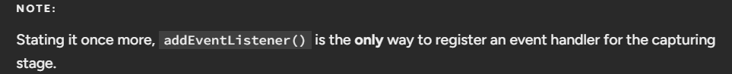

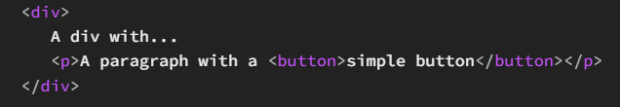
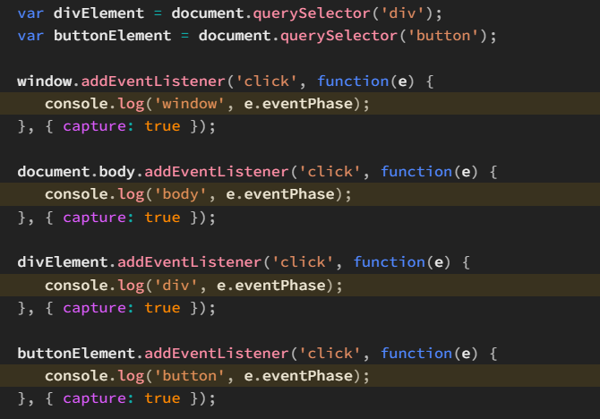
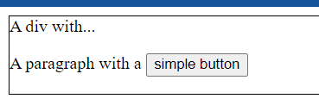
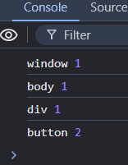
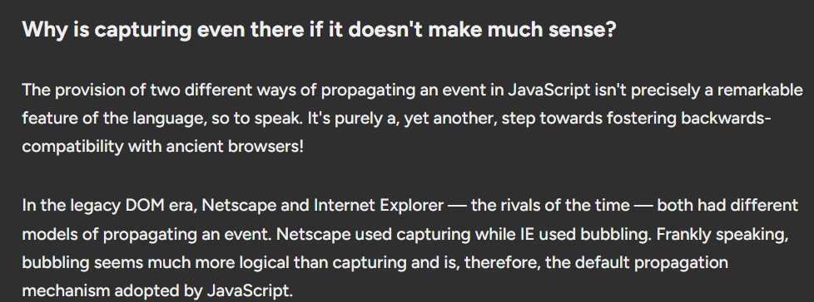

Event Bubbling
Bubbling is when an event is dispatched starting from its target, and then being propagated all the way up to the top-most ancestor of its target.
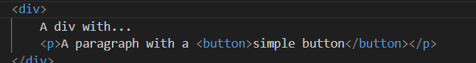
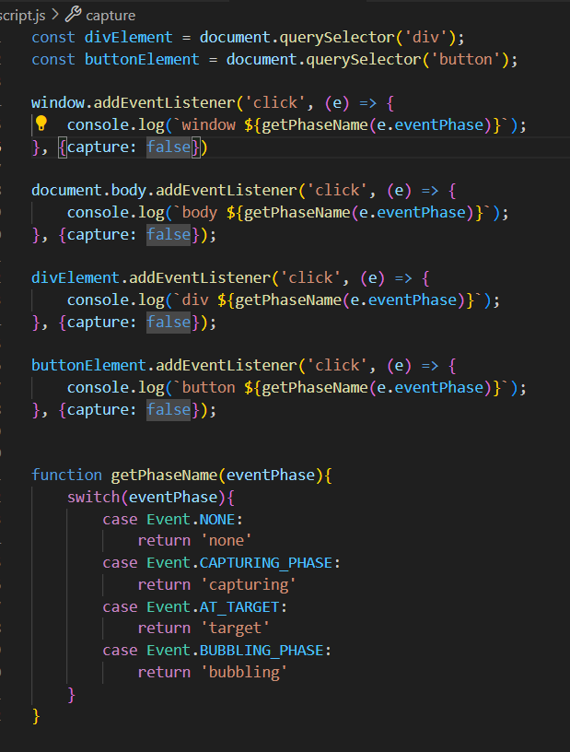
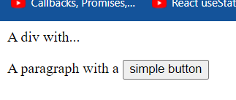
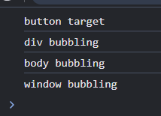

The stopPropagation() method
The Event interface defines a super useful method called stopPropagation() which aims to prevent an event's propagation further downstream or upstream, depending on when it's invoked. As one can guess, it doesn't require any arguments.
The moment stopPropagation() is called on an event, it puts a halt to the whole propagation chain.
- If it's called in the capturing stage, further capturing is stopped and even the bubbling stage gets ignored.
- Similarly, if it's called in the bubbling stage, further bubbling is stopped.
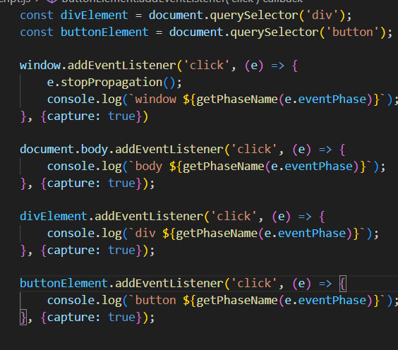
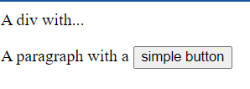
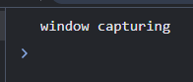
Similarly, for bubbling
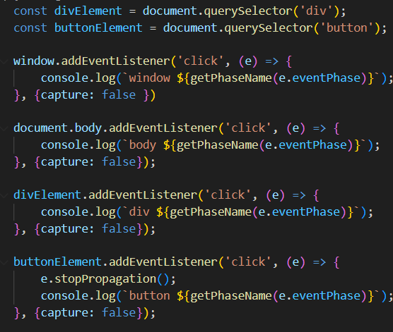
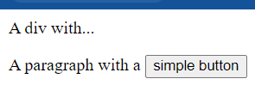
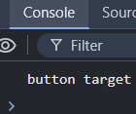

The stopImmediatePropagation method
addEventListener() could be used to set up multiple click handlers on a given target. And when a target does have multiple event handlers registered, they're all called in the order they were originally set up in, the moment the event gets dispatched on the target.
The method stopPropagation(), called from within any of these event handlers, would only stop the event from propagating to other objects in the chain — it won't stop the event from travelling to the rest of the handlers in the current object.
For this, we have the provision of stopImmediatePropagation() on the Event interface.
The purpose of stopImmediatePropagation() is to do two things:
- Stop the propagation of the event to other objects in the event's path, akin to stopPropagation().
- Stop other listeners registered on the current object from being invoked
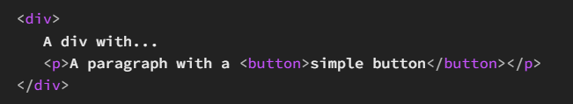
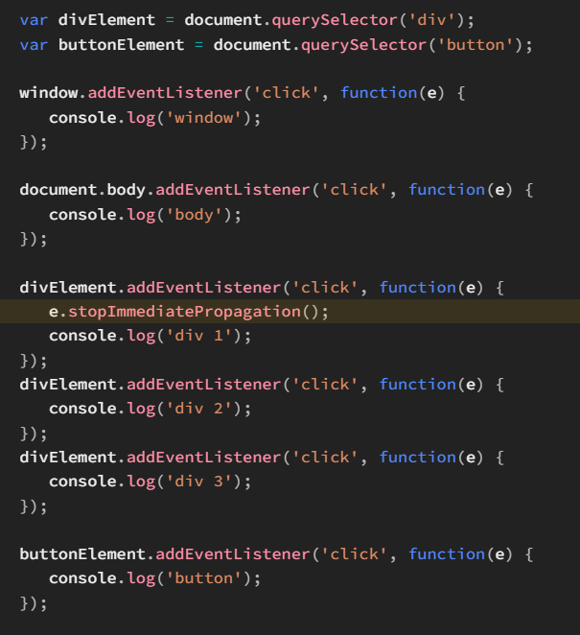
As you can see, we've set up three click handlers on the <div> element, calling stopImmediatePropagation() in the first one
This should stop the event from being bubbled further upstream and even the rest of the two click handlers of <div> from firing
