FUNCTIONAL PROGRAMMING

Functional Programming is the process of building software by composing pure functions, avoiding shared state, mutable data, and side-effects.
It is often declarative rather than imperative, and application state flows through pure functions
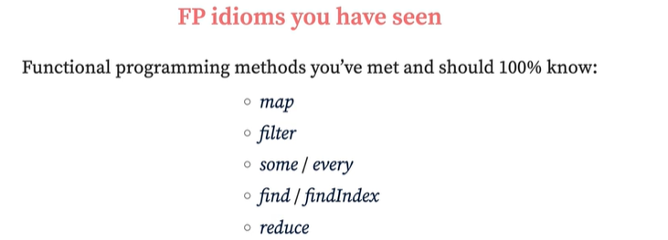
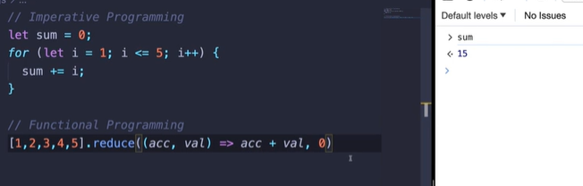
In imperative programming, we have declared a variable(state) and have incorporated a loop as well, but in functional programming example we have no variable or state that we are storing

