Functions Constructor
- If the function has to be called as a constructor, it has to be invoked with the new keyword, this creates a new instance of the object that the function represents

- Constructor Function -> Regular function intended to be used with `new`, When invoked with new, it creates a new object and sets the context (`this`) to that new object
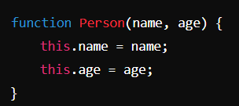
- Creating an Instance -> To create a new instance of `Person`, you use the `new` keyword
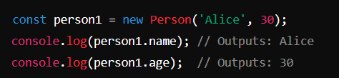

- Behaviour with `new` -> When you use the new keyword, JS does few things:
  - Creates a new object
  - Sets the prototype of the new object to the constructor’s prototype
  - Executes the constructor function with the new object as its context (`this`)
  - Returns the new object unless the constructor explicitly returns another object

- Without `new` -> If you call a constructor function without `new`, it won’t behave as expected, for example,
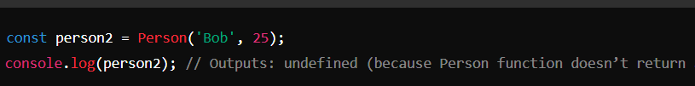
This is will not create a new instance but will instead execute the function in the global context, which is generally not what you want

- Class Syntax -> With ES6, you can use the `class` syntax, which is more syntactically sugar over the traditional constructor function approach
