GENERATORS
- Generators are a special type of function. Whereas a standard function produces at most a single value while running its code from start to finish, generators produce multiple values, on a per request basis, while suspending their execution between these requests

- A generator function is defined by putting an asterisk right after the function keyword. We can use the new yield keyword in generator functions

- We have to explicitly ask the generator for a new value, and the generator will either respond with a value or notify us that it has no more values to produce

- What’s even more curious is that after a value is produced, a generator function doesn’t end its execution, as a normal function would. Instead, a generator is merely suspended

- For starters, calling a generator doesn’t execute the generator function; instead it creates an object called an iterator, an object through which we can communicate with the generator

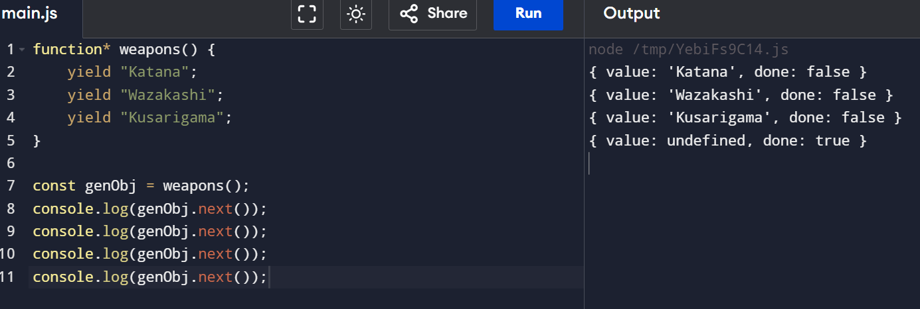
- One of the fundamental things that the iterator object exposes is the next method, which we can use to control the generator by requesting a value from it

- As a response to that call, the generator executes its code until it reaches a yield keyword that produces an intermediary result

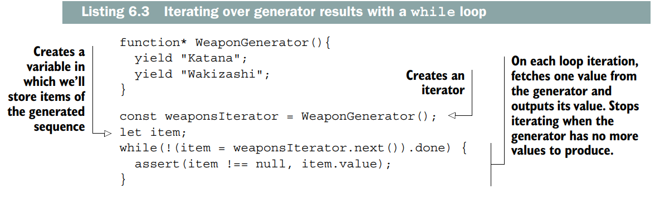

Yielding to Another Generator
Just as we often call one standard function from another standard function, in certain cases we want to be able to delegate the execution of one generator to another
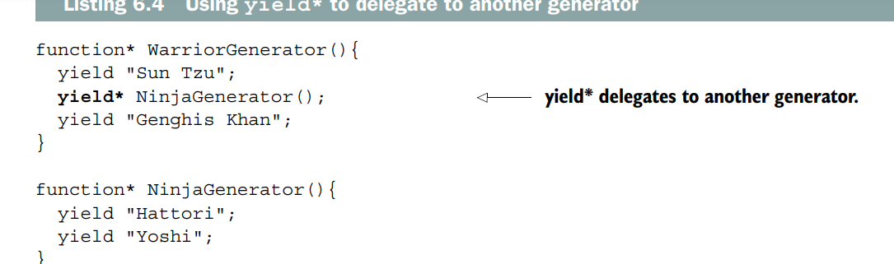
- By using the yield* operator on an iterator, we yield to another generator

Practical Examples
# Using Generators to generate ids
When creating certain objects, often we need to assign a unique ID to each object. The easiest way to do this is through a global counter variable, but that’s kind of ugly because the variable can be accidently messed up from anywhere in our code. Another option is to use a generator, as shown in the following listing
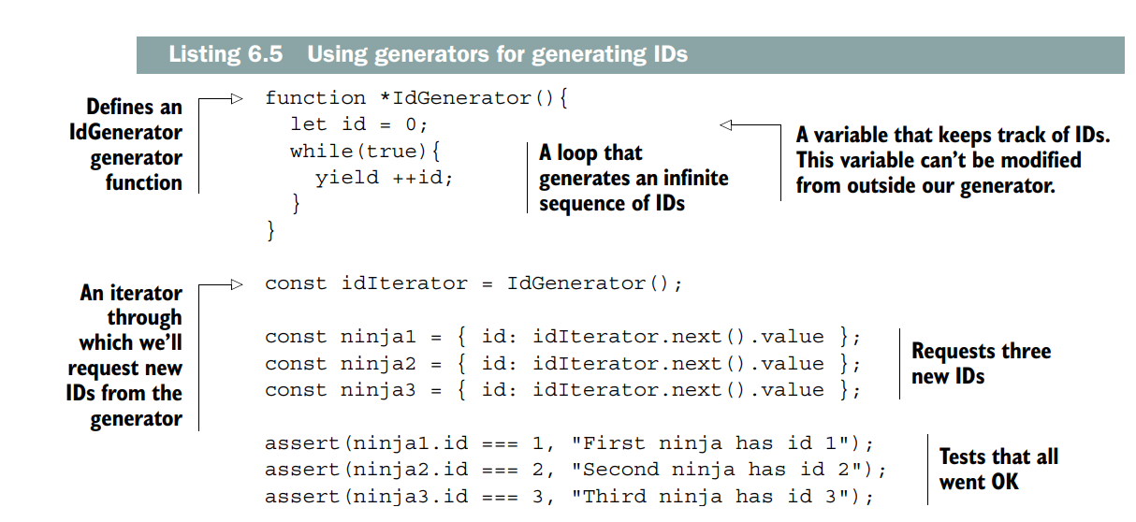

# Using Generators to Traverse the DOM
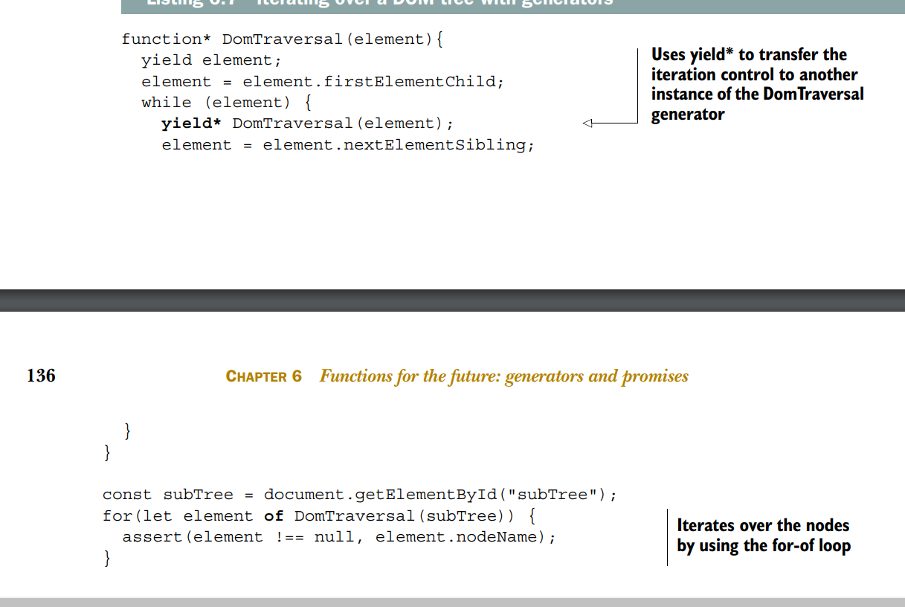

Communicating with a Generator
so far, you’ve seen how to return multiple values from a generator by using yield expressions.
We can also send data to a generator, thereby achieving two-way communication!
With a generator, we can produce an intermediary result, use that result to calculate something else from outside the generator, and then, whenever we’re ready, send completely new data back to the generator and resume its execution.
# Sending values as Generator function arguments
The easiest way to send data to a generator is by treating it like any other function and using function call arguments
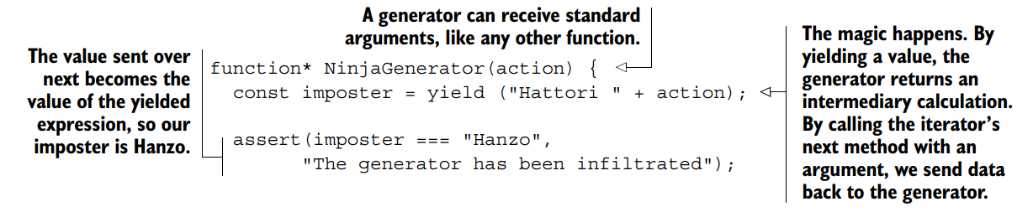
Using the next method to send values into a Generator
passed-in value is used by the generator as the value of the whole yield expression, in which the generator was currently suspended
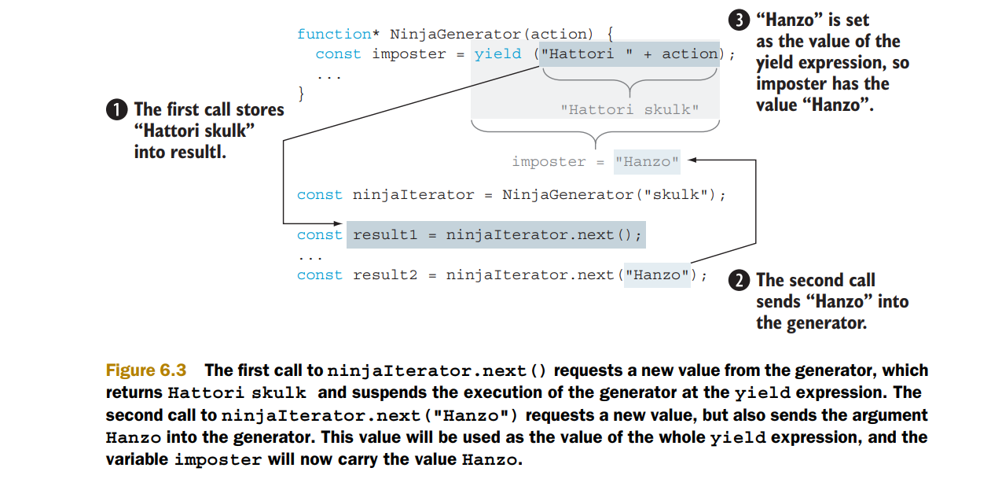

Generators Under the Hood
So far we know that calling a generator doesn’t execute it. Instead, it creates a new iterator that we can use to request values from the generator. After a generator produces (or yields) a value, it suspends its execution and waits for the next request. So in a way, a generator works almost like a small program, a state machine that moves between states:
