IMMEDIATELY INVOKED FUNCTION EXPRESSION(IIFE)

- Defined and executed immediately after it’s creation
- It’s a way to encapsulate code within a function and execute it right away
- IIFE creates a private scope for variables, preventing them from polluting the global scope and avoiding conflicts with other parts of your code
- IIFE can be named or anonymous
- Syntax ->

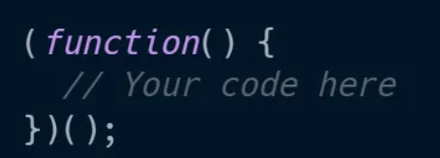

- Anonymous IIFE ->

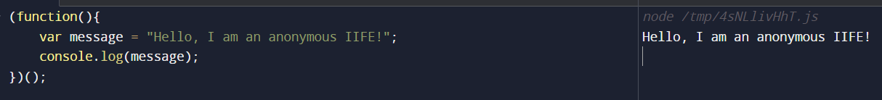

Here, IIFE encapsulates the message variable, preventing it from leaking into the global space

- Named IIFE ->

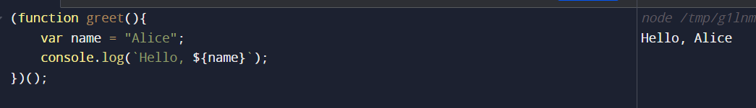

While named IIFE is less common, but it can be used for debugging and stack trace identification

- Returning Values ->

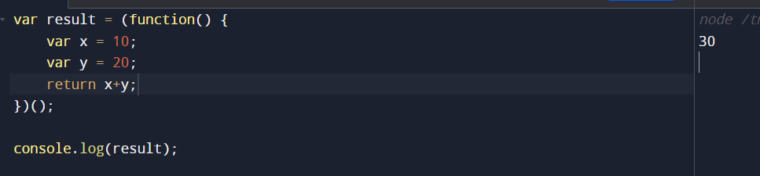

EXAMPLES ->

- Use of IIFE for creating private variables :

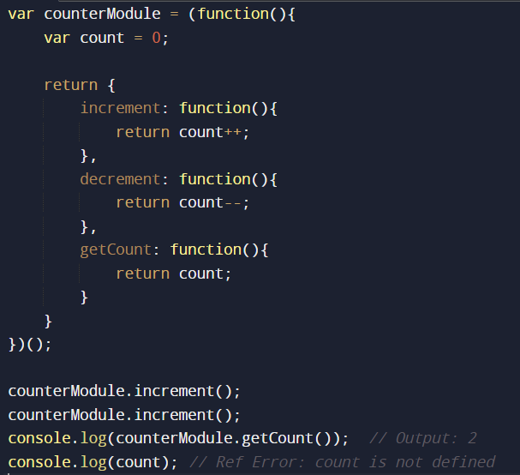

Here, count variable is encapsulated within the IIFE, making it inaccessible from outside the counterModule

- Avoiding Global Scope pollution :
One of the common issues of JavaScript is, variables declared on one part of code can unintentionally affect other parts, IIFE helps mitigate this problem by keeping variables and functions within their scope, preventing global pollution

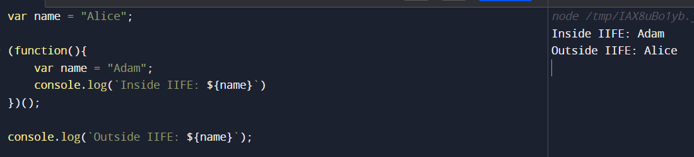
In this case, global variable name remains unaffected by the local variable name declared inside IIFE

- Module Pattern Example :

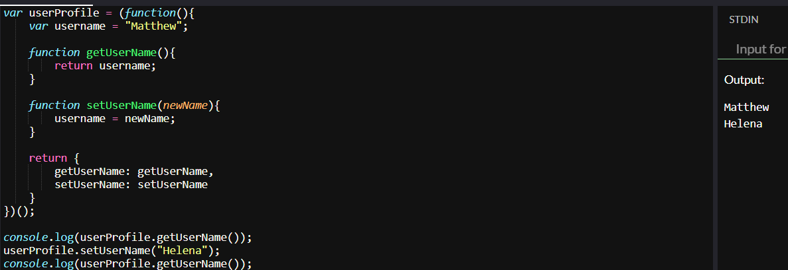
In this example, username variable is encapsulated within the IIFE, and functions getUserName and setUserName provide controlled access to it

- IIFE with Parameters
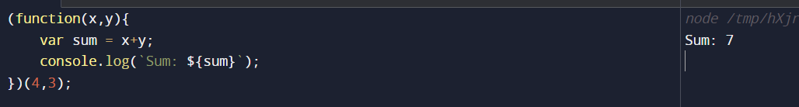

- Recursive Named IIFE
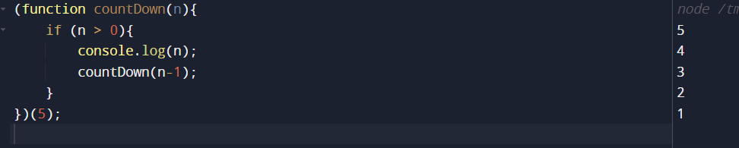
Example ->
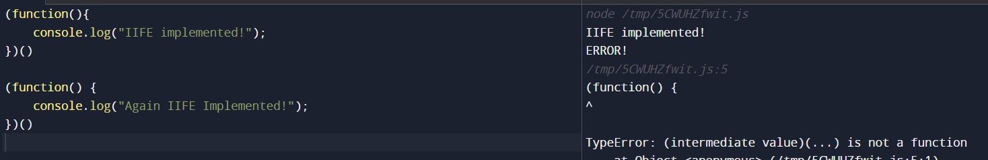
Can u guess the Error?
- Cause the above IIFE was invoked, but it does not know where to end the context, as we have skipped the semicolon (:)
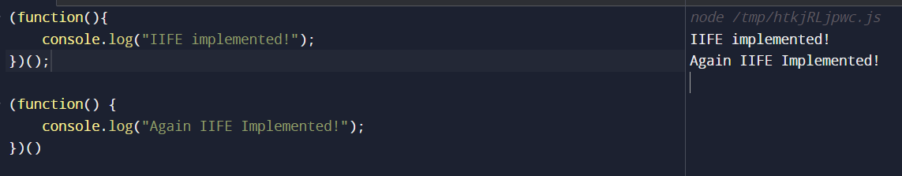
- Arrow functions also work in IIFE ,
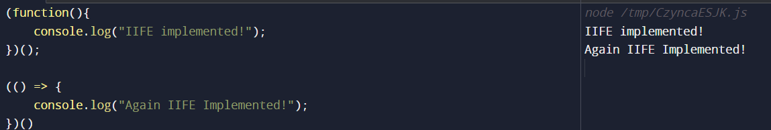

- Implment IIFE without extra pair of brackets ;
  - Simple, by making use of the void operator
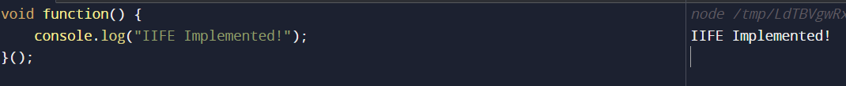

Void Operator ->
- When a function is void, it means it returns nothing
- It is similar to functions in JS which return undefined explicitly, like:
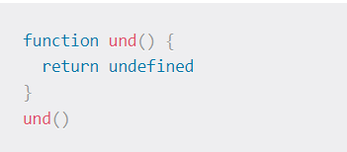
- Regardless of the expressions and statements in the function above, there is no results returned
- Let us understand what javascript: means,

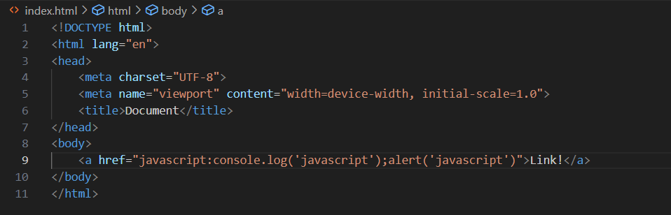
Saw, the code above,
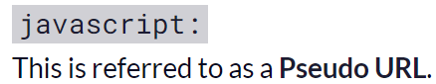
When the browser receives this value as the value of href on anchor tag, it interprets the JS code that follows the colon (:), rather than treating the value as a referenced path
When “Link” is clicked, here is the result ->
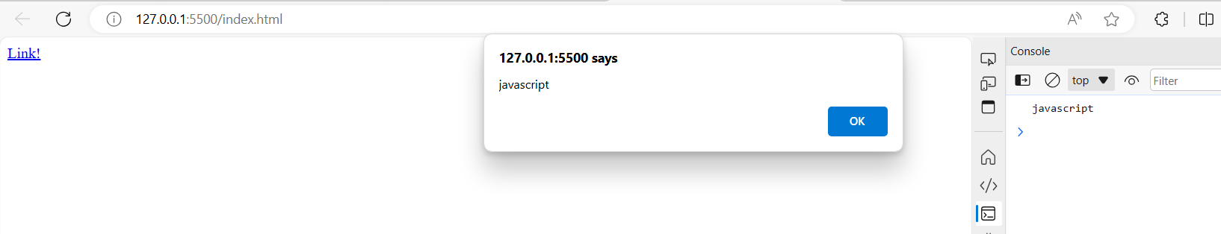
As seen above, the browser does not treat href as the referenced path,
Instead it treats it as some JS code starting after “javascript:” and separated by semi-colons
Now,
void(0) operator evaluates given expressions and returns undefined,
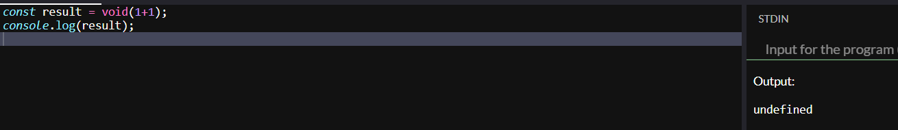
Here, 1+1 is evaluated but undefined is returned
Let’s take a look at another example to confirm that ->
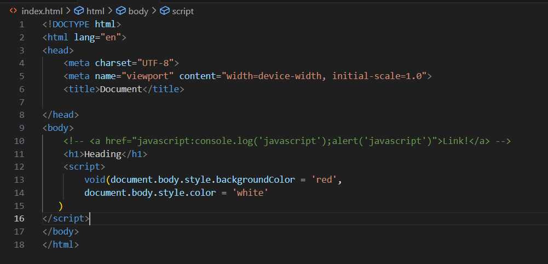
Result of the above code ->
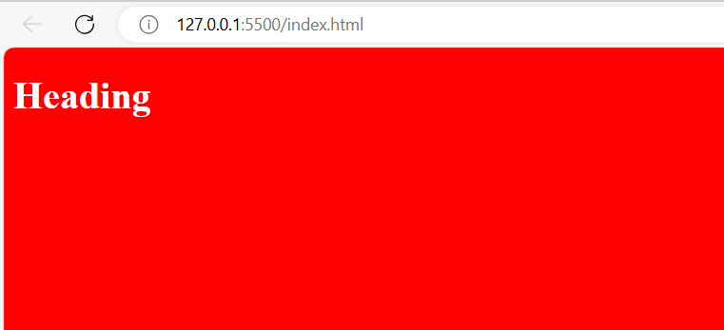
Another Example ->
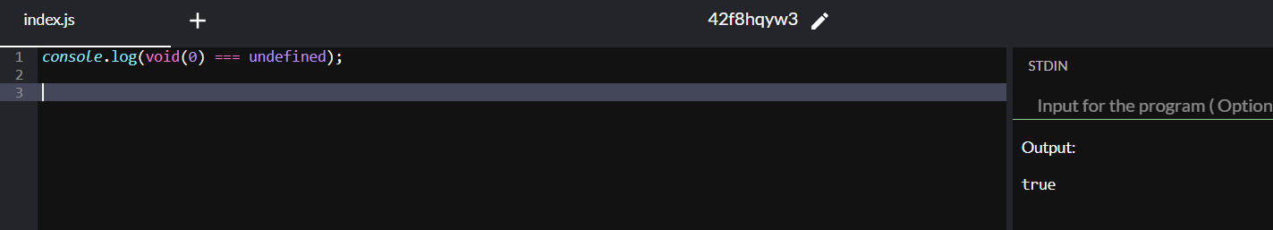
Combining javascript: and void(0)
Sometimes you do not want a link to navigate to other page or reload a page, Using javascript: , you can run the code that does not change the current page
This, used with void(0) means, do nothing – don’t reload, don’t navigate, do not run any code

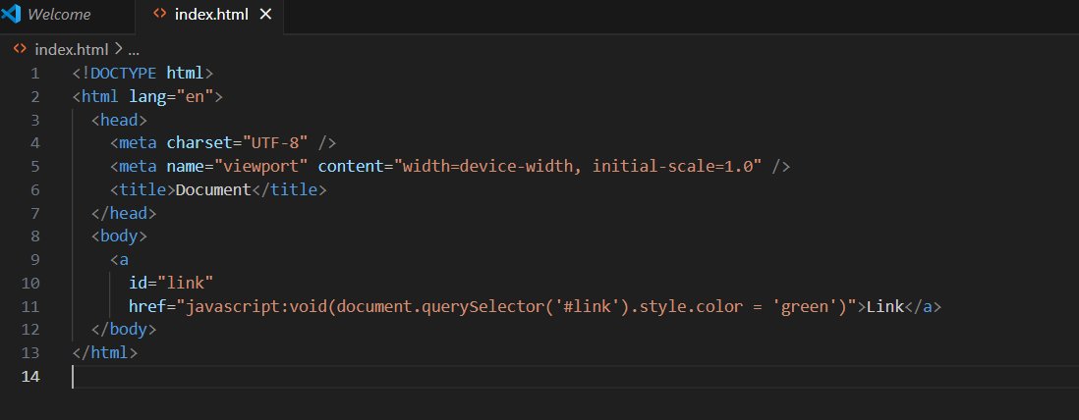

When the Link is clicked, this is the Result ->
