SCOPE, LEXICAL ENV, CLOSURES

SCOPE :
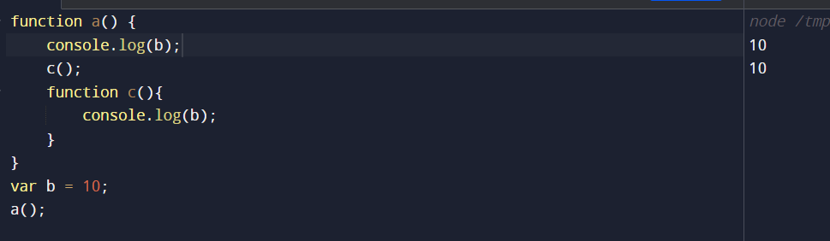
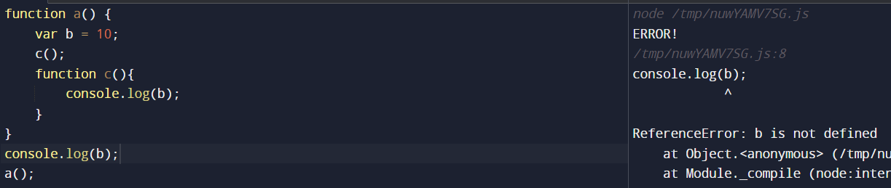

See, in second case we got the Reference Error: b is not defined
So here comes Scope, Scope means where you can access a particular variable or function in our code
So in second case, what is the scope of this variable b ?
- Scope tells where you can access this variable b
- And the other way to look at it is like, is b inside the scope of the executing function

*** Scope is directly dependent on the lexical environment

Let us understand the Lexical Environment now ->
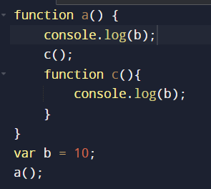
When we run this program a Global Execution Context (GEC) is created and is pushed onto the Call Stack
a()
c()
GEC
Memory | Code
b : undefined
c : { …function… }
Memory | Code
a : { .. function.. }
Memory | Code

Above firstly, Global Execution Context (GEC) is created, then function a’s execution context is created and lastly function c’s execution context is created,
And whenever an execution context is created, a lexical environment is also created, so lexical environment is the local memory along with the lexical environment of it’s parent

Let’s understand, lexical as a term means in hierarchy or in a sequence, so in our code c is lexically inside function a, and function a is lexically inside the Global Scope
- In our code, in when function c is called, it firstly tries to find value of variable b in local memory, but it couldn’t find, then it tried to find the value of variable b in lexical environment of c’s parent, i.e function a, it couldn’t find the value of variable b in a’s lexical environment as well, then it tries to find the value of variable b in a’s parent’s lexical environment, i.e. Global Scope, and eventually it finds the value of variable b there, and this way of finding is known as SCOPE CHAIN.

Global environment ->
- 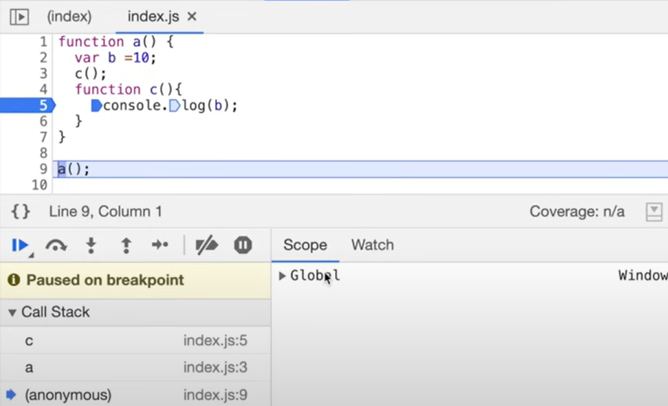

Lexical environment of function a ->
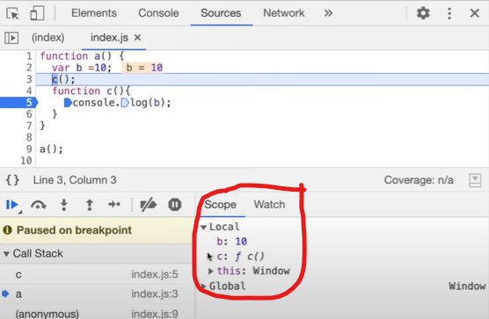
Lexical environment of function c ->
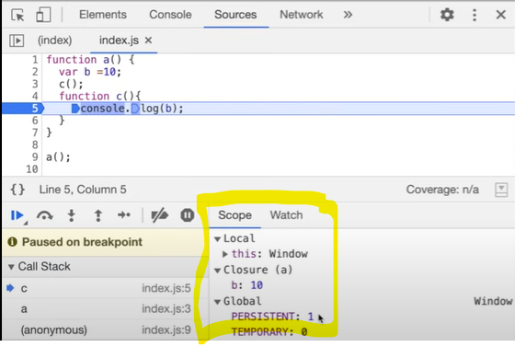

CLOSURES

Closure means a function bundled with it’s lexical environment,
The importance of closures can be witnessed when we return a function from a function, as given below ->
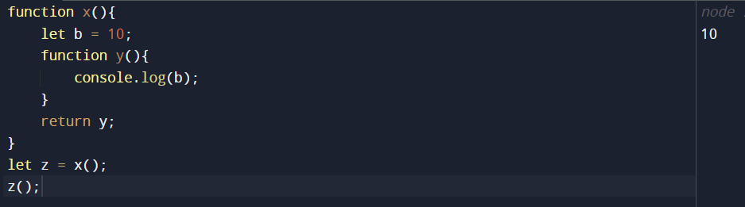
See, in the example, even though the function y was returned and executed outside in the Global Scope still it printed 10, just because even when functions are returned from another function, they still maintain their lexical scope..s
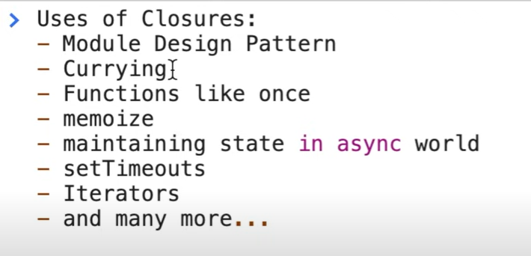

Questions ->

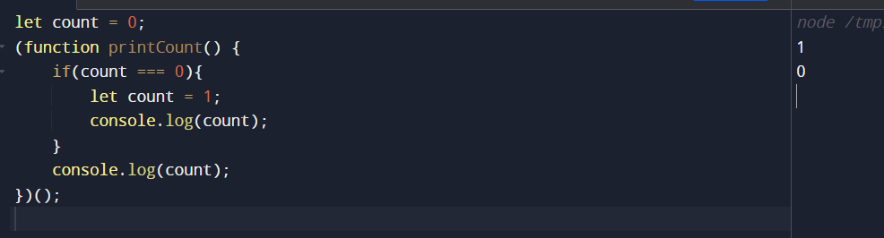

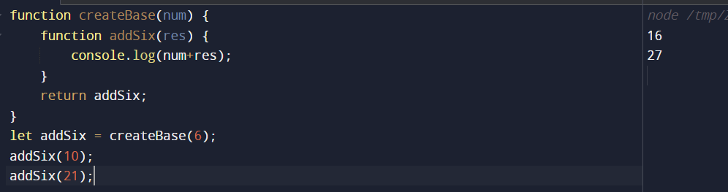

- Most Important Question ->

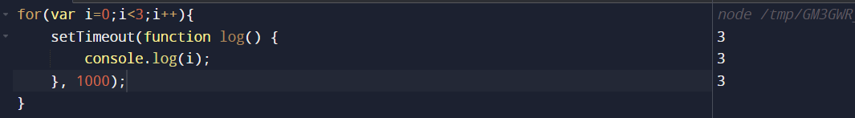
See, in the above code, we got three times 3, but why?
- Because of var keyword, var does not have a block scope, instead var has a function scope

Let’s understand how the above code is getting executed?
- First time the loop runs, var i’s value is 0, but it will not be printed right away, cause setTimeout only runs after the complete code runs successfully
- Then again the loop runs and value of i is 1.
- Then again the loop runs and value of i is 2.
- Then again loop will run, and now the value of i is 3, but the loop won’t run this time as we have the condition i<3
- Now, the last time JS Engine encountered the value of i it was 3, so JS Engine will refere to the current value of i, hence it print three times 3 in the output

So, what’s the solution for the above problem?
The solution for that problem is the use of let keyword
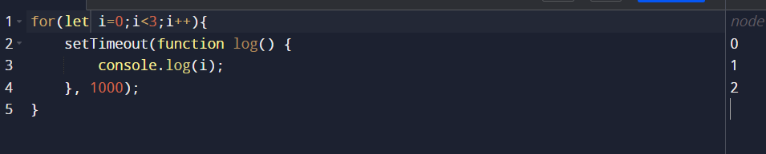
Let’s understand what’s happening:
- Firstly, let is block scoped, so after the complete code runs successfully, JS Engine is going to look into the scope of that i variable.

But what if the interview asks you to print the value of i as 0, 1, 2 using the var keyword only,
The solution to that is using Closures
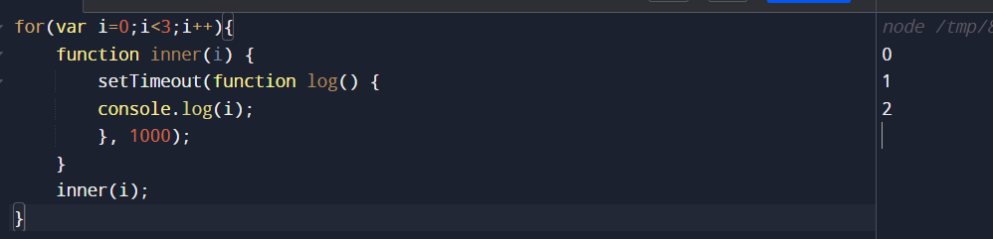
So, what’s gonna happen is, every time the i is gonna pass to the inner function, and every time the loop runs, a different memory space is created for the inner function, so the console log will take i from the local scope of that function rather than referencing it from the outer scope.

Let’s look at another example to better grasp the concept ->
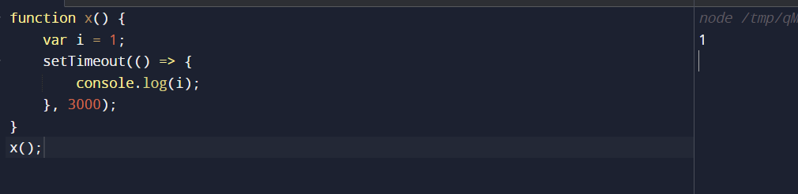
Above what setTimeout is doing is it takes the function(the arrow function) along with it’s lexical environment and stores it somewhere else, and attaches a timer of 3000ms to it, and the JavaScript proceeds,
And once the timer expires it takes that function again and push it onto the Call Stack and runs it,
And see the example above why it runs correctly as we require with Closures, cause in every iteration of the for loop, the function is stored somewhere and pushed onto the Call Stack only after the timer expires

