Memoization
To memorize a function is to ask a function to remember the result
If the function gets the same input again, it will quickly deliver the same result without recalculating the result
It is typically applied to functions that demand intensive processing
It really helps especially in the case of recursive functions, as recursive functions are already process intensive by nature
As a best practice, memorization should only be added to the Pure functions
Memoization also comes at cost of memory
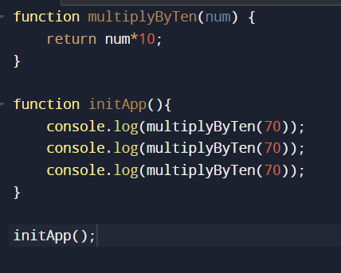
Check the above example
Here what I am trying to demonstrate is, even though I calculate the result of multiplyByTen(70) the first time itself, I am trying to calculate it two more times after the first calculation
Now let’s just create a memorized function,
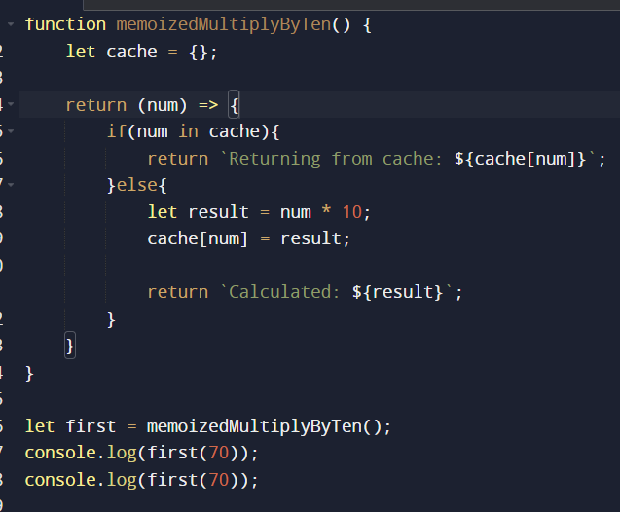
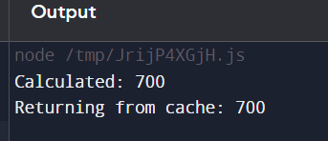
So what we have done?
- Inside memoizedMultiplyByTen function we have formed a closure and that’s where we have stored the cache, and cache is just an object where we are keeping the results
- And then we return an anonymous function, and that function received the num parameter and inside that anonymous function we are going to check the cache and see if num is already present in the cache
- If yes, then we are going to retrieve the result from the cache
- If not, we will do the calculations, and store the num as the key in cache and also the result, and return the value
- Now, if next time same num comes the value will be retrieved from the cache itself skipping the calculations altogether

