PROMISE

Before, promises let’s understand why using callbacks ain’t good,
Let’s assume a scenario,
Suppose we have a cart with some items in it
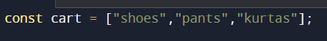
Then, we have a function createOrder(cart) which will return an order id,
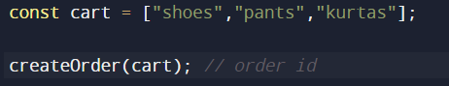
Then, we have proceedToPayment(orderID), which takes the order id and will let you proceed to payment,
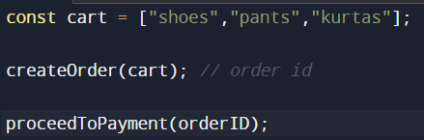
Now, these two APIs i.e createOrder and proceedToPayment are asynchronous, i.e. we don’t know how much time they will take, and they are dependent on each other, we can only call proceedToPayment once we have gotten the orderID
So, let’s handle this situation by using callbacks ->
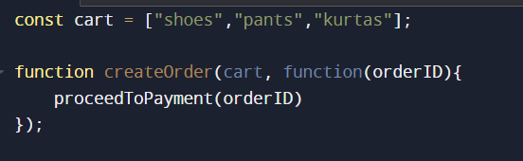
So, now it’s the responsibility of the createOrder function to create an order and call the proceedToPayment with that order ID
But there’s a very grave issue in this piece of code, inversion of control
i.e we have passed this proceedToPayment as a callback to createOrder API, and now we assume that at some point of time this createOrder function will call the proceedToPayment
But what if we are blindly trusting this createOrder function and it never calls the callback function
So let’s see how we can handle these type of situations using Promises
Now, this createOrder API will return a promise,
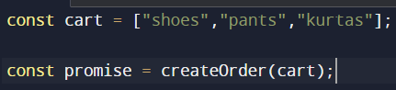
We don’t know how much time createOrder will take, but initially, it will return us an object, having data with some empty undefined value
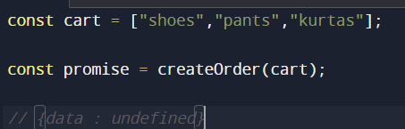
And further our program will execute, but and after n secs when createOrder will get completed, this promise object will get filled with data automatically
So then how we use the ProceedToPayment function now, simple, now we will attach a callback function to this promise object
And we will attach the callback function using then() ->
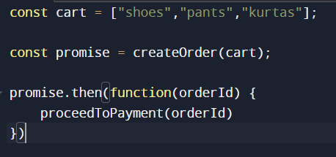
Now, we have the control of our program with us, unlike callbacks where we passes our function as a callback to createOrder function

Definition of Promise ->
The Promise object represents the eventual completion (or failure) of an asynchronous operation and its resulting value (MDN)
So, promise is a returned object to which you attach callbacks instead of passing callbacks into a function

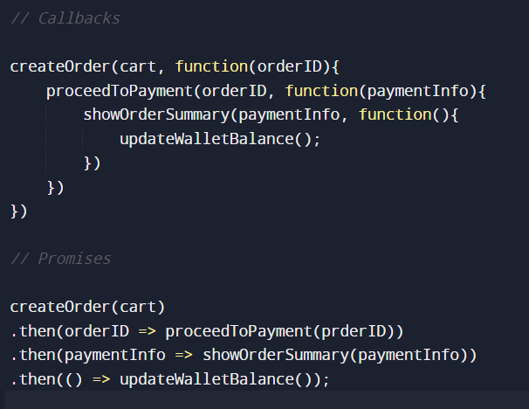

Note-> It is important to always return promises from then callbacks, even if the promise always resolves to undefined. If the previous handler started a promise but did not return it, there’s no way to track its settlement anymore, and the promise is said to be “floating”

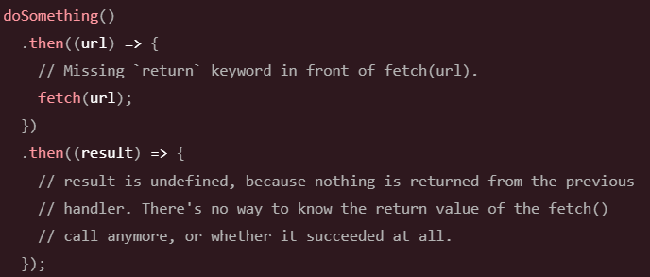
By returning the result of the fetch call (which is a promise), we can both track its completion and receive its value when it completes.
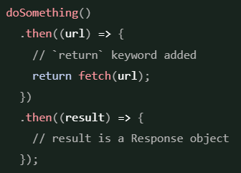

PROMISE APIs

Promise.all
Suppose you have 10 id’s and you want to make parallel API calls and get the results for 10 different users, in that scenario we use Promise.all
The Promise.all() static method takes an iterable of promises as input and returns a single Promise.
The returned promise fulfils when all of the input’s promises fulfil (including when an empty iterable is passed), with an array of fulfilment values.
It rejects when any of the input’s promise rejects, with this first rejection reason.
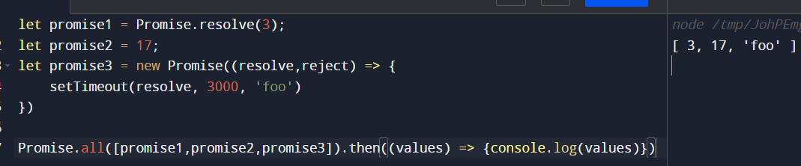
If the passed iterable is empty, then this method return a promise synchronously which is already resolved.
If all of the passed promises are fulfilled, the returned Promises are fulfilled asynchronously
If any of the passed promises are rejected, then this method rejects the value of that promise, whether or not the other promises have been resolved.

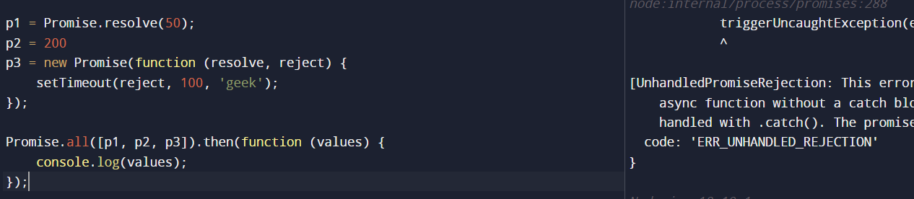

Promise.allSettled
Unlike Promise.all, Promise.allSettled does not short-circuit when one of the promises is rejected; instead it waits for all promises to settle, providing information about each one
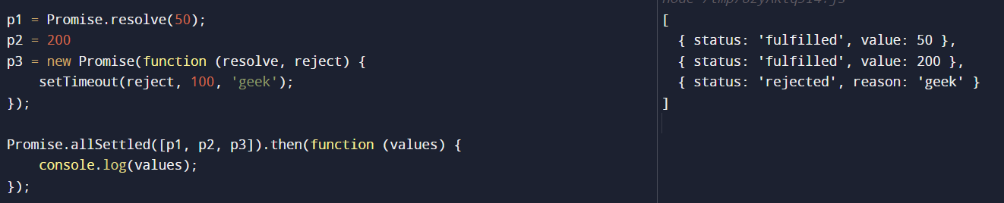
- If the passed argument is empty, it returns a Promise that is already resolved
- For all other cases, it returns pending Promise, along with the status as well as the values of all promises that are passed inside it individually

Promise.race
Promise.race returns a Promise that fulfils or rejects as soon as one of the promises in an iterable fulfils or rejects, with the value or reason from that promise,
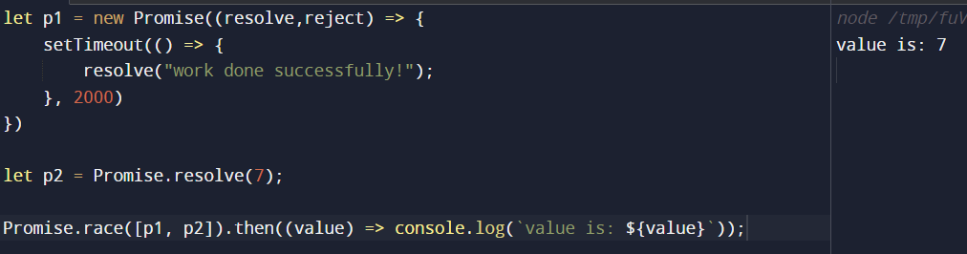
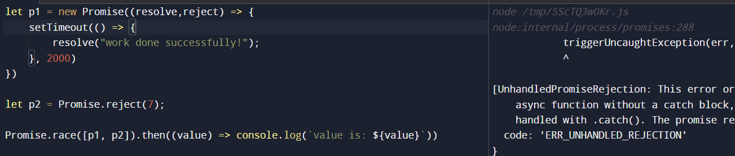
Promise.any
Promise.any take an array of promises as a parameter and returns the first fulfilled promise. It returns a rejected value when all of the promises in the array return rejects or if the array is empty.
Let’s check above example with, Promise.any
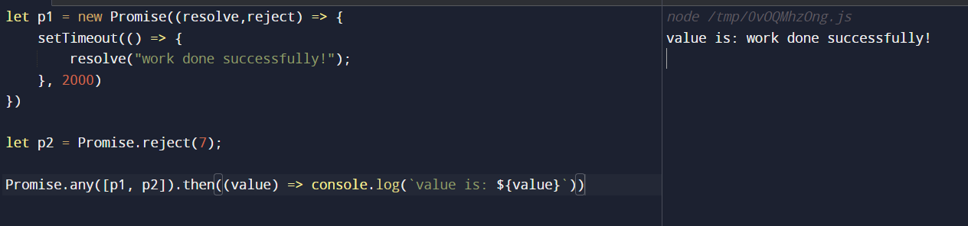
When all Promises are rejected an AggregateError is returned which contains the reason for rejection.
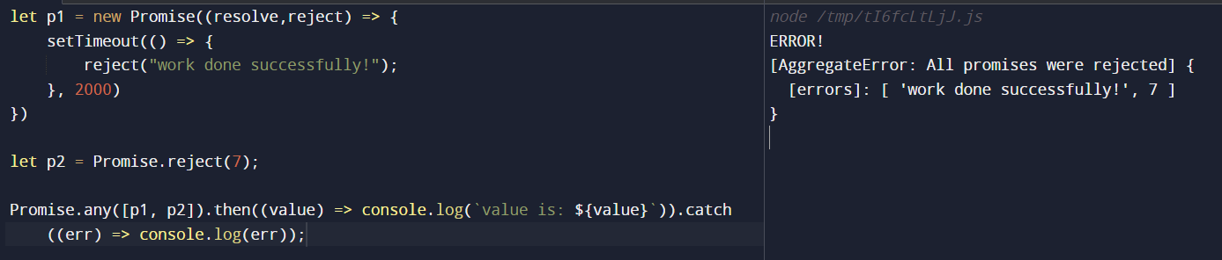

INTERVIEW QUESTIONS ->
#Q.1
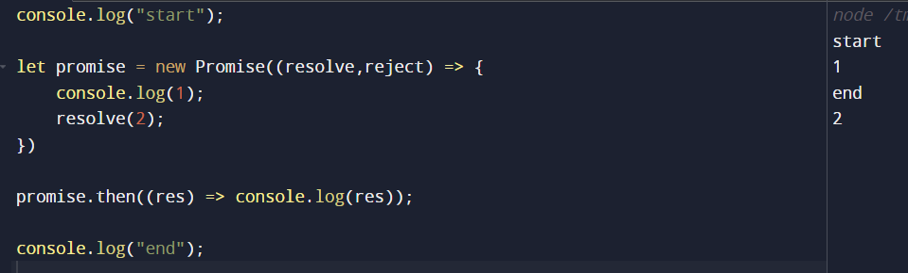
Explanation ->
- I was expecting start, end, 1, 2, but got different result
- When Promise runs, it’s gonna find whatever synchronous code is inside this, and it will execute that piece of synchronous code
- 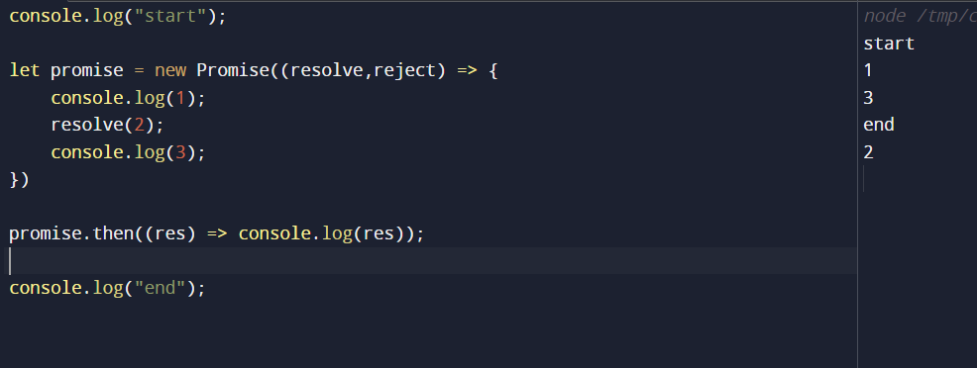
- See above too , 1 and 3 were printed as they were synchronous
- Now,suppose we remove resolve from inside of promise then,
- 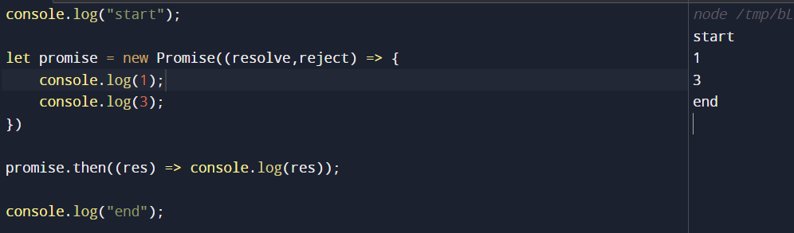
- I thought it would print undefined, but it did not, cause if there’s no resolve the flow will not go inside the .then method itself

#Q.2

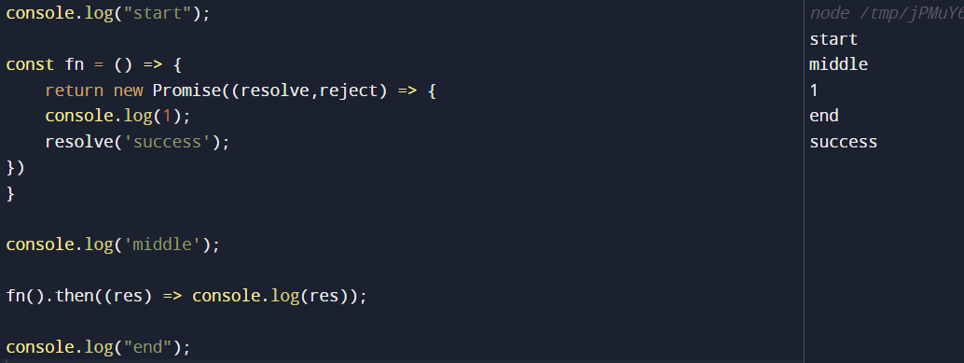
Explanation ->
- Simple, here we have a function fn, hence the output would be like that

#Q.3
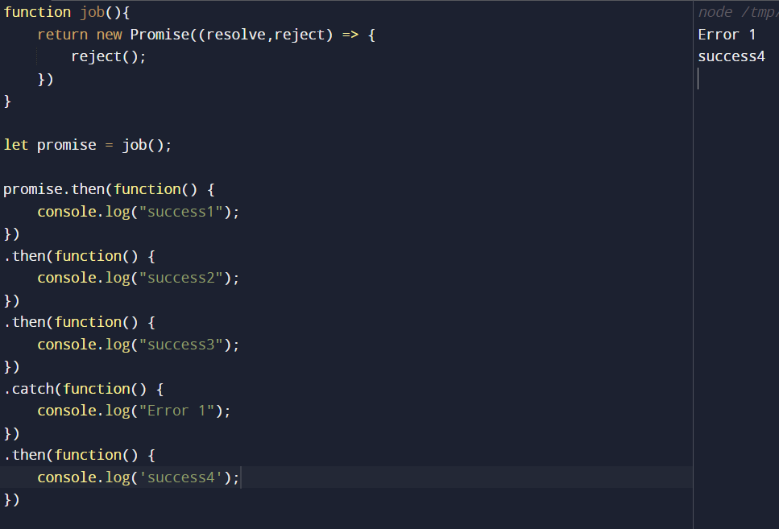
#Q.4 ->
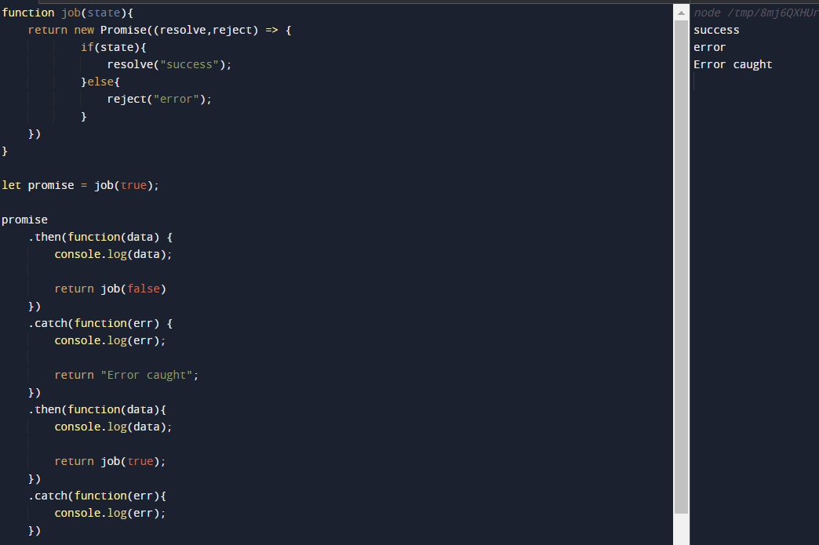
Explanation ->
- First then me jaega kyuki resolved Promise hai, success print hoga
- Ab first then me another Promise call ho raha hai, and that Promise is rejected
- So ab first catch me jaega and console karega error, and whi se return kar raha hai value “Error caught”
- Jo ki second then me jakr console hogi Error caught, then again we are calling the Promise, and this Promise will be resolve
- But fir koi then hai hi nh handle karne ke lie or resolved Promise hai so it will not go into the second catch block
#Q.5 -> Uper wale ka hi extended version hai ->
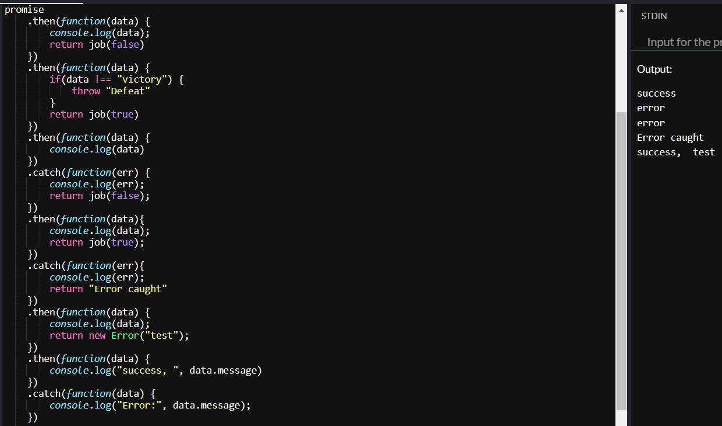
Is me ek hi doubt hai, second line me error print huva, but me Defeat expect kar rha tha, reason smjhna hai>
#Q.6 ->
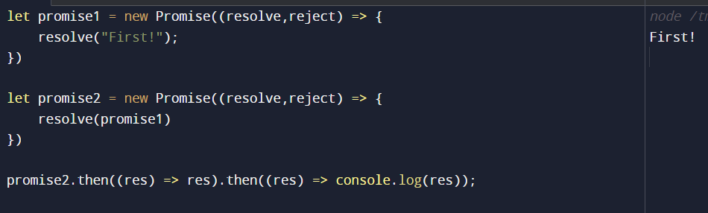
In the first then, the first promise is resolved and returned , and in the second then we simply printed the resolved value

