PURE FUNCTIONS

Why write pure functions?
- Clean Code
- Easy to test
- Easy to debug
- Decoupled and Independent
- Could be added to our utility functions
Rules for pure Functions:
- The same input always gives the same output
- No side effects

// same input – same output example ->
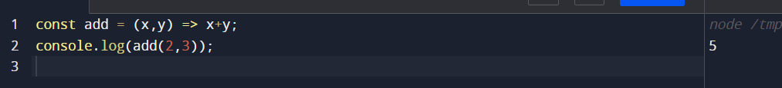
Another rule though it is not listed but should be is :
- A pure function should have at least one parameter, otherwise it is the same as a constant because they can only work with their input

Suppose we have a function

Const firstName = () => “Adam”

the above function simply returns the First Name, we might as well define that as a constant

const firstName = “Adam”

- A pure function should not work with any data that is not provided as an input

// side effects example ->
- Accessing the scope outside the function also makes it impure
Const z = 5;
Const sum = (x,y) => x+y+z;
- Pure functions cannot access a database, API, file system, storage, etc
- They cannot modify the DOM
- They cannot even log to the console

- No input state can be modified
- That is, no data should be mutated
- Consider all input data to be immutable

// Impure Example 1
Let x = 1;
Const increment = () => x += 1;
Console.log(increment()); // 2
Console.log(x); // 2
- Above example breaks all the rules of the pure functions, we mutated the state of x variable as it’s value is also changed to 2 and our increment function also reached outside of the function to reference the value of x, and that is what increase of value of x to 2

// Impure Example 2
Const myArray = [1, 2, 3];
Const addToArray = (array, data) => {
array.push(data)
return array;
}
Console.log(addToArray(myArray, 4)); // [1, 2, 3, 4]
Console.log(myArray); // [1, 2, 3, 4]
- The above example is impure cause the original array i.e. myArray is also changed

// Refactored Example 1.
In the first example, actually we don’t want to mutate x but we do want to return the new value
Const pureIncrement = (num) => num += 1;
Console.log(pureIncrement(x)); // 3
Console.log(x); // 2
In the above example, x’s value did not change and we got the updated value from the function as well

// Refactored Example 2.
Const pureAddToArray = (array,data) => [ …array, data ];
Console.log(pureAddToArray(myArray, 5)); // [1, 2, 3, 4, 5]
Console.log(myArray); // [1, 2, 3, 4]

// You may have already seen some great examples of pure functions and not realized it
// These common Higher Order Functions are Pure Functions:
