Throttling

Debouncing is used to make sure a function is called only after a certain amount of time is passed, since it was last called, we call a function and then we wait maybe n milliseconds and then we’ll call it again
But Throttling is different, Throttling is used to make sure that a function is called atmost one time within some duration
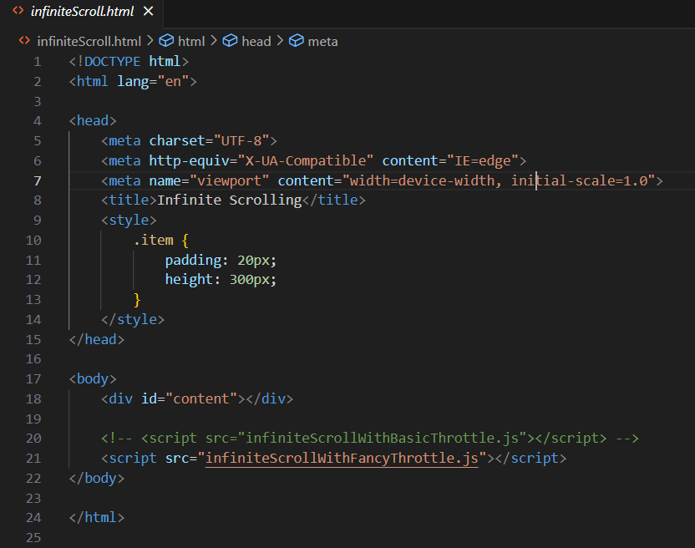
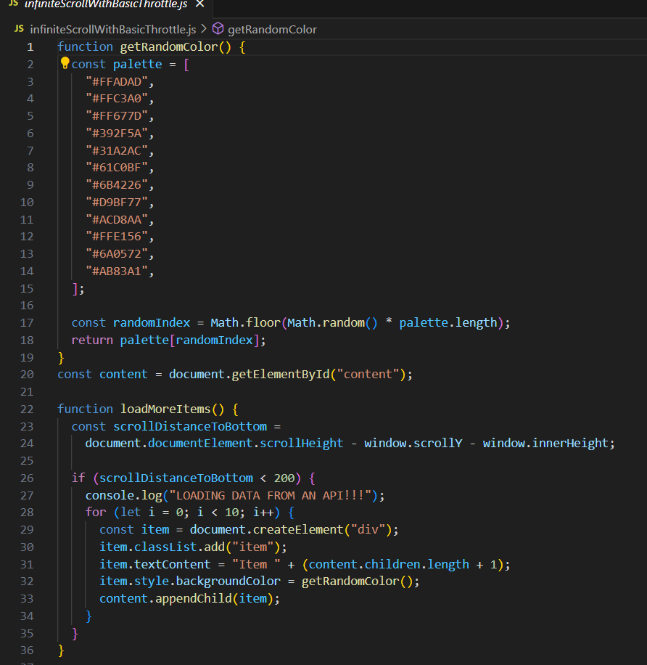
As we scroll loadMoreItems function is called a lot, and a bunch of new content added to the page every single scroll

