map, filter, reduce

map ->
- Instead of manually iterating over an array using a loop, you can simply use the built-in Array.map() method
- Array.map() methods allows you to iterate over an array and modify its elements using a callback function, the callback will be executed on each of the array’s elements

Suppose we have an array containing some numbers and we want to multiply each of the array element by 3
First Approach ( for loop ) ->
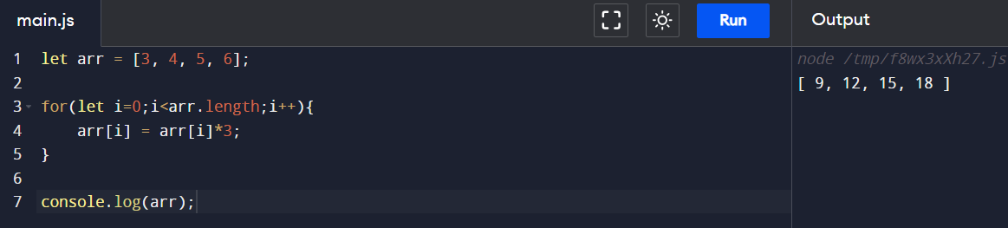
Second Approach ( map method ) ->
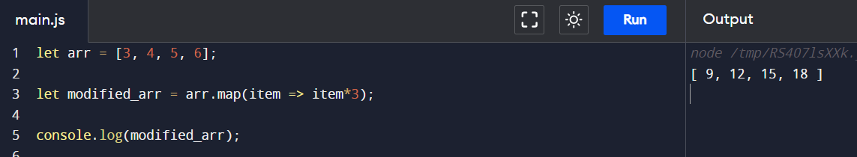
Use map over an array of objects ->
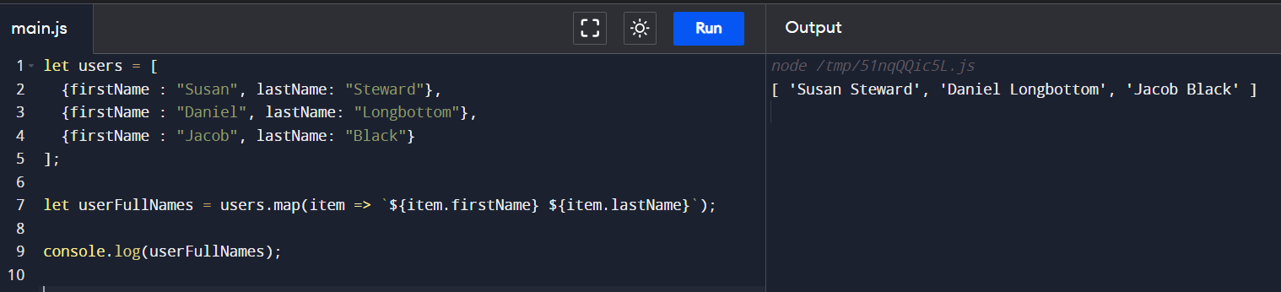
Complete map() method syntax ->
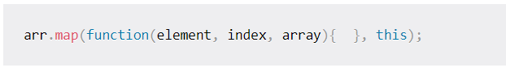
The callback function() is called on each array element, the map() method always passed the current element, the index of the current element, and the whole array object to it
The this argument will be used inside the callback function, by default, its value is undefined
Lets test all the arguments ->
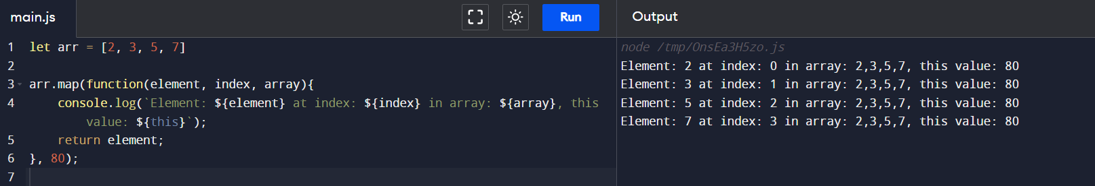

filter ->
- Selectively extracting elements from arrays based on certain conditions
- filter method does not modify the original array, but instead creates and returns a new array containing only the elements that meet the specified condition

syntax of filter method ->
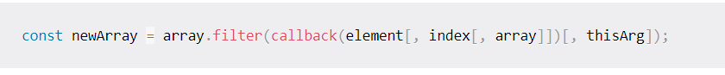
Examples:
- filter out all the odd values

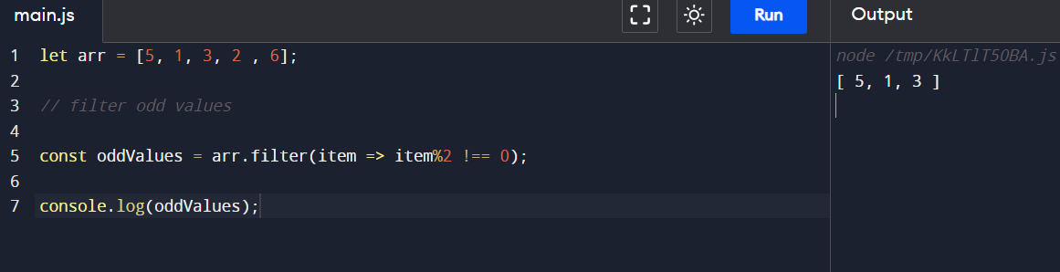
- filter out all values greater than 4
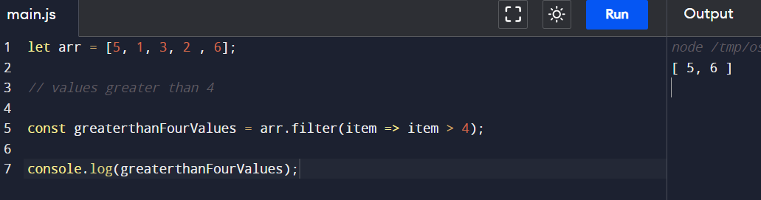

reduce ->
- Iterate and reduce an array’s values into one value
Let’s build a normal function first to get the sum of an array’s values ->
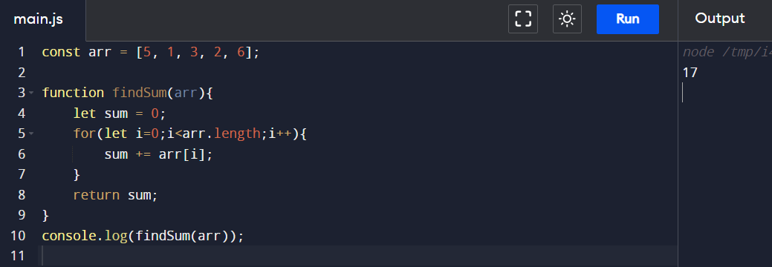
Now let’s sum the array elements using reduce function ->
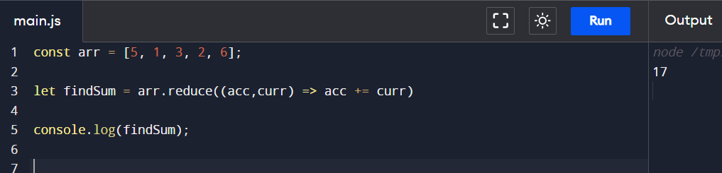
Here, acc is the accumulator
curr is the current array element
and the callback function in reduce applies to each and every element of the array
Now let’s find the max element in an array ->
Let’s first build a normal function for that:
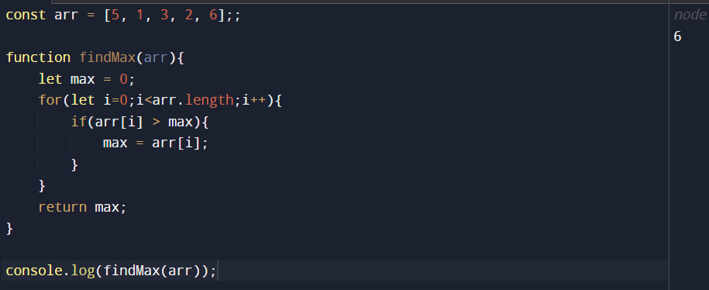
Let’s use reduce method to achieve max value in an array ->
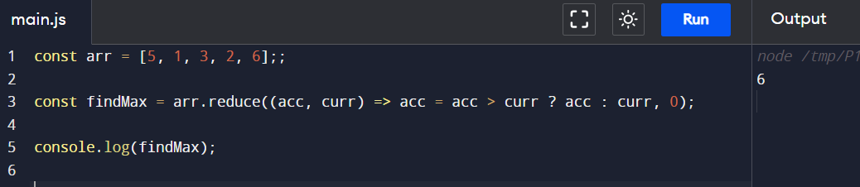
Another Example ( reduce ) ->
Now, suppose we have an array users such as:
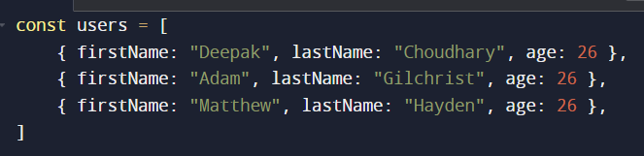
Now, we want to accumulate the number of people according to their age, such as
- If 2 people are there with age 10 and 3 people are there with age 15
- Result should be like -> { 10: 2, 15: 2}
Let’s first achieve this with a normal function ->
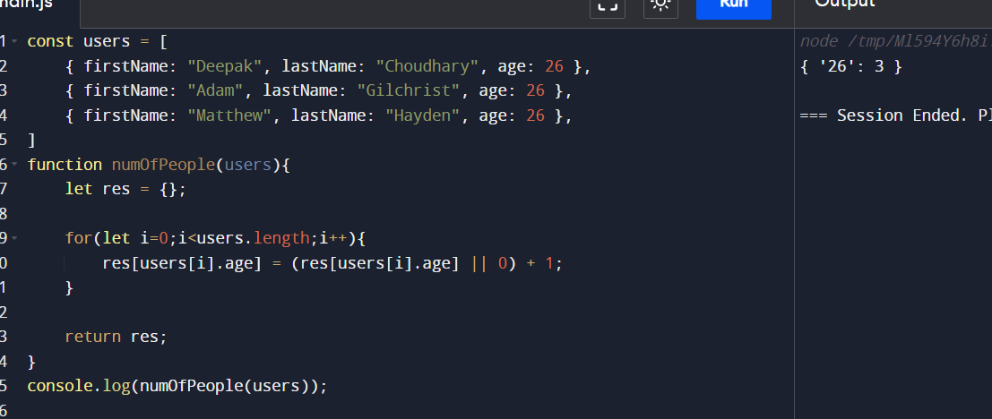
Now, let’s use reduce method to achieve this ->
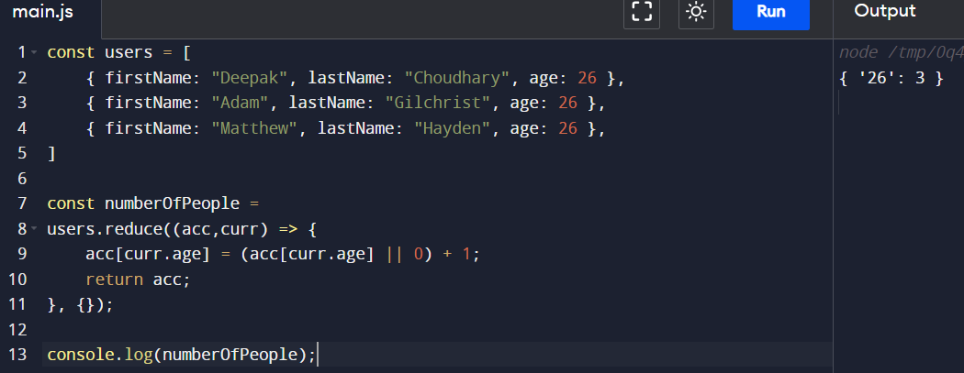

Example ->
Now, suppose we have a users array and we want the result to be the firstNames of all the people whose age is less than 30 ->

Using filter and map ->
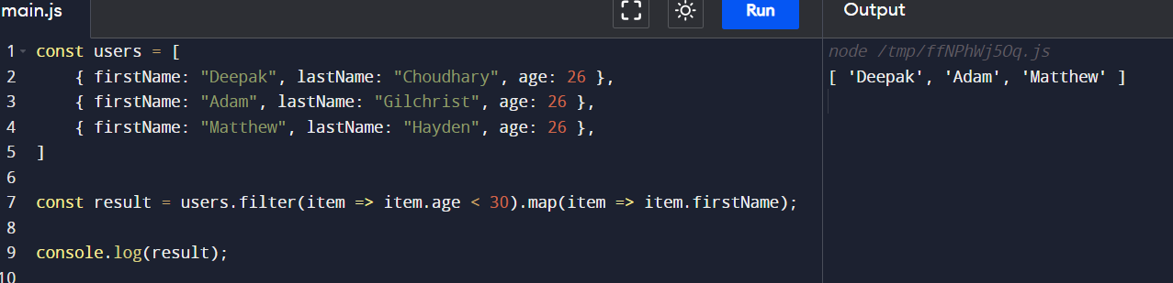
Using reduce ->
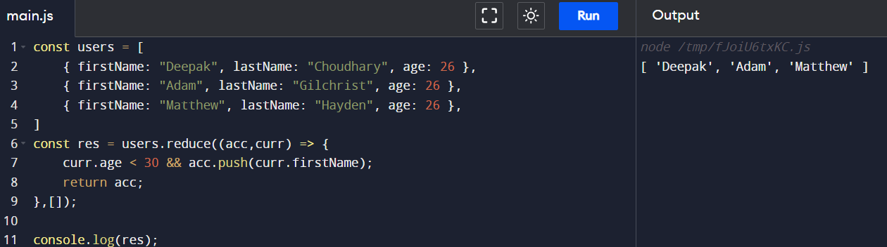

// Polyfill for map method ->
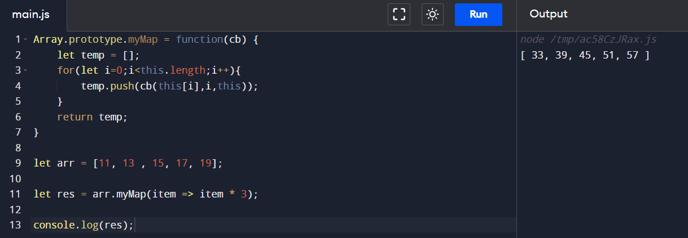
// Polyfill for filter method ->
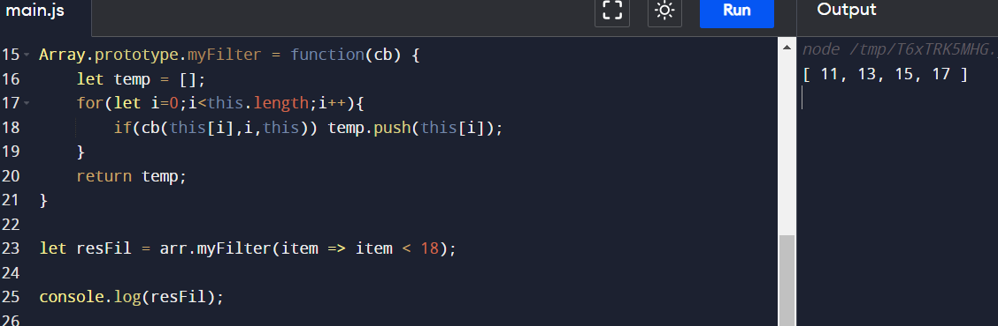
// Polyfill for reduce method ->
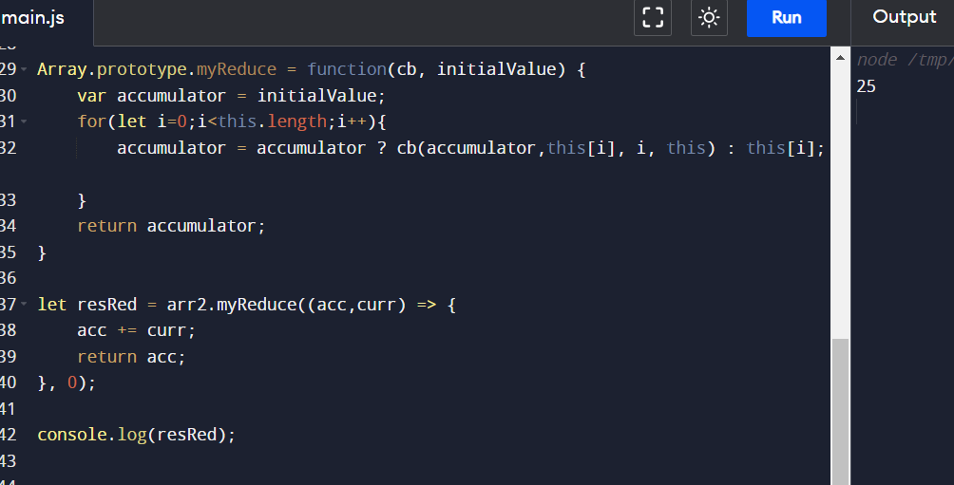

Questions ->
- map vs forEach
Lets understand forEach function first ->
- forEach method calls a function for each element in an array
- it does not return a new array

Lets see an example ->
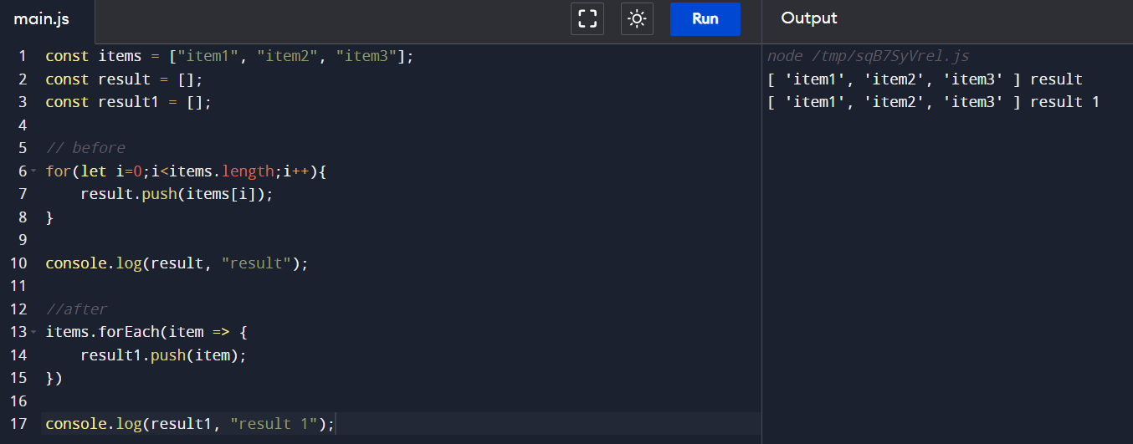
Now, coming back to question,
- first point is map returns a new array, whereas forEach does not return anything
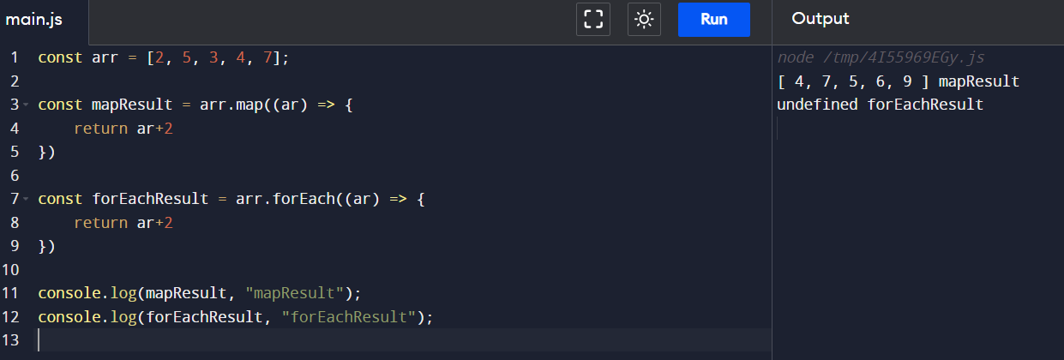
- Second, point is we can use forEach if we want to modify the existing array

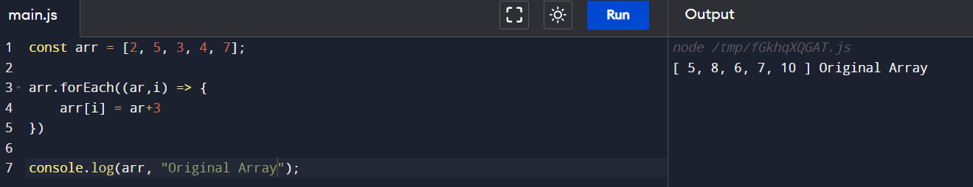
- Lastly, we can chain methods with map, but we cannot chain methods with forEach

- Return only name of students in capital ->
Using map method ->
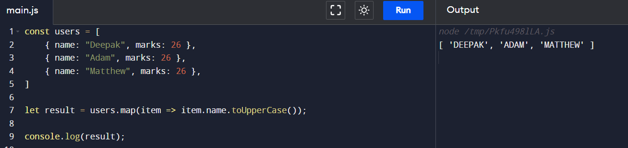
- Return only details of those students who scored more than 60
Using filter method ->
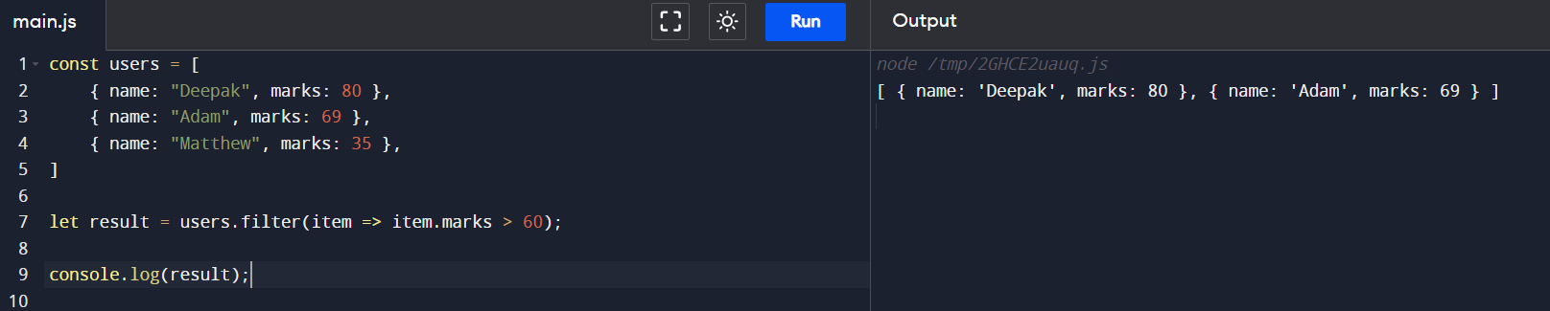

- Return total marks for students with marks greater than 60 after 20 marks have been added to those who scored less than 60

Approach 1 -> using only reduce
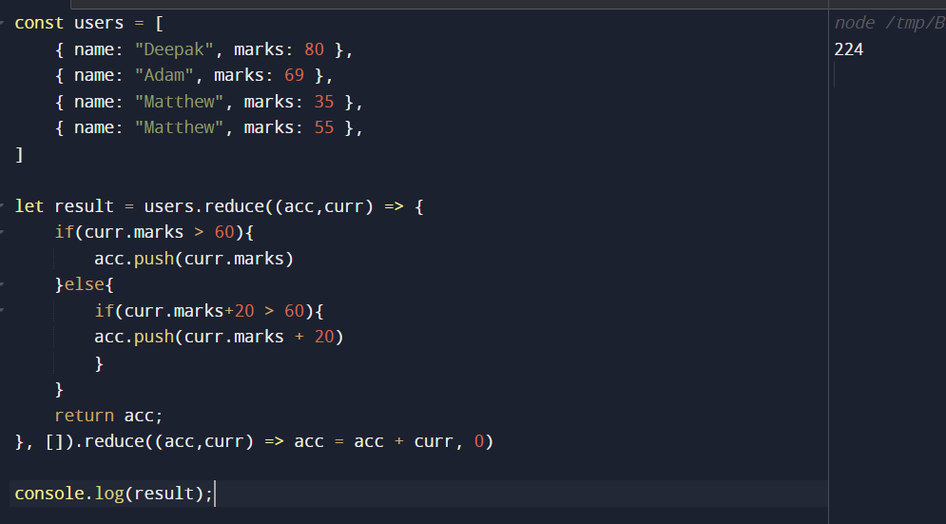
Approach 2 -> using map, filter, and reduce
