this

# this in Global Space
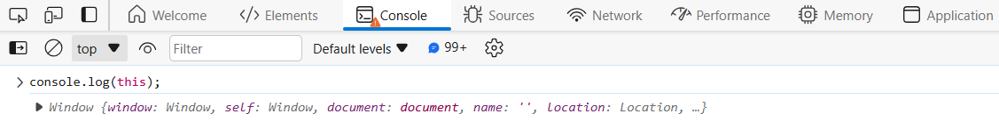
- We got window object, cause this in global space will represent the global object
- JavaScript not only runs in browser, it runs in many places like smartwatch ,etc, so wherever JS runs there’s a JavaScript Runtime Envrionment
- Inside browser, global object is different, inside node js global object is different, similarly wherever JS is running, global object can be different
- And whatever that global object will be, this will represent that
- In case of browsers, the global object is window, that’s why when we consoled this, we got window object
# this in a function
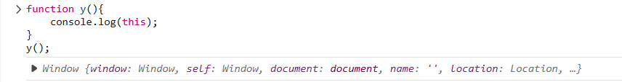
- It still referred to window even when called inside the function y
- Cause when this is called within a function, it refers to the object that called the function
- Let us see the behaviour in strict mode
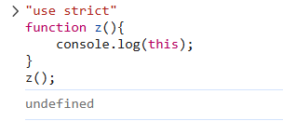
- In strict Mode, we got undefined
- This behaved differently in strict mode because of a phenonmenon known as this substitution
- If the value of this is undefined or null, this will be replaced with global object only in non-strict mode
Q. What is the value of this keyword inside a function?
Ans -> The value of this keyword inside a function is undefined but because has something known as this substitution so the value becomes equal to global object if we don’t use strict mode

- The value of this keyword also depends on how the function is called
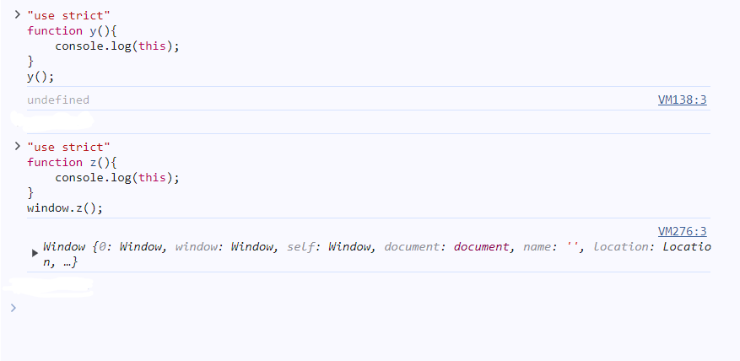
- See, in the example above, in the strict mode
  - When we called y(), we got undefined
  - When we called z(), we got window object
  - y() was called without any reference of an object, hence we got undefined
  - z() was called with the reference of the window object, hence the result

#this in an object’s method
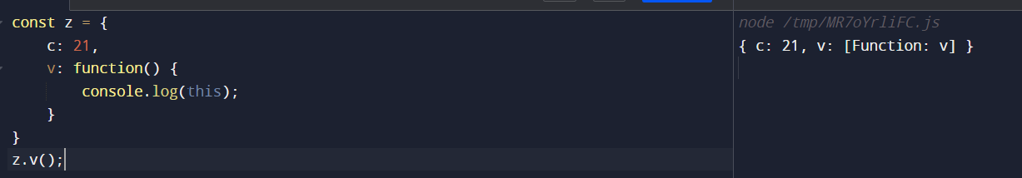
- Whenever you are inside a method, the value of this keyword becomes the object where this method is present
#this inside arrow functions
- Arrow functions do not have their own this, they take the value of this from their lexical environment
#this inside classes
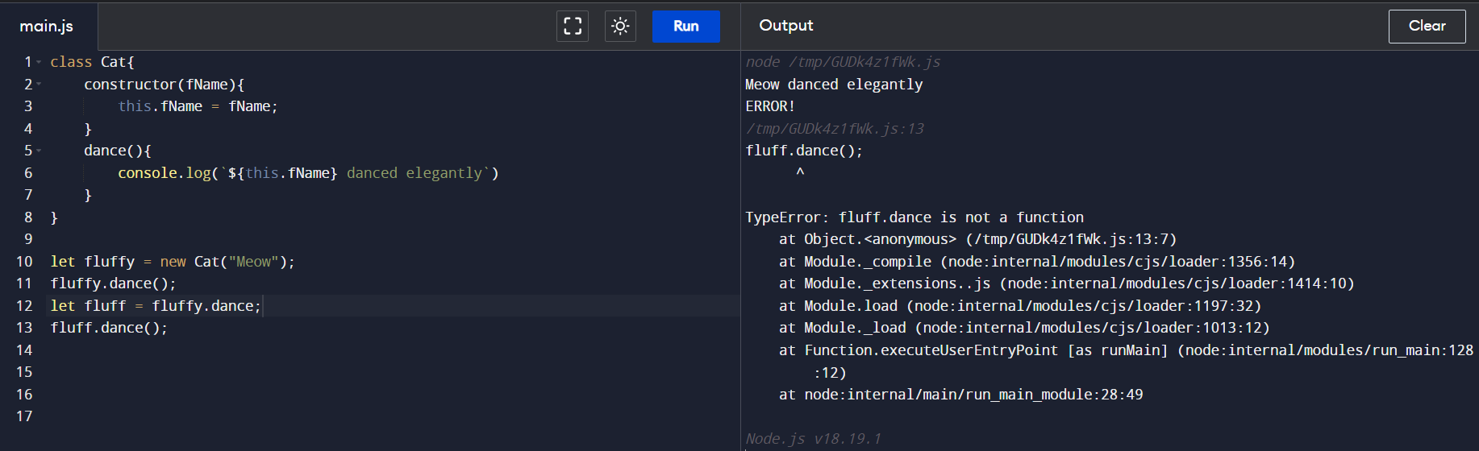
See, in case of classes, if we take out a method and assign it to a random variable, in our case, fluff, but as the function is coming from inside the class, the value of this will be undefined, and not the window

Questions ->
#Q.1 ->
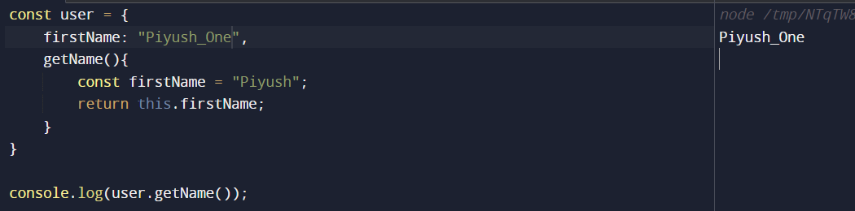
#Q.2 ->
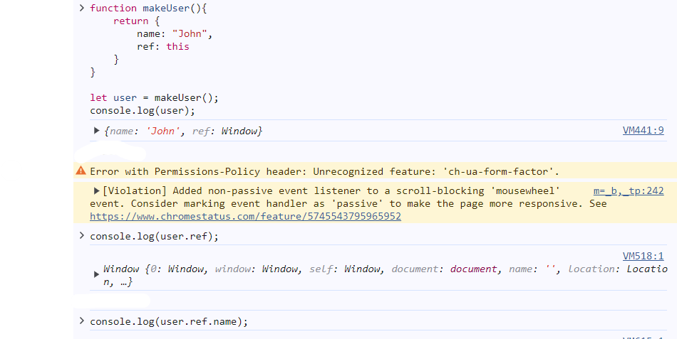
Explanation ->
- When we are calling the makeUser() function, the lexical environment of the function if window object, hence it will be assigned to ref
- If the interviwer asks you to correct the above approach, then –>

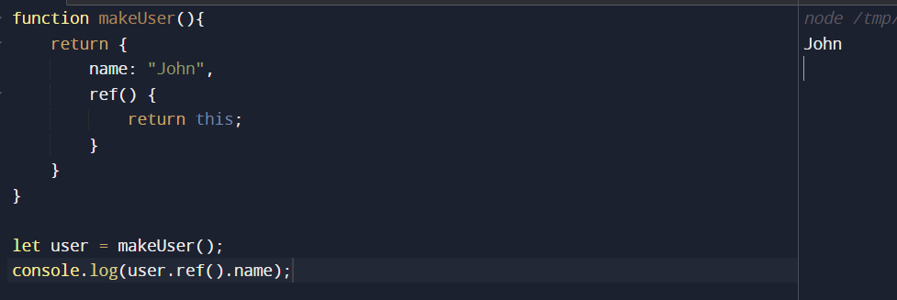
- We mafe ref a function, and it already present inside an object, hence it will point to that object only, and we get our answer

#Q.3 -> Most intriguing question ->
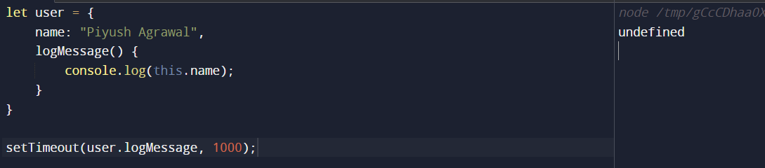
- The expected output was Piyush Agrawal, but rather we got undefined
- Cause, the user.logMessage was passed as a callback rather than a method and it will no longer have access to the user object
- Let’s make it work then ->
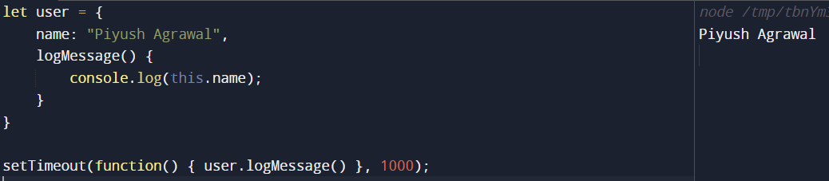
- We called the logMessage inside an anonymous function, so it’s getting called as a method of the user object

#Q.4 ->
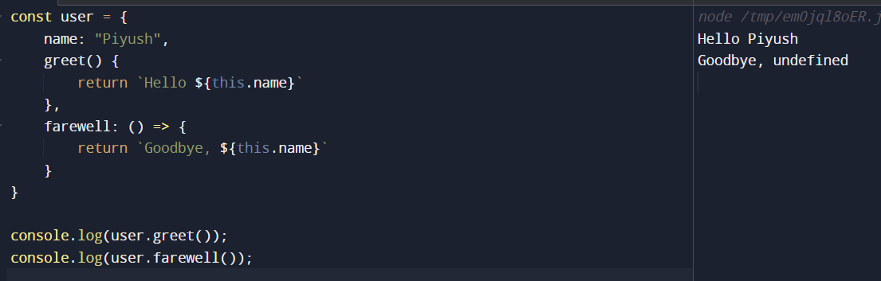
Explanation -> Simple, greet worked as we expected and farewell being an arrow function, took this from the lexical environment, therefore printed undefined

#Q.5 ->
