

Season 3

Team Details Form

Team Logo: (should be high quality PNG image. Please attach a copy of it with the email.) Mandatory

Team Name: Distinct Name of the team; MUST include the company name you are representing. Mandatory

# Team Details

## Officials

|  |  |  |  |
| --- | --- | --- | --- |
| Role | Name | Mobile Number (Mandatory) | Email ID (Mandatory) |
| Manager |  |  |  |
| Coach |  |  |  |
| Captain |  |  |  |
| Vice-Captain |  |  |  |
| Scorer |  |  |  |

## Players

|  |  |  |  |  |  |
| --- | --- | --- | --- | --- | --- |
| S. No. | Player Name | Playing Role (*) | Batting Style (#) | Bowling Style ($) | Email ID (%) (Required) |
| 1 |  |  |  |  |  |
| 2 |  |  |  |  |  |
| 3 |  |  |  |  |  |
| 4 |  |  |  |  |  |
| 5 |  |  |  |  |  |
| 6 |  |  |  |  |  |
| 7 |  |  |  |  |  |
| 8 |  |  |  |  |  |
| 9 |  |  |  |  |  |
| 10 |  |  |  |  |  |
| 11 |  |  |  |  |  |
| 12 |  |  |  |  |  |
| 13 |  |  |  |  |  |
| 14 |  |  |  |  |  |
| 15 |  |  |  |  |  |

**\*Playing Roles** : Batsman(BAT), Bowler(BOW), Wicket-keeper(WK), All-rounder(AR)

**#Batting Style**: Right Hand Bat (RHB), Left Hand Bat (LHB)

**$Bowling Style**: Right Arm Medium (RAM), Right Arm Fast (RAF), Right Arm Off-Spin (RAOS), Right Arm Leg-Spin (RALS), Left Arm Medium (LAM), Left Arm Fast (LAF), Left Arm Off-Spin (LAOS), Left Arm Leg-Spin (LALS)

**%Email ID:** Email is required if players wants to claim it’s profile on tournament portal. Email of Captain, Vice-Captain & scorer is mandatory.



## Player Images

Please attach player images in Team Jersey, preferably in similar background, without goggles and spectacles, in similar postures for all the players. Images should be clear and of good quality. It is advised to avoid the images which qualify for Facebook and WhatsApp DP.  
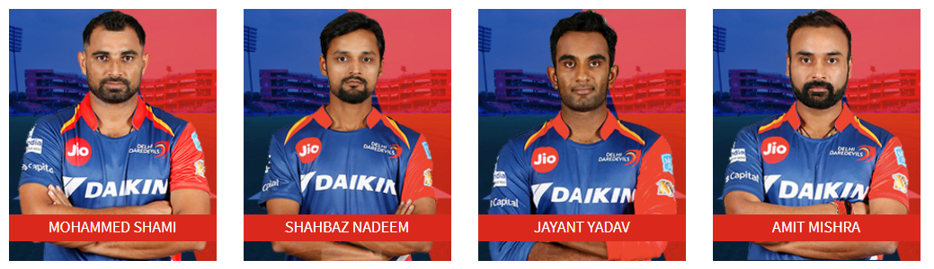

(Sample Posture, Delete it while editing this form)