OESON

GLOBAL TRAINING AND INTENSHIP PROGRAM

PROJECT 1 – EXCEL

BY C.DEEPAK KUMAR REDDY

ANALYSIS ON FYNTRA CUSTOMERS DATA
CONTENT :
1. Avg_Session_Length -Pg 3
2. Length_of_Membership -pg 4
3. Time_on_Website -pg 5
4. Yearly_Amount_Spent -pg 6
5. Time_on_App -pg7
6. Time_on_App VS Time_on_Website -pg 8
7. AVERAGE of Yearly_Amount_Spent vs. Length_of_Membership -pg 9
8. AVERAGE of Length_of_Membership vs.
Time_on_Website -pg10
9.Fyntra customer’s data -pg 11
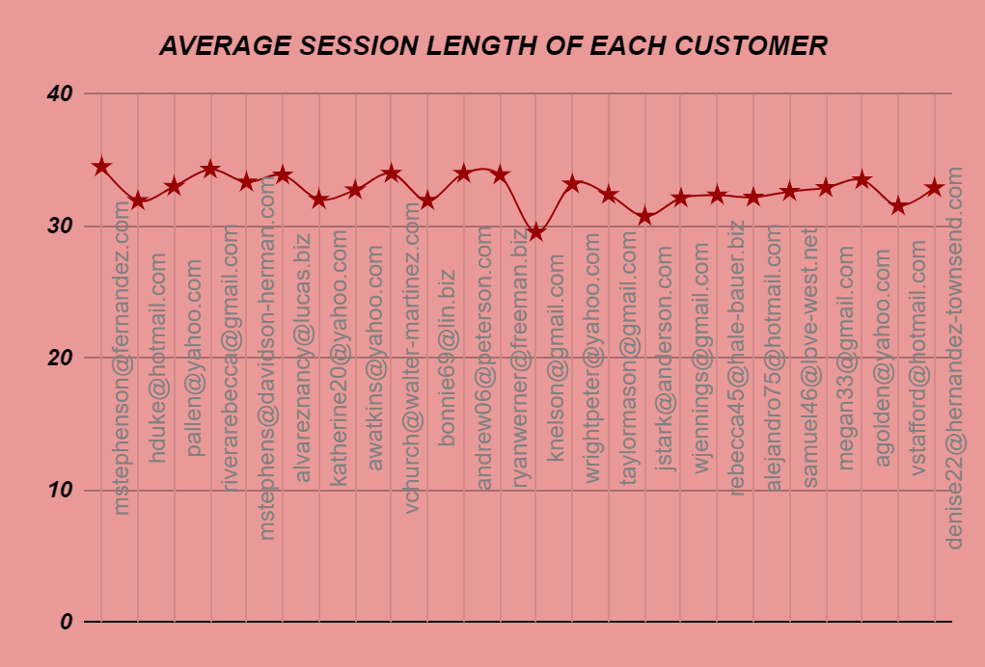
Figure 1 { NOTE:EVERY GRAPH IN THIS PROJECT DEPICTS 1ST 25 FYNTRA CUSTOMERS DATA}
*Average session length’s average of customer is 33.1
*Sum of all average session length of customers is 16526.6
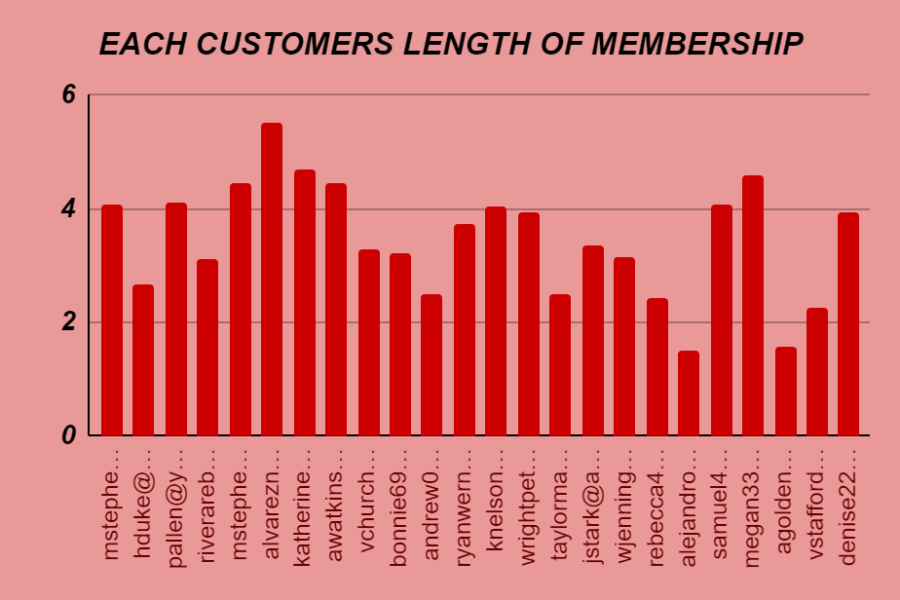
Figure 2
*Average length of membership of customers is 3.53.
*Total length of membership of customers is 1766.73
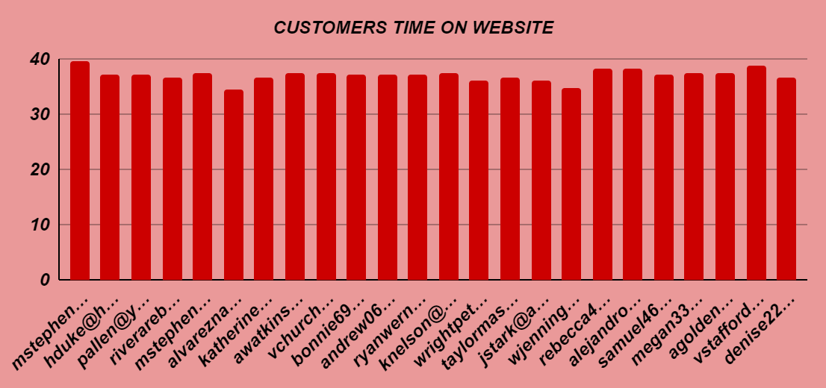
Figure 3
*Average of customers time on website is 37.1
*Total customers time on website is 18530.2
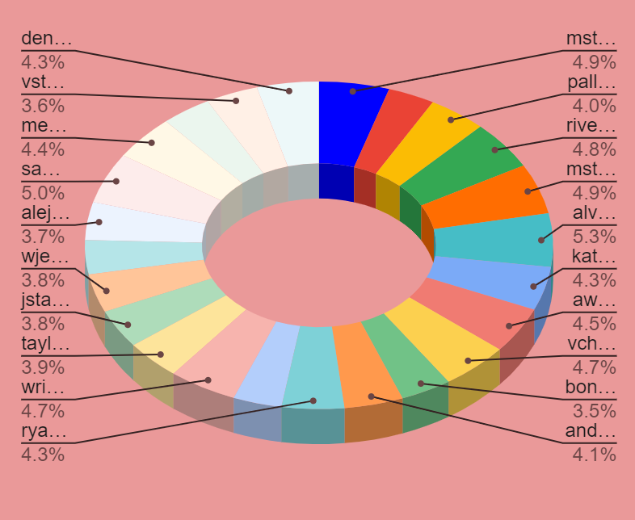
Figure 4
*Average amount received by customers is 499.3
*Total amount received by customers is 249657
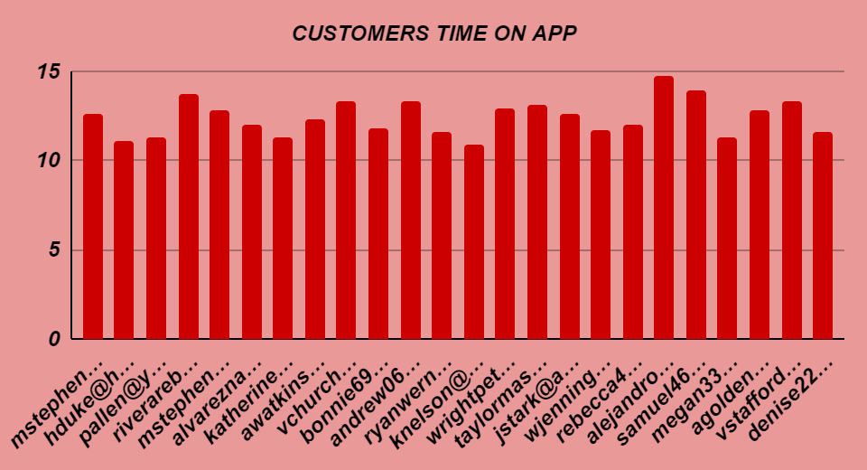
Figure 5
*Average time on app of customers is 12.1
*Total time on app of customers is 6026.2
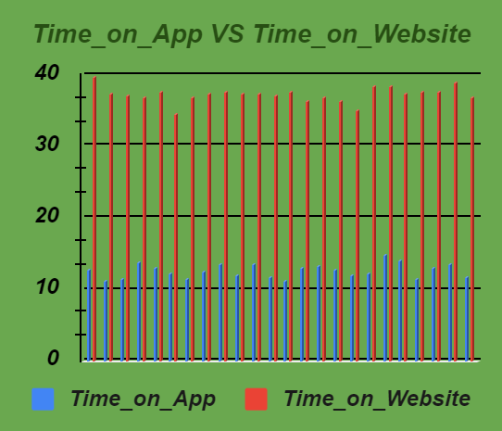
Figure 6
 | Average | Sum
Time on website | 37.1 | 18530.2
Time on app | 12.1 | 6026.2

*Above graph depicts customers spend more time on website .
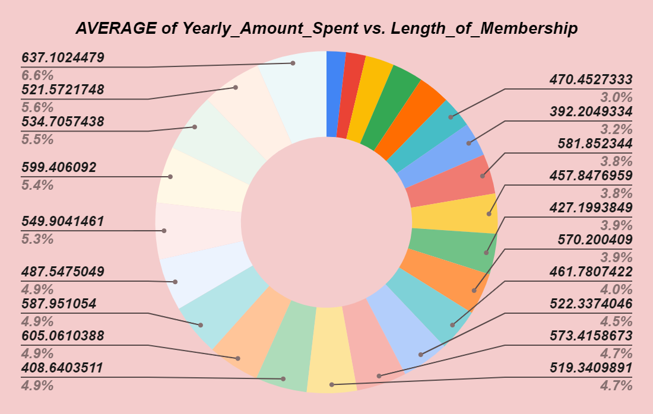
Figure 7

*Here you can see percentage of length of membership with respective to average of yearly amount spent by customers.
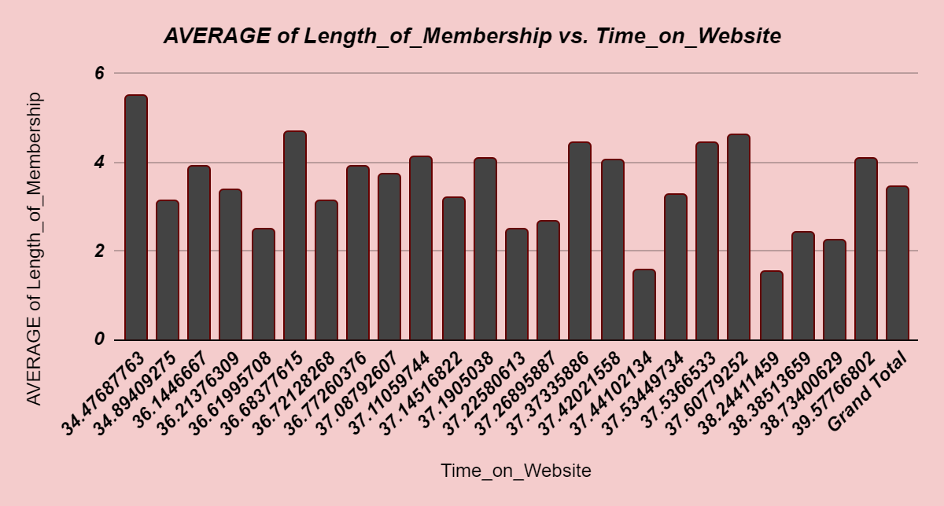
Figure 7

*The above graphs shows time on website with respective to average of length of membership of customers.

FYNTRA CUSTOMER’S DATA
{ALL CUSTOMERS DATA}
 | AVG |  | SUM | MAX | MIN
Avg_Session_Length | 33.1 |  | 16526.6 | 36.1 | 29.5
Yearly_Amount_Spent | 499.3 |  | 249657 | 765.5 | 256.7
Length_of_Membership | 3.53 |  | 1766.73 | 6.92 | 0.27
Time_on_Website | 37.1 |  | 18530.2 | 40 | 33.9
Time_on_App | 12.1 |  | 6026.2 | 15.1 | 8.5
Figure 8
Figure 9

FIGURE 8

