# Recursion #

Ques : Factorial of a number
Link: https://ide.geeksforgeeks.org/DIBhDm3mjw

Ques : Nth fibbonaci number using recursion
Link: https://ide.geeksforgeeks.org/8ewGwWeJTD

Ques : Check if array is sorted or not using recursion
Logic :
Recursive Case : if(a[0]<a[1] && isSorted(a+1,n-1)) return true;
Base Case : if(n==1) return true;
Link: https://ide.geeksforgeeks.org/fL80kcSwMC

Ques: Find a^b using recursion

Logic : we can write,
a^b = a*a^(b-1)

Example: 2^3 => 2*2^2
\>
2*2^1
\>
2*2^0
\>
1

Recursive equation :
power (a,b) => a*power(a,b-1)
Base Case : if(b==0) return 1;

Time Complexity : O(b) as number of steps depends upon the value of b

Now Let’s Optimize this Code,

Think of recursive equation in some other form,

See, 2⁴ = (2²)² and 2⁵ = 2*(2²)²
So we can think of it as ,
power(a,b) = ( power(a,b/2) )² If b is even
power(a,b) = a*( power(a,b/2) )² if b is odd

Base case: if(b==0) return 1;

Time Complexity : O(log₂b) + 1 => O(log₂b)
Link : https://ide.geeksforgeeks.org/6dmxL7FXdh

Ques : Print numbers in increasing and decreasing order from 1 to n and n to 1 respectively using recursion.

Link : https://ide.geeksforgeeks.org/xJtlyjEOMO

Ques: Multiply 2 numbers using recursion
Link : https://ide.geeksforgeeks.org/6WNJAACho1

Ques : Convert a string to a integer using recursion
Link : https://ide.geeksforgeeks.org/K83JRuZrV8

Ques : Find number of ways to fill a N x 4 matrix with 1 x 4 tiles.

Link: https://www.techiedelight.com/find-ways-fill-n-x-4-matrix-with-1-x-4-tiles/

Link2: https://ide.geeksforgeeks.org/NMNAU30Nnq

Ques: 2048 Problem, print it like Two Zero Four Eight

Link: https://ide.geeksforgeeks.org/j6RLHxyvls

Ques: Linear Search By Recursion

Link: https://ide.geeksforgeeks.org/Jei0xgR7qe

Ques: Implement Binary Search using recursion

Link: https://ide.geeksforgeeks.org/IplIHgkw52

Ques: Bubble sort using recursion

Link : https://ide.geeksforgeeks.org/ExiJTUwReJ

Ques: Tower of Hanoi

Link: https://ide.geeksforgeeks.org/fOVQ1z50ft

Ques: Merger Sort
Link: https://ide.geeksforgeeks.org/m75aBXjL4f

Ques: Quick Sort
Link: https://ide.geeksforgeeks.org/yCDBm9NgsL

Note: Sorted array is the worst case of sorted array with complexity O(n²).

Ques: Generate a random number in c++
Link: https://ide.geeksforgeeks.org/yCDBm9NgsL

Ques: Randomized quick sort

Logic: We all know that quick sort takes O(n²) time in worst case . So how to solve this problem. First make it clear that worst case occur in case of sorted array , What if we first randomly shuffled that sorted array and then applied the Quick Sort, Our Problem is solved and hence it will always take only O(nlog(n)) time.

Note: Interviewer might ask you that how you can randomly shuffle a array in c++.

Sol. and Link of both problems :
https://ide.geeksforgeeks.org/guJ12qZ3OK

Ques (very good question of recursion and backtracking) :
Print all the permutations of a given string , eg. For “abc”, possible permutations are abc,acb,bac,bca,cba,cab ; Total : 6

Link: https://ide.geeksforgeeks.org/EpajiSKf6f

Explanation:
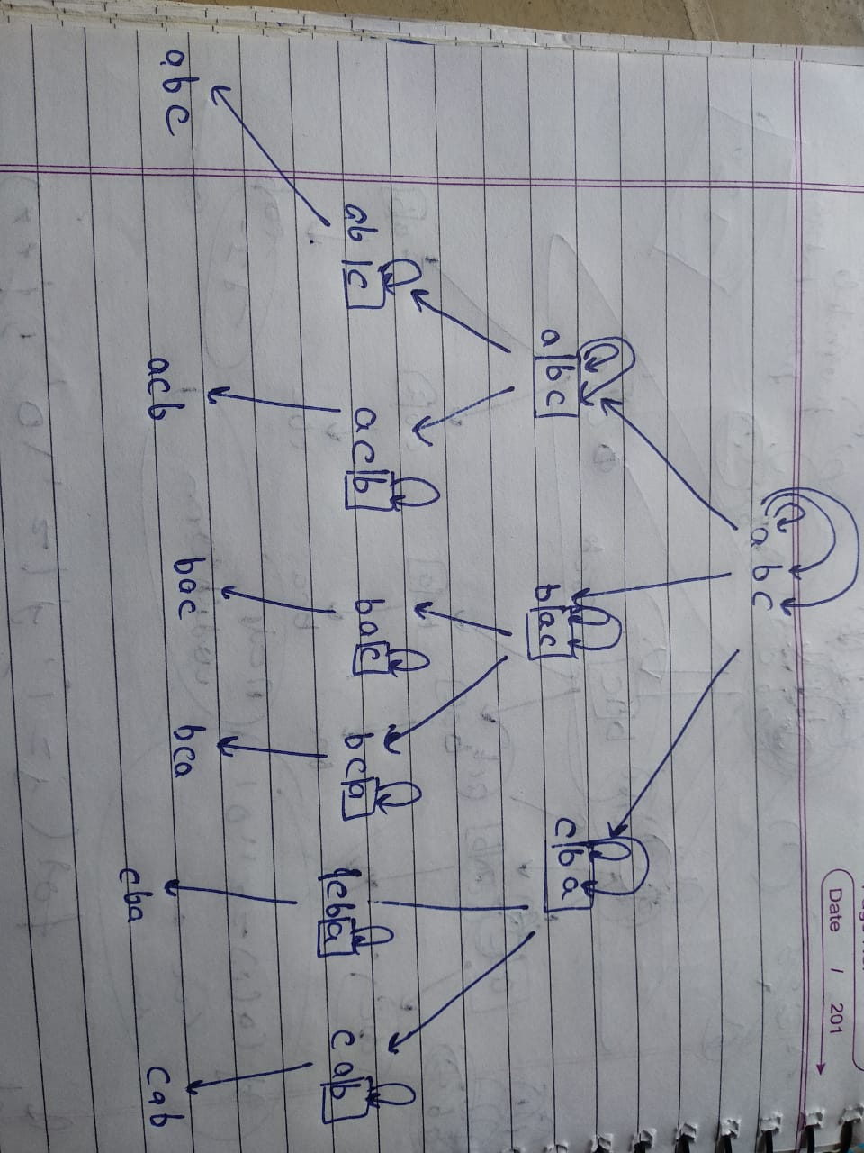
Ques: Subsequence of a string using recursion.

Logic: For every character, we have 2 options. Either to include it or not include it in the output string.

Link: https://ide.geeksforgeeks.org/XfL580JBLy

Ques: Implement N Queen Problem using recursion
Link: https://ide.geeksforgeeks.org/PUcrwiWgOS

Ques: Rat in a maze (good question of backtracking)

Link: https://ide.geeksforgeeks.org/gpt0MahIn9

Ques: Optimized way of finding no. Of possible configurations in N Qeen Problem using Bitset.

Link: https://ide.geeksforgeeks.org/j5OieCh4P2

Ques: Solve Soduku using recursion .

Link: https://ide.geeksforgeeks.org/PwLGVomRqa

