10 Beginner-Level Python Flowcharts
Flowchart diagrams extracted from each of the 10 case studies.

1. Progressive Electricity Billing (PDF Task 2)
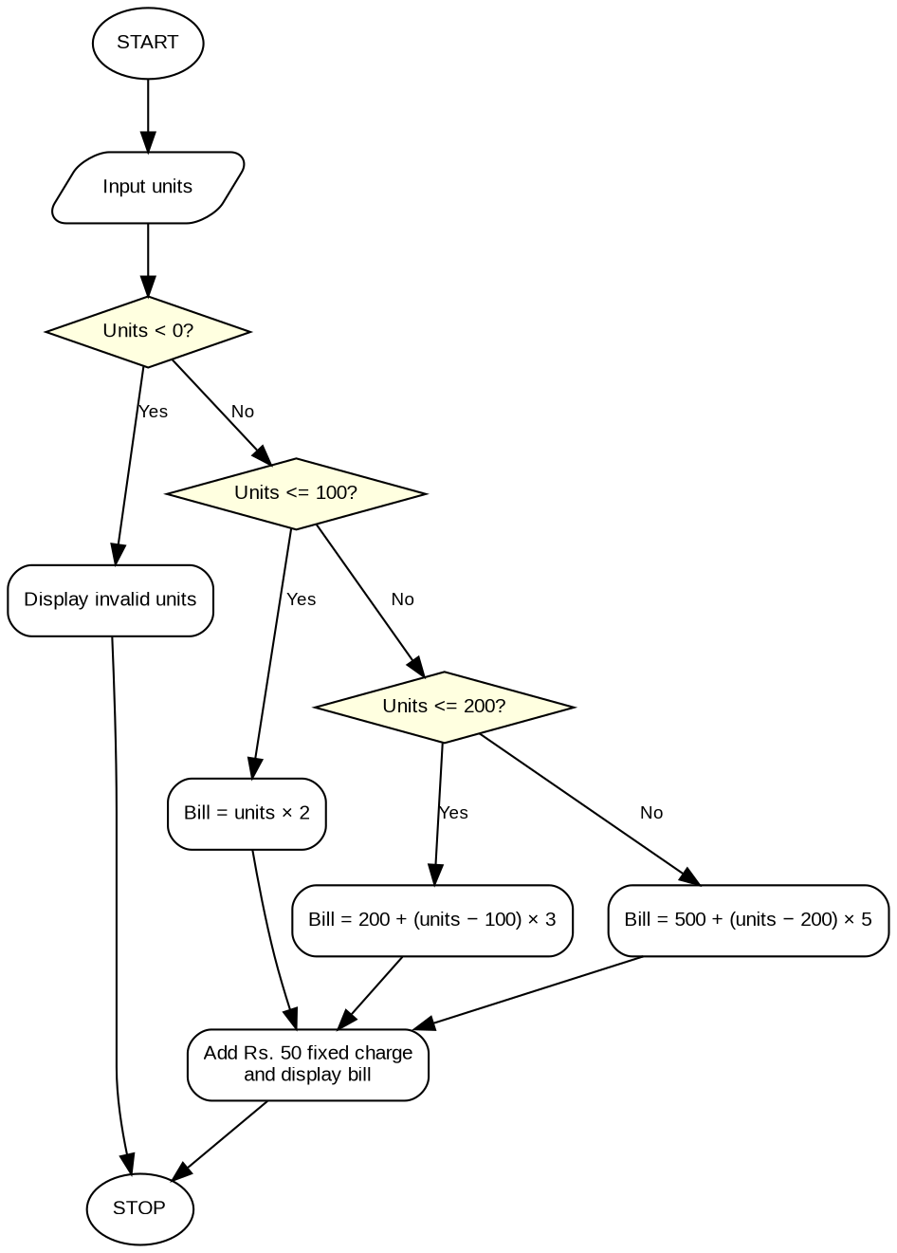

2. Retail Billing with Discounts (PDF Task 7)
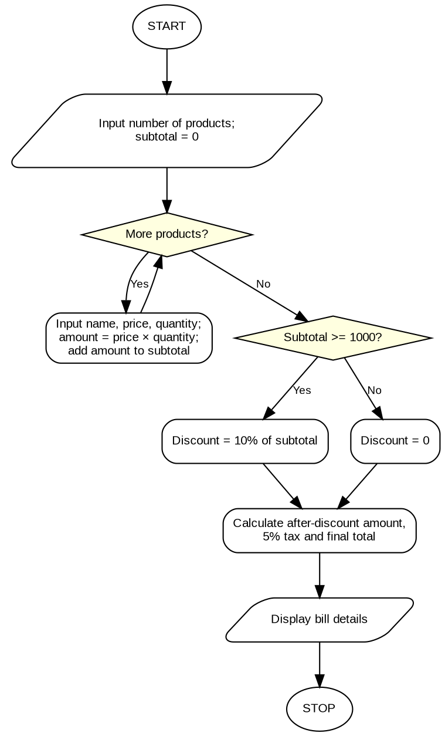

3. Examination Result and Grace-Mark Validation (PDF Task 11)
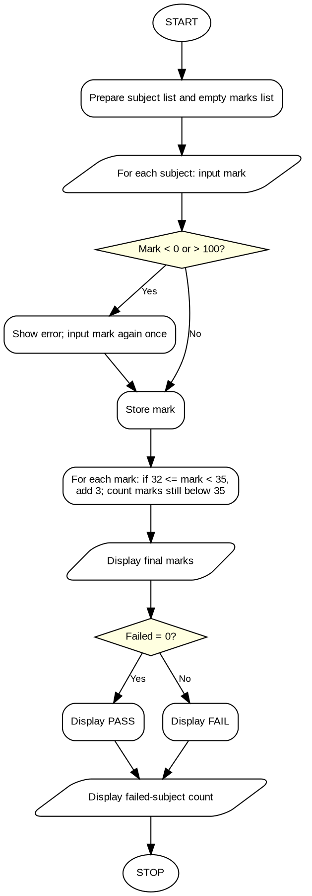

4. Attendance Recovery Computation (PDF Task 12)
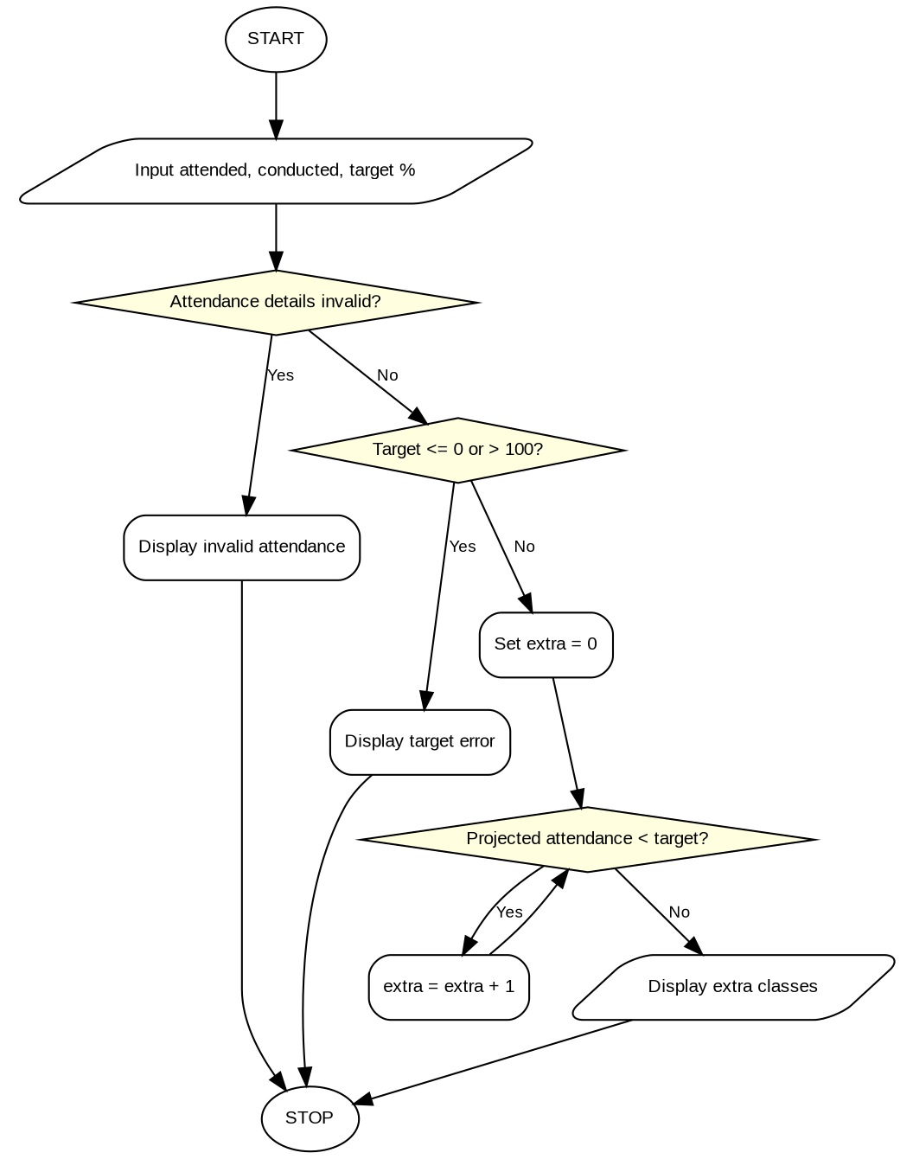

5. ATM Transaction Sequence Simulation (PDF Task 13)
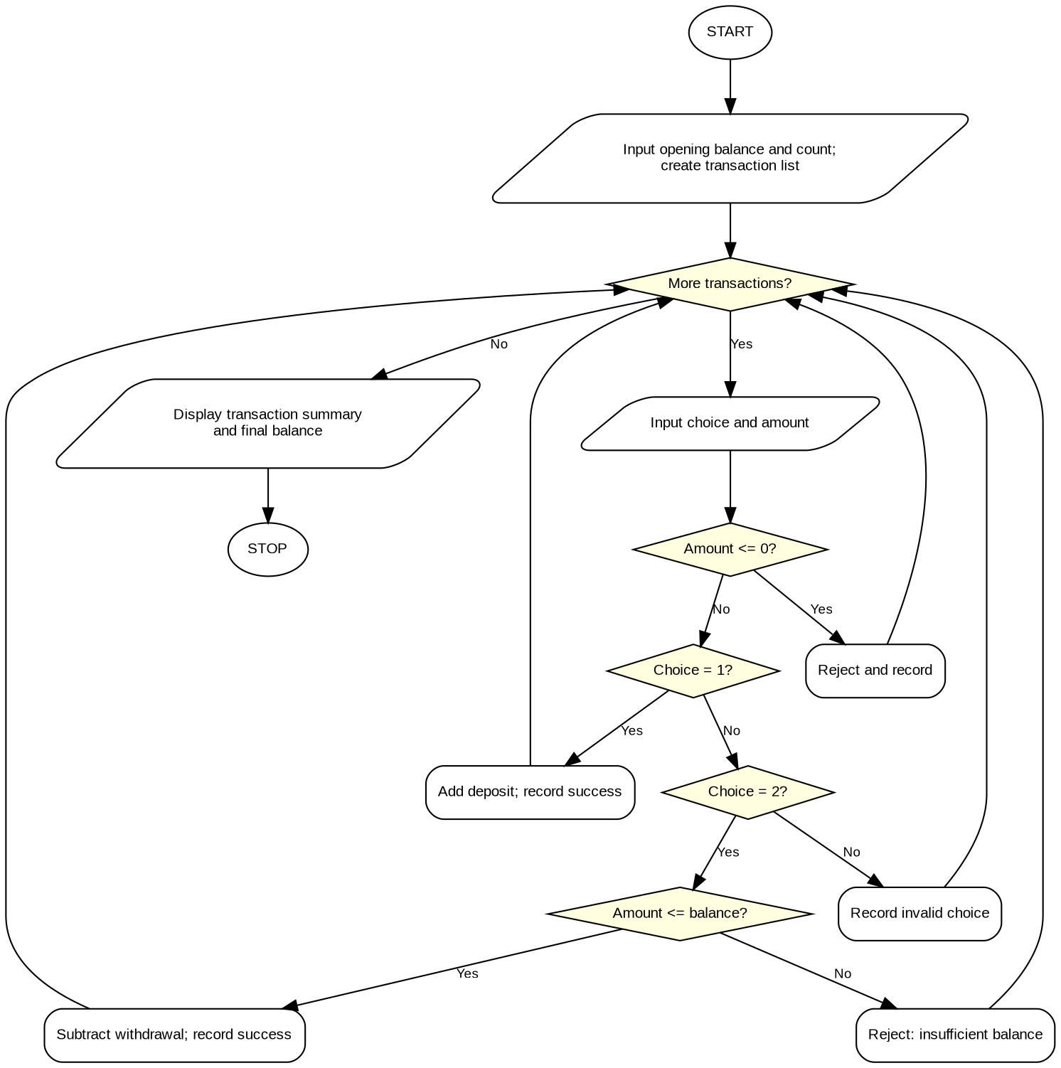

6. Student Performance Trend Analysis (PDF Task 17)
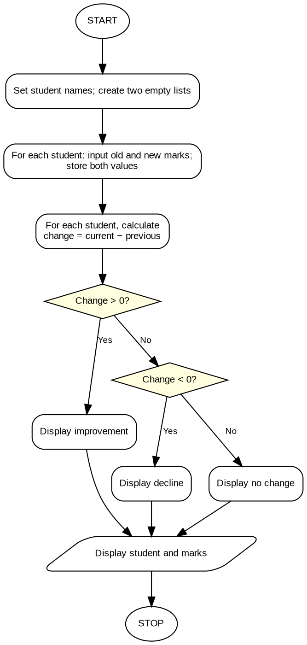

7. Advanced Numeric Pattern Generator (PDF Task 27)
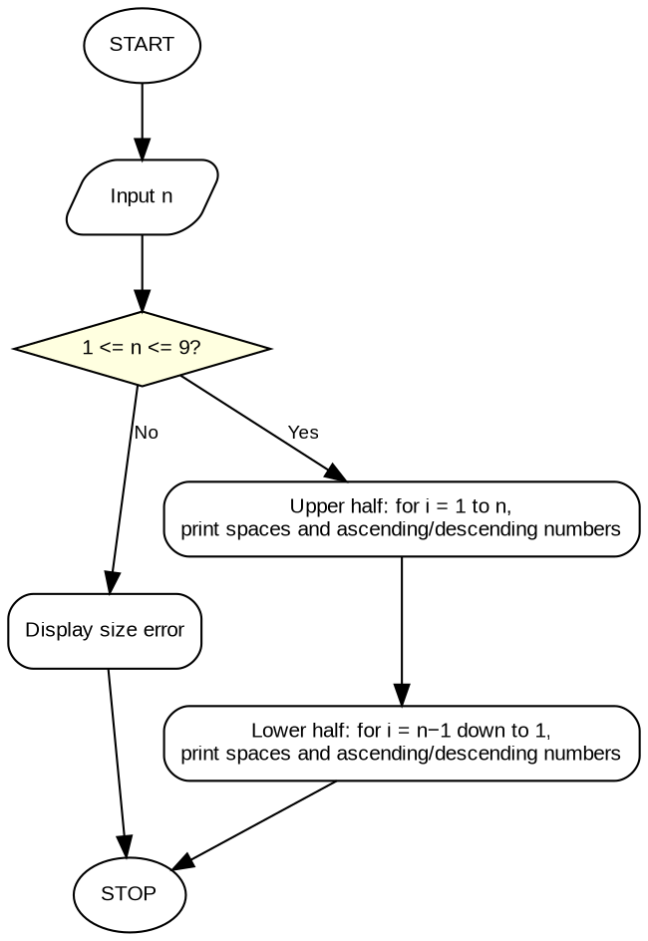

8. Password Policy Validation Engine (PDF Task 29)
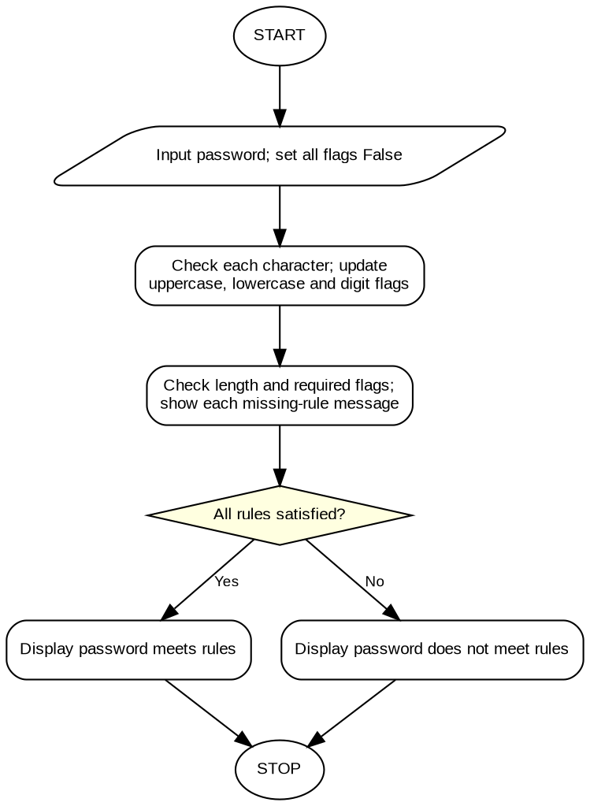

9. Student Marks Matrix Analysis (PDF Task 42)
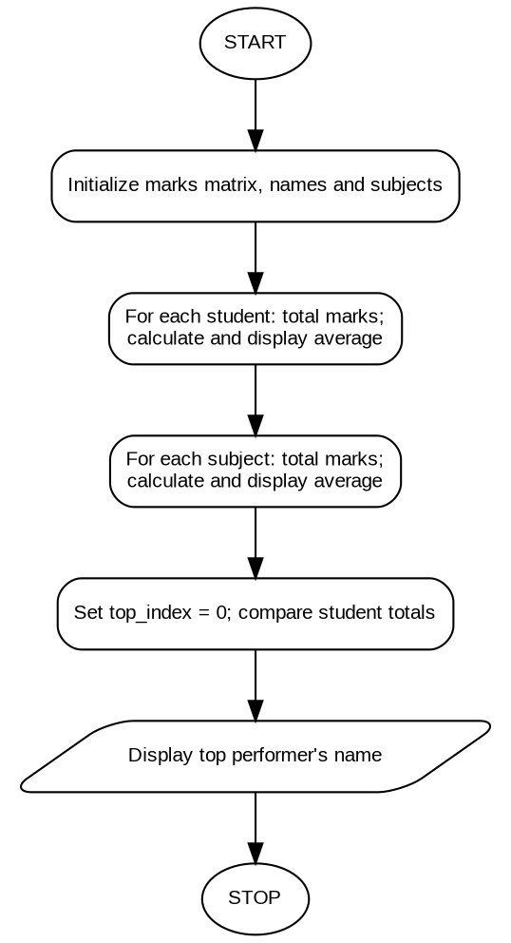

10. Tuple-Based Product Catalogue Audit (PDF Task 49)


