For Angular2.0 application we have to first install Node js

From <https://nodejs.org/en/>

Download nodejs

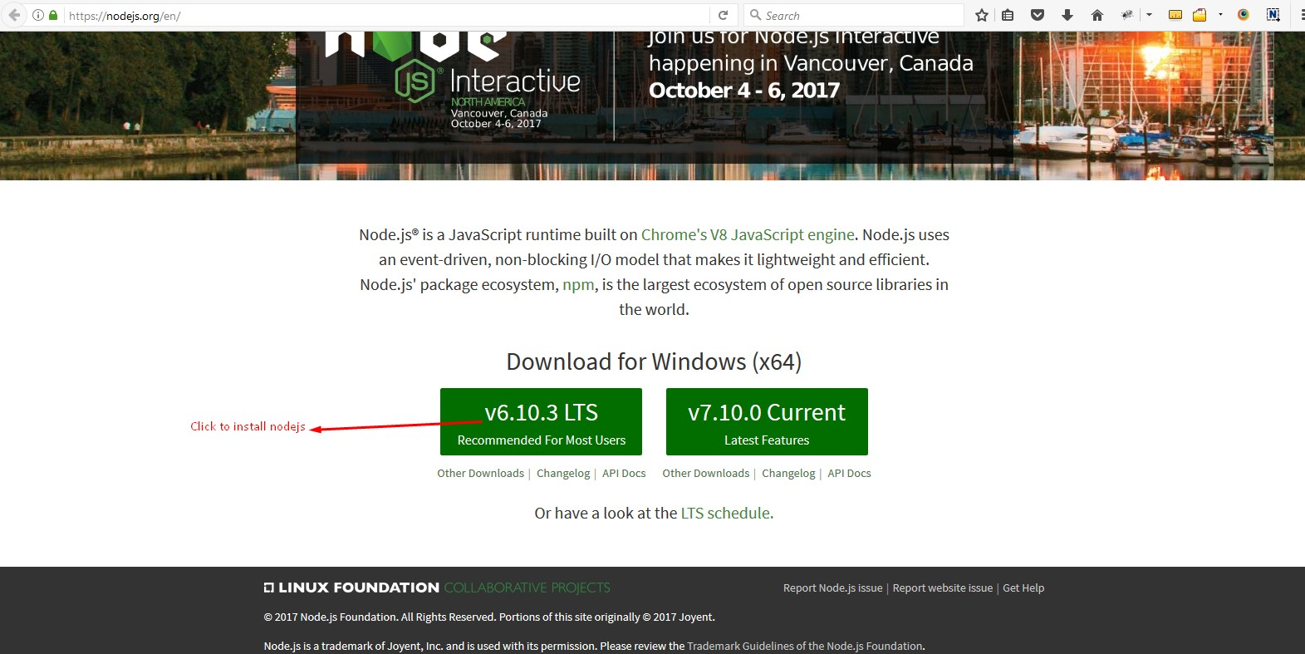

To check the npm version in command prompt

Type npm –version

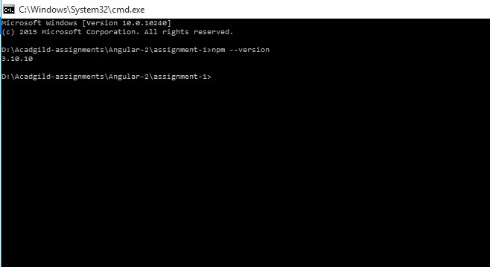

To check the node version type node –version

