Install Angular CLI thru NPM

Command npm install –g angular-cli

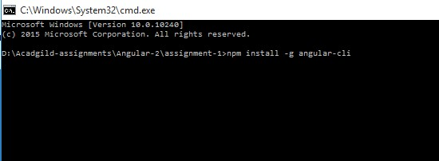

Command :- ng --version

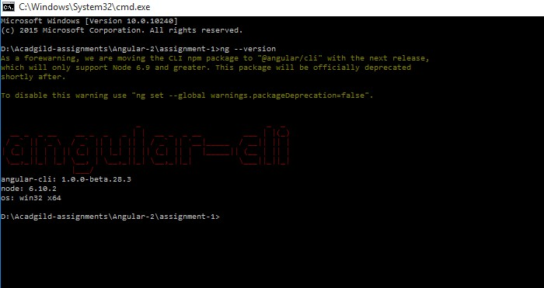

Creation of new project thru angular-cli

Command :- ng new first

