

|  |
| --- |
| Wireframes_blue |
| 01/02/16 13:24 |
| **Author:** John Doe  **File name:** Wireframes_blue.vp  **Version** 1.0 |

|  |
| --- |
| Site Map |
|  |

|  |
| --- |
|  |

01. Site Map / Wireframes_blue 

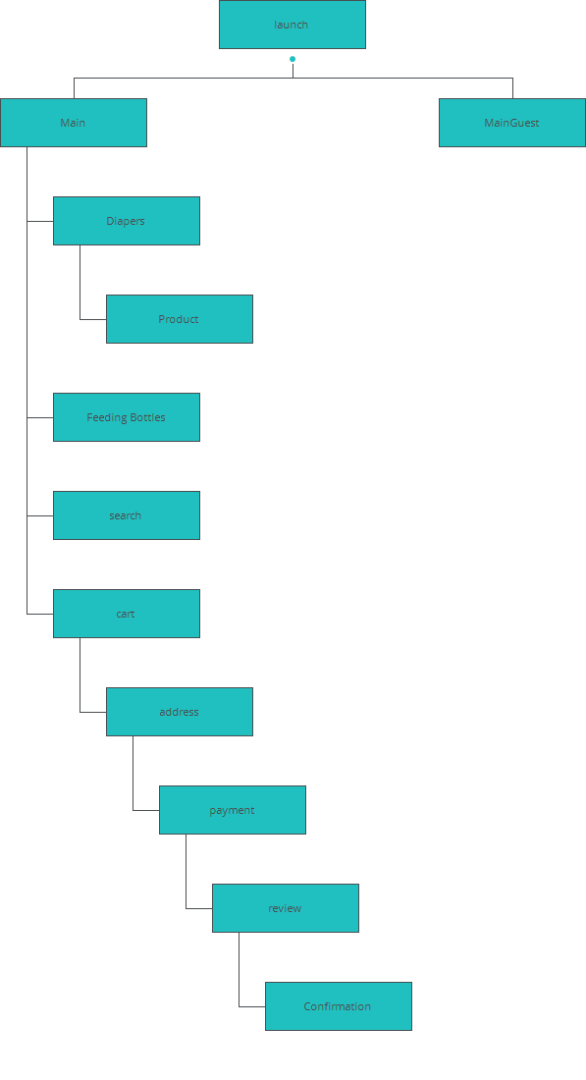

|  |
| --- |
| Screens |
|  |

|  |
| --- |
|  |

02. Screens / Wireframes_blue 

launch

|  |
| --- |
|  |

Interactions

|  |  |
| --- | --- |
| 1 | **on Click:** goes to 'Main' with effect: slide left 🡪 |
| 2 | **on Click:** goes to 'Main' with effect: slide left 🡪 |
| 3 | **on Click:** goes to 'Main' with effect: slide left 🡪 |
| 4 | **on Click:** goes to 'MainGuest' with effect: slide left 🡪 |

02. Screens / Wireframes_blue 

Main

|  |
| --- |
|  |

Interactions

|  |  |
| --- | --- |
| 6 | **on Click:** goes to 'Diapers' with effect: slide left 🡪 |
| 7 | **on Click:** goes to 'Feeding Bottles' with effect: slide left 🡪 |

02. Screens / Wireframes_blue 

MainGuest

|  |
| --- |
|  |

Interactions

|  |  |
| --- | --- |
| 8 | **on Click:** goes to 'Diapers' with effect: slide left 🡪 |
| 9 | **on Click:** goes to 'Feeding Bottles' with effect: slide left 🡪 |

02. Screens / Wireframes_blue 

Diapers

|  |
| --- |
|  |

Interactions

|  |  |
| --- | --- |
| 10 | **on Click:** goes to 'Product' with effect: slide left 🡪 |
| 11 | **on Click:** goes to 'Product' with effect: slide left 🡪 |

02. Screens / Wireframes_blue 

Product

|  |
| --- |
|  |

02. Screens / Wireframes_blue 

Feeding Bottles

|  |
| --- |
|  |

02. Screens / Wireframes_blue 

cart

|  |
| --- |
|  |

Interactions

|  |  |
| --- | --- |
| 12 | **on Click:** goes to 'address' with effect: slide left 🡪 |

02. Screens / Wireframes_blue 

search

|  |
| --- |
|  |

02. Screens / search 

Other states

|  |  |
| --- | --- |
|  |  |
|  |  |

02. Screens / Wireframes_blue 

address

|  |
| --- |
|  |

Interactions

|  |  |
| --- | --- |
| 13 | **on Click:** goes to 'payment' with effect: slide left 🡪 |
| 14 | **on Click:** goes to 'cart' with effect: slide right 🡪 |

02. Screens / Wireframes_blue 

payment

|  |
| --- |
|  |

Interactions

|  |  |
| --- | --- |
| 15 | **on Click:** goes to 'review' with effect: slide left 🡪 |
| 16 | **on Click:** goes to 'address' with effect: slide right 🡪 |

02. Screens / Wireframes_blue 

review

|  |
| --- |
|  |

Interactions

|  |  |
| --- | --- |
| 17 | **on Click:** goes to 'Confirmation' with effect: slide left 🡪 |
| 18 | **on Click:** goes to 'payment' with effect: slide right 🡪 |

02. Screens / Wireframes_blue 

Confirmation

|  |
| --- |
|  |

|  |
| --- |
| Templates |
|  |

|  |
| --- |
|  |

03. Templates / Wireframes_blue 

Guest

|  |
| --- |
|  |

Interactions

|  |  |
| --- | --- |
| 19 | **on Click:** goes to 'search' with effect: slide left 🡪 |
| 20 | **on Click:** goes to 'cart' with effect: slide left 🡪 |

03. Templates / Wireframes_blue 

Inner Pages

|  |
| --- |
|  |

Interactions

|  |  |
| --- | --- |
| 21 | **on Click:** goes to 'search' with effect: slide left 🡪 |
| 22 | **on Click:** goes to 'cart' with effect: slide left 🡪 |
| 23 | **on Click:** goes to 'Main' with effect: slide right 🡪 |

03. Templates / Wireframes_blue 

Launch

|  |
| --- |
|  |

03. Templates / Wireframes_blue 

Main Pages

|  |
| --- |
|  |

Interactions

|  |  |
| --- | --- |
| 24 | **on Click:** goes to 'search' with effect: slide left 🡪 |
| 25 | **on Click:** goes to 'cart' with effect: slide left 🡪 |

|  |
| --- |
| Scenarios |
|  |

|  |
| --- |
|  |

04. Scenarios / Wireframes_blue 

default

|  |
| --- |
|  |