

Wireframes_new
25/02/16 10:47
Author: Deepak Dhamuria
File name: Wireframes_new.vp
Version 1.0

Site Map

01. Site Map / Wireframes_new

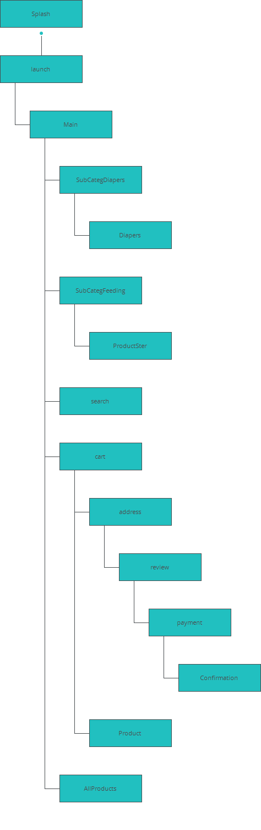

Screens

02. Screens / Wireframes_new
Splash
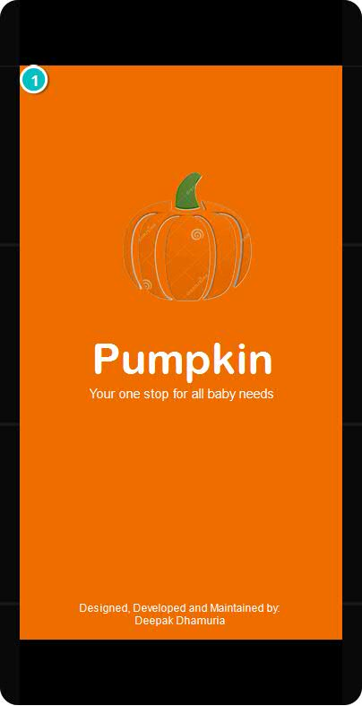

Interactions

1 | on Page Load: delays 2000ms goes to 'launch' with effect: slide left

02. Screens / Wireframes_new
launch
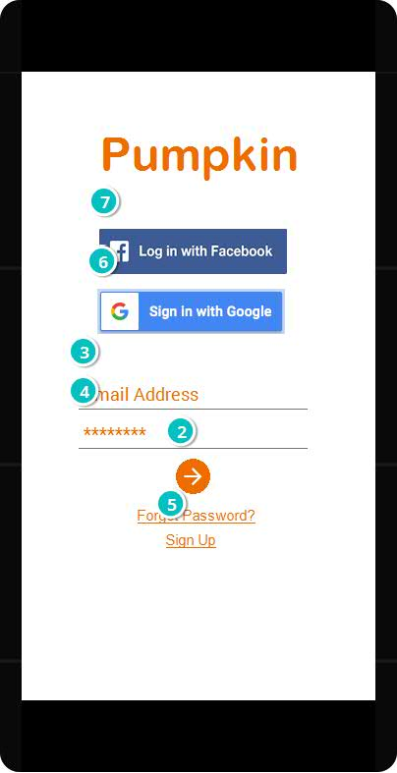

Interactions

2 | on Click: goes to 'Main' with effect: slide left
3 | on Focus In: shows 'Line_4' with effect: slide left and easing: linear in 200ms changes style of 'Input_2': Text When (Input_2.value = 'Type something') sets value '' to 'Input_2'  on Focus Out: When (Input_2.value = '') sets value 'Type something' to 'Input_2' hides 'Line_4' changes style of 'Input_2': Text
4 | on Focus In: shows 'Line_6' with effect: slide left and easing: linear in 200ms changes style of 'Input_3': Text When (Input_3.value = 'Type something') sets value '' to 'Input_3'  on Focus Out: When (Input_3.value = '') sets value 'Type something' to 'Input_3' hides 'Line_6' changes style of 'Input_3': Text
5 | on Click: shows 'SignUpForm' with effect: slide left in 500ms
6 | on Click: goes to 'Main' with effect: slide left
7 | on Click: goes to 'Main' with effect: slide left

02. Screens / Wireframes_new
Main
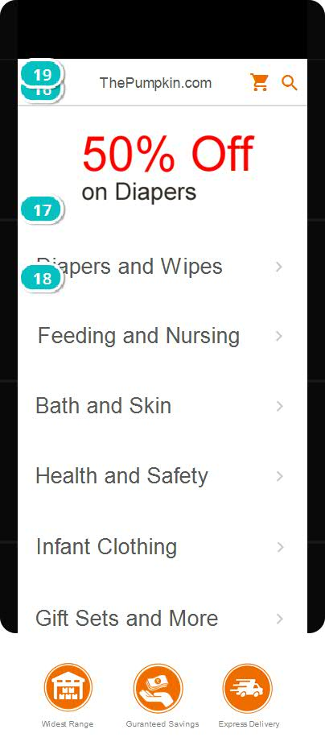

Interactions

16 | on Swipe Left: hides 'Image_1' shows 'Image_2' with effect: slide right in 500ms
17 | on Click: goes to 'SubCategDiapers' with effect: slide left
18 | on Click: goes to 'SubCategFeeding' with effect: slide left
19 | on Page Load: sets value '900' to variable 'screenSize'

02. Screens / Wireframes_new
SubCategDiapers
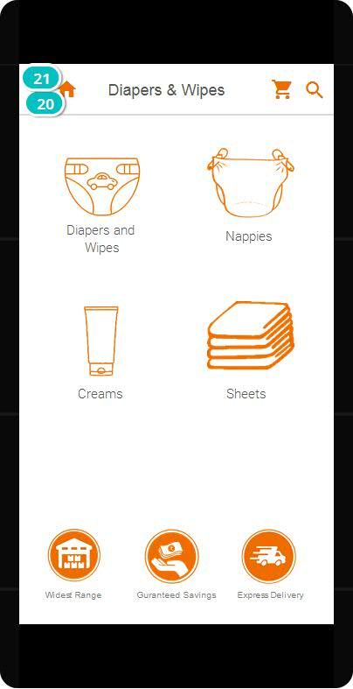

Interactions

20 | on Click: goes to 'Diapers' with effect: slide left
21 | on Page Load: sets value 'Diapers & Wipes' to variable 'titleBar'  on Swipe Left: goes to 'SubCategFeeding' with effect: slide left

02. Screens / Wireframes_new
Diapers
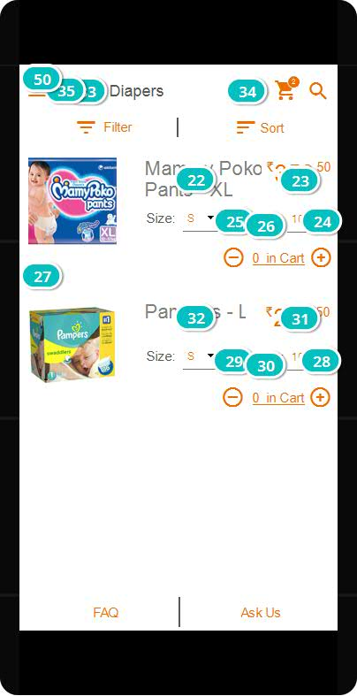

Interactions

22 | on Click: delays 250ms  on Focus In: shows 'Line_4' with effect: slide left and easing: linear in 200ms  on Focus Out: hides 'Line_4'
23 | on Click: delays 250ms  on Focus In: shows 'Line_6' with effect: slide left and easing: linear in 200ms  on Focus Out: hides 'Line_6'
24 | on Click: sets value '(noOfItems + addition)' to variable 'noOfItems' When (noOfItems > zero) shows 'counter' sets value 'noOfItems' to 'quantity' sets value 'noOfItems' to 'counter'
25 | on Click: When (noOfItems > zero) sets value '(noOfItems - addition)' to variable 'noOfItems' When (noOfItems = zero) hides 'counter' sets value 'noOfItems' to 'counter' sets value 'noOfItems' to 'quantity'
26 | on Page Load: sets value 'noOfItems' to 'quantity'
27 | on Click: goes to 'Product' with effect: slide left
28 | on Click: sets value '(noOfItems + addition)' to variable 'noOfItems' When (noOfItems > zero) shows 'counter' sets value 'noOfItems' to 'quantity_1' sets value 'noOfItems' to 'counter'
29 | on Click: When (noOfItems > zero) sets value '(noOfItems - addition)' to variable 'noOfItems' When (noOfItems = zero) hides 'counter' sets value 'noOfItems' to 'counter' sets value 'noOfItems' to 'quantity_1'
30 | on Page Load: sets value 'noOfItems' to 'quantity_1'
31 | on Click: delays 250ms  on Focus In: shows 'Line_10' with effect: slide left and easing: linear in 200ms  on Focus Out: hides 'Line_10'
32 | on Click: delays 250ms  on Focus In: shows 'Line_8' with effect: slide left and easing: linear in 200ms  on Focus Out: hides 'Line_8'
33 | on Toggle: shows 'Filter' hides 'Filter'
34 | on Click: shows 'Sorting'
35 | on Click: goes to 'SubCategDiapers' with effect: slide right
50 | on Page Load: sets value 'Diapers' to variable 'titleBar'

02. Screens / Wireframes_new
Product
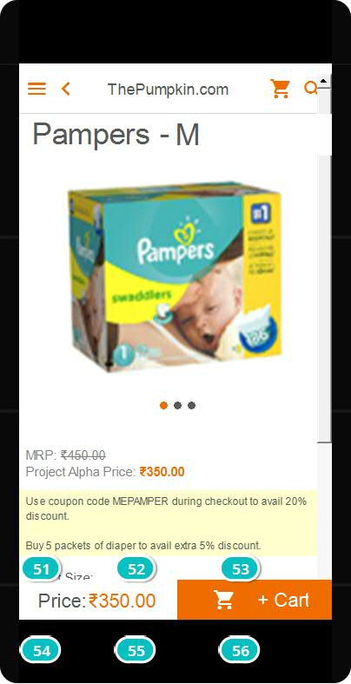

Interactions

51 | on Click: changes style of 'Label_6': Text changes style of 'Label_7': Text changes style of 'Label_8': Text moves 'Line_7' to x: 0px, y: 47px with easing: linear in 200ms sets value 'M' to 'diaperSize'  on Page Load: changes style of 'Label_6': Text
52 | on Click: changes style of 'Label_6': Text changes style of 'Label_7': Text changes style of 'Label_8': Text moves 'Line_7' to x: 120px, y: 47px with easing: linear in 200ms sets value 'L' to 'diaperSize'
53 | on Click: changes style of 'Label_7': Text changes style of 'Label_6': Text changes style of 'Label_8': Text moves 'Line_7' to x: 240px, y: 47px with easing: linear in 200ms sets value 'XL' to 'diaperSize'
54 | on Click: changes style of 'Label_9': Text changes style of 'Label_10': Text changes style of 'Label_11': Text moves 'Line_8' to x: 0px, y: 47px with easing: linear in 200ms  on Page Load: changes style of 'Label_9': Text
55 | on Click: changes style of 'Label_9': Text changes style of 'Label_10': Text changes style of 'Label_11': Text moves 'Line_8' to x: 120px, y: 47px with easing: linear in 200ms
56 | on Click: changes style of 'Label_10': Text changes style of 'Label_9': Text changes style of 'Label_11': Text moves 'Line_8' to x: 240px, y: 47px with easing: linear in 200ms

02. Screens / Wireframes_new
SubCategFeeding
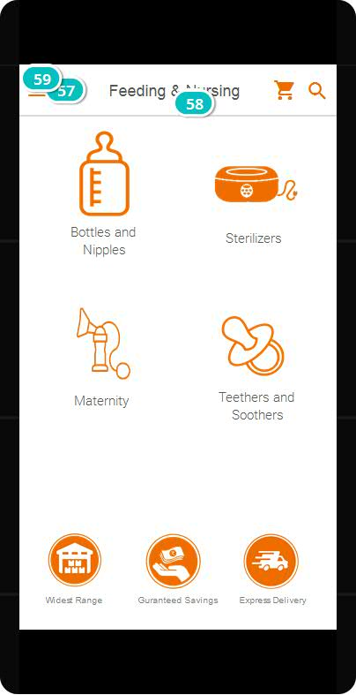

Interactions

57 | on Click: goes to 'SubCategFeeding' with effect: slide right
58 | on Click: goes to 'ProductSter' with effect: slide left
59 | on Page Load: sets value 'Feeding & Nursing' to variable 'titleBar'  on Swipe Right: goes to 'SubCategDiapers' with effect: slide right

02. Screens / Wireframes_new
ProductSter
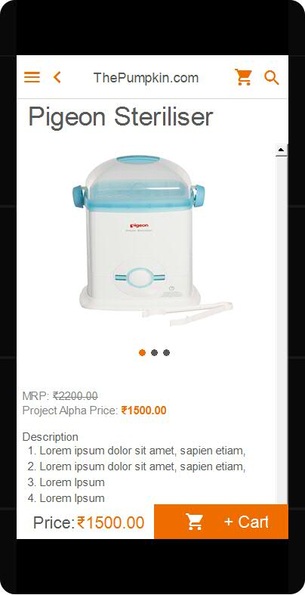

02. Screens / Wireframes_new
cart
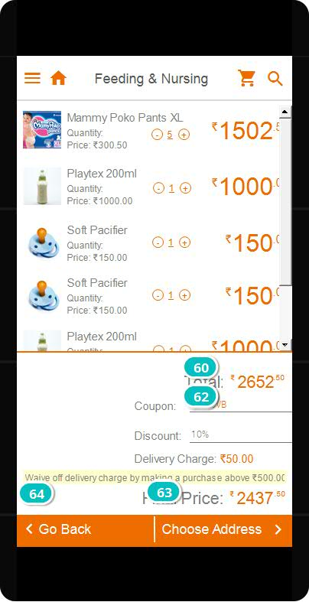

Interactions

60 | on Focus In: shows 'Line_6' with effect: slide left and easing: linear in 200ms changes style of 'Input_2': Text When (Input_2.value = 'Type something') sets value '' to 'Input_2'  on Focus Out: When (Input_2.value = '') sets value 'Type something' to 'Input_2' hides 'Line_6' changes style of 'Input_2': Text
61 | on Focus In: shows 'Line_10' with effect: slide left and easing: linear in 200ms changes style of 'Input_5': Text  on Focus Out: When (Input_5.value = '') moves 'Group_11' by x: 0px, y: 26px with easing: swing in 500ms changes style of 'Label_5': Text hides 'Rectangle_5' hides 'Line_10' changes style of 'Input_5': Text
62 | on Click: When (Input_5.value = '') focus on 'Input_5' changes style of 'Label_5': Text moves 'Group_11' by x: 0px, y: -26px with easing: swing in 500ms shows 'Rectangle_5'
63 | on Click: goes to 'address' with effect: slide left
64 | on Click: goes to 'Product' with effect: slide right

02. Screens / Wireframes_new
search
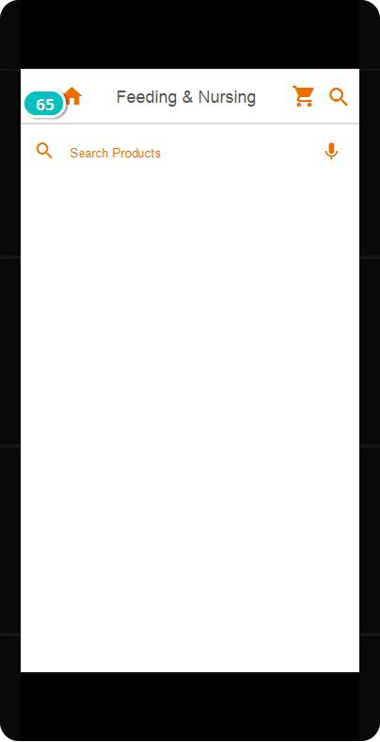

Interactions

65 | on Toggle: shows 'Keyboard-light' with effect: slide down in 500ms

02. Screens / search
Other states
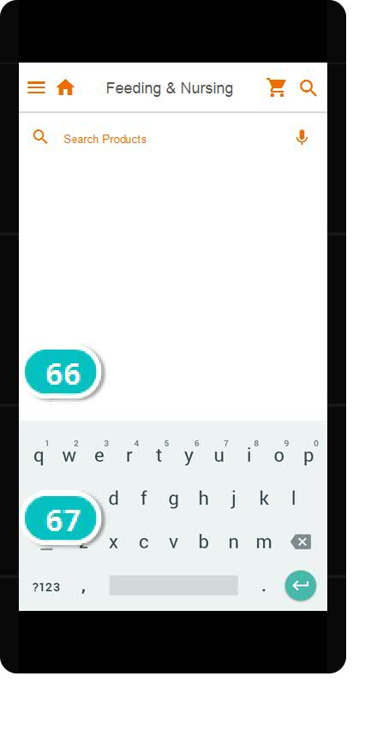 | Interactions
  66 | on Toggle: shows 'Dynamic_Panel_1' with effect: slide up in 500ms sets value 'Bottles' to 'Rectangle_8'
  67 | on Click: sets active panel 'keyboard_numbers_3'
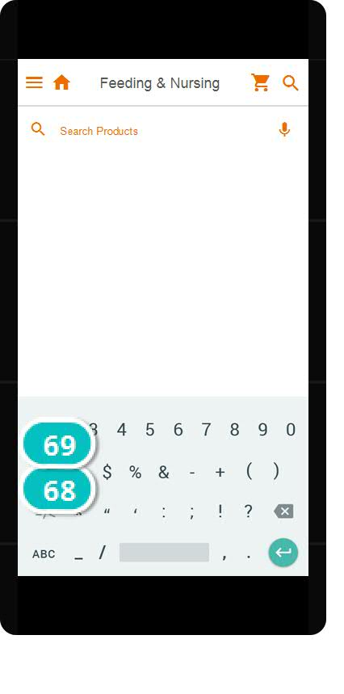 | Interactions
  68 | on Click: sets active panel 'keyboard_letters_3'
  69 | on Click: sets active panel 'keyboard_symbols_3'
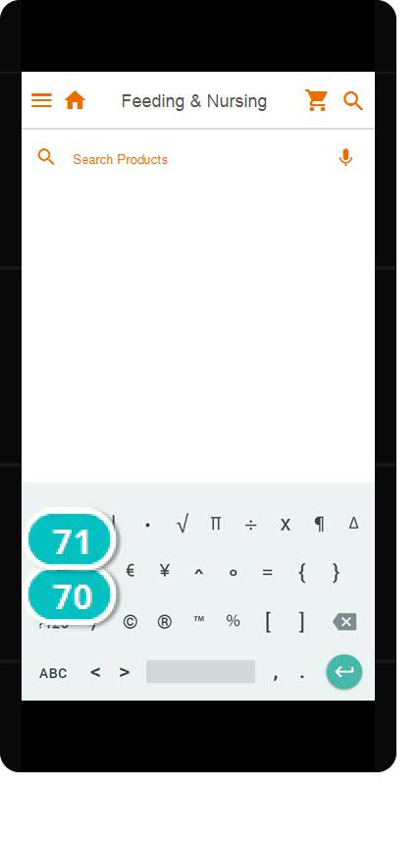 | Interactions
  70 | on Click: sets active panel 'keyboard_letters_3'
  71 | on Click: sets active panel 'keyboard_numbers_3'
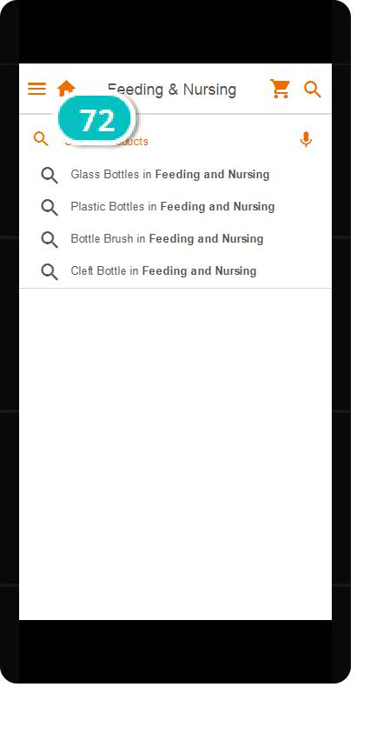 | Interactions
  72 | on Click: goes to 'Diapers' with effect: slide left

02. Screens / Wireframes_new
address
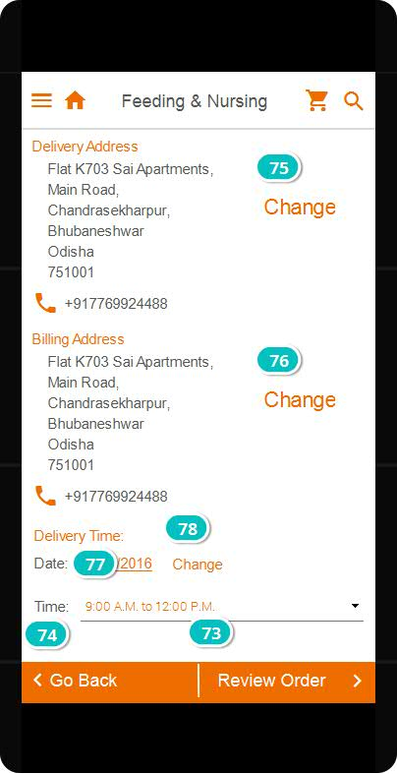

Interactions

73 | on Click: goes to 'review' with effect: slide left
74 | on Click: goes to 'cart' with effect: slide right
75 | on Click: shows 'Mask' shows 'AddressChange'
76 | on Click: shows 'Mask' shows 'AddressChange'
77 | on Click: delays 250ms  on Focus In: shows 'Line_2' with effect: slide left and easing: linear in 200ms  on Focus Out: hides 'Line_2'
78 | on Click: shows 'Date' shows 'Mask'

02. Screens / Wireframes_new
payment
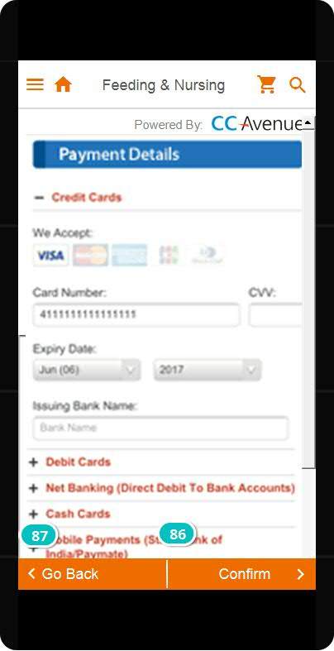

Interactions

86 | on Click: goes to 'Confirmation' with effect: slide left
87 | on Click: goes to 'review' with effect: slide right

02. Screens / Wireframes_new
review
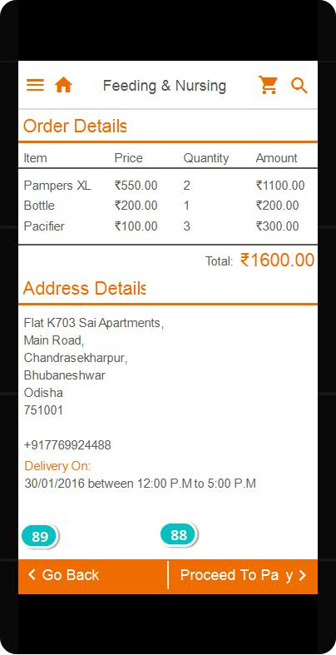

Interactions

88 | on Click: goes to 'payment' with effect: slide left
89 | on Click: goes to 'address' with effect: slide right

02. Screens / Wireframes_new
Confirmation
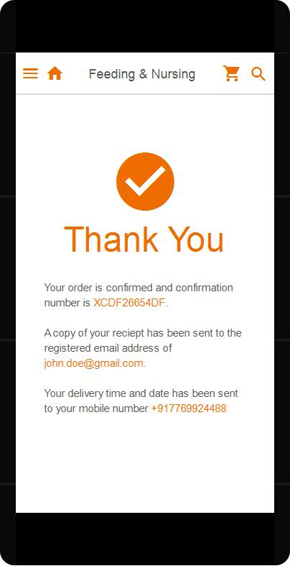

02. Screens / Wireframes_new
AllProducts
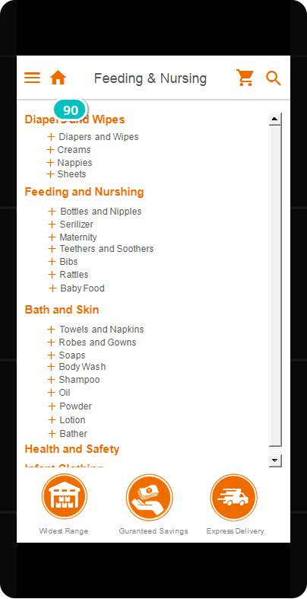

Interactions

90 | on Toggle: moves 'Group_2' to x: 0px, y: 80px with easing: linear in 500ms shows 'Group_1'

Templates

03. Templates / Wireframes_new
Deeper Pages
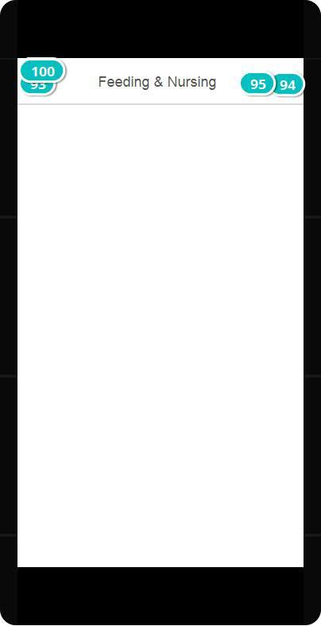

Interactions

92 | on Scroll: moves 'Dynamic_Panel_1' to x: 0px, y: 'windowScrollY'
93 | on Click: shows 'Menu' with effect: slide left in 500ms
94 | on Click: goes to 'search' with effect: slide left
95 | on Click: goes to 'cart' with effect: slide left
96 | on Swipe Left: hides 'Menu' with effect: slide left in 500ms  on Scroll: moves 'Menu' to x: 0px, y: 'windowScrollY'
100 | on Page Load: sets value 'titleBar' to 'innerTitleText'

03. Templates / Splash
Other states
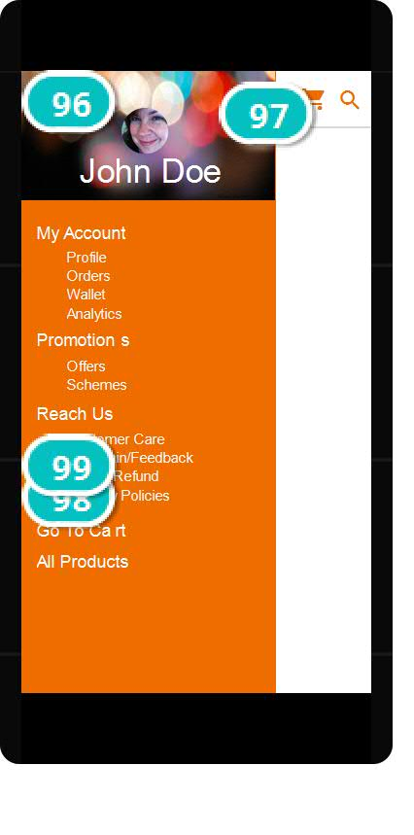 | Interactions
  96 | on Swipe Left: hides 'Menu' with effect: slide left in 500ms  on Scroll: moves 'Menu' to x: 0px, y: 'windowScrollY'
  97 | on Click: goes to 'launch' with effect: slide right
  98 | on Click: goes to 'AllProducts' with effect: slide left
  99 | on Click: goes to 'cart' with effect: slide left

03. Templates / Wireframes_new
Guest
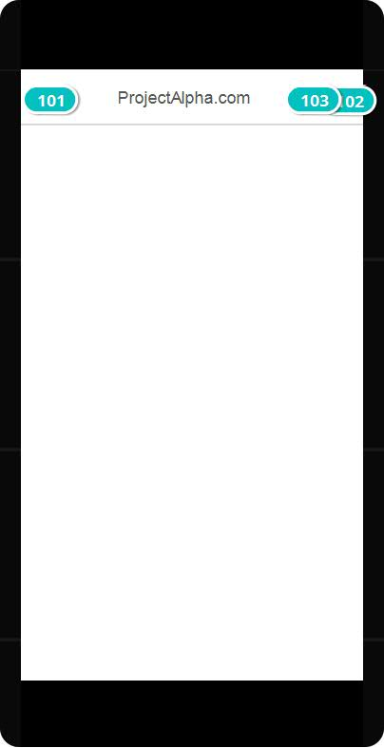

Interactions

101 | on Click: shows 'Menu' with effect: slide left in 500ms
102 | on Click: goes to 'search' with effect: slide left
103 | on Click: goes to 'cart' with effect: slide left

03. Templates / Wireframes_new
Inner Pages
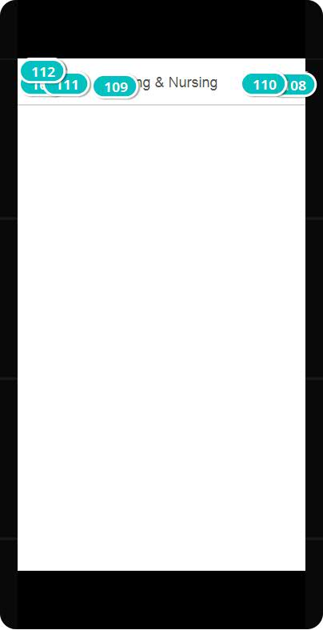

Interactions

106 | on Scroll: moves 'Dynamic_Panel_1' to x: 0px, y: 'windowScrollY'
107 | on Click: shows 'Menu' with effect: slide left in 500ms
108 | on Click: goes to 'search' with effect: slide left
109 | on Page Load: sets value 'titleBar' to 'titleBar'
110 | on Click: goes to 'cart' with effect: slide left
111 | on Click: goes to 'Main' with effect: slide right
112 | on Swipe Left: hides 'Menu' with effect: slide left in 500ms  on Scroll: moves 'Menu' to x: 0px, y: 'windowScrollY'

03. Templates / Splash
Other states
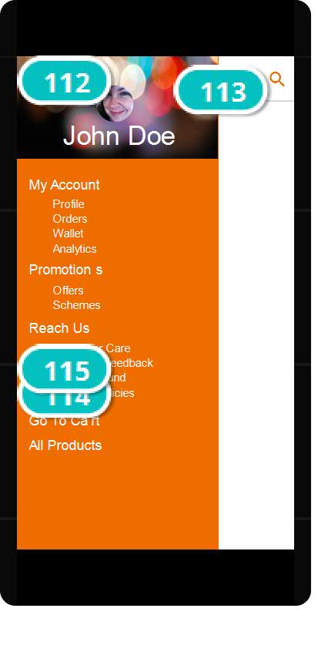 | Interactions
  112 | on Swipe Left: hides 'Menu' with effect: slide left in 500ms  on Scroll: moves 'Menu' to x: 0px, y: 'windowScrollY'
  113 | on Click: goes to 'launch' with effect: slide right
  114 | on Click: goes to 'AllProducts' with effect: slide left
  115 | on Click: goes to 'cart' with effect: slide left

03. Templates / Wireframes_new
Launch
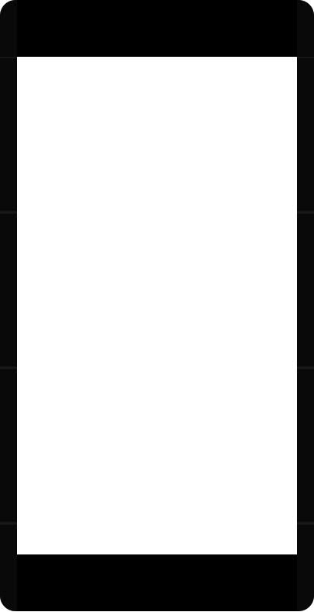

03. Templates / Wireframes_new
Main Pages
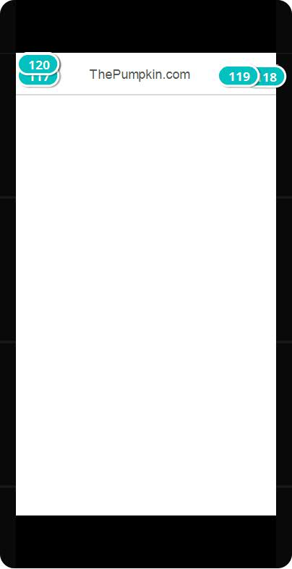

Interactions

116 | on Scroll: moves 'TopBar' to x: 0px, y: 'windowScrollY'
117 | on Click: shows 'Menu' with effect: slide left in 500ms
118 | on Click: goes to 'search' with effect: slide left
119 | on Click: goes to 'cart' with effect: slide left
120 | on Swipe Left: hides 'Menu' with effect: slide left in 500ms  on Scroll: moves 'Menu' to x: 0px, y: 'windowScrollY'

03. Templates / Splash
Other states
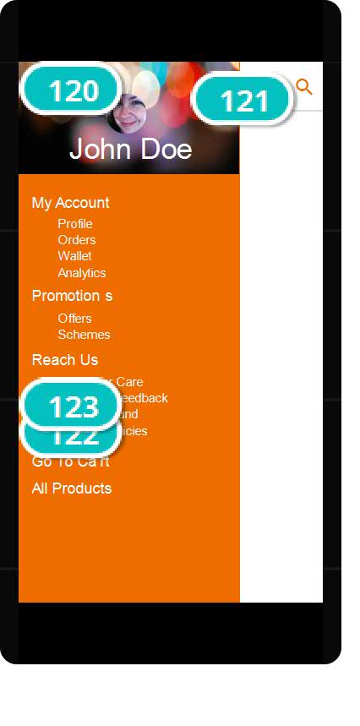 | Interactions
  120 | on Swipe Left: hides 'Menu' with effect: slide left in 500ms  on Scroll: moves 'Menu' to x: 0px, y: 'windowScrollY'
  121 | on Click: goes to 'launch' with effect: slide right
  122 | on Click: goes to 'AllProducts' with effect: slide left
  123 | on Click: goes to 'cart' with effect: slide left

03. Templates / Wireframes_new
Product Page
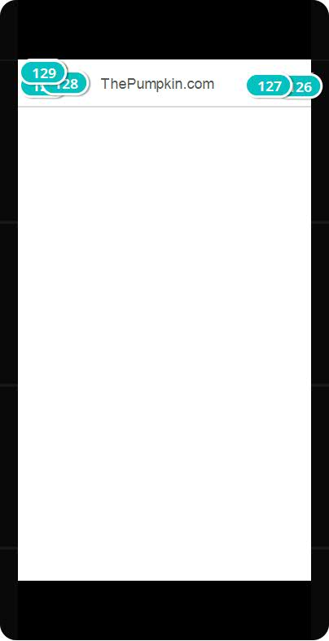

Interactions

124 | on Scroll: moves 'Dynamic_Panel_1' to x: 0px, y: 'windowScrollY'
125 | on Click: shows 'Menu' with effect: slide left in 500ms
126 | on Click: goes to 'search' with effect: slide left
127 | on Click: goes to 'cart' with effect: slide left
128 | on Click: goes to 'Diapers' with effect: slide right
129 | on Swipe Left: hides 'Menu' with effect: slide left in 500ms  on Scroll: moves 'Menu' to x: 0px, y: 'windowScrollY'

03. Templates / Splash
Other states
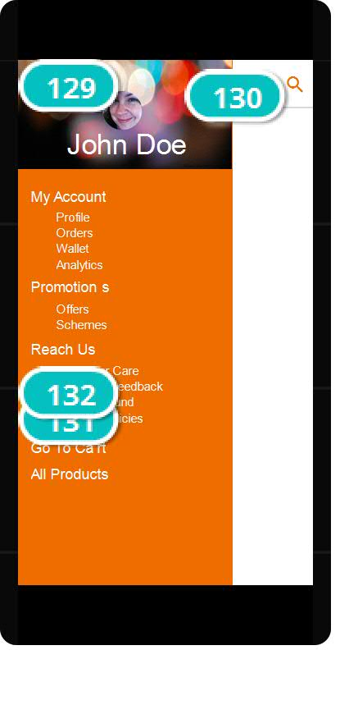 | Interactions
  129 | on Swipe Left: hides 'Menu' with effect: slide left in 500ms  on Scroll: moves 'Menu' to x: 0px, y: 'windowScrollY'
  130 | on Click: goes to 'launch' with effect: slide right
  131 | on Click: goes to 'AllProducts' with effect: slide left
  132 | on Click: goes to 'cart' with effect: slide left

