Data Analytics Capstone

Developing an Evaluation Methodology to Assess Accuracy, Groundedness, and Operational Value of Retrieval-Augmented Generation (RAG) as a Decision-Support System for Consumer Payment Disputes

Final Report

Deepak Dharani
Walsh College
QM640: Data Analytics Capstone
Instructor: Javad Katibai
Mentor: Jainesh Garg
Term 3, Group 3
[Submission date, e.g., November 24, 2026]

Abstract
[ABSTRACT, write last, ONE paragraph of 300-350 words (rubric 37 pts). Must state: the problem (5); the approach (5); data context with N = 225 complaints, unit = the complaint, window September 18, 2024 to August 11, 2026 (8); technology incl. CPU/GPU, e.g. the sentence in outputs/final/environment.json (4); concrete results with numbers from Table 11 and the best model (8); implementation / deployment (3). Run check_final.py to verify word count and single paragraph.]
Note. Technology sentence for the abstract: Retrieval (embedding, BM25 and cross-encoder re-ranking) and all analysis ran on one Apple M3 Pro CPU (11 logical cores, 18.0 GB RAM; Apple GPU (MPS) available) under Darwin 25.6.0 with Python 3.13.2; the language model ran on the provider's hosted infrastructure through its API.

GitHub Repository
Data files, code, configurations and outputs: https://github.com/deepakdm/QM640 ([release tag, e.g., final-v1]). The storage layout and access methods are described under Database Setup and Data Access.

Table of Contents
(Right-click and choose Update Field to build the table of contents.)

Developing an Evaluation Methodology to Assess Accuracy, Groundedness, and Operational Value of Retrieval-Augmented Generation (RAG) as a Decision-Support System for Consumer Payment Disputes

Introduction

Background and Context
[Carry over the three Background paragraphs from the interim report (domain context in 2-4 paragraphs, 6 pts). Keep the Regulation E deadlines, the 2025 CFPB complaint volumes and the legal-hallucination evidence; define every abbreviation at first use (RAG, LLM, CFPB, ATM).]

Problem Statement
[Carry over the interim Problem Statement (one focused paragraph); add one sentence that the final report tests the method on a locked, quarter-stratified test set.]

Variables, Unit of Analysis and Success Metrics
The dependent variables (Y) are the outcomes of each complaint under each condition: whether the determination equals the gold determination (primary, binary), whether a cited section is absent from the regulation (fabricated citation, binary), whether a governing clause is cited (binary), run-to-run consistency (binary), response time (seconds) and the failure category of an incorrect determination (nominal). The independent variable (X) is the retrieval condition, a four-level experimental factor: no retrieval (C0), dense retrieval with 512-token passages (A), dense retrieval with 256-token passages (B) and hybrid lexical-plus-dense retrieval with re-ranking (C). Case factors (dispute type, narrative length, ambiguity) and the mechanism variable clause in context enter the driver model for RQ3. The unit of analysis is the complaint; the timeframe is complaints received by the Consumer Financial Protection Bureau (CFPB) from September 18, 2024 to August 11, 2026. Table 1 lists the variables and the success metrics fixed before scoring.
Table 1
Variables and Success Metrics
Role | Variable | Type | Success metric (benchmark)
Y, primary | Determination correct | Binary | Gain over C0 of at least 15 points, Holm p < .05
Y | Fabricated citation | Binary | Upper 95% Wilson bound at most 5%
Y | Correct clause cited | Binary | Higher than C0, Holm p < .05
Y | Consistent across 3 runs | Binary | At least 90% of complaints
Y | Response time | Continuous (s) | 95th percentile at most 30 s
Y | Accuracy vs break-even | Proportion | Above modeled break-even accuracy
X | Retrieval condition | Categorical (4) | Experimental factor
Covariates | Dispute type, log length, ambiguity | Categorical / continuous / binary | RQ3 drivers
Mediator | Clause in context | Binary | RQ3 mechanism
Note. Benchmarks were fixed before any output was scored (interim Table 23).

Stakeholder Value
[Explain stakeholder value (3 pts): consumers (faster, correct provisional credit), investigators (drafted, cited determinations against the statutory clock), compliance and model-risk teams (an evidence-based adoption rule and audit trail), examiners (traceable citations).]

Study Pipeline
Figure 1 shows the end-to-end pipeline in six stages: data, preprocessing, exploratory data analysis, feature engineering, model and deployment, with the storage layer beneath them. Box colour marks who performs each step, so the figure also shows where people review the work.
Figure 1
End-to-End Pipeline From Complaint Archive to Deployment
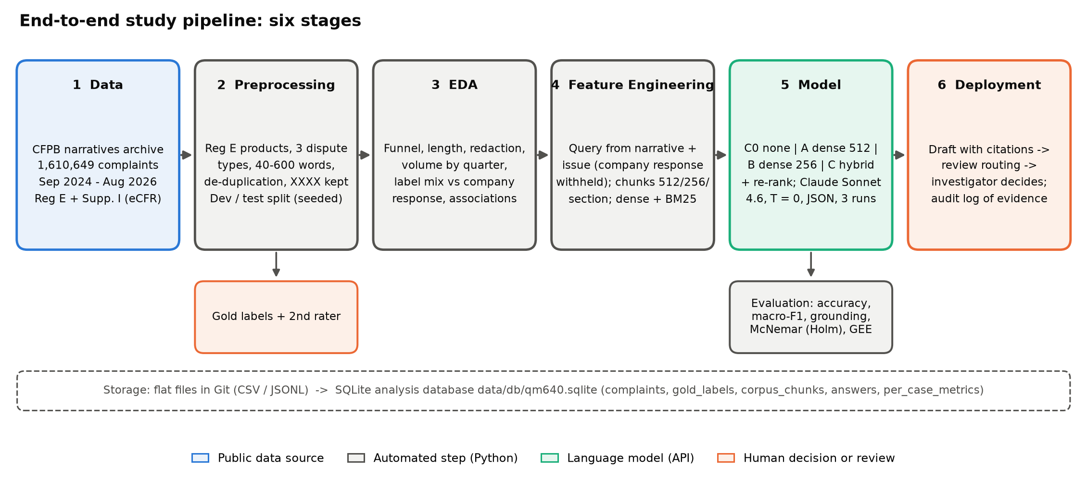
Note. EDA = exploratory data analysis; BM25 = Best Match 25 lexical ranking; T = temperature.

Research Questions and Hypotheses
Four research questions organize the study. Each is tested at the 5% significance level (α = .05); comparisons with the baseline are Holm-corrected over the three retrieval conditions. Table 2 states each question with its null (H₀) and alternative (Hₐ) hypotheses and test.
Table 2
Research Questions, Hypotheses and Tests
RQ | Question | H₀ and Hₐ | Test
RQ1 | To what extent does retrieval improve determination accuracy over the same LLM without retrieval? | H1₀: p(correct | retrieval k) = p(correct | C0); H1ₐ: they differ | Exact McNemar × 3, Holm; Cochran's Q
RQ2 | Does retrieval reduce fabricated citations and increase citation of the governing clause? | H2₀: fabricated and correct-clause rates equal C0's; H2ₐ: they differ | Exact McNemar × 3 per outcome, Holm
RQ3 | Which system and case factors explain a correct determination, and does the clause in context mediate the effect? | H3₀: OR(clause in context) = 1; H3ₐ: OR ≠ 1 | GEE logistic regression, clustered by complaint
RQ4 | Does Config C meet the adoption benchmarks, and which failure mode dominates? | H4₀: dominant failure share ≤ .20; H4ₐ: share > .20 | One-sided exact binomial; interval benchmarks
Note. OR = odds ratio; GEE = generalized estimating equations.

Literature Review

Search Approach
[Carry over the interim Search Approach; add the search for deep-learning retrieval and agentic/LLM work and the date of the final search.]

Literature Matrix
Table 3 compares the sources by author, domain, dataset, method, findings and the research question each one informs, and the decision it supports in this study.
Table 3
Literature Matrix
Author | Domain | Dataset | Method | Findings | RQ Linkage
Lewis et al. (2020) | Open-domain NLP | NQ, TriviaQA, FEVER; Wikipedia | Dense retriever + seq2seq generator (DL) | Retrieval beat parametric-only models | RQ1: defines RAG and the no-retrieval baseline C0
Karpukhin et al. (2020) | Open-domain QA | Five QA benchmarks | Dual-encoder dense retrieval (DL) | Beat BM25 by 9-19 points top-20 | RQ3: dense retriever of A and B
Robertson & Zaragoza (2009) | Information retrieval | Theory and review | BM25 probabilistic relevance | Robust lexical matching | RQ3: lexical half of C; section numbers
Nogueira & Cho (2019) | Passage ranking | MS MARCO, TREC-CAR | BERT cross-encoder re-ranking (DL) | 27% relative MRR@10 gain | RQ3: re-ranking step of C
Shuster et al. (2021) | Dialogue | Wizard of Wikipedia, CMU_DoG | Retrieval-augmented dialogue (DL) | Retrieval reduced hallucination | RQ2: direction of hypothesis
Y. Gao et al. (2023) | RAG survey | Literature to 2023 | Taxonomy of RAG | Chunking, hybrid, re-ranking are main levers | RQ3: choice of configuration factors
Liu et al. (2024) | Long-context LLMs | Multi-document QA | Vary context position and size | Mid-context evidence is lost | RQ1, RQ3: context budget of B; two-sided tests
Barnett et al. (2024) | RAG engineering | Three deployed systems | Case studies | Seven failure points | RQ4: failure taxonomy
T. Gao et al. (2023) | Cited generation | ALCE benchmark | Citation recall and precision | Half of citations unsupported on ELI5 | RQ2: citation-level measures
Es et al. (2024) | RAG evaluation | WikiEval | LLM-prompted metrics (RAGAS) | Tracked human judgments | RQ2: secondary judged support
Saad-Falcon et al. (2024) | RAG evaluation | KILT, SuperGLUE, AIS | Fine-tuned LM judges + PPI | Few hundred labels calibrate a judge | RQ2: judge validation design
Zheng et al. (2023) | LLM-as-a-judge | MT-Bench, Chatbot Arena | GPT-4 judge vs humans | >80% agreement, known biases | RQ2: judge kept secondary
Dahl et al. (2024) | Legal LLMs | U.S. federal case questions | Hallucination profiling | 58-88% hallucination | RQ2: motivation
Magesh et al. (2025) | Legal RAG tools | 200+ pre-registered queries | Commercial RAG vs GPT-4 | 17-33% hallucination; ~65% accuracy | RQ1, RQ2: planning values for sample size
Islam et al. (2023) | Financial QA | FinanceBench | 16 configurations, manual review | 81% failed or refused | RQ1, RQ3: retrieval design decides finance outcomes
Yao et al. (2023) | Agentic LLMs | HotpotQA, FEVER, ALFWorld, WebShop | Interleaved reasoning and tool actions (ReAct prompting) | Wikipedia look-ups reduced hallucination vs chain-of-thought; +34 and +10 points success on ALFWorld, WebShop | RQ4, future scope: agentic retrieval vs this study's single-pass drafting
Asai et al. (2024) | RAG with self-reflection | Open-domain QA, reasoning, fact verification, long-form generation | LM trained to retrieve on demand and critique its output with reflection tokens (DL, 7B/13B) | Beat ChatGPT and retrieval-augmented Llama2-chat; better factuality and citation accuracy | RQ2, RQ3: adaptive retrieval vs fixed top-k; citation quality
Note. DL = deep learning; QA = question answering; MRR = mean reciprocal rank; PPI = prediction-powered inference.

Synthesis of Prior Work
[Carry over the four interim synthesis paragraphs (3-6 paragraphs, 6 pts). Add one sentence each on the deep-learning basis of dense retrieval and cross-encoders (3 pts) and on agentic/LLM work (3 pts). End each paragraph with how the sources shaped a project decision (5 pts).]

Research Gap
[Carry over the interim Research Gap and Table 5 (coverage of pillars).]

Data

Data Source and Acquisition
The cases are complaints from the CFPB Consumer Complaint Database (https://www.consumerfinance.gov/data-research/consumer-complaints/). Because the CFPB stopped publishing narratives on August 14, 2026, the narratives were obtained from the CFPB narratives archive in its Freedom of Information Act reading room (files CCDB_Export_7 to CCDB_Export_21), merged by scripts/00a_build_from_archive.py into data/raw/cfpb/complaints.csv.gz. The regulatory corpus is Regulation E (12 C.F.R. Part 1005) and its Supplement I, downloaded as XML from the Electronic Code of Federal Regulations (https://www.ecfr.gov/current/title-12/chapter-X/part-1005) and converted by scripts/00b_build_corpus.py with section markers preserved. No scraping was required. Figure 2 shows sampled complaints as they appear in the data.
Figure 2
Preview of Sampled Complaints
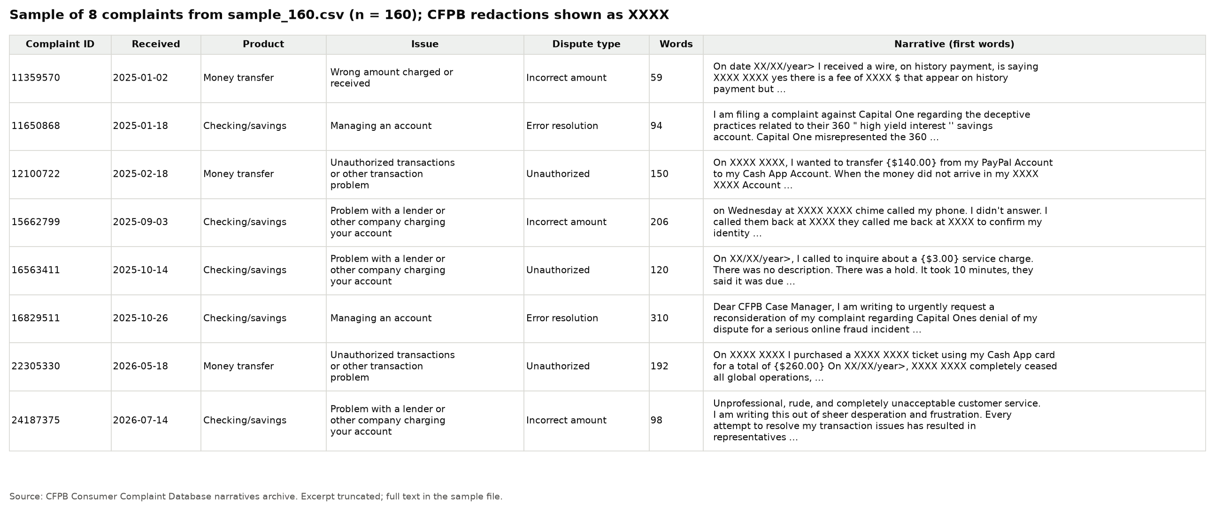
Note. Eight complaints from the development sample, at least two per dispute type, chosen with a fixed seed.

Inclusion and Exclusion Criteria
Table 4
Inclusion and Exclusion Criteria
Criterion | Included | Excluded | Reason
Narrative | Published consumer narrative | No narrative | Narrative is the model input
Window | Received Sep 18, 2024 to Aug 11, 2026 | Outside window | Archive coverage
Product | Checking or savings; prepaid card; money transfer, virtual currency or money service | All other products (mortgage, credit reporting, credit cards) | Governed by Regulation E
Dispute type | Unauthorized transaction; incorrect amount; error resolution | Issues mapping to no dispute type | Must be a payment dispute
Length | 40 to 600 words | Shorter or longer | Decidable facts; predictable prompt size
Duplicates | First occurrence | Repeated IDs; identical narratives | Each case counts once
Rater scope check | Dispute under Regulation E | Found out of scope while labelling | Valid ground truth
Test set only | Not in the pilot | Pilot IDs; narratives identical to a pilot narrative | No leakage from development

Data Dictionary
Table 5 defines every variable used in the analysis.
Table 5
Data Dictionary
Variable | Definition | Data type | Allowed values | Missing values | Notes
[Carry over interim Tables 7 and 8 (8 pts); add split and quarter]

Database Setup
The pipeline stores each stage as flat files (CSV and JSON Lines) under version control, so every intermediate result can be inspected and reproduced. After each stage, scripts/00e_build_db.py loads those files into a single SQLite 3 database, data/db/qm640.sqlite, with the tables in Table 6, foreign keys from labels and answers to complaints, and two analysis views. The database is derived: it is rebuilt from the flat files in under a minute and is never edited by hand.
Table 6
Analysis Database Tables
Table / view | One row per | Key fields
complaints | Sampled complaint (dev and test) | case_id (PK), split, quarter, product, dispute_type, narrative
gold_labels | Labelled complaint | case_id (PK, FK), determination, governing_clauses, ambiguous
corpus_chunks | Passage per chunking strategy | strategy, chunk_id (PK), section_refs, text
answers | Model response | split, config, case_id (FK), run_idx (PK), determination, citations, latency
per_case_metrics | Complaint × condition | determination_correct, fabricated_citation, correct_clause_cited
failure_records | Complaint × condition | failure category
v_outcomes, v_accuracy | View | Metrics joined to complaint and gold fields; rates by split and condition
Note. PK = primary key; FK = foreign key. Schema in src/dispute_rag/db.py.

Data Access
Data are accessed in three ways: the numbered scripts read the flat files directly; analysts query the SQLite database from Python (dispute_rag.db.query) or any SQLite client; and the public GitHub repository provides the raw archive, corpus, samples, labels and outputs. docs/data_access.md gives example queries. The model is accessed through the provider's application programming interface (API) with the key held in a local environment file that is not committed.

Data Splitting
No model is trained, so the split does not separate training from testing data. It separates the complaints used to make method decisions from those used to report results. The 160 sampled pilot complaints (125 labelled in scope) form the development set: the prompt, the clause-matching rule, the secondary analyses and the best-model rule were decided while viewing their results. A new test set of 290 complaints was then drawn by scripts/01c_draw_test_sample.py with seed 2026, stratified by calendar quarter and dispute type, excluding every pilot complaint and every narrative identical to a pilot narrative. Its labels were frozen and the protocol locked by SHA-256 hashes (scripts/02b_lock_protocol.py, docs/preregistration_final.md) before any model output on it existed. Table 7 summarises the two sets; hypothesis decisions use the test set only.
Table 7
Development and Test Sets
Set | Sampling | Drawn | Labelled in scope | Use
Development (pilot) | Seed 42, dispute type | 160 | 125 | Method decisions; development results
Test (locked) | Seed 2026, quarter × dispute type | 290 | 225 | Confirmatory results
Note. Membership and hashes: data/splits/split_manifest.json and protocol_lock.json.

Exploratory Data Analysis
[Carry over the interim EDA text (Tables 9-13); recompute on the test sample and add one sentence per figure on what it shows and which RQ it informs (5 pts understanding, 5 pts visuals).]
Figures 3 to 6 summarise the cleaning funnel (Figure 3), narrative length (Figure 4), dispute-type mix (Figure 5) and gold labels against the company's response (Figure 6).
Figure 3
Complaints Remaining After Each Cleaning Step
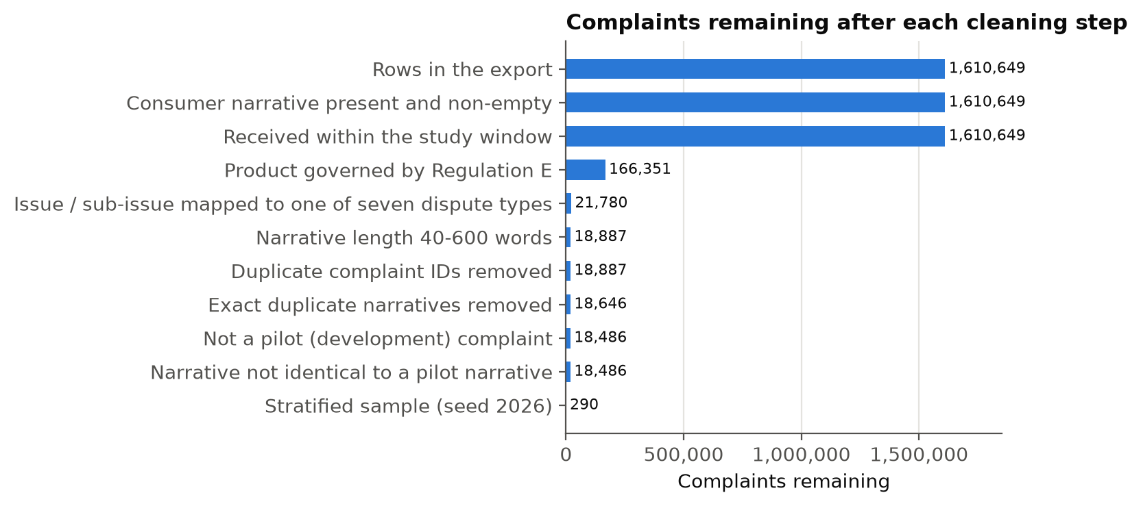

Figure 4
Distribution of Narrative Length (Log Scale)
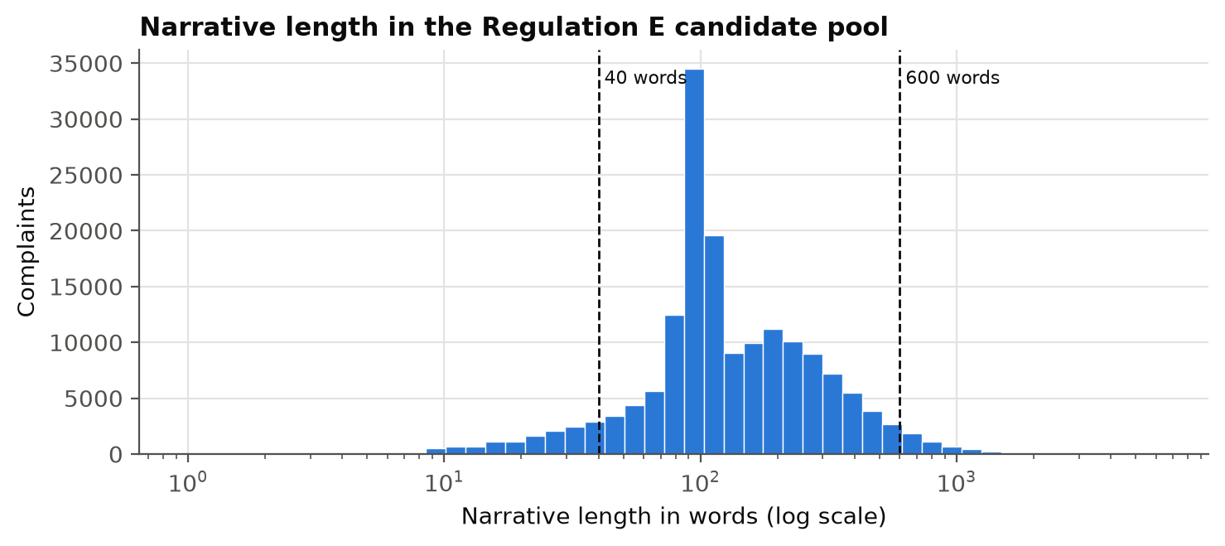

Figure 5
Dispute-Type Mix in the Pool and the Samples
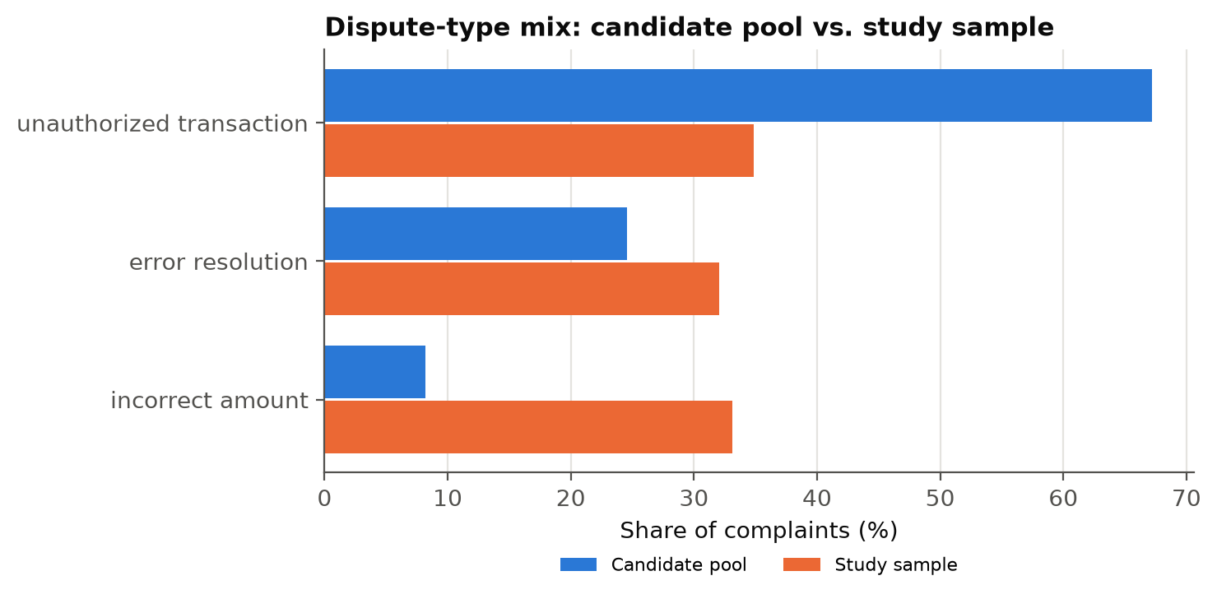

Figure 6
Gold Determination Against the Company's Response
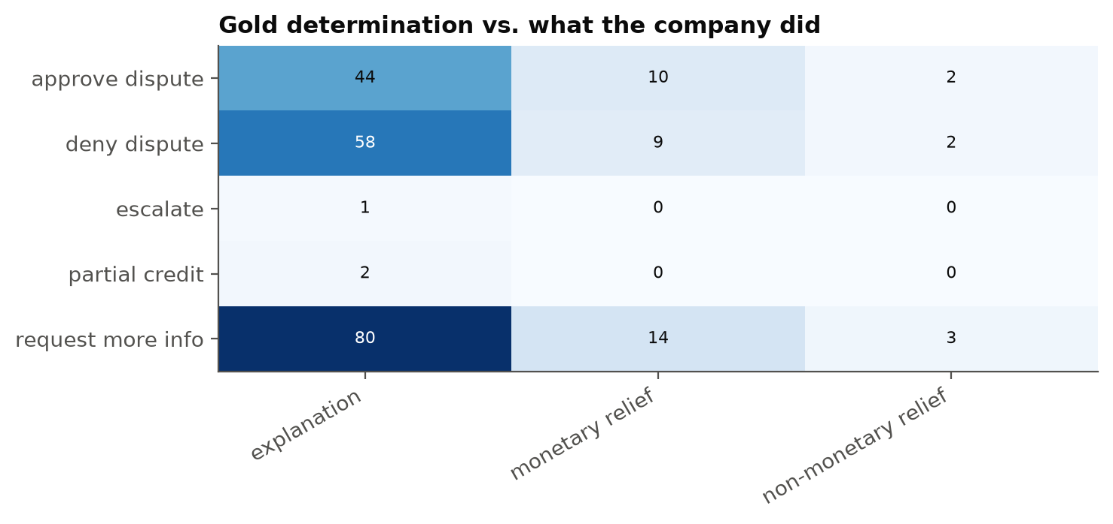

Outcome-Linked Exploratory Analysis
Figures 7 to 10 link case characteristics to model outcomes on the locked test set. Accuracy by narrative-length tercile (cut points 138 and 237 words; Figure 7) differs by length in C0 (χ² p = < .001), A (p = .015) and B (p = .001) but not C (p = .001). Figure 8 compares complaints the rater flagged as ambiguous with the rest, Figure 9 shows how often the governing clause reached the model by dispute type, and Figure 10 shows how often each condition answered escalate for each gold determination. [Interpret (EDA insights): what each pattern means for RQ1-RQ4; descriptive only, not causal; the GEE model is the confirmatory test.]
Figure 7
Accuracy by Narrative-Length Tercile
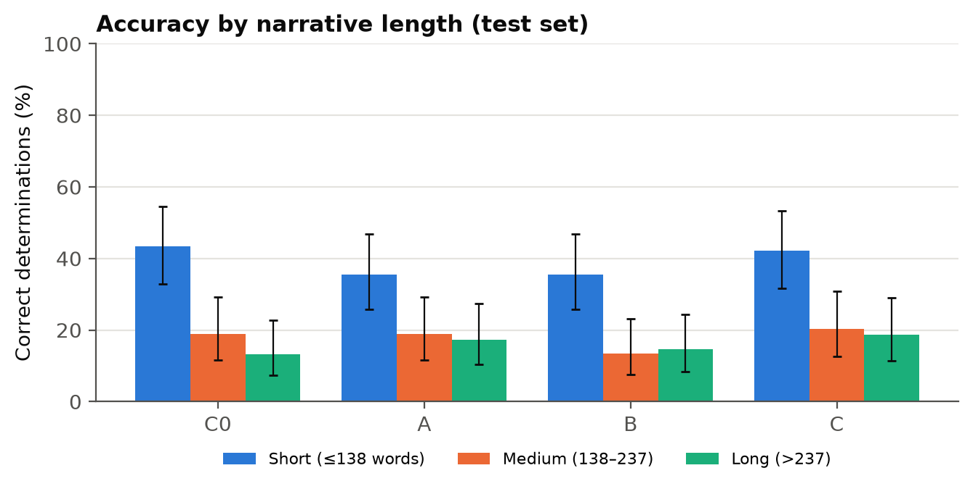
Note. First of three runs; bars show 95% Wilson intervals.
Figure 8
Accuracy by Rater-Flagged Ambiguity
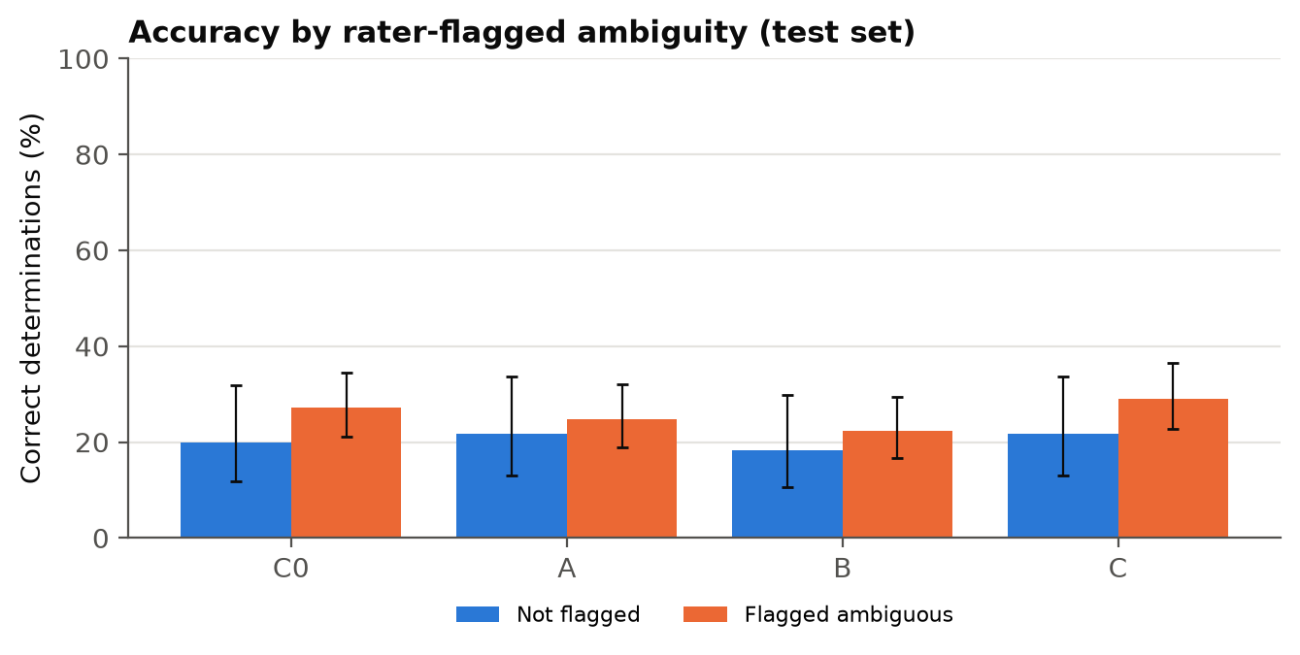
Note. First of three runs; bars show 95% Wilson intervals.
Figure 9
Governing Clause in Retrieved Context by Dispute Type
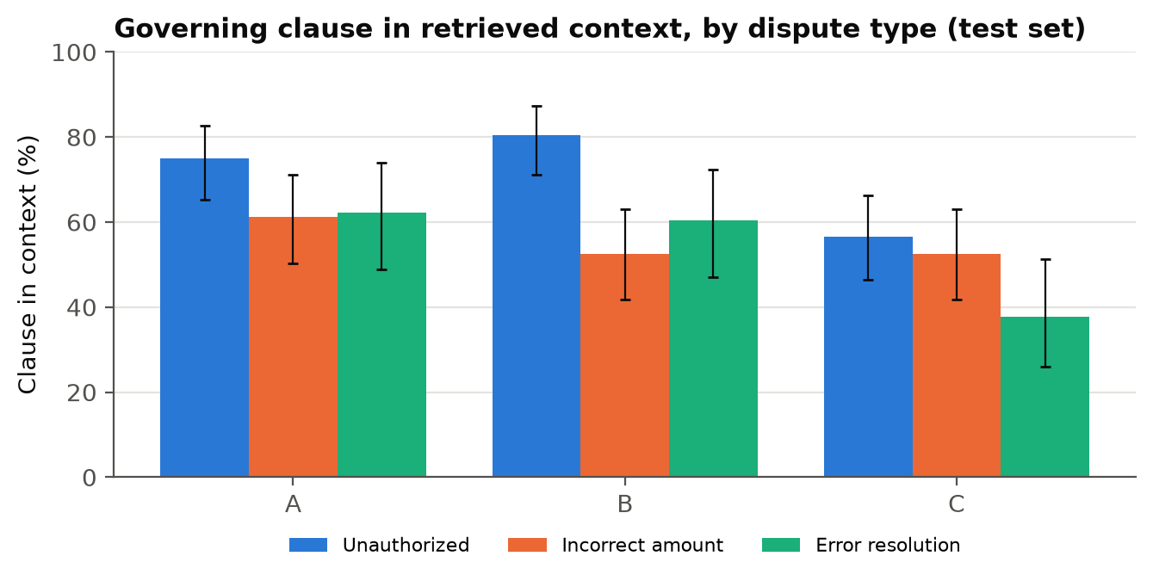
Note. First of three runs; bars show 95% Wilson intervals.
Figure 10
Share Answered Escalate by Gold Determination
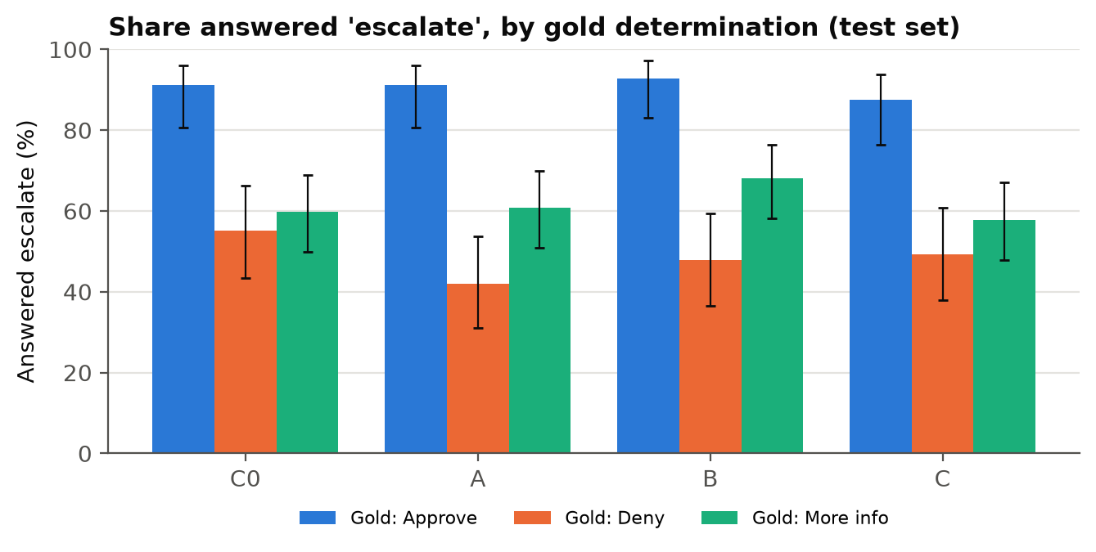
Note. First of three runs; bars show 95% Wilson intervals.

Sample Size
RQ1 and RQ2 compare paired proportions, so the number of complaints follows Connor (1987): n = [z₁₋α/2·√ψ + z₁₋β·√(ψ − δ²)]² / δ², where ψ is the probability that a pair is discordant and δ the smallest important difference. With α = .05/3 for three Holm-corrected comparisons (z = 2.394), power .80 (z = 0.842), ψ = 0.3 and δ = 0.15: n = (2.394 × 0.548 + 0.842 × 0.527)² / 0.0225 = 136.9, rounded up to 137. RQ4 needs 43 errors to estimate a failure share within ±.15 (n = 1.96² × .25 / .15² = 42.7), which at the planning error rate of .30 is 144 complaints, and RQ3 needs 152 after the design effect for three correlated observations per complaint (1 + 2 × .40 = 1.8; Hsieh et al., 1998). The study therefore needed at least 152 labelled complaints. The development set reached 125 (power 0.76); the test set reached 225 (power 0.96), which justifies the volume of data collected relative to the research questions. Table 8 summarises the calculation.
Table 8
Minimum Sample Size by Research Question
RQ | Method | Key parameters | Minimum N
RQ1 | Power, paired proportions (Connor, 1987) | α = .05/3, power = .80, δ = .15, ψ = .30 | 137
RQ2 | Same as RQ1 | Same | 137
RQ3 | Logistic regression (Hsieh et al., 1998) × design effect | P₁ = .55, P₂ = .75, B = .75, ICC = .40, m = 3 | 152
RQ4 | CI for a proportion | z = 1.96, e = .15, p = .50, error rate = .30 | 144
Required | Maximum of the four |  | 152
Achieved | Development / test |  | 125 / 225

Methodology

Data Ingestion
The methodology follows the six stages of Figure 1. Ingestion reads the merged archive in chunks of 200,000 rows (src/dispute_rag/cfpb_cases.py), resolves column names against the CFPB codebook, parses dates and applies the scope filters while streaming, so the 1.6-million-row file never has to fit in memory. Every count is written to selection_report.json. The corpus is ingested from eCFR XML into Markdown with its section markers.

Preprocessing
Preprocessing applies the filters in Table 4 in a fixed order, maps issue and sub-issue to a dispute type by ordered text rules (categorical encoding into three levels), removes duplicate IDs and identical narratives, and draws the stratified samples. Narratives are whitespace-normalized; redaction tokens (XXXX) are kept and the model is told to treat them as unknown facts. Scaling: no numeric scaling is applied to model inputs, because the language model reads text and embeddings are unit-normalized by construction; the only scaled variable is narrative length, which is log-transformed and centred for the driver model. Encoding: dispute type and condition are dummy-coded in the driver model (references: incorrect amount and Config A).

Missing Values
[Carry over the missing-value row of interim Table 10 (6 pts): sub-issue 6.3% blank mapped from issue alone; company public response, tags and state not used; no imputation; unparseable model output scored as incorrect; failed API calls re-run, never scored.]

Outliers
[Carry over the outlier row of interim Table 10 (6 pts): pre-set 40/600-word limits versus the IQR fence of 401 words; why limits were fixed before seeing the data; latency outliers kept and summarised by the 95th percentile.]

Feature Engineering
Table 9 lists the inputs the system receives and the predictors of the driver model.
Table 9
Feature Set and Usage
Feature | Original / engineered | Type | Reason | Used in
[Carry over interim Table 15 and its leakage paragraph]

Model Selection and Justification
[Carry over interim 'Choice of Models with Justification' and 'Generator model selection' (7 pts); keep the alternatives considered and why ROC-AUC is replaced by confusion matrices.]

Model Development
Table 10 gives the settings of the four conditions. [State the prompt version used on the test set (v6 or v7, from docs/preregistration_final.md) and the pre-run fixes.]
Table 10
Experimental Conditions and Settings
Setting | C0 | A | B | C
[Carry over interim Table 14]

Results
Results tables show the locked test set unless they say otherwise. Development and test results are shown side by side in Table 13.

Performance Comparison
Table 11 compares the four conditions on every pillar, Figure 11 shows accuracy and macro-F1 against the majority-class baseline, and Figure 12 gives the confusion matrices.
Table 11
Model Performance Comparison (locked test set)
Condition | n | Accuracy [95% CI] | Macro-F1 | Fabricated | Correct clause | Clause in context | Consistent | p95 s
C0 | 225 | 25.3% [20.1, 31.4] | 0.192 | 0.0% | 48.0% | — | 95.1% | 10.3
A | 225 | 24.0% [18.9, 30.0] | 0.187 | 4.4% | 23.6% | 67.1% | 96.9% | 13.0
B | 225 | 21.3% [16.5, 27.1] | 0.176 | 0.4% | 24.4% | 65.8% | 96.4% | 12.0
C | 225 | 27.1% [21.7, 33.3] | 0.214 | 6.2% | 35.1% | 50.7% | 93.3% | 12.5
Majority class (request more info) | 225 | 43.1% | — | — | — | — | — | —
Note. Accuracy and citation rates use the first of three runs; consistency uses all three. CI = Wilson interval; p95 = 95th-percentile response time. Source: outputs/final/<split>/condition_summary.csv.
Figure 11
Accuracy and Macro-F1 by Condition
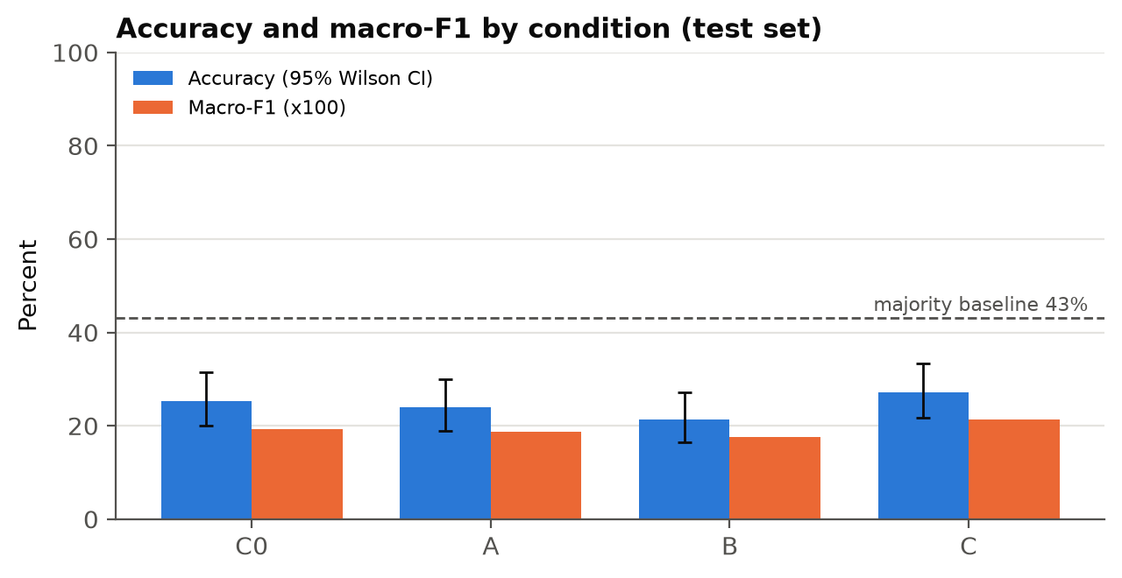
Note. The dashed line is the accuracy of always predicting the most common gold label.
Figure 12
Confusion Matrices by Condition
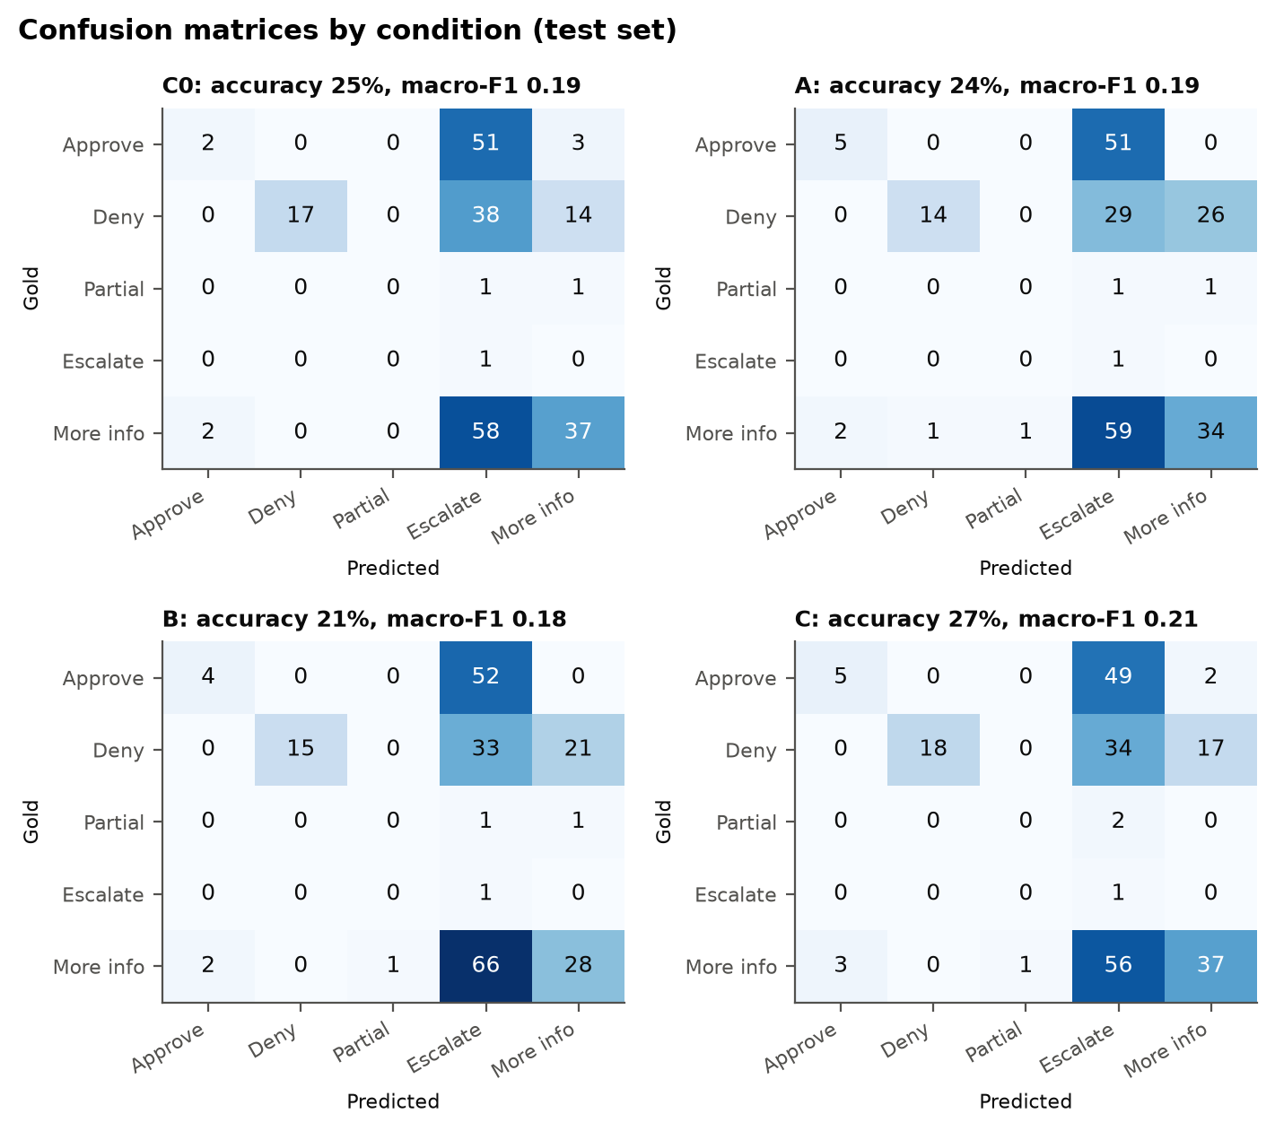
Note. Rows are gold determinations, columns the system's first-run determination.

Best Model
C ranks first under the pre-specified rule (accuracy 27.1%, macro-F1 0.214); its lead over C0 is 1.8 points (exact McNemar p = 0.481), so the two are statistically indistinguishable. The ranking rule, fixed on the development set, orders conditions by accuracy, then macro-F1, then the fabricated-citation rate, then the 95th-percentile response time. [Interpret (7 pts): name the best model clearly and say whether it is good enough to deploy, comparing it with the majority-class baseline and the break-even accuracy.]
Table 12 names the best condition on each metric.
Table 12
Best Condition by Metric
Metric | Better when | Best condition | Best value | Runner-up value
Determination accuracy | higher | C | 27.1% | 25.3%
Macro-F1 | higher | C | 0.214 | 0.192
Fabricated-citation rate | lower | C0 | 0.0% | 0.4%
Correct clause cited | higher | C0 | 48.0% | 35.1%
Consistency across runs | higher | A | 96.9% | 96.4%
95th-percentile response time (s) | lower | C0 | 10.3 | 12.0
Note. Ties are listed with an equals sign. The overall best model follows the ranking rule above.

Development Versus Test Results
Table 13
Separated Evaluation Results: Development and Test Sets
Condition | n dev / test | Accuracy dev / test | Diff (points) | Macro-F1 dev / test | Fabricated dev / test | Correct clause dev / test
C0 | 125 / 225 | 29.6% / 25.3% | -4.3 | 0.244 / 0.192 | 0.8% / 0.0% | 76.8% / 48.0%
A | 125 / 225 | 22.4% / 24.0% | +1.6 | 0.192 / 0.187 | 1.6% / 4.4% | 42.4% / 23.6%
B | 125 / 225 | 24.8% / 21.3% | -3.5 | 0.224 / 0.176 | 0.0% / 0.4% | 44.8% / 24.4%
C | 125 / 225 | 24.8% / 27.1% | +2.3 | 0.222 / 0.214 | 4.8% / 6.2% | 44.0% / 35.1%
Note. Equivalent of training and test accuracy for a system that is not trained. Source: outputs/final/dev_vs_test.csv.

Hypothesis Tests
Table 14 gives the decision on each null hypothesis at the 5% level.
Table 14
Hypothesis Tests at the 5% Significance Level
Hypothesis | Estimate | p | Decision (α = .05)
H1: A vs C0 accuracy | -1.3 pts | .961 | Fail to reject H₀
H1: B vs C0 accuracy | -4.0 pts | .279 | Fail to reject H₀
H1: C vs C0 accuracy | +1.8 pts | .961 | Fail to reject H₀
H2: A vs C0 fabricated | +4.4 pts | .004 | Reject H₀
H2: A vs C0 correct clause | -24.4 pts | < .001 | Reject H₀
H2: B vs C0 fabricated | +0.4 pts | 1.000 | Fail to reject H₀
H2: B vs C0 correct clause | -23.6 pts | < .001 | Reject H₀
H2: C vs C0 fabricated | +6.2 pts | < .001 | Reject H₀
H2: C vs C0 correct clause | -12.9 pts | .004 | Reject H₀
H3: clause in context | OR = 1.00 [0.69, 1.46] | .999 | Fail to reject H₀
H4: dominant failure share > .20 | retrieval miss 47.6% | < .001 | Reject H₀
Note. H1 and H2: exact McNemar tests, Holm-adjusted over three comparisons. H3: GEE logistic regression. H4: one-sided exact binomial test. Cochran's Q across four conditions: Q(3) = 8.85, p = .031.
[Interpret each decision in words (2 pts for notation and logic): what rejecting or failing to reject means for each RQ, with the effect size and interval, not only the p value.]

Secondary and Sensitivity Analyses
Table 15 and Figure 13 report the pre-specified secondary analyses; Figure 14 and Figure 15 show the drivers of a correct determination and the failure modes.
Table 15
Secondary and Sensitivity Analyses
Condition | Accuracy, needs-human merged | Accuracy, unambiguous only | Clause: strict | Clause: parent | Clause: section
C0 | 51.1% | 20.0% | 48.0% | 56.9% | 69.8%
A | 50.2% | 21.7% | 23.6% | 51.1% | 66.7%
B | 50.7% | 18.3% | 24.4% | 65.8% | 70.2%
C | 52.0% | 21.7% | 35.1% | 54.2% | 64.9%
Note. Needs-human merges escalate and request more information. Clause rules: strict (primary) credits the gold clause or a more specific one; parent credits either direction; section ignores paragraphs.
Figure 13
Correct-Clause Rate Under Three Matching Rules
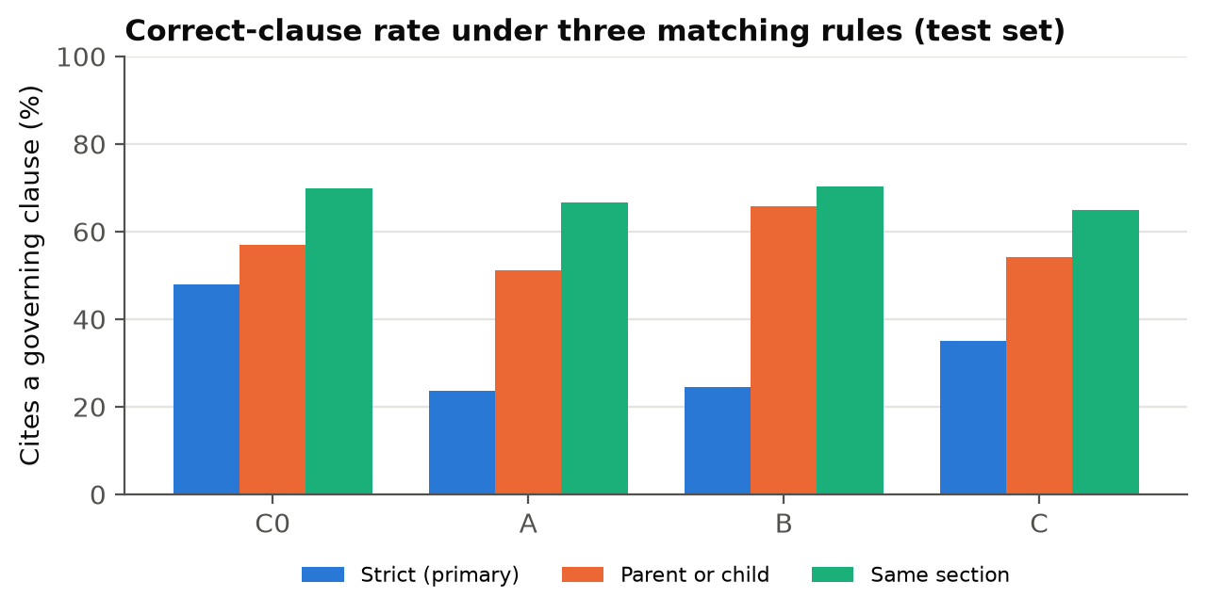

Figure 14
Drivers of a Correct Determination: GEE Odds Ratios
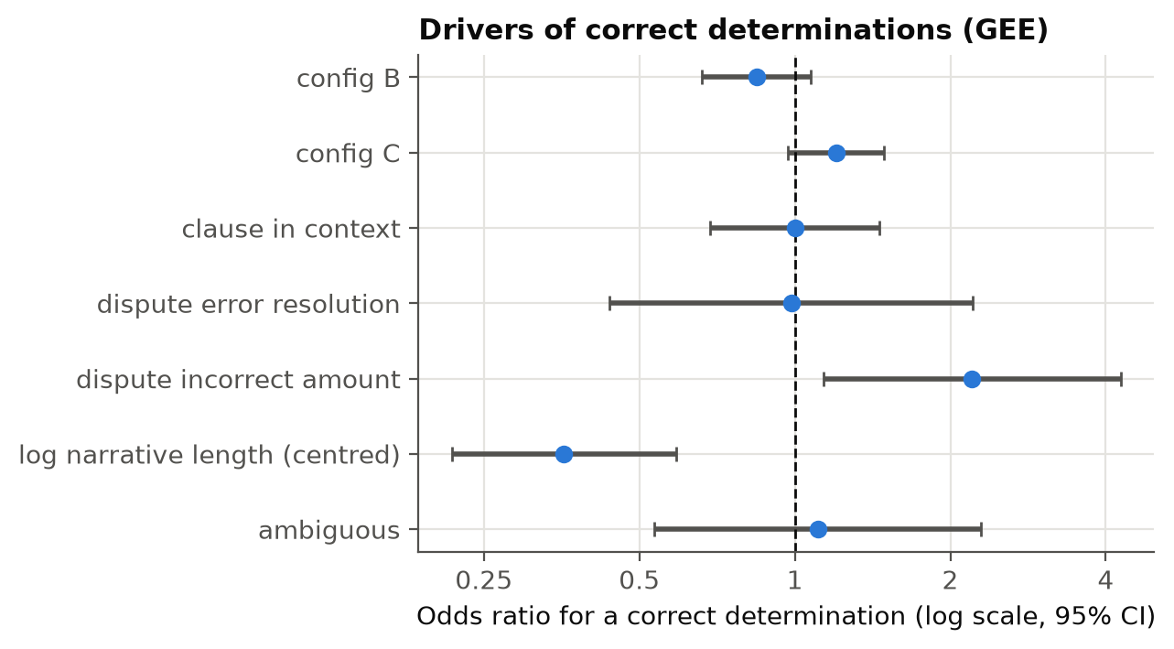

Figure 15
Failure Modes of Incorrect Determinations by Condition
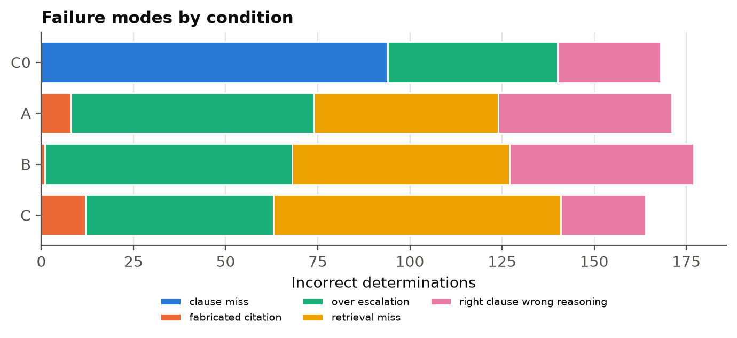

Interpretation
[Interpret the metrics and visuals in writing (8 pts): accuracy against the majority baseline; the escalate column of the confusion matrices; what the clause sensitivity shows; whether test results replicate development results; what the GEE drivers say. No causal claims for case factors.]

Deployment and Application
Table 16 checks Config C against the adoption benchmarks, and Figure 16 shows the modeled handling-time saving at each accuracy level.
Table 16
Adoption Benchmarks for Config C
Pillar | Indicator | Estimate | Benchmark | Verdict
Accuracy | Accuracy gain over C0 | +0.018 (Holm p = 0.9614) | >= .15 and Holm p < .05 | not met
Accuracy | Absolute accuracy | 0.271 | > break-even 0.46 | not met
Groundedness | Fabricated-citation rate | 0.062 [0.037, 0.102] | upper 95% Wilson bound <= .05 | not met
Groundedness | Correct clause cited vs C0 | -0.129 (Holm p = 0.0038) | higher than C0, Holm p < .05 | not met
Operational | Run-to-run consistency | 0.933 [0.893, 0.959] | >= .90 of cases identical in all runs | inconclusive
Operational | 95th-percentile response time | 12.5s [12.1, 13.6] | <= 30 s | met
Operational | Review burden | 0.969 [0.937, 0.985] | reported; enters cost model | reported
Operational | Cost per case | see sensitivity table | assisted < manual minutes at observed accuracy | not met
Note. Verdicts follow the interval rules fixed before scoring.
Figure 16
Modeled Handling-Time Saving by Assistant Accuracy
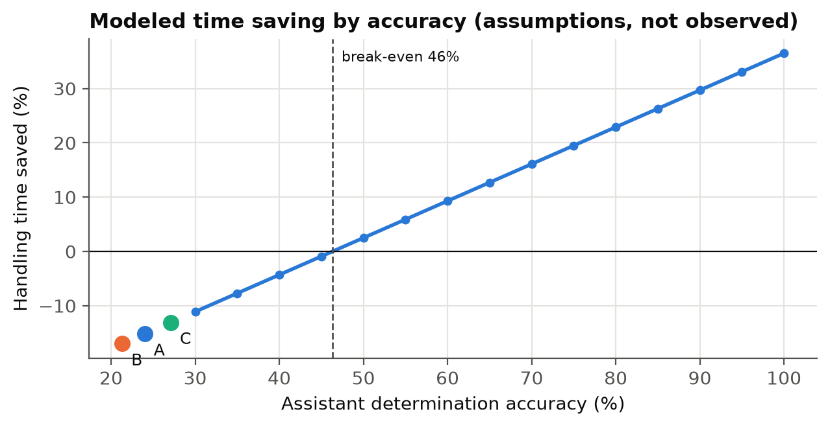
Note. Model under stated assumptions, not observation.

Deployment Approach
[Describe the deployment approach (8 pts): decision support only; batch or on-demand drafting per new dispute; pinned model version and corpus snapshot; shadow mode first (drafts not shown to the customer) with acceptance rate tracked; go/no-go tied to the benchmarks in the table above.]

System Integration
[Explain system integration (7 pts): case-management system sends the complaint text and issue fields; the service returns JSON (determination, reasoning, cited sections); citations are checked against the corpus index before display; every draft and reviewer action is logged to the audit store (the answers table shows the record kept per draft); corpus refreshed when eCFR amends Part 1005.]

Benefits to Users
[Explain user benefits (7 pts), tied to measured results only: consistency, latency, citation traceability; state plainly where the results do NOT yet support a benefit (accuracy).]

Example Use Case
[Example use case (8 pts): walk through one real complaint from the test set (query the database: SELECT * FROM v_outcomes WHERE condition='C' AND determination_correct=1) showing the redacted narrative excerpt, retrieved clauses, the drafted determination with citations, the review routing and what the investigator does. Use one correct case and, briefly, one over-escalated case.]

Limitations
[Data limitations (3 pts), model limitations (3 pts), impact on findings and generalizability (2 pts). Carry over interim Table 24; update: second-rater kappa (pending), single generator model, AI-assisted gold drafts, one-sided redacted narratives.]

Future Scope
[Future scope (2 pts): practitioner study with investigators; newer-model replication; confidence scores to allow ROC analysis; agentic retrieval; organizational case files under ethics approval.]

Conclusion
[Answer each RQ in one or two sentences and give the adoption recommendation (go / no-go / conditions).]

References
Asai, A., Wu, Z., Wang, Y., Sil, A., & Hajishirzi, H. (2024). Self-RAG: Learning to retrieve, generate, and critique through self-reflection. In The Twelfth International Conference on Learning Representations. https://openreview.net/forum?id=hSyW5go0v8
Barnett, S., Kurniawan, S., Thudumu, S., Brannelly, Z., & Abdelrazek, M. (2024). Seven failure points when engineering a retrieval augmented generation system (arXiv:2401.05856). arXiv. https://doi.org/10.48550/arXiv.2401.05856
Board of Governors of the Federal Reserve System. (2026). Revised guidance on model risk management (SR Letter 26-2). https://www.federalreserve.gov/supervisionreg/srletters/SR2602.htm
Cochran, W. G. (1950). The comparison of percentages in matched samples. Biometrika, 37(3/4), 256–266. https://doi.org/10.2307/2332378
Cohen, J. (1960). A coefficient of agreement for nominal scales. Educational and Psychological Measurement, 20(1), 37–46. https://doi.org/10.1177/001316446002000104
Connor, R. J. (1987). Sample size for testing differences in proportions for the paired-sample design. Biometrics, 43(1), 207–211. https://doi.org/10.2307/2531961
Consumer Financial Protection Bureau. (n.d.). Consumer complaint database [Data set]. https://www.consumerfinance.gov/data-research/consumer-complaints/
Consumer Financial Protection Bureau. (2015). Disclosure of consumer complaint narrative data [Final policy statement]. https://files.consumerfinance.gov/f/201503_cfpb_disclosure-of-consumer-complaint-narrative-data.pdf
Consumer Financial Protection Bureau. (2021). Supervisory highlights: Issue 25, fall 2021. https://www.consumerfinance.gov/data-research/research-reports/supervisory-highlights-issue-25-fall-2021/
Consumer Financial Protection Bureau. (2023). Chatbots in consumer finance [Issue spotlight]. https://files.consumerfinance.gov/f/documents/cfpb_chatbot-issue-spotlight_2023-06.pdf
Consumer Financial Protection Bureau. (2026a). Consumer complaint database narratives archive [Data set]. https://www.consumerfinance.gov/foia-requests/foia-electronic-reading-room/cfpb-consumer-complaint-database-narratives-archive/
Consumer Financial Protection Bureau. (2026b). Consumer Response annual report: January 1–December 31, 2025. https://files.consumerfinance.gov/f/documents/cfpb_2025-cr-annual-report_2026-03.pdf
Dahl, M., Magesh, V., Suzgun, M., & Ho, D. E. (2024). Large legal fictions: Profiling legal hallucinations in large language models. Journal of Legal Analysis, 16(1), 64–93. https://doi.org/10.1093/jla/laae003
Electronic Fund Transfers (Regulation E), 12 C.F.R. pt. 1005 (2026). https://www.ecfr.gov/current/title-12/chapter-X/part-1005
Es, S., James, J., Espinosa Anke, L., & Schockaert, S. (2024). RAGAs: Automated evaluation of retrieval augmented generation. In Proceedings of the 18th Conference of the European Chapter of the Association for Computational Linguistics: System Demonstrations (pp. 150–158). Association for Computational Linguistics. https://doi.org/10.18653/v1/2024.eacl-demo.16
Gao, T., Yen, H., Yu, J., & Chen, D. (2023). Enabling large language models to generate text with citations. In Proceedings of the 2023 Conference on Empirical Methods in Natural Language Processing (pp. 6465–6488). Association for Computational Linguistics. https://doi.org/10.18653/v1/2023.emnlp-main.398
Gao, Y., Xiong, Y., Gao, X., Jia, K., Pan, J., Bi, Y., Dai, Y., Sun, J., Wang, M., & Wang, H. (2023). Retrieval-augmented generation for large language models: A survey (arXiv:2312.10997). arXiv. https://doi.org/10.48550/arXiv.2312.10997
Holm, S. (1979). A simple sequentially rejective multiple test procedure. Scandinavian Journal of Statistics, 6(2), 65–70.
Hsieh, F. Y., Bloch, D. A., & Larsen, M. D. (1998). A simple method of sample size calculation for linear and logistic regression. Statistics in Medicine, 17(14), 1623–1634.
Islam, P., Kannappan, A., Kiela, D., Qian, R., Scherrer, N., & Vidgen, B. (2023). FinanceBench: A new benchmark for financial question answering (arXiv:2311.11944). arXiv. https://doi.org/10.48550/arXiv.2311.11944
Karpukhin, V., Oğuz, B., Min, S., Lewis, P., Wu, L., Edunov, S., Chen, D., & Yih, W. (2020). Dense passage retrieval for open-domain question answering. In Proceedings of the 2020 Conference on Empirical Methods in Natural Language Processing (pp. 6769–6781). Association for Computational Linguistics. https://doi.org/10.18653/v1/2020.emnlp-main.550
Kish, L. (1965). Survey sampling. Wiley.
Lewis, P., Perez, E., Piktus, A., Petroni, F., Karpukhin, V., Goyal, N., Küttler, H., Lewis, M., Yih, W., Rocktäschel, T., Riedel, S., & Kiela, D. (2020). Retrieval-augmented generation for knowledge-intensive NLP tasks. Advances in Neural Information Processing Systems, 33, 9459–9474.
Liang, K.-Y., & Zeger, S. L. (1986). Longitudinal data analysis using generalized linear models. Biometrika, 73(1), 13–22. https://doi.org/10.1093/biomet/73.1.13
Liu, N. F., Lin, K., Hewitt, J., Paranjape, A., Bevilacqua, M., Petroni, F., & Liang, P. (2024). Lost in the middle: How language models use long contexts. Transactions of the Association for Computational Linguistics, 12, 157–173. https://doi.org/10.1162/tacl_a_00638
Magesh, V., Surani, F., Dahl, M., Suzgun, M., Manning, C. D., & Ho, D. E. (2025). Hallucination-free? Assessing the reliability of leading AI legal research tools. Journal of Empirical Legal Studies, 22(2), 216–242. https://doi.org/10.1111/jels.12413
McNemar, Q. (1947). Note on the sampling error of the difference between correlated proportions or percentages. Psychometrika, 12(2), 153–157. https://doi.org/10.1007/BF02295996
National Institute of Standards and Technology. (2023). Artificial intelligence risk management framework (AI RMF 1.0) (NIST AI 100-1). U.S. Department of Commerce. https://doi.org/10.6028/NIST.AI.100-1
Nogueira, R., & Cho, K. (2019). Passage re-ranking with BERT (arXiv:1901.04085). arXiv. https://doi.org/10.48550/arXiv.1901.04085
Robertson, S., & Zaragoza, H. (2009). The probabilistic relevance framework: BM25 and beyond. Foundations and Trends in Information Retrieval, 3(4), 333–389. https://doi.org/10.1561/1500000019
Saad-Falcon, J., Khattab, O., Potts, C., & Zaharia, M. (2024). ARES: An automated evaluation framework for retrieval-augmented generation systems. In Proceedings of the 2024 Conference of the North American Chapter of the Association for Computational Linguistics (pp. 338–354). https://doi.org/10.18653/v1/2024.naacl-long.20
Shuster, K., Poff, S., Chen, M., Kiela, D., & Weston, J. (2021). Retrieval augmentation reduces hallucination in conversation. In Findings of the Association for Computational Linguistics: EMNLP 2021 (pp. 3784–3803). https://doi.org/10.18653/v1/2021.findings-emnlp.320
Wilson, E. B. (1927). Probable inference, the law of succession, and statistical inference. Journal of the American Statistical Association, 22(158), 209–212. https://doi.org/10.1080/01621459.1927.10502953
Yao, S., Zhao, J., Yu, D., Du, N., Shafran, I., Narasimhan, K., & Cao, Y. (2023). ReAct: Synergizing reasoning and acting in language models. In The Eleventh International Conference on Learning Representations. https://doi.org/10.48550/arXiv.2210.03629
Zheng, L., Chiang, W.-L., Sheng, Y., Zhuang, S., Wu, Z., Zhuang, Y., Lin, Z., Li, Z., Li, D., Xing, E. P., Zhang, H., Gonzalez, J. E., & Stoica, I. (2023). Judging LLM-as-a-judge with MT-Bench and Chatbot Arena. Advances in Neural Information Processing Systems, 36, 46595–46623.

Appendix A: Declaration of Generative AI Use
Table A1
Generative AI Use by Project Component
Component | AI used? | Model | What it did | Approval
Case selection, sampling, split | No | — | Deterministic filters, seeded stratified draws | Not applicable
Gold labels | Yes | Claude Sonnet 4.6 | Drafted clauses and determinations; every draft reviewed by the author; blind second rating | [date and approver ONLY if the written approval exists; otherwise state none]
System under study | Yes | Claude Sonnet 4.6 | Generates the determinations evaluated | [approval ref]
Groundedness judge | Yes | Claude Sonnet 4.6 | Rates claim support on a sample | [approval ref]
Writing and code assistance | Yes | [model(s) used] | Code review, analysis and report-builder scripts, drafting and formatting, reference checking | [approval ref]

Appendix B: Reproducibility
Table B1
Run Order for the Final Report
Step | Command | Output
0 | python scripts/00a_build_from_archive.py; 00b_build_corpus.py | Merged archive; corpus
1 | python scripts/01_prepare_data.py --n 160 --seed 42; 01b_eda.py | Development sample; EDA
1c | python scripts/01c_draw_test_sample.py --n-draw 205 --seed 2026 | Test sample; split manifest
2 | python scripts/02_import_gold.py [--split test] | Gold labels; kappa
2b | python scripts/02b_lock_protocol.py | Protocol lock (SHA-256)
3 | python scripts/03_run_experiment.py configs/<c>.yaml --split test | outputs/runs_test/
4 | python scripts/04_compare_and_business.py --split test | outputs/reports_test/
5 | python scripts/05_final_analysis.py --split both | outputs/final/
6 | python scripts/07_outcome_eda.py --split both; 08_sample_preview.py | Outcome-linked EDA; preview
6b | python scripts/06_pipeline_diagram.py; env_report.py; 00e_build_db.py | Figure; environment; database
7 | cd report; python build_final.py; python check_final.py QM640_Final_Report_DRAFT.docx | This report; checks

