---------------------------------------------------------Git Notes-------------------------------------------------------------
- git version
Syntax: git --version
Output: git version 2.34.1
- Git life cycle

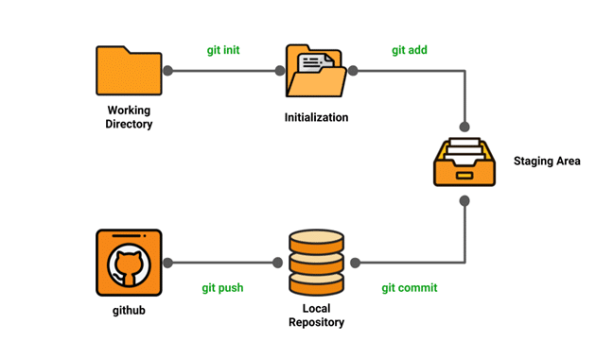

3.) Configure your git user name and email

Syntax: git config –global user.name “username”
Syntax: git config –global user.email email@example.com

3.1) check setting
Syntax: git config –list
Output: user.name=username
user.email=email@example.com
color.status=auto
color.branch=auto
color.interactive=auto
color.diff=auto
3.2) syntax: git config user.name or user.email
Output: username or email@example.com
4) Set up ssh key
Syntax: ssh -keygen -t ed25519 -C email@example.com

5) create local repository
Syntax: git init (initialize a empty Git repository in the root of a folder)
Output: Initialized empty Git repository in E:/traning notes/.git/

6) Add/track/stages files
Syntax1: git add filename (add only one file)
Syntax2: git add . or add * or add -A (add all)

7) View your stage and unstage files
Syntax: git status
Syntax: git status -s (short status)
Output: On branch master

No commits yet

Changes to be committed:
(use "git rm --cached <file>..." to unstage)
new file: git/git_notes.doc
new file: git/~$t_notes.doc
new file: git/~WRL0483.tmp
new file: linux/vi commands/.vi-editor.txt.swp

Changes not staged for commit:
(use "git add <file>..." to update what will be committed)
(use "git restore <file>..." to discard changes in working directory)
modified: git/git_notes.doc

8) reset files to unstage

Syntax: git reset
Output: it reset all staged files into back unstaged

Syntax: git rm –cached filename

9) git diff (modified file and not stage then can check diff)

Syntax: git diff

Syntax: git diff –cached

Syntax: git diff –staged

10) Committing your change

Syntax: git commit or git commit -m “message” or git commit (nano or vi)

11) commit history (log)

Syntax: git log
Output: all commit ( last commit show first)

1) log option

12) Undoing commit

Syntax:

13) Add remote repository into local

Syntax: git remote add origin ssh key

14) remove remote repository

Syntax: git remote rm origin

15) check status of remote

Syntax: git remote -v

14) push our content into remote repository

Syntax: git push -u origin master (create upstream branch when using u)

------------------------------------Branches-------------------------------------------

1) create branch (a branch is a new/separate version of the main repository.)

Syntax: git branch branchname

2) check branch list
Syntax: git branch
Output: *main (* mean active branch)
Branchname

3) switch to branch
Syntax: git checkout branchname or git switch branchname

If you modify a file but haven't staged the change, then git checkout <filename> will reverse the modifications... a quick and easy way to cancel changes to a file. You remain in the same branch.
git checkout <branchname> (as you noted) switches branches. And switch use for switch branch

4) add commit command run for new modification in sub branch
5) merge branches (switch branch where to merge) e.g syntax: git checkout main(master)
Syntax: git merge sub-branch
6) push to remote
Syntax: git push -u origin master
7) Add sub-branch in remote
Syntax: git push origin branchname
8) delete branch local repository
Syntax: git branch -d or -D branchname
9) delete branch remote repository
Syntax: git push origin –delete branchname

------------------------------------------------Fetch and pull-----------------------------------------------------
1) fetch - git fetch is the command that tells your local git to retrieve the latest meta-data info from the remote (yet doesn’t do any file transferring. It’s more like just checking to see if there are any changes available)
Syntax: git fetch origin master
2) see difference
Syntax: git diff origin/master
3) merge - merge combines the current branch, with a specified branch
Syntax: git merge origin/master

4) pull- git pull on the other hand does that AND brings (copy) those changes from the remote repository.
Syntax: git pull origin master

5) clone - is a full copy of a repository, including all logging and versions of files.
Syntax: git clone sshkey

-----------------------Git Undo---------------

1) Git Revert
revert is the command we use when we want to take a previous commit and add it as a new commit, keeping the log intact.

Syntax:

