

Week-1

1)Aim: To implement recursion in Python by creating a function that prints numbers in descending order from a given number.
Program:
"question 1"

def countdown(n):
if n > 0:
print(n)
countdown(n - 1)
n = int(input("Enter the countdown time:"))
countdown(n)
print("rocket launches!!")
Output:
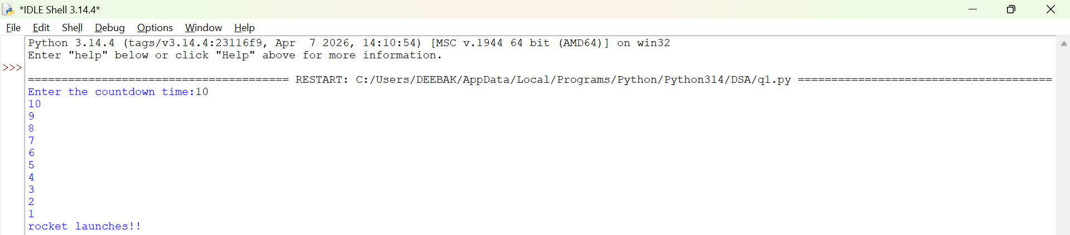
Explanation:
• The function launch(n) prints the current value of n.
• If n is greater than 0, it decreases n by 1 and calls itself recursively.
• The recursion continues until n becomes 0, which is the base case, and the function stops.

Error Table:
S.No | Error Obtained | Rectification
01. | Didn’t write the print statement after definition. | After execution I found the mistake and added it.

2)Aim: To implement a recursive binary search in Python to find the position (index) of a given element in a list. The program recursively checks each element of the list until the target element is found or the end of the list is reached.
Program:
"question 3"

def search(emp_list, key, index):
if index == len(emp_list):
return False
if emp_list[index] == key:
return True
return search(emp_list, key, index +1)
emp_list = [1000, 1001, 1002, 1003, 1004]
key = int(input("Enter employee to search"))

if search(emp_list, key, 0):
print("Employee ID found")
else:
print("Employee ID not found")

Output:
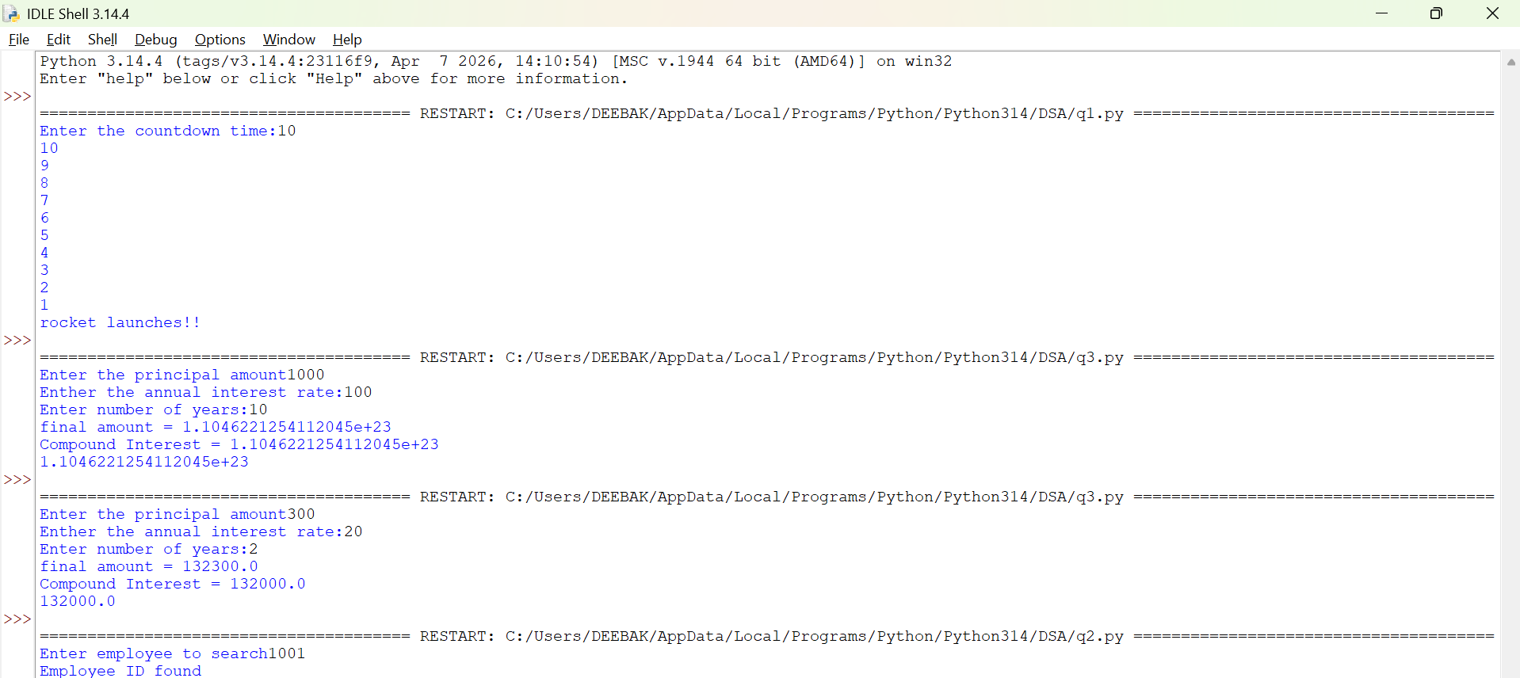

Explanation:
This program uses recursion to perform a linear search for an employee ID (or any target element) in a list.
- The function empid_Search(arr, target, n=0) is defined with three parameters:
  - arr: The list in which the search is performed.
  - target: The element to be searched.
  - n: The current index, initialized to 0.
- The statement if n == len(arr): return -1 is the base condition. It checks whether all elements in the list have been examined. If the end of the list is reached without finding the target, the function returns -1.
- The statement if arr[n] == target: return n compares the current element with the target. If they are equal, the function returns the current index where the target is found.
- If the current element does not match the target, the function calls itself recursively with the next index using return empid_Search(arr, target, n + 1).
- The list arr = [10, 20, 30, 50, 607, 809, 506] is created, and the function is called to search for the element 50.
- The returned value is stored in the variable result.
- If result is not equal to -1, the program prints the index where the element is found. Otherwise, it prints "Element not found."
Error table:
S.No | Error Obtained | Rectification
01. | Recursion Error: maximum recursion depth exceeded | Increment the index in the recursive call: return empid_Search(arr, target, n + 1).

3)Aim: This Python program uses recursion to calculate the value of pⁿ (p raised to the power n).
Program:
"question 2"

def power(base, exp):
if exp == 0:
return 1
return base * power(base, exp - 1)

P = float(input("Enter the principal amount"))
r = float(input("Enther the annual interest rate:"))
n = int(input("Enter number of years:"))
A = P * power(1 + r, n)
compound_interest = A - P
print("final amount =", round(A, 2))
print("Compound Interest =", round(compound_interest, 2))
print(compound_interest)
Output:
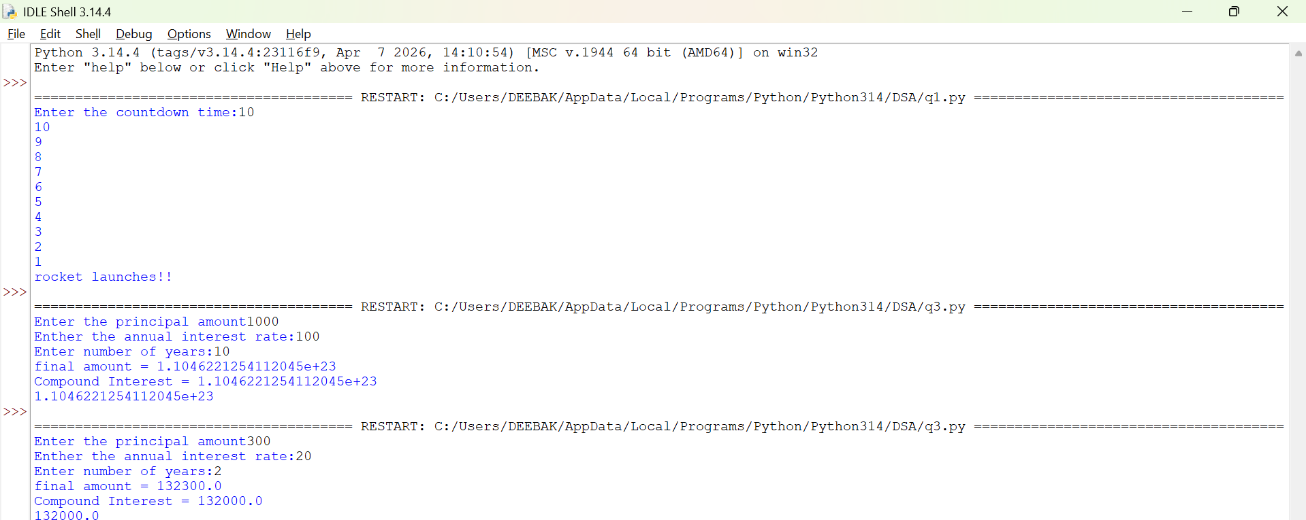
Explanation:
• The program is used to find the power of a number (pⁿ) using recursion.
• It takes two inputs from the user:
- p → Base number
- n → Exponent (power)
• The function power(p, n) is called to calculate the result.
• If the exponent n is 0, the function returns 1 because any number raised to the power 0 is
• If n is not 0, the function calls itself with n - 1 and multiplies the result by p.
• This recursive process continues until the exponent becomes 0.
• After reaching the base case, each recursive call returns its result, and the final value of pⁿ is obtained.
• The result is stored in the variable result.
• Finally, the program prints the calculated power of the given number.

Error Table:
S.No | Error Obtained | Rectification
01. | Not a int value of n we can also take float in place of int, I have taken float value to check. | By replacing int by float.

4)Aim: To write a Python program that generates and prints the Fibonacci series up to n terms using recursion.
Program:
"question 4"

def factorial(n):
if n == 0 or n == 1:
return 1
return n*factorial(n - 1)

n = int(input("Enter the number of possible ways to arrange n different parcels: "))
factorial(n)
print(factorial(n))
Output:
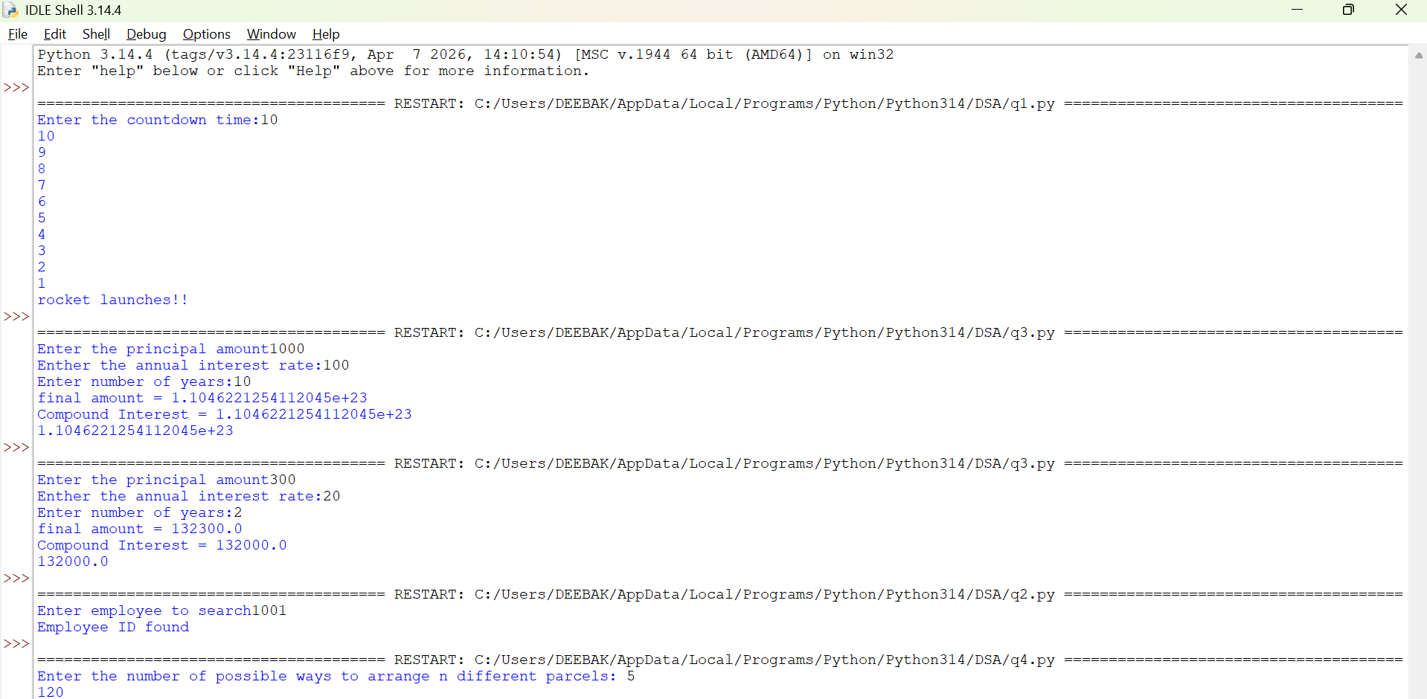

Explanation:
• The program uses a recursive function fib(n) to generate Fibonacci numbers.
• The base condition returns 0 when n = 0 and 1 when n = 1.
• For values greater than 1, the function returns the sum of the previous two Fibonacci numbers: fib(n-1) + fib(n-2).
• The user enters the number of terms (n) to be displayed.
• A for loop calls the fib() function repeatedly for each term from 0 to n-1.
• Finally, the program prints the Fibonacci series in sequence.
Error Table:
S.No | Error Obtained | Rectification
01. | No Errors obtained | -----------------------------------------

5)Aim: To write a Python program to find the factorial of a given number using recursion.
Program:
"question 5"

def fibbanocci(n):
if n == 0 or n == 1:
return 1
return fibbanocci(n - 1) + fibbanocci(n - 2)
n = int(input("Enter the number of fibbanocci terms"))
fibbanocci(n)
print(fibbanocci(n))
Output:
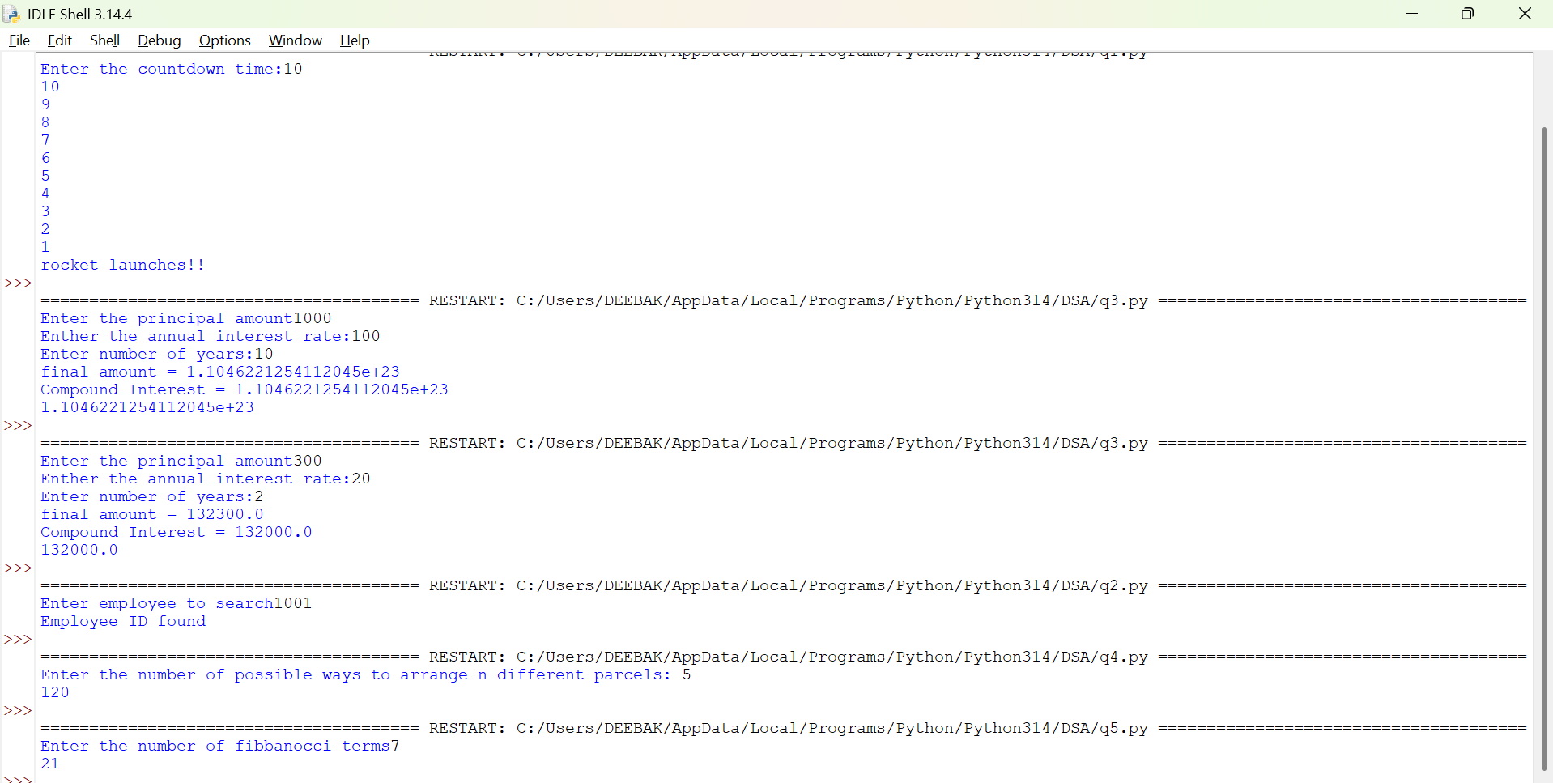

Explanation:
• The program defines a recursive function fact(n) to calculate the factorial of a number.
• The base condition checks if n <= 1. If true, it returns 1 (for factorial, 0! = 1 and 1! = 1).
• Otherwise, the function returns n * fact(n-1), multiplying the current number by the factorial of the previous number.
• The function is called with the value 6.
• Finally, the program prints the factorial of 6, which is 720.
Error Table:
S.No | Error Obtained | Rectification
01. | No Errors obatined | ---------------------------------------------------
Week-2
1)Aim:- Write a program to perform linear search on the given input.
Program:-
"""question1

write a python program to perform Linear Search on the given input"""

def linear_search(arr, key):
for i in range(len(arr)):
if arr[i] == key:
return i
return -1
n = int (input("Enter no of element : "))
arr = []
for j in range(n):
a = int(input("Enter the values of the array : "))
arr.append(a)
key = int(input("Enter the element to search : "))
result = linear_search(arr, key)
if result != -1:
print("Element found at index", result)
else:
print("Element not found")
Output:-
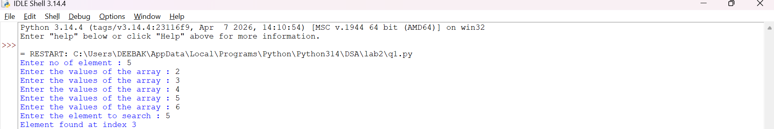
Explanation:-
This program uses a linear search technique to find a target element in a list.
- The function linear_search(arr, target) is defined with two parameters:
  - arr: The list in which the search is performed.
  - target: The element to be searched.
- A for loop is used to traverse each element of the list from index 0 to len(arr) - 1.
- The statement if arr[i] == target: compares each element of the list with the target element.
- If the element is found, the function returns "at position", i + 1, which gives the position of the element (starting from 1).
- If the loop completes without finding the element, the function returns "element not found".
- An empty list a is created, and the user is asked to input elements continuously.
- The loop continues until the user enters "stop", after which the input process ends.
- The user then enters the element to be searched, which is stored in variable b.
- The function is called using linear_search(a, b) and the result is printed.

Error Table and negatives where the code doesn’t give the effective result:-
S.No | Error Obtained | Rectification
01 | ValueError when entering non-integer input | Ensure only integer values are entered or handle using
02 | Program crashes if empty input is given before converting to int | Validate input before conversion
03 | Element not found even if list is empty | Check if list is empty before searching
04 | If duplicate elements exist, only first occurrence is returned | Modify logic if all occurrences are needed
05 | Program does not handle very large lists efficiently | Use better algorithms like binary search (for sorted lists)
2)Aim:-Write a python program to perform binary search on the given input verify by taking sorted array and unsorted array as a input:-
Program:-
(a)Sorted Array:
""" question 2
Write a python program to perform Binary Search on the given input.
Verify by taking Sorted array and unsorted array as a input"""

""" question 2(sorted array)"""

def binary_search(arr, key):
low = 0
high = len(arr) - 1
while low <= high :
mid = (low + high ) // 2
if arr[mid] == key:
return mid
elif arr[mid] < key:
low = mid + 1
else:
high = mid - 1
return -1
n = int(input("Enter no of elements : "))
arr = []
for i in range(n):
a = int(input("Enter the elements of the array : "))
arr.append(a)
key = int(input("Enter the elements to search : "))
result = binary_search(arr, key)
if result != -1:
print("Element found at the index : ",result)
else:
print("Element is not found")

(b) Unsorted Array:
"""question 2(array is not sorted)"""

def binary_search(arr, key):
low = 0
high = len(arr) - 1
while low <= high:
mid = (low + high)// 2
if arr[mid] == key:
return mid
elif arr[mid] < key:
low = mid +1
else:
high = mid - 1
return -1
n = int(input("Enter the no of elements of the array : "))
arr = []
for i in range(n):
a = int(input("Enter the elements of the array : "))
arr.append(a)
key = int(input("Enter the element to search : "))
if arr == sorted(arr):
print("The input list is already sorted")
else:
print("The input list is not sorted")
print("Sorting the element")
arr.sort()
print("Sorted List : ", arr)
result = binary_search(arr, key)
if result != -1:
print("Element found at the index : ",result)
else:
print("Element not found")

Output:-
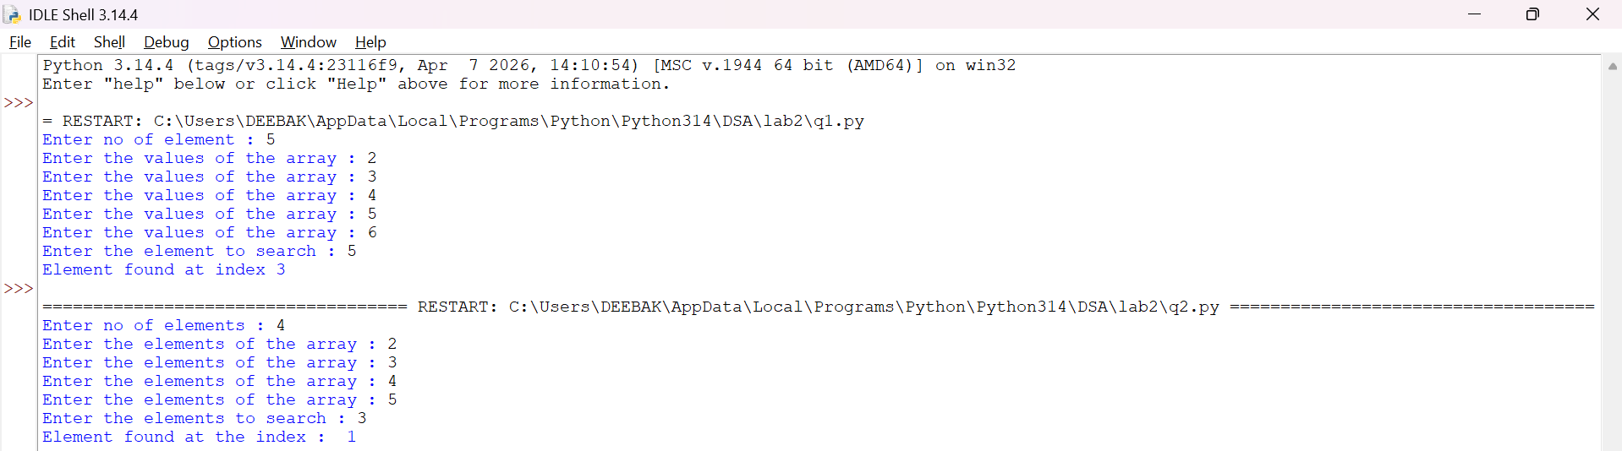
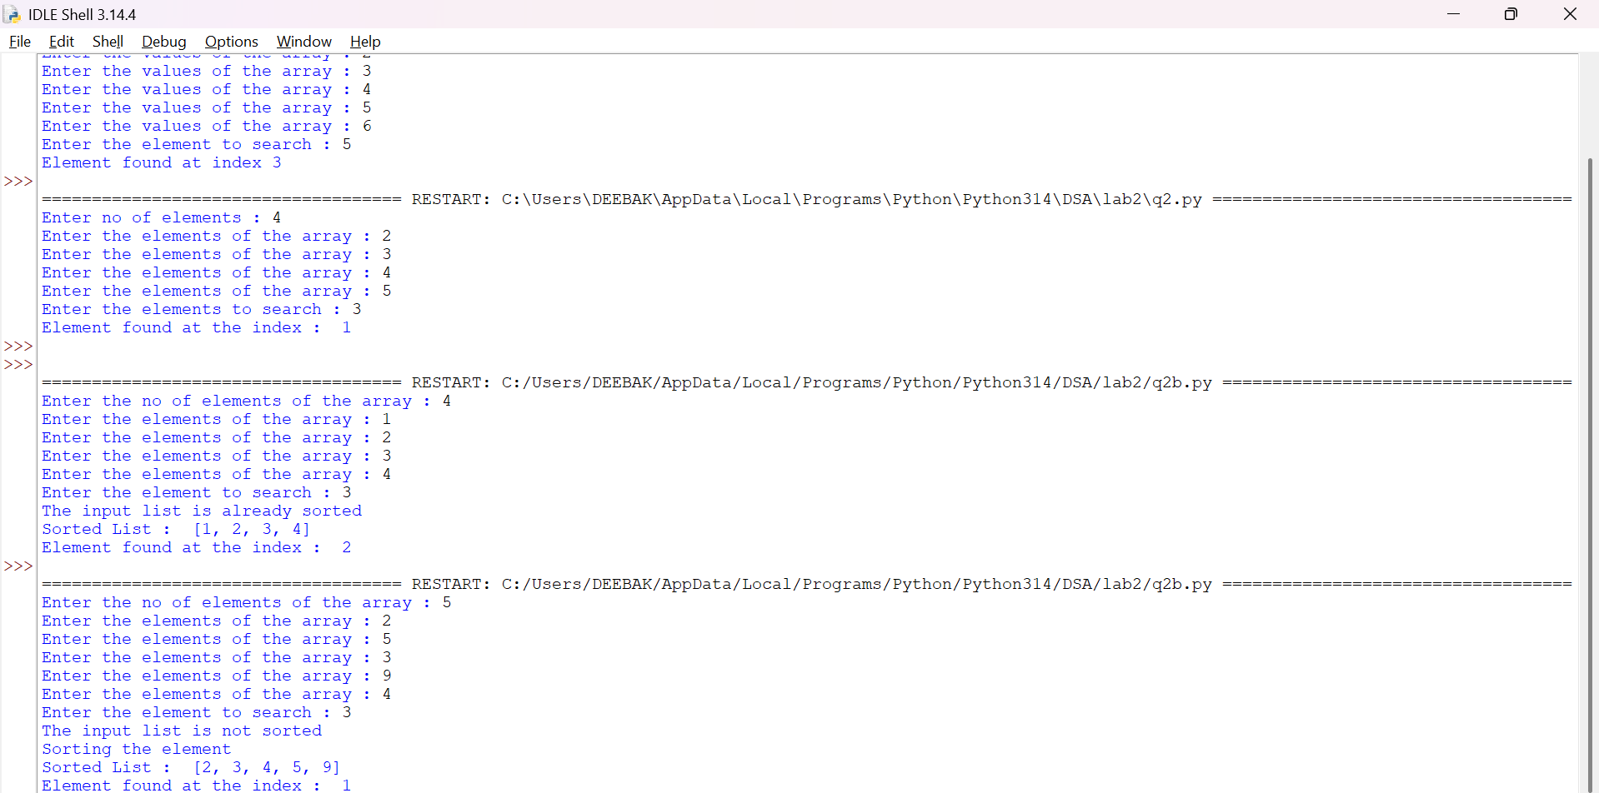
Explanation:-
This program uses the binary search technique to find a target element in a list.
- The function binary_search(arr, target) is defined to perform the search operation.
- Two variables are initialized:
  - low = 0: Represents the starting index of the list.
  - high = len(arr) - 1: Represents the last index of the list.
- A while loop runs as long as low <= high, ensuring the search space is valid.
- The middle index is calculated using mid = (low + high) // 2.
- The statement if arr[mid] == target: checks whether the middle element is equal to the target.
  - If true, the function returns "at position", mid.
- If the target is greater than the middle element (target > arr[mid]), the search continues in the right half by updating low = mid + 1.
- Otherwise, the search continues in the left half by updating high = mid - 1.
- The user inputs elements into the list a until "stop" is entered.
- The list is sorted using a.sort().
  - This ensures that even if the user enters an unsorted array, the binary search will still work correctly.
- The user enters the element to be searched, stored in variable b.
- The function is called using binary_search(a, b) and the result is printed.
Error Table and negatives where the code doesn’t give the effective result:-
Sno | Error Obtained | Rectification
01 | ValueError when non-integer input is entered | Ensure inputs are integers or use
02 | Incorrect position (0-based index returned) | Use mid + 1 if position should start from 1
03 | Program fails if list is empty | Check if list is empty before searching
04 | Binary search requires sorted array | Sorting is already handled using
05 | Element not found but no explicit message returned | Add return "element not found" after loop
06 | Output format shows tuple like ('at position', 2) | Use formatted print statement for better output
07 | Duplicate elements return only one occurrence | Modify logic if all positions are needed
08 | Sorting changes original order of elements | Inform user that positions are based on sorted list

3a)Aim:- Write a Python program to perform Bubble Sort on a given list of elements.
Program:-
def bubble_sort(arr):
n = len(arr)
for i in range(n):
swapped = False
for j in range(0, n - i - 1):
if arr[j] > arr[j + 1]:
arr[j], arr[j + 1] = arr[j + 1], arr[j]
swapped = True
if not swapped:
break
return arr

a = []
while True:
elem = input("Enter an element (or enter stop to finish):- ")
if elem.lower() == "stop":
break
a.append(int(elem))

print("Original List:", a)
sorted_list = bubble_sort(a)
print("Sorted List: ", sorted_list)
OUTPUT:-
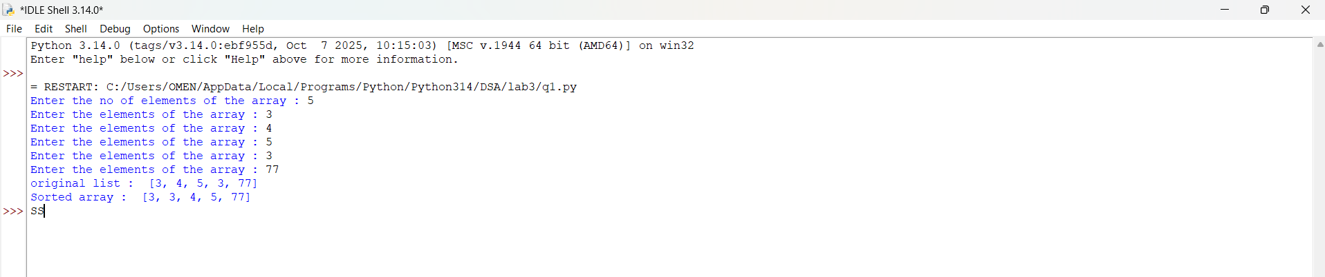
Explanation:
This program uses the Bubble Sort technique to sort elements in a list.
- The function bubble_sort(arr) is defined to sort the given list arr.
- The variable n = len(arr) stores the number of elements in the list.
- A loop runs from i = 0 to n-1, representing each pass of the sorting process.
- A variable swapped is initialized as False at the beginning of each pass.
  - It is used to check whether any swapping occurred during the pass.
- Another loop runs from j = 0 to n-i-2, comparing adjacent elements.
- The condition if arr[j] > arr[j + 1]: checks if the current element is greater than the next element.
  - If true, the elements are swapped using arr[j], arr[j + 1] = arr[j + 1], arr[j].
  - The variable swapped is set to True.
- After each pass, if no swapping occurs (swapped == False), the loop breaks early.
  - This indicates that the list is already sorted.
- The function returns the sorted list.
- The user inputs elements into the list a until "stop" is entered.
- The original list is printed, followed by the sorted list after calling bubble_sort(a).

Error Table:
S.No | Error Obtained | Rectification
01. | ValueError when non-integer input is entered | Ensure input is integer or handle using try-except
02. | Program fails for empty list (no elements entered) | Check if list is empty before sorting
03. | Sorting modifies original list | Use a copy of list if original order must be preserved
04. | Inefficient for large inputs (high time complexity) | Use faster algorithms like merge sort or quick sort
3b)
Aim:-
Write a Python program to perform Insertion Sort on a given list of elements.
Program:-
def insertion_sort(arr):
for i in range(1, len(arr)):
key = arr[i]
j = i - 1
while j >= 0 and key < arr[j]:
arr[j + 1] = arr[j]
j -= 1
arr[j + 1] = key
return arr

a = []
while True:
elem = input("Enter an element (or enter stop to finish):- ")
if elem.lower() == "stop":
break
a.append(int(elem))

print("Original List:", a)
sorted_list = insertion_sort(a)
print("Sorted List: ", sorted_list)
Output:-
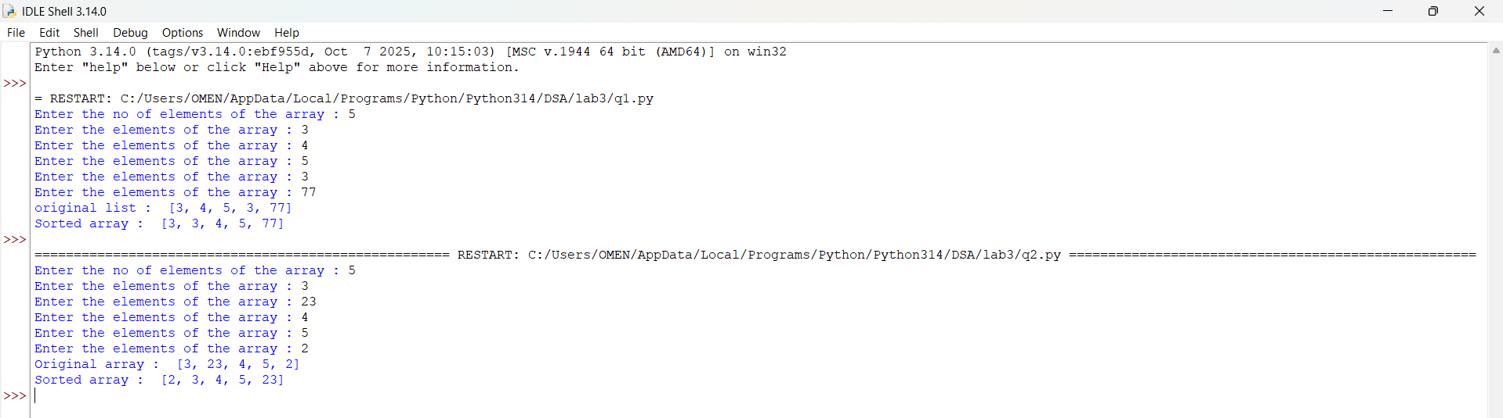
Explanation:
This program uses the Insertion Sort technique to sort elements in a list.
- The function insertion_sort(arr) is defined to sort the given list arr.
- A loop runs from i = 1 to len(arr) - 1, considering one element at a time as the key element.
- The variable key = arr[i] stores the current element to be inserted into the sorted portion of the list.
- The variable j = i - 1 points to the last element of the already sorted portion.
- A while loop runs as long as j >= 0 and key < arr[j].
  - This shifts elements one position ahead using arr[j + 1] = arr[j].
  - The value of j is decreased by 1 after each shift.
- After shifting all larger elements, the key is placed at the correct position using arr[j + 1] = key.
- This process continues until the entire list is sorted.
- The function returns the sorted list.
- The user inputs elements into the list a until "stop" is entered.
- The original list is printed, followed by the sorted list after calling insertion_sort(a).

Error Table:
S.No | Error Obtained | Rectification
01. | ValueError when non-integer input is entered | Ensure input is integer or handle using try-except
02. | Program fails for empty list | Check if list is empty before sorting
03. | Sorting modifies original list | Use a copy of list if original order must be preserved
04. | Incorrect output if comparison condition is wrong (key > arr[j]) | Ensure correct condition key < arr[j] is used
3c)
Aim:-
Write a Python program to perform Selection Sort on a given list of elements.
Program:-
def selection_sort(arr):
n = len(arr)
for i in range(n):
min_idx = i
for j in range(i + 1, n):
if arr[j] < arr[min_idx]:
min_idx = j
arr[i], arr[min_idx] = arr[min_idx], arr[i]
return arr

a = []
while True:
elem = input("Enter an element (or enter stop to finish):- ")
if elem.lower() == "stop":
break
a.append(int(elem))

print("Original List:", a)
sorted_list = selection_sort(a)
print("Sorted List: ", sorted_list)
Output:-
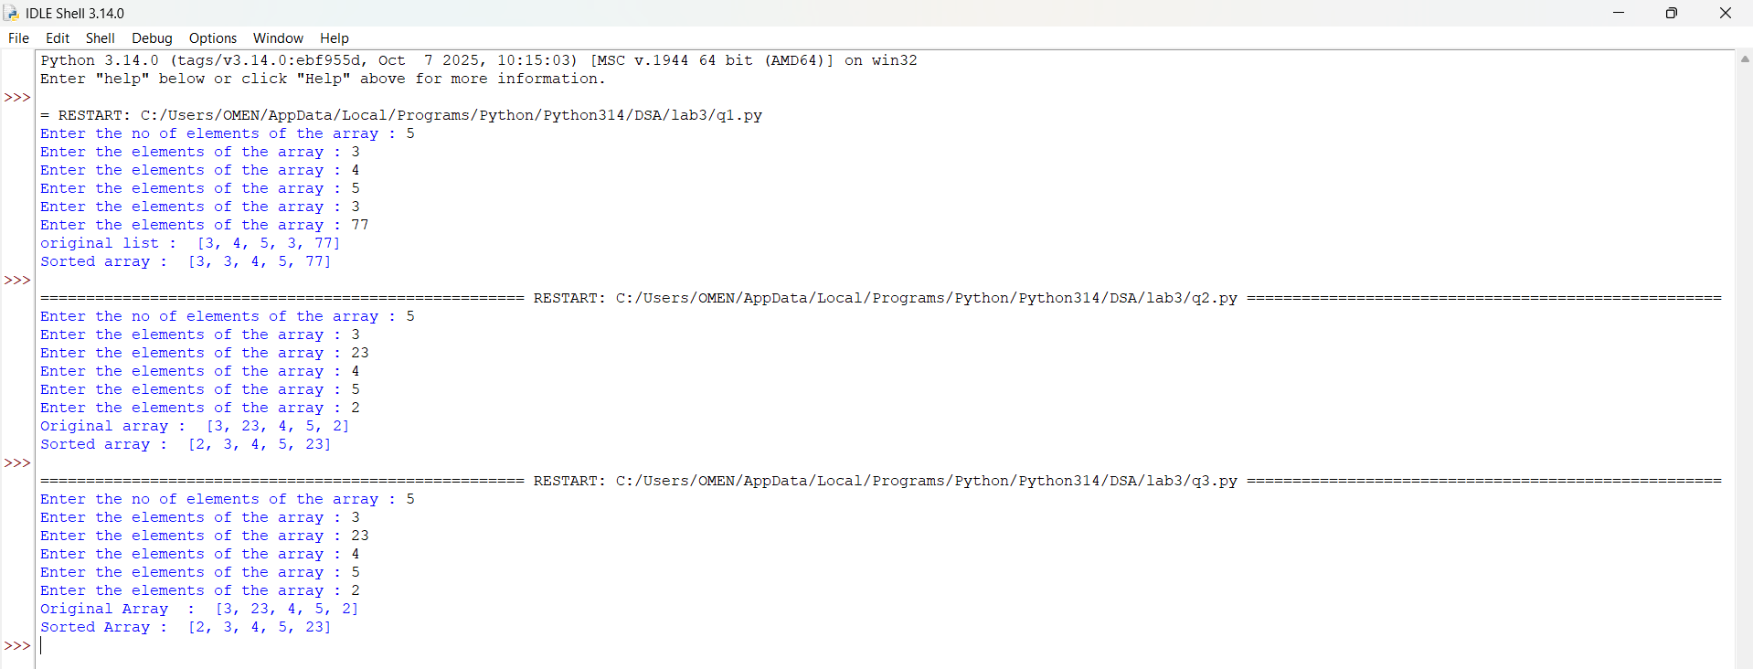
Explanation:
This program uses the Selection Sort technique to sort elements in a list.
- The function selection_sort(arr) is defined to sort the given list arr.
- The variable n = len(arr) stores the number of elements in the list.
- A loop runs from i = 0 to n-1, representing the position where the smallest element should be placed.
- The variable min_idx = i is initialized to store the index of the minimum element in the unsorted portion.
- Another loop runs from j = i + 1 to n-1, comparing elements in the unsorted part of the list.
- The condition if arr[j] < arr[min_idx]: checks if a smaller element is found.
  - If true, min_idx is updated with the index of that smaller element.
- After finding the smallest element, it is swapped with the element at position i using
arr[i], arr[min_idx] = arr[min_idx], arr[i].
- This process continues until the entire list is sorted.
- The function returns the sorted list.
- The user inputs elements into the list a until "stop" is entered.
- The original list is printed, followed by the sorted list after calling selection_sort(a).

Error Table:
S.No | Error Obtained | Rectification
01. | ValueError when non-integer input is entered | Ensure input is integer or handle using try-except
02. | Program fails for empty list | Check if list is empty before sorting
03. | Sorting modifies original list | Use a copy of list if original order must be preserved
04. | Incorrect sorting if comparison condition is wrong (arr[j] > arr[min_idx]) | Ensure correct condition arr[j] < arr[min_idx] is used

3d)
Aim:-
Write a Python program to perform Merge Sort on a given list of elements.
Program:-
def merge_sort(arr):
if len(arr) > 1:
mid = len(arr) // 2
L = arr[:mid]
R = arr[mid:]

merge_sort(L)
merge_sort(R)

i = j = k = 0

while i < len(L) and j < len(R):
if L[i] <= R[j]:
arr[k] = L[i]
i += 1
else:
arr[k] = R[j]
j += 1
k += 1

while i < len(L):
arr[k] = L[i]
i += 1
k += 1

while j < len(R):
arr[k] = R[j]
j += 1
k += 1
return arr

a = []
while True:
elem = input("Enter an element (or enter stop to finish):- ")
if elem.lower() == "stop":
break
a.append(int(elem))

print("Original List:", a)
sorted_list = merge_sort(a)
print("Sorted List: ", sorted_list)
Output:-
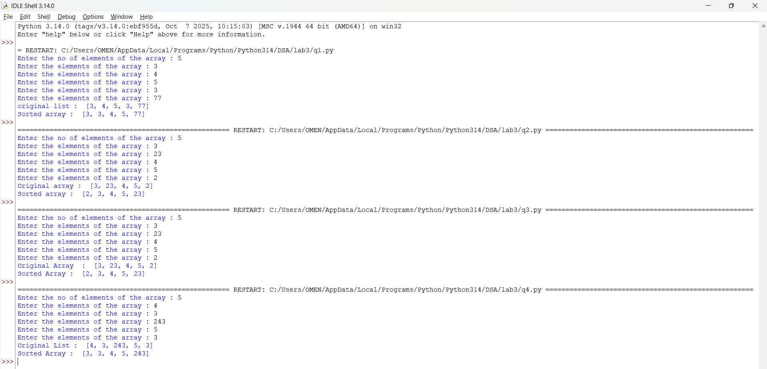
Explanation:
This program uses the Merge Sort technique to sort elements in a list using recursion.
- The function merge_sort(arr) is defined to sort the given list arr.
- The condition if len(arr) > 1: checks whether the list has more than one element.
  - If not, the list is already sorted (base case).
- The list is divided into two halves:
  - mid = len(arr) // 2 finds the middle index.
  - L = arr[:mid] stores the left half.
  - R = arr[mid:] stores the right half.
- The function recursively calls itself on both halves using merge_sort(L) and merge_sort(R).
- Three variables i, j, and k are initialized to 0:
  - i → index for left sublist
  - j → index for right sublist
  - k → index for merged list
- A while loop compares elements of L and R:
  - The smaller element is placed into arr[k].
  - Corresponding indices are incremented.
- After one sublist is exhausted, remaining elements of the other sublist are copied using two separate while loops.
- The sorted elements are merged back into the original list arr.
- The function returns the sorted list.
- The user inputs elements into the list a until "stop" is entered.
- The original list is printed, followed by the sorted list after calling merge_sort(a).

Error Table:
S.No | Error Obtained | Rectification
01. | ValueError when non-integer input is entered | Ensure input is integer or handle using try-except
02. | Program fails for empty list | Check if list is empty before sorting
03. | Incorrect merging if indices (i, j, k) are not updated properly | Ensure all indices are incremented correctly
04. | High memory usage due to creating sublists (L and R) | Use optimized in-place merge sort if required
3e)
Aim:- Write a Python program to perform Quick Sort on a given list of elements.
Program:-
def quick_sort(arr, low=0, high=None):
if high is None:
high = len(arr) - 1

if low < high:
pivot = arr[high]
i = low - 1

for j in range(low, high):
if arr[j] <= pivot:
i += 1
arr[i], arr[j] = arr[j], arr[i]
arr[i + 1], arr[high] = arr[high], arr[i + 1]
pi = i + 1
quick_sort(arr, low, pi - 1)
quick_sort(arr, pi + 1, high)

return arr

a = []
while True:
elem = input("Enter an element (or enter stop to finish):- ")
if elem.lower() == "stop":
break
a.append(int(elem))

print("Original List:", a)
sorted_list = quick_sort(a)
print("Sorted List: ", sorted_list)
Output:-
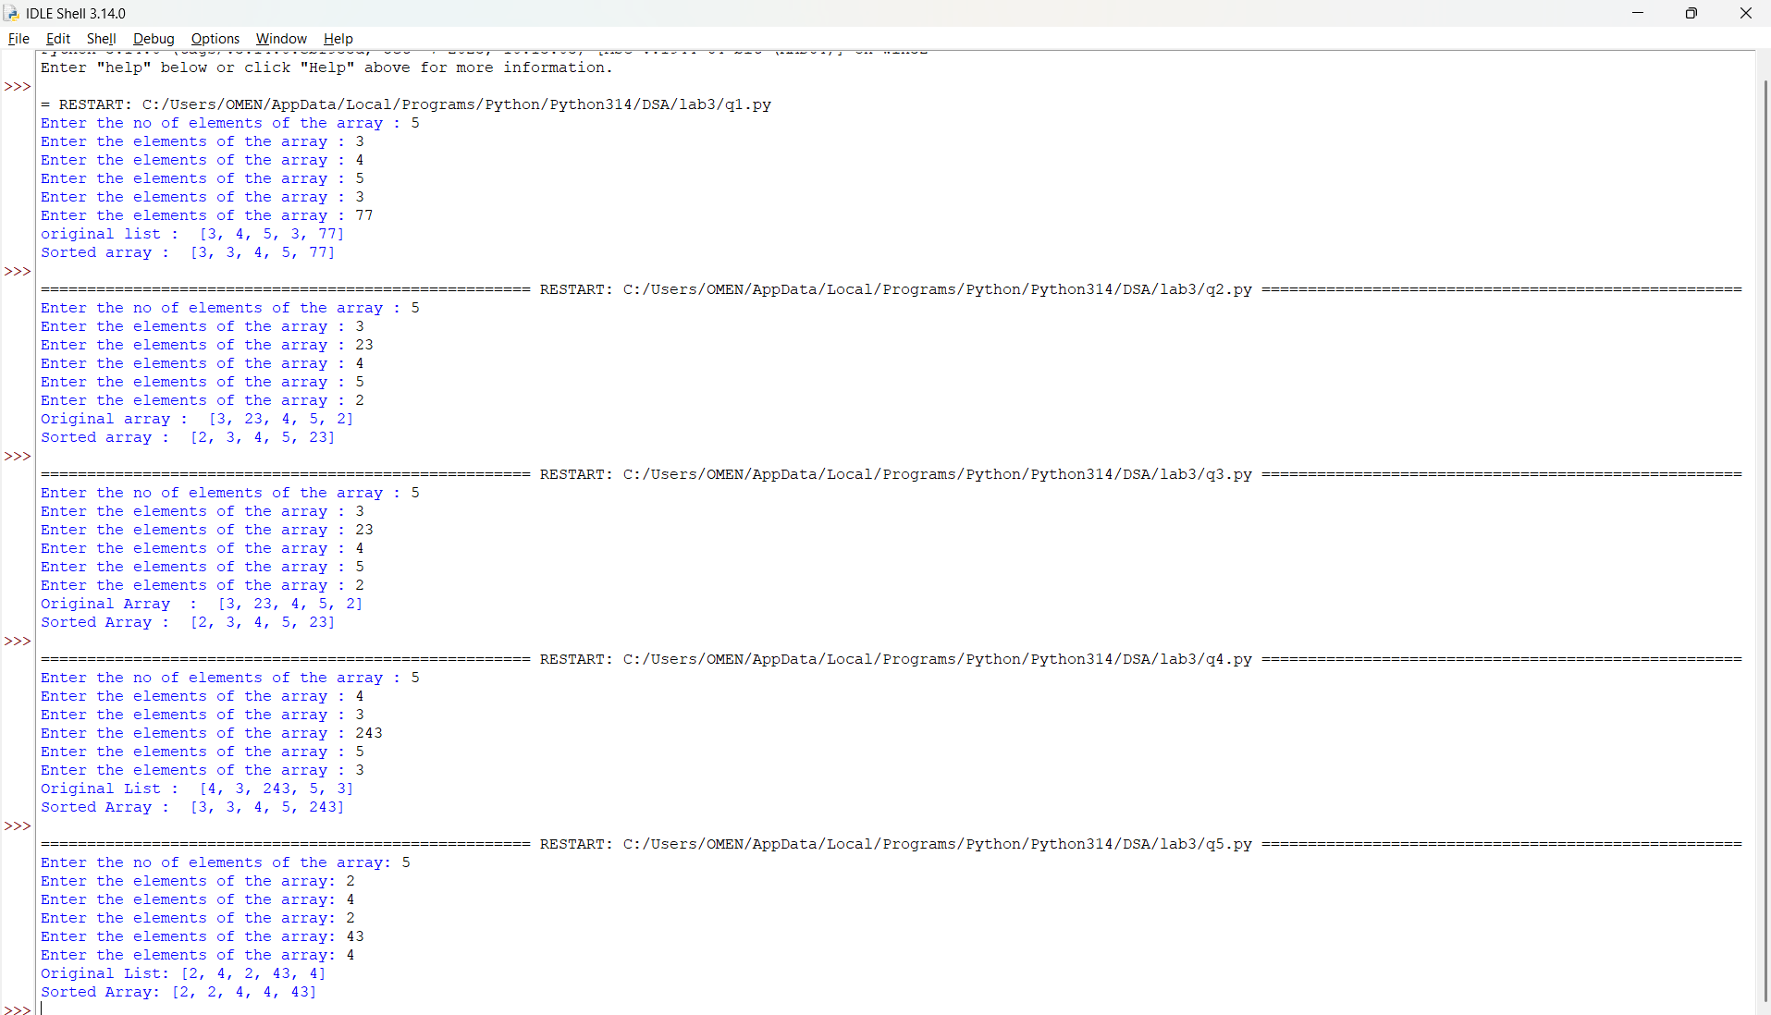

Explanation:
This program uses the Quick Sort technique to sort elements in a list using recursion.
- The function quick_sort(arr, low=0, high=None) is defined with parameters:
  - arr: The list to be sorted
  - low: Starting index (default 0)
  - high: Ending index (default last index of list)
- If high is None, it is initialized as len(arr) - 1.
- The condition if low < high: ensures that sorting is performed only when there are at least two elements.
- The last element arr[high] is chosen as the pivot.
- The variable i = low - 1 is used to track the position of smaller elements.
- A loop runs from j = low to high - 1:
  - If arr[j] <= pivot, i is incremented and elements are swapped using
arr[i], arr[j] = arr[j], arr[i].
- After the loop, the pivot is placed at its correct position using
arr[i + 1], arr[high] = arr[high], arr[i + 1].
- The pivot index pi = i + 1 divides the array into two parts.
- The function recursively sorts:
  - Left subarray → quick_sort(arr, low, pi - 1)
  - Right subarray → quick_sort(arr, pi + 1, high)
- The function returns the sorted list.
- The user inputs elements into list a until "stop" is entered.
- The original list and sorted list are printed.

Error Table:
S.No | Error Obtained | Rectification
01. | ValueError when non-integer input is entered | Ensure input is integer or handle using try-except
02. | Program fails for empty list | Check if list is empty before sorting
03. | Worst-case performance (O(n²)) for already sorted list | Use better pivot selection (e.g., middle or random pivot)
04. | Recursion depth error for very large lists | Increase recursion limit or use iterative approach

