

Week-1

1)Aim: To implement recursion in Python by creating a function that prints numbers in descending order from a given number.
Program:
"question 1"

def countdown(n):
if n > 0:
print(n)
countdown(n - 1)
n = int(input("Enter the countdown time:"))
countdown(n)
print("rocket launches!!")
Output:
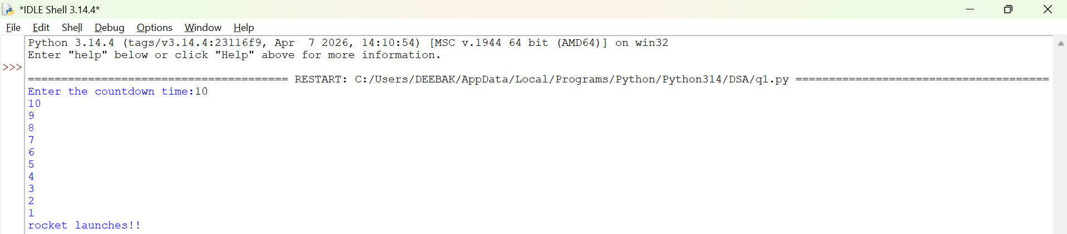
Explanation:
• The function launch(n) prints the current value of n.
• If n is greater than 0, it decreases n by 1 and calls itself recursively.
• The recursion continues until n becomes 0, which is the base case, and the function stops.

Error Table:
S.No | Error Obtained | Rectification
01. | Didn’t write the print statement after definition. | After execution I found the mistake and added it.

2)Aim: To implement a recursive binary search in Python to find the position (index) of a given element in a list. The program recursively checks each element of the list until the target element is found or the end of the list is reached.
Program:
"question 3"

def search(emp_list, key, index):
if index == len(emp_list):
return False
if emp_list[index] == key:
return True
return search(emp_list, key, index +1)
emp_list = [1000, 1001, 1002, 1003, 1004]
key = int(input("Enter employee to search"))

if search(emp_list, key, 0):
print("Employee ID found")
else:
print("Employee ID not found")

Output:
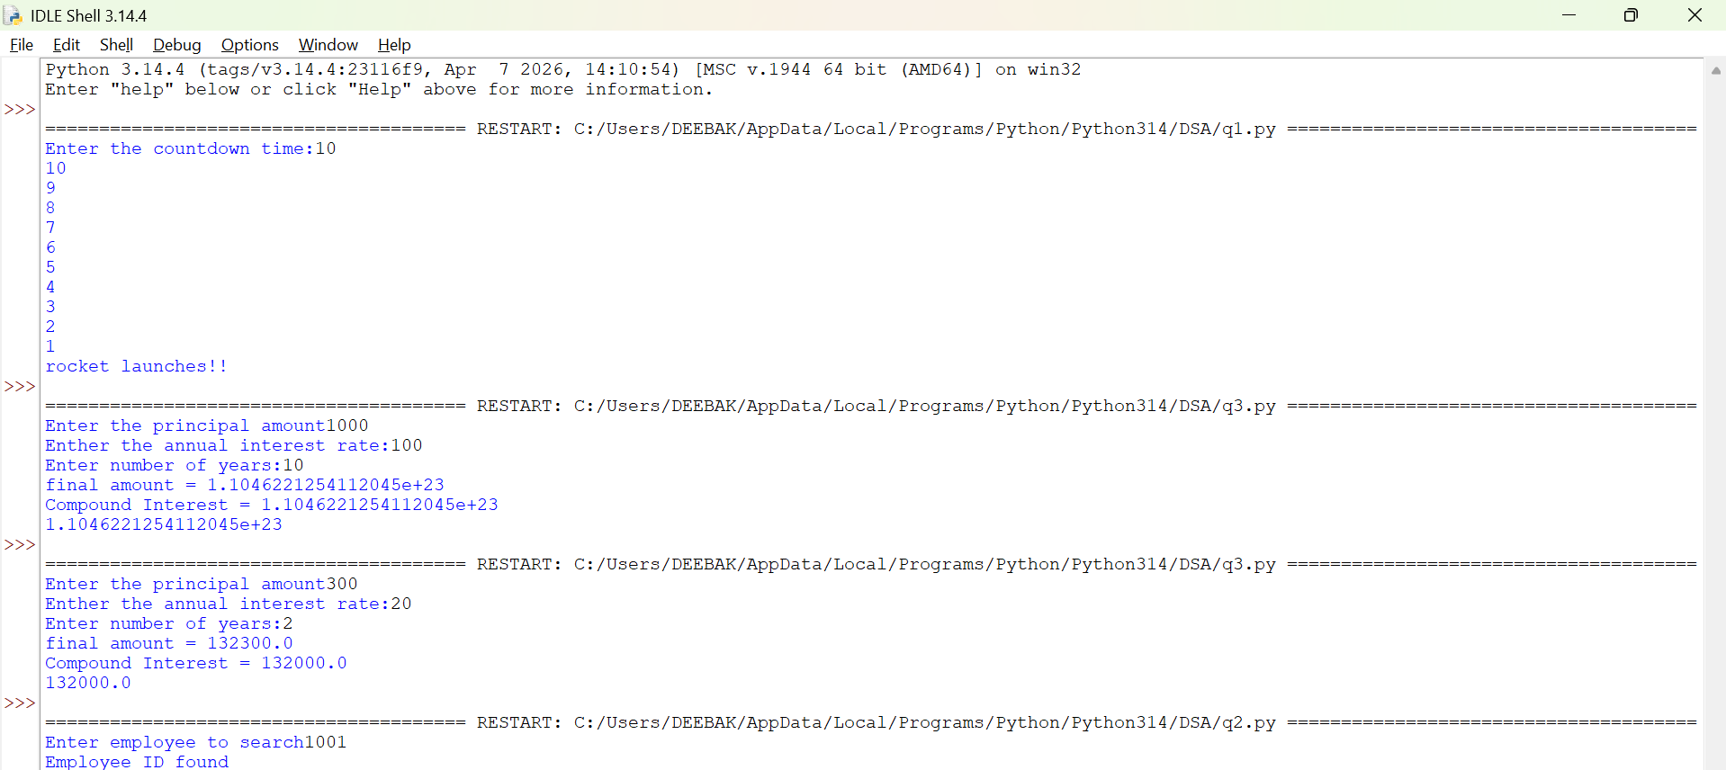

Explanation:
This program uses recursion to perform a linear search for an employee ID (or any target element) in a list.
- The function empid_Search(arr, target, n=0) is defined with three parameters:
  - arr: The list in which the search is performed.
  - target: The element to be searched.
  - n: The current index, initialized to 0.
- The statement if n == len(arr): return -1 is the base condition. It checks whether all elements in the list have been examined. If the end of the list is reached without finding the target, the function returns -1.
- The statement if arr[n] == target: return n compares the current element with the target. If they are equal, the function returns the current index where the target is found.
- If the current element does not match the target, the function calls itself recursively with the next index using return empid_Search(arr, target, n + 1).
- The list arr = [10, 20, 30, 50, 607, 809, 506] is created, and the function is called to search for the element 50.
- The returned value is stored in the variable result.
- If result is not equal to -1, the program prints the index where the element is found. Otherwise, it prints "Element not found."
Error table:
S.No | Error Obtained | Rectification
01. | Recursion Error: maximum recursion depth exceeded | Increment the index in the recursive call: return empid_Search(arr, target, n + 1).

3)Aim: This Python program uses recursion to calculate the value of pⁿ (p raised to the power n).
Program:
"question 2"

def power(base, exp):
if exp == 0:
return 1
return base * power(base, exp - 1)

P = float(input("Enter the principal amount"))
r = float(input("Enther the annual interest rate:"))
n = int(input("Enter number of years:"))
A = P * power(1 + r, n)
compound_interest = A - P
print("final amount =", round(A, 2))
print("Compound Interest =", round(compound_interest, 2))
print(compound_interest)
Output:
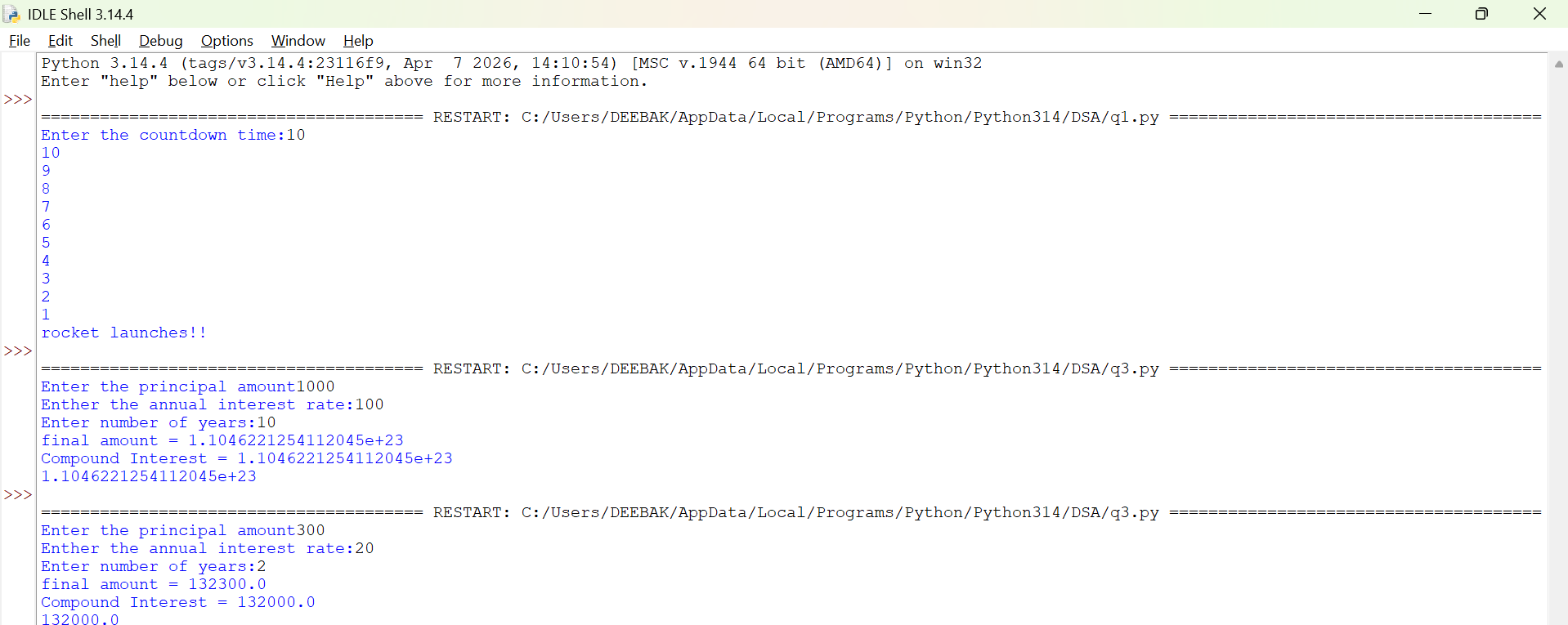
Explanation:
• The program is used to find the power of a number (pⁿ) using recursion.
• It takes two inputs from the user:
- p → Base number
- n → Exponent (power)
• The function power(p, n) is called to calculate the result.
• If the exponent n is 0, the function returns 1 because any number raised to the power 0 is
• If n is not 0, the function calls itself with n - 1 and multiplies the result by p.
• This recursive process continues until the exponent becomes 0.
• After reaching the base case, each recursive call returns its result, and the final value of pⁿ is obtained.
• The result is stored in the variable result.
• Finally, the program prints the calculated power of the given number.

Error Table:
S.No | Error Obtained | Rectification
01. | Not a int value of n we can also take float in place of int, I have taken float value to check. | By replacing int by float.

4)Aim: To write a Python program that generates and prints the Fibonacci series up to n terms using recursion.
Program:
"question 4"

def factorial(n):
if n == 0 or n == 1:
return 1
return n*factorial(n - 1)

n = int(input("Enter the number of possible ways to arrange n different parcels: "))
factorial(n)
print(factorial(n))
Output:
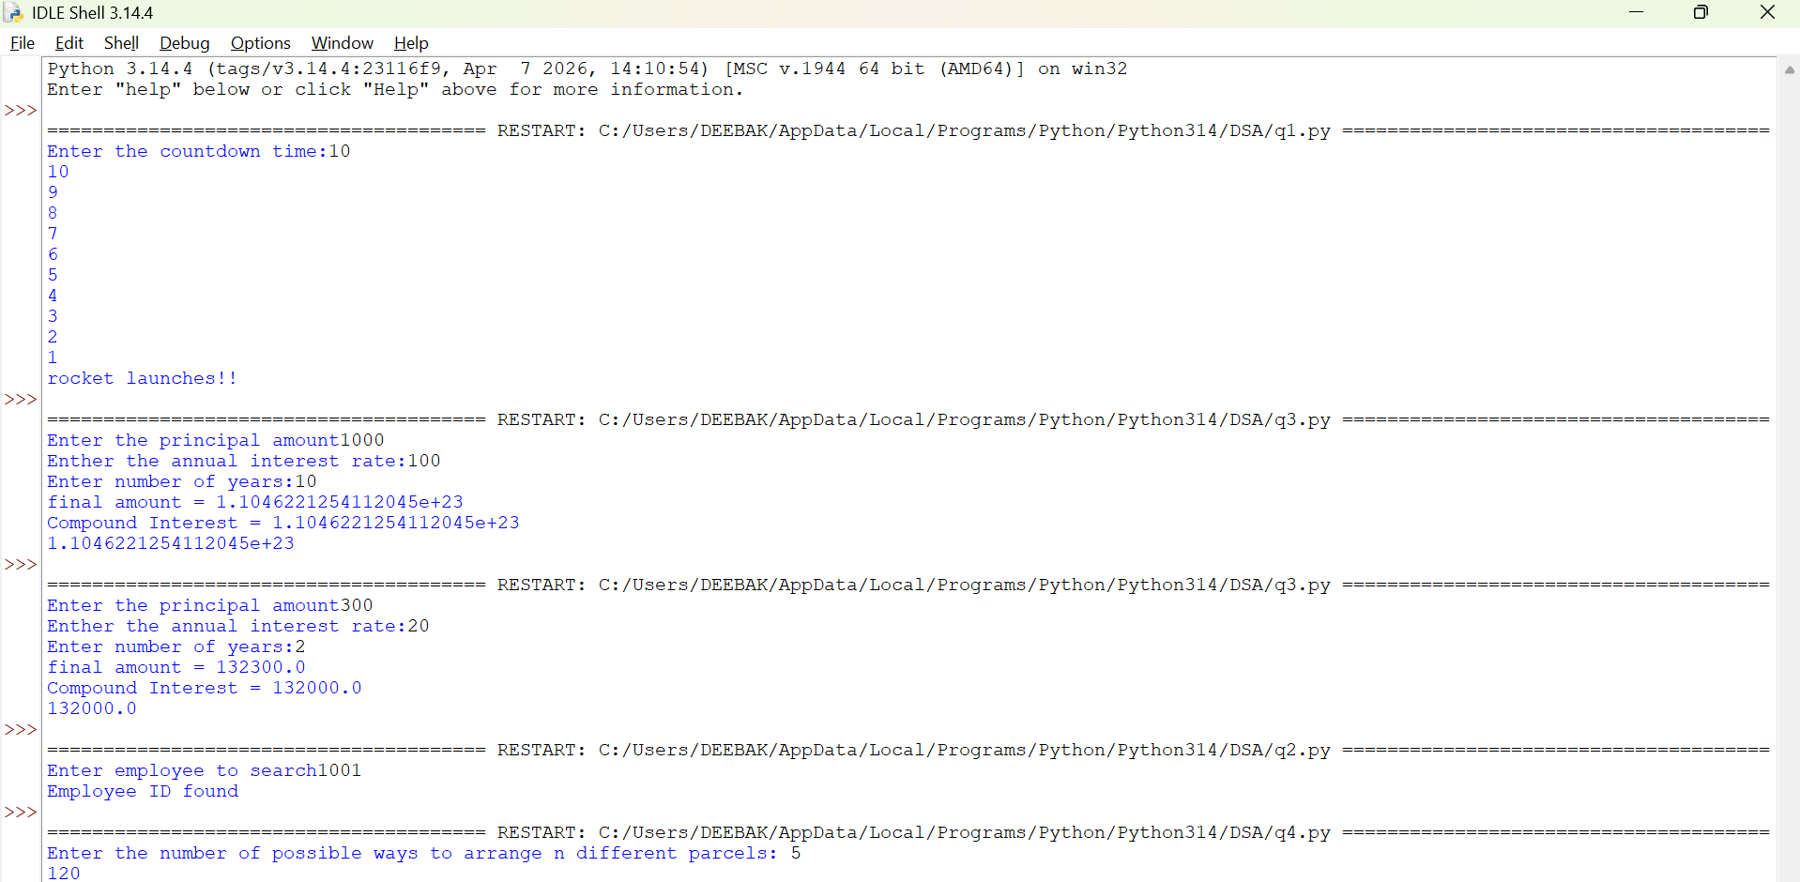

Explanation:
• The program uses a recursive function fib(n) to generate Fibonacci numbers.
• The base condition returns 0 when n = 0 and 1 when n = 1.
• For values greater than 1, the function returns the sum of the previous two Fibonacci numbers: fib(n-1) + fib(n-2).
• The user enters the number of terms (n) to be displayed.
• A for loop calls the fib() function repeatedly for each term from 0 to n-1.
• Finally, the program prints the Fibonacci series in sequence.
Error Table:
S.No | Error Obtained | Rectification
01. | No Errors obtained | -----------------------------------------

5)Aim: To write a Python program to find the factorial of a given number using recursion.
Program:
"question 5"

def fibbanocci(n):
if n == 0 or n == 1:
return 1
return fibbanocci(n - 1) + fibbanocci(n - 2)
n = int(input("Enter the number of fibbanocci terms"))
fibbanocci(n)
print(fibbanocci(n))
Output:
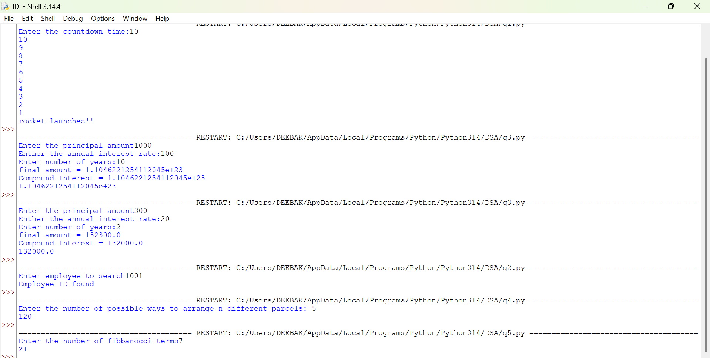

Explanation:
• The program defines a recursive function fact(n) to calculate the factorial of a number.
• The base condition checks if n <= 1. If true, it returns 1 (for factorial, 0! = 1 and 1! = 1).
• Otherwise, the function returns n * fact(n-1), multiplying the current number by the factorial of the previous number.
• The function is called with the value 6.
• Finally, the program prints the factorial of 6, which is 720.
Error Table:
S.No | Error Obtained | Rectification
01. | No Errors obatined | ---------------------------------------------------
Week-2
1)Aim:- Write a program to perform linear search on the given input.
Program:-
"""question1

write a python program to perform Linear Search on the given input"""

def linear_search(arr, key):
for i in range(len(arr)):
if arr[i] == key:
return i
return -1
n = int (input("Enter no of element : "))
arr = []
for j in range(n):
a = int(input("Enter the values of the array : "))
arr.append(a)
key = int(input("Enter the element to search : "))
result = linear_search(arr, key)
if result != -1:
print("Element found at index", result)
else:
print("Element not found")
Output:-
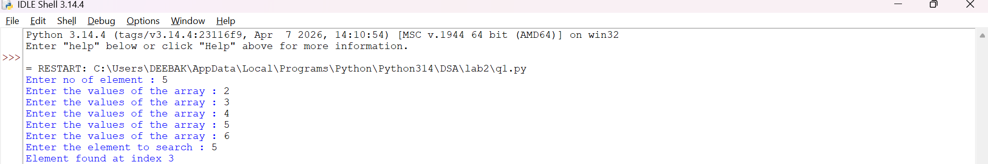
Explanation:-
This program uses a linear search technique to find a target element in a list.
- The function linear_search(arr, target) is defined with two parameters:
  - arr: The list in which the search is performed.
  - target: The element to be searched.
- A for loop is used to traverse each element of the list from index 0 to len(arr) - 1.
- The statement if arr[i] == target: compares each element of the list with the target element.
- If the element is found, the function returns "at position", i + 1, which gives the position of the element (starting from 1).
- If the loop completes without finding the element, the function returns "element not found".
- An empty list a is created, and the user is asked to input elements continuously.
- The loop continues until the user enters "stop", after which the input process ends.
- The user then enters the element to be searched, which is stored in variable b.
- The function is called using linear_search(a, b) and the result is printed.

Error Table and negatives where the code doesn’t give the effective result:-
S.No | Error Obtained | Rectification
01 | ValueError when entering non-integer input | Ensure only integer values are entered or handle using
02 | Program crashes if empty input is given before converting to int | Validate input before conversion
03 | Element not found even if list is empty | Check if list is empty before searching
04 | If duplicate elements exist, only first occurrence is returned | Modify logic if all occurrences are needed
05 | Program does not handle very large lists efficiently | Use better algorithms like binary search (for sorted lists)
2)Aim:-Write a python program to perform binary search on the given input verify by taking sorted array and unsorted array as a input:-
Program:-
(a)Sorted Array:
""" question 2
Write a python program to perform Binary Search on the given input.
Verify by taking Sorted array and unsorted array as a input"""

""" question 2(sorted array)"""

def binary_search(arr, key):
low = 0
high = len(arr) - 1
while low <= high :
mid = (low + high ) // 2
if arr[mid] == key:
return mid
elif arr[mid] < key:
low = mid + 1
else:
high = mid - 1
return -1
n = int(input("Enter no of elements : "))
arr = []
for i in range(n):
a = int(input("Enter the elements of the array : "))
arr.append(a)
key = int(input("Enter the elements to search : "))
result = binary_search(arr, key)
if result != -1:
print("Element found at the index : ",result)
else:
print("Element is not found")

(b) Unsorted Array:
"""question 2(array is not sorted)"""

def binary_search(arr, key):
low = 0
high = len(arr) - 1
while low <= high:
mid = (low + high)// 2
if arr[mid] == key:
return mid
elif arr[mid] < key:
low = mid +1
else:
high = mid - 1
return -1
n = int(input("Enter the no of elements of the array : "))
arr = []
for i in range(n):
a = int(input("Enter the elements of the array : "))
arr.append(a)
key = int(input("Enter the element to search : "))
if arr == sorted(arr):
print("The input list is already sorted")
else:
print("The input list is not sorted")
print("Sorting the element")
arr.sort()
print("Sorted List : ", arr)
result = binary_search(arr, key)
if result != -1:
print("Element found at the index : ",result)
else:
print("Element not found")

Output:-
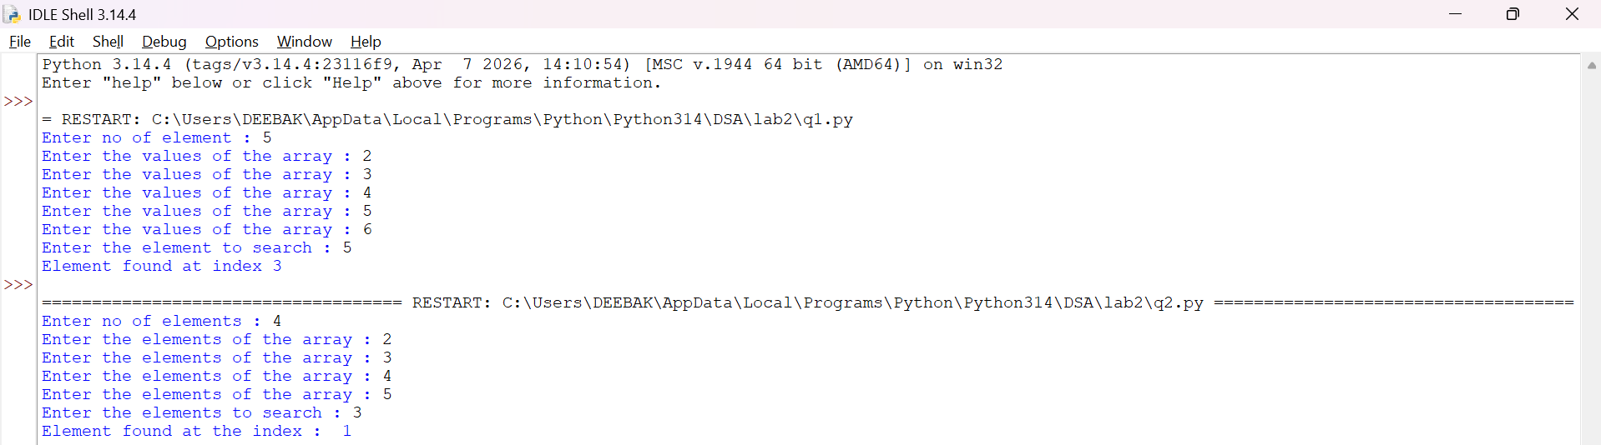
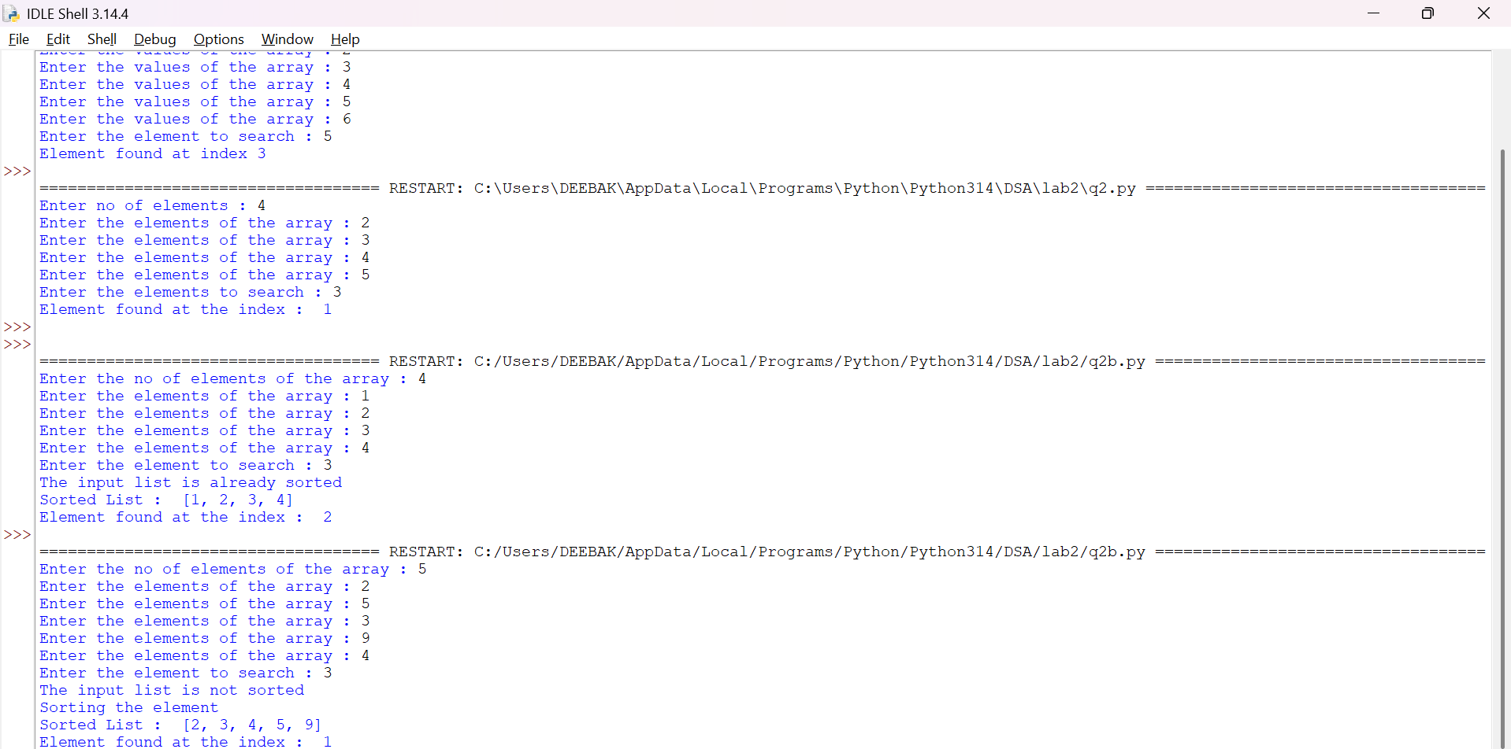
Explanation:-
This program uses the binary search technique to find a target element in a list.
- The function binary_search(arr, target) is defined to perform the search operation.
- Two variables are initialized:
  - low = 0: Represents the starting index of the list.
  - high = len(arr) - 1: Represents the last index of the list.
- A while loop runs as long as low <= high, ensuring the search space is valid.
- The middle index is calculated using mid = (low + high) // 2.
- The statement if arr[mid] == target: checks whether the middle element is equal to the target.
  - If true, the function returns "at position", mid.
- If the target is greater than the middle element (target > arr[mid]), the search continues in the right half by updating low = mid + 1.
- Otherwise, the search continues in the left half by updating high = mid - 1.
- The user inputs elements into the list a until "stop" is entered.
- The list is sorted using a.sort().
  - This ensures that even if the user enters an unsorted array, the binary search will still work correctly.
- The user enters the element to be searched, stored in variable b.
- The function is called using binary_search(a, b) and the result is printed.
Error Table and negatives where the code doesn’t give the effective result:-
Sno | Error Obtained | Rectification
01 | ValueError when non-integer input is entered | Ensure inputs are integers or use
02 | Incorrect position (0-based index returned) | Use mid + 1 if position should start from 1
03 | Program fails if list is empty | Check if list is empty before searching
04 | Binary search requires sorted array | Sorting is already handled using
05 | Element not found but no explicit message returned | Add return "element not found" after loop
06 | Output format shows tuple like ('at position', 2) | Use formatted print statement for better output
07 | Duplicate elements return only one occurrence | Modify logic if all positions are needed
08 | Sorting changes original order of elements | Inform user that positions are based on sorted list

