 DATA STRUCUTRES AND ALGORITHMS
23CSE203
LAB MANUAL

Submitted by

Name | DEEPAK E
Roll No | AV.SC.U4CSE25027
Year/Sem/Section | 2nd year/Sem-3/CSE-A
Credits | 05

Submitted to

Name | Dr. RAJ KUMAR BATCHU
Department | School of Computing
Designation | Asst. Professor (SI Grade)

S.NO | TITLE | PAGE NO | REMARKS
1. | WEEK 1: 1a. Recursive countdown from n to Launch.  1b. Recursive calculation of compound growth factor.  1c. Recursive search for employee ID in list.  1d. Recursive factorial calculation for parcel arrangements.  1e. Recursive Fibonacci series generation. | 4 - 12
2. | WEEK 2: 2a. Write a python program to perform linear search on the give input.  2b. Write a python program to perform binary search on the given. Verify by taking sorted array as an input.  2c. Write a python program to perform binary search on the given. Verify by taking unsorted array as an input. | 13 – 19
3. | WEEK 3: 3a. Write a program to perform Bubble Sort technique on the user given input.  3b. Write a program to perform Insertion Sort technique on the user given input.  3c. Write a program to perform Selection Sort technique on the user given input.  3d. Write a program to perform Merge Sort technique on the user given input.  3e. Write a program to perform Quick Sort technique on the user given input. | 20- 31
4. | WEEK 4: 4a. Write a python program to implement a single linked list which would perform the below operations, by taking an input from the user.  a. Create a linked list. | 32 - 40
4. | b. Insert at beginning. c. Insert at end.  d. Insert at a specific index.  e. Delete by value. f. Delete 1st node.  g. Delete last node. h. Count no. of nodes i. Display. j. Exit.  4b. Write a python program to implement a double linked list which would perform the below operations, by taking an input from the user.  4c. Write a python program to implement a circular linked list which would perform the below operations, by taking an input from the user. Also add these two options accordingly.  - Display head and tail.  - Print data from tail to head. | 32 - 61
5. | WEEK 5: Write a python program to implement a stack using an Array, Linked list. Implement the stack operations such as push, pop, peak and also display the stack elements. | 62 - 68

Week-1

1)Aim: To implement recursion in Python by creating a function that prints numbers in descending order from a given number.
Program:
"question 1"

def countdown(n):
if n > 0:
print(n)
countdown(n - 1)
n = int(input("Enter the countdown time:"))
countdown(n)
print("rocket launches!!")
Output:
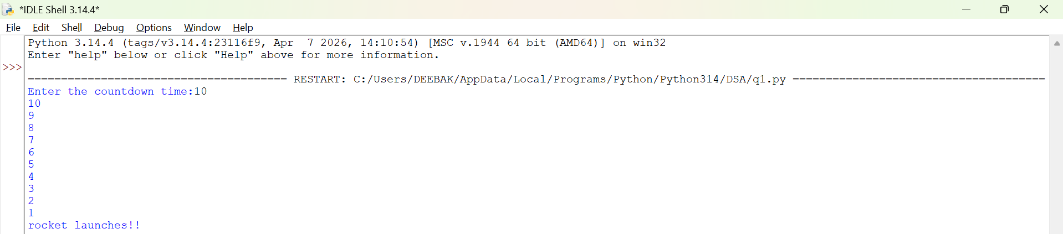
Explanation:
• The function launch(n) prints the current value of n.
• If n is greater than 0, it decreases n by 1 and calls itself recursively.
• The recursion continues until n becomes 0, which is the base case, and the function stops.

Error Table:
S.No | Error Obtained | Rectification
01. | Didn’t write the print statement after definition. | After execution I found the mistake and added it.

2)Aim: To implement a recursive binary search in Python to find the position (index) of a given element in a list. The program recursively checks each element of the list until the target element is found or the end of the list is reached.
Program:
"question 3"

def search(emp_list, key, index):
if index == len(emp_list):
return False
if emp_list[index] == key:
return True
return search(emp_list, key, index +1)
emp_list = [1000, 1001, 1002, 1003, 1004]
key = int(input("Enter employee to search"))

if search(emp_list, key, 0):
print("Employee ID found")
else:
print("Employee ID not found")

Output:
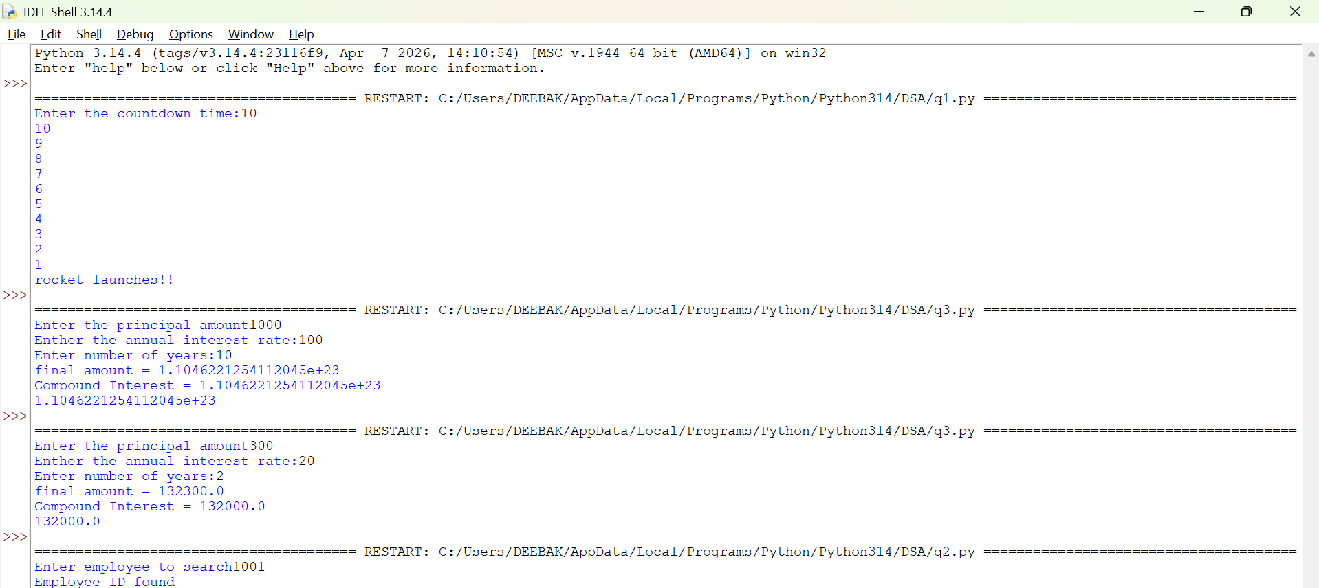

Explanation:
This program uses recursion to perform a linear search for an employee ID (or any target element) in a list.
- The function empid_Search(arr, target, n=0) is defined with three parameters:
  - arr: The list in which the search is performed.
  - target: The element to be searched.
  - n: The current index, initialized to 0.
- The statement if n == len(arr): return -1 is the base condition. It checks whether all elements in the list have been examined. If the end of the list is reached without finding the target, the function returns -1.
- The statement if arr[n] == target: return n compares the current element with the target. If they are equal, the function returns the current index where the target is found.
- If the current element does not match the target, the function calls itself recursively with the next index using return empid_Search(arr, target, n + 1).
- The list arr = [10, 20, 30, 50, 607, 809, 506] is created, and the function is called to search for the element 50.
- The returned value is stored in the variable result.
- If result is not equal to -1, the program prints the index where the element is found. Otherwise, it prints "Element not found."
Error table:
S.No | Error Obtained | Rectification
01. | Recursion Error: maximum recursion depth exceeded | Increment the index in the recursive call: return empid_Search(arr, target, n + 1).

3)Aim: This Python program uses recursion to calculate the value of pⁿ (p raised to the power n).
Program:
"question 2"

def power(base, exp):
if exp == 0:
return 1
return base * power(base, exp - 1)

P = float(input("Enter the principal amount"))
r = float(input("Enther the annual interest rate:"))
n = int(input("Enter number of years:"))
A = P * power(1 + r, n)
compound_interest = A - P
print("final amount =", round(A, 2))
print("Compound Interest =", round(compound_interest, 2))
print(compound_interest)
Output:
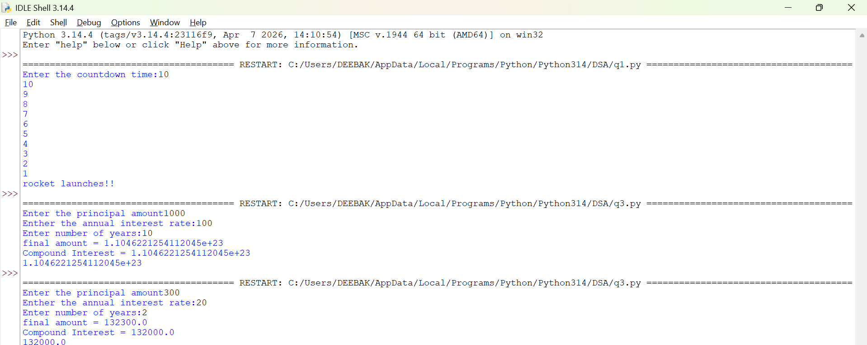
Explanation:
• The program is used to find the power of a number (pⁿ) using recursion.
• It takes two inputs from the user:
- p → Base number
- n → Exponent (power)
• The function power(p, n) is called to calculate the result.
• If the exponent n is 0, the function returns 1 because any number raised to the power 0 is
• If n is not 0, the function calls itself with n - 1 and multiplies the result by p.
• This recursive process continues until the exponent becomes 0.
• After reaching the base case, each recursive call returns its result, and the final value of pⁿ is obtained.
• The result is stored in the variable result.
• Finally, the program prints the calculated power of the given number.

Error Table:
S.No | Error Obtained | Rectification
01. | Not a int value of n we can also take float in place of int, I have taken float value to check. | By replacing int by float.

4)Aim: To write a Python program that generates and prints the Fibonacci series up to n terms using recursion.
Program:
"question 4"

def factorial(n):
if n == 0 or n == 1:
return 1
return n*factorial(n - 1)

n = int(input("Enter the number of possible ways to arrange n different parcels: "))
factorial(n)
print(factorial(n))
Output:
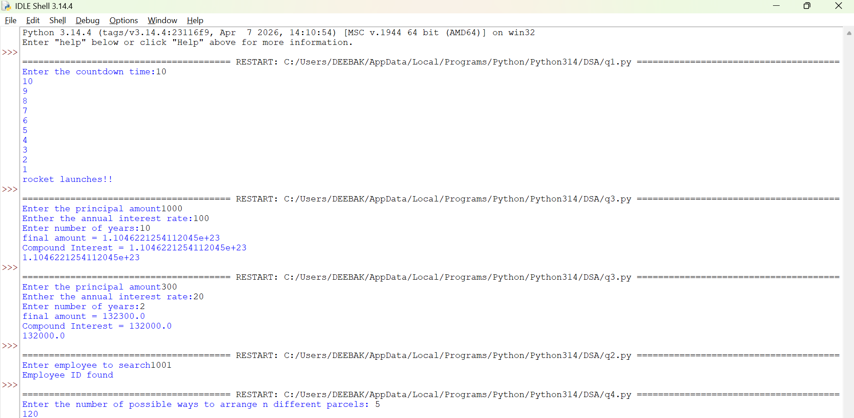

Explanation:
• The program uses a recursive function fib(n) to generate Fibonacci numbers.
• The base condition returns 0 when n = 0 and 1 when n = 1.
• For values greater than 1, the function returns the sum of the previous two Fibonacci numbers: fib(n-1) + fib(n-2).
• The user enters the number of terms (n) to be displayed.
• A for loop calls the fib() function repeatedly for each term from 0 to n-1.
• Finally, the program prints the Fibonacci series in sequence.
Error Table:
S.No | Error Obtained | Rectification
01. | No Errors obtained | -----------------------------------------

5)Aim: To write a Python program to find the factorial of a given number using recursion.
Program:
"question 5"

def fibbanocci(n):
if n == 0 or n == 1:
return 1
return fibbanocci(n - 1) + fibbanocci(n - 2)
n = int(input("Enter the number of fibbanocci terms"))
fibbanocci(n)
print(fibbanocci(n))
Output:
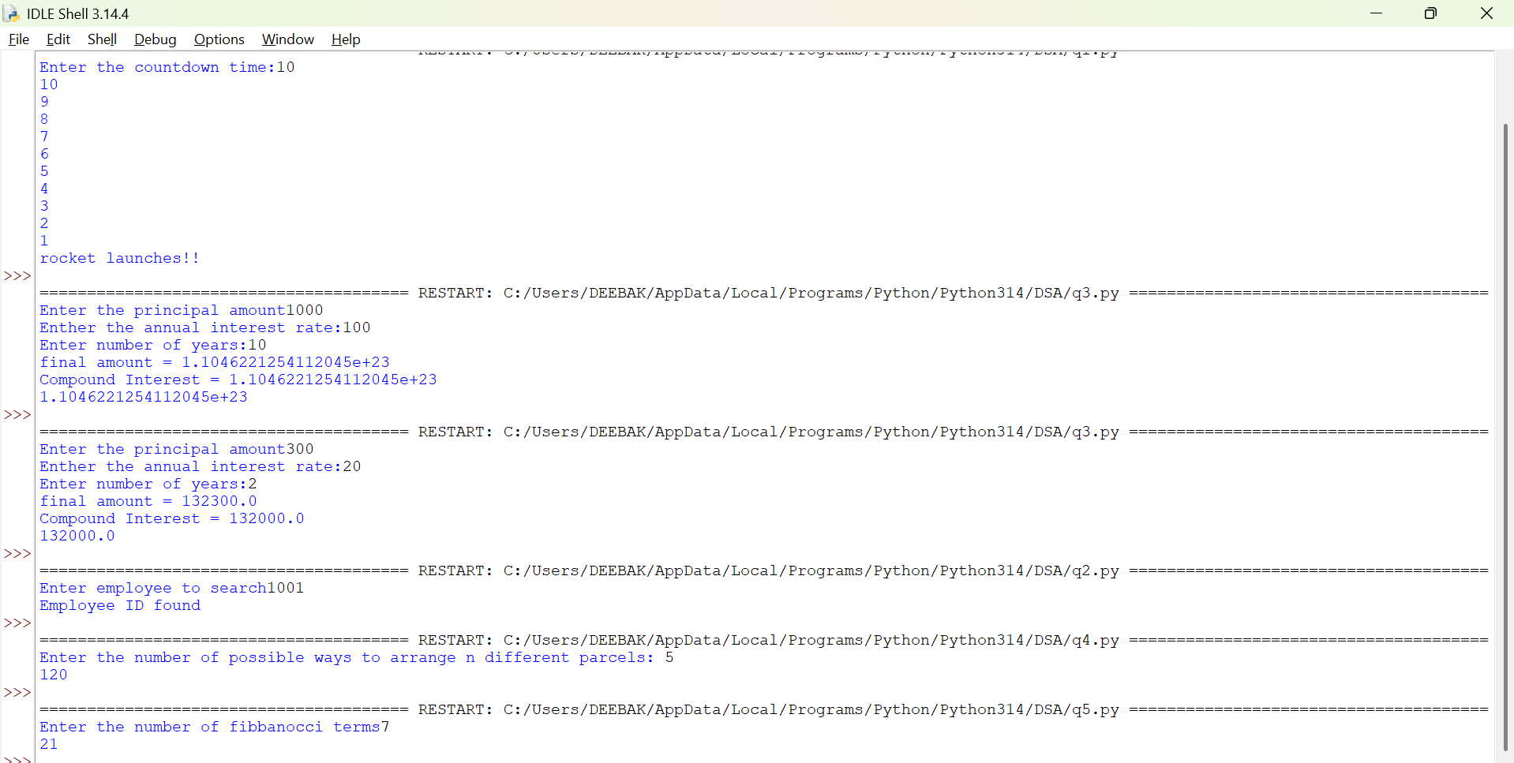

Explanation:
• The program defines a recursive function fact(n) to calculate the factorial of a number.
• The base condition checks if n <= 1. If true, it returns 1 (for factorial, 0! = 1 and 1! = 1).
• Otherwise, the function returns n * fact(n-1), multiplying the current number by the factorial of the previous number.
• The function is called with the value 6.
• Finally, the program prints the factorial of 6, which is 720.
Error Table:
S.No | Error Obtained | Rectification
01. | No Errors obatined | ---------------------------------------------------

Week-2
1)Aim:- Write a program to perform linear search on the given input.
Program:-
"""question1

write a python program to perform Linear Search on the given input"""

def linear_search(arr, key):
for i in range(len(arr)):
if arr[i] == key:
return i
return -1
n = int (input("Enter no of element : "))
arr = []
for j in range(n):
a = int(input("Enter the values of the array : "))
arr.append(a)
key = int(input("Enter the element to search : "))
result = linear_search(arr, key)
if result != -1:
print("Element found at index", result)
else:
print("Element not found")
Output:-
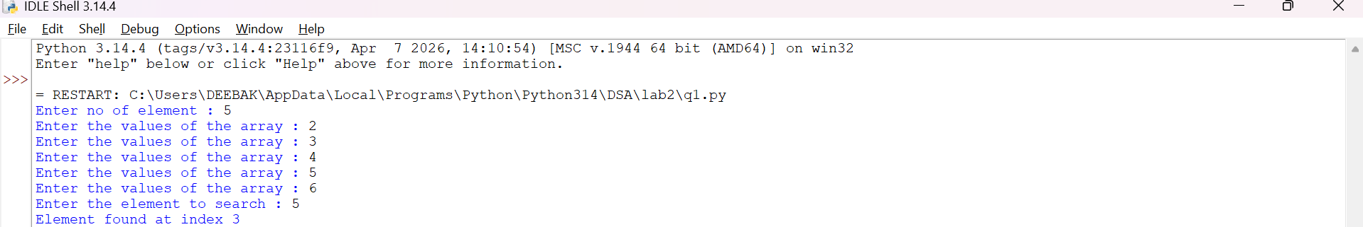
Explanation:-
This program uses a linear search technique to find a target element in a list.
- The function linear_search(arr, target) is defined with two parameters:
  - arr: The list in which the search is performed.
  - target: The element to be searched.
- A for loop is used to traverse each element of the list from index 0 to len(arr) - 1.
- The statement if arr[i] == target: compares each element of the list with the target element.
- If the element is found, the function returns "at position", i + 1, which gives the position of the element (starting from 1).
- If the loop completes without finding the element, the function returns "element not found".
- An empty list a is created, and the user is asked to input elements continuously.
- The loop continues until the user enters "stop", after which the input process ends.
- The user then enters the element to be searched, which is stored in variable b.
- The function is called using linear_search(a, b) and the result is printed.

Error Table and negatives where the code doesn’t give the effective result:-
S.No | Error Obtained | Rectification
01 | ValueError when entering non-integer input | Ensure only integer values are entered or handle using
02 | Program crashes if empty input is given before converting to int | Validate input before conversion
03 | Element not found even if list is empty | Check if list is empty before searching
04 | If duplicate elements exist, only first occurrence is returned | Modify logic if all occurrences are needed
05 | Program does not handle very large lists efficiently | Use better algorithms like binary search (for sorted lists)
2)Aim:-Write a python program to perform binary search on the given input verify by taking sorted array and unsorted array as a input:-
Program:-
(a)Sorted Array:
""" question 2
Write a python program to perform Binary Search on the given input.
Verify by taking Sorted array and unsorted array as a input"""

""" question 2(sorted array)"""

def binary_search(arr, key):
low = 0
high = len(arr) - 1
while low <= high :
mid = (low + high ) // 2
if arr[mid] == key:
return mid
elif arr[mid] < key:
low = mid + 1
else:
high = mid - 1
return -1
n = int(input("Enter no of elements : "))
arr = []
for i in range(n):
a = int(input("Enter the elements of the array : "))
arr.append(a)
key = int(input("Enter the elements to search : "))
result = binary_search(arr, key)
if result != -1:
print("Element found at the index : ",result)
else:
print("Element is not found")

(b) Unsorted Array:
"""question 2(array is not sorted)"""

def binary_search(arr, key):
low = 0
high = len(arr) - 1
while low <= high:
mid = (low + high)// 2
if arr[mid] == key:
return mid
elif arr[mid] < key:
low = mid +1
else:
high = mid - 1
return -1
n = int(input("Enter the no of elements of the array : "))
arr = []
for i in range(n):
a = int(input("Enter the elements of the array : "))
arr.append(a)
key = int(input("Enter the element to search : "))
if arr == sorted(arr):
print("The input list is already sorted")
else:
print("The input list is not sorted")
print("Sorting the element")
arr.sort()
print("Sorted List : ", arr)
result = binary_search(arr, key)
if result != -1:
print("Element found at the index : ",result)
else:
print("Element not found")

Output:-
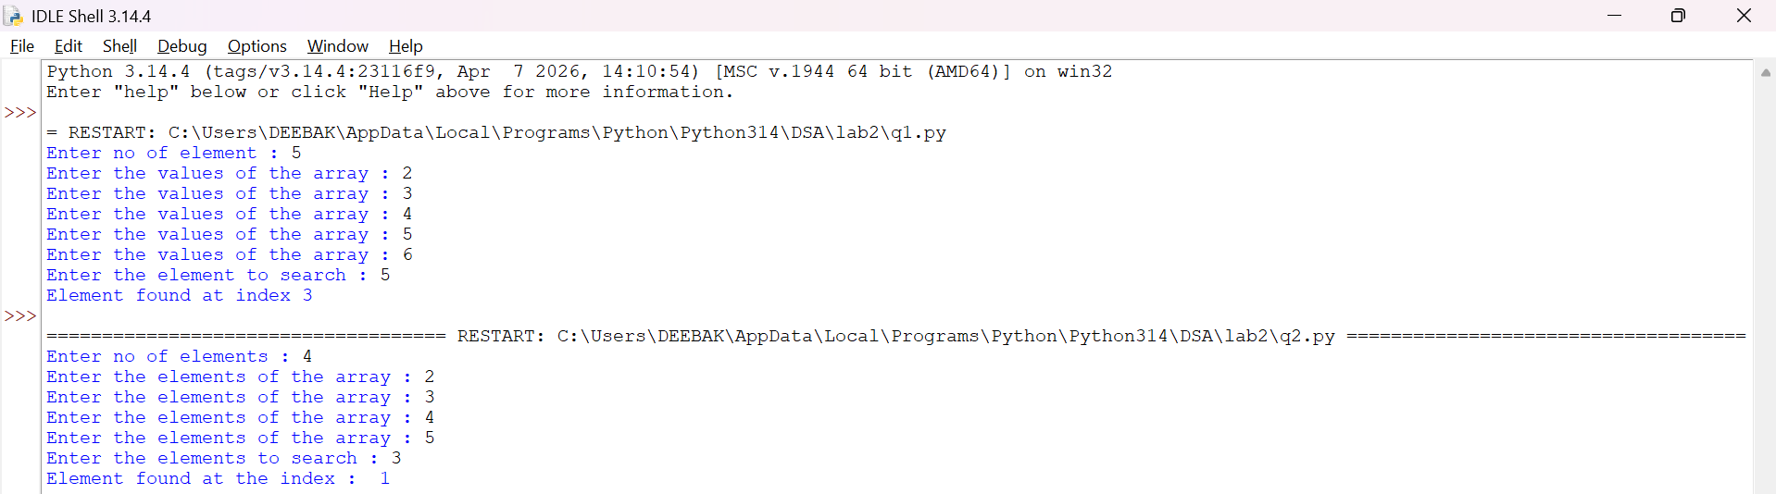
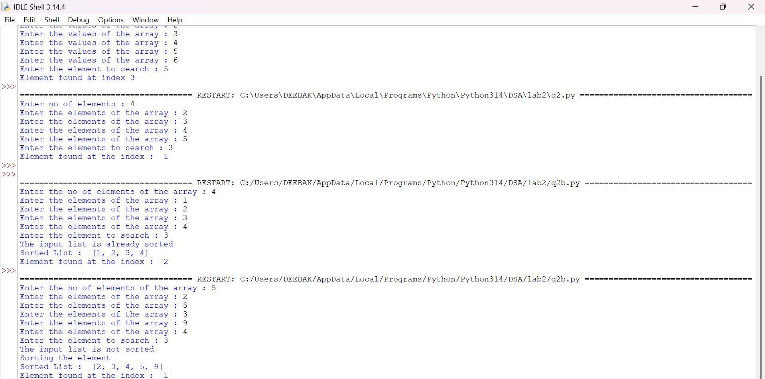
Explanation:-
This program uses the binary search technique to find a target element in a list.
- The function binary_search(arr, target) is defined to perform the search operation.
- Two variables are initialized:
  - low = 0: Represents the starting index of the list.
  - high = len(arr) - 1: Represents the last index of the list.
- A while loop runs as long as low <= high, ensuring the search space is valid.
- The middle index is calculated using mid = (low + high) // 2.
- The statement if arr[mid] == target: checks whether the middle element is equal to the target.
  - If true, the function returns "at position", mid.
- If the target is greater than the middle element (target > arr[mid]), the search continues in the right half by updating low = mid + 1.
- Otherwise, the search continues in the left half by updating high = mid - 1.
- The user inputs elements into the list a until "stop" is entered.
- The list is sorted using a.sort().
  - This ensures that even if the user enters an unsorted array, the binary search will still work correctly.
- The user enters the element to be searched, stored in variable b.
- The function is called using binary_search(a, b) and the result is printed.
Error Table and negatives where the code doesn’t give the effective result:-
Sno | Error Obtained | Rectification
01 | ValueError when non-integer input is entered | Ensure inputs are integers or use
02 | Incorrect position (0-based index returned) | Use mid + 1 if position should start from 1
03 | Program fails if list is empty | Check if list is empty before searching
04 | Binary search requires sorted array | Sorting is already handled using
05 | Element not found but no explicit message returned | Add return "element not found" after loop
06 | Output format shows tuple like ('at position', 2) | Use formatted print statement for better output
07 | Duplicate elements return only one occurrence | Modify logic if all positions are needed
08 | Sorting changes original order of elements | Inform user that positions are based on sorted list

WEEK-3
3a)Aim:- Write a Python program to perform Bubble Sort on a given list of elements.
Program:-
def bubble_sort(arr):
n = len(arr)
for i in range(n):
swapped = False
for j in range(0, n - i - 1):
if arr[j] > arr[j + 1]:
arr[j], arr[j + 1] = arr[j + 1], arr[j]
swapped = True
if not swapped:
break
return arr

a = []
while True:
elem = input("Enter an element (or enter stop to finish):- ")
if elem.lower() == "stop":
break
a.append(int(elem))

print("Original List:", a)
sorted_list = bubble_sort(a)
print("Sorted List: ", sorted_list)
OUTPUT:-
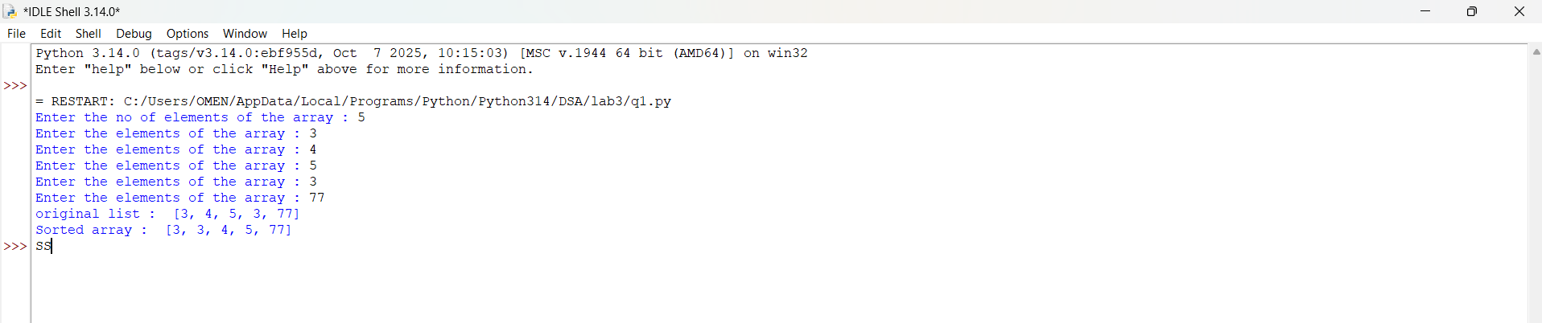
Explanation:
This program uses the Bubble Sort technique to sort elements in a list.
- The function bubble_sort(arr) is defined to sort the given list arr.
- The variable n = len(arr) stores the number of elements in the list.
- A loop runs from i = 0 to n-1, representing each pass of the sorting process.
- A variable swapped is initialized as False at the beginning of each pass.
  - It is used to check whether any swapping occurred during the pass.
- Another loop runs from j = 0 to n-i-2, comparing adjacent elements.
- The condition if arr[j] > arr[j + 1]: checks if the current element is greater than the next element.
  - If true, the elements are swapped using arr[j], arr[j + 1] = arr[j + 1], arr[j].
  - The variable swapped is set to True.
- After each pass, if no swapping occurs (swapped == False), the loop breaks early.
  - This indicates that the list is already sorted.
- The function returns the sorted list.
- The user inputs elements into the list a until "stop" is entered.
- The original list is printed, followed by the sorted list after calling bubble_sort(a).

Error Table:
S.No | Error Obtained | Rectification
01. | ValueError when non-integer input is entered | Ensure input is integer or handle using try-except
02. | Program fails for empty list (no elements entered) | Check if list is empty before sorting
03. | Sorting modifies original list | Use a copy of list if original order must be preserved
04. | Inefficient for large inputs (high time complexity) | Use faster algorithms like merge sort or quick sort
3b)
Aim:-
Write a Python program to perform Insertion Sort on a given list of elements.
Program:-
def insertion_sort(arr):
for i in range(1, len(arr)):
key = arr[i]
j = i - 1
while j >= 0 and key < arr[j]:
arr[j + 1] = arr[j]
j -= 1
arr[j + 1] = key
return arr

a = []
while True:
elem = input("Enter an element (or enter stop to finish):- ")
if elem.lower() == "stop":
break
a.append(int(elem))

print("Original List:", a)
sorted_list = insertion_sort(a)
print("Sorted List: ", sorted_list)
Output:-
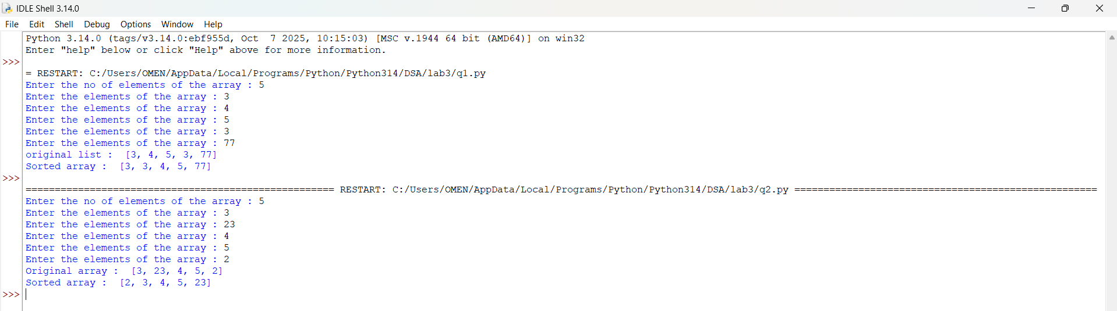
Explanation:
This program uses the Insertion Sort technique to sort elements in a list.
- The function insertion_sort(arr) is defined to sort the given list arr.
- A loop runs from i = 1 to len(arr) - 1, considering one element at a time as the key element.
- The variable key = arr[i] stores the current element to be inserted into the sorted portion of the list.
- The variable j = i - 1 points to the last element of the already sorted portion.
- A while loop runs as long as j >= 0 and key < arr[j].
  - This shifts elements one position ahead using arr[j + 1] = arr[j].
  - The value of j is decreased by 1 after each shift.
- After shifting all larger elements, the key is placed at the correct position using arr[j + 1] = key.
- This process continues until the entire list is sorted.
- The function returns the sorted list.
- The user inputs elements into the list a until "stop" is entered.
- The original list is printed, followed by the sorted list after calling insertion_sort(a).

Error Table:
S.No | Error Obtained | Rectification
01. | ValueError when non-integer input is entered | Ensure input is integer or handle using try-except
02. | Program fails for empty list | Check if list is empty before sorting
03. | Sorting modifies original list | Use a copy of list if original order must be preserved
04. | Incorrect output if comparison condition is wrong (key > arr[j]) | Ensure correct condition key < arr[j] is used
3c)
Aim:-
Write a Python program to perform Selection Sort on a given list of elements.
Program:-
def selection_sort(arr):
n = len(arr)
for i in range(n):
min_idx = i
for j in range(i + 1, n):
if arr[j] < arr[min_idx]:
min_idx = j
arr[i], arr[min_idx] = arr[min_idx], arr[i]
return arr

a = []
while True:
elem = input("Enter an element (or enter stop to finish):- ")
if elem.lower() == "stop":
break
a.append(int(elem))

print("Original List:", a)
sorted_list = selection_sort(a)
print("Sorted List: ", sorted_list)
Output:-
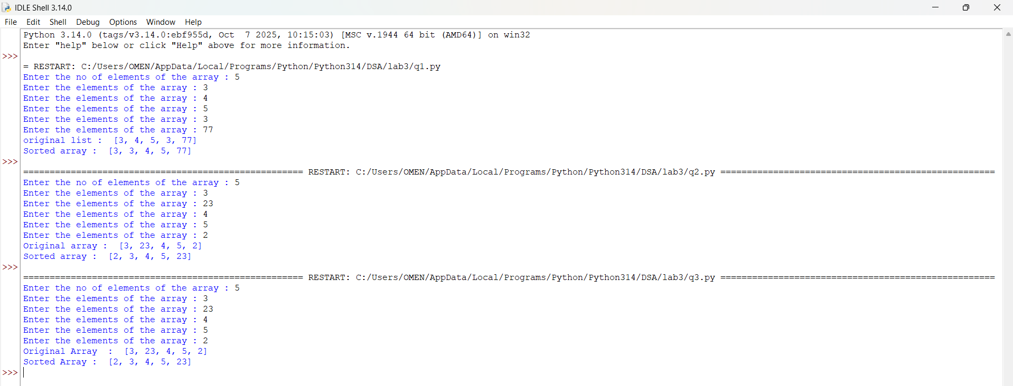
Explanation:
This program uses the Selection Sort technique to sort elements in a list.
- The function selection_sort(arr) is defined to sort the given list arr.
- The variable n = len(arr) stores the number of elements in the list.
- A loop runs from i = 0 to n-1, representing the position where the smallest element should be placed.
- The variable min_idx = i is initialized to store the index of the minimum element in the unsorted portion.
- Another loop runs from j = i + 1 to n-1, comparing elements in the unsorted part of the list.
- The condition if arr[j] < arr[min_idx]: checks if a smaller element is found.
  - If true, min_idx is updated with the index of that smaller element.
- After finding the smallest element, it is swapped with the element at position i using
arr[i], arr[min_idx] = arr[min_idx], arr[i].
- This process continues until the entire list is sorted.
- The function returns the sorted list.
- The user inputs elements into the list a until "stop" is entered.
- The original list is printed, followed by the sorted list after calling selection_sort(a).

Error Table:
S.No | Error Obtained | Rectification
01. | ValueError when non-integer input is entered | Ensure input is integer or handle using try-except
02. | Program fails for empty list | Check if list is empty before sorting
03. | Sorting modifies original list | Use a copy of list if original order must be preserved
04. | Incorrect sorting if comparison condition is wrong (arr[j] > arr[min_idx]) | Ensure correct condition arr[j] < arr[min_idx] is used

3d)
Aim:-
Write a Python program to perform Merge Sort on a given list of elements.
Program:-
def merge_sort(arr):
if len(arr) > 1:
mid = len(arr) // 2
L = arr[:mid]
R = arr[mid:]

merge_sort(L)
merge_sort(R)

i = j = k = 0

while i < len(L) and j < len(R):
if L[i] <= R[j]:
arr[k] = L[i]
i += 1
else:
arr[k] = R[j]
j += 1
k += 1

while i < len(L):
arr[k] = L[i]
i += 1
k += 1

while j < len(R):
arr[k] = R[j]
j += 1
k += 1
return arr

a = []
while True:
elem = input("Enter an element (or enter stop to finish):- ")
if elem.lower() == "stop":
break
a.append(int(elem))

print("Original List:", a)
sorted_list = merge_sort(a)
print("Sorted List: ", sorted_list)
Output:-
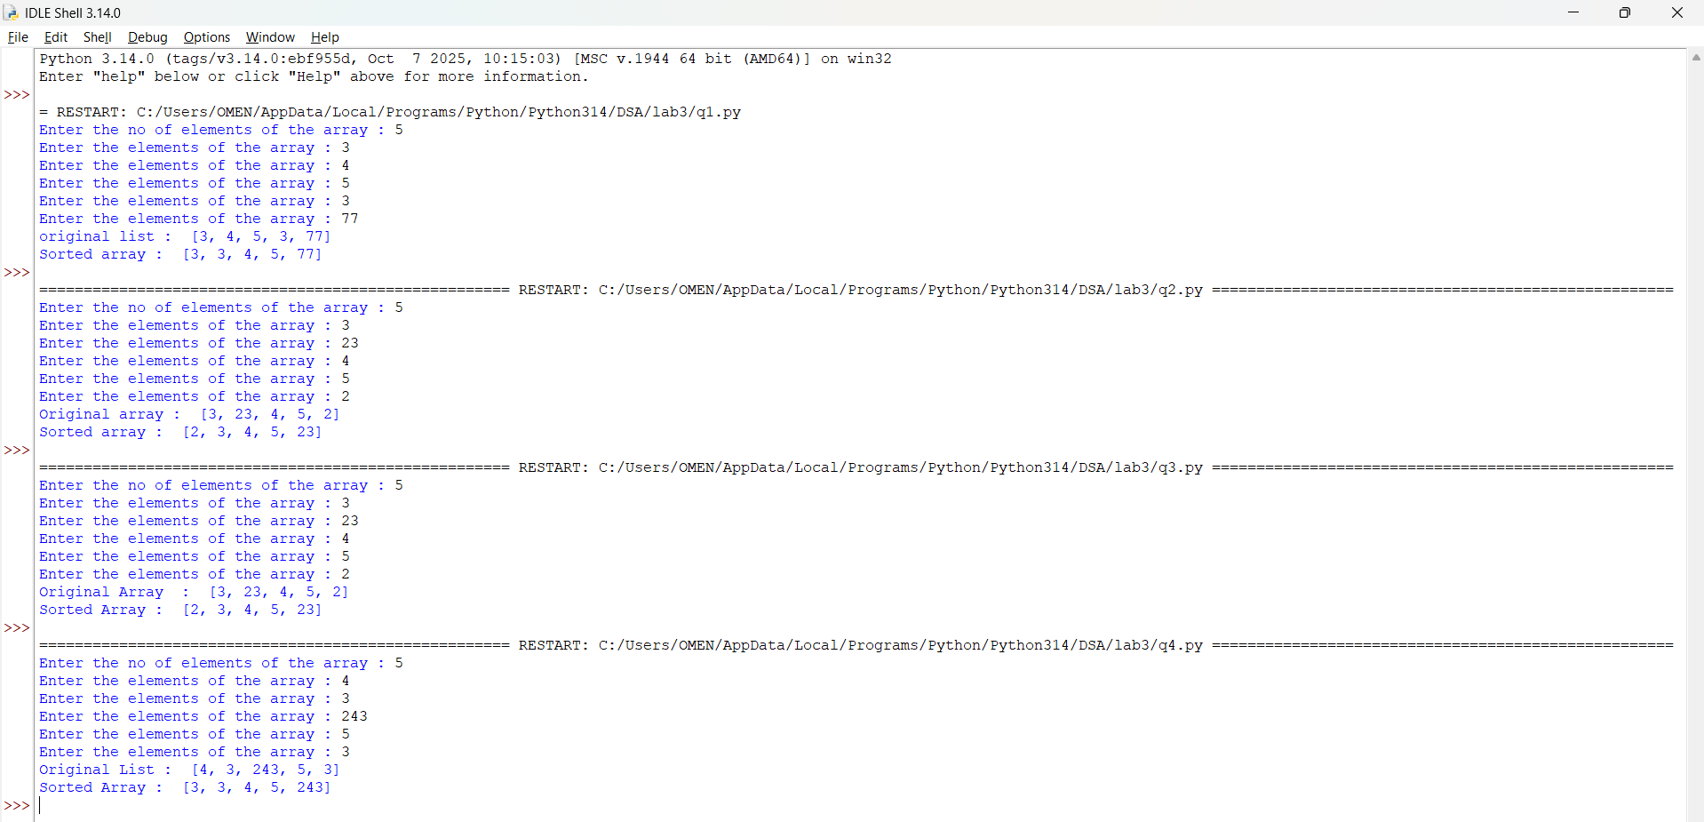
Explanation:
This program uses the Merge Sort technique to sort elements in a list using recursion.
- The function merge_sort(arr) is defined to sort the given list arr.
- The condition if len(arr) > 1: checks whether the list has more than one element.
  - If not, the list is already sorted (base case).
- The list is divided into two halves:
  - mid = len(arr) // 2 finds the middle index.
  - L = arr[:mid] stores the left half.
  - R = arr[mid:] stores the right half.
- The function recursively calls itself on both halves using merge_sort(L) and merge_sort(R).
- Three variables i, j, and k are initialized to 0:
  - i → index for left sublist
  - j → index for right sublist
  - k → index for merged list
- A while loop compares elements of L and R:
  - The smaller element is placed into arr[k].
  - Corresponding indices are incremented.
- After one sublist is exhausted, remaining elements of the other sublist are copied using two separate while loops.
- The sorted elements are merged back into the original list arr.
- The function returns the sorted list.
- The user inputs elements into the list a until "stop" is entered.
- The original list is printed, followed by the sorted list after calling merge_sort(a).

Error Table:
S.No | Error Obtained | Rectification
01. | ValueError when non-integer input is entered | Ensure input is integer or handle using try-except
02. | Program fails for empty list | Check if list is empty before sorting
03. | Incorrect merging if indices (i, j, k) are not updated properly | Ensure all indices are incremented correctly
04. | High memory usage due to creating sublists (L and R) | Use optimized in-place merge sort if required
3e)
Aim:- Write a Python program to perform Quick Sort on a given list of elements.
Program:-
def quick_sort(arr, low=0, high=None):
if high is None:
high = len(arr) - 1

if low < high:
pivot = arr[high]
i = low - 1

for j in range(low, high):
if arr[j] <= pivot:
i += 1
arr[i], arr[j] = arr[j], arr[i]
arr[i + 1], arr[high] = arr[high], arr[i + 1]
pi = i + 1
quick_sort(arr, low, pi - 1)
quick_sort(arr, pi + 1, high)

return arr

a = []
while True:
elem = input("Enter an element (or enter stop to finish):- ")
if elem.lower() == "stop":
break
a.append(int(elem))

print("Original List:", a)
sorted_list = quick_sort(a)
print("Sorted List: ", sorted_list)
Output:-
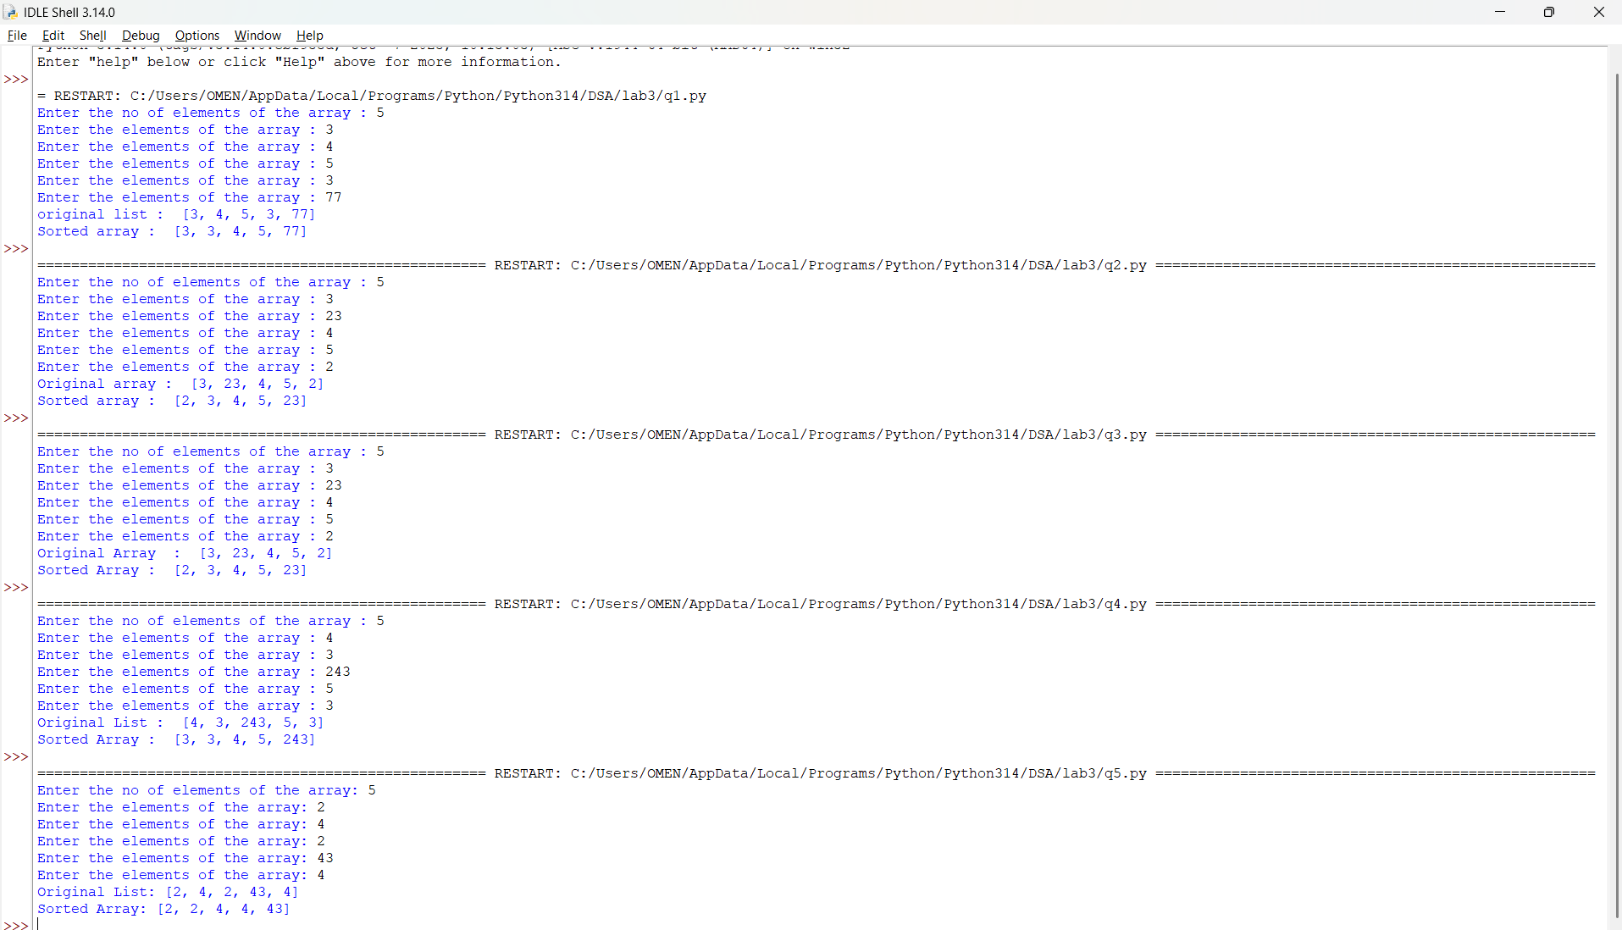

Explanation:
This program uses the Quick Sort technique to sort elements in a list using recursion.
- The function quick_sort(arr, low=0, high=None) is defined with parameters:
  - arr: The list to be sorted
  - low: Starting index (default 0)
  - high: Ending index (default last index of list)
- If high is None, it is initialized as len(arr) - 1.
- The condition if low < high: ensures that sorting is performed only when there are at least two elements.
- The last element arr[high] is chosen as the pivot.
- The variable i = low - 1 is used to track the position of smaller elements.
- A loop runs from j = low to high - 1:
  - If arr[j] <= pivot, i is incremented and elements are swapped using
arr[i], arr[j] = arr[j], arr[i].
- After the loop, the pivot is placed at its correct position using
arr[i + 1], arr[high] = arr[high], arr[i + 1].
- The pivot index pi = i + 1 divides the array into two parts.
- The function recursively sorts:
  - Left subarray → quick_sort(arr, low, pi - 1)
  - Right subarray → quick_sort(arr, pi + 1, high)
- The function returns the sorted list.
- The user inputs elements into list a until "stop" is entered.
- The original list and sorted list are printed.

Error Table:
S.No | Error Obtained | Rectification
01. | ValueError when non-integer input is entered | Ensure input is integer or handle using try-except
02. | Program fails for empty list | Check if list is empty before sorting
03. | Worst-case performance (O(n²)) for already sorted list | Use better pivot selection (e.g., middle or random pivot)
04. | Recursion depth error for very large lists | Increase recursion limit or use iterative approach

WEEK-4

4(a)Aim:-
Write a Python program to implement a Singly Linked List with the following operations:
- Create a singly linked list with n nodes.
- Insert a node at the beginning of the linked list.
- Insert a node at the end of the linked list.
- Insert a node at a specific position.
- Delete a node by its value.
- Delete the first node.
- Delete the last node.
- Count the number of nodes in the linked list.
- Display/Traverse the linked list.
- Exit the program.
Implement the above operations using a menu-driven program and a Node class.
PROGRAM:-
class Node: def init(self, data): self.data = data self.next = None
class SinglyLinkedList:
def __init__(self):
self.head = None
def create(self):
n = int(input("Enter number of nodes: "))
if n <= 0:
print("Number of nodes must be greater than 0.")
return
for i in range(n):
data = int(input(f"Enter data for node {i + 1}: "))
new_node = Node(data)
if self.head is None:
self.head = new_node
else:
temp = self.head
while temp.next is not None:
temp = temp.next
temp.next = new_node
print("Linked List created successfully.")
def insert_beginning(self, data):
new_node = Node(data)
new_node.next = self.head
self.head = new_node
print("Node inserted successfully.")
def insert_end(self, data):
new_node = Node(data)
if self.head is None:
self.head = new_node
print("Node inserted successfully.")
return
temp = self.head
while temp.next is not None:
temp = temp.next
temp.next = new_node
print("Node inserted successfully.")
def insert_at_position(self, data, position):
if position < 1:
print("Invalid position.")
return
new_node = Node(data)
if position == 1:
new_node.next = self.head
self.head = new_node
print("Node inserted successfully.")
return
temp = self.head
for i in range(position - 2):
if temp is None:
print("Invalid position.")
return
temp = temp.next
if temp is None:
print("Invalid position.")
return
new_node.next = temp.next
temp.next = new_node
print("Node inserted successfully.")
def delete_by_value(self, value):
if self.head is None:
print("Linked List is empty.")
return
if self.head.data == value:
self.head = self.head.next
print("Node deleted successfully.")
return
temp = self.head
while temp.next is not None:
if temp.next.data == value:
temp.next = temp.next.next
print("Node deleted successfully.")
return
temp = temp.next
print("Value not found.")
def delete_first(self):
if self.head is None:
print("Linked List is empty.")
return
deleted_value = self.head.data
self.head = self.head.next
print("First node deleted:", deleted_value)
def delete_last(self):
if self.head is None:
print("Linked List is empty.")
return
if self.head.next is None:
deleted_value = self.head.data
self.head = None
print("Last node deleted:", deleted_value)
return
temp = self.head
while temp.next.next is not None:
temp = temp.next
deleted_value = temp.next.data
temp.next = None
print("Last node deleted:", deleted_value)
def count_nodes(self):
count = 0
temp = self.head
while temp is not None:
count += 1
temp = temp.next
print("Number of nodes:", count)
def display(self):
if self.head is None:
print("Linked List is empty.")
return
temp = self.head
print("Linked List:")
while temp is not None:
print(temp.data, end=" -> ")
temp = temp.next
print("None")
sll = SinglyLinkedList()
while True:
print("\n======================================")
print(" SINGLY LINKED LIST")
print("======================================")
print("1. Create Linked List")
print("2. Insert at beginning")
print("3. Insert at end")
print("4. Insert at specific position")
print("5. Delete by value")
print("6. Delete First Node")
print("7. Delete Last Node")
print("8. Count no of nodes")
print("9. Display / Traverse")
print("10. Exit")
print("======================================")
ch = int(input("Enter your choice: "))
if ch == 1:
sll.create()
elif ch == 2:
data = int(input("Enter data: "))
sll.insert_beginning(data)
elif ch == 3:
data = int(input("Enter data: "))
sll.insert_end(data)
elif ch == 4:
data = int(input("Enter data: "))
position = int(input("Enter position (starting from 1): "))
sll.insert_at_position(data, position)
elif ch == 5:
value = int(input("Enter value to delete: "))
sll.delete_by_value(value)
elif ch == 6:
sll.delete_first()
elif ch == 7:
sll.delete_last()
elif ch == 8:
sll.count_nodes()
elif ch == 9:
sll.display()
elif ch == 10:
print("Exiting program...")
break
else:
print("Invalid choice. Please enter a number between 1 and 10.")
OUTPUT:
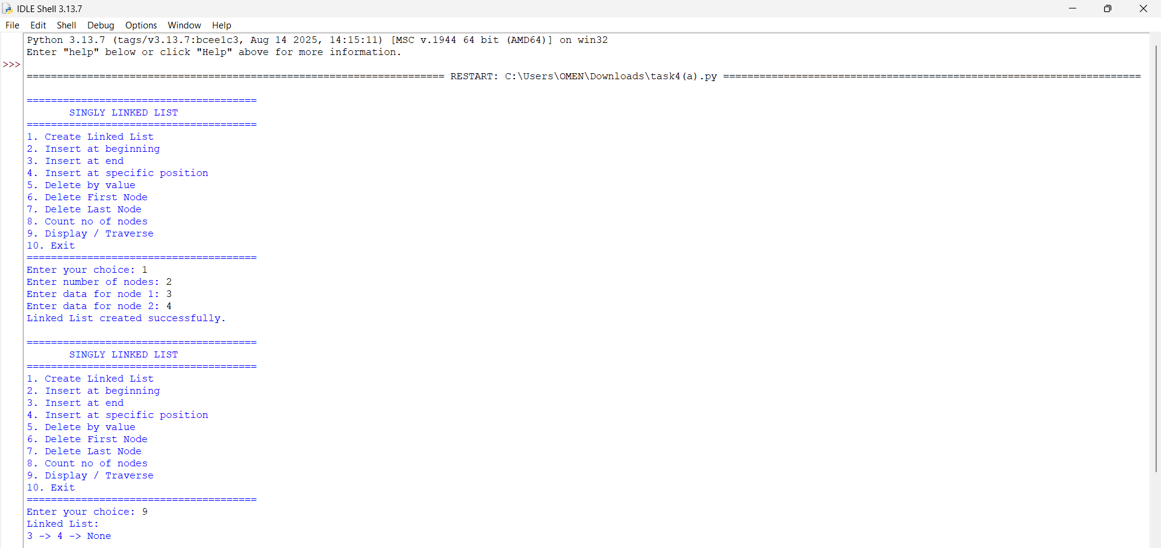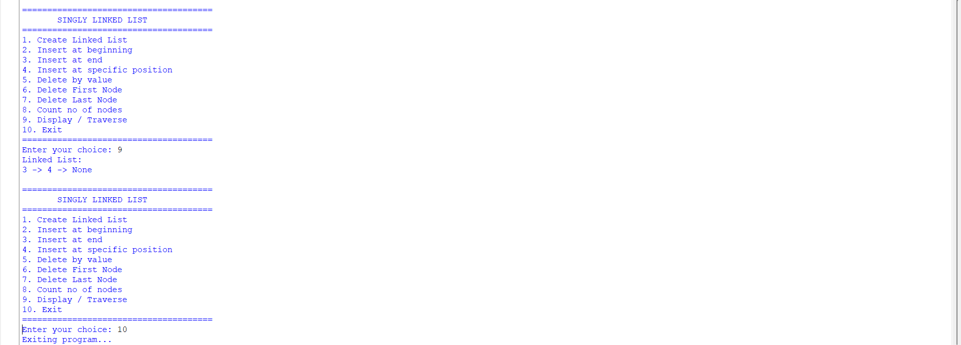

Explanation:
- The program implements a Singly Linked List using Node and SinglyLinkedList classes.
- Each node contains data and a next pointer that stores the reference to the next node.
- The head points to the first node of the linked list.
- The program supports insertion at the beginning, end, and a specific position.
- It supports deletion by value, from the beginning, and from the end.
- The count_nodes() function counts the total number of nodes.
- The display() function traverses and prints all nodes in the list.
- A menu-driven program is used to allow the user to select different operations.

ERROR TABLE:

S.NO | Error Obtained | Rectification
1. | Index out of range  When inserting/deleting at an index greater than the number of nodes. | Traverse carefully;  if temp becomes None before reaching index, print "Index out of range" and stop.
2. | Logical error in insertion  if index is negative. | Validate index: if index < 0: print ("Invalid index").
3. | Wrong output format  In display (missing None at end). | After traversal, always print "None" to mark end of list.
4. | Indentation Error  In the Count node part | It was rectified later,  By maintaining proper indentation.

4(b)aim:-
To write a Python program to implement a Doubly Linked List and perform insertion, deletion, counting, and traversal operations in both forward and backward directions.

Program:-
class Node: def init(self, data): self.data = data self.prev = None self.next = None
class DoublyLinkedList: def init(self): self.head = None
def create(self):
n = int(input("Enter number of nodes: "))
if n <= 0:
print("Number of nodes must be greater than 0.")
return
for i in range(n):
data = int(input(f"Enter data for node {i + 1}: "))
new_node = Node(data)
if self.head is None:
self.head = new_node
else:
temp = self.head
while temp.next is not None:
temp = temp.next
temp.next = new_node
new_node.prev = temp
print("Linked List created successfully.")
def insert_beginning(self):
data = int(input("Enter data: "))
new_node = Node(data)
if self.head is None:
self.head = new_node
else:
new_node.next = self.head
self.head.prev = new_node
self.head = new_node
print("Node inserted at beginning.")
def insert_end(self):
data = int(input("Enter data: "))
new_node = Node(data)
if self.head is None:
self.head = new_node
else:
temp = self.head
while temp.next is not None:
temp = temp.next
temp.next = new_node
new_node.prev = temp
print("Node inserted at end.")
def insert_position(self):
position = int(input("Enter position: "))
data = int(input("Enter data: "))
if position <= 0:
print("Invalid position.")
return
new_node = Node(data)
if position == 1:
if self.head is not None:
new_node.next = self.head
self.head.prev = new_node
self.head = new_node
print("Node inserted.")
return
temp = self.head
for i in range(position - 2):
if temp is None:
print("Position does not exist.")
return
temp = temp.next
if temp is None:
print("Position does not exist.")
return
new_node.next = temp.next
new_node.prev = temp
if temp.next is not None:
temp.next.prev = new_node
temp.next = new_node
print("Node inserted.")
def delete_by_value(self):
value = int(input("Enter value to delete: "))
temp = self.head
while temp is not None:
if temp.data == value:
if temp.prev is None:
self.head = temp.next
if self.head is not None:
self.head.prev = None
else:
temp.prev.next = temp.next
if temp.next is not None:
temp.next.prev = temp.prev
print("Node deleted.")
return
temp = temp.next
print("Value not found.")
def delete_first(self):
if self.head is None:
print("Linked List is empty.")
return
self.head = self.head.next
if self.head is not None:
self.head.prev = None
print("First node deleted.")
def delete_last(self):
if self.head is None:
print("Linked List is empty.")
return
temp = self.head
while temp.next is not None:
temp = temp.next
if temp.prev is None:
self.head = None
else:
temp.prev.next = None
print("Last node deleted.")
def count(self):
count = 0
temp = self.head
while temp is not None:
count += 1
temp = temp.next
print("Number of nodes:", count)
def display_forward(self):
if self.head is None:
print("Linked List is empty.")
return
temp = self.head
print("Forward:", end=" ")
while temp is not None:
print(temp.data, end=" <-> ")
temp = temp.next
print("None")
def display_backward(self):
if self.head is None:
print("Linked List is empty.")
return
temp = self.head
while temp.next is not None:
temp = temp.next
print("Backward:", end=" ")
while temp is not None:
print(temp.data, end=" <-> ")
temp = temp.prev
print("None")
dll = DoublyLinkedList()
while True:
print("\n======================================")
print(" DOUBLY LINKED LIST")
print("======================================")
print("1. Create Linked List")
print("2. Insert at beginning")
print("3. Insert at end")
print("4. Insert at specific position")
print("5. Delete by value")
print("6. Delete First Node")
print("7. Delete Last Node")
print("8. Count no of nodes")
print("9. Display Forward")
print("10. Display Backward")
print("11. Exit")
choice = int(input("Enter your choice: "))
if choice == 1:
dll.create()
elif choice == 2:
dll.insert_beginning()
elif choice == 3:
dll.insert_end()
elif choice == 4:
dll.insert_position()
elif choice == 5:
dll.delete_by_value()
elif choice == 6:
dll.delete_first()
elif choice == 7:
dll.delete_last()
elif choice == 8:
dll.count()
elif choice == 9:
dll.display_forward()
elif choice == 10:
dll.display_backward()
elif choice == 11:
print("Program ended.")
break
else:
print("Invalid choice.")
Output:-
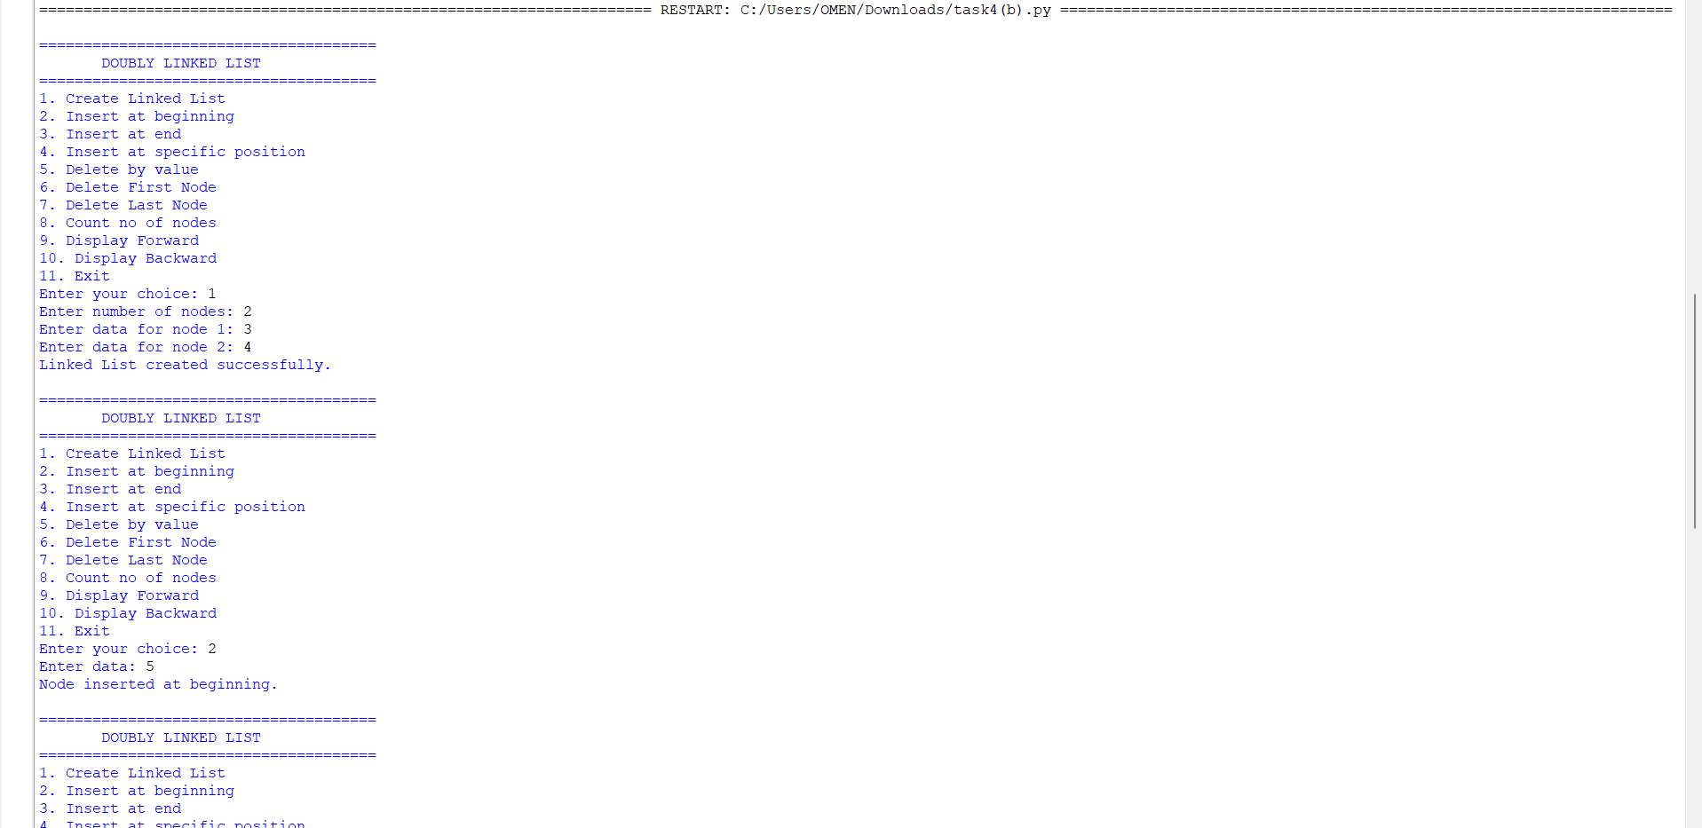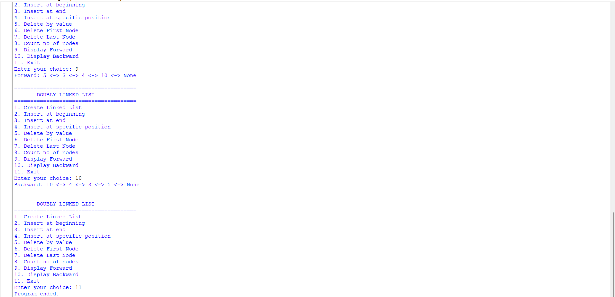

Explanation
- The program implements a Doubly Linked List using a Node class.
- Each node contains data, prev, and next references.
- The head points to the first node of the list.
- Nodes can be inserted at the beginning, end, or a specific position.
- Nodes can be deleted by value, from the beginning, or from the end.
- The program counts the nodes and displays the list in forward and backward directions.

ERROR TABLE:

S.NO | Error Obtained | Rectification
1. | Invalid index entered (negative or too large). | Add a check: if index < 0 → print "Invalid index"; if traversal reaches None before index → print "Index out of range".
2. | Deleting from an empty list. | Before deletion, check if self.head is None: → print "Doubly Linked List is empty."
3. | Value not found during deletion by value. | Traverse list; if node not found → print "value not found in the Linked List."
4. | Insertion at index when list is empty but index > 0. | Handle separately: if self.head is None and index! = 0 → print "Index out of range."

4(c)aim:-
To write a Python program to implement a Circular Linked List and perform insertion, deletion, counting, and traversal operations.

Program:-
class Node: def init(self, data): self.data = data self.next = None
class CircularLinkedList: def init(self): self.head = None
def create(self):
n = int(input("Enter number of nodes: "))
if n <= 0:
print("Number of nodes must be greater than 0.")
return
for i in range(n):
data = int(input(f"Enter data for node {i + 1}: "))
new_node = Node(data)
if self.head is None:
self.head = new_node
new_node.next = self.head
else:
temp = self.head
while temp.next != self.head:
temp = temp.next
temp.next = new_node
new_node.next = self.head
print("Circular Linked List created successfully.")
def insert_beginning(self):
data = int(input("Enter data: "))
new_node = Node(data)
if self.head is None:
self.head = new_node
new_node.next = self.head
else:
temp = self.head
while temp.next != self.head:
temp = temp.next
new_node.next = self.head
temp.next = new_node
self.head = new_node
print("Node inserted at beginning.")
def insert_end(self):
data = int(input("Enter data: "))
new_node = Node(data)
if self.head is None:
self.head = new_node
new_node.next = self.head
else:
temp = self.head
while temp.next != self.head:
temp = temp.next
temp.next = new_node
new_node.next = self.head
print("Node inserted at end.")
def insert_position(self):
position = int(input("Enter position: "))
data = int(input("Enter data: "))
if position <= 0:
print("Invalid position.")
return
new_node = Node(data)
if position == 1:
if self.head is None:
self.head = new_node
new_node.next = self.head
else:
temp = self.head
while temp.next != self.head:
temp = temp.next
new_node.next = self.head
temp.next = new_node
self.head = new_node
print("Node inserted.")
return
if self.head is None:
print("Position does not exist.")
return
temp = self.head
for i in range(position - 2):
temp = temp.next
if temp == self.head:
print("Position does not exist.")
return
new_node.next = temp.next
temp.next = new_node
print("Node inserted.")
def delete_by_value(self):
if self.head is None:
print("Circular Linked List is empty.")
return
value = int(input("Enter value to delete: "))
current = self.head
previous = None
while True:
if current.data == value:
if current == self.head and current.next == self.head:
self.head = None
elif current == self.head:
temp = self.head
while temp.next != self.head:
temp = temp.next
self.head = self.head.next
temp.next = self.head
else:
previous.next = current.next
print("Node deleted.")
return
previous = current
current = current.next
if current == self.head:
break
print("Value not found.")
def delete_first(self):
if self.head is None:
print("Circular Linked List is empty.")
return
if self.head.next == self.head:
self.head = None
else:
temp = self.head
while temp.next != self.head:
temp = temp.next
self.head = self.head.next
temp.next = self.head
print("First node deleted.")
def delete_last(self):
if self.head is None:
print("Circular Linked List is empty.")
return
if self.head.next == self.head:
self.head = None
print("Last node deleted.")
return
temp = self.head
while temp.next.next != self.head:
temp = temp.next
temp.next = self.head
print("Last node deleted.")
def count(self):
if self.head is None:
print("Number of nodes: 0")
return
count = 0
temp = self.head
while True:
count += 1
temp = temp.next
if temp == self.head:
break
print("Number of nodes:", count)
def display(self):
if self.head is None:
print("Circular Linked List is empty.")
return
temp = self.head
print("Head to Tail:", end=" ")
while True:
print(temp.data, end=" -> ")
temp = temp.next
if temp == self.head:
break
print("(back to head)")
def display_tail_to_head(self):
if self.head is None:
print("Circular Linked List is empty.")
return
tail = self.head
while tail.next != self.head:
tail = tail.next
print("Tail to Head:", end=" ")
current = tail
while True:
print(current.data, end="")
if current == self.head:
break
print(" <- ", end="")
temp = self.head
while temp.next != current:
temp = temp.next
current = temp
print(" (reached head)")
def exit_program(self):
print("Program ended.")
cll = CircularLinkedList()
while True:
print("\n======================================")
print(" CIRCULAR LINKED LIST")
print("======================================")
print("1. Create Linked List")
print("2. Insert at beginning")
print("3. Insert at end")
print("4. Insert at specific position")
print("5. Delete by value")
print("6. Delete First Node")
print("7. Delete Last Node")
print("8. Count no of nodes")
print("9. Display Head to Tail")
print("10. Display Tail to Head")
print("11. Exit")
choice = int(input("Enter your choice: "))
if choice == 1:
cll.create()
elif choice == 2:
cll.insert_beginning()
elif choice == 3:
cll.insert_end()
elif choice == 4:
cll.insert_position()
elif choice == 5:
cll.delete_by_value()
elif choice == 6:
cll.delete_first()
elif choice == 7:
cll.delete_last()
elif choice == 8:
cll.count()
elif choice == 9:
cll.display()
elif choice == 10:
cll.display_tail_to_head()
elif choice == 11:
cll.exit_program()
break
else:
print("Invalid choice.")
Output:-
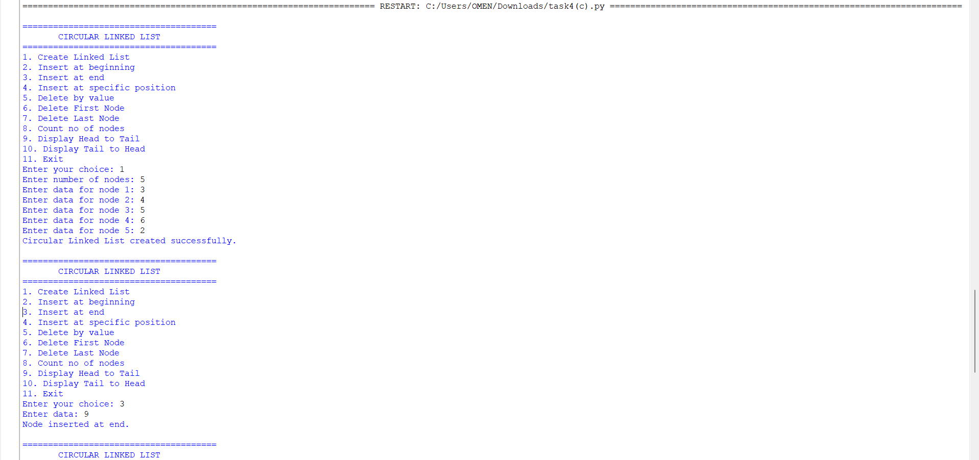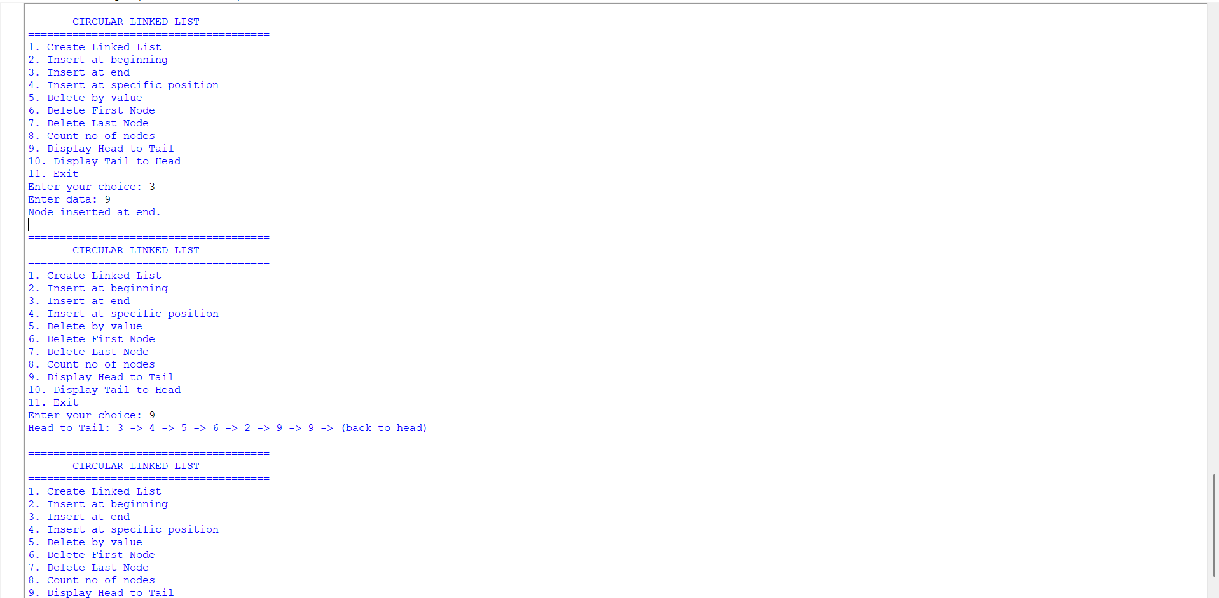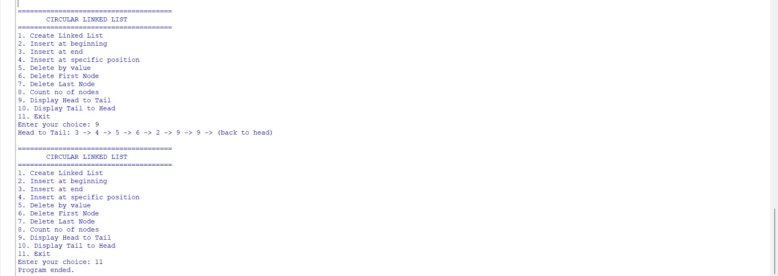

Explanation
- The program implements a Circular Linked List using a Node class.
- Each node contains data and a next reference.
- The last node points back to the head, forming a circular structure.
- Nodes can be inserted at the beginning, end, or a specific position.
- Nodes can be deleted by value, from the beginning, or from the end.
- The program counts the nodes and displays the list in head-to-tail and tail-to-head directions.
- A menu-driven approach is used to perform all the operations.

ERROR TABLE:

S.NO | Error Obtained | Rectification
1. | Display on empty list. | Add condition:  if self.head is None: → print "Circular Linked List is empty."
2. | Deleting from an empty list. | Before deletion, check if self.head is None: → print "Circular Linked List is empty."
3. |  | Ensure every insertion/deletion maintains circularity: last node’s next must always point to self.head.
  Infinite loop in traversal
  (if circularity broken).
4. | Reverse traversal  (Tail to Head) inefficient. | Current implementation repeatedly searches for predecessor. Rectify by using a doubly circular linked list if reverse traversal is frequent.

WEEK – 5

5)aim:-
write a python program to implement a stack using an array, linked list. Also
implement the stack operation such as push, pop, peep and also display the stack elements

Program:-
class StackArray:
def init(self, size):
self.size = size self.stack = [None] * size self.top = -1
def push(self, item):
if self.top == self.size - 1:
print("Stack Overflow")
else:
self.top += 1
self.stack[self.top] = item
print(item, "pushed into the stack")
def pop(self):
if self.top == -1:
print("Stack Underflow")
else:
item = self.stack[self.top]
self.stack[self.top] = None
self.top -= 1
print(item, "popped from the stack")
def peek(self):
if self.top == -1:
print("Stack is empty")
else:
print("Top element:", self.stack[self.top])
def display(self):
if self.top == -1:
print("Stack is empty")
else:
print("Stack elements (top to bottom):")
for i in range(self.top, -1, -1):
print(self.stack[i])
size = int(input("Enter size of stack: ")) s = StackArray(size)
while True: print("\n--- STACK USING ARRAY ---") print("1. Push") print("2. Pop") print("3. Peek") print("4. Display") print("5. Exit")
choice = int(input("Enter your choice: "))
if choice == 1:
item = int(input("Enter element to push: "))
s.push(item)
elif choice == 2:
s.pop()
elif choice == 3:
s.peek()
elif choice == 4:
s.display()
elif choice == 5:
print("Exiting program...")
break
else:
print("Invalid choice. Try again.")
Output:
Stack using linkedlist
Program:
class Node:
def init(self, data):
self.data = data self.next = None
class StackLinkedList: def init(self): self.top = None
def push(self, data):
new_node = Node(data)
new_node.next = self.top
self.top = new_node
print(data, "pushed into the stack")
def pop(self):
if self.top is None:
print("Stack Underflow")
else:
popped = self.top.data
self.top = self.top.next
print(popped, "popped from the stack")
def peek(self):
if self.top is None:
print("Stack is empty")
else:
print("Top element:", self.top.data)
def display(self):
if self.top is None:a
print("Stack is empty")
else:
print("Stack elements (top to bottom):")
temp = self.top
while temp:
print(temp.data)
temp = temp.next
s = StackLinkedList()
while True: print("\n--- STACK USING LINKED LIST ---") print("1. Push") print("2. Pop") print("3. Peek") print("4. Display") print("5. Exit")
choice = int(input("Enter your choice: "))
if choice == 1:
item = int(input("Enter element to push: "))
s.push(item)
elif choice == 2:
s.pop()
elif choice == 3:
s.peek()
elif choice == 4:
s.display()
elif choice == 5:
print("Exiting program...")
break
else:
print("Invalid choice. Try again.")
Output:EXPLANATION:
🧩 Stack Using Array
Structure:
- Uses a Python list (self.stack) to store elements.
- self.top keeps track of the index of the last pushed element.
- self.size defines the maximum capacity.
Operations:
- Push
  - Check if top == size - 1 → Overflow.
  - Otherwise, increment top and insert the element at that position.
- Pop
  - Check if top == -1 → Underflow (empty stack).
  - Otherwise, remove the element at top, decrement top.
- Peek
  - Shows the element at top without removing it.
- Display
  - Prints elements from top down to 0 (top to bottom order).
🧩 Stack Using Linked List
Structure:
- Each element is a Node with:
  - data (value)
  - next (pointer to the next node).
- self.top points to the most recently pushed node.
Operations:
- Push
  - Create a new node.
  - Link its next to the current top.
  - Update top to this new node.
- Pop
  - If top is None → Underflow.
  - Otherwise, remove the node at top and update top to top.next.
- Peek
  - Shows the data at top.
- Display
  - Traverse from top downwards, printing each node’s data.

ERROR TABLE:
S.NO | Error Obtained | Rectification
1. | def _init_(self, size): | Python expects two underscores before and after init.
2. | Display on empty stack. | Add condition: if self.top is None: → print  "Stack is empty".
3. |  | Add a check: if self.top == self.size - 1: → print "Stack Overflow".
  Stack Overflow
  when pushing beyond the defined size
4. | Stack Underflow  when popping from empty stack | Add a check: if self.top is None: → print "Stack Underflow".
5. | Syntax error | Later it was rectified in the for loop of display section.

WEEK-6
6. AIM: To implement Queue and its operations such as Enqueue, Dequeue, Peek, Display with a menu driven approach.
6a. Using Array, Linked list, Data structures.
6b. Circular Queue.
PROGRAM:
class QueueEx:
def init(self, size=5):
self.size = size self.queue =
[None] * size self.front = -1
self.rear = -1
def enqueue(self, x):
if self.rear == self.size - 1:
print("Queue Overflow")
else:
if self.front == -1:
self.front = 0
self.rear += 1
self.queue[self.rear] = x
print(f"{x} inserted into the queue")
def dequeue(self):
if self.front == -1 or self.front > self.rear:
print("Queue Underflow")
else:
x = self.queue[self.front]
self.queue[self.front] = None
self.front += 1
print(f"{x} deleted from the queue")
if self.front > self.rear:
self.front = -1
self.rear = -1
def peek(self):
if self.front == -1:
print("Queue is empty")
else:
print("Front element:", self.queue[self.front])
def display(self):
if self.front == -1:
print("Queue is empty")
else:
print("The elements of the queue are:")
for i in range(self.front, self.rear + 1):
print(self.queue[i])
size = int(input("Enter the size of Queue: ")) q = QueueEx(size)
while True: print("\n----- Queue Menu -----") print("1. Enqueue") print("2. Dequeue") print("3. Peek") print("4. Display") print("5. Exit")
choice = int(input("Enter your choice: "))
if choice == 1:
item = int(input("Enter the element to enqueue: "))
q.enqueue(item)
elif choice == 2:
q.dequeue()
elif choice == 3:
q.peek()
elif choice == 4:
q.display()
elif choice == 5:
print("Exiting Program")
break
else:
print("Invalid choice")

Output:
Program:
class CircularQueue:
def init(self, size):
self.size = size self.queue = [None] * size self.front = -1 self.rear = -1
def enqueue(self, item):
if (self.rear + 1) % self.size == self.front:
print("Queue Overflow")
elif self.front == -1:
self.front = 0
self.rear = 0
self.queue[self.rear] = item
print(item, "inserted into the queue")
else:
self.rear = (self.rear + 1) % self.size
self.queue[self.rear] = item
print(item, "inserted into the queue")
def dequeue(self):
if self.front == -1:
print("Queue Underflow")
elif self.front == self.rear:
item = self.queue[self.front]
self.queue[self.front] = None
self.front = -1
self.rear = -1
print(item, "deleted from the queue")
else:
item = self.queue[self.front]
self.queue[self.front] = None
self.front = (self.front + 1) % self.size
print(item, "deleted from the queue")
def display(self):
if self.front == -1:
print("Queue is empty")
else:
print("The elements of the queue are:")
i = self.front
while True:
print(self.queue[i])
if i == self.rear:
break
i = (i + 1) % self.size
size = int(input("Enter the size of the queue: ")) q = CircularQueue(size)
while True: print("\n----- CIRCULAR QUEUE MENU -----") print("1. Enqueue") print("2. Dequeue") print("3. Display") print("4. Exit")
choice = int(input("Enter your choice: "))
if choice == 1:
item = int(input("Enter the element to enqueue: "))
q.enqueue(item)
elif choice == 2:
q.dequeue()
elif choice == 3:
q.display()
elif choice == 4:
print("Program terminated.")
break
else:
print("Invalid choice")
Output:
EXPLANATION:
🔹 Concept of Circular Queue
- A Circular Queue is a linear data structure that follows the FIFO (First In First Out) principle.
- Unlike a simple linear queue, the last position connects back to the first position, forming a circle.
- This design solves the problem of wasted space in a linear queue when elements are deleted from the front.
🔹 Structure in the Code
- Initialization (__init__)
  - Creates a queue of fixed size.
  - Uses an array (self.queue) to store elements.
  - front and rear pointers track the first and last elements.
  - Both start at -1 (empty queue).
- Enqueue (Insertion)
  - Adds an element at the rear.
  - Overflow occurs if (rear + 1) % size == front (queue full).
  - If queue is empty (front == -1), both front and rear are set to 0.
  - Otherwise, rear moves forward using modulo arithmetic: (rear + 1) % size.
3. Dequeue (Deletion)
- Removes an element from the front.
- Underflow occurs if front == -1 (queue empty).
- If only one element is left (front == rear), both pointers reset to -1.
- Otherwise, front moves forward using (front + 1) % size.
4.Display
- Prints all elements from front to rear using modulo arithmetic.
- Traverses circularly until it reaches the rear.
🔹 Menu-Driven Program
- User chooses operations from a menu:
  - Enqueue → Insert element.
  - Dequeue → Remove element.
  - Display → Show all elements.
  - Exit → End program.
- The loop continues until the user selects Exit.
🔹 Characteristics of Circular Queue
- Efficient use of memory: Freed spaces are reused.
- FIFO principle maintained.
- Overflow condition: (rear + 1) % size == front.
- Underflow condition: front == -1.

ERROR TABLE:
S.NO | Error Obtained | Rectification
1. | Redundant underflow check → Condition if self.front == -1 or self.front > self.rear: is slightly redundant because resetting pointers already handles empty state. | Simplify to if self.front == -1.
2. | Missing underflow condition → In dequeue, only checks if self.front == -1. If multiple deletions occur, front > rear is not handled, leading to incorrect behavior. | Add condition: if self.front == -1 or self.front > self.rear.
3. | Circular Queue: Display traversal limitation → Display prints values but not indices, making debugging harder. | Optional improvement: print both index and value.

WEEK – 7
7A.1).AIM: Write a Python Program to implement a binary tree using an array with all of its operations

PROGRAM:
class BinaryTreeArray: def init(self, size): self.tree = [None]*size self.size = size
def set_root(self,data):
self.tree[0] = data
def set_left(self,parent_index,data):
child_index = parent_index* 2 + 1
if child_index < self.size:
self.tree[child_index] = data
else:
print("Index is out of the range")
def set_right(self,parent_index,data):
child_index = parent_index*2 + 2
if child_index < self.size:
self.tree[child_index] = data
else:
print("Index is out of the range")
def preorder(self, index= 0):
if index >= self.size or self.tree[index] is None:
return
print(self.tree[index], end=" ")
self.preorder(index*2 + 1)
self.preorder(index*2 + 2)
def inorder(self, index= 0):
if index >= self.size or self.tree[index] is None:
return
self.inorder(index*2 + 1)
print(self.tree[index], end=" ")
self.inorder(index*2 + 2)
def postorder(self, index = 0):
if index >= self.size or self.tree[index] is None:
return
self.postorder(index*2 + 1)
self.postorder(index*2 + 2)
print(self.tree[index], end =" ")
def levelorder(self):
for value in self.tree:
if value is not None:
print(value, end =" ")
def display(self):
print("Array Representation")
for i in range(self.size):
print(f"Index{i} : {self.tree[i]}")
tree = BinaryTreeArray(8) tree.set_root('A') tree.set_left(0,'B') tree.set_right(0,'C') tree.set_left(1,'D') tree.set_right(1,'E') tree.set_right(2,'F') tree.display() print("\nPreorder: ", end="") tree.preorder() print("\nInorder: ", end="") tree.inorder() print("\nPostorder: ", end="") tree.postorder() print("\nLevel-order: ", end="") tree.levelorder()
Output:

Explanation:
- Array Representation: The binary tree is stored in an array, where the root node is placed at index 0. For a node at index i, its left child is at 2i + 1 and the right child is at 2i
+ 2.
- Insertion: The insert () function adds elements to the tree. In this program, smaller values are placed in the left subtree and larger values in the right subtree.
- Tree Traversals: The program supports order, preorder, post order, and level-order traversal to visit all nodes in different orders.
- Searching and Counting: The program can search for a particular value and calculate the total number of nodes and leaf nodes in the tree.
- Other Operations: The program calculates the height of the tree and displays the array of representation. A menu-driven approach allows the user to select different operations.

Error Table:

S.No | Error | Correction
1 | Using the wrong index for the left child. | Use 2 * index + 1 for the left child.
2 | Using the wrong index for the right  child. | Use 2 * index + 2 for the right child.
3 | Accessing an array index beyond MAX. | Check if index >= MAX before accessing  the array.
4 | Not checking whether an array position  is None. | Check if tree[index] is None before  processing the node.
5 | Forgetting to initialize the array. | Initialize it using tree = [None] * MAX.

7A.2).AIM: Write a Python Program to implement a binary tree using an linked list with all of its operations
PROGRAM:
class Node: def init(self,data): self.data = data self.left = None self.right= None
class BinaryTree: def init(self): self.root = None
def create_tree(self):
self.root = Node('A')
self.root.left = Node('B')
self.root.right = Node('C')
self.root.left.left = Node('D')
self.root.left.right = Node('E')
self.root.right.right = Node('F')
def preorder(self,node):
if node is None:
return
print(node.data, end= " ")
self.preorder(node.left)
self.preorder(node.right)
def inorder(self,node):
if node is None:
return
self.inorder(node.left)
print(node.data, end =" ")
self.inorder(node.right)
def postorder(self,node):
if node is None:
return
self.postorder(node.left)
self.postorder(node.right)
print(node.data, end =" ")
def levelorder(self):
if self.root is None:
return
queue = [self.root]
while queue:
node = queue.pop(0)
print(node.data, end =" ")
if node.left is not None:
queue.append(node.left)
if node.right is not None:
queue.append(node.right)
tree = BinaryTree() tree.create_tree() print("Preorder: ", end="") tree.preorder(tree.root)
print("\nInorder: ", end="") tree.inorder(tree.root)
print("\nPostorder: ", end="") tree.postorder(tree.root)
print("\nLevel-order: ", end="") tree.levelorder()
Output:
Explanation
- Node Structure: Each tree node is created using a Node class containing three parts:

data, left pointer, and right pointer.
- Insertion: The insert() function adds nodes using level-order insertion, filling the left and right positions of each level before moving to the next level.
- Tree Traversals: The program provides inorder, preorder, postorder, and level-order traversal to display the elements of the binary tree.
- Searching and Counting: The program can search for a value and calculate the total number of nodes and leaf nodes using recursive functions.
- Additional Operations: The program calculates the height of the tree and finds the
minimum and maximum values. A menu-driven system allows the user to perform each operation easily.

Error Table:

S.No | Error | Correction
1 | Creating a node without initializing its child  pointers. | Set self.left = None and self.right  = None in the constructor.
2 | Accessing node.data when node is None. | Add if node is None: return  before accessing the node.
3 | Forgetting to set the root when the tree is  empty. | Use if self.root is None: self.root  = new_node.
4 | Not adding existing child nodes to the queue during insertion. | Add them using  queue.append(current.left) and queue.append(current.right).
5 | Calling traversal without passing the root  node. | Call it as tree.inorder(tree.root),  tree.preorder(tree.root), etc.

WEEK-8
8A).AIM: Write a Program to implement Binary Search Tree with it's operations Transversals also.

Program:
class Node: def init(self, data): self.data = data self.left = None self.right = None
def insert(root, data): if root is None: return Node(data)
if data < root.data:
root.left = insert(root.left, data)
elif data > root.data:
root.right = insert(root.right, data)
return root
def search(root, key): if root is None or root.data == key: return root
if key < root.data:
return search(root.left, key)
return search(root.right, key)
def find_min(root): while root.left is not None: root = root.left return root
def delete(root, key): if root is None: return None
if key < root.data:
root.left = delete(root.left, key)
elif key > root.data:
root.right = delete(root.right, key)
else:
if root.left is None:
return root.right
if root.right is None:
return root.left
temp = find_min(root.right)
root.data = temp.data
root.right = delete(root.right, temp.data)
return root
def inorder(root): if root: inorder(root.left) print(root.data, end=" ") inorder(root.right)
def preorder(root): if root: print(root.data, end=" ") preorder(root.left) preorder(root.right)
def postorder(root): if root: postorder(root.left) postorder(root.right) print(root.data, end=" ")
root = None
values = [50, 30, 70, 20, 40, 60, 80]
for value in values: root = insert(root, value)
print("BST Inorder Traversal:") inorder(root)
key = 40
if search(root, key): print("\n", key, "found in BST") else: print("\n", key, "not found in BST")
root = delete(root, 30)
print("After deleting 30:") inorder(root) print()
Output:

Explanation:
- Node Creation: The Node class stores data and references to the left and right child nodes.
- Insertion: The insert() function adds elements to the BST. Smaller values go to the left, and larger values go to the right.
- Searching: The search() function checks whether a given value exists in the tree by comparing it with each node.
- Deletion: The delete() function removes a node from the BST. It handles nodes with zero, one, or two children.
- Inorder Traversal: The inorder() function visits the left subtree, root, and right subtree, displaying the elements in ascending order.

Error Table:

S.No | Error | Explanation
1. | Not updating root | Always use root = insert(root, value) and root  = delete(root, key) because these functions may return a new root.
2. | Searching for a missing value | search() returns None when the key does not exist. Your if search(root, key) check handles this correctly.
3. | Inserting duplicate values | insert() ignores duplicates because neither comparison is true when the values are equal. This is intentional behavior.
4. | Deleting a node with two children | Simply removing the node could break the BST structure. Your code correctly uses find_min() to find its inorder successor.
5. | Empty-tree minimum lookup | Calling find_min(None) directly would cause an error. Call it only when the subtree is non-empty, as your deletion code does.

8B).AIM: Write a Program to implement AVL Tree with it's operations Transversals also.

Program:
class Node: def init(self, data): self.data = data self.left = None self.right = None self.height = 1
def height(node): if node is None: return 0 return node.height
def balance_factor(node): if node is None: return 0 return height(node.left) - height(node.right)
def right_rotate(y): x = y.left t2 = x.right
x.right = y
y.left = t2
y.height = 1 + max(height(y.left), height(y.right))
x.height = 1 + max(height(x.left), height(x.right))
return x
def left_rotate(x): y = x.right t2 = y.left
y.left = x
x.right = t2
x.height = 1 + max(height(x.left), height(x.right))
y.height = 1 + max(height(y.left), height(y.right))
return y
def insert(root, data): if root is None: return Node(data)
if data < root.data:
root.left = insert(root.left, data)
elif data > root.data:
root.right = insert(root.right, data)
else:
return root
root.height = 1 + max(height(root.left), height(root.right))
bf = balance_factor(root)
# LL Case
if bf > 1 and data < root.left.data:
return right_rotate(root)
# RR Case
if bf < -1 and data > root.right.data:
return left_rotate(root)
# LR Case
if bf > 1 and data > root.left.data:
root.left = left_rotate(root.left)
return right_rotate(root)
# RL Case
if bf < -1 and data < root.right.data:
root.right = right_rotate(root.right)
return left_rotate(root)
return root
def search(root, key): if root is None or root.data == key: return root
if key < root.data:
return search(root.left, key)
return search(root.right, key)
def find_min(root): while root.left is not None: root = root.left return root
def delete(root, key): if root is None: return None
if key < root.data:
root.left = delete(root.left, key)
elif key > root.data:
root.right = delete(root.right, key)
else:
if root.left is None:
return root.right
elif root.right is None:
return root.left
temp = find_min(root.right)
root.data = temp.data
root.right = delete(root.right, temp.data)
if root is None:
return None
root.height = 1 + max(height(root.left), height(root.right))
bf = balance_factor(root)
# LL Case
if bf > 1 and balance_factor(root.left) >= 0:
return right_rotate(root)
# LR Case
if bf > 1 and balance_factor(root.left) < 0:
root.left = left_rotate(root.left)
return right_rotate(root)
# RR Case
if bf < -1 and balance_factor(root.right) <= 0:
return left_rotate(root)
# RL Case
if bf < -1 and balance_factor(root.right) > 0:
root.right = right_rotate(root.right)
return left_rotate(root)
return root
def inorder(root): if root: inorder(root.left) print(root.data, end=" ") inorder(root.right)
root = None values = [10, 20, 30, 40, 50, 25]
for value in values: root = insert(root, value)
print("AVL Inorder Traversal:") inorder(root)
key = 25
if search(root, key): print("\n", key, "found in AVL tree") else: print("\n", key, "not found in AVL tree")
root = delete(root, 40)
print("After deleting 40:") inorder(root) print()
Output:

Explanation:
- Node Creation and Height: The Node class stores data, left and right child references, and the height of each node.
- Height and Balance Factor: The height() function calculates a node's height, while balance_factor() checks whether the tree is balanced.
- Insertion and Rotations: The insert() function adds values to the
- AVL tree and performs LL, RR, LR, or RL rotations to maintain balance.
- Searching and Deletion: The search() function finds a value, while delete() removes a node and rebalances the tree using rotations when necessary.'
- Inorder Traversal and Output: The inorder() function displays the elements in ascending order. The main program inserts values, searches for 25, deletes 40, and prints the updated tree.

Error Table:

S.No. | Error / Limitation | Explanation / Solution
1. | Incorrect height update | If node heights are not updated after rotations, the balance factor becomes incorrect. Update heights after every rotation.
2.. | Incorrect balance factor | Using height(right) - height(left) instead of height(left) - height(right) reverses the rotation conditions.
3. | Missing rotation cases | Handling only LL and RR cases can leave the tree unbalanced. Handle all four cases: LL, RR, LR, and RL.
4. | Root not updated | If the root changes after insertion, deletion, or rotation, assign the returned node to root.
5. | Duplicate values | The insertion function ignores duplicate values using else: return root. Add separate duplicate-handling logic if duplicates are required.

