 User Interface Design

23CSE113 LAB

THE SOULED STORE CLONE WEBSITE MANUAL

Submitted by
Name | DEEPAK E
Roll Number | AV.SC.U4CSE25027
Year/Sem/Section | 1st YEAR / SEM-2 / CSE-A
Credits | 03

Submitted to | DR .RAJ KUMAR BATCHU
Designation | ASST.PROFFESSOR (Sl. Grade)
Department | SCHOOL OF COMPUTING

Souled Stone clone Website
Aim: Create a Souled Store-style shopping website using HTML, CSS, and JavaScript with an attractive and responsive user interface. The website should include a navigation menu, category sections, and product display cards with images, prices, and ratings. Implement interactive features to explore products and ensure the design works smoothly on different screen sizes.
Programme:
Index.html
<!DOCTYPE html>
<html lang="en">
<head>
<meta charset="UTF-8" />
<meta name="viewport" content="width=device-width, initial-scale=1.0"/>
<title>The Souled Store</title>
<link rel="stylesheet" href="style.css" />
<link href="https://fonts.googleapis.com/css2?family=Bebas+Neue&family=Nunito:wght@400;600;700;800&display=swap" rel="stylesheet"/>
<link rel="stylesheet" href="https://cdnjs.cloudflare.com/ajax/libs/font-awesome/6.5.0/css/all.min.css"/>
</head>
<body>

<!-- TOP BAR -->
<div class="topbar">
<marquee behavior="scroll" direction="left" scrollamount="4">
🚚 FREE DELIVERY on orders above ₹499 &nbsp;|&nbsp; 🎉 NEW ARRIVALS: Anime, Movies & TV drops &nbsp;|&nbsp; 🔥 USE CODE: INKED10 for 10% OFF &nbsp;|&nbsp; 💥 OFFICIAL LICENSED MERCHANDISE
</marquee>
</div>

<!-- HEADER -->
<header class="header" id="header">
<div class="header-inner">
<div class="header-left">
<button class="hamburger" id="hamburgerBtn"><i class="fa fa-bars"></i></button>
<a href="#" class="logo">
<span class="logo-text">The Souled Store </span>
</a>
</div>

<nav class="main-nav" id="mainNav">
<ul>
<li class="nav-item has-dropdown">
<a href="#">Men <i class="fa fa-chevron-down"></i></a>
<div class="mega-dropdown">
<div class="mega-col">
<h4>Categories</h4>
<ul>
<li><a href="#">T-Shirts</a></li>
<li><a href="#">Oversized Tees</a></li>
<li><a href="#">Hoodies & Sweatshirts</a></li>
<li><a href="#">Joggers</a></li>
<li><a href="#">Shorts</a></li>
<li><a href="#">Jackets</a></li>
</ul>
</div>
<div class="mega-col">
<h4>By Theme</h4>
<ul>
<li><a href="#">Anime</a></li>
<li><a href="#">Marvel & DC</a></li>
<li><a href="#">TV & Movies</a></li>
<li><a href="#">Music</a></li>
<li><a href="#">Minimalist</a></li>
<li><a href="#">Sports</a></li>
</ul>
</div>
<div class="mega-col">
<h4>Featured</h4>
<ul>
<li><a href="#">New Arrivals</a></li>
<li><a href="#">Best Sellers</a></li>
<li><a href="#">Limited Edition</a></li>
<li><a href="#">Sale</a></li>
</ul>
</div>
</div>
</li>
<li class="nav-item has-dropdown">
<a href="#">Women <i class="fa fa-chevron-down"></i></a>
<div class="mega-dropdown">
<div class="mega-col">
<h4>Categories</h4>
<ul>
<li><a href="#">T-Shirts</a></li>
<li><a href="#">Crop Tops</a></li>
<li><a href="#">Hoodies</a></li>
<li><a href="#">Dresses</a></li>
<li><a href="#">Joggers</a></li>
</ul>
</div>
<div class="mega-col">
<h4>By Theme</h4>
<ul>
<li><a href="#">Anime</a></li>
<li><a href="#">Pop Culture</a></li>
<li><a href="#">Pastel Drops</a></li>
<li><a href="#">Minimalist</a></li>
</ul>
</div>
<div class="mega-col">
<h4>Featured</h4>
<ul>
<li><a href="#">New Arrivals</a></li>
<li><a href="#">Best Sellers</a></li>
<li><a href="#">Sale</a></li>
</ul>
</div>
</div>
</li>
<li class="nav-item has-dropdown">
<a href="#">Kids <i class="fa fa-chevron-down"></i></a>
<div class="mega-dropdown">
<div class="mega-col">
<h4>Categories</h4>
<ul>
<li><a href="#">T-Shirts</a></li>
<li><a href="#">Sets</a></li>
<li><a href="#">Hoodies</a></li>
</ul>
</div>
</div>
</li>
<li class="nav-item has-dropdown">
<a href="#">Accessories <i class="fa fa-chevron-down"></i></a>
<div class="mega-dropdown">
<div class="mega-col">
<h4>Products</h4>
<ul>
<li><a href="#">Phone Cases</a></li>
<li><a href="#">Mugs</a></li>
<li><a href="#">Bags & Totes</a></li>
<li><a href="#">Caps & Hats</a></li>
<li><a href="#">Socks</a></li>
<li><a href="#">Stickers</a></li>
</ul>
</div>
</div>
</li>
<li class="nav-item"><a href="#" class="sale-link">SALE 🔥</a></li>
</ul>
</nav>

<div class="header-right">
<div class="search-box" id="searchBox">
<input type="text" placeholder="Search for products, themes..." id="searchInput"/>
<button id="searchClose"><i class="fa fa-times"></i></button>
</div>
<button class="icon-btn" id="searchToggle"><i class="fa fa-search"></i></button>
<button class="icon-btn"><i class="fa fa-user"></i></button>
<button class="icon-btn" id="wishlistBtn"><i class="fa fa-heart"></i><span class="badge" id="wishlistCount">0</span></button>
<button class="icon-btn" id="cartBtn"><i class="fa fa-shopping-bag"></i><span class="badge" id="cartCount">0</span></button>
</div>
</div>
</header>

<!-- MOBILE NAV -->
<div class="mobile-nav-overlay" id="mobileNavOverlay"></div>
<nav class="mobile-nav" id="mobileNav">
<div class="mobile-nav-header">
<span class="logo-text">The Souled Store</span>
<button id="mobileNavClose"><i class="fa fa-times"></i></button>
</div>
<ul>
<li><a href="#">Men</a></li>
<li><a href="#">Women</a></li>
<li><a href="#">Kids</a></li>
<li><a href="#">Accessories</a></li>
<li><a href="#" class="sale-link">SALE 🔥</a></li>
</ul>
<div class="mobile-nav-footer">
<a href="#"><i class="fa fa-user"></i> Login / Sign Up</a>
<a href="#"><i class="fa fa-heart"></i> Wishlist</a>
<a href="#"><i class="fa fa-headset"></i> Help & Support</a>
</div>
</nav>

<!-- HERO SLIDER -->
<section class="hero-slider" id="heroSlider">
<div class="slide active" style="background: linear-gradient(135deg, #1a1a2e 0%, #16213e 40%, #0f3460 100%);">
<div class="slide-content">
<p class="slide-eyebrow">NEW DROP</p>
<h1>Anime<br/>Universe<br/><span>Collection</span></h1>
<p class="slide-sub">Officially licensed merch from your favourite anime worlds</p>
<div class="slide-ctas">
<a href="#" class="btn btn-primary">Shop Now</a>
<a href="#" class="btn btn-outline">View All</a>
</div>
</div>
<div class="slide-visual anime-visual">
<div class="floating-badge">NEW</div>
<div class="hero-product-cards">
<div class="hero-card" style="background:#e8472a;">
<div class="hero-card-label">Dragon<br/>Force</div>
</div>
<div class="hero-card active-card" style="background:#7c3aed;">
<div class="hero-card-label">Soul<br/>Reaper</div>
</div>
<div class="hero-card" style="background:#0ea5e9;">
<div class="hero-card-label">Ninja<br/>Way</div>
</div>
</div>
</div>
</div>

<div class="slide" style="background: linear-gradient(135deg, #1c0a00 0%, #3d1500 40%, #7c2d12 100%);">
<div class="slide-content">
<p class="slide-eyebrow">MARVEL X SOULED STORE</p>
<h1>Heroes<br/>Never<br/><span>Fade</span></h1>
<p class="slide-sub">Officially licensed superhero apparel for every fan</p>
<div class="slide-ctas">
<a href="#" class="btn btn-primary">Explore Now</a>
<a href="#" class="btn btn-outline">See All Heroes</a>
</div>
</div>
<div class="slide-visual marvel-visual">
<div class="floating-badge" style="background:#e11d48;">HOT</div>
<div class="hero-product-cards">
<div class="hero-card" style="background:#991b1b;">
<div class="hero-card-label">Iron<br/>Man</div>
</div>
<div class="hero-card active-card" style="background:#1d4ed8;">
<div class="hero-card-label">Captain<br/>America</div>
</div>
<div class="hero-card" style="background:#166534;">
<div class="hero-card-label">The<br/>Hulk</div>
</div>
</div>
</div>
</div>

<div class="slide" style="background: linear-gradient(135deg, #064e3b 0%, #065f46 40%, #047857 100%);">
<div class="slide-content">
<p class="slide-eyebrow">MONSOON SALE</p>
<h1>Up To<br/>50%<br/><span>Off</span></h1>
<p class="slide-sub">Limited time deals on hoodies, tees and more</p>
<div class="slide-ctas">
<a href="#" class="btn btn-primary">Shop Sale</a>
<a href="#" class="btn btn-outline">All Deals</a>
</div>
</div>
<div class="slide-visual sale-visual">
<div class="floating-badge" style="background:#16a34a;">50% OFF</div>
<div class="sale-circle">
<span>SALE</span>
<big>50%</big>
<span>OFF</span>
</div>
</div>
</div>

<button class="slider-arrow prev" id="sliderPrev"><i class="fa fa-chevron-left"></i></button>
<button class="slider-arrow next" id="sliderNext"><i class="fa fa-chevron-right"></i></button>
<div class="slider-dots" id="sliderDots">
<span class="dot active"></span>
<span class="dot"></span>
<span class="dot"></span>
</div>
</section>

<!-- CATEGORIES STRIP -->
<section class="categories-strip">
<div class="container">
<div class="cat-grid">
<a href="#" class="cat-item">
<div class="cat-icon" style="background:#fef3c7;color:#d97706;"><i class="fa fa-fire"></i></div>
<span>Anime</span>
</a>
<a href="#" class="cat-item">
<div class="cat-icon" style="background:#ede9fe;color:#7c3aed;"><i class="fa fa-mask"></i></div>
<span>Marvel & DC</span>
</a>
<a href="#" class="cat-item">
<div class="cat-icon" style="background:#fce7f3;color:#db2777;"><i class="fa fa-tv"></i></div>
<span>TV & Movies</span>
</a>
<a href="#" class="cat-item">
<div class="cat-icon" style="background:#dbeafe;color:#2563eb;"><i class="fa fa-music"></i></div>
<span>Music</span>
</a>
<a href="#" class="cat-item">
<div class="cat-icon" style="background:#dcfce7;color:#16a34a;"><i class="fa fa-leaf"></i></div>
<span>Minimalist</span>
</a>
<a href="#" class="cat-item">
<div class="cat-icon" style="background:#ffedd5;color:#ea580c;"><i class="fa fa-futbol"></i></div>
<span>Sports</span>
</a>
<a href="#" class="cat-item">
<div class="cat-icon" style="background:#f0fdf4;color:#15803d;"><i class="fa fa-gamepad"></i></div>
<span>Gaming</span>
</a>
<a href="#" class="cat-item">
<div class="cat-icon" style="background:#fdf4ff;color:#a21caf;"><i class="fa fa-star"></i></div>
<span>Originals</span>
</a>
</div>
</div>
</section>

<!-- NEW ARRIVALS -->
<section class="product-section" id="newArrivals">
<div class="container">
<div class="section-header">
<div>
<h2 class="section-title">New Arrivals</h2>
<p class="section-sub">Fresh drops every week</p>
</div>
<a href="#" class="view-all">View All <i class="fa fa-arrow-right"></i></a>
</div>

<div class="product-tabs">
<button class="tab-btn active" data-tab="all">All</button>
<button class="tab-btn" data-tab="men">Men</button>
<button class="tab-btn" data-tab="women">Women</button>
<button class="tab-btn" data-tab="kids">Kids</button>
</div>

<div class="product-grid" id="productGrid">
<!-- Products injected by JS -->
</div>
</div>
</section>

<!-- BANNER STRIP -->
<section class="banner-strip">
<div class="banner-item" style="background: linear-gradient(120deg,#1e1b4b,#312e81);">
<div class="banner-content">
<p>Anime Drop</p>
<h3>Explore 500+<br/>Anime Designs</h3>
<a href="#" class="btn btn-light">Shop Anime</a>
</div>
</div>
<div class="banner-item" style="background: linear-gradient(120deg,#450a0a,#7f1d1d);">
<div class="banner-content">
<p>Marvel X Souled Store</p>
<h3>Superhero<br/>Fan Store</h3>
<a href="#" class="btn btn-light">Shop Marvel</a>
</div>
</div>
<div class="banner-item" style="background: linear-gradient(120deg,#052e16,#14532d);">
<div class="banner-content">
<p>Monsoon Sale</p>
<h3>Up To<br/>50% Off</h3>
<a href="#" class="btn btn-light">Shop Sale</a>
</div>
</div>
</section>

<!-- BEST SELLERS -->
<section class="product-section" style="background:#f9f9f9;">
<div class="container">
<div class="section-header">
<div>
<h2 class="section-title">Best Sellers</h2>
<p class="section-sub">Fan favourites, loved by thousands</p>
</div>
<a href="#" class="view-all">View All <i class="fa fa-arrow-right"></i></a>
</div>
<div class="product-grid" id="bestSellerGrid">
<!-- injected by JS -->
</div>
</div>
</section>

<!-- USP STRIP -->
<section class="usp-strip">
<div class="container">
<div class="usp-grid">
<div class="usp-item">
<i class="fa fa-truck-fast"></i>
<div>
<h4>Free Delivery</h4>
<p>On orders above ₹499</p>
</div>
</div>
<div class="usp-item">
<i class="fa fa-rotate-left"></i>
<div>
<h4>Easy Returns</h4>
<p>15-day hassle-free returns</p>
</div>
</div>
<div class="usp-item">
<i class="fa fa-shield-halved"></i>
<div>
<h4>100% Authentic</h4>
<p>Officially licensed merch</p>
</div>
</div>
<div class="usp-item">
<i class="fa fa-lock"></i>
<div>
<h4>Secure Payment</h4>
<p>UPI, Cards, Wallets & more</p>
</div>
</div>
</div>
</div>
</section>

<!-- FEATURED COLLECTIONS -->
<section class="featured-collections">
<div class="container">
<div class="section-header">
<div>
<h2 class="section-title">Featured Collections</h2>
<p class="section-sub">Curated for every kind of fan</p>
</div>
</div>
<div class="collections-grid">
<a href="#" class="collection-card big" style="background:linear-gradient(135deg,#1e1b4b,#4c1d95);">
<div class="collection-overlay">
<span class="collection-label">Anime</span>
<h3>Dragon Ball<br/>Universe</h3>
<span class="collection-cta">Shop Now →</span>
</div>
</a>
<a href="#" class="collection-card" style="background:linear-gradient(135deg,#450a0a,#991b1b);">
<div class="collection-overlay">
<span class="collection-label">Marvel</span>
<h3>Avengers<br/>Assemble</h3>
<span class="collection-cta">Shop Now →</span>
</div>
</a>
<a href="#" class="collection-card" style="background:linear-gradient(135deg,#0c4a6e,#0369a1);">
<div class="collection-overlay">
<span class="collection-label">TV & Movies</span>
<h3>Breaking<br/>Bad Drop</h3>
<span class="collection-cta">Shop Now →</span>
</div>
</a>
<a href="#" class="collection-card" style="background:linear-gradient(135deg,#14532d,#166534);">
<div class="collection-overlay">
<span class="collection-label">Originals</span>
<h3>Souled Store<br/>Classics</h3>
<span class="collection-cta">Shop Now →</span>
</div>
</a>
<a href="#" class="collection-card" style="background:linear-gradient(135deg,#713f12,#92400e);">
<div class="collection-overlay">
<span class="collection-label">Gaming</span>
<h3>Level Up<br/>Collection</h3>
<span class="collection-cta">Shop Now →</span>
</div>
</a>
</div>
</div>
</section>

<!-- TESTIMONIALS -->
<section class="testimonials">
<div class="container">
<h2 class="section-title center">What Our Fans Say</h2>
<div class="testimonials-grid">
<div class="testimonial-card">
<div class="stars">★★★★★</div>
<p>"Absolutely love the quality! The anime tees are super soft and the print is sharp. Will definitely order again!"</p>
<div class="tester-info">
<div class="tester-avatar" style="background:#7c3aed;">A</div>
<div>
<strong>Arjun M.</strong>
<span>Mumbai</span>
</div>
</div>
</div>
<div class="testimonial-card">
<div class="stars">★★★★★</div>
<p>"Got the Marvel hoodie as a gift and everyone keeps asking where I got it from. Fast delivery too!"</p>
<div class="tester-info">
<div class="tester-avatar" style="background:#e11d48;">P</div>
<div>
<strong>Priya K.</strong>
<span>Bangalore</span>
</div>
</div>
</div>
<div class="testimonial-card">
<div class="stars">★★★★☆</div>
<p>"Best fan merch store in India. The oversized tees fit perfectly and the designs are fire. 10/10 recommend."</p>
<div class="tester-info">
<div class="tester-avatar" style="background:#0369a1;">R</div>
<div>
<strong>Rahul S.</strong>
<span>Delhi</span>
</div>
</div>
</div>
</div>
</div>
</section>

<!-- NEWSLETTER -->
<section class="newsletter">
<div class="container">
<div class="newsletter-inner">
<div class="newsletter-text">
<h2>Stay in the Loop</h2>
<p>New drops, exclusive deals and fan news — straight to your inbox</p>
</div>
<div class="newsletter-form">
<input type="email" placeholder="Enter your email address" id="newsletterEmail"/>
<button class="btn btn-primary" id="newsletterBtn">Subscribe</button>
</div>
</div>
</div>
</section>

<!-- FOOTER -->
<footer class="footer">
<div class="container">
<div class="footer-grid">
<div class="footer-brand">
<div class="logo-text footer-logo">The Souled Store</div>
<p>India's favourite fan merch destination. Officially licensed. Passionately made.</p>
<div class="social-icons">
<a href="#"><i class="fab fa-instagram"></i></a>
<a href="#"><i class="fab fa-facebook"></i></a>
<a href="#"><i class="fab fa-twitter"></i></a>
<a href="#"><i class="fab fa-youtube"></i></a>
</div>
</div>
<div class="footer-col">
<h4>Quick Links</h4>
<ul>
<li><a href="#">Men</a></li>
<li><a href="#">Women</a></li>
<li><a href="#">Kids</a></li>
<li><a href="#">Accessories</a></li>
<li><a href="#">Sale</a></li>
</ul>
</div>
<div class="footer-col">
<h4>Customer Care</h4>
<ul>
<li><a href="#">Track Order</a></li>
<li><a href="#">Returns & Exchange</a></li>
<li><a href="#">Size Guide</a></li>
<li><a href="#">FAQs</a></li>
<li><a href="#">Contact Us</a></li>
</ul>
</div>
<div class="footer-col">
<h4>Company</h4>
<ul>
<li><a href="#">About Us</a></li>
<li><a href="#">Careers</a></li>
<li><a href="#">Press</a></li>
<li><a href="#">Privacy Policy</a></li>
<li><a href="#">Terms of Use</a></li>
</ul>
</div>
</div>
<div class="footer-bottom">
<p>© 2025 The Souled Store. All rights reserved.</p>
<div class="payment-icons">
<span>VISA</span><span>MC</span><span>UPI</span><span>Paytm</span><span>GPay</span>
</div>
</div>
</div>
</footer>

<!-- CART DRAWER -->
<div class="cart-overlay" id="cartOverlay"></div>
<div class="cart-drawer" id="cartDrawer">
<div class="cart-header">
<h3>Your Bag (<span id="cartItemCount">0</span>)</h3>
<button id="cartClose"><i class="fa fa-times"></i></button>
</div>
<div class="cart-body" id="cartBody">
<div class="cart-empty" id="cartEmpty">
<i class="fa fa-shopping-bag"></i>
<p>Your bag is empty</p>
<a href="#" class="btn btn-primary">Start Shopping</a>
</div>
<div class="cart-items" id="cartItems"></div>
</div>
<div class="cart-footer" id="cartFooter" style="display:none;">
<div class="cart-total">
<span>Total</span>
<strong id="cartTotal">₹0</strong>
</div>
<button class="btn btn-primary full-width">Proceed to Checkout</button>
</div>
</div>

<!-- TOAST -->
<div class="toast" id="toast"></div>

<script src="script.js"></script>
</body>
</html>

Script.js

/* ===== THE SOULED STORE - MAIN SCRIPT ===== */

/* -------- DATA -------- */
const PRODUCTS = [
{ id:1, name:"Dragon Force Oversized Tee", theme:"Anime", price:699, original:999, off:30, badge:"new", sizes:["S","M","L","XL","XXL"], emoji:"🐉", category:"men" },
{ id:2, name:"Soul Reaper Classic Tee", theme:"Anime", price:549, original:799, off:31, badge:"hot", sizes:["S","M","L","XL"], emoji:"⚔️", category:"men" },
{ id:3, name:"Ninja Way Graphic Tee", theme:"Anime", price:599, original:899, off:33, badge:"new", sizes:["S","M","L","XL","XXL"], emoji:"🍥", category:"men" },
{ id:4, name:"Iron Legacy Hoodie", theme:"Marvel", price:1199, original:1799, off:33, badge:"", sizes:["S","M","L","XL"], emoji:"🦾", category:"men" },
{ id:5, name:"Captain's Shield Tee", theme:"Marvel", price:649, original:899, off:28, badge:"hot", sizes:["S","M","L","XL","XXL"], emoji:"🛡️", category:"men" },
{ id:6, name:"Gamma Surge Oversized", theme:"Marvel", price:699, original:999, off:30, badge:"new", sizes:["M","L","XL","XXL"], emoji:"💚", category:"men" },
{ id:7, name:"Sakura Bloom Crop Tee", theme:"Anime", price:549, original:799, off:31, badge:"new", sizes:["XS","S","M","L"], emoji:"🌸", category:"women" },
{ id:8, name:"Wonder Drop Hoodie", theme:"DC", price:1099, original:1599, off:31, badge:"", sizes:["S","M","L","XL"], emoji:"⚡", category:"women" },
{ id:9, name:"Breaking Law Oversized", theme:"TV & Movies", price:749, original:999, off:25, badge:"hot", sizes:["S","M","L","XL","XXL"], emoji:"🧪", category:"men" },
{ id:10, name:"Heisenberg Classic Tee", theme:"TV & Movies", price:599, original:799, off:25, badge:"", sizes:["S","M","L","XL"], emoji:"🎩", category:"men" },
{ id:11, name:"Mini Heroes Tee", theme:"Marvel", price:449, original:599, off:25, badge:"new", sizes:["2-4Y","4-6Y","6-8Y","8-10Y"], emoji:"🦸", category:"kids" },
{ id:12, name:"Level Up Gaming Tee", theme:"Gaming", price:649, original:899, off:28, badge:"", sizes:["S","M","L","XL","XXL"], emoji:"🎮", category:"men" },
];

const BESTSELLERS = [
{ id:13, name:"Pirate King Oversized Tee", theme:"Anime", price:799, original:1099, off:27, badge:"hot", sizes:["S","M","L","XL","XXL"], emoji:"☠️", category:"men" },
{ id:14, name:"Survey Corps Graphic Tee", theme:"Anime", price:649, original:899, off:28, badge:"", sizes:["S","M","L","XL"], emoji:"🦅", category:"men" },
{ id:15, name:"Fullmetal Drop Hoodie", theme:"Anime", price:1299, original:1799, off:28, badge:"hot", sizes:["S","M","L","XL","XXL"], emoji:"⚙️", category:"men" },
{ id:16, name:"Black Panther Tee", theme:"Marvel", price:699, original:999, off:30, badge:"new", sizes:["S","M","L","XL"], emoji:"🐾", category:"men" },
{ id:17, name:"F.R.I.E.N.D.S Central Perk", theme:"TV & Movies", price:599, original:799, off:25, badge:"", sizes:["XS","S","M","L","XL"], emoji:"☕", category:"women" },
{ id:18, name:"Matrix Code Oversized", theme:"Movies", price:749, original:999, off:25, badge:"new", sizes:["S","M","L","XL","XXL"], emoji:"💊", category:"men" },
{ id:19, name:"Demon Slayer Drop Tee", theme:"Anime", price:699, original:999, off:30, badge:"hot", sizes:["S","M","L","XL"], emoji:"🗡️", category:"men" },
{ id:20, name:"Originals Inked Logo Tee", theme:"Originals", price:549, original:749, off:27, badge:"new", sizes:["S","M","L","XL","XXL"], emoji:"🖋️", category:"men" },
];

/* -------- STATE -------- */
let cart = [];
let wishlist = [];
let activeTab = "all";
let sliderIndex = 0;
let sliderTimer;

/* -------- UTILITIES -------- */
function formatPrice(n) { return "₹" + n.toLocaleString("en-IN"); }

function showToast(msg, duration = 2500) {
const toast = document.getElementById("toast");
toast.textContent = msg;
toast.classList.add("show");
setTimeout(() => toast.classList.remove("show"), duration);
}

/* -------- PRODUCT CARD -------- */
function createProductCard(product) {
const inWishlist = wishlist.includes(product.id);
const badge = product.badge
? `<span class="product-badge ${product.badge}">${product.badge === "new" ? "NEW" : "HOT"}</span>`
: "";
const off = product.off
? `<span class="price-off">-${product.off}%</span>`
: "";
const sizes = product.sizes.map(s => `<span class="size-chip">${s}</span>`).join("");

const card = document.createElement("div");
card.className = "product-card";
card.innerHTML = `
<div class="product-image-wrap">
<div class="product-image-placeholder" style="background:${randomPastel()};">
<div class="pimg-icon">${product.emoji}</div>
<div class="pimg-name">${product.theme}</div>
</div>
${badge}
<button class="product-wishlist ${inWishlist ? "active" : ""}" data-id="${product.id}">
<i class="fa${inWishlist ? "-solid" : "-regular"} fa-heart"></i>
</button>
<div class="product-actions" data-id="${product.id}">
+ Add to Bag
</div>
</div>
<div class="product-info">
<p class="product-theme">${product.theme}</p>
<p class="product-name">${product.name}</p>
<div class="product-price">
<span class="price-current">${formatPrice(product.price)}</span>
<span class="price-original">${formatPrice(product.original)}</span>
${off}
</div>
<div class="product-sizes">${sizes}</div>
</div>
`;

// Wishlist toggle
card.querySelector(".product-wishlist").addEventListener("click", (e) => {
e.stopPropagation();
toggleWishlist(product.id, card.querySelector(".product-wishlist"));
});

// Add to cart
card.querySelector(".product-actions").addEventListener("click", (e) => {
e.stopPropagation();
addToCart(product);
});

return card;
}

function randomPastel() {
const hue = Math.floor(Math.random() * 360);
return `hsl(${hue}, 60%, 93%)`;
}

/* -------- RENDER PRODUCTS -------- */
function renderProducts(containerId, products) {
const grid = document.getElementById(containerId);
grid.innerHTML = "";
products.forEach(p => grid.appendChild(createProductCard(p)));
}

function filterProducts(tab) {
activeTab = tab;
const filtered = tab === "all" ? PRODUCTS : PRODUCTS.filter(p => p.category === tab);
renderProducts("productGrid", filtered);
}

/* -------- TABS -------- */
document.querySelectorAll(".tab-btn").forEach(btn => {
btn.addEventListener("click", () => {
document.querySelectorAll(".tab-btn").forEach(b => b.classList.remove("active"));
btn.classList.add("active");
filterProducts(btn.dataset.tab);
});
});

/* -------- WISHLIST -------- */
function toggleWishlist(id, btn) {
if (wishlist.includes(id)) {
wishlist = wishlist.filter(i => i !== id);
btn.classList.remove("active");
btn.innerHTML = `<i class="fa-regular fa-heart"></i>`;
showToast("Removed from wishlist");
} else {
wishlist.push(id);
btn.classList.add("active");
btn.innerHTML = `<i class="fa-solid fa-heart"></i>`;
showToast("❤️ Added to wishlist!");
}
updateWishlistCount();
}

function updateWishlistCount() {
document.getElementById("wishlistCount").textContent = wishlist.length;
}

/* -------- CART -------- */
function addToCart(product) {
const existing = cart.find(i => i.id === product.id);
if (existing) {
existing.qty++;
} else {
cart.push({ ...product, qty: 1 });
}
updateCart();
showToast(`🛍️ "${product.name}" added to bag!`);
}

function removeFromCart(id) {
cart = cart.filter(i => i.id !== id);
updateCart();
renderCartItems();
}

function updateCart() {
const count = cart.reduce((sum, i) => sum + i.qty, 0);
document.getElementById("cartCount").textContent = count;
document.getElementById("cartItemCount").textContent = count;

const total = cart.reduce((sum, i) => sum + i.price * i.qty, 0);
document.getElementById("cartTotal").textContent = formatPrice(total);

const hasItems = cart.length > 0;
document.getElementById("cartEmpty").style.display = hasItems ? "none" : "flex";
document.getElementById("cartItems").style.display = hasItems ? "flex" : "none";
document.getElementById("cartFooter").style.display = hasItems ? "block" : "none";
}

function renderCartItems() {
const container = document.getElementById("cartItems");
container.innerHTML = "";
cart.forEach(item => {
const el = document.createElement("div");
el.className = "cart-item";
el.innerHTML = `
<div class="cart-item-img">${item.emoji}</div>
<div class="cart-item-details">
<p class="cart-item-name">${item.name}</p>
<p class="cart-item-meta">${item.theme} · Qty: ${item.qty}</p>
<p class="cart-item-price">${formatPrice(item.price * item.qty)}</p>
<span class="cart-item-remove" data-id="${item.id}">Remove</span>
</div>
`;
el.querySelector(".cart-item-remove").addEventListener("click", () => {
removeFromCart(item.id);
});
container.appendChild(el);
});
}

/* CART DRAWER */
const cartDrawer = document.getElementById("cartDrawer");
const cartOverlay = document.getElementById("cartOverlay");

document.getElementById("cartBtn").addEventListener("click", () => {
cartDrawer.classList.add("active");
cartOverlay.classList.add("active");
renderCartItems();
document.body.style.overflow = "hidden";
});
document.getElementById("cartClose").addEventListener("click", closeCart);
cartOverlay.addEventListener("click", closeCart);

function closeCart() {
cartDrawer.classList.remove("active");
cartOverlay.classList.remove("active");
document.body.style.overflow = "";
}

/* -------- HERO SLIDER -------- */
const slides = document.querySelectorAll(".slide");
const dots = document.querySelectorAll(".dot");
const totalSlides = slides.length;

function goToSlide(index) {
slides[sliderIndex].classList.remove("active");
dots[sliderIndex].classList.remove("active");
sliderIndex = (index + totalSlides) % totalSlides;
slides[sliderIndex].classList.add("active");
dots[sliderIndex].classList.add("active");
}

function nextSlide() { goToSlide(sliderIndex + 1); }
function prevSlide() { goToSlide(sliderIndex - 1); }

document.getElementById("sliderNext").addEventListener("click", () => {
nextSlide();
resetSliderTimer();
});
document.getElementById("sliderPrev").addEventListener("click", () => {
prevSlide();
resetSliderTimer();
});
dots.forEach((dot, i) => {
dot.addEventListener("click", () => {
goToSlide(i);
resetSliderTimer();
});
});

function startSliderTimer() {
sliderTimer = setInterval(nextSlide, 4000);
}
function resetSliderTimer() {
clearInterval(sliderTimer);
startSliderTimer();
}
startSliderTimer();

/* -------- SEARCH -------- */
const searchToggle = document.getElementById("searchToggle");
const searchBox = document.getElementById("searchBox");
const searchClose = document.getElementById("searchClose");
const searchInput = document.getElementById("searchInput");

searchToggle.addEventListener("click", () => {
searchBox.classList.add("active");
searchInput.focus();
});
searchClose.addEventListener("click", () => {
searchBox.classList.remove("active");
searchInput.value = "";
});
document.addEventListener("keydown", (e) => {
if (e.key === "Escape") {
searchBox.classList.remove("active");
searchInput.value = "";
}
});

/* -------- MOBILE NAV -------- */
const hamburgerBtn = document.getElementById("hamburgerBtn");
const mobileNav = document.getElementById("mobileNav");
const mobileNavOverlay = document.getElementById("mobileNavOverlay");
const mobileNavClose = document.getElementById("mobileNavClose");

hamburgerBtn.addEventListener("click", () => {
mobileNav.classList.add("active");
mobileNavOverlay.classList.add("active");
document.body.style.overflow = "hidden";
});
function closeMobileNav() {
mobileNav.classList.remove("active");
mobileNavOverlay.classList.remove("active");
document.body.style.overflow = "";
}
mobileNavClose.addEventListener("click", closeMobileNav);
mobileNavOverlay.addEventListener("click", closeMobileNav);

/* -------- HEADER SCROLL -------- */
const header = document.getElementById("header");
window.addEventListener("scroll", () => {
if (window.scrollY > 40) {
header.classList.add("scrolled");
} else {
header.classList.remove("scrolled");
}
}, { passive: true });

/* -------- NEWSLETTER -------- */
document.getElementById("newsletterBtn").addEventListener("click", () => {
const email = document.getElementById("newsletterEmail").value.trim();
if (!email || !email.includes("@")) {
showToast("⚠️ Please enter a valid email address.");
return;
}
showToast("🎉 You're subscribed! Welcome to the fam.");
document.getElementById("newsletterEmail").value = "";
});

/* -------- INIT -------- */
filterProducts("all");
renderProducts("bestSellerGrid", BESTSELLERS);
updateCart();
updateWishlistCount();

Style.CSS:
*, *::before, *::after { box-sizing: border-box; margin: 0; padding: 0; }
html { scroll-behavior: smooth; }
body { font-family: 'Nunito', sans-serif; color: #1a1a1a; background: #fff; overflow-x: hidden; }
a { text-decoration: none; color: inherit; }
ul { list-style: none; }
img { max-width: 100%; display: block; }
button { cursor: pointer; border: none; background: none; font-family: inherit; }

/* ===== CSS VARIABLES ===== */
:root {
--red: #e53935;
--red-dark: #b71c1c;
--black: #1a1a1a;
--white: #ffffff;
--gray-100: #f9f9f9;
--gray-200: #f0f0f0;
--gray-400: #999;
--gray-600: #555;
--header-height: 64px;
--topbar-height: 36px;
--transition: 0.25s ease;
--shadow: 0 2px 16px rgba(0,0,0,0.10);
--shadow-hover: 0 6px 28px rgba(0,0,0,0.16);
--radius: 10px;
}

/* ===== CONTAINER ===== */
.container { max-width: 1280px; margin: 0 auto; padding: 0 24px; }

/* ===== TOP BAR ===== */
.topbar {
background: var(--black);
color: var(--white);
font-size: 13px;
font-weight: 700;
height: var(--topbar-height);
display: flex;
align-items: center;
letter-spacing: 0.02em;
}
.topbar marquee { color: #ffd700; }

/* ===== HEADER ===== */
.header {
position: sticky;
top: 0;
z-index: 1000;
background: var(--white);
border-bottom: 2px solid var(--black);
transition: box-shadow var(--transition);
}
.header.scrolled { box-shadow: 0 4px 20px rgba(0,0,0,0.12); }
.header-inner {
display: flex;
align-items: center;
height: var(--header-height);
gap: 24px;
max-width: 1280px;
margin: 0 auto;
padding: 0 24px;
}
.header-left { display: flex; align-items: center; gap: 14px; flex-shrink: 0; }
.hamburger { display: none; font-size: 20px; color: var(--black); }
.logo-text {
font-family: 'Bebas Neue', sans-serif;
font-size: 28px;
letter-spacing: 0.04em;
color: var(--black);
white-space: nowrap;
}
.logo-text .red { color: var(--red); }

/* ===== MAIN NAV ===== */
.main-nav { flex: 1; display: flex; justify-content: center; }
.main-nav > ul { display: flex; gap: 4px; align-items: center; }
.nav-item > a {
display: flex;
align-items: center;
gap: 5px;
padding: 8px 14px;
font-size: 13.5px;
font-weight: 800;
text-transform: uppercase;
letter-spacing: 0.05em;
color: var(--black);
border-radius: 6px;
transition: background var(--transition), color var(--transition);
}
.nav-item > a:hover { background: var(--gray-100); color: var(--red); }
.nav-item > a .fa-chevron-down { font-size: 10px; transition: transform var(--transition); }
.nav-item:hover > a .fa-chevron-down { transform: rotate(180deg); }
.sale-link { color: var(--red) !important; }

/* MEGA DROPDOWN */
.mega-dropdown {
position: absolute;
top: calc(var(--header-height) + 2px);
left: 50%;
transform: translateX(-50%) translateY(10px);
background: var(--white);
border: 2px solid var(--black);
border-radius: var(--radius);
padding: 28px 32px;
display: none;
gap: 40px;
min-width: 480px;
box-shadow: var(--shadow-hover);
opacity: 0;
transition: opacity var(--transition), transform var(--transition);
}
.has-dropdown { position: relative; }
.has-dropdown:hover .mega-dropdown {
display: flex;
opacity: 1;
transform: translateX(-50%) translateY(0);
animation: dropIn 0.2s ease forwards;
}
@keyframes dropIn {
from { opacity: 0; transform: translateX(-50%) translateY(10px); }
to { opacity: 1; transform: translateX(-50%) translateY(0); }
}
.mega-col h4 {
font-size: 11px;
font-weight: 800;
text-transform: uppercase;
letter-spacing: 0.1em;
color: var(--gray-400);
margin-bottom: 12px;
padding-bottom: 8px;
border-bottom: 1px solid var(--gray-200);
}
.mega-col ul { display: flex; flex-direction: column; gap: 8px; }
.mega-col ul li a {
font-size: 13.5px;
font-weight: 700;
color: var(--black);
transition: color var(--transition);
}
.mega-col ul li a:hover { color: var(--red); }

/* ===== HEADER RIGHT ===== */
.header-right { display: flex; align-items: center; gap: 4px; flex-shrink: 0; }
.icon-btn {
position: relative;
width: 40px; height: 40px;
border-radius: 8px;
display: flex; align-items: center; justify-content: center;
font-size: 17px;
color: var(--black);
transition: background var(--transition), color var(--transition);
}
.icon-btn:hover { background: var(--gray-100); color: var(--red); }
.badge {
position: absolute;
top: 3px; right: 3px;
background: var(--red);
color: var(--white);
font-size: 10px;
font-weight: 800;
width: 17px; height: 17px;
border-radius: 50%;
display: flex; align-items: center; justify-content: center;
line-height: 1;
}
.search-box {
display: none;
position: absolute;
top: calc(var(--header-height) + 2px);
left: 0; right: 0;
background: var(--white);
border-bottom: 2px solid var(--black);
padding: 12px 24px;
z-index: 999;
gap: 12px;
align-items: center;
}
.search-box.active { display: flex; }
.search-box input {
flex: 1;
font-family: 'Nunito', sans-serif;
font-size: 15px;
font-weight: 700;
border: 2px solid var(--black);
border-radius: 8px;
padding: 10px 16px;
outline: none;
}
.search-box input:focus { border-color: var(--red); }
#searchClose { font-size: 18px; color: var(--gray-600); padding: 8px; }

/* ===== MOBILE NAV ===== */
.mobile-nav-overlay {
position: fixed; inset: 0;
background: rgba(0,0,0,0.5);
z-index: 1100;
display: none;
}
.mobile-nav-overlay.active { display: block; }
.mobile-nav {
position: fixed;
top: 0; left: -100%;
width: 300px; height: 100%;
background: var(--white);
z-index: 1200;
transition: left 0.3s ease;
display: flex; flex-direction: column;
border-right: 2px solid var(--black);
}
.mobile-nav.active { left: 0; }
.mobile-nav-header {
display: flex; align-items: center; justify-content: space-between;
padding: 18px 20px;
border-bottom: 2px solid var(--black);
}
.mobile-nav-header .logo-text { font-size: 22px; }
#mobileNavClose { font-size: 20px; }
.mobile-nav > ul { flex: 1; padding: 12px 0; }
.mobile-nav > ul li a {
display: block;
padding: 14px 24px;
font-size: 15px;
font-weight: 800;
text-transform: uppercase;
letter-spacing: 0.05em;
border-bottom: 1px solid var(--gray-200);
transition: background var(--transition), color var(--transition);
}
.mobile-nav > ul li a:hover { background: var(--gray-100); color: var(--red); }
.mobile-nav-footer {
padding: 20px;
border-top: 2px solid var(--black);
display: flex; flex-direction: column; gap: 12px;
}
.mobile-nav-footer a {
font-size: 13.5px;
font-weight: 700;
display: flex; align-items: center; gap: 10px;
color: var(--gray-600);
}
.mobile-nav-footer a:hover { color: var(--red); }

/* ===== HERO SLIDER ===== */
.hero-slider {
position: relative;
overflow: hidden;
height: 520px;
}
.slide {
position: absolute;
inset: 0;
display: flex;
align-items: center;
padding: 0 5%;
gap: 40px;
opacity: 0;
transition: opacity 0.6s ease;
pointer-events: none;
}
.slide.active { opacity: 1; pointer-events: all; }
.slide-content { flex: 1; color: var(--white); z-index: 2; }
.slide-eyebrow {
font-size: 12px;
font-weight: 800;
letter-spacing: 0.2em;
text-transform: uppercase;
color: #ffd700;
margin-bottom: 12px;
display: inline-block;
background: rgba(255,255,255,0.1);
padding: 4px 12px;
border-radius: 20px;
}
.slide-content h1 {
font-family: 'Bebas Neue', sans-serif;
font-size: clamp(56px, 8vw, 100px);
line-height: 0.95;
letter-spacing: 0.02em;
margin-bottom: 16px;
}
.slide-content h1 span { color: #ffd700; }
.slide-sub { font-size: 15px; font-weight: 600; opacity: 0.85; margin-bottom: 28px; max-width: 380px; }
.slide-ctas { display: flex; gap: 14px; flex-wrap: wrap; }

/* BUTTONS */
.btn {
display: inline-flex; align-items: center; gap: 6px;
padding: 12px 26px;
font-family: 'Nunito', sans-serif;
font-size: 13.5px;
font-weight: 800;
text-transform: uppercase;
letter-spacing: 0.06em;
border-radius: 8px;
transition: all var(--transition);
cursor: pointer;
}
.btn-primary { background: var(--red); color: var(--white); border: 2px solid var(--red); }
.btn-primary:hover { background: var(--red-dark); border-color: var(--red-dark); transform: translateY(-1px); }
.btn-outline { background: transparent; color: var(--white); border: 2px solid var(--white); }
.btn-outline:hover { background: var(--white); color: var(--black); }
.btn-light { background: var(--white); color: var(--black); border: 2px solid var(--white); font-size: 12.5px; padding: 10px 20px; }
.btn-light:hover { background: transparent; color: var(--white); }
.full-width { width: 100%; justify-content: center; }

/* SLIDE VISUAL */
.slide-visual {
flex: 1;
display: flex;
align-items: center;
justify-content: center;
position: relative;
height: 100%;
}
.floating-badge {
position: absolute;
top: 40px; right: 20px;
background: #ffd700;
color: var(--black);
font-size: 11px;
font-weight: 800;
padding: 6px 14px;
border-radius: 20px;
letter-spacing: 0.08em;
z-index: 3;
animation: pulse 2s infinite;
}
@keyframes pulse { 0%,100%{transform:scale(1)} 50%{transform:scale(1.06)} }
.hero-product-cards {
display: flex;
gap: 14px;
align-items: flex-end;
padding: 40px 20px;
}
.hero-card {
width: 100px; height: 130px;
border-radius: 12px;
display: flex; align-items: flex-end;
padding: 12px;
border: 3px solid rgba(255,255,255,0.2);
transition: transform var(--transition);
transform: rotate(-4deg);
}
.hero-card:nth-child(2) { transform: rotate(0deg) translateY(-14px); }
.hero-card:nth-child(3) { transform: rotate(4deg); }
.active-card { border-color: rgba(255,255,255,0.7) !important; }
.hero-card-label {
font-family: 'Bebas Neue', sans-serif;
font-size: 15px;
color: var(--white);
line-height: 1.1;
letter-spacing: 0.05em;
}
.sale-circle {
width: 200px; height: 200px;
border-radius: 50%;
background: rgba(255,255,255,0.12);
border: 4px dashed rgba(255,255,255,0.5);
display: flex; flex-direction: column;
align-items: center; justify-content: center;
color: var(--white);
animation: spin-slow 12s linear infinite;
}
.sale-circle span { font-size: 14px; font-weight: 800; letter-spacing: 0.1em; }
.sale-circle big { font-family: 'Bebas Neue', sans-serif; font-size: 64px; line-height: 1; }
@keyframes spin-slow { from{transform:rotate(0)} to{transform:rotate(360deg)} }

/* SLIDER CONTROLS */
.slider-arrow {
position: absolute;
top: 50%; transform: translateY(-50%);
width: 44px; height: 44px;
background: rgba(255,255,255,0.15);
border: 2px solid rgba(255,255,255,0.5);
border-radius: 50%;
color: var(--white);
font-size: 16px;
display: flex; align-items: center; justify-content: center;
z-index: 10;
transition: background var(--transition);
backdrop-filter: blur(4px);
}
.slider-arrow:hover { background: rgba(255,255,255,0.3); }
.slider-arrow.prev { left: 20px; }
.slider-arrow.next { right: 20px; }
.slider-dots {
position: absolute;
bottom: 20px;
left: 50%;
transform: translateX(-50%);
display: flex; gap: 8px;
z-index: 10;
}
.dot {
width: 8px; height: 8px;
border-radius: 50%;
background: rgba(255,255,255,0.4);
cursor: pointer;
transition: all var(--transition);
}
.dot.active { background: var(--white); width: 24px; border-radius: 4px; }

/* ===== CATEGORIES STRIP ===== */
.categories-strip { padding: 32px 0; border-bottom: 1px solid var(--gray-200); }
.cat-grid {
display: flex;
gap: 8px;
justify-content: center;
flex-wrap: wrap;
}
.cat-item {
display: flex; flex-direction: column;
align-items: center; gap: 8px;
padding: 14px 20px;
border-radius: var(--radius);
transition: background var(--transition), transform var(--transition);
cursor: pointer;
min-width: 90px;
}
.cat-item:hover { background: var(--gray-100); transform: translateY(-3px); }
.cat-icon {
width: 52px; height: 52px;
border-radius: 50%;
display: flex; align-items: center; justify-content: center;
font-size: 20px;
}
.cat-item span {
font-size: 12px;
font-weight: 800;
text-align: center;
white-space: nowrap;
color: var(--black);
}

/* ===== PRODUCT SECTION ===== */
.product-section { padding: 56px 0; }
.section-header {
display: flex;
align-items: flex-start;
justify-content: space-between;
margin-bottom: 20px;
}
.section-title {
font-family: 'Bebas Neue', sans-serif;
font-size: 38px;
letter-spacing: 0.04em;
color: var(--black);
line-height: 1;
}
.section-title.center { text-align: center; }
.section-sub { font-size: 13.5px; color: var(--gray-600); font-weight: 600; margin-top: 4px; }
.view-all {
font-size: 13px;
font-weight: 800;
color: var(--red);
text-transform: uppercase;
letter-spacing: 0.05em;
display: flex; align-items: center; gap: 6px;
white-space: nowrap;
margin-top: 6px;
transition: gap var(--transition);
}
.view-all:hover { gap: 10px; }

/* PRODUCT TABS */
.product-tabs { display: flex; gap: 6px; margin-bottom: 28px; }
.tab-btn {
padding: 8px 20px;
border: 2px solid var(--black);
border-radius: 20px;
font-size: 13px;
font-weight: 800;
text-transform: uppercase;
letter-spacing: 0.05em;
transition: all var(--transition);
color: var(--black);
}
.tab-btn:hover, .tab-btn.active {
background: var(--black);
color: var(--white);
}

/* PRODUCT GRID */
.product-grid {
display: grid;
grid-template-columns: repeat(4, 1fr);
gap: 20px;
}

/* PRODUCT CARD */
.product-card {
border-radius: var(--radius);
background: var(--white);
border: 1.5px solid var(--gray-200);
overflow: hidden;
transition: box-shadow var(--transition), transform var(--transition);
cursor: pointer;
position: relative;
}
.product-card:hover {
box-shadow: var(--shadow-hover);
transform: translateY(-4px);
}
.product-card:hover .product-actions { opacity: 1; transform: translateY(0); }
.product-image-wrap {
position: relative;
padding-top: 110%;
background: var(--gray-100);
overflow: hidden;
}
.product-image-placeholder {
position: absolute; inset: 0;
display: flex; align-items: center; justify-content: center;
flex-direction: column;
gap: 8px;
}
.product-image-placeholder .pimg-icon {
font-size: 42px;
opacity: 0.25;
}
.product-image-placeholder .pimg-name {
font-family: 'Bebas Neue', sans-serif;
font-size: 16px;
letter-spacing: 0.05em;
opacity: 0.5;
text-align: center;
padding: 0 12px;
}
.product-badge {
position: absolute;
top: 10px; left: 10px;
background: var(--red);
color: var(--white);
font-size: 10px;
font-weight: 800;
padding: 3px 8px;
border-radius: 4px;
text-transform: uppercase;
letter-spacing: 0.06em;
z-index: 2;
}
.product-badge.new { background: #16a34a; }
.product-badge.hot { background: #f59e0b; color: var(--black); }
.product-wishlist {
position: absolute;
top: 10px; right: 10px;
width: 34px; height: 34px;
background: var(--white);
border-radius: 50%;
display: flex; align-items: center; justify-content: center;
font-size: 15px;
color: var(--gray-400);
box-shadow: var(--shadow);
z-index: 2;
transition: color var(--transition), transform var(--transition);
}
.product-wishlist:hover, .product-wishlist.active { color: var(--red); transform: scale(1.1); }
.product-actions {
position: absolute;
bottom: 0; left: 0; right: 0;
background: var(--black);
color: var(--white);
text-align: center;
padding: 12px;
font-size: 12.5px;
font-weight: 800;
text-transform: uppercase;
letter-spacing: 0.06em;
opacity: 0;
transform: translateY(10px);
transition: opacity var(--transition), transform var(--transition);
}
.product-actions:hover { background: var(--red); }
.product-info { padding: 12px 14px 14px; }
.product-theme {
font-size: 11px;
font-weight: 800;
text-transform: uppercase;
letter-spacing: 0.1em;
color: var(--gray-400);
margin-bottom: 4px;
}
.product-name {
font-size: 13.5px;
font-weight: 800;
color: var(--black);
margin-bottom: 6px;
line-height: 1.3;
white-space: nowrap;
overflow: hidden;
text-overflow: ellipsis;
}
.product-price { display: flex; align-items: center; gap: 8px; }
.price-current {
font-size: 15px;
font-weight: 800;
color: var(--black);
}
.price-original {
font-size: 13px;
color: var(--gray-400);
text-decoration: line-through;
font-weight: 600;
}
.price-off {
font-size: 11px;
font-weight: 800;
color: #16a34a;
background: #dcfce7;
padding: 2px 6px;
border-radius: 4px;
}
.product-sizes { display: flex; gap: 4px; margin-top: 8px; flex-wrap: wrap; }
.size-chip {
font-size: 10px;
font-weight: 800;
padding: 3px 7px;
border: 1.5px solid var(--gray-200);
border-radius: 4px;
color: var(--gray-600);
transition: all var(--transition);
}
.size-chip:hover { border-color: var(--black); color: var(--black); }

/* ===== BANNER STRIP ===== */
.banner-strip {
display: grid;
grid-template-columns: repeat(3, 1fr);
gap: 0;
}
.banner-item { padding: 48px 40px; position: relative; overflow: hidden; }
.banner-item::before {
content: '';
position: absolute; inset: 0;
background: rgba(0,0,0,0.2);
}
.banner-content {
position: relative; z-index: 2;
color: var(--white);
}
.banner-content p {
font-size: 11px;
font-weight: 800;
letter-spacing: 0.15em;
text-transform: uppercase;
color: #ffd700;
margin-bottom: 10px;
}
.banner-content h3 {
font-family: 'Bebas Neue', sans-serif;
font-size: 36px;
line-height: 1.05;
margin-bottom: 20px;
}

/* ===== USP STRIP ===== */
.usp-strip { padding: 40px 0; background: var(--black); }
.usp-grid {
display: grid;
grid-template-columns: repeat(4, 1fr);
gap: 24px;
}
.usp-item {
display: flex; align-items: center; gap: 16px;
color: var(--white);
}
.usp-item > i { font-size: 28px; color: #ffd700; flex-shrink: 0; }
.usp-item h4 { font-size: 14px; font-weight: 800; margin-bottom: 2px; }
.usp-item p { font-size: 12px; color: rgba(255,255,255,0.6); font-weight: 600; }

/* ===== FEATURED COLLECTIONS ===== */
.featured-collections { padding: 56px 0; }
.collections-grid {
display: grid;
grid-template-columns: 2fr 1fr 1fr;
grid-template-rows: 260px 260px;
gap: 14px;
}
.collection-card {
border-radius: var(--radius);
overflow: hidden;
position: relative;
display: block;
transition: transform var(--transition);
}
.collection-card:hover { transform: scale(1.02); }
.collection-card.big { grid-row: 1 / 3; }
.collection-overlay {
position: absolute; inset: 0;
background: linear-gradient(to top, rgba(0,0,0,0.7) 0%, rgba(0,0,0,0.1) 60%);
display: flex; flex-direction: column;
justify-content: flex-end;
padding: 24px;
color: var(--white);
}
.collection-label {
font-size: 11px;
font-weight: 800;
letter-spacing: 0.12em;
text-transform: uppercase;
color: #ffd700;
margin-bottom: 6px;
}
.collection-overlay h3 {
font-family: 'Bebas Neue', sans-serif;
font-size: 28px;
line-height: 1.05;
margin-bottom: 10px;
}
.collection-card.big .collection-overlay h3 { font-size: 44px; }
.collection-cta {
font-size: 12.5px;
font-weight: 800;
color: var(--white);
text-transform: uppercase;
letter-spacing: 0.08em;
opacity: 0.8;
transition: opacity var(--transition);
}
.collection-card:hover .collection-cta { opacity: 1; }

/* ===== TESTIMONIALS ===== */
.testimonials { padding: 56px 0; background: var(--gray-100); }
.testimonials-grid {
display: grid;
grid-template-columns: repeat(3, 1fr);
gap: 20px;
margin-top: 32px;
}
.testimonial-card {
background: var(--white);
border: 1.5px solid var(--gray-200);
border-radius: var(--radius);
padding: 24px;
transition: box-shadow var(--transition);
}
.testimonial-card:hover { box-shadow: var(--shadow-hover); }
.stars { color: #f59e0b; font-size: 18px; margin-bottom: 12px; letter-spacing: 2px; }
.testimonial-card p { font-size: 14px; font-weight: 600; color: var(--gray-600); line-height: 1.6; margin-bottom: 16px; }
.tester-info { display: flex; align-items: center; gap: 12px; }
.tester-avatar {
width: 40px; height: 40px;
border-radius: 50%;
display: flex; align-items: center; justify-content: center;
color: var(--white);
font-size: 16px;
font-weight: 800;
flex-shrink: 0;
}
.tester-info strong { display: block; font-size: 13.5px; font-weight: 800; }
.tester-info span { font-size: 12px; color: var(--gray-400); font-weight: 600; }

/* ===== NEWSLETTER ===== */
.newsletter { padding: 60px 0; background: var(--black); }
.newsletter-inner {
display: flex;
align-items: center;
justify-content: space-between;
gap: 40px;
flex-wrap: wrap;
}
.newsletter-text h2 {
font-family: 'Bebas Neue', sans-serif;
font-size: 40px;
color: var(--white);
letter-spacing: 0.04em;
margin-bottom: 8px;
}
.newsletter-text p { font-size: 14px; color: rgba(255,255,255,0.6); font-weight: 600; }
.newsletter-form { display: flex; gap: 10px; flex: 1; max-width: 480px; }
.newsletter-form input {
flex: 1;
padding: 12px 18px;
border: 2px solid rgba(255,255,255,0.2);
background: rgba(255,255,255,0.08);
color: var(--white);
border-radius: 8px;
font-family: 'Nunito', sans-serif;
font-size: 14px;
font-weight: 600;
outline: none;
transition: border-color var(--transition);
}
.newsletter-form input::placeholder { color: rgba(255,255,255,0.4); }
.newsletter-form input:focus { border-color: var(--red); }

/* ===== FOOTER ===== */
.footer { background: #111; padding: 56px 0 0; color: rgba(255,255,255,0.7); }
.footer-grid {
display: grid;
grid-template-columns: 2fr 1fr 1fr 1fr;
gap: 40px;
padding-bottom: 40px;
border-bottom: 1px solid rgba(255,255,255,0.1);
}
.footer-logo { color: var(--white) !important; font-size: 24px !important; margin-bottom: 14px; }
.footer-brand p { font-size: 13.5px; line-height: 1.6; max-width: 280px; margin-bottom: 20px; }
.social-icons { display: flex; gap: 12px; }
.social-icons a {
width: 38px; height: 38px;
border-radius: 8px;
background: rgba(255,255,255,0.08);
display: flex; align-items: center; justify-content: center;
font-size: 16px;
color: rgba(255,255,255,0.6);
transition: background var(--transition), color var(--transition);
}
.social-icons a:hover { background: var(--red); color: var(--white); }
.footer-col h4 {
font-size: 12px;
font-weight: 800;
text-transform: uppercase;
letter-spacing: 0.12em;
color: var(--white);
margin-bottom: 16px;
}
.footer-col ul { display: flex; flex-direction: column; gap: 10px; }
.footer-col ul li a {
font-size: 13.5px;
font-weight: 600;
color: rgba(255,255,255,0.55);
transition: color var(--transition);
}
.footer-col ul li a:hover { color: var(--white); }
.footer-bottom {
display: flex;
align-items: center;
justify-content: space-between;
padding: 20px 0;
font-size: 12.5px;
color: rgba(255,255,255,0.35);
flex-wrap: wrap;
gap: 12px;
}
.payment-icons { display: flex; gap: 8px; }
.payment-icons span {
background: rgba(255,255,255,0.1);
padding: 4px 10px;
border-radius: 4px;
font-size: 11px;
font-weight: 800;
letter-spacing: 0.05em;
color: rgba(255,255,255,0.5);
}

/* ===== CART DRAWER ===== */
.cart-overlay {
position: fixed; inset: 0;
background: rgba(0,0,0,0.5);
z-index: 1400;
display: none;
backdrop-filter: blur(2px);
}
.cart-overlay.active { display: block; }
.cart-drawer {
position: fixed;
top: 0; right: -420px;
width: 420px; height: 100%;
background: var(--white);
z-index: 1500;
display: flex; flex-direction: column;
transition: right 0.3s ease;
border-left: 2px solid var(--black);
}
.cart-drawer.active { right: 0; }
.cart-header {
display: flex; align-items: center; justify-content: space-between;
padding: 20px 24px;
border-bottom: 2px solid var(--black);
}
.cart-header h3 { font-size: 18px; font-weight: 800; }
#cartClose { font-size: 20px; color: var(--gray-600); }
#cartClose:hover { color: var(--red); }
.cart-body { flex: 1; overflow-y: auto; padding: 20px 24px; }
.cart-empty { display: flex; flex-direction: column; align-items: center; justify-content: center; height: 100%; gap: 14px; color: var(--gray-400); }
.cart-empty i { font-size: 56px; }
.cart-empty p { font-size: 16px; font-weight: 700; }
.cart-items { display: flex; flex-direction: column; gap: 16px; }
.cart-item {
display: flex; gap: 14px;
padding-bottom: 16px;
border-bottom: 1px solid var(--gray-200);
}
.cart-item-img {
width: 80px; height: 90px;
border-radius: 8px;
background: var(--gray-100);
display: flex; align-items: center; justify-content: center;
font-size: 28px;
flex-shrink: 0;
border: 1.5px solid var(--gray-200);
}
.cart-item-details { flex: 1; }
.cart-item-name { font-size: 13.5px; font-weight: 800; margin-bottom: 4px; }
.cart-item-meta { font-size: 12px; color: var(--gray-400); font-weight: 600; margin-bottom: 8px; }
.cart-item-price { font-size: 15px; font-weight: 800; color: var(--red); }
.cart-item-remove { font-size: 12px; color: var(--gray-400); font-weight: 700; cursor: pointer; }
.cart-item-remove:hover { color: var(--red); }
.cart-footer {
padding: 20px 24px;
border-top: 2px solid var(--black);
}
.cart-total { display: flex; justify-content: space-between; align-items: center; margin-bottom: 16px; }
.cart-total span { font-size: 15px; font-weight: 700; color: var(--gray-600); }
.cart-total strong { font-size: 22px; font-weight: 800; }

/* ===== TOAST ===== */
.toast {
position: fixed;
bottom: 30px; left: 50%;
transform: translateX(-50%) translateY(20px);
background: var(--black);
color: var(--white);
padding: 12px 28px;
border-radius: 30px;
font-size: 13.5px;
font-weight: 700;
box-shadow: var(--shadow-hover);
z-index: 2000;
opacity: 0;
pointer-events: none;
transition: opacity 0.3s ease, transform 0.3s ease;
white-space: nowrap;
}
.toast.show { opacity: 1; transform: translateX(-50%) translateY(0); }

/* ===== RESPONSIVE ===== */
@media (max-width: 1100px) {
.product-grid { grid-template-columns: repeat(3, 1fr); }
}
@media (max-width: 900px) {
.main-nav { display: none; }
.hamburger { display: flex; }
.hero-slider { height: 420px; }
.slide-content h1 { font-size: 56px; }
.slide-visual { display: none; }
.banner-strip { grid-template-columns: 1fr; }
.usp-grid { grid-template-columns: repeat(2, 1fr); }
.product-grid { grid-template-columns: repeat(2, 1fr); }
.collections-grid { grid-template-columns: 1fr 1fr; grid-template-rows: auto; }
.collection-card.big { grid-column: 1 / 3; grid-row: auto; }
.footer-grid { grid-template-columns: 1fr 1fr; }
}
@media (max-width: 640px) {
.hero-slider { height: 360px; }
.slide { padding: 0 20px; }
.slide-content h1 { font-size: 44px; }
.slide-ctas { gap: 10px; }
.cat-item span { font-size: 11px; }
.product-grid { grid-template-columns: repeat(2, 1fr); gap: 12px; }
.testimonials-grid { grid-template-columns: 1fr; }
.newsletter-inner { flex-direction: column; }
.newsletter-form { flex-direction: column; width: 100%; max-width: 100%; }
.footer-grid { grid-template-columns: 1fr; }
.cart-drawer { width: 100%; right: -100%; }
.collections-grid { grid-template-columns: 1fr; }
.collection-card.big { grid-column: auto; }
.usp-grid { grid-template-columns: 1fr; }
}

Output:
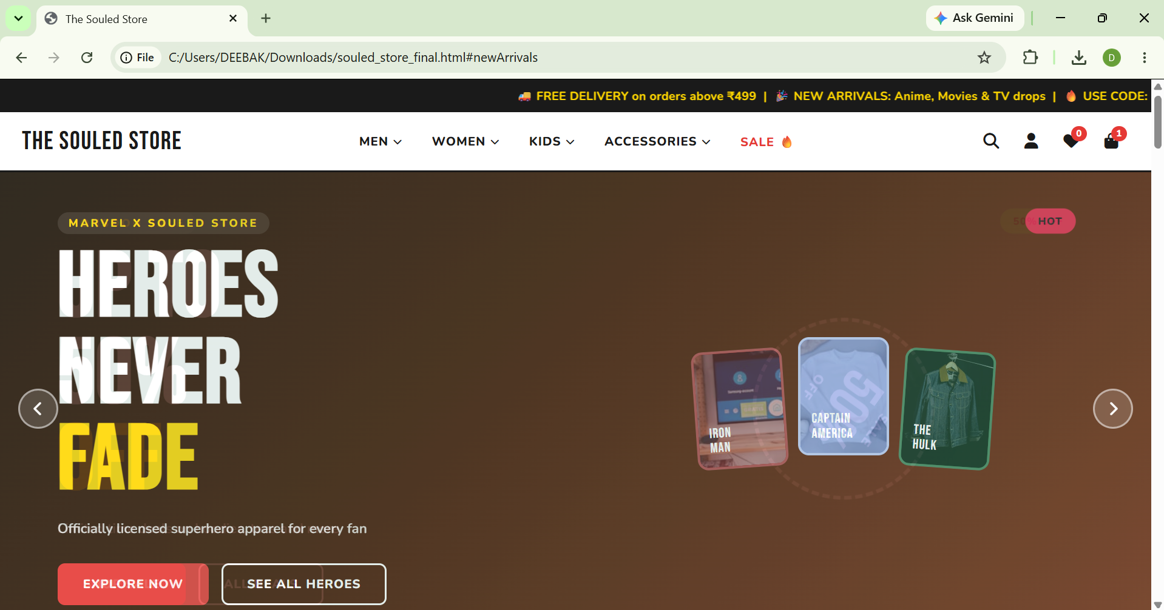
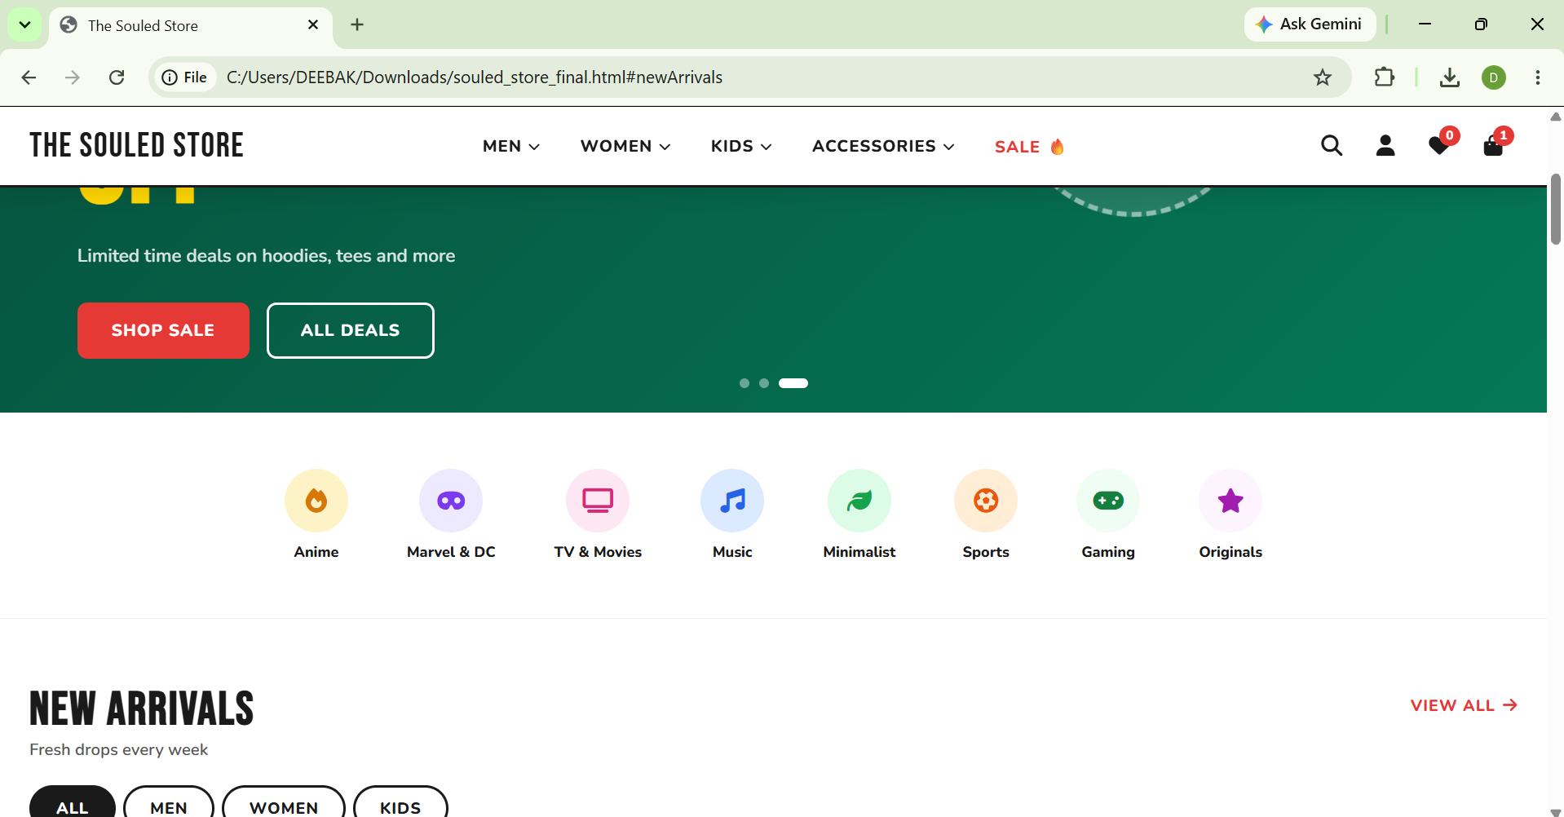

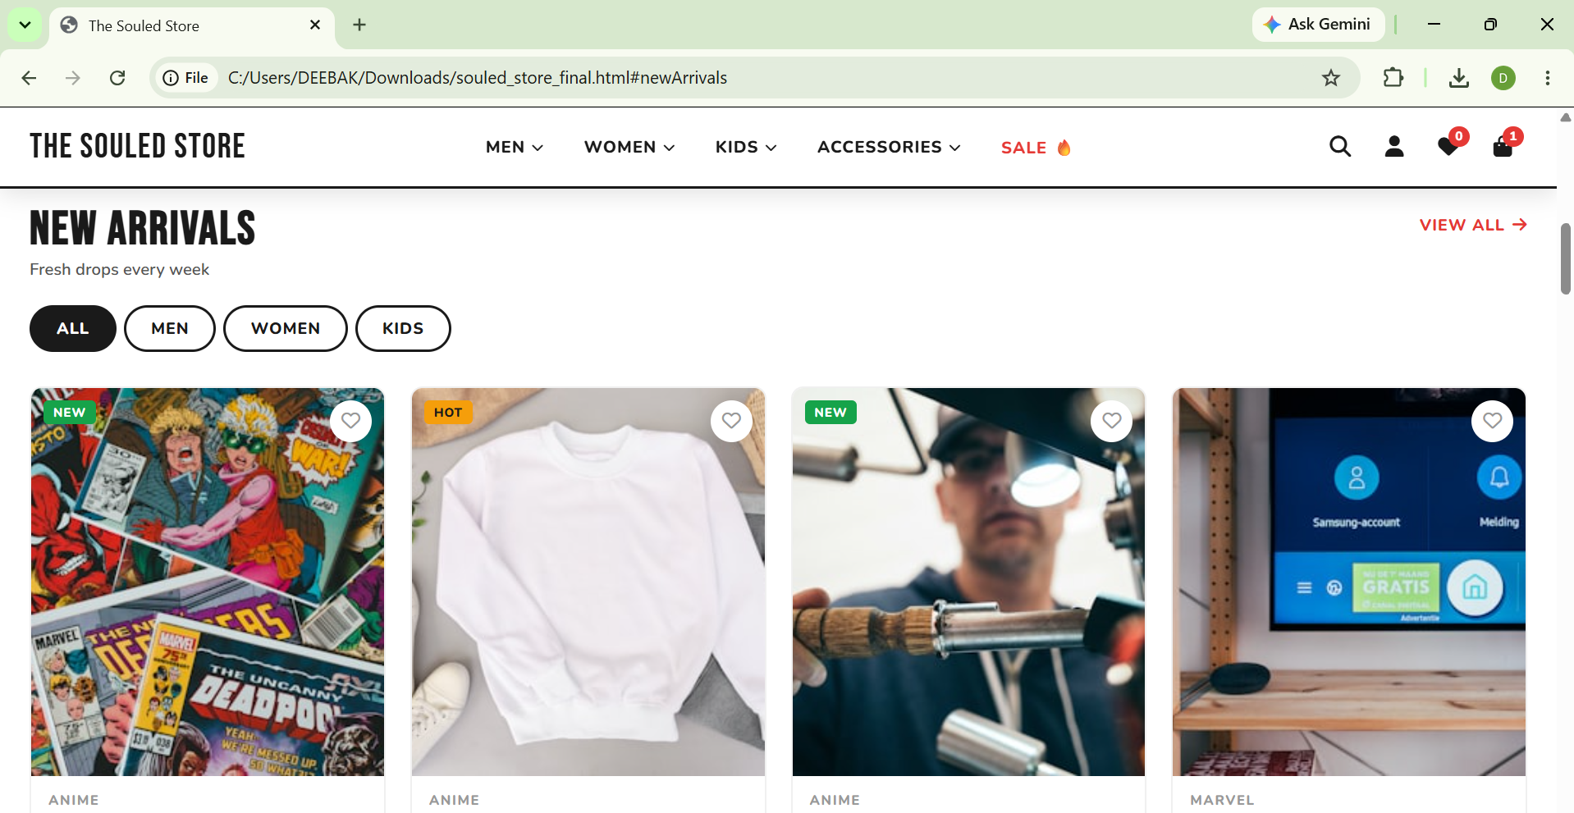
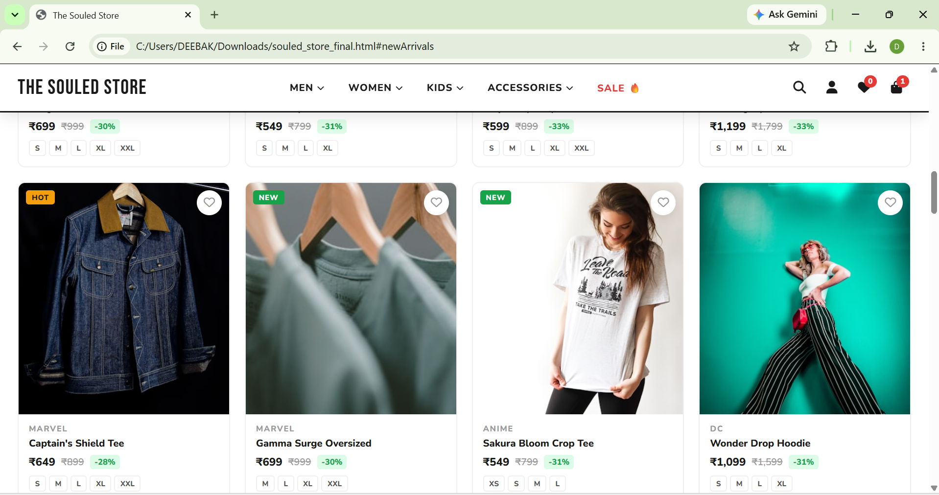
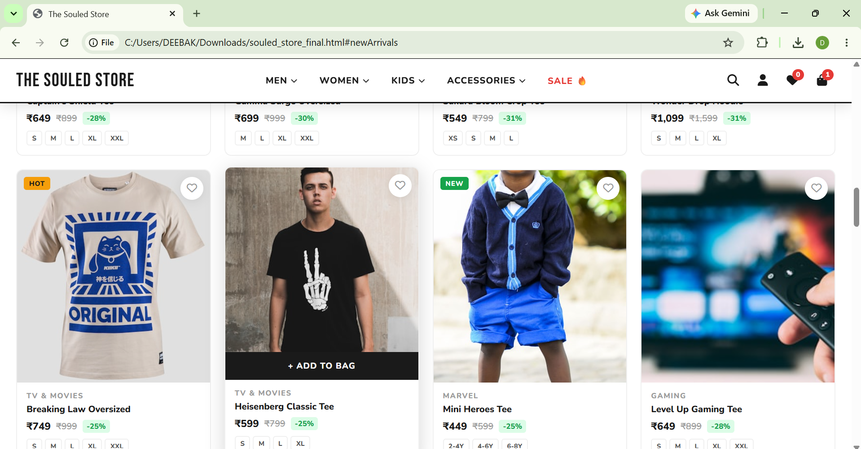
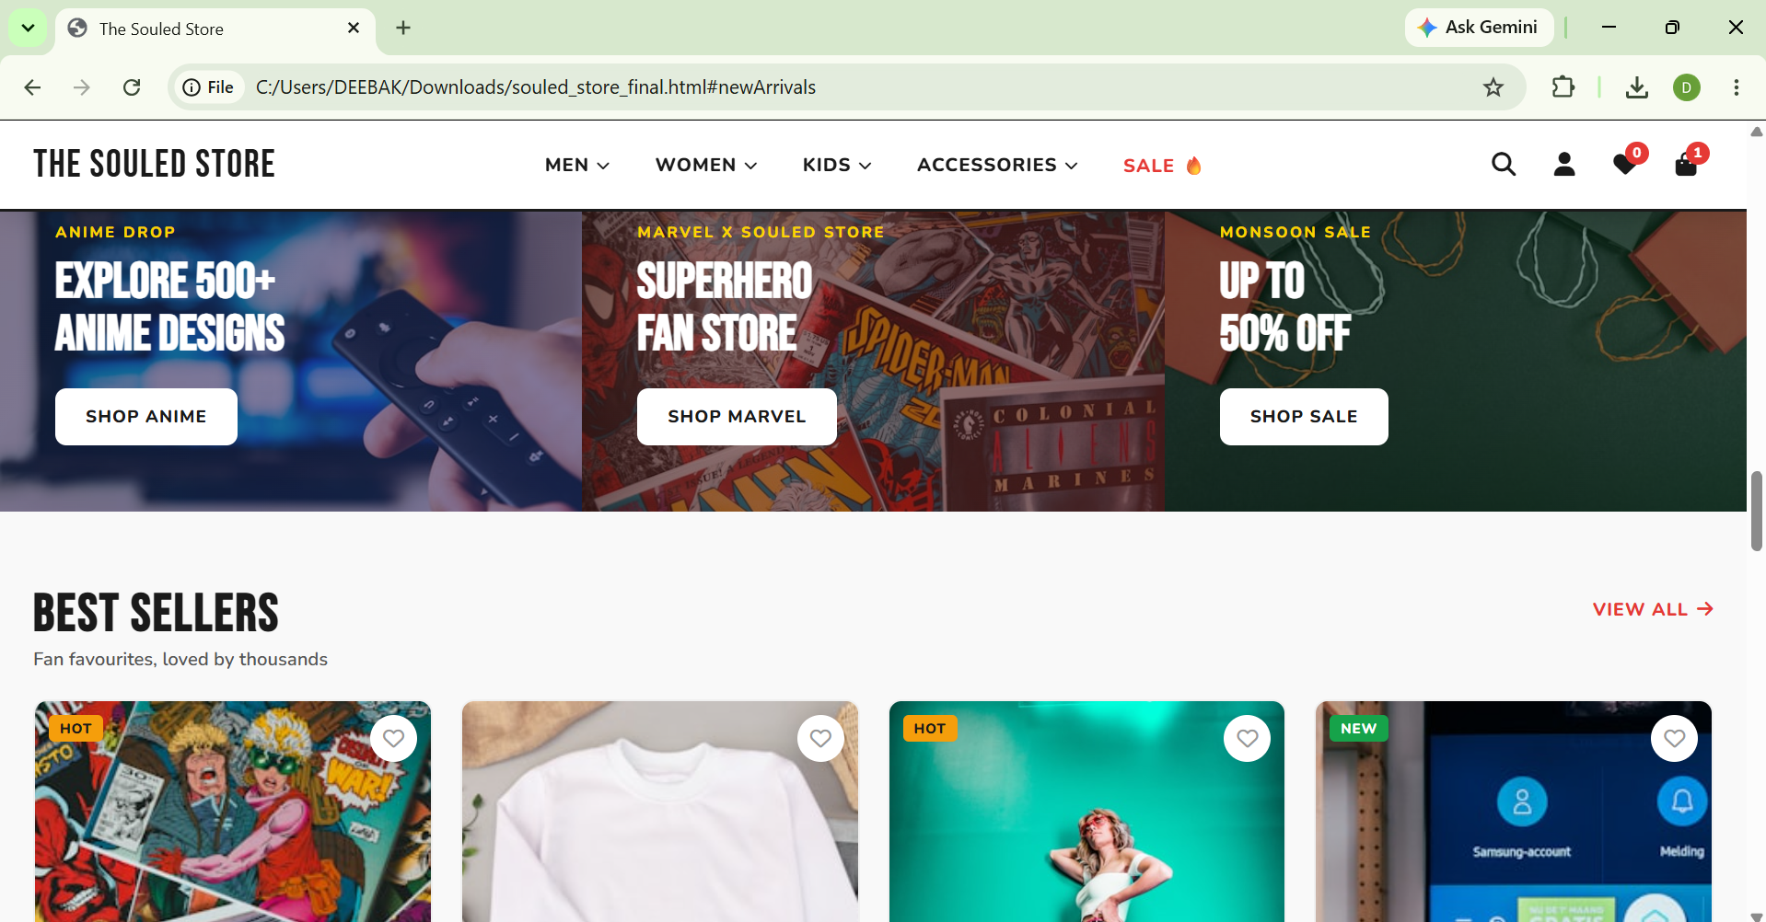
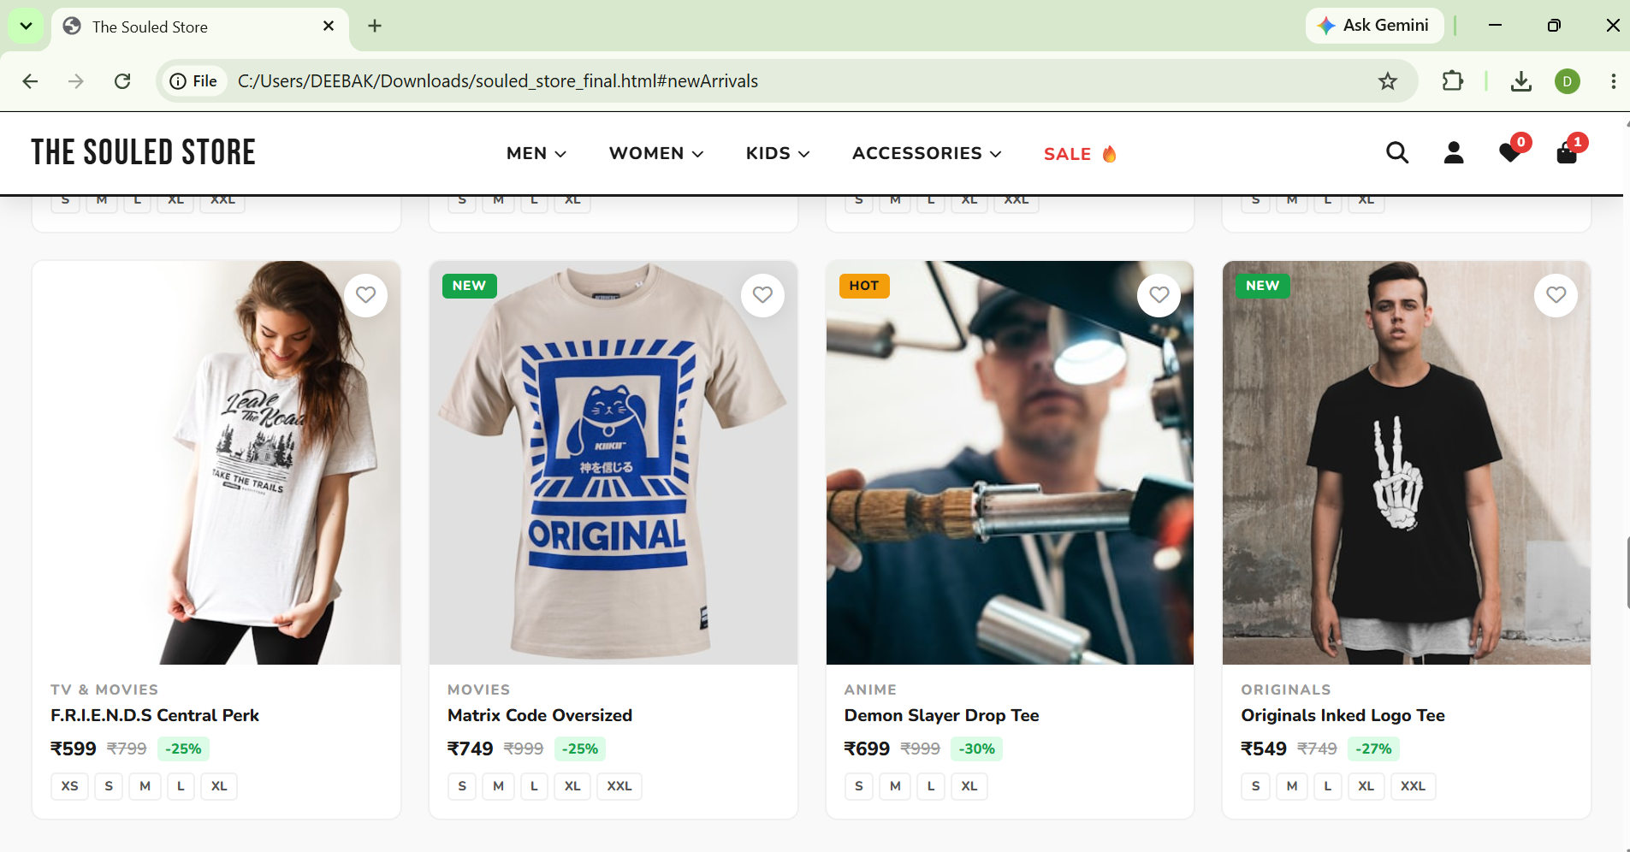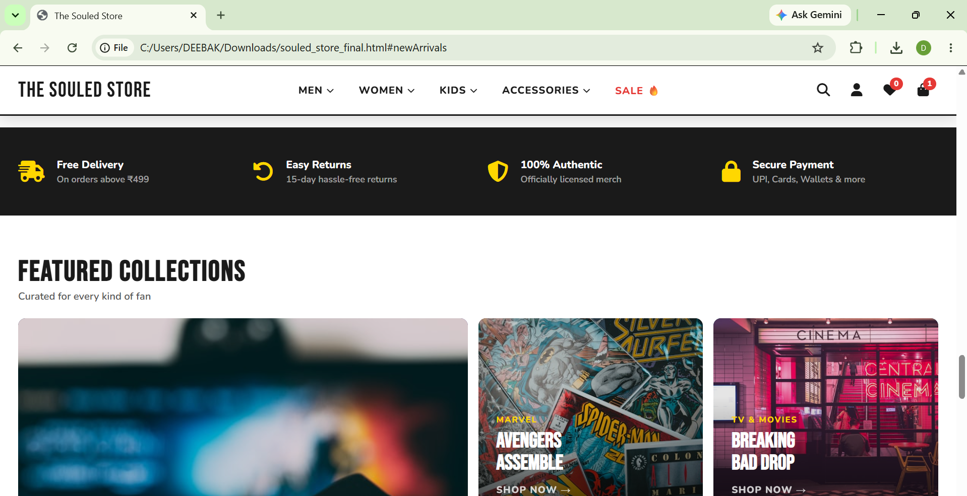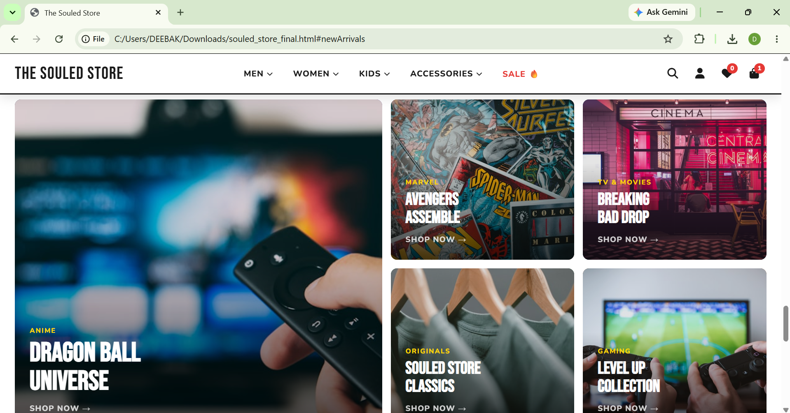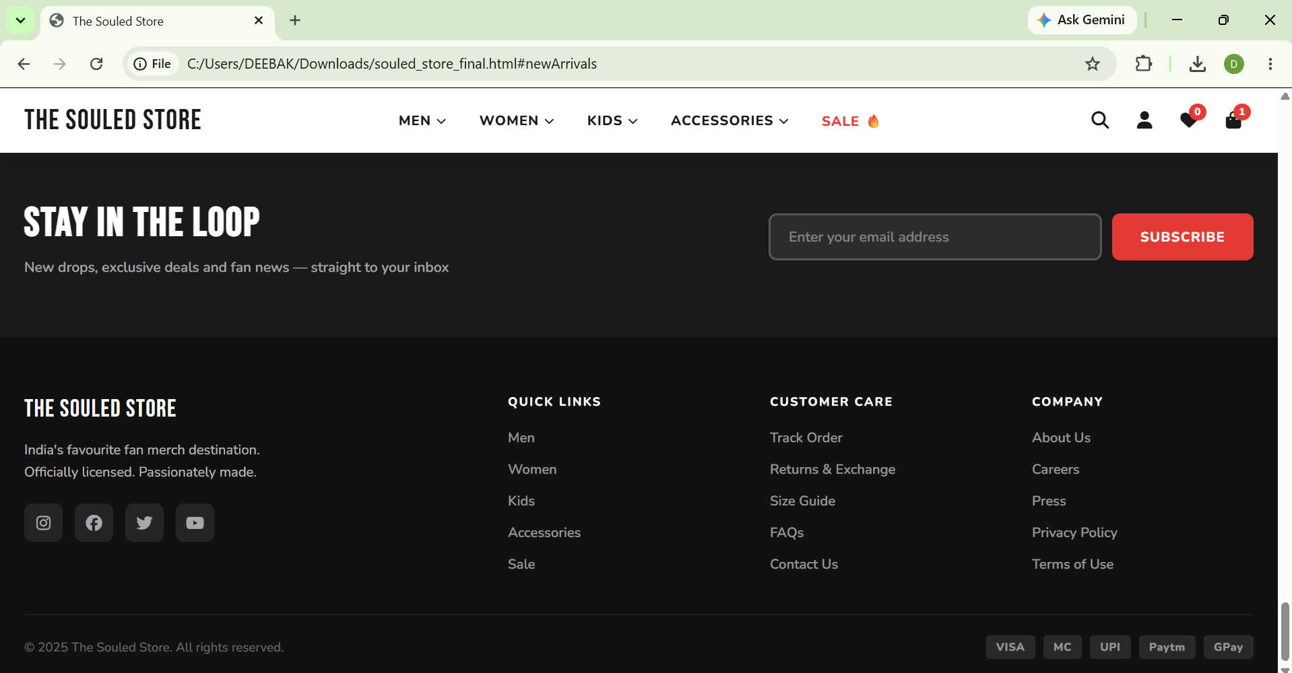
Explanation:
- Introduction:
Project Title: The Souled Store Clone Website
This project is a frontend e-commerce website inspired by The Souled Store. The website is designed using HTML, CSS, and JavaScript.
The project includes modern e-commerce features such as:
- Responsive Navigation Bar
- Hero Image Slider
- Product Categories
- Product Cards
- Wishlist Functionality
- Shopping Cart Functionality
- Search Bar
- Featured Collections
- Customer Testimonials
- Newsletter Subscription
- Footer Navigation
The main objective of this project is to understand how professional online shopping websites are developed using frontend technologies.
2) Project Goal :
The goal of this project is to recreate a real-world e-commerce homepage that provides users with an engaging shopping experience.
Users can:
- Browse different categories
- View featured products
- Explore collections
- Add products to wishlist
- Add products to cart
- Navigate through promotional banners
- Subscribe to newsletters
This project helped me understand frontend development concepts and real-world website structure.
3) HTML Structure:
The webpage is divided into multiple sections.
Header Section
Contains:
- Logo
- Navigation Menu
- Search Button
- User Account Icon
- Wishlist Icon
- Cart Icon
Hero Slider Section
Displays promotional banners and featured offers.
Categories Section
Shows categories such as:
- Anime
- Marvel & DC
- TV & Movies
- Music
- Sports
- Gaming
- Originals
Product Section
Contains:
- New Arrivals
- Best Sellers
Featured Collections Section
Displays special collections and promotional categories.
Testimonials Section
Shows customer reviews and ratings.
Newsletter Section
Allows users to subscribe using email.
Footer Section
Contains:
- Quick Links
- Customer Support
- Company Information
- Social Media Links

4) CSS Design:
CSS is used to create a modern and professional design.
Main design features include:
Responsive Layout
The website automatically adjusts according to:
- Desktop
- Tablet
- Mobile Devices
Flexbox and Grid Layout
Used to organize:
- Navigation
- Product Cards
- Collections
- Footer Sections
Hover Effects
Added to:
- Buttons
- Product Cards
- Categories
- Navigation Links
Animations
Implemented for:
- Hero Slider
- Product Cards
- Dropdown Menus
- Notifications
Color Scheme
The website uses:
- Red
- Black
- White
which matches the original Souled Store branding.

5) JavaScript Product Data:
JavaScript is used to make the website interactive.
Hero Slider
The hero slider automatically changes banners and allows manual navigation using previous and next buttons.
Product Rendering
Products are stored inside arrays and displayed dynamically.
Benefits:
- Easy to manage products
- Easy to add new products
- Better code organization
Wishlist Functionality
Users can:
- Add products to wishlist
- Remove products from wishlist
Wishlist count updates dynamically.
Shopping Cart Functionality
Users can:
- Add products to cart
- View cart items
- Check total amount
Cart count updates automatically.
Search Functionality
Users can search products using keywords.
Toast Notifications
Notifications are displayed when:
- Product added to cart
- Product added to wishlist
- Newsletter subscribed

6) Website Interactivity:

The website includes the following features:
Navigation Menu
Provides quick access to different sections.
Mega Dropdown Menu
Displays product categories in a structured layout.
Hero Image Slider
Promotes featured collections and offers.
Product Cards
Each card contains:
- Product Image
- Product Name
- Price
- Discount
- Sizes
- Wishlist Option
- Add to Cart Option
Shopping Cart
Displays:
- Added Products
- Quantity
- Total Amount
Featured Collections
Promotes popular themes and categories.
Customer Testimonials
Improves user trust and engagement.
Newsletter Subscription
Collects user email information for updates.

7) Output Explanation
Homepage
Displays the complete homepage with navigation, slider, categories, and products.
Category Navigation
Users can browse different product categories.
Product Interaction
Users can:
- Add items to cart
- Add items to wishlist
Cart Drawer
Displays selected products and total amount.
Responsive Design
The website works properly on:
- Mobile Phones
- Tablets
- Desktop Systems

8) Advantages of the Project
- Modern UI Design
- Responsive Layout
- Interactive User Experience
- Easy Navigation
- Dynamic Product Display
- Reusable Components
- Real-world E-commerce Structure

9) Challenges Faced
During development, the following challenges were encountered:
- Creating a responsive layout
- Implementing the hero slider
- Managing cart functionality
- Maintaining consistent design
- Creating dropdown navigation menus
These challenges helped improve frontend development skills.

10) Conclusion
The Souled Store Clone Website is a frontend e-commerce project developed using HTML, CSS, and JavaScript.
The project successfully recreates many features found in modern shopping websites, including navigation menus, product displays, hero sliders, wishlist functionality, shopping cart management, and responsive design.
Through this project, I gained practical experience in:
- HTML Structure Design
- CSS Styling
- Responsive Web Design
- JavaScript Programming
- DOM Manipulation
- User Interface Design
This project helped me understand how real-world e-commerce websites are built and how frontend technologies work together to create a complete user experience.

