**Evaluation Boardlet: ADUCM350**

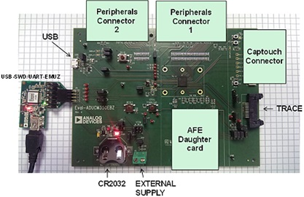

**Characteristics:**

**3 Power supply options: (Indicated Using an LED)**

* 2.5 to 3.6 v from external power supply
* 5 v interface/emulator board
* CR2034 Battery connection

**Analog Performance :**

* 160 kSPS, 16-bit, precision analog-to-digital converter (ADC)
* 12-bit digital-to-analog converter (DAC)

**Connection**: UART and Serial wire through 8-pin J-link OB Connector Trace capability.

**Processor**: 16MHZ ARM-cortex-M3 with a high precision AFE Specifically for high precision DAQ.

**Memory:** 384 KB of Flash, 32 KB of SRAM and 16 KB of Flask configuration as an EEPROM.

**ANALOG FRONT END:**

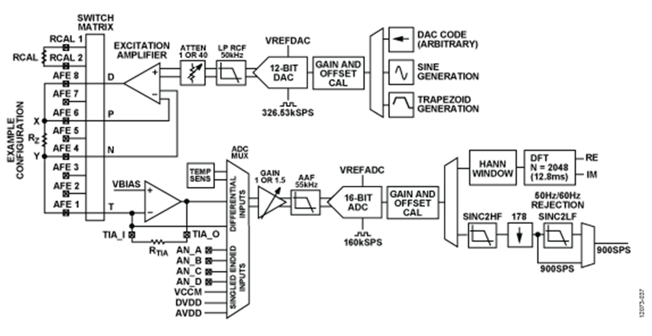

Fig: AFE System Block Diagram

**Impedance Measurement:**

|  |  |  |  |
| --- | --- | --- | --- |
| Parameter | Max | Unit | Test Conditions |
| Accuracy:   1. Magnitude 2. Phase   Precision:   1. Magnitude 2. Phase | 0.33  0.17  0.17  0.08 | %  Degrees  %  Degrees | Std. Deviation as a % of Z  Std. Deviation of Z  Std. Deviation as a % of Z  Std. Deviation of Z |

**Working Range:**

This board is best suited for measuring impedance over a wide range of frequencies. *Min freq: 80 Hz to a Max freq: 75 kHz approx*.

**Impedance Measurement Method:**

* 2 wire method
* 4 wire method

**Connecting DUT’s for measuring impedance:**

* Connect the AFE daughter card to the main board
* Connect the unknown impedance of the DUT/ Sensor to the daughter board using the 2/ 4 wire method
* Once the DUT/ Sensor is connected, use the software to obtain the required plot
* From the plot obtained calculate the impedance (Magnitude and Phase) of the circuit
* Compare the result with value measured using the Agilent
* Also compare the parameters (Accuracy and Precision) with the other boards

**Software:**

1. Open the Software (IAR).
2. Go to File-Examples and Select 2-Wire measurement (Example).
3. Download it to the Development Board.
4. Graph is automatically plotted in customized **LabView software**.