**PROTOCOL TITLE: *Inferring Mode Switch Intent to Improve Limited Control Interface Usage with Shared-Control***

**PRINCIPAL INVESTIGATOR:**

*Brenna Argall*

*Shirley Ryan AbilityLab, 355 E. Erie, Lvl 24 Ability Lab, Chicago, IL 60611*

*312-238-1686*

*brenna.argall@northwestern.edu*

**VERSION DATE:**

January 10, 2020

**Study Summary:**

|  |  |
| --- | --- |
| Investigational Agent(s)  (Drugs or Devices) | NA |
| IND / IDE / HDE # | NA |
| Indicate  Special Population(s) | Children  Children who are wards of the state  Adults Unable to Consent  Cognitively Impaired Adults  Neonates of Uncertain Viability  Pregnant Women  Prisoners (or other detained/paroled individuals)  Students/Employees |
| Sample Size | 40 |
| Funding Source | NIH |
| Indicate the type of consent to be obtained | Written  Verbal/Waiver of Documentation of Informed Consent  Waiver of HIPAA Authorization  Waiver/Alteration of Consent Process |
| Site | Lead Site ( For A Multiple Site Research Study)  Data Coordinating Center (DCC) |
| Research Related Radiation Exposure | Yes  No |
| DSMB / DMC / IDMC | Yes  No |

**Objectives:**

Assistive machines promote independence and ability in those with severe motor impairments. However, as these machines become more capable, they often also become more complex. Traditional interfaces cover only a portion of the control space, and during teleoperation it is necessary to switch between different control modes to access the full control space. When using limited interfaces, the user will often issue unintended mode-switch commands for various reasons (such as spasms due to their injury, fatigue, or insufficient skill). These unintended commands negatively affect the user’s interaction with the robotic device and overall task performance. Machine and statistical learning tools may be used to anticipate when an executed command differs from an un-observable intended action, and robotics autonomy can leverage this information to make corrective decisions.

Our long-term objective is to empower severely paralyzed patients with greater independence in daily living activities through the introduction of robotics autonomy by overcoming the challenges in operating assistive machines. The goal of this protocol is to pioneer and validate a control-intent inference framework that assists people in controlling a complex robot with limited control interfaces and that adapts to variations in the user’s control input behavior.

**Hypothesis:** Designing a system that can correct for unintended mode switches by reasoning about unobserved human control intent can improve human-robot performance metrics such as cognitive load and task completion time.

**Aim1 (A1):** **Develop a framework that infers intended control mode switching from the measured command.** When a low-dimensional control interface such as sip-and-puff or switch-based head array are used for controlling higher-dimensional devices such as robotic arms, the user must switch between which control dimension of the robot a limited interface input is mapped to (i.e. mode switching) which carries a high cost. We will implement and evaluate probabilistic algorithms that model the user’s unobserved intended mode-switch intent from the measured user input.

**Aim2 (A2): Improve the control of complex robotic machines with limited control interfaces by handling unintended control-mode switches.** This approach is a departure from the majority of control sharing approaches within assistive domains, which either partition the control space and allocate different portions to the robot and human, or augment the human’s control signals to bridge the dimensionality gap. How to best share control within assitive domains remains an open question, and an appealing characteristic of our approach is that the user is kept maximally in control since their signals are not altered or augmented. In this study we will evaluate two ways of handling unintended control-mode switches: (1) Filtering autonomy which will ignore mode-switch commands deemed as unintentional (2) Corrective autonomy which will reason about which mode-switch was intended and switch the most likey control mode automatically. We will compare the autonomy assistance based on quantitative and qualitative task performance metrics such as task completion time and user prefernce.

**Background:**

Assistive machines—like power wheelchairs, robotic arms, exoskeletons, electric prostheses—are crucial in facilitating the independence of those with severe motor impairments. Such machines can extend and enable mobility and manipulation abilities of persons with motor limitations in their own legs and arms. However, there are circumstances under which the control of assistive machines remains a challenge—to the point even of making use of the machine entirely inaccessible. In addition to the motor impairments of the user, these circumstances include the limited control interfaces which are available to those with severe impairments, and also the complexity of the machine to be controlled. To illustrate, the most ubiquitous assistive machine is the powered wheelchair, and there are many impairments for which driving a powered wheelchair can be a challenge (such as upper-body physical im-pairments like ataxia or bradykinesia, cognitive impairments like deficits in executive reasoning, and visual impairments like limitations in head, neck or eye movement [1]. According to a survey of 200 clinicians, more than 50% of powered wheelchair users reported complaints with wheelchair control [2]. In another assistive domain, a survey of 1,575 prosthesis users points to a want for better control mechanisms [3]. Factors like fatigue and pain also can be huge for those with physical impairments; who might, for example, trade a reduction in control precision for an interface that is less fatiguing.

The potential for robotics autonomy to ease control burden within assistive domains has been recognized for decades. While full autonomy is an option, it removes all control from the user. When this is not desired by the human, the assistive technology in fact has made them less able. It also discards useful input the human might provide, leveraging for example their superior situational awareness, that would add to system robustness. Control sharing is a way to offload some control burden, without removing all control authority, from the human [5-9]. The most common paradigms augment or adjust control signals from the human (e.g. to bridge the gap in control signal dimensionality), or partition the control problem (e.g. high-level decisions like which task to execute lie with the human, and low-level execution decisions lie with the robot). On the other hand, mode-switching assistance has the key benefit that it is low-bandwidth and intermittent, and hence possibly easier to learn.

There has been limited study of robot learning from non-experts, who do not understand the details of how a given machine learning algorithm is working. The proposed domain is even more challenging—not only are the instructors not machine learning experts, they might not even be task experts. They are, however, who the robot should be learning from—their preferences are precisely what the system is meant to optimize.

The results of this study will put forth a mathematical framework of modeling unintended human control inputs based on known intended actions. The proposed studies will investigate the efficacy of our outlined approach in inferring unintentional human commands. Additionally, we will compare how well our assistive systems based on this inference is able to improve human-robot task performance by correcting for those unintentional commands.

**Study Endpoints:**

Studies will be conducted until the total number of participants needed to complete the study have been enrolled.

**Procedures Involved:**

Study Environment. Some experiments will be conducted in simulation using custom-built game environments in which the user will control the motion of a 2D object on the computer screen for various tasks (e.g. responding to a prompt or following a path). Other experiments will take place using real physical robots. The physical robot platforms we will use in this work include the Kinova *robotic arms* (such as the MICO and JACO in Figure 1) and the *smart wheelchair* developed in our lab and built on a Permobil base. These robots are designed specifically to interact with the human partners and are considered extremely safe. Kinova products are designed as assistive devices for people have limited motor control due to injury or disease. Kinova’s stated goal is to develop produces that let “users become less dependent on family and professional attendants and enjoy an improved quality of life, enhanced feeling of independence and improved confidence in their ability to go about their daily lives.” ([www.kinova.com](http://www.kinova.com/)). Permobil is one of the largest manufacturers of wheelchair systems for people with motor impairments and has a long history. To the Permobil base we have added sensing and computing components. The software suit we have developed for this platform is extensive with structured autonomy behaviors and control sharing paradigms. These devices are designed specifically to operate in cooperation with human partners. The goal of this work is to improve the efficacy of just such devices to improve the lives of people in need of physical assistance. For these reasons, the Kinova robotic devices are We will make use of the open-source Robot Operating System (ROS)[10] software architecture, which allows us to easily recreate experimental conditions and record user data.

Data and Metadata Standards. A standard tab-delimited data file format will be used for all data files. Data files will include the position and velocity data of the simulated dynamic system. No contextual data files are needed to make the configuration and signal data meaningful. All data will be recorded in .bag format during the study using the open source ROS software. For analysis purposes the data will be transformed into standard tab-delimited data file formats. Objective user data pertaining to the human-robot system will also be collected using questionnaires which will be administered at the start, end and during the study session. Documentation on data recording procedures and bug reporting will be maintained on an internal lab wiki, backed up by the IT department at the Shirley Ryan AbilityLab.

Study Design. The proposed study will follow a within-subject design methodology for **A1** and **A2.** Each study aim will occur as two separate sessions each lasting between 1 and 2 hours. SCI participants will be selected randomly from a population of potential volunteers with complete injuries at the C4-6 cervical level (ASIA A), or incomplete injuries in the cervical cord (ASIA B and C). We include uninjured participants for primary tests and parameter settings. Our preliminary work furthermore suggests similar performance between SCI and uninjured subjects.

Study Procedures:

In A1, our goal is to derive a mathematical framework that explicitly . Subjects will first become acquainted with teleoperating either the simulated robot or physical robot during a training phase. Subjects will operate the selected study platform under various tasks/environments, and will complete several questionnaires, as well as a NASA Task Load Index for each task.

* The wheelchair tasks will consist of navigation tasks derived from the clinical Wheelchair Skills Test for Power Wheelchair Users [11]. Some examples include docking at a table, traversing a doorway, navigating a wheelchair accessible ramp, or turning tight corners. The subject will sit in the wheelchair seat during operation.
* The robotic arm tasks will simulate household Activities of Daily Living (ADL) manipulation tasks that a subject may encounter in everyday life. Some examples include moving a small object from one location to another or opening a drawer.
* The simulated robot tasks will include navigational and command following and response tasks. Example simulated tasks are depected in Figure (2).

Procedure 1 (P1):

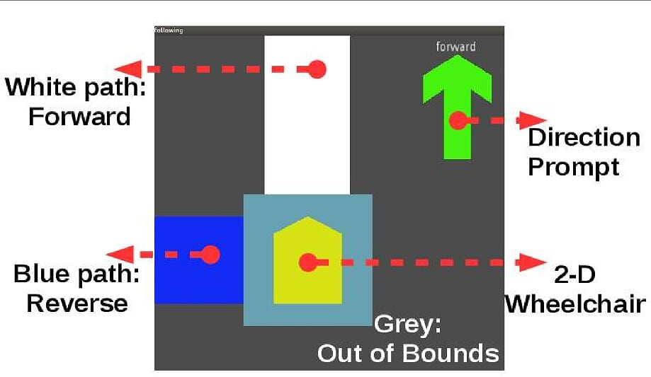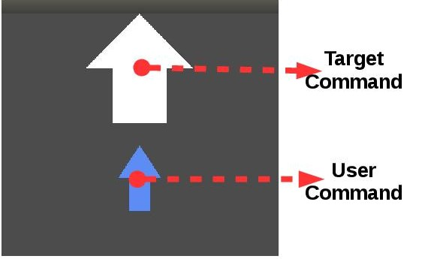Each subject will participate in 1-2 sessions lasting approximately 1-2 hours each. Participants will use a low-dimensional interface (e.g. sip-and-puff or headarray) to control various navigation, reaching or response tasks either in simulation or on real hardware. The tasks are designed to gain information about the user’s mode switching and control behavior in order to generate probabilistic maps that can be used to inform our mathematical framework for the mode switch assistance (A1). Each session will consist of a set number of trials during which time each user will control either the physical or simulated system without any assistance from the automation.

Procedure 2:

Each subject will participate in 1-2 sessions lasting approximately 1-2 hours each. Subjects will perform various evaluation tasks either in simulation or using the robot hardware both with and without the mode-switch assistance paradigms designed based on data generated from P1. We will compare the performance between the assisted and non-assisted paradimgs through statistical tests on task-performance metrics (e.g. time-to-task-completion and number of mode switches) user-preference using post-task questionnaires.

**Study Timelines**

Individual participants will be involved with either A1 or A2 studies, which will occur as one separate session each, lasting between 1 and 2 hours. It is anticipated that it will take 6 months to enroll all study participants. It is estimated that the investigation's primary analyses will be completed in one year.

**Inclusion and Exclusion Criteria**



We plan to evaluate 200 uninjured subjects over the duration of the study. We also plan to recruit 40 SCI volunteers.

Inclusion Criteria (unimpaired participants):

* Ages 18 and up.
* All subjects must have given signed, informed consent prior to registration on study.
* Ability to follow simple commands, and to respond to questions.

Exclusion Criteria:

* Does not meet the inclusion criteria.

Additional Inclusion Criteria (SCI participants):

* Ages 18 and up.
* Complete (ASIA A) or lesion at C3-6 or incomplete (ASIA B and C) lesion in the cervical cord.
* One year or more post injury.
* Stable medical condition and absence of concurrent significant complications.

Additional Exclusion Criteria (SCI participants):

* Cognitive impairments
* Severe hearing or visual deficiency
* Sitting tolerance less than one hour
* Concurrent pressure sores or urinary tract infection, or other uncontrolled infection

**Participant Population(s)**

|  |  |  |  |
| --- | --- | --- | --- |
| Accrual Number: | Category/Group:  (Adults/Children Special/Vulnerable Populations) | Consented:  Maximum Number to be Consented or Reviewed/Collected/Screened | Enrolled:  Number to Complete the Study or Needed to Address the Research Question |
| Local | Adults | 200 | 200 |
| Adults SCI | 40 | 40 |
| Study-wide |  |  |  |
|  |  |  |
| Total: |  | 240 | 240 |

**Recruitment Methods**

Uninjured subjects will be recruited from the visitors, staff and students of the Shirley Ryan AbilityLab and Northwestern, by word of mouth, email and posted advertisements. We will also use a list-serve of registered students who are interested in participating in research (provided by the Psychology department at Northwestern).

SCI subjects will be recruited by Jessica Pederson, MBA, OTR/L, ATP who is an Occupational Therapist at the Shirley Ryan AbilityLab.

Assessment of inclusion/exclusion criteria will be performed by PI Argall and study team members. We will also use the SCI model registry database to recruit end-user subjects. We will also use consumer and professional organizations for recruitment via mail, phone, email, or posting our recruitment flyer.

**Compensation for Participation in Research Activities**

Participants will receive an honorarium of $20 per hour for participation in the study via ClinCard. SCI participants will receive an honorarium of $35 per session and will further be reimbursed for travel costs (upon receipt).

**Withdrawal of Participants**

Subjects will be allowed to withdraw from the study at any time upon request. Their participation will be terminated if any of the inclusion criteria ceases to be valid or if any exclusion criteria will manifest after enrollment.

**Risks to Participants**

* Interaction with a robot arm: During the teleoperation of a robotic arm, there is a chance that the subject could come into contact with the arm, which is a potential injury risk. The arm is a commercial product specifically designed for safe use close to humans. The subject will be seated outside of the reach of the arm. Additionally, the experimenter has an emergency button that immediately stops the arm. The experimenter will constantly monitor this button.
* Interaction with a powered wheelchair: During the operation, there is a chance that the subject could experience mild collisions with the environment, which is a potential injury risk. The wheelchair platform is a commercial product specifically designed for safe use. Additionally, the subject and the experimenter will have an emergency button that immediately stops the mechanism. The experimenter will constantly monitor this button.
* Discomfort or fatigue: There is a risk of discomfort or fatigue when operating a teleoperation devices (joystick, headarray, sip-and-puff) for extended periods of time. Participants will be given sufficient brakes to reduce the risk of developing physical or mental fatigue. Fatigue will be assessed based on the subjects’ verbal report. They will be explicitly invited to inform the experimenter, who will promptly interrupt the session.
* Answering the questionnaires: There is no risk in answering the questions because all of the questions are specially related to the study.

This study does not involve any other risk to the subject. All studies will be carried out in the hospital environment were medical care is immediately available if needed.

**Potential Benefits to participants**

There is no direct benefits to the individual participants.

**Data Management and Confidentiality**

Upon enrollment, subjects will be assigned a random study ID number, and thereafter any data gathered will be associated with the study ID number only. The key matching subject name to study ID number will be maintained in a locked file accessible only by the PI. Patient health history (self-reported) will be maintained in a secure locked area, accessibly only by the PI and shared with other study personnel only on a need to know basis as required to safely and accurately conduct the study.

Electronic data will be stored on a secure file server requiring authorization to access. Copies of paper data will be stored in a locked file cabinet accessible only to the PI. Data will be made available upon request, after the conclusion of each of study. The availability of data (raw and analyzed) will be advertised on the lab’s website on the existing SMPP web server (http://www.ric.org/research/centers/smpp/), along with our written analyses of the data. Access will be free, but the original data collector/creator/principal investigator retains the right to use the data for analysis before making it publicly available. No patient identifying information will be included in any of the available data files.

Select videos of the experiments will be distributed, with subject faces blurred so as to be unidentifiable. Experimental analyses results will be made available through peer-reviewed journal publications and conference presentations. There will be no copyright or licensing required for any of the data generated in this project.

The data storage server is archived and maintained by the Northwestern IT and backed up by the IT department at the Shirley Ryan AbilityLab. Data archival, backup, auditing capabilities for reporting on access, creation, replication, updates and deletion of files are available upon request by Northwestern IT. Any and all documentation will be provided in PDF or HTML format, to ensure continued accessibility. We anticipate keeping the data for at least one decade past the duration of the project. At such point when it is discarded, hard copies will be destroyed and soft copies deleted.

**Provisions to Protect the Privacy Interests of Participants**

The audio and video records will be destroyed after the time period chosen by the subject in the consent form. Demographic data collection will be done in a private room. Subject scheduling will be done with deidentified information.

**Economic Burden to Participants**

Uninjured participants will be responsible for transportation to and from the Shirley Ryan AbilityLab. SCI subjects will be responsible for any personal caregiver costs.

**Consent Process**

Prior to or on the day of the testing session the investigator will present subjects with an informed consent form that clearly states the potential risks and benefits of participation in the study. It will be clearly stated, on the form and verbally, that subjects may withdraw from the study at any time and without penalty. The investigator will offer to answer any questions, and will explain the procedures and purpose of the study. The consent process will be carried out in a private room by IRB approved study team members. The session will begin only after the consent form has been signed.

**Qualifications to Conduct Research and Resources Available**

We expect to recruit 240 subjects which is feasible to recruit from the visitors, staff, students and research registry of Shirley Ryan AbilityLab and Northwestern University.

The experiments will be conducted at Shirley Ryan AbilityLab with the hardware and software developed and maintained by PI Argall’s labs.

All study team members will maintain CITI training compliance. Team members conducting the experiments will be adequately trained on other lab-members prior to conducting studies with the recruited subjects.

**References**

[1] R. Simpson, E. LoPresti, and R. Cooper. How many people would benefit from a smart wheelchair? Journal of Rehabilitation Research & Development, 45(1):53–72, 2008.

[2] L. Fehr, W. E. Langbein, and S. B. . Skaar. Adequacy of power wheelchair control interfaces for persons with severe disabilities : A clinical survey. Journal of Rehabilitation Research & Development, 37(3):353–360, 2000.

[3] D. Atkins, D. Heard, and W. Donovan. Epidemiologic overview of individuals with upper-limb loss and their reported research priorities. Journal of Prosthetics and Orthotics, 8:2 – 11, 1996.

[4]G. Bourhis and M. Sahnoun. Assisted control mode for a smart wheelchair. In Rehabilitation

Robotics, 2007. ICORR 2007. IEEE 10th International Conference on, pages 158–163. IEEE, 2007.

[5] A. Dragan and S. Srinivasa. Formalizing assistive teleoperation. In Robotics: Science and

Systems, 2012.

[6] A. D. Dragan and S. S. Srinivasa. A policy-blending formalism for shared control. The

International Journal of Robotics Research, 32(7):790–805, 2013.

[7] J. Philips, J. del R Millan, G. Vanacker, E. Lew, F. Galán, P. W. Ferrez, H. Van Brussel,

and M. Nuttin. Adaptive shared control of a brain-actuated simulated wheelchair. In

Rehabilitation Robotics, 2007. ICORR 2007. IEEE 10th International Conference on, pages 408–414. IEEE, 2007.

[8] D. Vanhooydonck, E. Demeester, M. Nuttin, and H. Van Brussel. Shared control for in-

telligent wheelchairs: an implicit estimation of the user intention. In Proceedings of the 1st international workshop on advances in service robotics (ASERâA ̆Z03) ́ , pages 176–182. Citeseer, 2003.

[9] H. A. Yanco. Shared user-computer control of a robotic wheelchair system. PhD thesis, Citeseer, 2000**.**

[10] Robot Operating System. Willow Garage. [Online]. Available: [http://www.ros.org](http://www.ros.org/)

[11] Wheelchair skills test (WST) version 4.2 form. http://www.wheelchairskillsprogram.ca/eng/testers.php, 2013