MODULE 8: Portfolio Project
The Future of Data Science and Analytics
Deepak Gupta
MIS500 - Foundations of Data Analytics
Colorado State University – Global Campus
Dr. Eric M. Straw
July 07, 2019
Introduction
Mobile Operator called American Wireless recently launched prepaid Travel Pass bundle plans to allow domestic and International talk plan and data plan in more than 185 countries. The plan is basically divided in 2 categories Daily and Bi-Weekly plan. Using any of these plans, subscriber can call within / outside the country they’re visiting and can call back to the US using these bundles.

The sample fee applicable is for Daily and Bi-Weekly Plan is:

1) $5 per day Travel-Pass

2) $30 Bi-Weekly Travel-Pass.

After the successful launch of both plans, Operator wants to run analysis to see the consumption percentage of these 2 plans and identify whether there is need for weekly plan as well. Currently these decisions will help roamer who are on short trip to roaming country and doesn’t want to spend for Bi-Weekly and for daily plans due to cost.

Raw Dataset

To obtain this dataset, I have used sample records that I was exposed too during launch of Travel-Pass, the dataset shows the roaming country, roaming network, opted travel bundle and consumed percentage from bundle to show the extensive usage of plan.

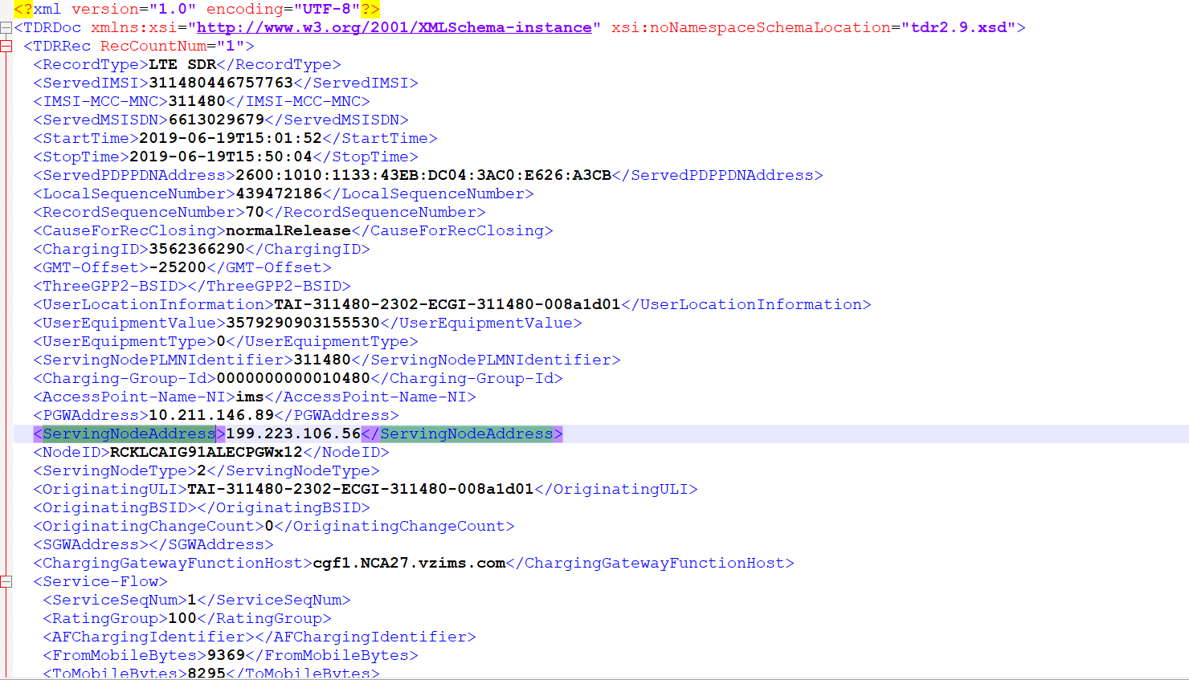

Figure 1. Original Data-Set for Travel-Pass Bundle Consumption.

Cleaning and Filtering of Dataset

The raw dataset contains additional columns such as – ServingNodeAddress, UserLocationInformation, UserEquipmentValue etc , so therefore each columns is analyzed and processed to ensure columns which was not needed as part of hypothesis test, can be removed and only refined columns are listed in Excel format to perform hypothesis tests.

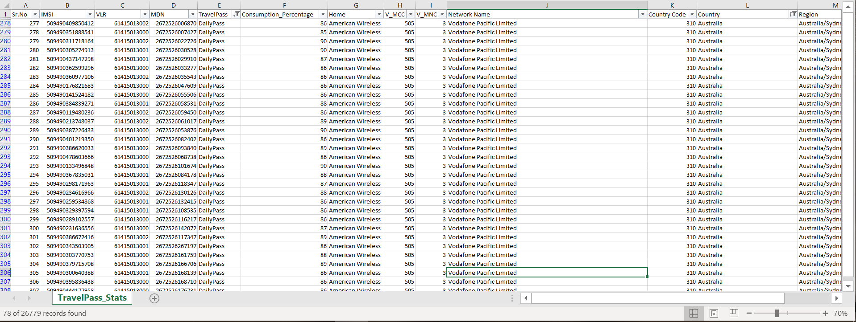

Table 1. Filtered Data-Set for Travel-Pass Bundle Consumption.

Planned analysis and expected results

As part of this exercise, analysis is performed to validate the current consumption of daily pass and biweekly pass to see if weekly pass bundle can be launched by operator.

Analytics test to address weekly bundle problem

Using hypothesis test, the population can be validated to see if the consumption mean for Daily is greater than Bi-weekly plan so that sufficient evidence can be found and operator can feel encouraged to launch weekly bundle plans.

More intense relationship can also be sought to see if any dedicated plans need to be launched specially for some countries. For example, instead of launching Weekly plans for all countries only selected countries can be picked, however under this exercise we are examining the launch for all countries.

Case Study for Travel Pass Retail Analytics
Data Set

Table 1 shows sample population for Travel-Pass to Consumption report. The key fields in the report is TravelPass with possible values DailyPass and Bi-WeeklyPass, Consumption_Percentage which shows total consumption on opted plan.

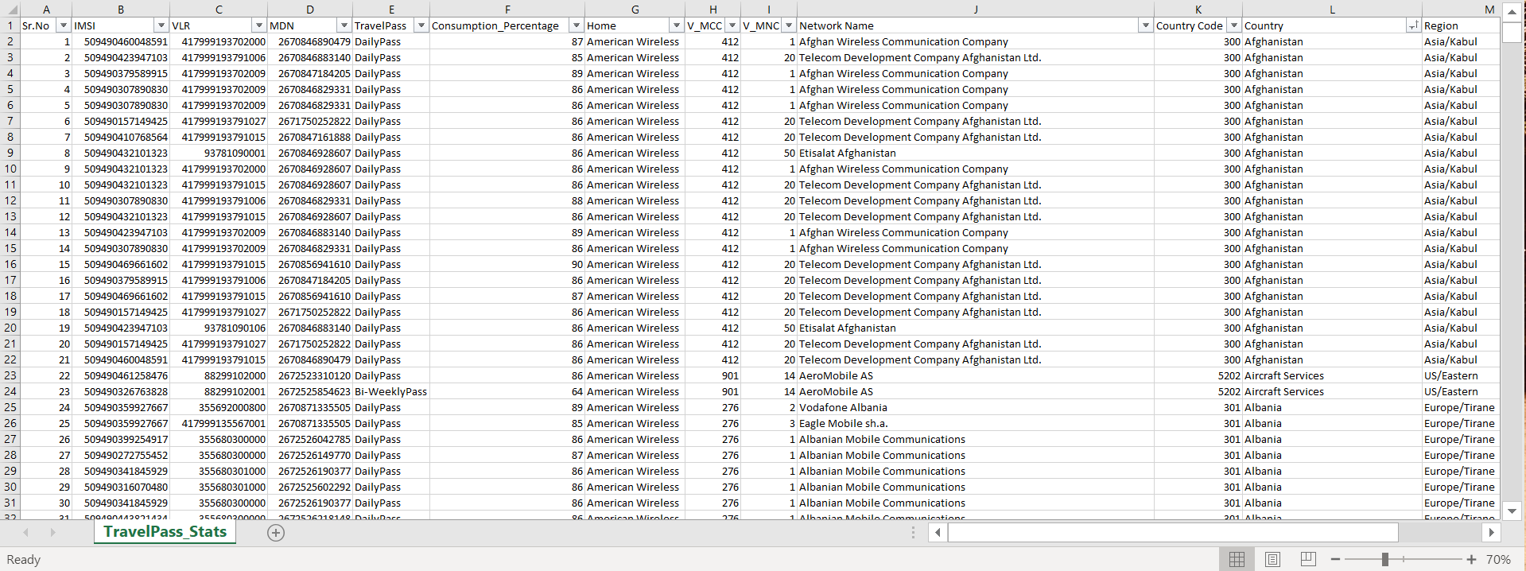
Table 2. Data-Set for Travel-Pass Bundle Consumption.

Importing Data-Set to R

Figure 2 shows sample population for Travel-Pass to Consumption report imported in R studio and Summary stats is populated. Highlights of summary stats-

- Various Region and respective count.
- Different Travel-Pass and respective count.
- Consumption-Percentage and respective summary stats.

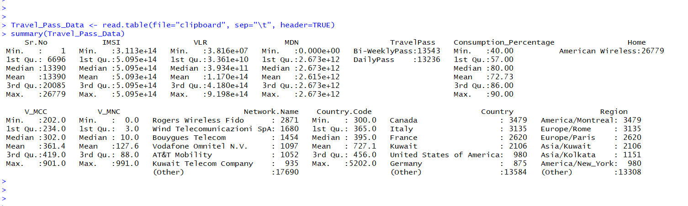
Figure 2. Summary Statistics using R.

Performing t-test for Hypotheses for a two-sample dataset

The population dataset contains independent samples for Daily and Bi-Weekly population. We can consider this as an UNPAIRED t-test. And consequently, we must attempt for an independent t-test. Considering population 1 as TravelPass.DailyPass & population 2 as TravelPass.Bi-WeeklyPass for consumption percentage.
Null and Alternative hypotheses.
Ho: Mean for DailyPass and Bi-WeeklyPass. Return is equal. (p1 = p2)
Ha: Mean for DailyPass is greater than Bi-WeeklyPass (p1 > p2)
Performing hypothesis test using R.
We can perform left-tailed independent t-test and verify the mean of the population with significance value of 0.05 -
t.test(Travel_Pass_Data$Consumption_Percentage ~ Travel_Pass_Data$TravelPass , alternative="less", paired=FALSE)

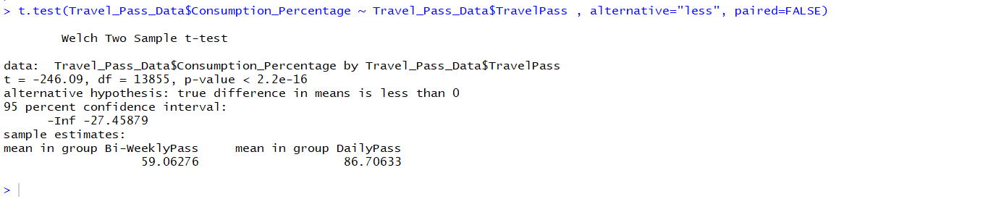
Figure 3. Hypothesis test using R.

Conclusion
The p-value is 2.2e-16 which signifies very small number and is less than chosen significance levels as 0.05. Small p-values suggest that the null hypothesis should be rejected which is, Mean for DailyPass and Bi-WeeklyPass is equal. In other words, significant evidence exists to support the conclusion that the mean for DailyPass is higher than Bi-WeeklyPass.

Visualization of Data-Set using Tableau

Dataset is exported to tableau for visualization and to validate the countries covered for Travel-Pass hypothesis.
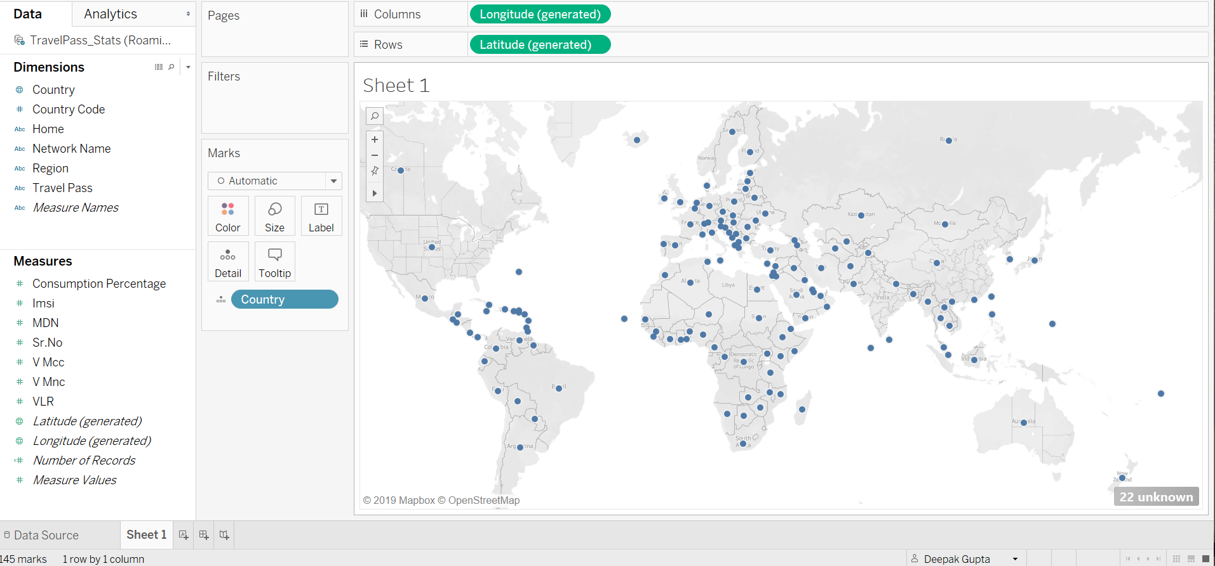
Figure 4. Tableau Visualization using Country field..

After Country Field, TravelPass bundle is also interated to see the subscriber bundle plans within the country. These visualization helps to identify reach of these bundle across each country,

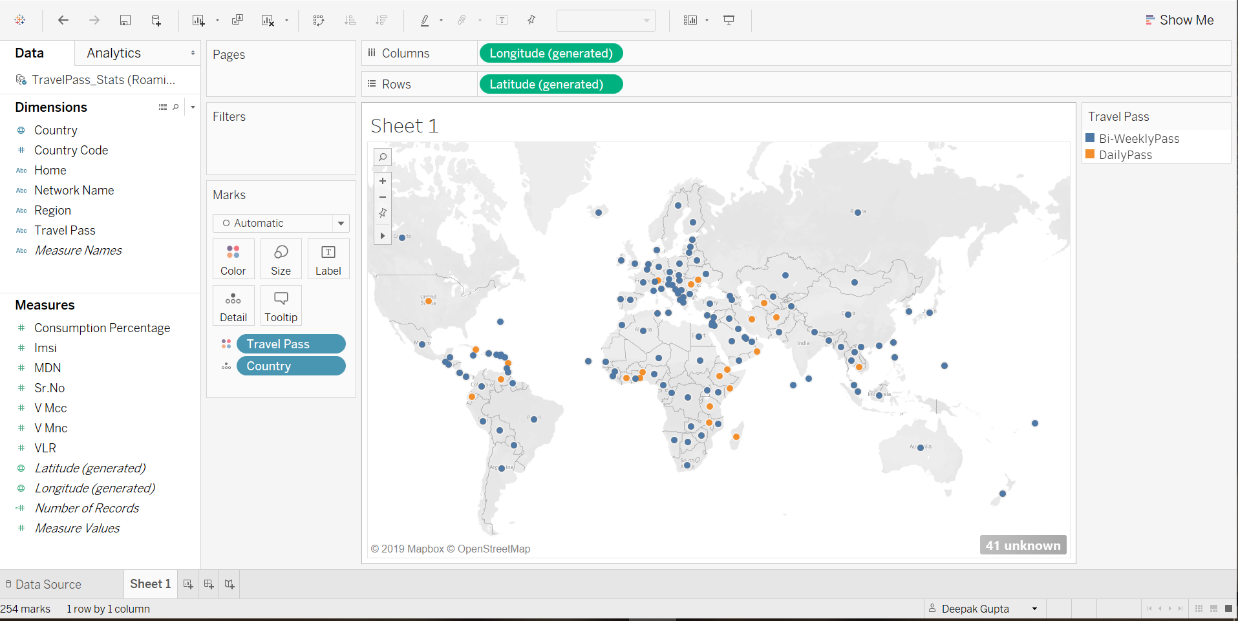
Figure 5. Country and Travel-Pass Visualization

Adding Consumption_Percentage count against each TravelPass bundle under each country provides the dataset count. For example- 180 DailyPass users are roaming in Pakistan under given dataset.
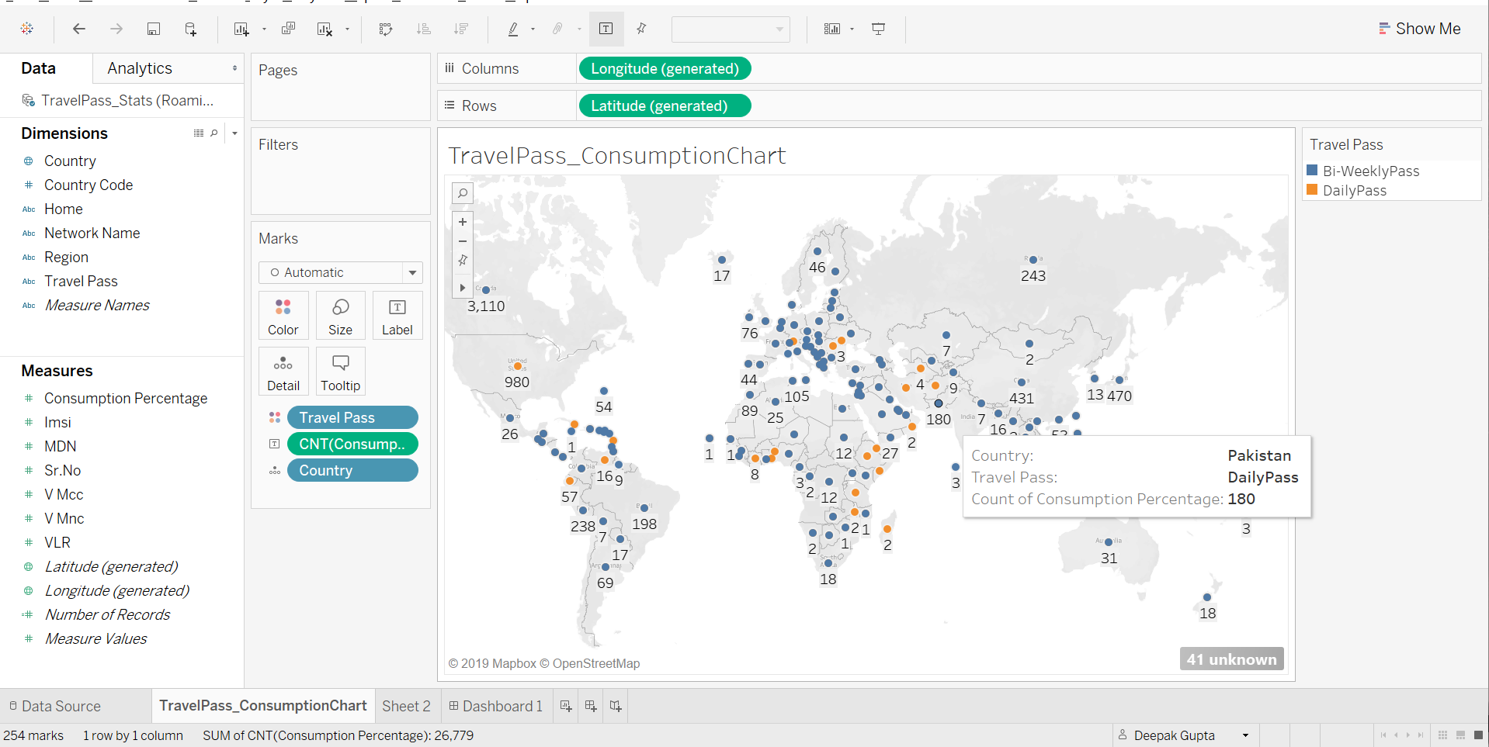
Figure 6. Country, Consumption_Percentage and Travel-Pass Visualization

References
Tableau Public Overview (2016a). Learn the basics of creating visualizations with Tableau Public. Retrieved from
https://public.tableau.com/en-us/s/resources
Student's T-Test. Performs one and two sample t-tests on vectors of data. Retrieved from
https://www.rdocumentation.org/packages/stats/versions/3.6.0/topics/t.test
Independent Samples T Tests with R. Retrieved from
http://core.ecu.edu/psyc/wuenschk/R-Lessons/R-t_Independent-Samples.pdf

