MODULE 4: CRITICAL THINKING
Data Modeling, Environments, Tools, & Programming
Deepak Gupta
MIS500 - Foundations of Data Analytics
Colorado State University – Global Campus
Dr. Eric M. Straw
June 10, 2019

SAS Hypothesis Tests
Hypothesis testing considering samples from two populations having a group of students with scores compared before and after tutoring. Below test allow us to understand the possible impact of tutoring.

Option #1: Implementing SAS Hypothesis Testing
Below is the SAS IDE code to examine tutoring effect on student, twelve students participate in the study. Each student’s score is measured both before and after tutoring took place.
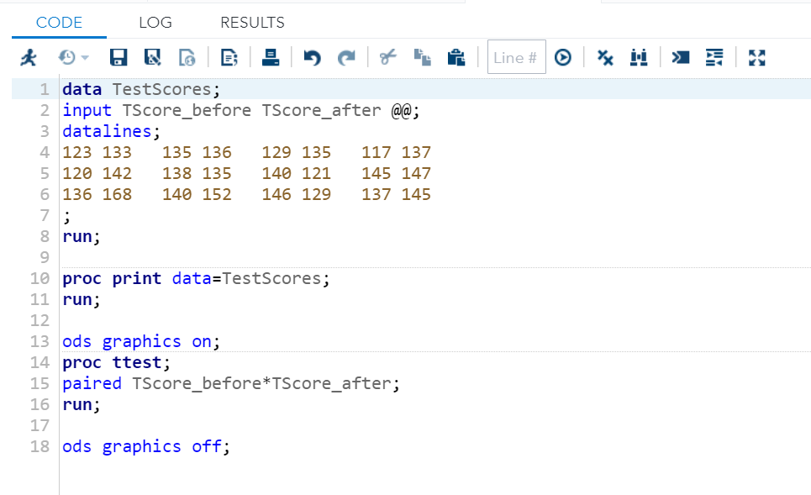
Figure 1. SAS IDE Code to simulate the hypothesis test.

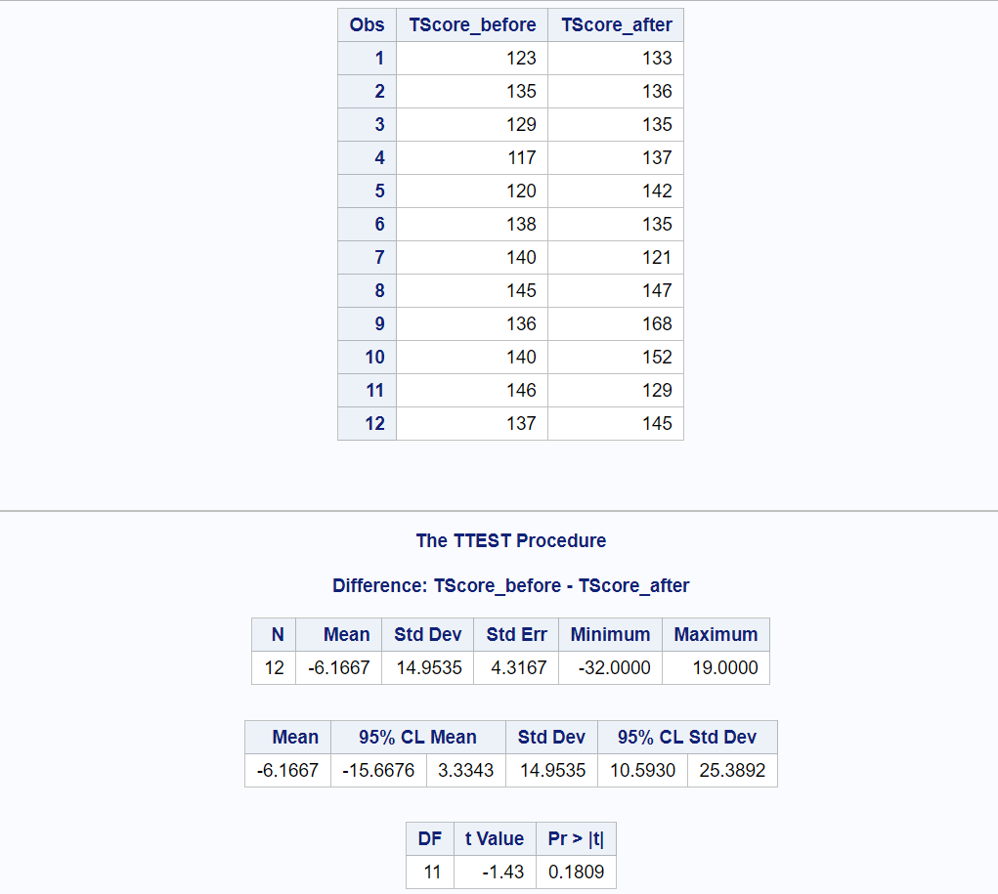
Figure 2. The TTEST Procedure
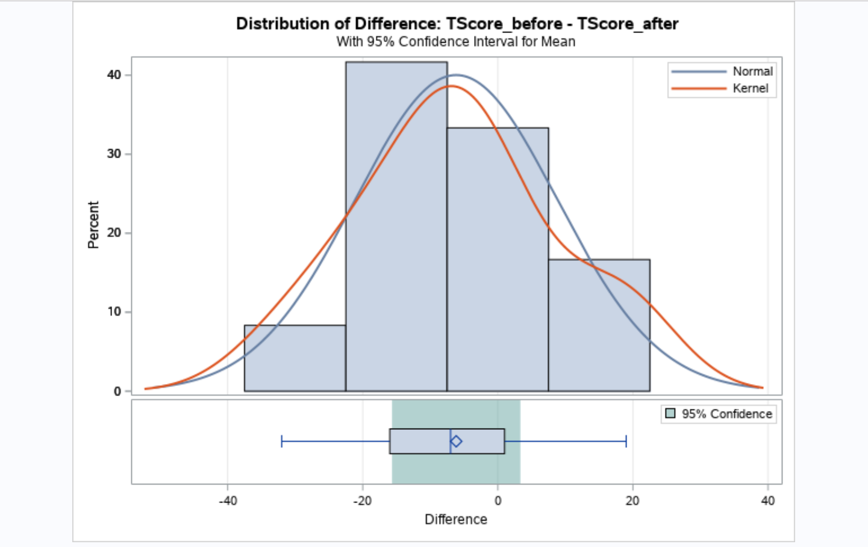
Figure 3. Distribution of Difference

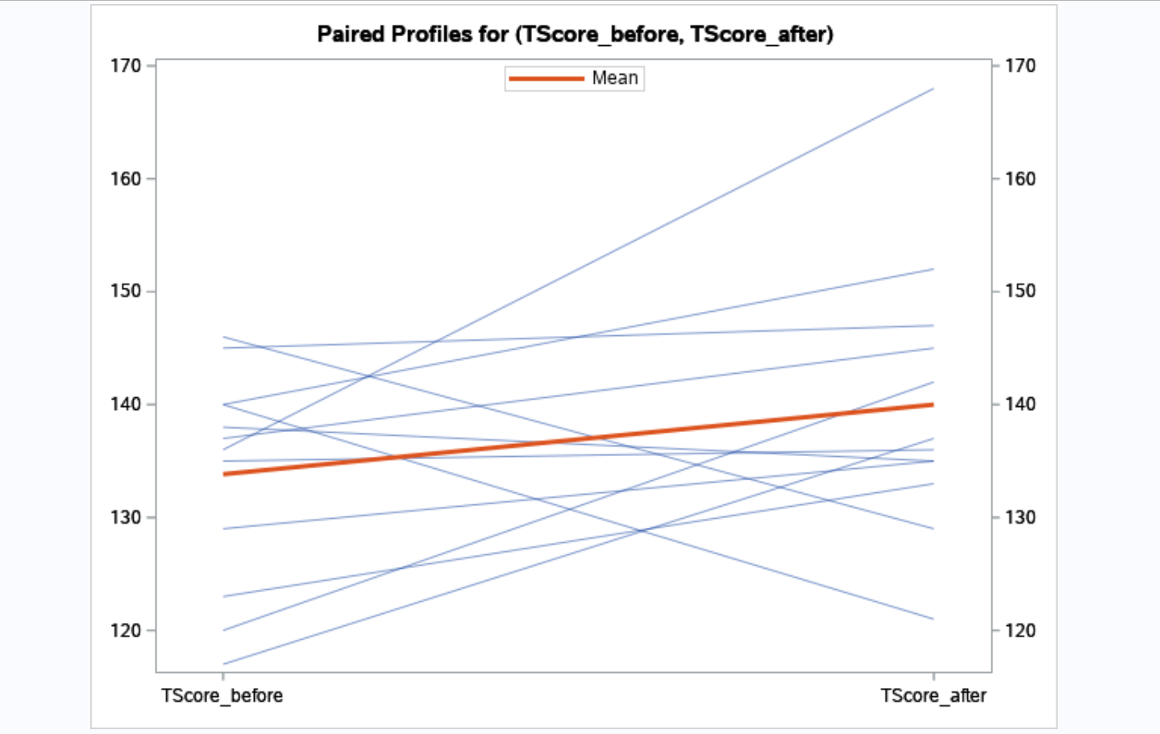
Figure 4. Paired Profiles for (TScore_before and TScore_after)

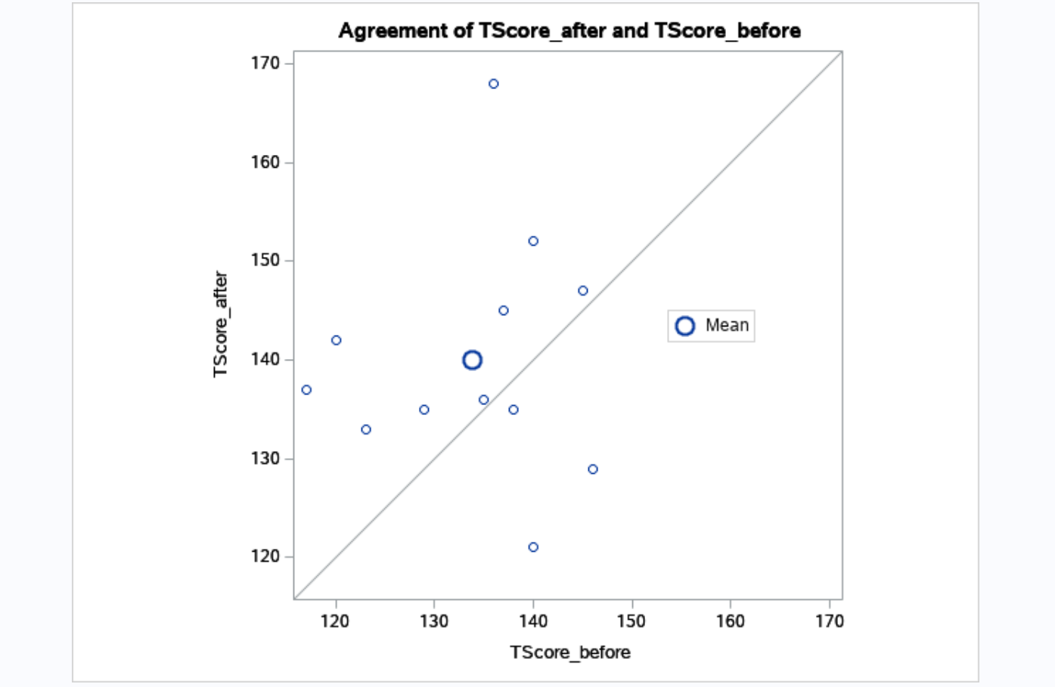
Figure 5. Agreement of TScore_after and TScore_before.
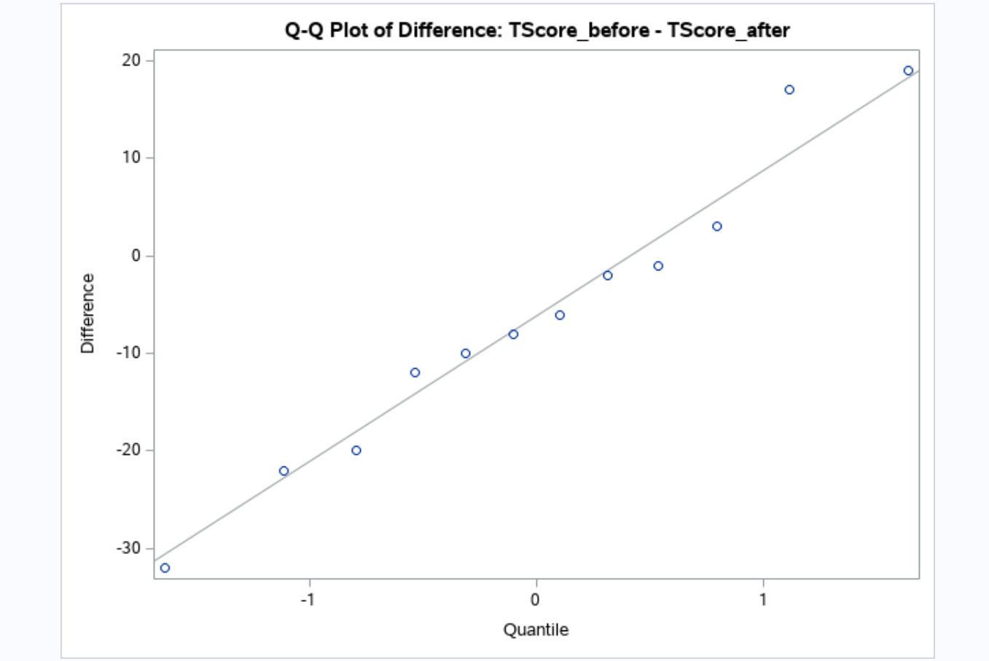

References
SAS Documentation. (2009a). The TTEST Procedure. Retrieved from
https://support.sas.com/documentation/cdl/en/statug/63033/HTML/default/viewer.htm#ttest_toc.htm
SAS Documentation. (2009b). Paired Comparisons. Retrieved from
https://support.sas.com/documentation/cdl/en/statug/63033/HTML/default/viewer.htm#statug_ttest_sect011.htm

