# **K8’s pipeline**

Deploys latest version of code in existing enviroment

# 

# **K8s_Build_pipeline**

Build completely new environment based on the parameters

**Variables:**

**Namespace , keystore**

**Xms_api, Xmx_api**

**Xms_web, Xmx_web**

**Db_details**

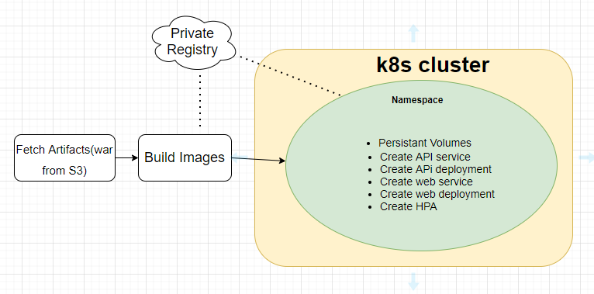

# **K8s Build pipeline**

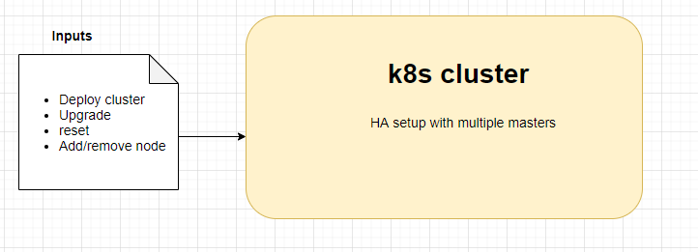

# Windows jenkins - linux salve

Ssh for windows :

<https://git-scm.com/download/win>

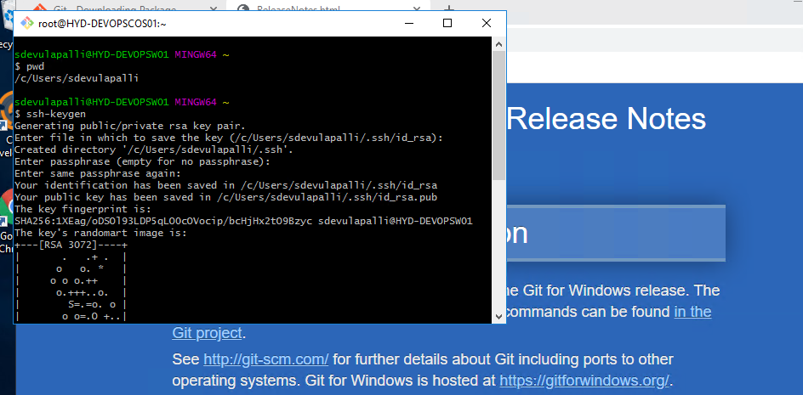

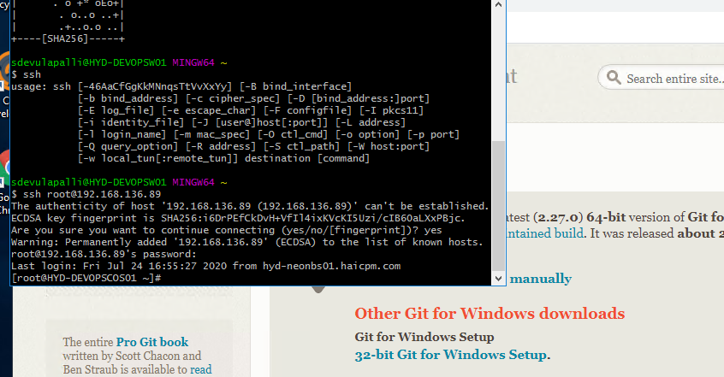

# Manage Jenkins -new node

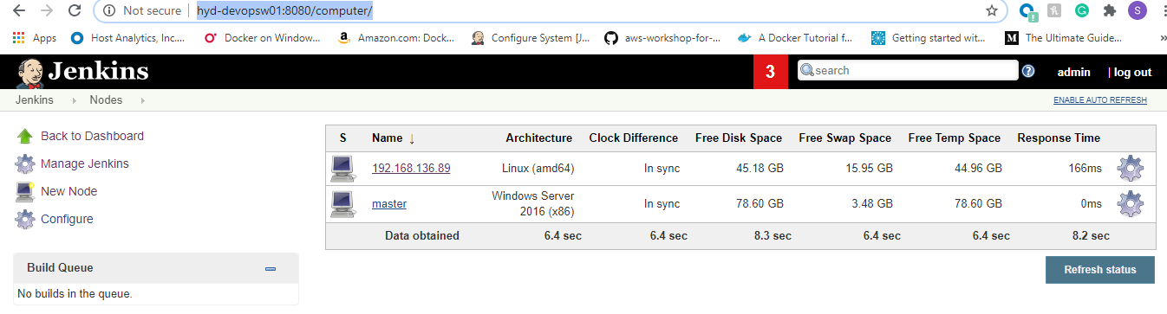

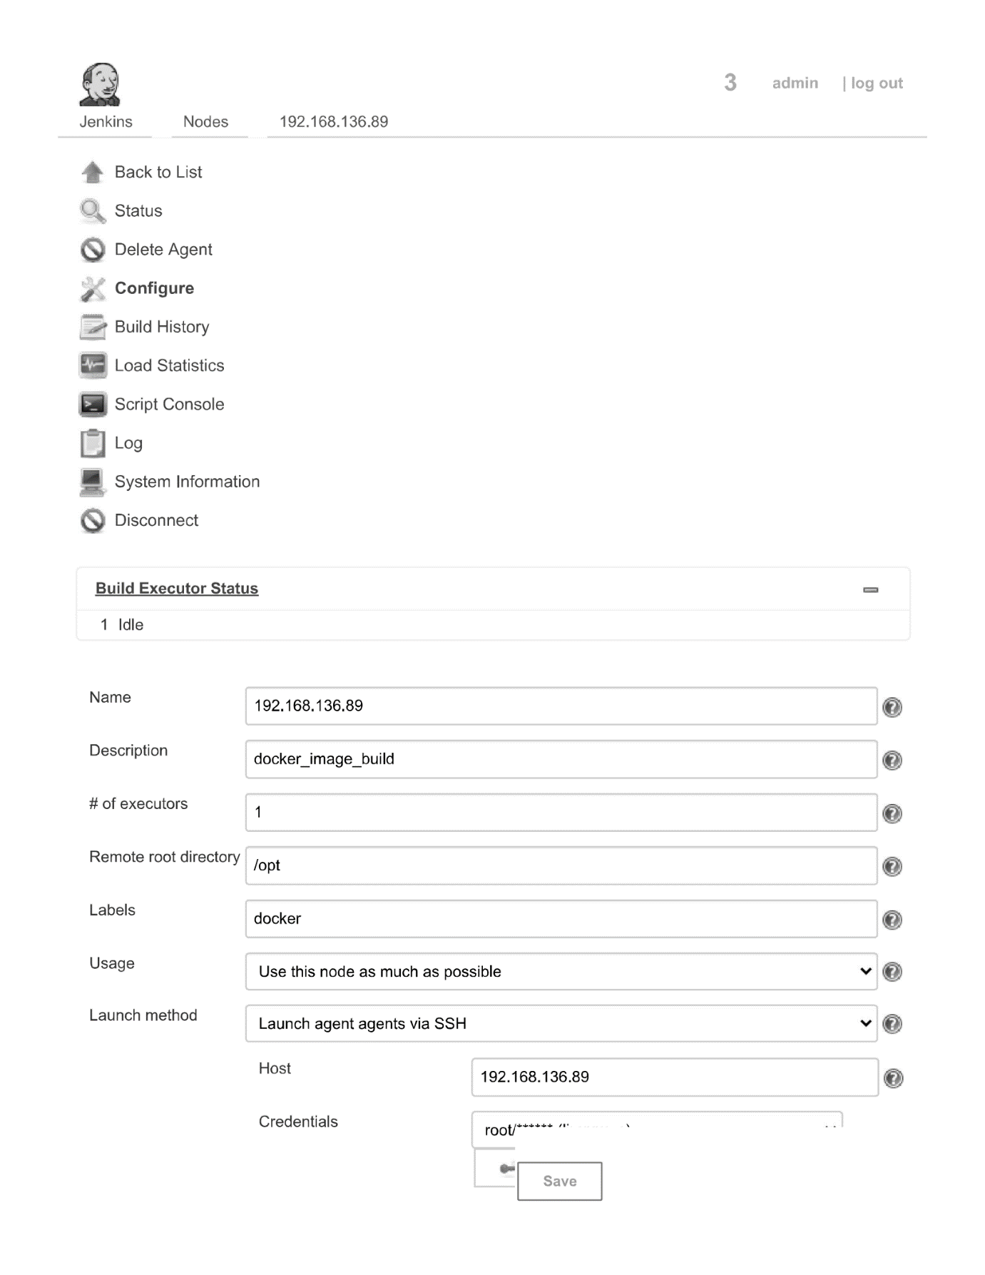

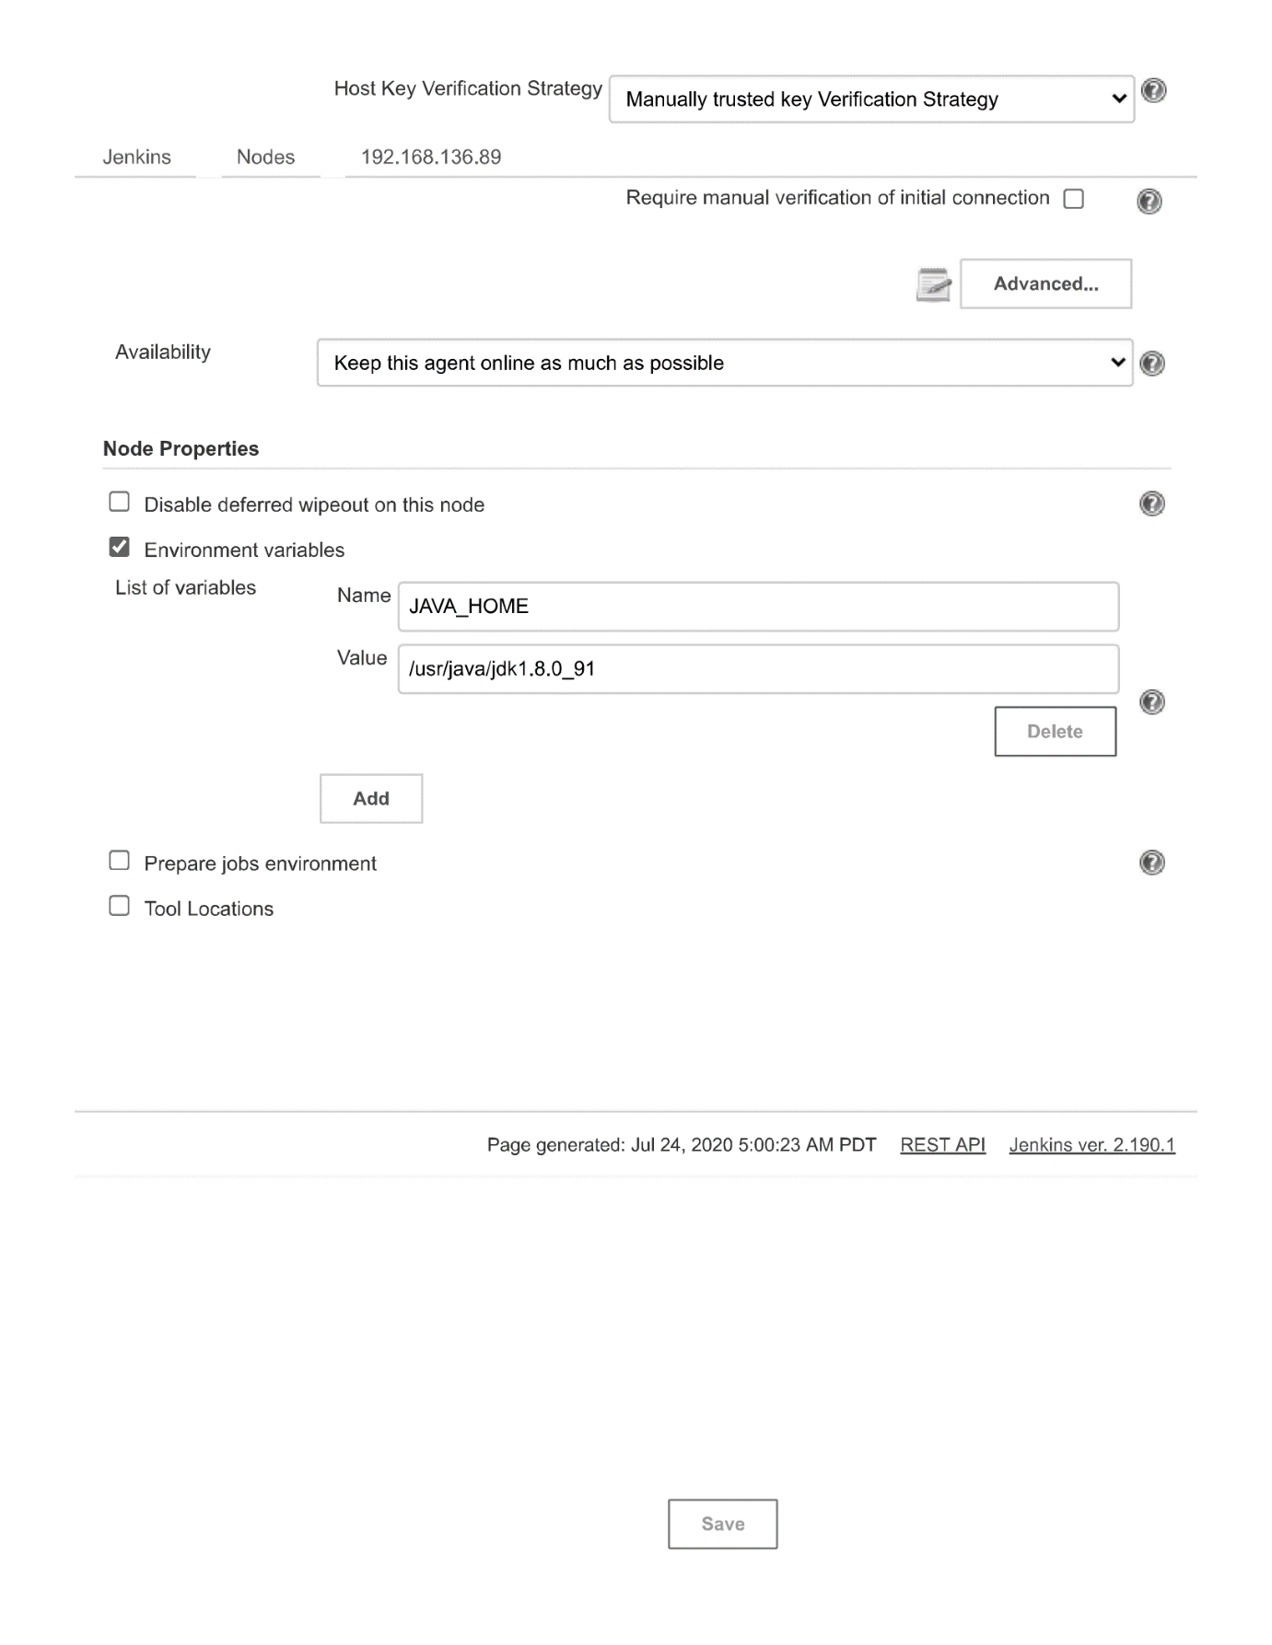

Require Kubernetes CLI plugin.