Vibration Signal Analysis of Beard Trimmer

**ME 710: Course Project**

Submitted by

**Deepak Kumar Thakur (213101001)**

**Yogesh S Sale (213100061)**

Under the Supervision of

**Prof. V Karthik**

**Department of Mechanical Engineering**

**Indian Institute of Technology Bombay, 400076**

*May 10,2022*

**Chapter 1: Introduction**

In beard trimmer, movable blade oscillates at a quick pace with the help of DC motor. When the movable and stationary blades overlap each other, trimming effect takes place and hairs are pinched off the skin. Average RPM of beard trimmers varies from 5000 to 8000.

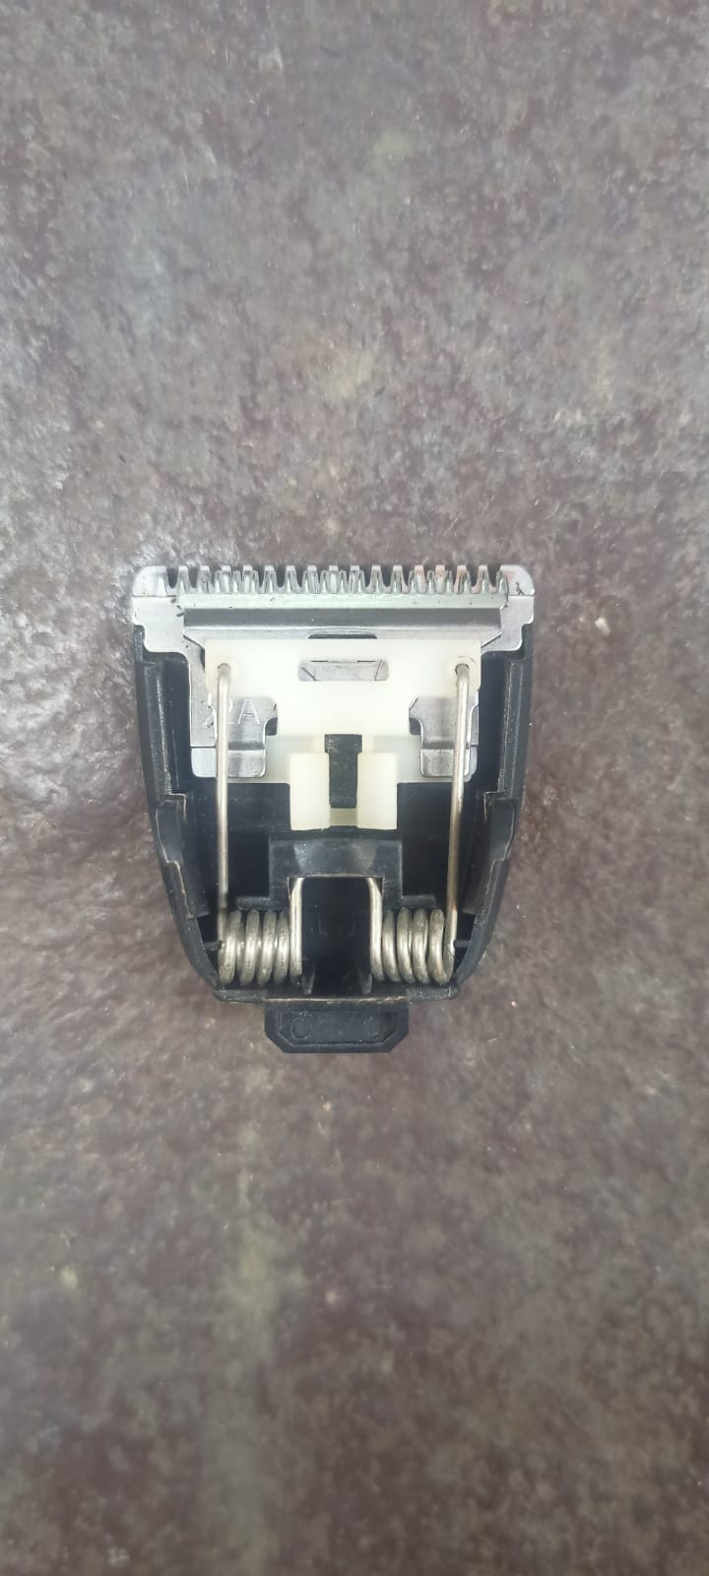

Movable blade

**Fig 1.1: Cutting element**

DC movable cam

**Fig 1.2: Trimmer body**

**Chapter 2: Data Acquisition**

Mobile phone was mounted on a horizontal table with the help of double sided tape in such a way that the screen faces the ceiling. Axis perpendicular to the screen is taken as Z axis, axis along the length of the phone is Y axis and axis along the width is X axis. Trimmer attached to a mobile phone with the help of double tape. Movable blade adjusted in such a way that it oscillates along Z axis of mobile phone as shown in the fig 1.3.

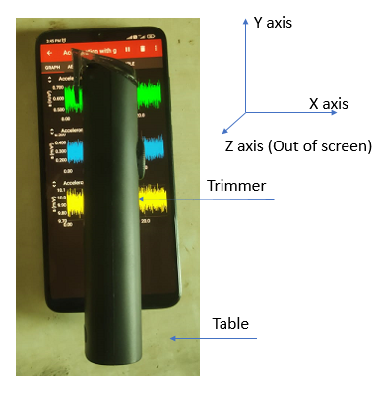

**Fig 2.1: Setup**

Data of acceleration along x, y and z axis is acquired using Phyphox application by keeping the trimmer off for few seconds and then turning it on. Data was collected for around 40 seconds.

Data collected foe each trimmer can be access through below link:

https://drive.google.com/drive/folders/1Qk_DKgIQ1QP2oTO3eYgHRsTH0c0YfgKY?usp=sharing

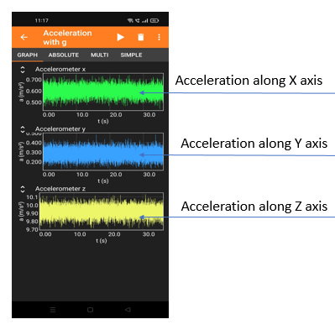

**Fig 2.2: Acceleration of trimmer blade in x, y and z direction**

Five trimmers namely Trimmer 1, 2, 3, 4 and 5 were selected for data acquisition which can be seen below.

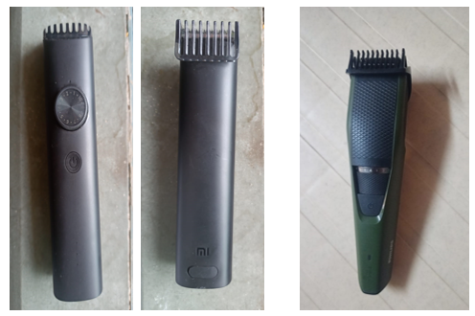

**Fig 2.3: Trimmer 1 (Front/Back) Fig 2.4: Trimmer 2 (Front)**

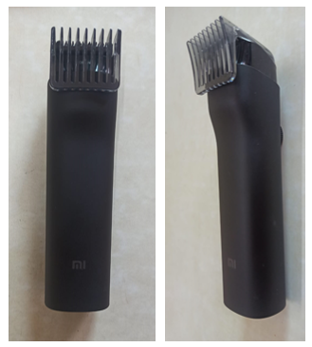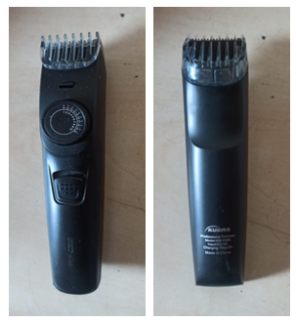

**Fig 2.5: Trimmer 3 (Front/Back) Fig 2.6: Trimmer 4 (Front/Back)**

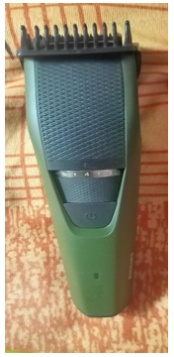

**Fig 2.7: Trimmer 5 (Front)**

Trimmer 2 and 5 having same specifications and belongs to same company. Trimmer 1 and 4 belongs to the same company but falls under different RPM series. Trimmer 3 having poor build quality compare to others.

**Chapter 3: Time and Frequency Domain Analysis**

Data collected through Phyphox application are used to find the FFT for each trimmer respectively. FFT was found through MATLAB code given below:

clc;

clear all; close all;

data = readtable('T5.csv');

time = table2array(data(:,1)); accdata = table2array(data(:,4)); num = length(time);

accdata = accdata - mean(accdata);

if mod(num,2) == 0 halfnum = num/2;

else

halfnum = (num-1)/2

end

dtdata = time(2:num)-time(1:num-1); dt = mean(dtdata)

w = hann(num);

ACC = accdata.*w;

acc = fft(ACC)/(num/2); acc = acc(1:halfnum); macc = abs(acc);

Fs = 1/dt

f = linspace(0,Fs/2,num/2);

plot(f,(macc)); xlabel('Frequency'); ylabel('|Amplitude|'); xlim([0,300])

ylim([0, 1])

**3.1 Time and Frequency Domain Analysis of Trimmer 1**

**Fig 3.1: Acceleration (z axis) vs time**

**Fig 3.2: Acceleration (z axis) vs time (zoomed view)**

**Fig 3.3: Amplitude vs Frequency (x axis)**

**Fig 3.4: Amplitude vs Frequency (y axis)**

**Fig 3.5: Amplitude vs Frequency (z axis)**

Vibrations of the oscillating blade are predominantly along z axis. As we can see from FFT diagram, amplitude along x and y axis are significantly lower compare to amplitude along z axis. Hence, the FFT in z axis is our prime focus.

**3.2 Time and Frequency Domain Analysis of Trimmer 2**

**Fig 3.6: Acceleration (z axis) vs time (zoomed view)**

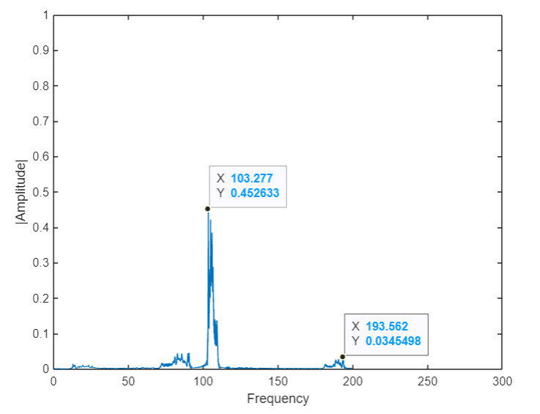

**Fig 3.7: Amplitude vs Frequency (z axis)**

**3.3 Time and Frequency Domain Analysis of Trimmer 3**

**Fig 3.8: Acceleration (z axis) vs time (zoomed view)**

**Fig 3.9: Amplitude vs Frequency (z axis)**

**3.4 Time and Frequency Domain Analysis of Trimmer 4**

**Fig 3.10: Acceleration (z axis) vs time (zoomed view)**

**Fig 3.11: Amplitude vs Frequency (z axis)**

**3.5 Time and Frequency Domain Analysis of Trimmer 5**

**Fig 3.12: Acceleration (z axis) vs time (zoomed view)**

**Fig 3.13: Amplitude vs Frequency (z axis)**

**Chapter 4: Observations and Conclusion**

Age of trimmers is calculated from date of purchase and expressed in terms of days respectively. Frequency of each trimmer is obtained from their respective FFT plot. Approximate RPM is calculated based on a formula given by: RPM = Frequency x 60.

RPM range of trimmers are collected from the company website.

**Table 4.1**

|  |  |  |  |  |
| --- | --- | --- | --- | --- |
| **Trimmer no.** | **Age (days)** | **Obtained frequency (Approx.)** | **RPM (Approx.)** | **RPM range from company** |
| Trimmer 1 | 189 | 75.9 | 4554 | 5000 series |
| Trimmer 2 | 399 | 103.3 | 6200 | 7000 series (1) |
| Trimmer 3 | 211 | 106.1 | 6366 | 7000 series (2) |
| Trimmer 4 | 466 | 90.4 | 5424 | 6000 series |
| Trimmer 5 | 1313 | 96.7 | 5802 | 7000 series (1) |

* Peak amplitude of trimmer 3 is significantly higher in spite of lower age among all the trimmers. It may be because of poor built quality.
* Trimmer 1 and 4 belong to the same company under different series which can be seen in the observation table.
* Trimmer 2 and 5 have same specifications and belong to the same company under same rpm series. Age difference between the two is large. It is found that trimmer 5 has significant drop in rpm count compared to trimmer 2
* Also, peak amplitude of trimmer 5 is large compared to trimmer 2. This may be because the age of trimmer 5 is much larger than trimmer 2.

**References**

[1] <https://www.youtube.com/watch?v=bNX8gk52k24&t=148s>

[2] <https://www.engineersgarage.com/insight-how-electric-beard-trimmer-works/>

[3] [https://www.philips.co.in/c-f/XC000002892/how-do-i-replace-the-attachments-of-my- philips-groomer](https://www.philips.co.in/c-f/XC000002892/how-do-i-replace-the-attachments-of-my-%20%20philips-groomer)