


GRAPHIC ERA HILL UNIVERSITY, DEHRADUN

ACADEMIC YEAR : 2024-25

PROJECT REPORT ON

REAL-TIME DROWSINESS

DETECTION USING

OPENCV AND DLIB

ROLL NO : 2219825

NAME : TEJASWI BISHT

COURSE : B.Tech CSE (SEC-L2) SUBJECT : MINI PROJECT

CERTIFICATE

This is to certify that the mini-project in domain "DRIVER DROWSINESS DETECTION USING OPENCV & DLIB" has been completed by Ms.Tejaswi Bisht, a student of Section L2 with Student ID 2219825. The report has been reviewed and approved, meeting all the academic requirements specified for the mini-project work in the course.

TABLE OF CONTENTS [ T O C ]
SER | DESCRIPTION | PAGE NO
01 | INTRODUCTION | 04
02 | METHODOLOGY | 05
03 | SYSTEM OVERVIEW | 07
04 | ALGORITHM OVERVIEW | 08
05 | SOURCE CODE AND RESULT | 09
08 | CONCLUSION | 14
09 | REFERENCES | 15

INTRODUCTION

Our current data shows that in 2022 alone, around 1,55,622 people will die in traffic accidents in India. At least 15% of these are due to tired and faulty drivers. This may be a small number on the whole, but there are still many that can be cured because people die from the condition. In most cases, driver fatigue is not seen as a major problem in car crashes and is a cause for concern. In a few countries, such as India, fatigue combined with inadequate infrastructure can cause serious damage and invite disaster. Unlike alcohol or drug addiction, which has clear symptoms and tests to consider, fatigue is difficult to imagine or monitor. Perhaps the best solution to this problem is to realize that the driver feels some kind of weakness and needs a solution. For example, the avoidance results of these questions focus on fatigue-related accidents and drivers' recognition of fatigue when necessary. The former is more difficult and more valuable and cannot accomplish the latter without the former, as it is a true long-term business driver. As demand for a job increases, so do the perks associated with it, making more and more people adopt it. The same goes for driving at night. This is mainly because drivers themselves are not worried about the serious threat of drowsy driving. Some countries have already implemented restrictions on the number of hours drivers can drive at a time, but this is still not enough to solve the problem as it is too real and too expensive to implement.

METHODOLOGIES
• D-lib: Dlib is a modern C++ toolkit containing machine learning algorithms and tools for creating complex software in C++ to solve real-world problems. It is developed by Davis King and is widely used in the fields of computer vision, facial recognition, and machine learning. Dlib contains a variety of machine learning algorithms, including support vector machines, deep learning neural networks, clustering algorithms, and others. In addition to machine learning algorithms, Dlib also provides a number of useful utilities for working with images, video streams, and other data types commonly used in computer vision applications.
• Open CV: OpenCV (Open Source Computer Vision) is a free and open-source computer vision and machine learning software library. It provides a wide range of tools and functions that can be used for tasks such as image processing, feature detection, object recognition, and more. OpenCV was initially developed by Intel Corporation in 1999 and is now maintained by the OpenCV Foundation, a non-profit organization. It supports a variety of programming languages, including Python, C++, and Java, making it widely accessible for developers and researchers working on computer vision applications.
• Operating System: An operating system (OS) is a software system that manages computer hardware and software resources and provides common services for computer programs. The operating system acts as an interface between computer programs and the computer hardware, allowing them to communicate with each other and perform their designated tasks. Examples of popular operating systems include Windows, macOS, Linux, and Android.
• Numpy: NumPy is a Python library used for working with arrays. It provides functionality for performing mathematical operations on arrays, such as linear algebra and random number generation, as well as the ability to manipulate and reshape arrays. NumPy arrays are also much faster than Python lists for operations involving large amounts of data, making it a popular tool for data analysis and scientific computing.
• Imutils: Imutils is a popular library in Python for image processing tasks such as resizing, rotating, and cropping images. It is built on top of OpenCV and provides a simplified interface to perform common image processing operations. Imutils also includes convenience functions to work with video streams, webcams, and file systems. It is a lightweight and easyto-use library that is widely used in computer vision and image processing applications

System Overview

The system processes the webcam feed using the following steps:
- Face Detection: A frontal face detector from dlib identifies faces in the image.
- Facial Landmark Detection: For each detected face, facial landmarks are predicted, specifically focusing on the eyes to detect blinking.
- Blink Detection: Using specific eye landmarks, a ratio of the eye's open and closed states is calculated to assess whether the user is blinking.
- State Detection: Based on the blink ratio, the system categorizes the user into one of three states: sleeping, drowsy, or active.
- Real-Time Feedback: The system displays the user’s current state in real-time using a webcam feed.

Algorithm Overview

The algorithm consists of the following major components:
- Face Detection: The dlib.get_frontal_face_detector() detects faces in the image.
- Facial Landmark Detection: The dlib.shape_predictor() detects facial landmarks using a pre-trained model (shape_predictor_68_face_landmarks.dat), which returns 68 key points on the face.
- Blink Detection: The eyes' blinking is monitored using the following landmarks:
  - Left Eye: Landmarks 36-41
  - Right Eye: Landmarks 42-47 The blinked() function calculates the ratio of the vertical and horizontal eye distances to detect blinking.
- State Classification:
  - Sleeping: If the eyes are closed for a prolonged period, the system marks the user as sleeping.
  - Drowsy: If the eyes are partially closed frequently, the system marks the user as drowsy.
  - Active: If the user is blinking normally, the system marks the user as active

SOURCE CODE :

import cv2 # OpenCV for image processing
import numpy as np # NumPy for array operations
import dlib # Dlib for face detection and landmark prediction
from imutils import face_utils # Utilities for face processing

# Initializing the camera
cap = cv2.VideoCapture(0)

# Initializing the face detector and landmark predictor
detector = dlib.get_frontal_face_detector()
predictor = dlib.shape_predictor("shape_predictor_68_face_landmarks.dat")

# Status marking for current state
sleep = 0
drowsy = 0
active = 0
status = ""
color = (0, 0, 0)

def compute(ptA, ptB):
"""Compute the Euclidean distance between two points."""
dist = np.linalg.norm(ptA - ptB)
return dist

def blinked(a, b, c, d, e, f):
"""Determine if the eyes are blinking based on landmark positions."""
up = compute(b, d) + compute(c, e)
down = compute(a, f)
ratio = up / (2.0 * down)

# Checking if it is blinked
if ratio > 0.25:
return 2 # Eyes are closed
elif ratio > 0.21 and ratio <= 0.25:
return 1 # Eyes are partially closed
else:
return 0 # Eyes are open

while True:
# Capture frame-by-frame
ret, frame = cap.read()

# Check if the frame is valid
if not ret or frame is None:
print("Error: Invalid frame captured.")
break

# Convert frame to grayscale for face detection
gray = cv2.cvtColor(frame, cv2.COLOR_BGR2GRAY)

# Ensure the grayscale image is of type uint8
gray = gray.astype(np.uint8)

# Detect faces in the grayscale image
faces = detector(gray)

# Process each detected face
for face in faces:
x1 = face.left()
y1 = face.top()
x2 = face.right()
y2 = face.bottom()

# Draw rectangle around the detected face
face_frame = frame.copy()
cv2.rectangle(face_frame, (x1, y1), (x2, y2), (0, 255, 0), 2)

# Get facial landmarks
landmarks = predictor(gray, face)
landmarks = face_utils.shape_to_np(landmarks)

# Blink detection using specific landmark indices for eyes
left_blink = blinked(landmarks[36], landmarks[37],
landmarks[38], landmarks[41],
landmarks[40], landmarks[39])
right_blink = blinked(landmarks[42], landmarks[43],
landmarks[44], landmarks[47],
landmarks[46], landmarks[45])

# Update status based on blink detection
if left_blink == 0 or right_blink == 0:
sleep += 1
drowsy = 0
active = 0
if sleep > 6:
status = "SLEEPING !!!"
color = (255, 0, 0) # Red color for sleeping

elif left_blink == 1 or right_blink == 1:
sleep = 0
active = 0
drowsy += 1
if drowsy > 6:
status = "Drowsy !"
color = (0, 0, 255) # Blue color for drowsy

else:
drowsy = 0
sleep = 0
active += 1
if active > 6:
status = "Active :)"
color = (0, 255, 0) # Green color for active

# Display status on the frame
cv2.putText(frame, status, (100,100), cv2.FONT_HERSHEY_SIMPLEX,
1.2, color,3)

# Draw facial landmarks on the frame (optional)
for n in range(68):
(x, y) = landmarks[n]
cv2.circle(face_frame, (x, y), 1, (255, 255, 255), -1)

# Show the frames with annotations
cv2.imshow("Frame", frame)
cv2.imshow("Result of detector", face_frame)

key = cv2.waitKey(1)
if key == 27: # Press 'Esc' to exit the loop
break

# Release the camera and close all OpenCV windows
cap.release()
cv2.destroyAllWindows()

RESULTS

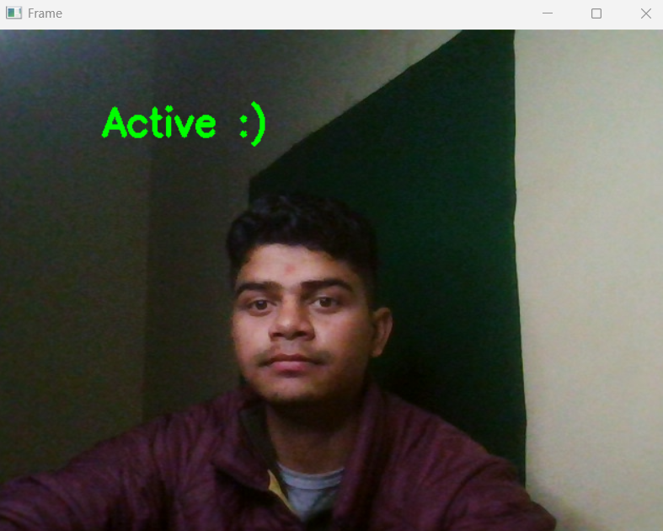
(sample input 1)
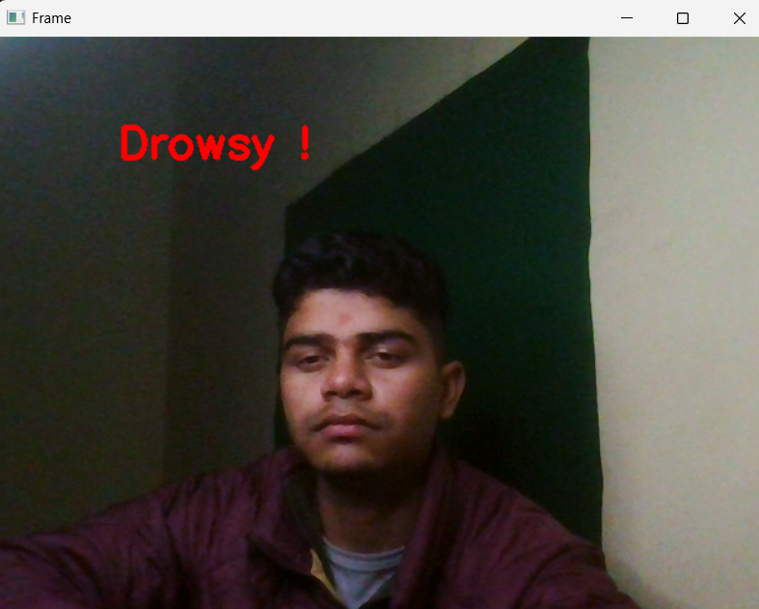
( Sample input 2 )

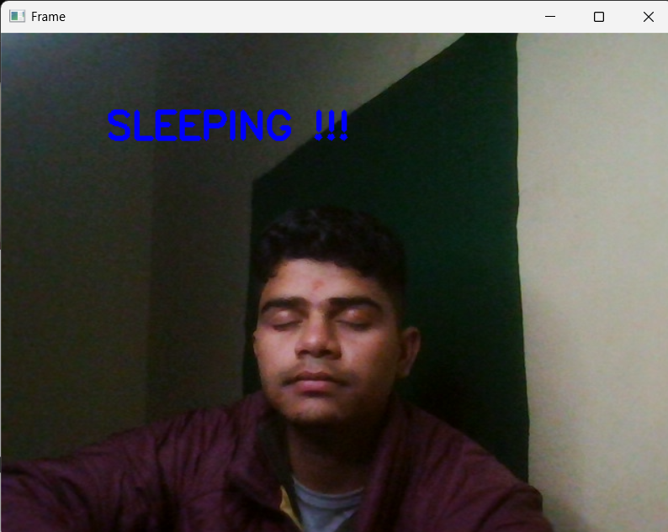
(sample input 3)

CONCLUSIONS

This project demonstrates a basic, real-time drowsiness detection system using facial landmarks. By analyzing the blinking patterns of the eyes, the system effectively categorizes the user’s state as either active, drowsy, or sleeping. This approach can be used in safety-critical applications, such as monitoring drivers or operators in control rooms to prevent accidents due to drowsiness

REFERENCES

• Dlib Library - https://github.com/davisking/dlib
• OpenCV Documentation - https://docs.opencv.org
• Imutils Library - https://github.com/jrosebr1/imutils

