**M S Ramaiah Institute of Technology**

(An Autonomous Institute, Affiliated to VTU)

MSR Nagar, MSRIT post, Bangalore-54

**Project Plan**

Title: **Alcatraz, an end-to-end SaaS product for complete computer and network security**

Team:

Akash Gupta 1MS13CS014

Ayush Kumar 1MS13CS034

Bineet Kumar 1MS13CS036

Deepak Jayaprakash 1MS13CS037

**Alcatraz,** an end-to-end SaaS product for complete computer and network security

1. **Project Model**

The project model that we have adapted is the Agile Development Methodology. “Agile Development” is an umbrella term for several iterative and incremental software development methodologies. The most popular agile methodologies include Extreme Programming (XP), Scrum, Crystal, Dynamic Systems Development Method (DSDM), Lean Development, and Feature-Driven Development (FDD).

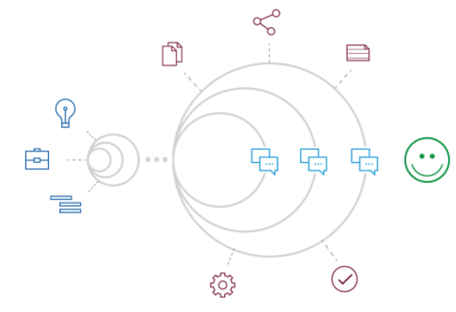

Fig: Agile Development Methodology

We have used **Extreme Programming (XP)** in our project because of the suitability of the product requirements and the similarity in its implementation. XP has emerged as one of the most popular and controversial agile methodologies. XP is a disciplined approach to delivering high-quality software quickly and continuously. It promotes high customer involvement, rapid feedback loops, continuous testing, continuous planning, and close teamwork to deliver working software at very frequent intervals, typically every 1-3 weeks.

The principles that have been used with regard to XP in the project are:

* Planning architecture, tech stack, implementation, etc.
* Small releases
* User acceptance tests
* Simple Design
* Pair programming
* Test driven development
* Refactoring
* Continuous Integration
* Coding standards

1. **Project Schedule using Gantt Chart**

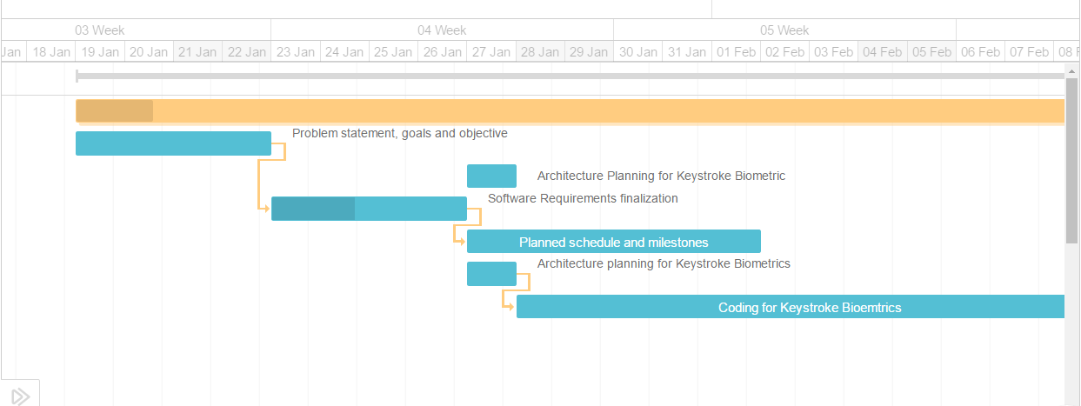

**Fig: Planning and SRS**

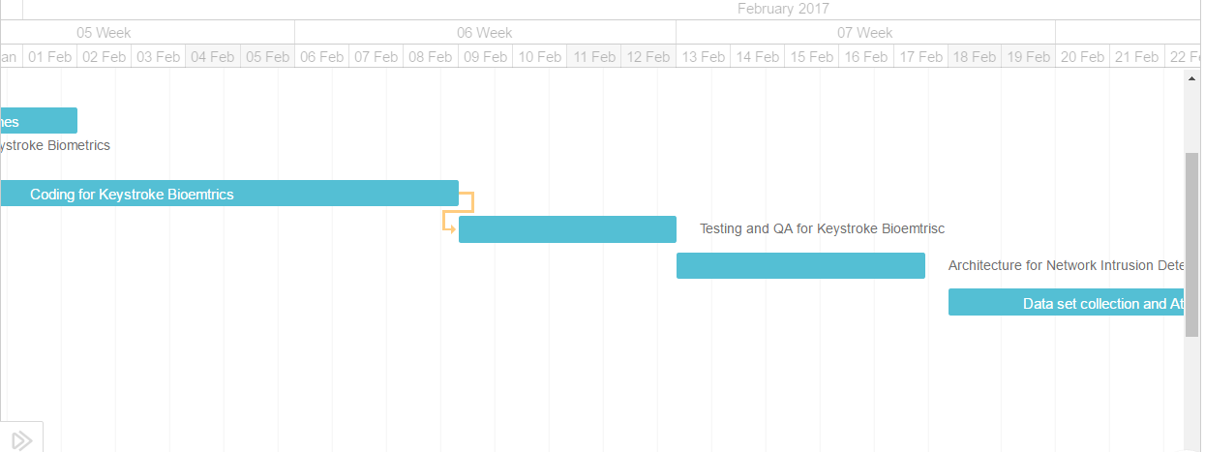

**Fig: Keystroke Biometric Authentication**

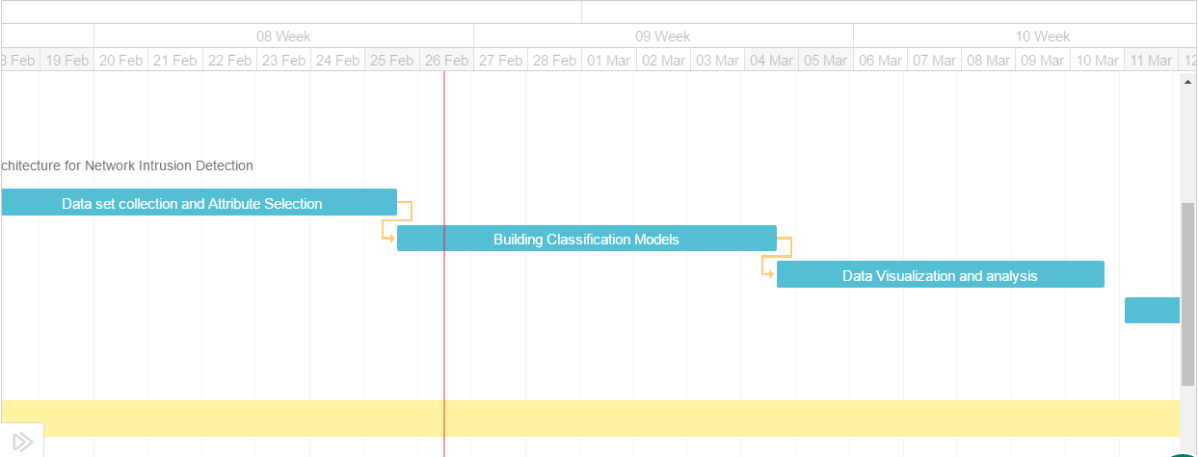

**Fig: Network Intrusion Detection**

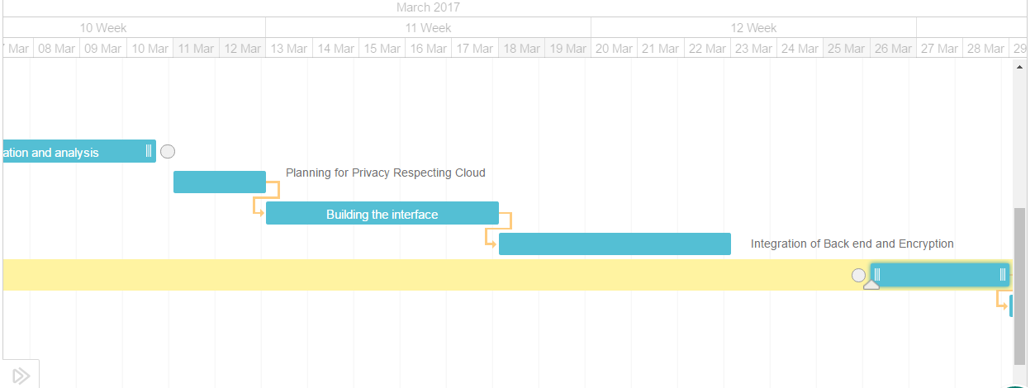

**Fig: Privacy Respecting Cloud**

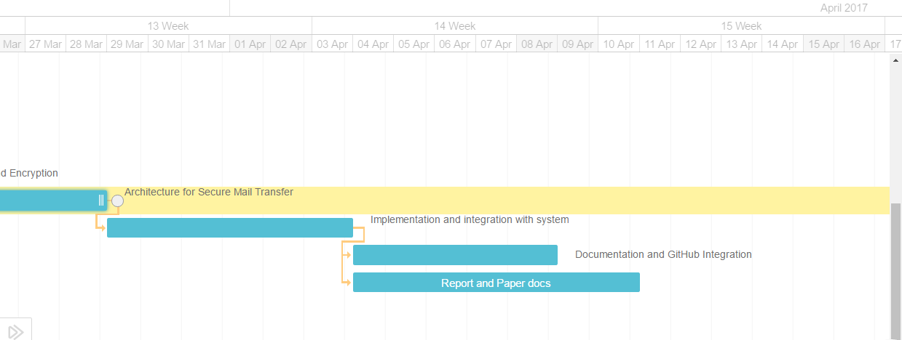

**Fig: Secure Mail Transfer and Documentation**

1. **Cost and effort estimation using COCOMO model**

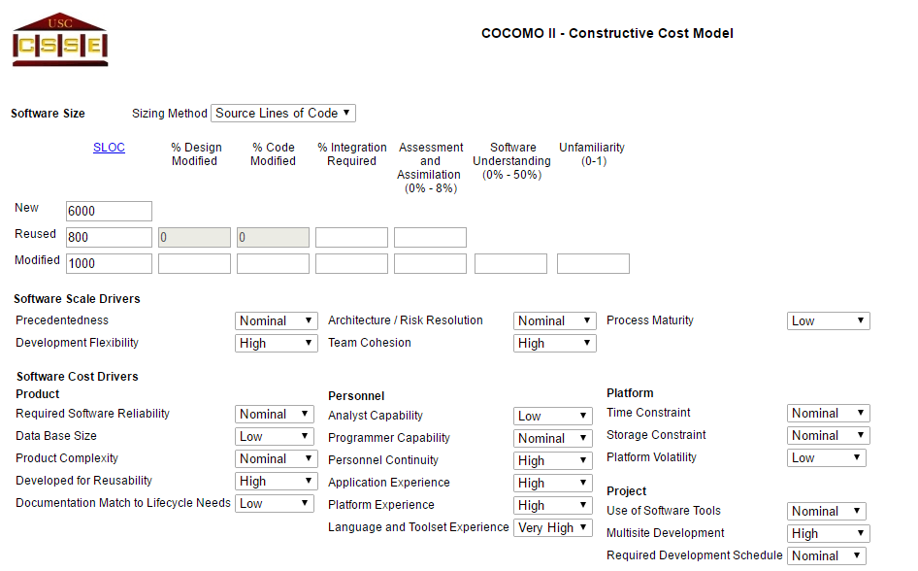

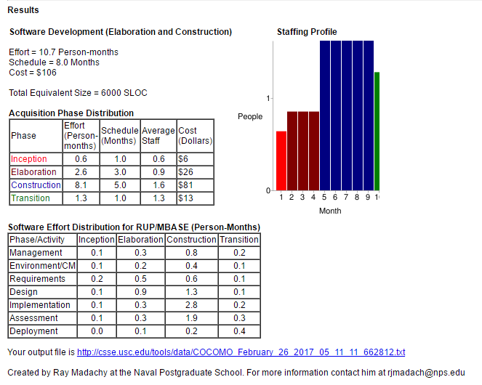

1. **Risk Identification and Mitigation**

|  |  |  |  |
| --- | --- | --- | --- |
| **Sl.No** | **Risk** | **Point of source** | **Mitigation Strategy** |
| 1 | **Scope Creep:** The scope of the project may keep increasing if it is not accounted at each step | Project Planning | Accountability of the scope and proper documentation |
| 2 | **Wrong Choice of Tech stack:** The technologies used must be clear and clean. Otherwise the product will be dysfunctional and will have lot of bugs | Architecture planning and SRS analysis | Time must be spent in understanding the software requirements and then decision must be taken in choosing the technology. |
| 3 | **Failure to do incremental testing:** If testing is not done at each phase and is kept till the end, the product will fail to work | Development and implementation | Module wise testing must be done after achieving each milestone. |
| 4 | **Improper integration of modules:** Since the product has lot of sub features, each model needs to be embedded properly | Integration of features in the final phase | After developing each feature, integrate and check if existing modules are working. |
| 5 | **Insufficient documentation and lack of reusability:** Since the product is made open source, and the sole purpose of the project is to the developers to make use of this code, the documentation must be simple and clear | Design and documentation | Each feature must e clearly explained and documented. Finally the code must be very clean and understandable. |