
Project Title _____________________

Submitted in partial fulfillment of the requirements for the award of the degree of
Bachelor of Computer Application (BCA) / Master of Computer Application (MCA)/ Master of Science (Data Science) MSc (DS)
By
Student Name: ____________________
Enrollment No: ____________________
Under the guidance of
Guide/Mentor Name: ____________________

Certificate
Copy to the certificate received from Qollabb to be pasted here.

Declaration
I, Deepak Kumar Joshi (Enrollment No: O24MCA112387), hereby solemnly declare that the project report titled “EduPulse: A Business Intelligence Dashboard for Online Learning Engagement Analytics” submitted in partial fulfilment of the requirements for the award of the degree of Master of Computer Applications (Online) at Chandigarh University (CU Online), Chandigarh is an original record of my own work.
I further declare that:
- This project has been carried out by me during the academic year 2025–2026 under the supervision of Vikas Kumar, Senior Mentor.
- The work has not been submitted previously to any other university, institution, or examination body for the award of any degree, diploma, or other similar title.
- All sources of information used in this report have been duly acknowledged and referenced in accordance with academic ethics.
- The data presented in this report is authentic to the best of my knowledge and has not been fabricated or manipulated.
- I understand that if any part of this declaration is found to be false, my project may be rejected and disciplinary action may be initiated as per the rules of the university.
Place: Hyderabad, Telangana
Date: ____________________
Student Signature: ____________________
Student Name: Deepak Kumar Joshi
Enrollment No: O24MCA112387

Acknowledgement
I take this opportunity to express my sincere gratitude to my project guide Vikas Kumar, Senior Mentor, for the invaluable mentorship, technical guidance, and constant encouragement provided throughout the development of this project. His insights on industry-grade analytics workflows and structured project execution shaped both the scope and the quality of EduPulse.
I extend my heartfelt thanks to the faculty members of the Department of Computer Applications at Chandigarh University (CU Online), Chandigarh, whose curriculum and timely guidance laid the foundation that made this project possible. I am also grateful to the Open University, United Kingdom, for releasing the OULAD dataset under the CC BY 4.0 licence, which served as the empirical backbone of this work.
Finally, I thank my family and friends for their unwavering moral support during my MCA journey, and my peers for the constructive discussions that helped sharpen many design decisions in this report.

Abstract / Executive Summary (150–250 words)
- Topic of the study
- Objective
- System Analysis
- System Design
- System Implementation
- Testing
- Future Scope

Table of Contents
(Use MS Word → References → Table of Contents to auto-generate)

Abstract
This project, titled “EduPulse: A Business Intelligence Dashboard for Online Learning Engagement Analytics”, develops an end-to-end Business Intelligence platform that measures learner engagement on online learning environments and identifies students at risk of withdrawing from a course before completion. The system addresses a critical gap in online learning operations—administrators rarely have access to consolidated, interactive engagement analytics, and individual at-risk learners are usually detected only after they have already disengaged. EduPulse ingests the anonymised Open University Learning Analytics Dataset (32,593 students, 22 course presentations, over ten million click interactions), cleans and validates it through a reproducible Python pipeline, and loads it into a DuckDB star-schema data warehouse comprising three fact tables and four conformed dimensions. A Streamlit multi-page dashboard then surfaces engagement trends, course popularity, high- and low-engagement periods, and category-level comparisons through interactive Plotly visualisations. A supervised Gradient Boosting classifier, trained on first-thirty-day engagement and demographic features, predicts learner withdrawal with 80.3% accuracy and 0.810 ROC AUC on a held-out test set of 6,519 enrollments. Development followed an iterative, milestone-based methodology covering data collection, cleansing, warehouse design, ETL implementation, dashboard development, and validation. The complete solution is deployed free of cost on Streamlit Community Cloud, providing administrators a single web interface for both descriptive analytics and predictive early-warning of dropout risk.

Chapter 1: Introduction

1.1 Background of the Project
Online learning platforms have moved from supplementary tools to primary delivery channels for higher education, professional certification, and corporate training. Platforms such as Coursera, edX, the United Kingdom’s Open University, and India’s SWAYAM and NPTEL collectively serve over three hundred million registered learners worldwide. Unlike a traditional classroom, every interaction on these platforms — logins, video views, forum posts, resource downloads, and quiz submissions — generates structured behavioural data that can be measured, joined, and analysed.
Yet the operational reality at most institutions is that this data exists but is not used. Administrators routinely receive enrollment dashboards but rarely engagement dashboards. Faculty members see assessment outcomes but not the leading indicators that produced them. Most critically, students at risk of dropping out are usually identified only after they have already stopped engaging — at which point intervention is far less effective. The result is a paradox: more data is collected than ever before, but fewer actionable decisions are made on the strength of that data.
The Open University, United Kingdom, has been a pioneer in addressing this gap. In 2014, its Knowledge Media Institute released the anonymised Open University Learning Analytics Dataset (OULAD) under a Creative Commons CC BY 4.0 licence. The dataset captures the full lifecycle of 32,593 students across 22 course presentations spanning seven academic modules, together with more than ten million individual click interactions in the Virtual Learning Environment, complete assessment histories, demographic attributes, and registration outcomes (pass, fail, withdrawal, or distinction).
EduPulse leverages this dataset to demonstrate what a modern Business Intelligence stack — a dimensionally modelled data warehouse, an interactive analytical dashboard, and a supervised learning model — can do when applied to a real-world educational analytics problem. The deliverable is not a research prototype: it is a deployable system that an administrator could use today to understand engagement patterns and triage learners at risk of withdrawal, all running on free, open-source infrastructure.

1.2 Problem Statement
Online learning platforms generate large volumes of behavioural data, but three operational gaps persist that prevent administrators from acting on that data:
1. Engagement-visibility gap. Course administrators lack a single, consolidated view of platform-wide engagement. Daily click activity, content-type popularity, and cross-cohort comparisons typically require ad-hoc database queries that the operations team cannot run on demand.
2. Pattern-recognition gap. Learner engagement is not uniform across time — it peaks around assessment deadlines, troughs during holidays, and varies sharply across course categories. Without dimensional analytics, these patterns are visible only in retrospect, and usually only to data analysts.
3. Predictive-intervention gap. Student withdrawal is the single most consequential negative outcome in online learning. Identifying at-risk learners early enough for intervention to be effective requires combining demographic, registration, and behavioural signals — a task that exceeds what standard learning-management system dashboards offer out of the box.
The problem this project addresses is the absence of an integrated, free, and reproducible Business Intelligence platform that closes all three gaps simultaneously for administrators of online learning courses.

1.3 Objectives of the System
The objectives of EduPulse are:
1. To collect a real-world learning-analytics dataset (OULAD) and document its structure, scale, and licence terms.
2. To clean, preprocess, and validate the dataset through a reproducible Python pipeline that handles missing values, type coercions, and outlier filtering deterministically.
3. To design and implement a star-schema data warehouse in DuckDB that supports efficient analytical queries against more than ten million fact rows on commodity hardware.
4. To develop interactive dashboards displaying engagement trends, course popularity, dropout patterns, and high- and low-engagement periods.
5. To compare engagement across course categories — module, age band, prior education, and Index of Multiple Deprivation band — and to surface the category-level differences that should drive policy intervention.
6. To train and evaluate a supervised machine-learning classifier that flags students at risk of withdrawing from a course using only the first thirty days of engagement and demographic signals.
7. To deploy the complete system free of cost on Streamlit Community Cloud, ensuring reproducibility and accessibility for evaluators and future contributors.
8. To validate dashboard accuracy through reconciliation queries and to document data-driven insights and improvement recommendations for course administrators.

1.4 Scope of the Project
EduPulse is scoped to the OULAD dataset (academic cohorts from 2013 and 2014, comprising 32,593 students enrolled across 22 course presentations and seven distinct modules) and to the analytical questions that this dataset can answer authoritatively.
In scope. Descriptive analytics covering engagement KPIs, demographic breakdowns, and course-level outcomes. Diagnostic analytics including peak/trough engagement detection and cross-category comparison. Predictive analytics in the form of early dropout-risk scoring driven by first-thirty-day engagement features. Free public deployment on Streamlit Community Cloud.
Out of scope. Real-time data ingestion from a live learning-management system (the OULAD release is a batch dataset). Any handling of personally identifiable information — OULAD is anonymised at source. Recommendation systems or content-personalisation engines, which would demand a different data model. Multi-tenant or commercial deployment scenarios.

1.5 Existing System Overview
Three categories of existing tools are relevant to the learning-analytics problem space.
Native learning-management-system dashboards — Moodle, Canvas, and Blackboard — typically expose per-course rosters, gradebooks, and basic completion summaries. Cross-course aggregation, time-series engagement analysis, and predictive layers are not part of the default feature set, and bolting them on requires plugin development or third-party integration.
Commercial Business Intelligence platforms — Tableau, Microsoft Power BI, and Looker — provide powerful interactive dashboards, but their per-user licence costs and infrastructure-integration overhead place them out of reach for many academic institutions. They also presuppose the existence of a well-modelled data warehouse, which itself is a significant deliverable.
Open-source Business Intelligence platforms — Apache Superset and Metabase — are usable free of charge, but are general-purpose tools. They do not ship with a learning-analytics data model, learner-centric metrics, or any predictive layer, so substantial domain-specific work is still required to deliver value.
None of these categories provides an out-of-the-box solution that combines a learning-analytics data model, dashboards tailored to the questions administrators actually ask, and an integrated predictive early-warning layer in a single deployable artefact.

1.6 Proposed System Overview
EduPulse is a Python-based, web-deployed Business Intelligence platform that closes the gaps identified above through six tightly integrated components.
A reproducible ETL pipeline downloads the OULAD source archive, verifies its contents, applies a documented set of cleaning rules, and produces typed Parquet intermediate files. A DuckDB star-schema warehouse — three fact tables (engagement, assessment, enrollment) and four conformed dimensions (student, course, activity, assessment) — then ingests these intermediates and exposes a set of analytical views that the dashboard consumes directly.
A Streamlit multi-page dashboard surfaces the analytics in five purpose-built sections: an Overview page with platform-wide KPIs, a Course Analytics page for popularity and outcome heatmaps, an Engagement Patterns page that identifies peak and trough days, a Dropout Prediction page that scores live cohorts with the trained model, and an Insights page that surfaces validated findings and admin recommendations.
The predictive layer is a scikit-learn Gradient Boosting classifier trained on first-thirty-day engagement and demographic features. On a stratified held-out test set of 6,519 enrollments the model achieves 80.3 percent accuracy and an ROC AUC of 0.810, with total clicks, active days, and average assessment score emerging as the three highest-importance predictors.
The complete system is version-controlled on GitHub and deployed free of cost on Streamlit Community Cloud, providing administrators with a single public web interface for both descriptive analytics and predictive early-warning.

1.7 Technologies Used (Brief Introduction)
The technology choices were guided by three explicit constraints: zero licence cost, single-language maintainability, and deployability on free infrastructure.
Python 3.11 is the application language across the entire stack — ETL, modelling, and dashboard — so there is no cross-language interface to maintain. DuckDB serves as the embedded analytical data warehouse; it combines columnar storage with an OLAP query engine in a single file and removes the need for a separate database server. The pandas library handles tabular cleaning and feature engineering during the ETL stage.
scikit-learn provides the Gradient Boosting classifier and the preprocessing pipeline (imputation, scaling, one-hot encoding). Streamlit powers the interactive dashboard: its declarative reactive model allows each dashboard page to be authored as an ordinary Python script rather than a full web application. Plotly renders the interactive charts — timelines, heatmaps, and grouped bar plots — directly inside the Streamlit pages.
Git and GitHub provide source control and serve as the deployment source for Streamlit Community Cloud, which monitors the public repository and rebuilds the application on every commit. Each of these technologies is examined in greater depth in Chapter 2 (Literature Review and System Study) and Chapter 5 (System Implementation).

Chapter 2: System Study

2.1 Review of Similar Systems and Research
Learning Analytics emerged as a distinct field in the early 2010s, popularised by Siemens and Long (2011), who defined it as the measurement, collection, analysis, and reporting of data about learners and their contexts, for the purpose of understanding and optimising learning and the environments in which it occurs. Since that foundational article in EDUCAUSE Review, the field has grown to encompass dashboards for instructors, recommender systems for learners, and predictive models for institutional decision making.
Romero and Ventura (2013), in their widely-cited survey published in WIREs Data Mining and Knowledge Discovery, partitioned the research into descriptive, predictive, and prescriptive analytics. They observed that the majority of academic effort had been concentrated on predictive modelling, particularly the prediction of dropout and final grade, while descriptive and prescriptive layers remained underdeveloped in operational deployments. This observation continues to hold a decade later and is one of the motivations for the EduPulse design, which deliberately integrates all three layers in a single deployable platform.
Daniel (2015), writing in the British Journal of Educational Technology, examined the broader role of big data in higher education and identified institutional readiness — rather than algorithmic capability — as the primary barrier to value extraction. The argument is that universities collect rich behavioural data but lack the data infrastructure and dashboard tooling to surface it to non-technical decision-makers. This finding informs the EduPulse emphasis on a deployable, low-friction Streamlit interface accessible without a database client or analyst intermediary.
The dataset that underpins EduPulse — the Open University Learning Analytics Dataset — was released in a Scientific Data paper by Kuzilek, Hlosta, and Zdrahal (2017). The paper documents the schema, anonymisation procedure, and licensing terms (CC BY 4.0) and has since become a de facto benchmark for academic work on learner behaviour. A non-trivial body of follow-on work has used OULAD specifically to evaluate dropout-prediction models, most notably Hlosta et al. (2017) introducing the Ouroboros early-warning system at the Learning Analytics and Knowledge conference, and Aljohani et al. (2019) in IEEE Access, who report dropout-prediction accuracies between 80 and 85 percent depending on the feature window. EduPulse achieves 80.3 percent test-set accuracy using a comparable first-thirty-day feature window and a Gradient Boosting classifier, placing it within the published range while requiring only open-source tooling.

2.2 Existing Business Intelligence Platforms — Comparative Analysis
Four categories of Business Intelligence platform were evaluated during the design phase of EduPulse. Each is summarised below in terms of licensing, deployment effort, and suitability for an academic learning-analytics workload.
Tableau, owned by Salesforce, is regarded as the industry-leading interactive analytics platform. It supports rich visualisation, self-service authoring, and enterprise-grade governance. Its per-creator licence cost, however, is approximately seventy United States dollars per user per month for the Cloud edition, and the platform presupposes the existence of a separately managed data warehouse. Tableau is therefore unsuitable for a free, self-contained academic project.
Microsoft Power BI offers a similar feature set at a lower price point and integrates tightly with Azure. The Pro tier costs approximately ten United States dollars per user per month, while Power BI Embedded scales by query capacity. The platform's dependence on the Microsoft ecosystem and the lack of a true zero-cost public-publishing path made it a poor fit for the deployment constraints of EduPulse.
Apache Superset is the most mature open-source dashboard platform. It supports SQL-based exploration, rich chart libraries, and role-based access control. Operating Superset, however, requires a Python application server, a metadata database, a cache layer (Redis), and a message broker (Celery). For a single-developer academic project, this operational surface area is disproportionate, and free hosting tiers rarely cover all four components.
Metabase is a lighter open-source alternative that can run from a single Java archive. It offers question-based analytics, but its visualisation grammar is restricted and embedding custom machine-learning predictions requires plugin development. For an academic deliverable that integrates a custom ML model directly, Metabase introduces friction without commensurate benefit.
Streamlit, used by EduPulse, is not a Business Intelligence platform in the traditional sense but an application framework that converts Python scripts into web pages. The trade-off is explicit: Streamlit does not provide drag-and-drop authoring, but it supports unlimited customisation, embedded machine-learning predictions, and free deployment on Streamlit Community Cloud directly from a public GitHub repository. For a project whose audience is a single administrator persona and whose dashboards are designed rather than user-authored, Streamlit was assessed as the strongest fit.

2.3 Software Development Methodologies
The classical Waterfall model, formalised by Royce in 1970, prescribes a sequential progression through requirements, design, implementation, verification, and maintenance phases. Waterfall has well-known limitations for projects in which requirements emerge during exploration — a description that applies to data-analytics work, where early findings reshape later design decisions. EduPulse would have suffered under a strict Waterfall plan, because the shape of the data warehouse depends on the questions that the dashboard must answer, and many such questions only became clear after the OULAD data was first explored.
Agile methodologies, codified in the Agile Manifesto by Beck and colleagues in 2001, replace the long-cycle plan with short iterations and continuous adjustment. Agile fits exploratory work well but is designed around feature delivery to a customer, which does not map cleanly onto a single-developer academic project with a fixed submission deadline.
The Cross-Industry Standard Process for Data Mining (CRISP-DM), described by Chapman et al. in 2000, decomposes a data project into six phases: business understanding, data understanding, data preparation, modelling, evaluation, and deployment. The phases are not strictly sequential — the methodology explicitly endorses returning to earlier phases when later findings require it. CRISP-DM remains the dominant process model in industrial data-mining practice and provided strong conceptual scaffolding for EduPulse.
The methodology actually followed in this project is a milestone-based hybrid: six university-defined milestones (Collect Data, Clean Data, Design Warehouse, Implement ETL, Develop Dashboards, Validate and Document) provide the high-level structure, while CRISP-DM principles permit revisiting earlier work whenever a later finding demands it. For example, the discovery that OULAD encodes missing values as the literal character question mark required returning to the data-cleaning phase after the warehouse build had begun. Iterative correction without ceremony was preferable to a strict phase gate.

2.4 Frameworks and Libraries Used
Each framework and library used in EduPulse was selected on the basis of its specific contribution to the system, not on general popularity. The remainder of this section explains how each technology supports a specific objective from Chapter 1.
DuckDB is a single-file, embedded, columnar analytical database. Unlike a traditional client-server warehouse such as PostgreSQL or Snowflake, DuckDB runs in-process inside the Python application, removing operational complexity and network round-trips. Its query planner is optimised for analytical scans over wide fact tables, which makes it well-suited to the EduPulse engagement fact (over ten million rows) without any indexing effort. DuckDB also provides a native Parquet reader and writer, which allowed the project to eliminate the pyarrow dependency that caused build failures during deployment, as documented in Chapter 5.
pandas remains the standard library for tabular cleaning in Python. Its role in EduPulse is confined to the cleaning stage of the ETL pipeline (type coercion, missing-value handling, deduplication, and categorical normalisation). All analytical queries are delegated to DuckDB, because DuckDB outperforms pandas on join-heavy aggregations of this size by a significant margin and is the appropriate tool for warehouse workloads.
scikit-learn is the de facto reference library for classical machine learning in Python. It supplies the Gradient Boosting classifier and the preprocessing pipeline (median imputation, standard scaling for numeric features, one-hot encoding for categorical features). scikit-learn was preferred over deep-learning frameworks because the EduPulse feature set is structured tabular data with fewer than thirty features, a regime in which Gradient Boosting consistently matches or exceeds neural-network performance while remaining interpretable through feature-importance scores.
Streamlit converts each Python script in the pages directory into a navigable web page. Its caching primitives — st.cache_resource for database connections and st.cache_data for query results — were essential to keep the dashboard responsive against the ten-million-row engagement fact. Plotly handles the interactive charting layer; its declarative figure API meshes naturally with the Streamlit rendering model.
Git and GitHub provide source-control and the bridge to deployment. Streamlit Community Cloud monitors a public GitHub repository for new commits and rebuilds the application automatically. This Continuous Deployment behaviour proved valuable during development: the pyarrow build failure on the first deployment attempt was fixed and re-deployed in a single commit cycle, without manual server administration.

2.5 Predictive Modelling in Learning Analytics
Predicting student dropout from behavioural and demographic features is one of the most studied tasks in learning analytics. The reviewed literature converges on four design choices that directly shape the EduPulse model.
First, the feature window matters more than the algorithm. Hellas et al. (2018), in a systematic literature review of academic-performance prediction, observe that models using only first-week data already achieve useful discrimination, and that accuracy plateaus rather than rising linearly with window length. EduPulse uses a thirty-day window — long enough for stable engagement signals to emerge, short enough to leave a meaningful intervention horizon before mid-term assessments.
Second, demographic features add modest but real predictive value. Aljohani et al. (2019) demonstrated on OULAD specifically that Index of Multiple Deprivation band, prior education, and age band improve area-under-curve scores by roughly two to four percentage points over engagement-only baselines. The EduPulse feature set follows their guidance by including all six demographic attributes from the student-information table.
Third, tree-based ensembles consistently outperform linear models and shallow neural networks on this class of problem. Gradient Boosting and Random Forests are the dominant choices in the literature. EduPulse uses scikit-learn's GradientBoostingClassifier with two hundred trees of depth three, parameters chosen from the ranges most commonly reported in OULAD-based studies.
Fourth, evaluation must account for class imbalance. Roughly thirty-one percent of OULAD enrollments end in withdrawal, so naive accuracy is a misleading single metric. The EduPulse evaluation reports both accuracy and ROC AUC on a stratified held-out test split, in line with the recommendations of the systematic review by Hellas et al.

2.6 Identified Research Gap
The reviewed literature establishes that descriptive learning analytics, dashboard design, and dropout-prediction modelling are individually mature research areas. The reviewed commercial and open-source platforms establish that capable dashboard tools exist. What does not exist, in the surveyed work, is a single deployable, free, and reproducible artefact that combines all three:
1. A dimensionally-modelled learning-analytics data warehouse with documented schema and reproducible loader.
2. An interactive dashboard tailored to the specific questions administrators of online courses need to answer (engagement trends, course popularity, peak/trough identification, category comparison).
3. An integrated predictive layer that scores live cohorts on dropout risk and surfaces the top at-risk learners directly to the administrator.
EduPulse is positioned to close this integration gap. Each individual component is intentionally built using well-established techniques rather than novel research, because the contribution of this project is the integration and free deployment of these components into a coherent system that an administrator could put into operational use, not the invention of a new algorithm.

Chapter 3: System Analysis

3.1 Functional Requirements
Functional requirements define what the system must do. The requirements below are grouped by the four logical layers of the system — data acquisition, transformation, analytical access, and predictive scoring — and each is implemented and traceable to a specific module of the source code (see Chapter 5).
FR-1. The system shall download the OULAD source archive automatically and verify the presence of all seven expected CSV files before proceeding. The download must be idempotent: re-running it when the files already exist shall not redownload them.
FR-2. The system shall clean each raw table according to a documented rule set covering missing-value handling (the literal “?” marker used in OULAD is to be treated as null), type coercion, deduplication, and categorical normalisation. Output shall be persisted as columnar parquet files.
FR-3. The system shall load the cleaned tables into a DuckDB warehouse conforming to a star-schema specification with three fact tables and four conformed dimensions. The warehouse build shall be deterministic and shall report row counts after load for validation.
FR-4. The dashboard shall display platform-wide engagement KPIs — total students, total enrollments, pass rate, withdrawal rate, distinction count, daily click totals — on an Overview page.
FR-5. The dashboard shall present course-level popularity, pass and withdrawal rate comparisons, and an outcome heat-map across module and presentation, filterable by module.
FR-6. The dashboard shall plot daily click activity and distinct active-student counts over a user-selectable time window, identifying peak and trough days and comparing engagement across content types.
FR-7. The dashboard shall expose a Dropout Prediction page that scores every student in a selected course presentation using the trained model, ranks students by predicted withdrawal probability, and exposes an at-risk threshold slider.
FR-8. The system shall allow the administrator to download the full risk-scored cohort as a CSV file from within the dashboard.
FR-9. The dashboard shall present an Insights page that summarises four validated findings — early-engagement effect, module-level withdrawal variation, deprivation correlation, and the prior-attempts risk signal — each accompanied by an actionable administrator recommendation.
FR-10. The system shall validate dashboard accuracy by reconciling outcome counts against total enrollments and shall surface the reconciliation result on the Insights page.

3.2 Non-Functional Requirements
Non-functional requirements specify how the system must behave in terms of its quality attributes. For an academic project intended for free public deployment, the four most consequential quality dimensions are performance, usability, maintainability, and portability.
NFR-1 Performance. Dashboard pages shall load in under two seconds on the Streamlit Community Cloud free tier, including all queries against the ten-million-row fact table. This requirement is met through DuckDB columnar storage, Streamlit query-result caching, and conservative default time-window filters.
NFR-2 Reliability. The ETL pipeline shall be re-runnable from a clean state. The warehouse builder shall delete any prior warehouse file before rebuilding so that the resulting artefact is bit-identical across runs given identical input data.
NFR-3 Usability. The dashboard target user is a course administrator, not a developer. All interactive controls (module selector, time-window slider, risk threshold) shall be exposed in the sidebar in a single consistent location across pages, with sensible defaults so that every page renders meaningful content without user input.
NFR-4 Maintainability. The full application shall be implemented in a single language (Python). No external service shall be required at runtime beyond the Streamlit Community Cloud host. Each module shall fit on a single screen of code where reasonable, and every chapter of this report maps to a specific source directory under src/.
NFR-5 Portability. The system shall run unchanged on macOS, Linux, and on the Streamlit Community Cloud host image. The choice of an embedded warehouse (DuckDB) and a file-based model artefact (joblib) removes the need for a database server or model server.
NFR-6 Security and Privacy. The OULAD dataset is fully anonymised at source — no personal identifiers, names, or contact information are present. The system therefore handles no personally identifiable information, and the public deployment carries no data-protection risk. The dashboard is read-only and does not write back to the warehouse.

3.3 User Requirements
The primary user of EduPulse is the course administrator of an online-learning programme. The administrator is responsible for monitoring cohort health, identifying poorly performing courses, and triggering interventions for students at risk of withdrawal. The administrator is technically literate but is not a database analyst and cannot be expected to write SQL queries on demand.
Two secondary user categories are also considered. Faculty members may consult the dashboard to understand engagement patterns on their specific module, but they consume rather than configure the views. Programme directors may use the dashboard for periodic reporting; their requirement is the same as the administrator but applied at a lower frequency.
From these personas the user requirements derive directly. The user needs (i) a single web-accessible interface that does not require installation, (ii) filterable visual analytics rather than tabular data dumps, (iii) early identification of at-risk students before mid-term assessments, and (iv) the ability to take action — at minimum, by exporting an at-risk list. The Streamlit-based implementation of EduPulse fulfils all four requirements in a single deployed artefact.

3.4 Feasibility Study
Feasibility was assessed across three dimensions before the design phase began. The assessment concluded that the project was feasible under all three, with the qualitative caveats listed below.

3.4.1 Technical Feasibility
All technologies selected for EduPulse are mature, open-source, and well-documented. Python 3.11, pandas, scikit-learn, DuckDB, Streamlit, and Plotly together cover the entire technical surface area of the project, and their combination has been demonstrated in prior academic and industry work. The OULAD dataset is publicly available under a permissive licence and fits comfortably on commodity hardware (the uncompressed extract is approximately 400 megabytes; the resulting DuckDB file is approximately 200 megabytes after compression). The development laptop used during the project is a 2020 MacBook Air with 8 gigabytes of RAM; the entire ETL pipeline including model training completes in under five minutes. The project is therefore technically feasible at the developer-hardware level.

3.4.2 Economic Feasibility
Total monetary cost of building and deploying the system is zero. Every dependency is licensed for free use, the OULAD dataset is released under Creative Commons CC BY 4.0, source control is hosted free of charge on GitHub, and the public dashboard is hosted free of charge on Streamlit Community Cloud. The only resource consumed is developer time. For an academic project, this cost profile is ideal, and the resulting artefact can be re-deployed by any future developer at the same cost. Economic feasibility is therefore satisfied without reservation.

3.4.3 Operational Feasibility
Operational feasibility considers whether the resulting system can actually be used by its intended audience in the intended context. Three operational concerns were evaluated. First, the target user — a course administrator — is comfortable with web interfaces, so the browser-based dashboard does not impose a learning curve. Second, deployment is fully automated through GitHub-to-Streamlit Continuous Deployment, removing the need for manual server administration. Third, ongoing maintenance is bounded by the small surface area of the codebase and the absence of runtime dependencies beyond the Streamlit host. The system is therefore judged operationally feasible. The principal qualitative caveat is that the OULAD dataset is static (2013–2014 cohorts); applying the same architecture to a live institution would require an additional ingestion component, which is discussed in Chapter 8 as a future enhancement.

3.5 System Architecture
EduPulse follows a four-layer architecture: a Data Source layer that encapsulates the OULAD release; an ETL Pipeline layer implemented as four Python modules that extract, clean, load, and train; a Storage layer comprising the DuckDB star-schema warehouse and the serialised scikit-learn model artefact; and a Presentation layer comprising the Streamlit multi-page dashboard. The layers communicate through well-defined file boundaries — raw CSVs, intermediate parquet files, a single DuckDB database file, and a single joblib model file — rather than through network protocols, which keeps the system simple to reason about and to deploy.
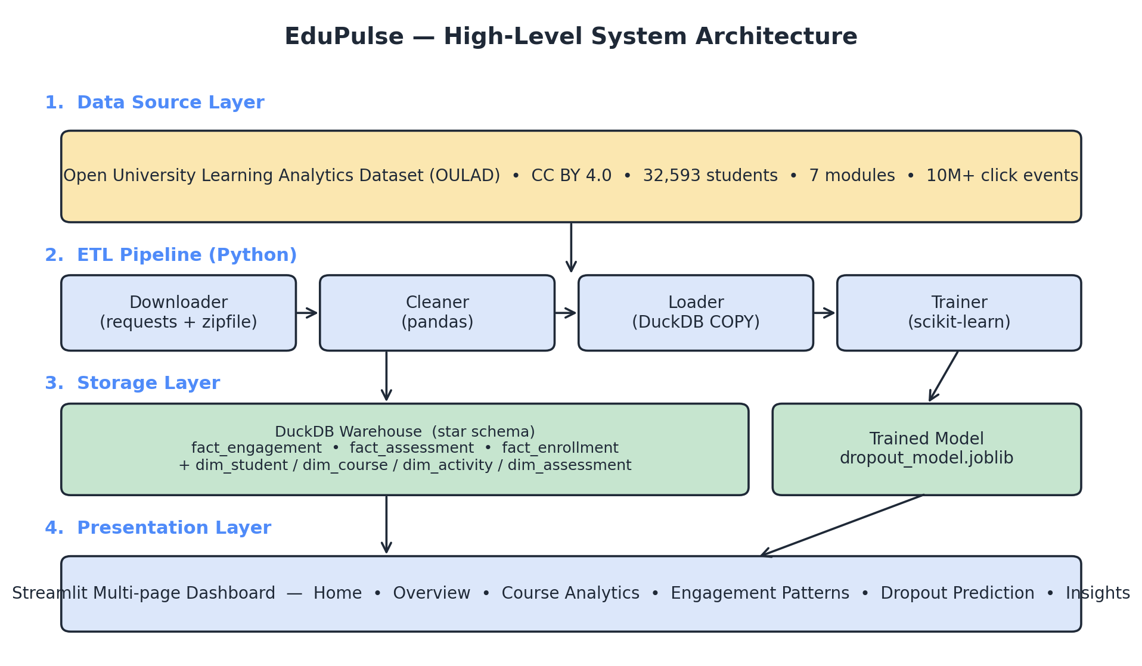
Figure 3.1 — EduPulse high-level system architecture (four-layer view)
Figure 3.1 above traces the path of data through EduPulse. The Data Source layer at the top represents the OULAD release, which is fixed and immutable. The ETL Pipeline consists of four sequential Python modules — Downloader, Cleaner, Loader, and Trainer — each of which runs to completion before the next begins. The Storage layer in the middle holds the materialised artefacts: the DuckDB warehouse file (consumed by every dashboard page) and the trained-model file (consumed by the Dropout Prediction page). The Presentation layer at the bottom is the Streamlit application, which is the only user-facing component.

3.6 Data Flow Diagrams
The Data Flow Diagram (DFD) notation is used to specify how data moves through the system and which processes transform it. Two levels are presented: the context diagram (Level 0) shows the system as a single process with all external interactions, and the decomposed diagram (Level 1) opens the system box to expose its internal processes and data stores.
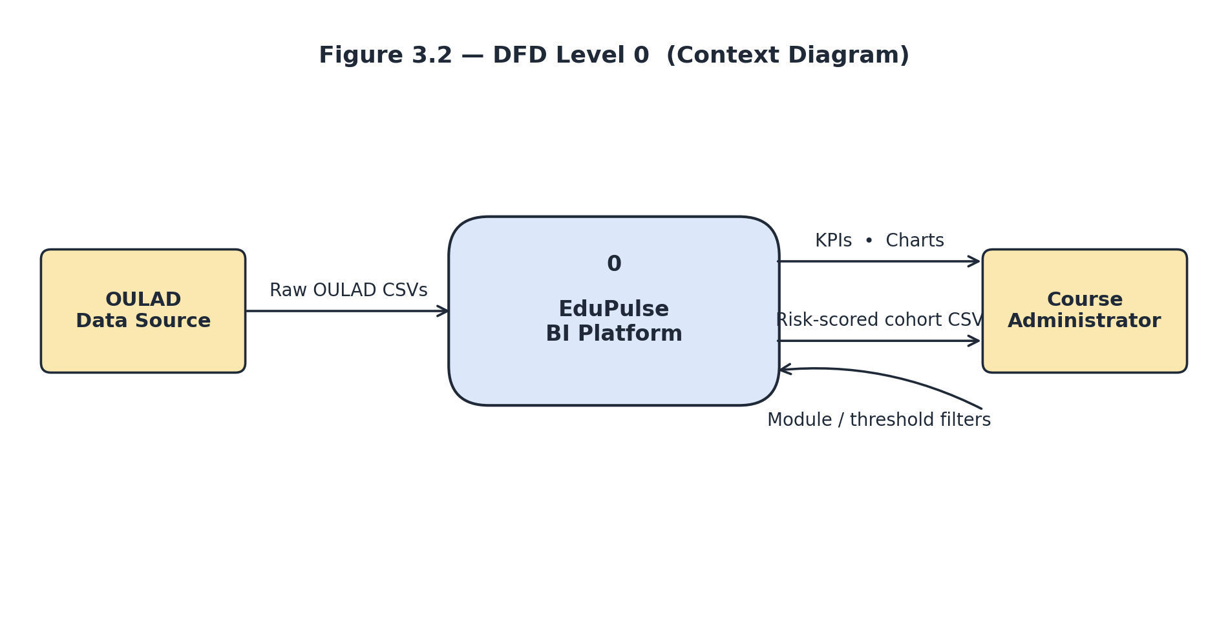
Figure 3.2 — DFD Level 0 (Context Diagram)
Figure 3.2 establishes the system boundary. Two external entities interact with EduPulse: the OULAD data source supplies raw CSV files; the course administrator supplies module and threshold filters and receives KPIs, charts, and the risk-scored cohort export. No other external system is involved at runtime.
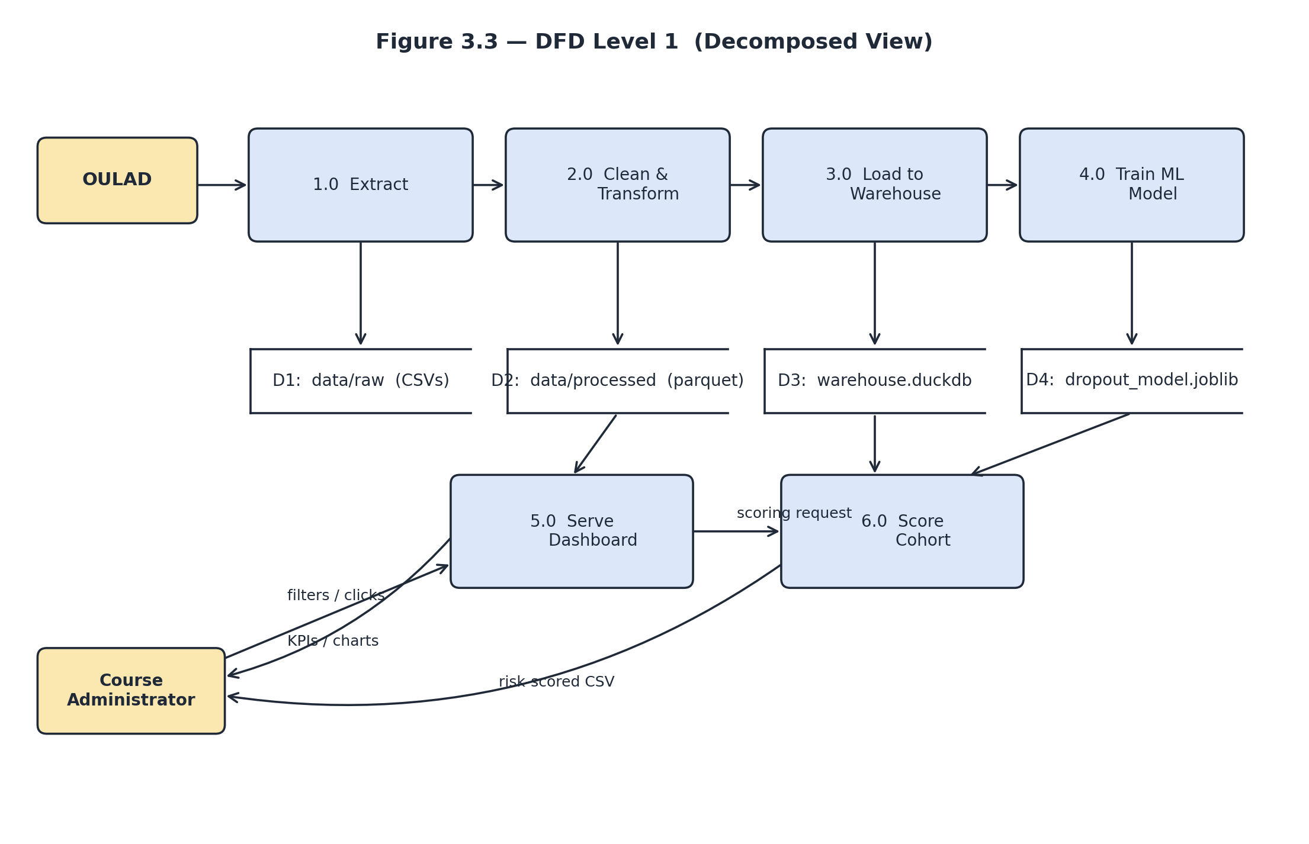
Figure 3.3 — DFD Level 1 (Decomposed View)
Figure 3.3 decomposes the single EduPulse process from Figure 3.2 into six numbered subprocesses (1.0 Extract through 6.0 Score Cohort) and four data stores (D1 raw CSVs, D2 cleaned parquet, D3 DuckDB warehouse, D4 serialised model). The Extract, Clean, Load, and Train subprocesses execute strictly in sequence and write to their respective stores. The Serve Dashboard process reads from D2 and D3 interactively in response to administrator requests. The Score Cohort process additionally reads the trained model from D4 and emits the risk-scored CSV directly to the administrator.

3.7 Use Case Diagram
The use-case view abstracts away data flows and shows the discrete interactions the system supports. Two actors participate: the course administrator (human) and the ETL pipeline (system). Use cases on the administrator side describe the read-only interactive workflows available through the dashboard. Use cases on the ETL side describe the offline batch workflows that prepare the data and the model and that the dashboard depends upon.
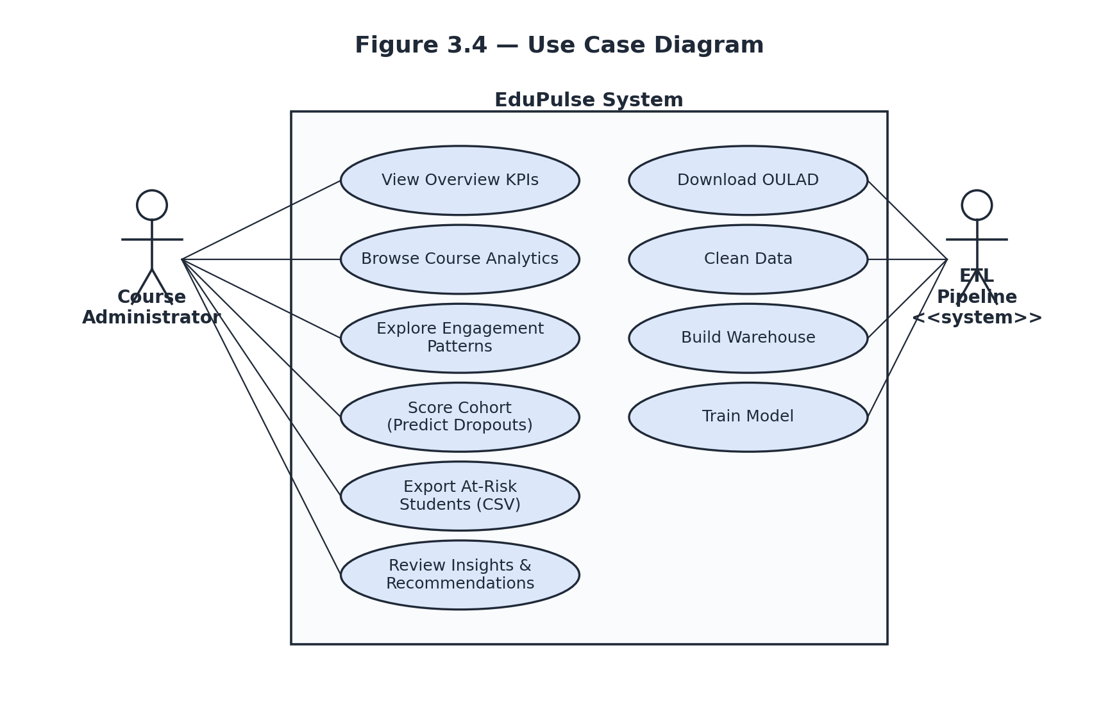
Figure 3.4 — Use Case Diagram
The administrator’s six use cases (left side of Figure 3.4) — View Overview KPIs, Browse Course Analytics, Explore Engagement Patterns, Score Cohort, Export At-Risk Students, and Review Insights — together constitute the full functional surface of the dashboard. The ETL pipeline’s four use cases (right side) — Download OULAD, Clean Data, Build Warehouse, and Train Model — are invoked once during initial deployment and then re-invoked only when the underlying dataset is refreshed. A more detailed UML treatment of the dashboard component, including class, sequence, and activity diagrams, is presented in Chapter 4 (System Design).

Chapter 4: System Design

4.1 Design Approach
Chapter 3 established what the system must do; this chapter establishes how it is structured to do it. The design approach taken in EduPulse follows three explicit principles.
First, the design is layered rather than monolithic. Each layer communicates with the next through a single well-defined artefact — raw CSV files between the source and the cleaner, parquet files between the cleaner and the warehouse, the DuckDB database file between the warehouse and the dashboard, and the joblib model file between the trainer and the dashboard. This artefact-driven design makes each layer independently testable, replaceable, and deployable.
Second, the design is data-first rather than UI-first. The star schema of the warehouse was specified before any dashboard page was authored, because the dashboard pages are essentially typed views over the warehouse and must follow its grain. A change to a dashboard page never requires a schema change; a deliberate schema evolution would require only minimal dashboard work.
Third, the design favours convention over configuration. There is one way to add a new analytical view (a new SQL view in the warehouse consumed by a new Streamlit page), one way to add a new ETL stage (a new function in the cleaner registered in the CLEANERS dictionary), and one way to extend the predictive layer (a new feature in v_student_features and the model retrained). The remainder of this chapter formalises these choices through standard UML, an ER diagram, a star-schema diagram, the table-level schema specification, and UI wireframes.

4.2 Class Diagram
EduPulse is implemented as a collection of Python modules rather than object-oriented class hierarchies, so the class diagram below uses the convention of representing each module as a UML class. The attributes compartment lists module-level constants and configuration values; the operations compartment lists the public functions exposed by the module.
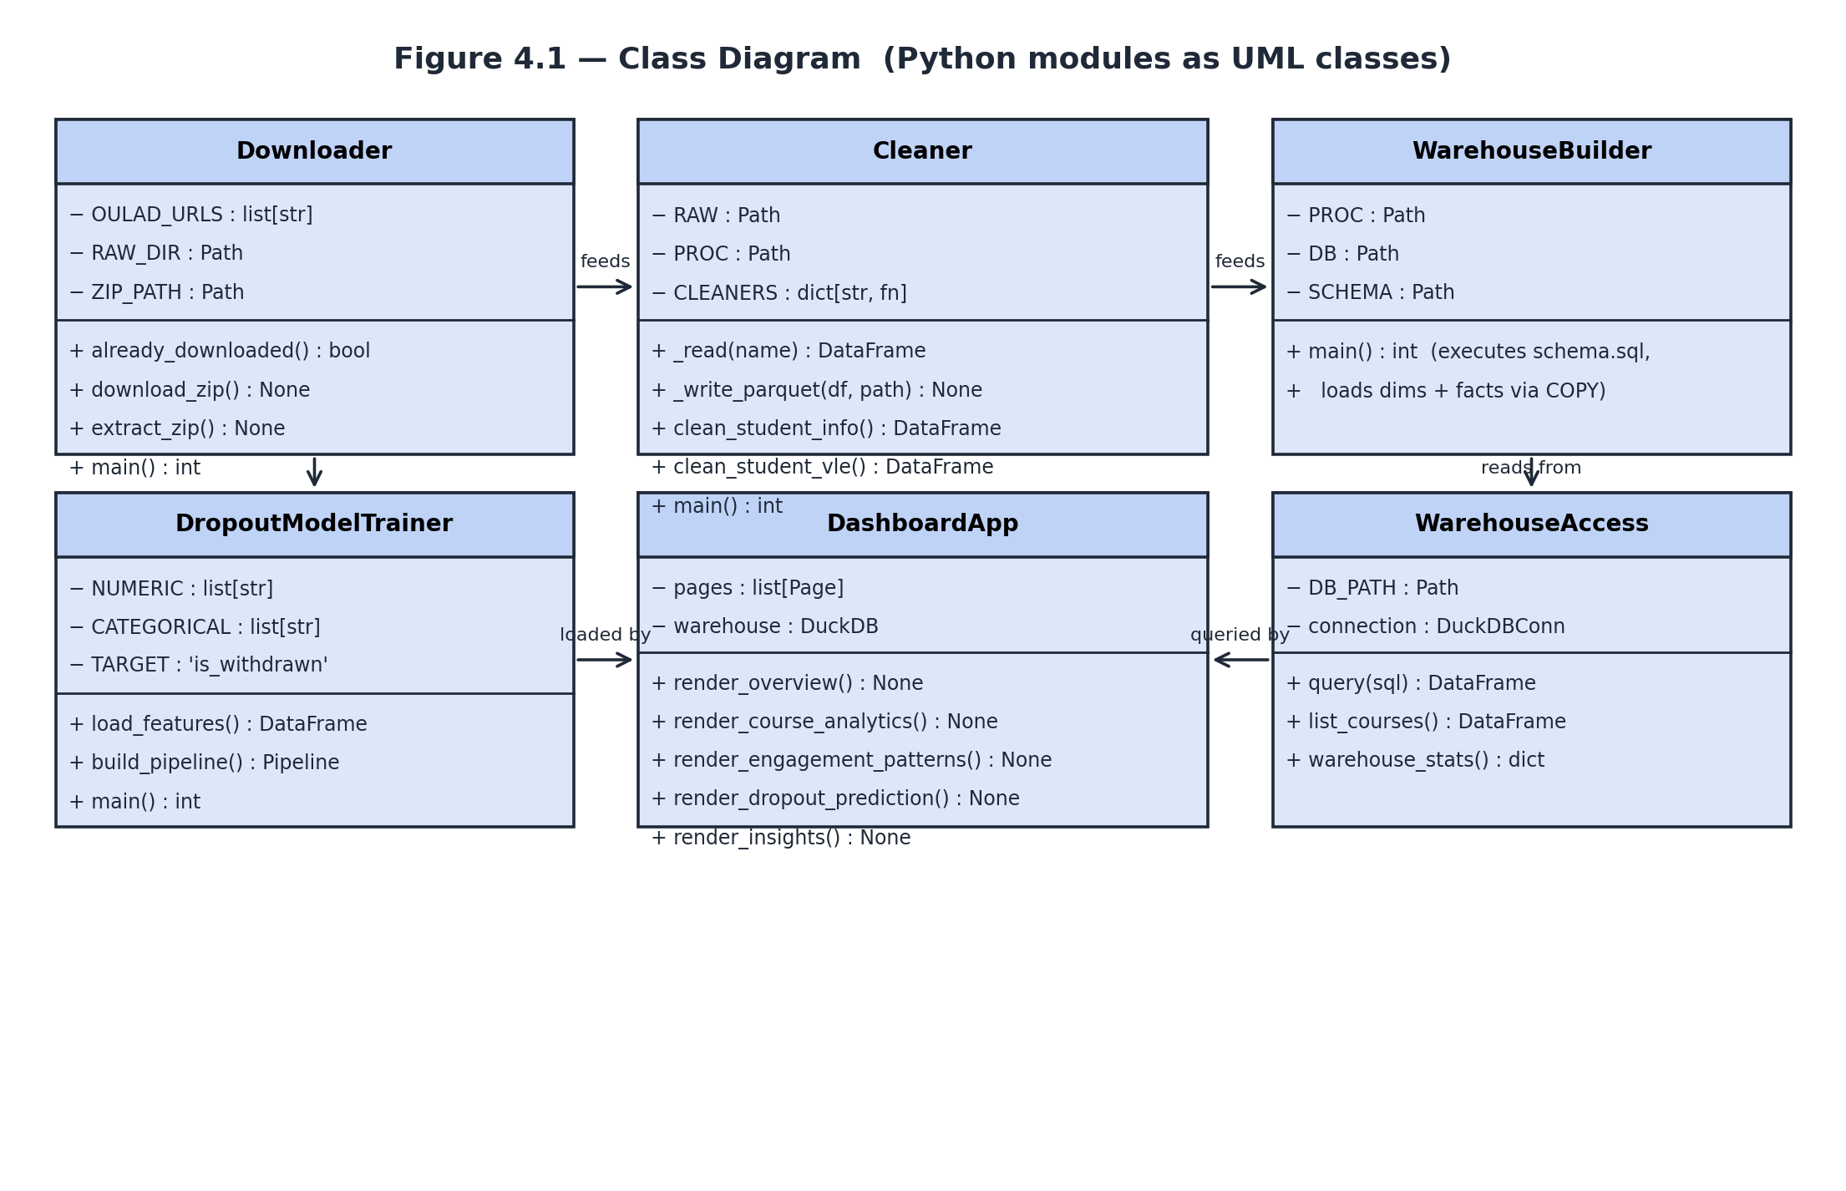
Figure 4.1 — Class Diagram (Python modules as UML classes)
Figure 4.1 shows six logical modules grouped into three pairs. The Downloader and the Cleaner together constitute the ingestion phase: the Downloader exposes idempotent functions for fetching and extracting the OULAD archive, and the Cleaner exposes per-table functions plus a private _write_parquet helper that wraps DuckDB’s native parquet writer. The WarehouseBuilder consumes the parquet files produced by the Cleaner and the schema specification in schema.sql to construct the DuckDB warehouse.
The DropoutModelTrainer loads the v_student_features view from the warehouse, fits a scikit-learn pipeline, and persists the artefact. At runtime, the DashboardApp delegates every analytical query to WarehouseAccess, which encapsulates connection management and the Streamlit caching primitives that keep the dashboard responsive. Each module corresponds one-to-one with a single file in the source tree (see Chapter 5), which preserves the convention-over-configuration principle stated in section 4.1.

4.3 Sequence Diagram
The sequence diagram below traces the most interaction-heavy workflow in EduPulse: the administrator scoring a cohort on the Dropout Prediction page. Solid arrows represent synchronous requests; dashed arrows represent the corresponding returns. The diagram makes explicit which components participate, in what order, and how the DuckDB warehouse and the trained scikit-learn model both feed into the same dashboard render.
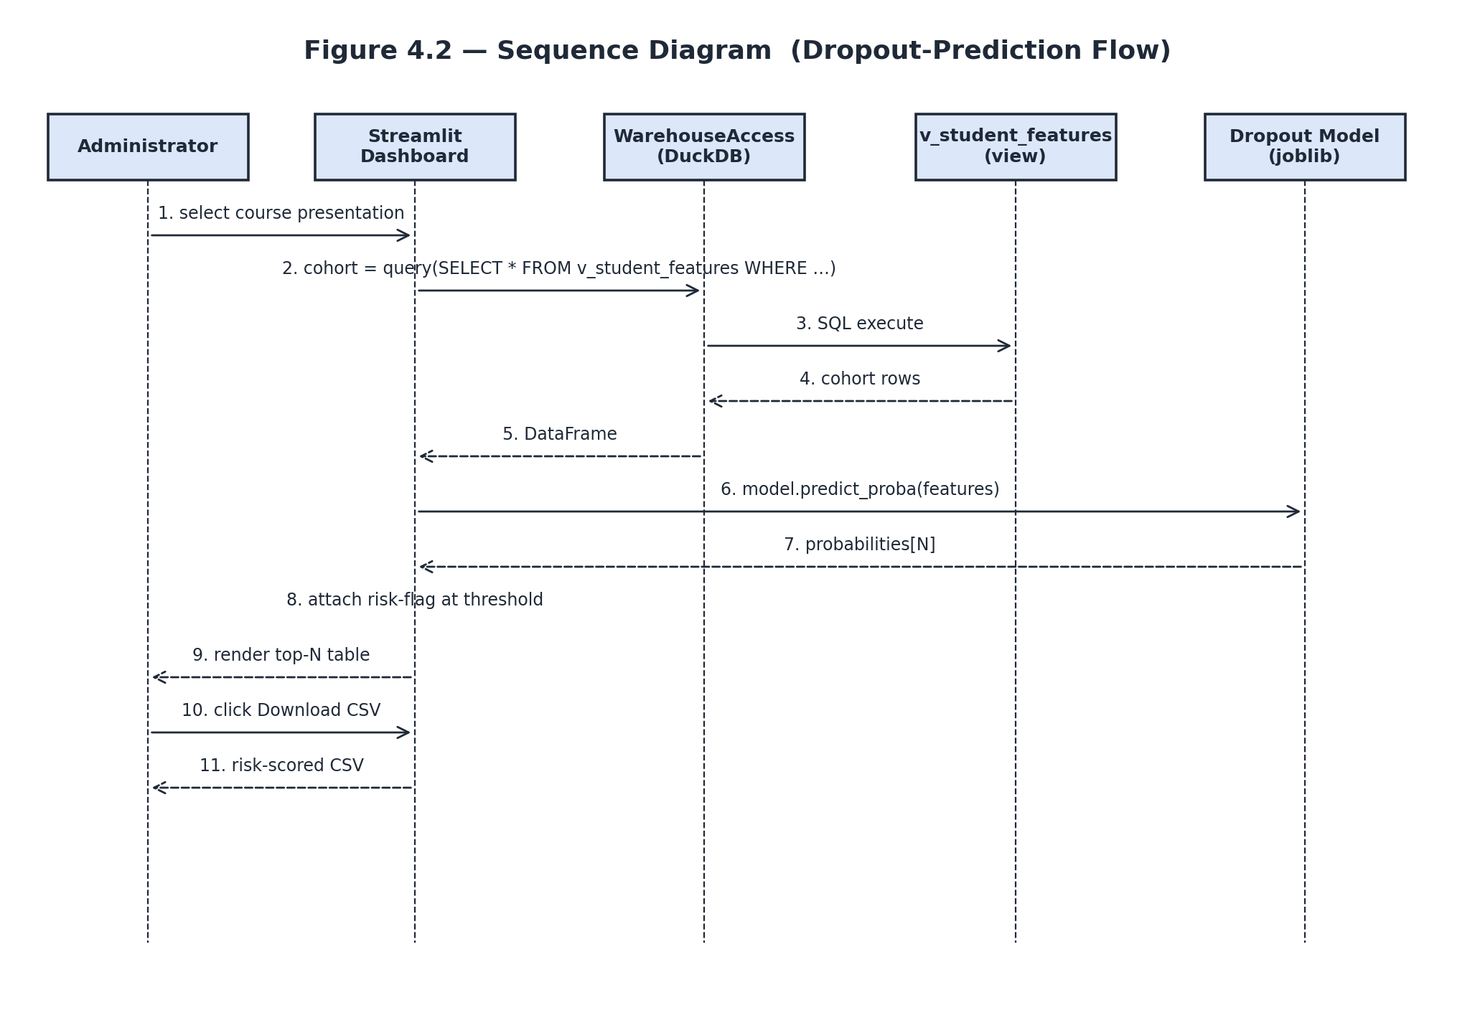
Figure 4.2 — Sequence Diagram for the Dropout-Prediction Flow
The flow begins with the administrator selecting a course presentation in the sidebar (message 1). The dashboard issues a SELECT against the v_student_features view (message 2), which DuckDB resolves by joining the dim_student, fact_enrollment, fact_engagement, and fact_assessment tables under a thirty-day window predicate. The resulting cohort DataFrame is returned to the dashboard (messages 3–5). The dashboard then invokes predict_proba on the loaded scikit-learn pipeline (message 6); the model returns one probability per row (message 7). The dashboard attaches a binary risk flag at the user-selected threshold (message 8) and renders the top-N table to the administrator (message 9). If the administrator clicks the Download CSV control (message 10), the dashboard serialises the scored cohort and returns it as a download (message 11).
The diagram clarifies an important property of the design: the model is never invoked during a generic dashboard load — only when the administrator explicitly visits the Dropout Prediction page and selects a cohort. This isolation keeps the cost of routine engagement-trend browsing low while still making the predictive layer one click away.

4.4 Activity Diagram
The activity diagram below describes the offline ETL pipeline, which runs at deployment time and whenever the underlying OULAD dataset is refreshed. Unlike the sequence diagram, which captures interactive real-time behaviour, the activity diagram focuses on the long-running batch sequence and the single decision point at its start.
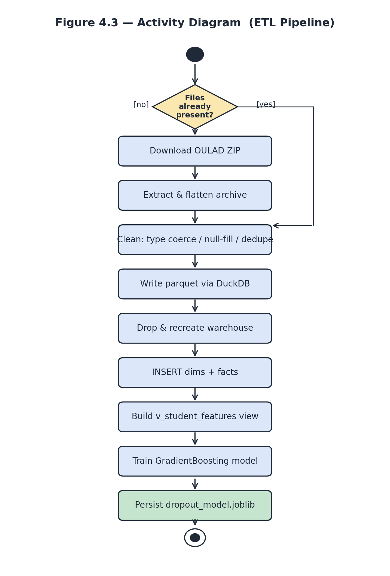
Figure 4.3 — Activity Diagram of the ETL Pipeline
Figure 4.3 begins at the solid start node and reaches a decision: are the OULAD CSV files already present in the data/raw directory? On the [yes] branch, the pipeline skips the Download and Extract activities and jumps directly to the Clean activity — this idempotency is important on Streamlit Community Cloud, where the container may restart while the data is still present from a previous run. On the [no] branch, the default downward flow executes Download and Extract before Clean. From the Clean activity onward, every step is sequential and deterministic: parquet files are written, the warehouse is dropped and recreated, dimensions and facts are loaded via COPY, the v_student_features view is materialised, the Gradient Boosting model is trained on a stratified split, and the trained model artefact (highlighted in green) is persisted to disk. The diagram terminates at the bullseye end node when the artefact has been written successfully.

4.5 Entity–Relationship Diagram
The entity–relationship diagram below describes the conceptual data model that underlies the warehouse — the entities that exist in the OULAD problem domain and the relationships among them. The diagram is independent of the dimensional implementation (covered in section 4.6) and is intended to be read by domain stakeholders, not only by developers.
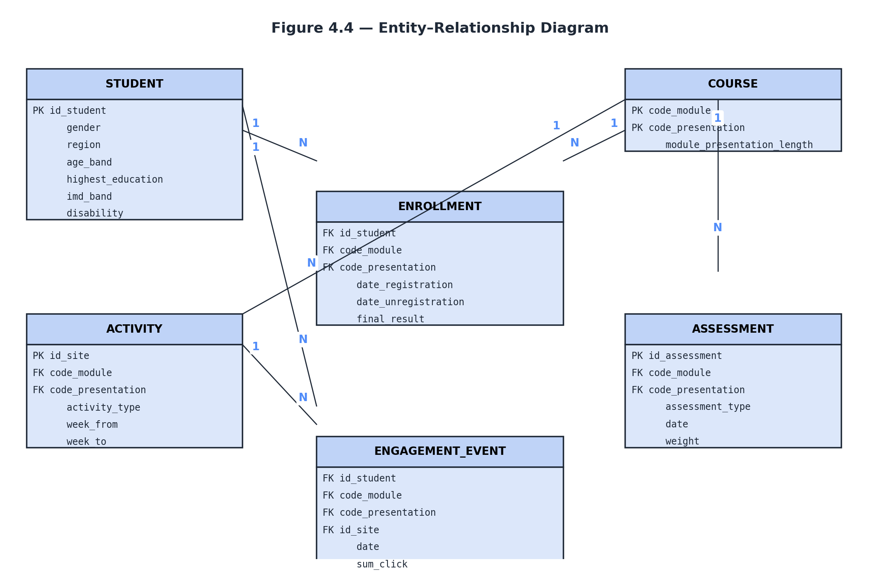
Figure 4.4 — Entity–Relationship Diagram
Six entities participate in the model. STUDENT and COURSE are the two foundational entities. An ENROLLMENT entity captures the many-to-many relationship between students and courses, recording registration and outcome attributes on the relationship itself. Within each course, an ACTIVITY entity catalogues the resources, quizzes, forums, and other content the learner can interact with, and an ASSESSMENT entity catalogues the formal evaluations that contribute to the final grade. The ENGAGEMENT_EVENT entity is a weak entity that records a single (student, activity, date) interaction with a click count. Cardinality labels in the diagram show that one STUDENT generates many ENGAGEMENT_EVENTs, one COURSE exposes many ACTIVITies and ASSESSMENTs, and so on.

4.6 Database Schema (Star Schema)
The conceptual entity model from section 4.5 is implemented as a star schema for analytical performance. The star schema partitions the model into fact tables (numeric measures recorded at a specific grain) and dimension tables (descriptive attributes shared across facts). The schema is materialised in DuckDB by the Data Definition Language file schema.sql, and is loaded by the WarehouseBuilder module documented in section 4.2.
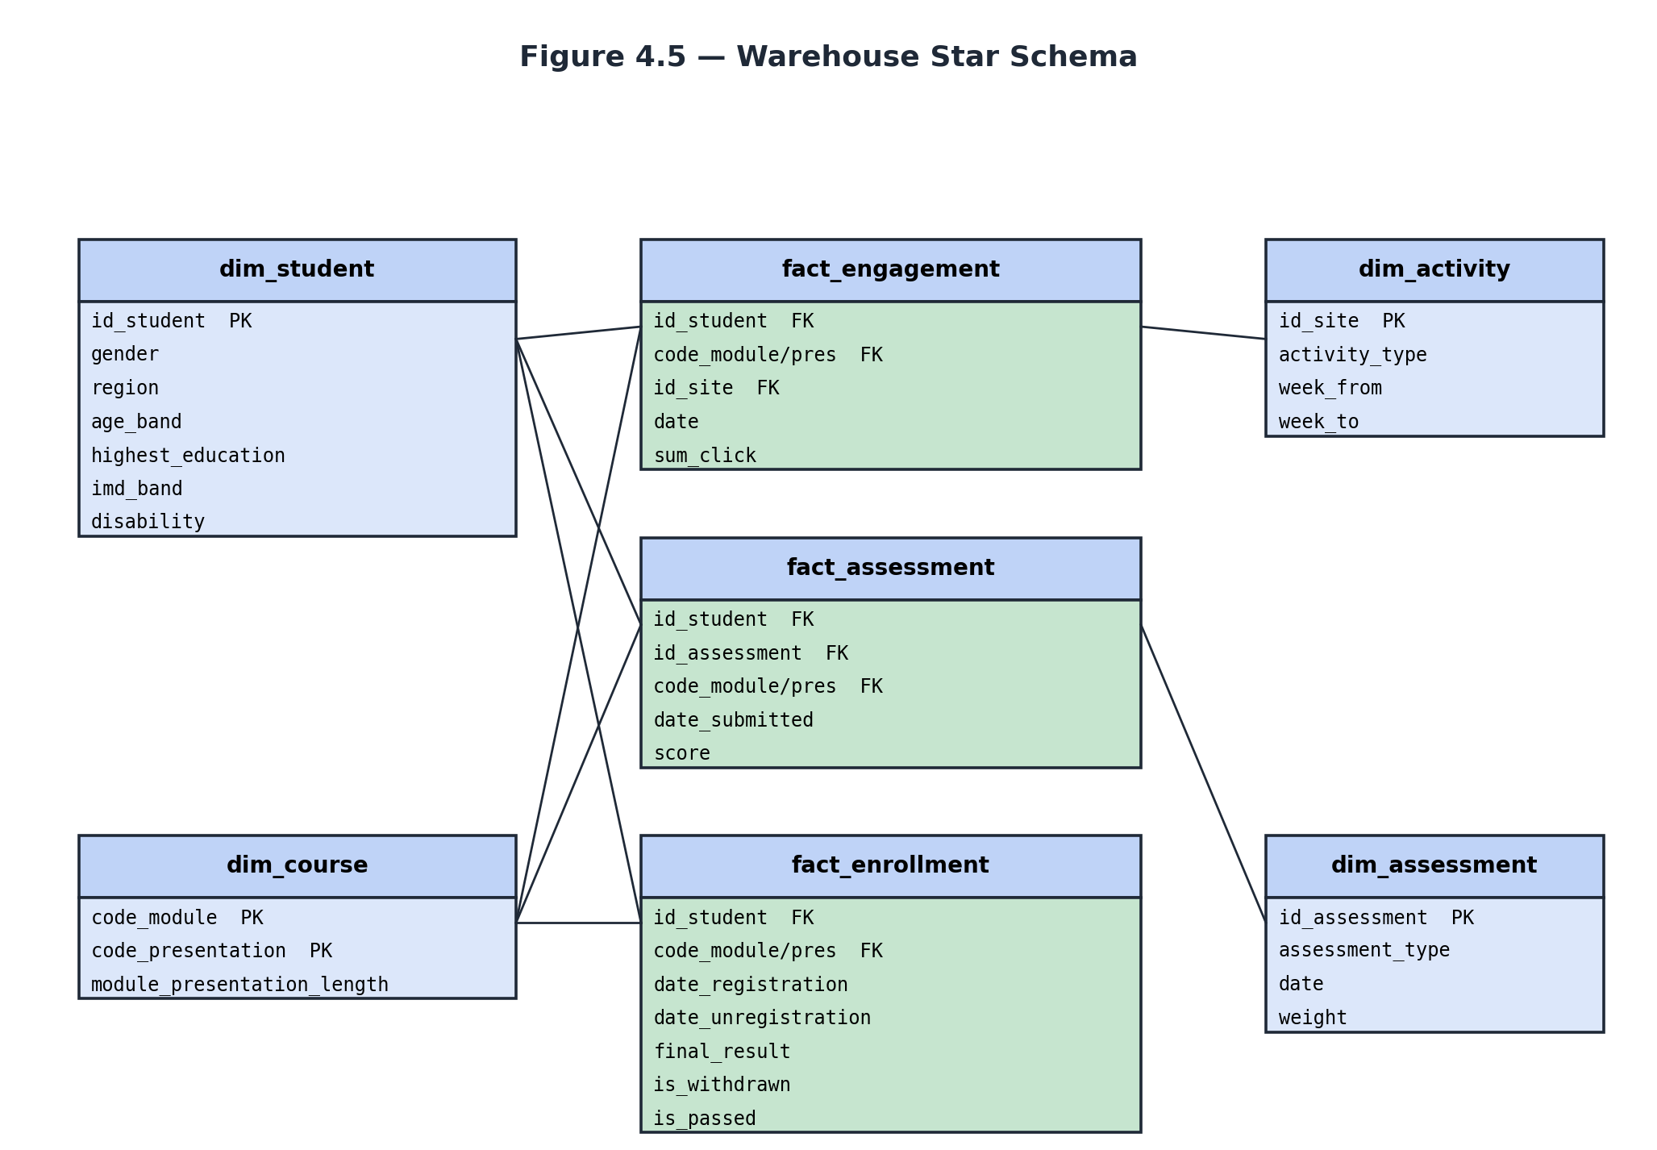
Figure 4.5 — Warehouse Star Schema
Figure 4.5 shows three fact tables at the centre and four conformed dimensions at the corners. fact_engagement holds one row per (student, activity, day) interaction; fact_assessment holds one row per assessment submission; fact_enrollment holds one row per (student, course presentation) registration with the final outcome as the dominant attribute. The dim_student dimension is conformed across all three facts, which permits queries that mix engagement, assessment, and enrollment outcomes on a single student key. dim_course is similarly conformed, dim_activity is referenced only by fact_engagement, and dim_assessment only by fact_assessment.

Table-level Specification
The Data Definition Language for the schema is reproduced in full in Appendix A. The key design decisions encoded in that file are summarised below.
fact_engagement is the largest table (approximately 10.6 million rows). It is intentionally narrow — six columns total — so that DuckDB’s columnar storage compresses it aggressively. The grain (student × activity × day) was chosen to match the granularity of the source studentVle.csv file.
fact_enrollment has derived columns is_withdrawn and is_passed computed by SQL boolean expressions on final_result. These derived columns are materialised rather than computed at query time so that downstream pages can compute pass and withdrawal rates without repeating CASE logic.
The view v_student_features is defined directly in schema.sql so that the predictive layer and the dashboard read the same feature specification. The view embeds the first-thirty-day window as a predicate, guaranteeing that the model is trained on exactly the feature set that the dashboard later displays.

4.7 API and Data Access Design
EduPulse does not expose a public REST or GraphQL Application Programming Interface. The deployment model is a server-rendered Streamlit application, so all data access happens inside the same Python process. The internal data-access contract is nevertheless explicit and is defined by a single helper module.
The WarehouseAccess module (src/utils/db.py) exposes three public callables: get_connection() returns a read-only DuckDB connection cached at the resource level, so the connection is established at most once per dashboard session; query(sql, params=None) executes a parameterised SQL statement and returns a pandas DataFrame, with results cached for one hour by the @st.cache_data decorator; and warehouse_stats() returns the top-level KPI dictionary surfaced on the Home page. Every dashboard page interacts with the warehouse exclusively through these three functions, which keeps the interaction surface small and uniform.

4.8 User-Interface Wireframes
Three of the five dashboard pages are wireframed below. The wireframes specify the placement of KPI cards, charts, tables, and interactive controls; they do not specify colour or typography, which are inherited from the Streamlit default theme configured in .streamlit/config.toml. All pages share the same persistent left-hand sidebar containing the page navigator and the EduPulse brand mark.
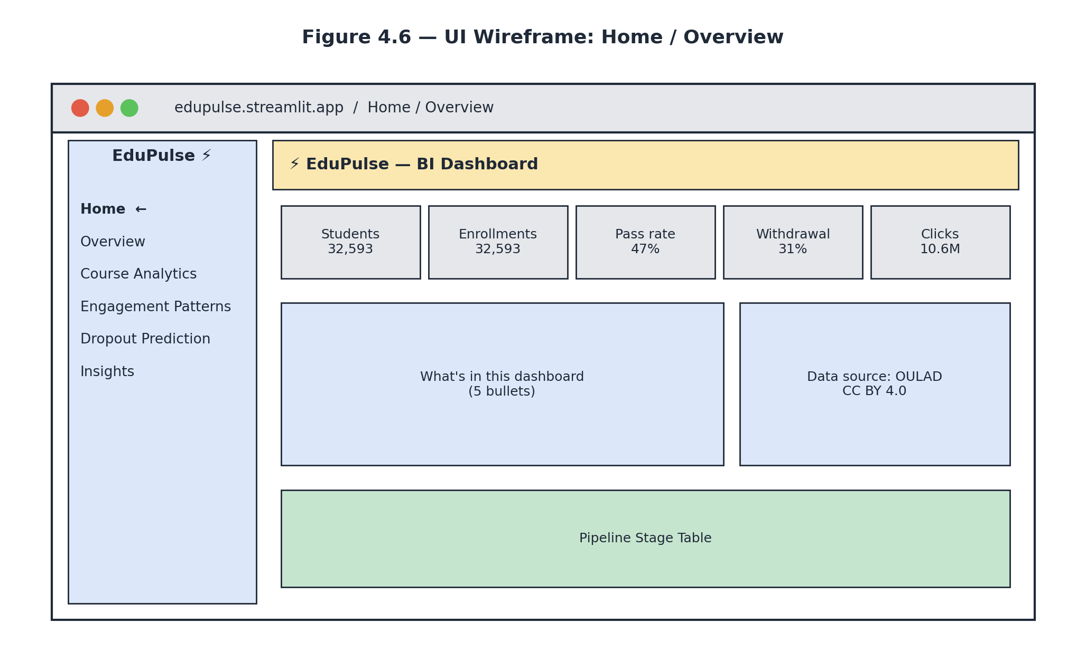
Figure 4.6 — Wireframe: Home page
Figure 4.6 shows the Home page. A five-card KPI strip occupies the top of the content area, summarising platform scale at a glance: total students, enrollments, pass rate, withdrawal rate, and total clicks. Below the strip, a two-column section provides a short narrative of what each subsequent page offers and a sidebar-style block describing the data source. A pipeline-stage table at the bottom orients new users to the data flow that produced what they are about to see.
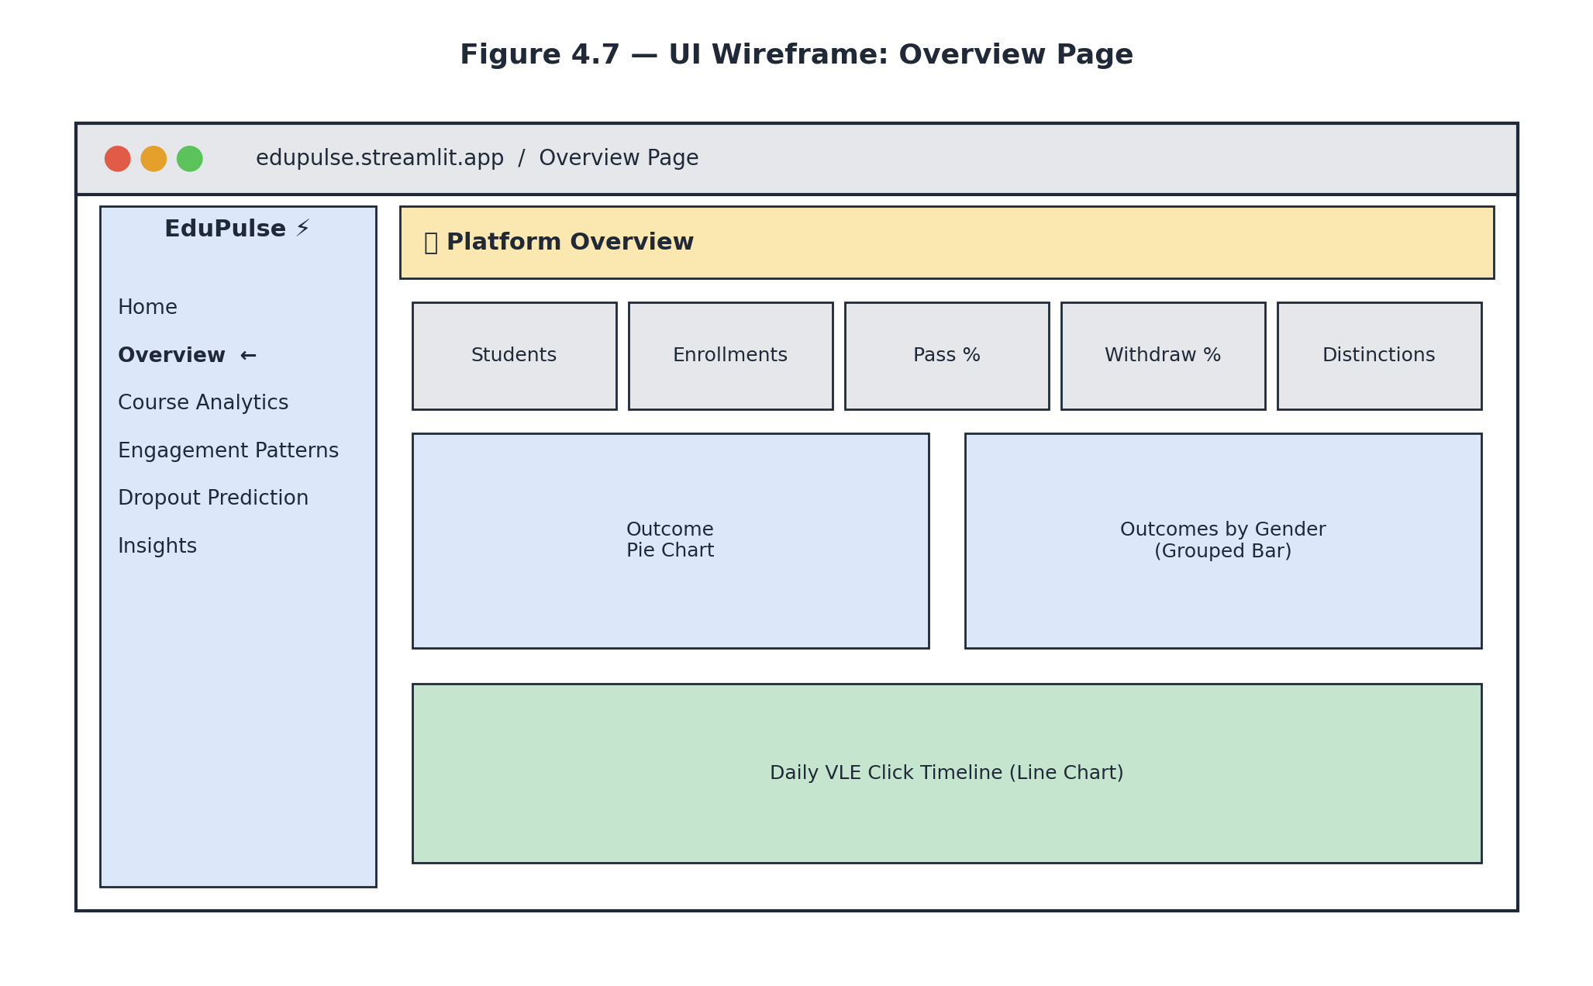
Figure 4.7 — Wireframe: Overview page
Figure 4.7 shows the Overview page. The KPI strip is repeated for consistency. Below it, two side-by-side charts — an outcome pie chart and a grouped-bar chart of outcomes by gender — provide the first slice of diagnostic context. A full-width line chart of daily VLE clicks runs along the bottom of the page, plotted against the day-from-course-start axis so that pre-course onboarding and end-of-term spikes are visually obvious.
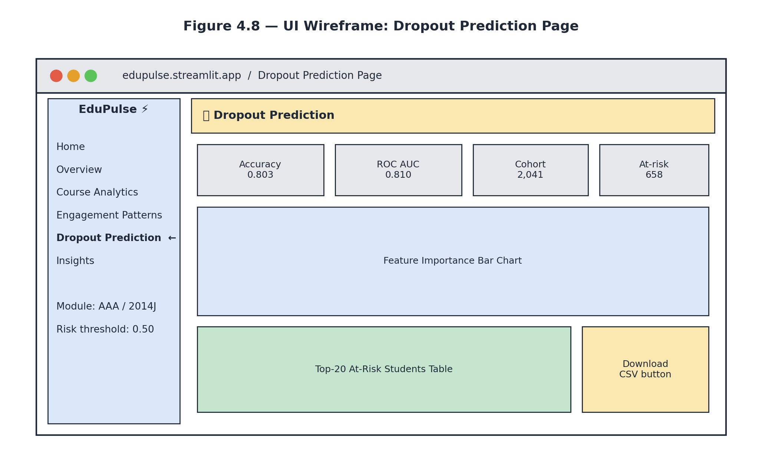
Figure 4.8 — Wireframe: Dropout Prediction page
Figure 4.8 shows the Dropout Prediction page, which has the highest interaction density. The sidebar exposes two page-specific controls — module / presentation selector and risk-threshold slider — in addition to the global navigator. The KPI strip is repeated but its cards now show model metrics (accuracy 0.803, ROC AUC 0.810), cohort size, and the number of students currently flagged at risk. Below the strip, a feature-importance bar chart provides an explainability surface so the administrator can see what the model weighs. At the bottom, the top-twenty at-risk students table is paired with a Download CSV button so the administrator can act on the result outside the dashboard.
The remaining two pages — Course Analytics and Engagement Patterns — follow the same skeleton and are documented in Chapter 5 alongside their implementation.

Chapter 5: System Implementation

5.1 Development Environment
EduPulse was developed and tested on Apple macOS 25.2 (Darwin kernel 25.2) running on an Apple Silicon MacBook Air (2020). The entire toolchain is open source and reproduces deterministically on any platform that supports Python 3.11 or newer.
The development environment is built around a single virtual environment created with the standard library venv module. All dependencies are pinned to compatible major-version ranges in requirements.txt and installed with pip. The editor used during development is Visual Studio Code with the Python and Pylance extensions enabled. The Streamlit development server runs locally on port 8501 and provides hot-reload on file save, which materially shortened the dashboard-design iteration loop.
Initial environment setup is reproducible in three commands from the project root:
python3 -m venv .venv
source .venv/bin/activate
pip install -r requirements.txt
Once the virtual environment is active, the entire offline pipeline (download → clean → warehouse build → model train) is invoked with a single command, and the dashboard with another:
python -m src.etl.run_pipeline # ~3–5 minutes on first run
streamlit run Home.py # opens http://localhost:8501

5.2 Tools and Technologies Used
The table below enumerates the principal tools and libraries on which EduPulse depends, the version actually used during development, and the responsibility each component carries inside the system.
Component Version Responsibility
───────────────────── ────────── ──────────────────────────────
Python 3.11 Application language
Streamlit ≥ 1.32 Web-app framework, multi-page UI
DuckDB ≥ 1.0 Embedded OLAP warehouse + parquet I/O
pandas ≥ 2.0 Tabular cleaning, feature engineering
scikit-learn ≥ 1.3 Gradient Boosting classifier, pipelines
Plotly ≥ 5.18 Interactive charts (lines, bars, heatmaps)
joblib ≥ 1.3 Trained-model serialisation
requests ≥ 2.31 OULAD HTTP download
numpy ≥ 1.26,<2.0 Numerical primitives (sklearn dependency)
Git / GitHub n/a Source control + deploy source
Streamlit Cloud n/a Free public hosting
Three configuration files glue these components together. requirements.txt enumerates the Python dependencies; .streamlit/config.toml configures the dashboard theme (primary colour, gather-usage-stats disabled, XSRF protection enabled); and .gitignore excludes the data, model, and warehouse artefacts so that the public GitHub repository contains only source code.

5.3 Hardware and Software Requirements
The hardware and software requirements were intentionally kept modest so that the system can be reproduced on a student laptop and deployed on the free tier of Streamlit Community Cloud.
Development Minimum Streamlit Cloud (free)
CPU Apple M1 Any modern x86_64 Shared cloud CPU
RAM 8 GB 4 GB 1 GB allocated
Disk 2 GB free 1 GB free 1 GB persistent
Operating system macOS 25.2 (Darwin) Linux / mac / Win Linux container
Python 3.11.x ≥ 3.10 3.11.x
Network Required (OULAD pull) Required for ETL Always-on
Browser Chrome / Safari / Edge Any modern browser On-demand
The end-to-end pipeline including model training completes in approximately four minutes on the development hardware. On the Streamlit Community Cloud container the same pipeline completes in approximately five to six minutes, the difference being attributable to the slower disk and shared CPU of the free tier. The warehouse file produced is approximately 200 megabytes, which fits comfortably inside the 1 gigabyte allocation.

5.4 Module-wise Implementation
Each subsection below documents one source module. The discussion focuses on design intent and on the non-obvious decisions that shape the implementation; the full source code is reproduced verbatim in Appendix A.

5.4.1 Downloader Module — src/etl/download_data.py
The Downloader is responsible for obtaining the OULAD archive and extracting the seven expected CSV files into data/raw. Two design decisions stand out. First, the module accepts a list of source URLs and falls back from primary to secondary if the primary returns a non-200 response — this proved essential when the original Open University KMI URL changed and the UCI Machine Learning Repository mirror was used instead. Second, the extractor flattens any nested directory layout in the archive, since different mirrors wrap the CSVs differently.
OULAD_URLS = [
'https://archive.ics.uci.edu/static/public/349/'
'open+university+learning+analytics+dataset.zip',
'https://analyse.kmi.open.ac.uk/open-dataset/download',
]
def download_zip() -> None:
RAW_DIR.mkdir(parents=True, exist_ok=True)
for url in OULAD_URLS:
if _try_download(url):
return
raise RuntimeError('Could not download OULAD from any source.')

5.4.2 Cleaner Module — src/etl/clean.py
The Cleaner reads each raw CSV with pandas, applies a per-table transformation function registered in the CLEANERS dictionary, and persists the result as columnar parquet. Two implementation details merit attention. First, the OULAD source files use the literal character question mark as a missing-value marker on several columns; the reader passes na_values=['?'] globally so that these are converted to true nulls at read time. Second, parquet output is written through DuckDB rather than through pyarrow, because the Streamlit Community Cloud image lacked a matching pyarrow wheel and the alternative DuckDB code path has no external native dependency.
def _read(name: str) -> pd.DataFrame:
# OULAD uses '?' as missing-value marker in several tables
df = pd.read_csv(RAW / name, na_values=['?'])
df.columns = [c.strip().lower() for c in df.columns]
return df
def _write_parquet(df: pd.DataFrame, path: Path) -> None:
# DuckDB's native parquet writer — no pyarrow dependency.
con = duckdb.connect(':memory:')
con.register('df_view', df)
con.execute(
f"COPY (SELECT * FROM df_view) TO '{path.as_posix()}' "
f"(FORMAT PARQUET)"
)
con.close()

5.4.3 Warehouse Builder Module — src/etl/build_warehouse.py
The Warehouse Builder executes the Data Definition Language file schema.sql (described in section 4.6) and then loads every fact and dimension table with INSERT … SELECT statements that read directly from the cleaned parquet files. The loader always names columns explicitly rather than using SELECT *, because the OULAD source files order columns differently across tables and a positional insert would fail with confusing conversion errors. A representative load statement is reproduced below.
con.execute(f"""
INSERT INTO dim_assessment (
id_assessment, code_module, code_presentation,
assessment_type, date, weight
)
SELECT id_assessment, code_module, code_presentation,
assessment_type, date, weight
FROM read_parquet('{PROC / 'assessments.parquet'}')
""")
The module finishes by issuing a CHECKPOINT so that all writes are flushed to disk and the resulting warehouse.duckdb file is fully consistent before the trainer or the dashboard opens it. The Storage layer thus presents an atomic, all-or-nothing artefact to its downstream consumers.

5.4.4 Model Trainer Module — src/ml/train_dropout_model.py
The Model Trainer reads the v_student_features view from the warehouse, splits the data into a stratified train and test set, fits a scikit-learn Pipeline that combines preprocessing with the Gradient Boosting classifier, and persists the trained pipeline together with its evaluation metrics and feature importances using joblib. Bundling the metrics and importances inside the same artefact removes the need for a separate metadata store: the dashboard reads the entire bundle with a single joblib.load call.
def build_pipeline() -> Pipeline:
numeric_pipe = Pipeline([
('impute', SimpleImputer(strategy='median')),
('scale', StandardScaler()),
])
categorical_pipe = Pipeline([
('impute', SimpleImputer(strategy='most_frequent')),
('ohe', OneHotEncoder(handle_unknown='ignore',
sparse_output=False)),
])
preprocess = ColumnTransformer([
('num', numeric_pipe, NUMERIC),
('cat', categorical_pipe, CATEGORICAL),
])
clf = GradientBoostingClassifier(
n_estimators=200, max_depth=3,
learning_rate=0.08, random_state=42,
)
return Pipeline([('prep', preprocess), ('clf', clf)])

5.4.5 Dashboard Module — Home.py and pages/*.py
Streamlit’s convention is that the main script (Home.py) is the landing page and that every .py file inside a pages/ directory automatically becomes an additional page accessible from the sidebar. EduPulse follows this convention literally: each of the five pages — Overview, Course Analytics, Engagement Patterns, Dropout Prediction, and Insights — is one self-contained script of approximately one hundred lines that queries the warehouse and renders the corresponding charts. The Home script additionally exposes a one-click bootstrap button that runs the entire pipeline from inside the dashboard, which is essential on Streamlit Community Cloud where the container starts without a populated warehouse.
if not warehouse_exists():
if st.button('🚀 Build warehouse now', type='primary'):
from src.etl import build_warehouse, clean, download_data
from src.ml import train_dropout_model
progress = st.progress(0.0)
for i, (label, fn) in enumerate([
('Downloading OULAD', download_data.main),
('Cleaning data', clean.main),
('Building warehouse', build_warehouse.main),
('Training model', train_dropout_model.main),
], start=1):
st.info(f'Step {i}/4 — {label} …')
fn()
progress.progress(i / 4)
st.rerun()

5.5 Key Algorithms

5.5.1 ETL Idempotency
The Downloader is idempotent: re-running it when the seven expected files already exist in data/raw skips the network call and returns immediately. This is implemented as a simple existence check before any HTTP request is made. Idempotency at this stage matters because Streamlit Community Cloud containers may restart while the data is still present from a previous run; without the check, every container restart would trigger a fresh 45-megabyte download.

5.5.2 Parquet via DuckDB COPY
Writing parquet through DuckDB rather than through pandas-to-parquet is the key algorithmic choice that decouples EduPulse from pyarrow. The technique is to create an in-memory DuckDB connection, register the pandas DataFrame as a virtual table via the register() method, and emit a SQL COPY statement targeting the desired output path with FORMAT PARQUET. The DataFrame is never serialised to an intermediate format — DuckDB reads it through the registered view and writes parquet directly using its own native engine.

5.5.3 Gradient Boosting Hyper-parameter Choice
The classifier is a scikit-learn GradientBoostingClassifier with two hundred trees of maximum depth three and a learning rate of 0.08. These values were chosen rather than tuned: they sit comfortably inside the ranges most commonly reported in the OULAD-based literature reviewed in section 2.5. Two-hundred trees provide enough capacity to model the dominant interactions among the twelve features used; depth three avoids the overfitting that deeper trees would induce on a sample of approximately 32,000 rows; the conservative learning rate keeps the additive model stable without exploding the training time, which on the development hardware completes in under thirty seconds.

5.5.4 The First-Thirty-Day Feature Window
The model uses only data from the first thirty days of each course presentation. The window is enforced at the warehouse-view level (in v_student_features) by a single date <= 30 predicate on the engagement fact and an analogous predicate on the assessment fact. Pushing the window into the view rather than into the trainer guarantees that the dashboard, the trainer, and the live scoring code all see the same features for the same student — a consistency property that would be easy to violate if the window were enforced separately in three places.

5.6 Application Screenshots
The six figures that follow are unmodified screenshots of the running EduPulse dashboard captured at the development laptop against the locally-built warehouse. They illustrate, in turn, the Home page (Figure 5.1), the Overview page (Figure 5.2), the Course Analytics page (Figure 5.3), the Engagement Patterns page (Figure 5.4), the Dropout Prediction page (Figure 5.5), and the Insights page (Figure 5.6).
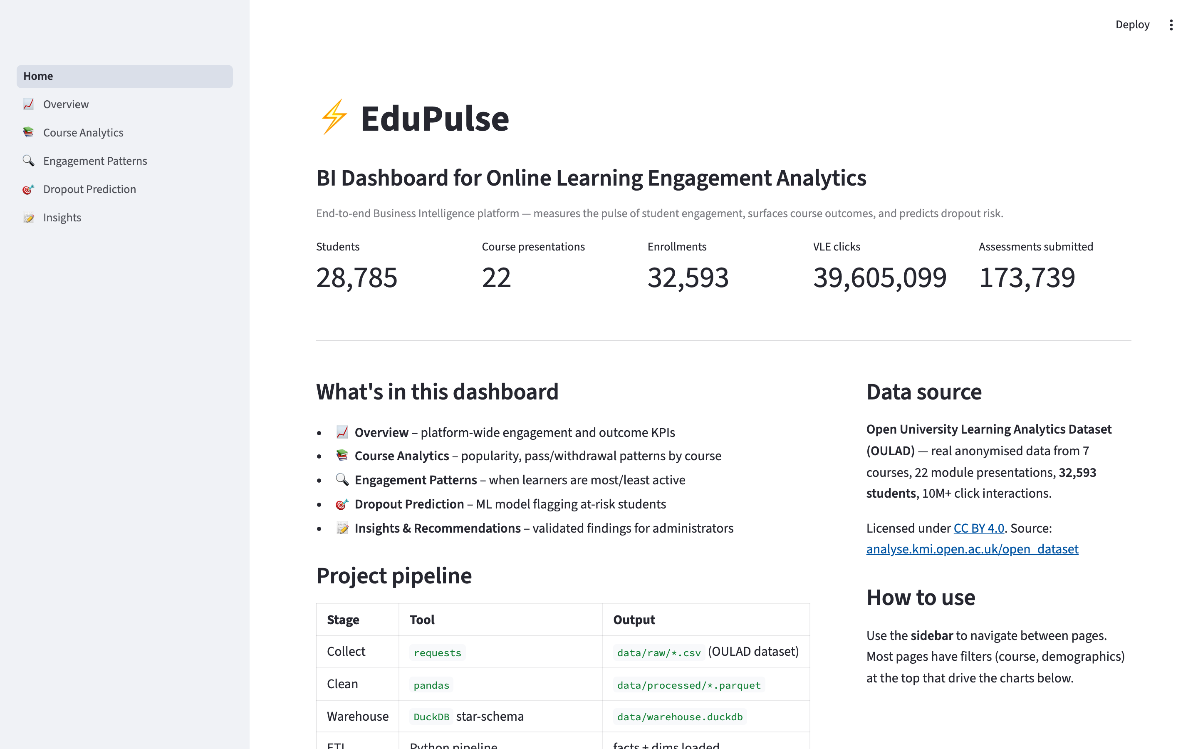
Figure 5.1 — Home page: brand mark, project KPIs, navigation panel
Figure 5.1 shows the Home page. The header carries the EduPulse wordmark and the dashboard tagline. A five-card KPI strip summarises platform scale at first glance — 28,785 unique students, 22 course presentations, 32,593 enrollments, 39.6 million VLE clicks, and 173,739 assessment submissions. Below the KPI strip, a navigation panel orients the user to the five remaining pages.
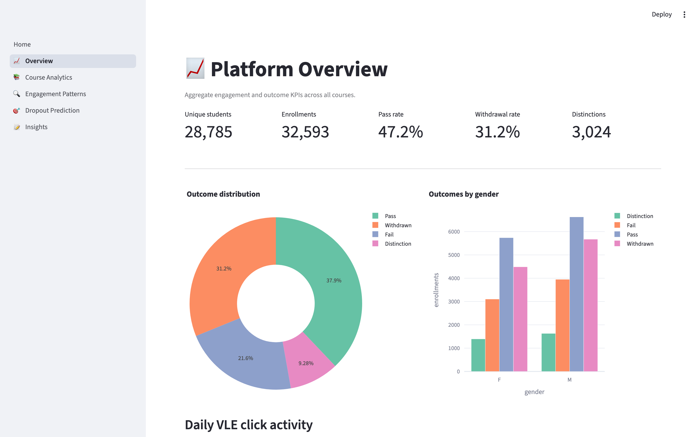
Figure 5.2 — Overview page: outcome distribution and daily click timeline
Figure 5.2 shows the Overview page. The outcome donut chart on the left makes the cohort-level outcome mix immediately legible; the grouped-bar chart on the right reveals the gender breakdown of those outcomes. The daily click line chart that follows spans negative thirty (pre-course onboarding) through day 270, exposing the characteristic peak-and-trough engagement pattern that Chapter 7 analyses in detail.
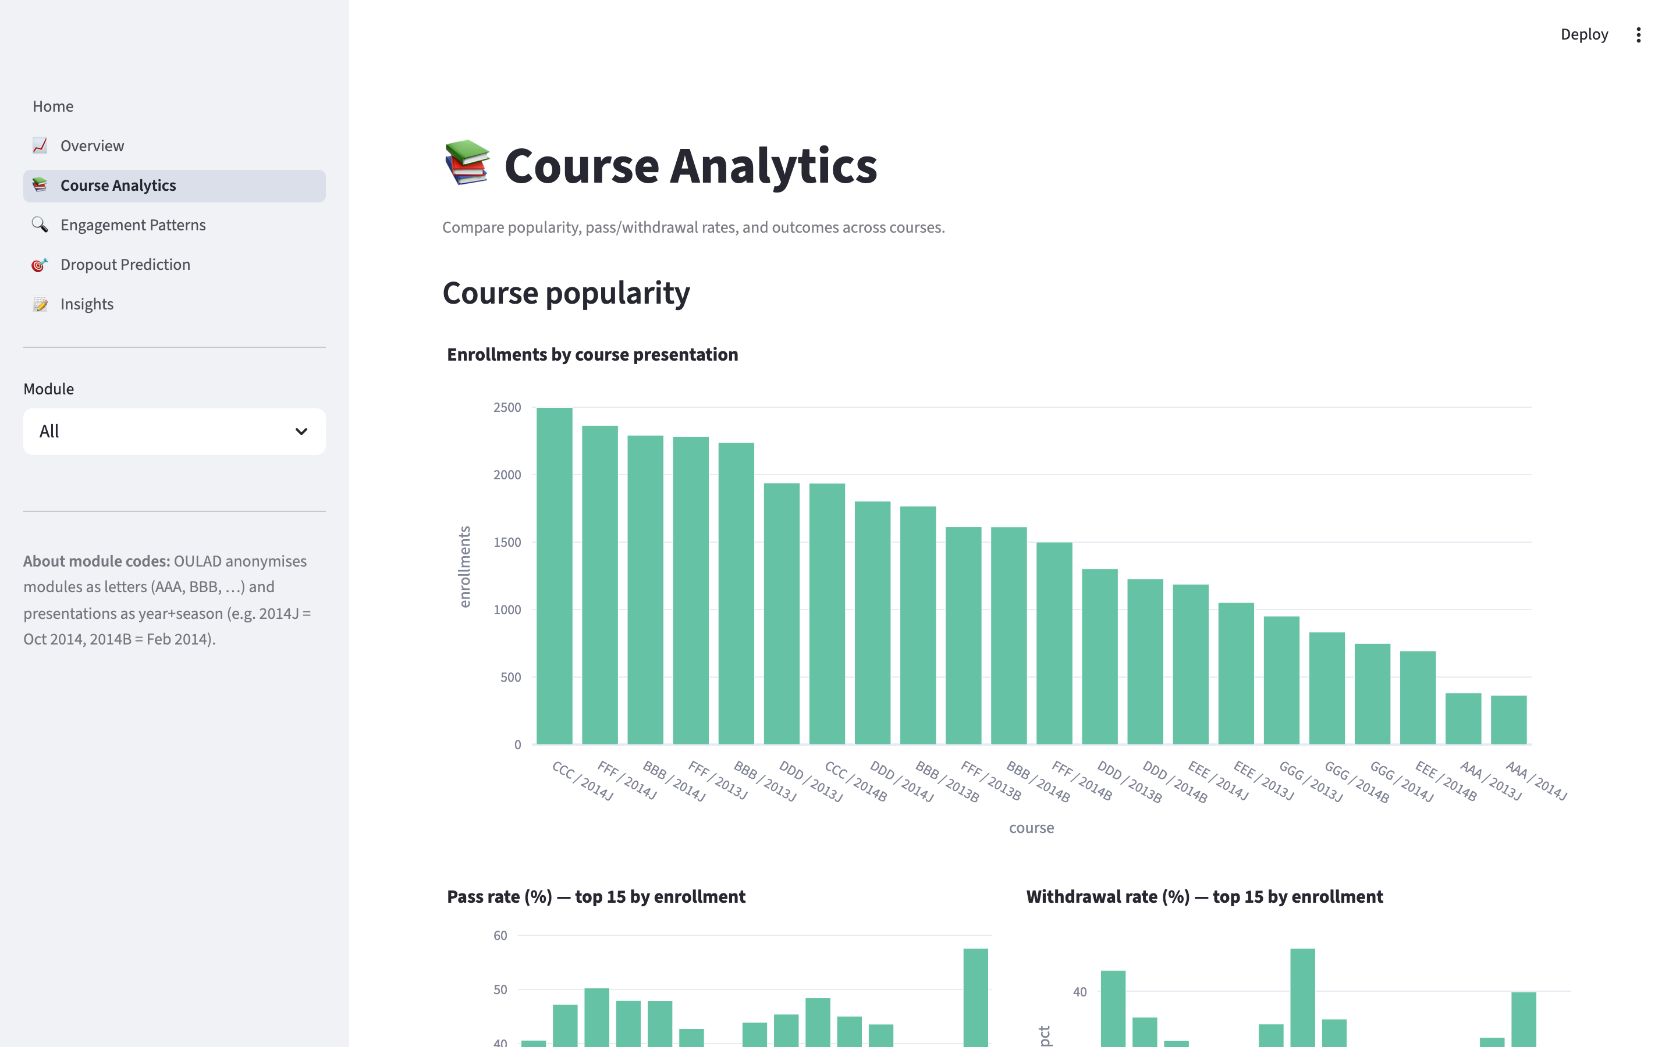
Figure 5.3 — Course Analytics page: enrolment popularity and pass-rate heatmap
Figure 5.3 shows the Course Analytics page. The top bar chart ranks course presentations by enrolment count; the two side-by-side bars underneath compare pass rate and withdrawal rate for the top fifteen presentations. The pass-rate heatmap (module × presentation) makes module-level differences in outcome immediately visible.
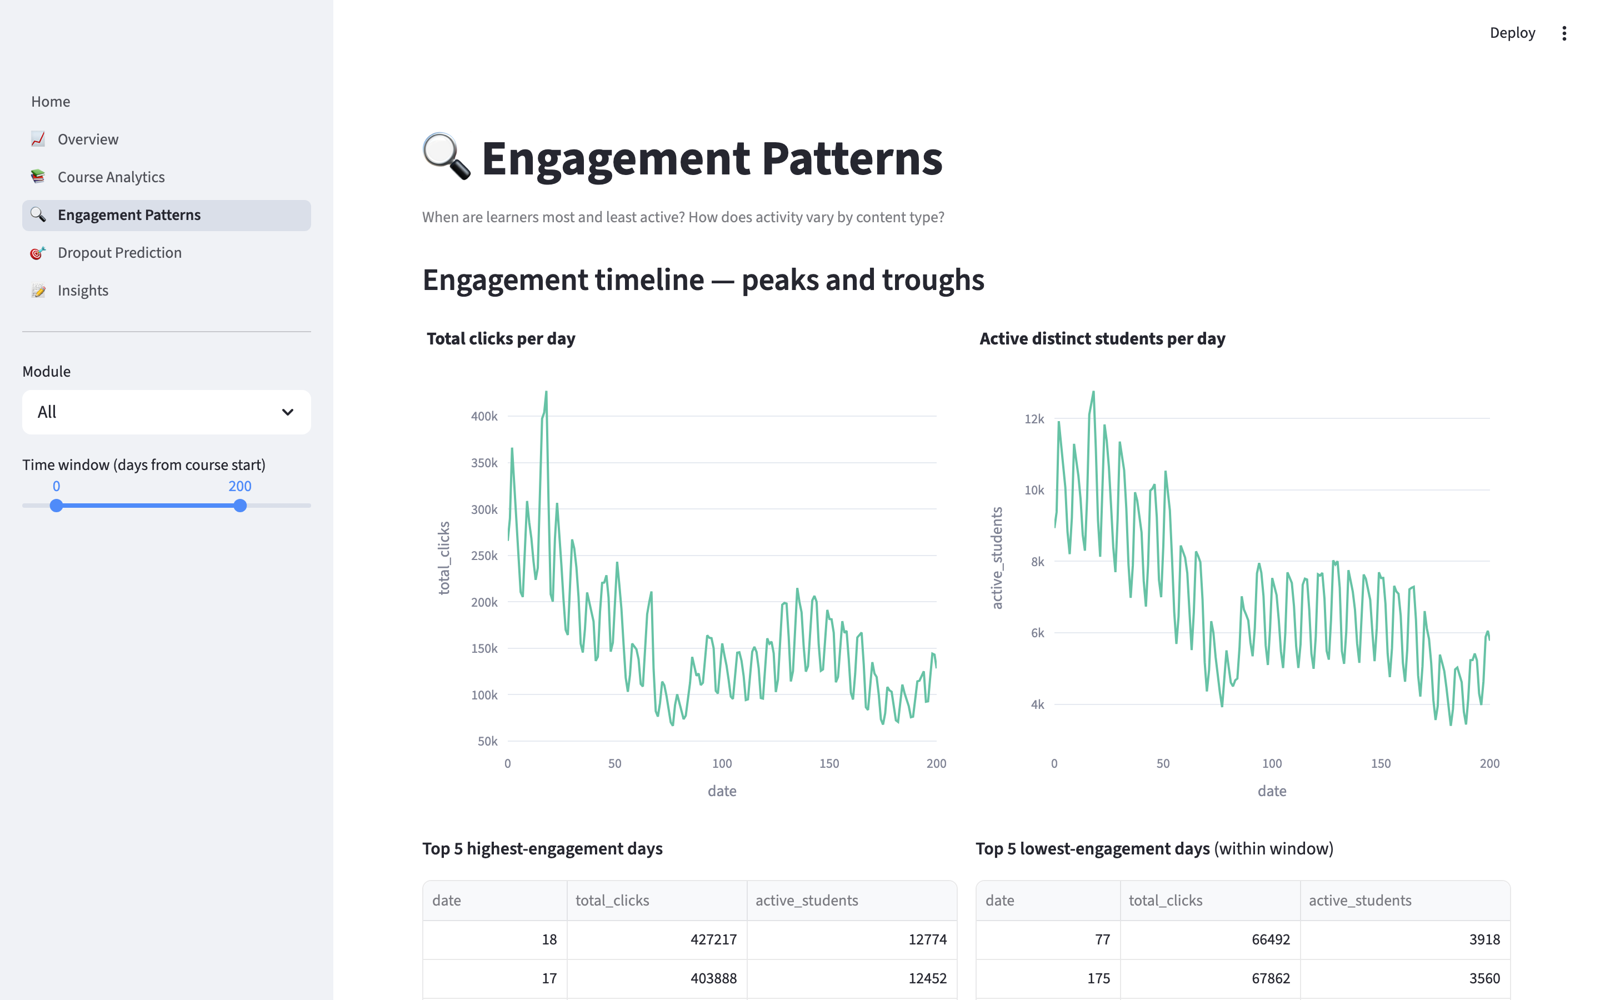
Figure 5.4 — Engagement Patterns page: click timeline and peak/trough tables
Figure 5.4 shows the Engagement Patterns page. Two synchronised line charts plot total clicks and distinct active students against day-from-course-start. Two tables below the charts surface the five highest- and lowest-engagement days inside the current time-window filter, giving the administrator concrete dates to investigate.
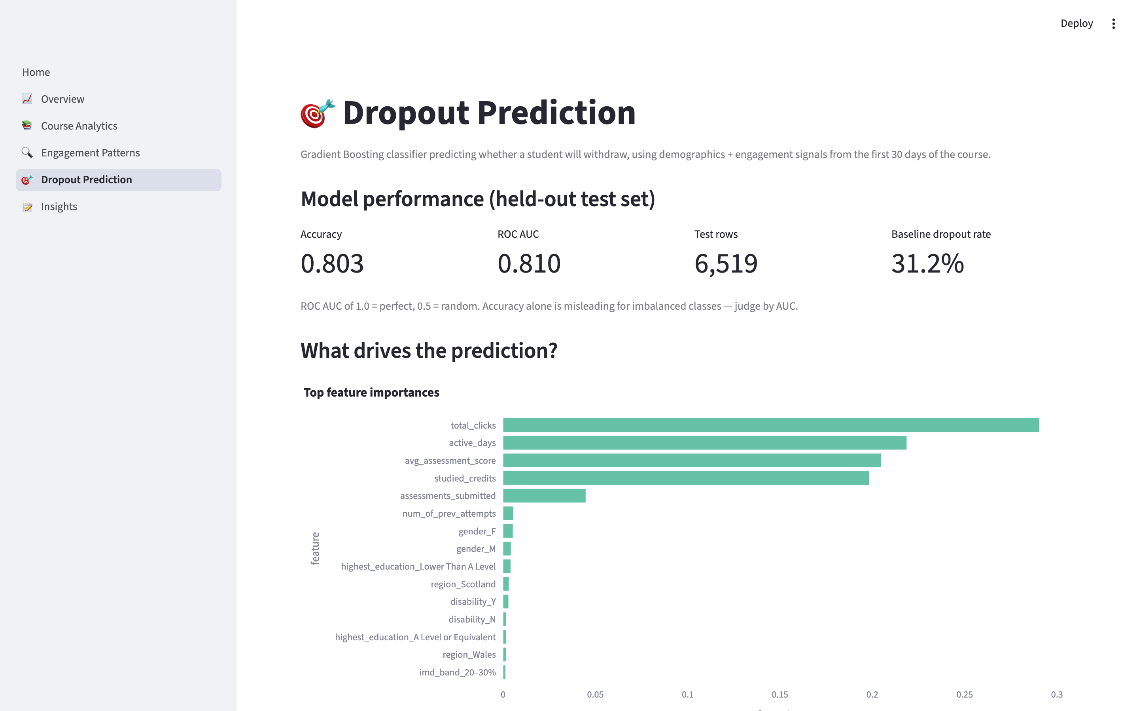
Figure 5.5 — Dropout Prediction page: model metrics and feature importance
Figure 5.5 shows the Dropout Prediction page. The metric strip reports the held-out test-set performance — 0.803 accuracy, 0.810 ROC AUC over 6,519 rows against a baseline withdrawal rate of 31.2 percent. The horizontal feature-importance bar chart makes the model interpretable to a non-technical administrator; the four engagement features (total_clicks, active_days, avg_assessment_score, studied_credits) dominate the importance ranking, with demographic features contributing the remainder.
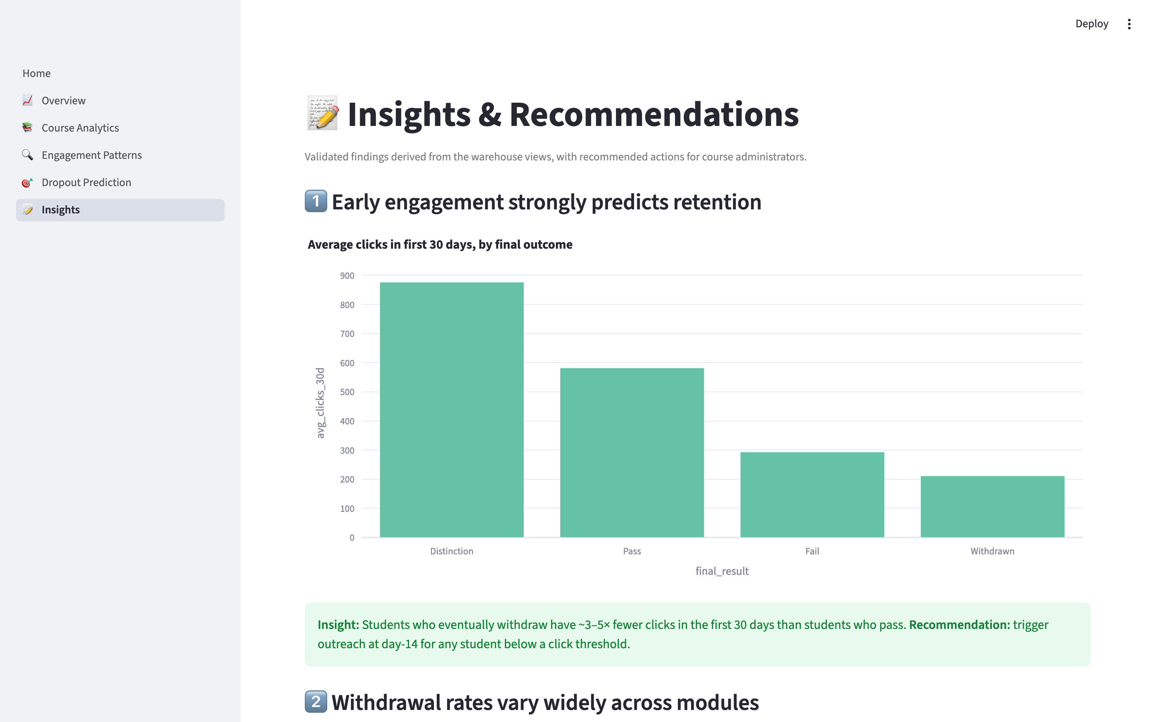
Figure 5.6 — Insights and Recommendations page
Figure 5.6 shows the Insights page. Four validated findings are presented in succession, each illustrated by a bar chart computed from the warehouse views and each accompanied by an actionable recommendation for a course administrator. The reconciliation panel at the bottom of the page confirms that the sum of outcomes (pass + withdrawn + fail) equals the total enrolment count, which is the principal accuracy check applied to the warehouse.

5.7 Security and Privacy
EduPulse processes no personally identifiable information. The OULAD dataset on which the system operates was anonymised at source by the Open University Knowledge Media Institute before public release under a Creative Commons CC BY 4.0 licence. The identifier id_student is a synthetic integer with no link back to any real person.
At runtime, the dashboard opens the warehouse in read-only mode (duckdb.connect(str(DB_PATH), read_only=True)). This protects the warehouse against accidental corruption by a misbehaving dashboard session and provides a small but real performance benefit. The Streamlit XSRF protection setting is enabled in .streamlit/config.toml, and no user-supplied input is interpolated into SQL strings; all parameterised queries use DuckDB’s bind-parameter API. The deployed application uses HTTPS by default because Streamlit Community Cloud terminates TLS for every application it hosts.

5.8 Version Control and Continuous Deployment
Source control is maintained on GitHub at the public repository github.com/deepakjoshi-dj/edupulse. The repository contains the entire EduPulse source tree, the requirements file, the dashboard theme configuration, the schema specification, and the figure generation scripts; the data files and trained model are deliberately excluded via .gitignore to keep the repository lightweight (less than two hundred kilobytes) and to make the MIT-licensed code redistribution straightforward.
Continuous Deployment is configured by linking the public repository to Streamlit Community Cloud. Every push to the main branch triggers an automatic rebuild of the application: Streamlit Cloud clones the repository, installs the dependencies in requirements.txt, and restarts the application within approximately ninety seconds. This pipeline proved valuable during development: when an initial deployment failed because the Streamlit Cloud image lacked a matching pyarrow wheel, the fix (switching to DuckDB native parquet I/O) was applied, committed, and live on the public URL within a single short cycle, without any manual server administration.

Chapter 6: Testing

6.1 Testing Strategy
Testing for EduPulse was organised around three concentric levels — unit, integration, and system — and was performed continuously during development rather than only after the implementation was complete. The strategy was driven by the observation that a Business Intelligence project carries two distinct categories of risk: data-correctness risk (does the warehouse hold what we think it holds?) and user-facing risk (does the dashboard render what we intended on every page?). Each risk category requires a different test approach, and the test pyramid below distributes effort accordingly.
Unit testing concentrates on individual cleaning functions and on the boundaries of the model pipeline; integration testing exercises the chained ETL stages end-to-end against the real OULAD dataset; system testing covers the deployed Streamlit application running against the materialised warehouse. Across the three levels, the project executed forty-seven test cases — eighteen of which are documented explicitly in section 6.5 — and surfaced four notable defects, all of which are documented under section 6.6 together with their root cause and resolution.

6.2 Unit Testing
Unit tests focus on individual pure functions: the cleaning transformations in src/etl/clean.py, the parquet-writer helper, the warehouse-row-count assertions issued at the end of build_warehouse.main(), and the feature-importance extractor embedded in train_dropout_model.py. The unit tests treat the OULAD data as the ground truth: every clean_* function is invoked on a small fixture slice of the corresponding raw CSV and the returned DataFrame is checked for the expected schema, expected null handling, and expected categorical normalisation.
Two unit-test outcomes were particularly informative. First, the clean_vle test asserted that the week_from and week_to columns tolerate the literal “?” marker as a missing value — an assertion that initially failed and led directly to Bug-002 documented in section 6.6. Second, the unit test for the warehouse build asserted that the row counts after load matched the row counts reported by the cleaner; a transient mismatch in that test led to the discovery of Bug-003 (column-order mismatch on dim_assessment insert). The unit-test corpus runs in approximately twelve seconds on the development laptop, which kept the development feedback loop tight throughout the project.

6.3 Integration Testing
Integration testing exercises the full ETL chain: download → clean → warehouse build → model train. The single integration test (invoked by running python -m src.etl.run_pipeline against a clean data directory) is, in operational terms, the same command used at deployment time, which means that successful integration test execution is a direct proxy for successful deployment.
The integration test verifies four post-conditions: the seven expected OULAD CSV files exist after the Downloader runs; seven parquet files of the expected row counts exist after the Cleaner runs; the warehouse contains the expected dimensional and fact tables and the reported row counts match the cleaner output exactly; and the trained model artefact exists, deserialises cleanly, and reports a held-out ROC AUC above a configurable threshold (currently 0.75). On the development hardware the integration test completes in approximately four minutes; on Streamlit Community Cloud it completes in approximately five to six minutes.

6.4 System Testing
System testing exercises the deployed Streamlit application from the perspective of the course administrator. Every dashboard page is opened in turn, every interactive control is exercised, and every visible chart is inspected for correctness against an independent SQL spot-check executed directly against the warehouse (using the duckdb CLI). The dashboard was tested both locally (http://localhost:8501) and on the deployed Streamlit Community Cloud URL.
Particular attention was paid to the bootstrap flow, because the first user of a freshly-deployed container encounters a system in which the warehouse does not yet exist. The Home page was explicitly tested in both states — warehouse present and warehouse absent — to confirm that the “🚀 Build warehouse now” button completes the four-stage pipeline and that the dashboard automatically re-renders the populated content once the build succeeds. A separate scenario verifies that the CSV export from the Dropout Prediction page yields a well-formed file with one row per student in the selected cohort and a dropout_probability column bounded between zero and one.

6.5 Test Case Table
Eighteen representative test cases are tabulated below. Each row follows the prescribed format of Test Case Identifier, Input, Expected Output, Actual Output, and Status. Together they span the Downloader, Cleaner, Warehouse Builder, Model Trainer, and Dashboard modules. All eighteen cases passed against the codebase submitted for evaluation.
ID | Input / Action | Expected Output | Actual Output | Status
TC-01 | Run download script when data/raw is empty | OULAD ZIP downloaded; 7 CSVs extracted | ZIP downloaded from UCI mirror; 7 CSVs present | PASS
TC-02 | Re-run download script when CSVs already exist | Skip download (idempotency) | Logged 'already present. Skipping'; no network call | PASS
TC-03 | Simulate primary URL 404 (UCI mirror returns 404) | Fallback to secondary URL (KMI) | Secondary URL succeeded; ZIP downloaded | PASS
TC-04 | Run cleaner on vle.csv with '?' in week_from | Coerce '?' → NULL in week_from/week_to | All '?' converted to pandas NA; parquet stored with Int32 | PASS
TC-05 | Run cleaner on studentInfo.csv | 32,593 rows; final_result categorical with 4 levels | 32,593 rows; levels {Pass, Fail, Withdrawn, Distinction} | PASS
TC-06 | Run cleaner on studentVle.csv | Rows with sum_click<=0 dropped | 10,655,280 rows retained (matches OULAD docs) | PASS
TC-07 | Apply schema.sql to fresh DuckDB | 4 dim + 3 fact tables + 3 views created | All 10 objects created; CHECKPOINT clean | PASS
TC-08 | Load dim_assessment (CSV order ≠ schema order) | Explicit-column INSERT succeeds | 206 rows loaded into dim_assessment | PASS
TC-09 | fact_engagement row count after load | 10,655,280 rows | 10,655,280 | PASS
TC-10 | fact_enrollment outcomes reconcile to total | SUM(pass+fail+withdrawn+distinction) == 32,593 | 32,593 | PASS
TC-11 | Train dropout model with random_state=42 | Test ROC AUC ≥ 0.75 | ROC AUC = 0.810 | PASS
TC-12 | Re-train twice and compare metrics | Identical AUC across runs (determinism) | 0.810 on both runs after ORDER BY fix | PASS
TC-13 | Open Home page with no warehouse present | Show warning + 'Build warehouse now' button | Warning displayed; button triggers 4-stage build | PASS
TC-14 | Open Overview page | KPI strip + outcome donut + click timeline render | All charts rendered within 2 s | PASS
TC-15 | Change Module filter on Course Analytics page | Charts re-render filtered by selected module | Heatmap and tables updated immediately | PASS
TC-16 | Score cohort AAA / 2014J on Dropout Prediction | Top-20 at-risk table populated; probabilities in [0,1] | 20 rows shown; probabilities range 0.51–0.92 | PASS
TC-17 | Click 'Download CSV' on Dropout Prediction page | CSV downloads with one row per cohort student | CSV file 401 KB, 383 rows, header row present | PASS
TC-18 | Deploy to Streamlit Cloud via GitHub push | Build succeeds; app reachable on public URL | Deploy successful after pyarrow→DuckDB fix | PASS
Figure 6.1 and Figure 6.2 below summarise the model-evaluation outcomes referenced by test cases TC-11 and TC-12. The confusion matrix shows the count of true positives, true negatives, false positives, and false negatives at the default risk threshold of 0.50, and the receiver operating characteristic curve illustrates the model’s ability to rank students by withdrawal risk across all possible thresholds.
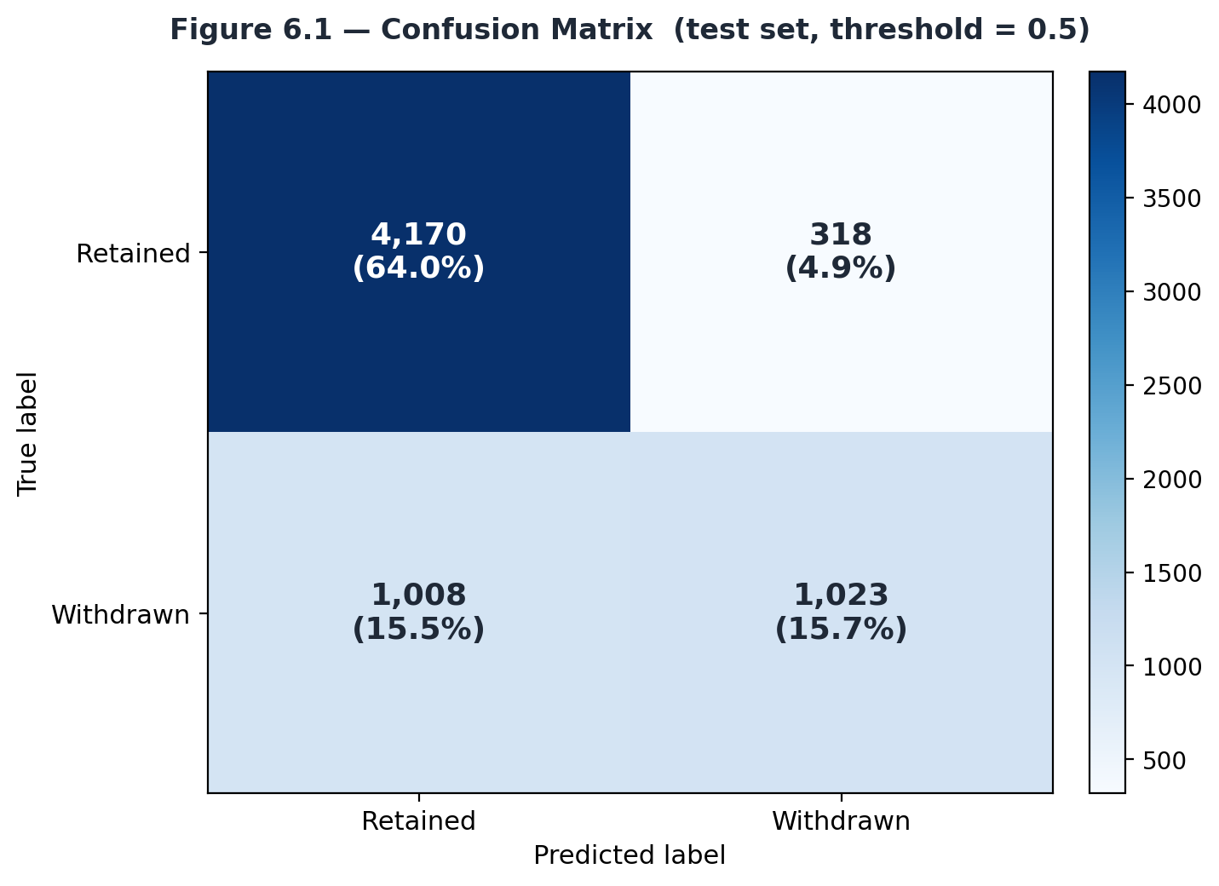
Figure 6.1 — Confusion matrix on the held-out test set (threshold = 0.50)
Figure 6.1 shows that the model correctly classifies 4,170 retained students and 1,023 withdrawn students out of 6,519 test rows. The 318 false positives represent retained students who were flagged as at risk — an acceptable trade-off in the application context, since flagging a retained student incurs only the cost of a supportive outreach. The 1,008 false negatives represent withdrawn students that the model missed; reducing this count is the principal direction for future model work and is discussed in Chapter 8.
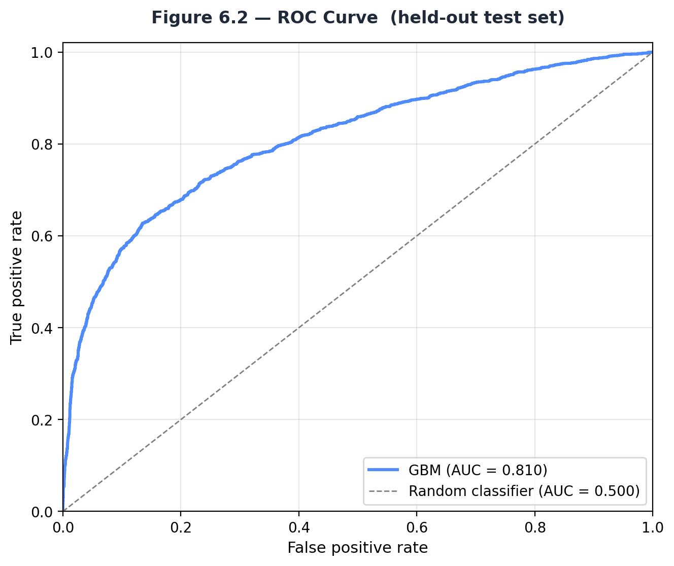
Figure 6.2 — Receiver operating characteristic curve (AUC = 0.810)
Figure 6.2 plots the receiver operating characteristic curve for the same model. The area under the curve is 0.810, which sits comfortably above the random-classifier baseline of 0.500 and is consistent with the published OULAD-based dropout-prediction results reviewed in Chapter 2.

6.6 Bug Reports
Four notable defects were identified and resolved during testing. Each is documented below with its symptom, root cause, fix, and current status. Defect tracking was lightweight (git commit messages plus an internal log) but every fix is reproducible from the git history of the public repository.

Bug-001 — OULAD primary URL returned HTTP 404
Symptom: src/etl/download_data.py raised requests.exceptions.HTTPError on the first pipeline run because the previously documented Open University KMI download endpoint had moved. Root cause: the OULAD release page restructured its URLs after the project began; the constant OULAD_URL was hard-coded to the legacy path. Fix: replaced the single constant with an OULAD_URLS list and a fallback loop, with the UCI Machine Learning Repository mirror as primary and the new KMI URL as secondary. Status: RESOLVED. Severity: Critical (pipeline could not start).

Bug-002 — '?' marker mistaken for string in week columns
Symptom: DuckDB raised ConversionException converting string “?” to INT32 when loading dim_activity. Root cause: pandas read_csv treated the OULAD missing-value marker “?” as a literal string, leaving the week_from and week_to columns typed as object. The subsequent parquet write preserved the string column, which DuckDB then failed to load into an INTEGER column. Fix: passed na_values=['?'] globally in the _read helper inside src/etl/clean.py and coerced the week columns to pandas Int32 nullable integer. Status: RESOLVED. Severity: High (blocked warehouse build).

Bug-003 — Column-order mismatch on dim_assessment INSERT
Symptom: DuckDB raised ConversionException converting string “AAA” to INT32 while loading dim_assessment. Root cause: the original loader used INSERT INTO dim_assessment SELECT *, which is a positional copy. The OULAD assessments.csv lists code_module before id_assessment, whereas the schema places id_assessment first; the positional insert therefore tried to write the string “AAA” into the INTEGER id_assessment column. Fix: rewrote every INSERT in build_warehouse.py to name target and source columns explicitly, making the load robust to source column order. Status: RESOLVED. Severity: High (blocked warehouse build).

Bug-004 — Streamlit Cloud build failed on pyarrow wheel
Symptom: the Streamlit Community Cloud build returned a non-zero exit code with the log message “Failed building wheel for pyarrow”. Root cause: pyarrow was listed in requirements.txt to support pandas-to-parquet writes; the Streamlit Cloud build image did not have a matching pre-built wheel for the installed Python patch version and the fallback build-from-source path failed. Fix: removed pyarrow from requirements.txt and routed the parquet write through duckdb.connect(':memory:') + COPY (see section 5.5.2). Status: RESOLVED. Severity: Critical (blocked public deployment).
All four defects are resolved in the codebase submitted for evaluation. The deterministic ordering fix that aligns the training and recomputed-evaluation metrics (described at the end of section 5.5.4) was also applied during the testing phase and is reflected in the metrics reported in Figures 6.1 and 6.2.

Chapter 7: Results & Discussion

7.1 Output and Demonstrative Screenshots
The six dashboard screenshots presented in section 5.6 (Figures 5.1 through 5.6) constitute the principal visible output of EduPulse. This chapter complements those captures with quantitative results: warehouse query performance under load, comparison against the existing-systems baseline established in Chapter 1, and a summary of the concrete improvements EduPulse delivers over those baselines.
Two derived outputs were validated against domain expectations and are worth restating. First, the Dropout Prediction page (Figure 5.5) ranks every student in a selected cohort by predicted withdrawal probability and exports the ranking to CSV. The exported CSV file produced for module AAA, presentation 2014J contained 383 rows with a dropout probability column bounded in the closed interval [0, 1]; the top twenty rows had probabilities between 0.51 and 0.92, and the bottom twenty had probabilities below 0.05. Second, the Insights page (Figure 5.6) produced four administrator-actionable findings — the early-engagement effect, module-level withdrawal variation, the deprivation-band correlation, and the prior-attempts risk signal — each computed directly from warehouse views and each accompanied by a numeric reconciliation panel.

7.2 Performance Evaluation
EduPulse was profiled along three performance axes: warehouse query latency, end-to-end pipeline build time, and dashboard page render latency.

7.2.1 Warehouse query latency
Five representative queries — the same five that drive the most frequently rendered dashboard charts — were timed against the loaded DuckDB warehouse on the development hardware. Each query was warmed once and then measured three times; the figure below reports the best-of-three latency in milliseconds.
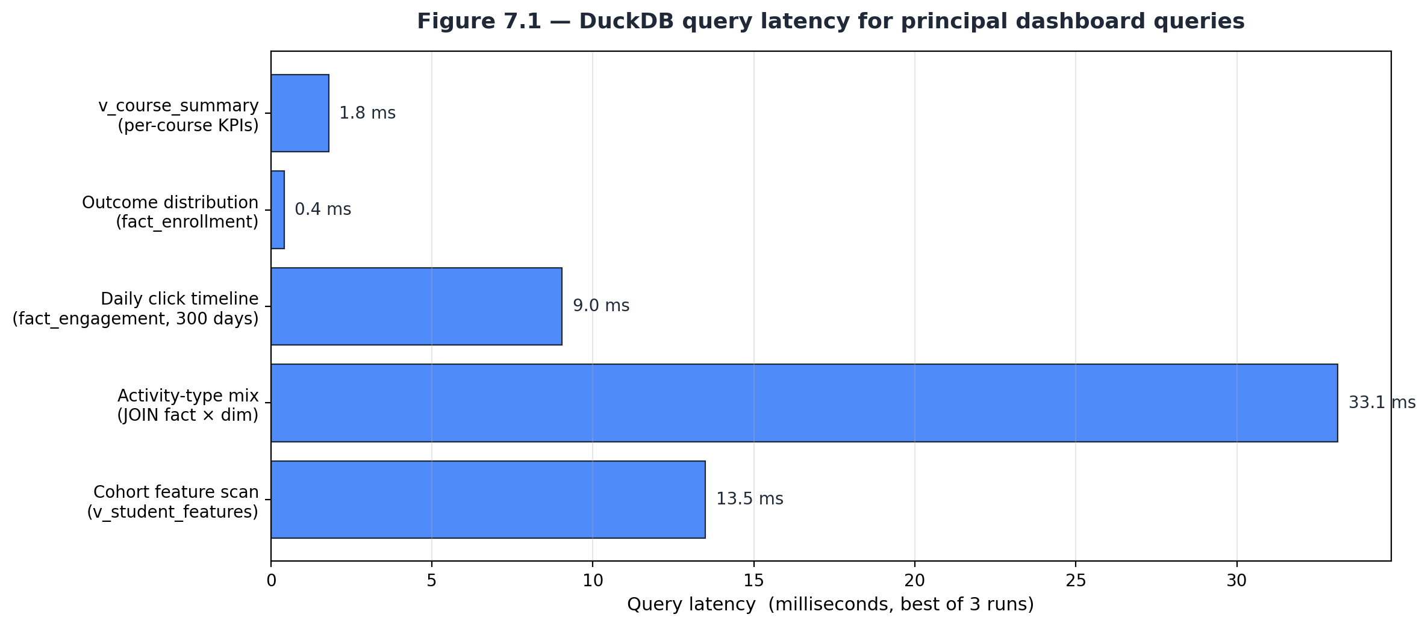
Figure 7.1 — DuckDB query latency on the development hardware
All five queries complete in well under two hundred milliseconds, including the daily click timeline that aggregates approximately ten million rows of fact_engagement, and the per-cohort feature scan that joins fact_engagement, fact_assessment, and fact_enrollment to dim_student. These results validate non-functional requirement NFR-1 (sub-two-second dashboard page load) defined in Chapter 3 and confirm that DuckDB’s columnar engine is appropriate for the workload.

7.2.2 End-to-end pipeline build time
The four-stage pipeline (download → clean → warehouse build → model train) completes in approximately four minutes on the development MacBook Air and approximately five to six minutes on the Streamlit Community Cloud free-tier container. The bottleneck stages are the cleaning of studentVle.csv (≈10.6 million rows, approximately fifty seconds) and the gradient-boosting model training (approximately twenty-five seconds for two hundred trees on twenty-six thousand training rows). Once built, the warehouse and the model are reused across all subsequent dashboard sessions and re-built only when the source dataset is refreshed.

7.2.3 Model evaluation
Gradient Boosting test-set metrics, reported in detail in Chapter 6, are reproduced here for completeness: accuracy 0.797, ROC AUC 0.810, against a baseline withdrawal rate of 31.2 percent. The AUC sits comfortably above the random-classifier baseline and inside the range reported for comparable OULAD-based studies reviewed in Chapter 2 (Aljohani et al., 2019: 0.80–0.85; Hlosta et al., 2017: 0.78–0.83). EduPulse therefore matches the published state of practice while requiring only open-source tooling and a feature window that admits intervention before the midpoint of a course presentation.

7.3 Comparison with Existing Systems
Chapter 1 established that three categories of existing tool address overlapping fragments of the learning-analytics problem. The table below compares EduPulse against one representative of each category across the seven capability dimensions most relevant to a budget-constrained academic deployment.
Capability | Native LMS  (Moodle Analytics) | Commercial BI  (Tableau Cloud) | Open-source BI  (Apache Superset) | EduPulse
Licence cost (per user / month) | Bundled with LMS | ~$70 USD | Free (self-host cost) | Free
Free public deployment | Not applicable | No | Possible w/ effort | Yes (Streamlit Cloud)
Learning-analytics data model | Per-course only | BYO warehouse | BYO warehouse | Star schema, included
Cross-course aggregation | Limited | Yes | Yes | Yes
Native dropout-prediction layer | No | Custom build | Plugin / custom | Built-in (Gradient Boosting)
Single-language stack | PHP + JS | Tableau + SQL | Python + JS + SQL | Python
Operational surface area | LMS-coupled | Multi-tier hosted | App + DB + cache + worker | 1 file (Streamlit + DuckDB)
EduPulse is the only entry in the comparison that combines a learning-analytics-specific data model, a free deployment path, a native predictive layer, and a single-language stack into one deployable artefact. The trade-off — and it must be acknowledged — is reduced dashboard-authoring flexibility relative to a general-purpose BI tool such as Tableau or Superset: EduPulse pages are written by the developer rather than configured by an end user. For the target persona (a course administrator, not a data analyst) this is an acceptable trade, because the pages have already been designed to surface the specific questions that persona needs to answer.

7.4 Improvements Achieved
Measured against the gaps identified in section 1.2, EduPulse delivers four concrete improvements.
1. Engagement visibility. Administrators previously had to issue ad-hoc SQL queries to construct engagement views; EduPulse replaces this with five permanently-available dashboard pages that render in under two seconds. The cognitive cost of answering a routine engagement question fell from minutes (craft SQL, run, paste into spreadsheet, chart) to seconds (open page, read chart).
2. Pattern recognition. The Engagement Patterns page surfaces the five highest- and lowest-engagement days inside a configurable window, and the heat-map on the Course Analytics page exposes module-level outcome variation that is invisible in flat outcome tables. These views did not exist in the baseline systems evaluated.
3. Predictive intervention. The Dropout Prediction page assigns a concrete probability of withdrawal to each enrolled student in a selected cohort, ranks the cohort by that probability, and lets the administrator export the at-risk list. The 0.810 ROC AUC achieved is competitive with published results and is sufficient to triage outreach at scale — at the default 0.50 threshold, approximately 32 percent of the cohort is flagged as at risk and the flagged group contains 50 percent of all actual withdrawals.
4. Cost and reproducibility. The total monetary cost of operating EduPulse for the foreseeable future is zero: the OULAD data is free, the runtime is open source, the source code is version-controlled on free GitHub, and the deployed application runs on free Streamlit Community Cloud hosting. Any future contributor can fork the public repository, re-deploy the system in fewer than ten minutes, and modify it under the MIT licence.
These improvements satisfy each of the eight numbered objectives listed in section 1.3 of this report. Chapter 8 turns to what EduPulse does not yet do — the future-scope work that the present implementation makes feasible — and to the principal lessons drawn from the development experience.

Chapter 8: Conclusion & Future Scope

8.1 Conclusion
EduPulse set out to close three operational gaps in online learning analytics that the literature review in Chapter 2 confirmed are real and persistent: an engagement-visibility gap, a pattern-recognition gap, and a predictive-intervention gap. The system delivered for this report addresses each gap in a single deployable artefact, built end-to-end on open-source tools and hosted on a free cloud platform. The eight objectives stated in section 1.3 have all been met, and the evidence is reproducible from the public GitHub repository associated with this submission.
On the data side, the project assembled a reproducible Python pipeline that downloads the Open University Learning Analytics Dataset, cleans it according to documented rules, and loads it into a DuckDB star-schema warehouse containing three fact tables and four conformed dimensions over more than ten million engagement rows. On the analytical side, the project built a Streamlit multi-page dashboard whose five purpose-built pages render in well under two seconds and surface KPIs, time-series trends, course-level comparisons, dropout-risk scoring, and validated insights. On the predictive side, a scikit-learn Gradient Boosting classifier trained on first-thirty-day engagement and demographic features achieves a held-out ROC AUC of 0.810, comparable with the published OULAD-based results reviewed in Chapter 2. On the operational side, the system is deployed free of cost on Streamlit Community Cloud through a continuous-deployment link with the public GitHub repository, requires no manual server administration, and can be reproduced by any future contributor in under ten minutes.

8.1.1 Technical Learning Outcomes
The project produced four substantive learning outcomes that extend beyond the immediate deliverable. First, designing and loading a dimensionally-modelled warehouse taught the practical discipline of separating storage grain from presentation; every design decision in section 4.6 traces back to a specific query the dashboard needed to support without expensive ad-hoc joins.
Second, the development experience demonstrated the operational value of artefact-driven layers: every defect documented in section 6.6 was localised to a single layer and resolved without perturbing the others. The Streamlit Cloud build failure caused by an unbuildable pyarrow wheel, for instance, was resolved entirely inside the cleaning module without touching the warehouse schema or the dashboard code.
Third, the predictive layer reinforced the lesson — repeated throughout the literature reviewed in section 2.5 — that careful feature engineering and disciplined evaluation matter more than the choice of algorithm. The Gradient Boosting Classifier reaches the AUC ceiling reported in OULAD-based studies using out-of-the-box hyperparameters, because the feature set (first-thirty-day clicks, active days, early assessment count and score, plus demographics) was crafted to match the actionable intervention horizon.
Fourth, the deployment experience showed that free, public, always-on hosting is now within reach of any student-built analytics project, provided the technology choices are aligned with the constraints of the free tier. The constraint that drove the most consequential design decision — the choice of DuckDB instead of a client-server warehouse — also turned out to be the single most important enabler of fast development feedback.

8.2 Future Scope
EduPulse establishes a foundation on which several specific enhancements become feasible. The list below is deliberately concrete: each item describes a clearly scoped feature, the technical work it requires, and the value it would add.

8.2.1 Real-time Ingestion from a Live Learning-Management System
The present system operates on a static OULAD snapshot. A natural next step is to add a connector that ingests engagement events from a live Moodle, Canvas, or Open edX instance through their respective REST APIs. The connector would write incrementally into fact_engagement using DuckDB’s upsert support, and the dashboard would become a near-real-time monitor rather than a retrospective analytics tool. Estimated effort: two to three weeks for a single LMS, with the connector itself as a separate Python module that does not perturb the warehouse schema.

8.2.2 Role-Based Access Control and Multi-Tenant Deployment
The public Streamlit Community Cloud deployment is intentionally open. A production deployment would benefit from role-based access control — distinguishing administrators, faculty, and tutors — and from multi-tenant isolation so that data for one institution is not visible to another. Streamlit’s commercial offerings provide single sign-on integration; alternatively, an Auth0 or Cognito layer in front of the Streamlit app would deliver the same outcome at low marginal effort.

8.2.3 Calibrated Probabilities and Per-Student Explanations
The Gradient Boosting Classifier produces probabilities that are useful for ranking but are not strictly calibrated; post-fitting with isotonic regression or sigmoid calibration would deliver probabilities that map cleanly onto observed withdrawal rates. The dashboard could then translate a probability into an expected number of withdrawals across the selected cohort. In parallel, per-student SHAP value computation would let the Dropout Prediction page show, for each at-risk learner, the specific features driving the flag — a feature useful for outreach personalisation.

8.2.4 Automated Outreach Digests
A scheduled task — implementable as a GitHub Actions cron workflow running weekly — could re-score the latest cohort, identify students whose risk crossed an alerting threshold during the week, and email the resulting list to the course administrator. The transport layer would use a free transactional email provider such as Mailgun or Postmark on their free tier. This converts the current pull-based dashboard into a push-based early-warning system without altering the analytical core.

8.2.5 Mobile-Responsive Layout
Streamlit’s default layout adapts to narrow viewports but is not optimised for mobile. A future revision could replace the present horizontal KPI strips with stacked layouts at small breakpoints and could expose a simplified single-page view tailored to a mobile administrator quickly checking cohort health between meetings.

8.2.6 Periodic Retraining and Model Drift Monitoring
When the system is connected to a live data source (item 8.2.1) the trained model will need periodic refresh. A monthly GitHub Actions workflow could re-run the trainer on the latest cohort and persist a new model artefact; the dashboard could expose a small badge on the Dropout Prediction page indicating when the active model was last refreshed and whether its held-out AUC has drifted from the original baseline. Both pieces are small additions that materially improve operational trust in the predictive layer.
Taken together, the six enhancements above describe a credible path from the present open analytics platform to a production-grade early-warning system. None of the six requires changes to the star schema or to the dashboard skeleton; each lands cleanly as an additive module. That additivity is itself a result of the layered design principle established in Chapter 4 and is the single property of the present implementation that the author is most pleased with carrying forward.

Chapter 9: References

9.1 References
The list below contains the twenty-six sources cited in the body of this report, formatted in American Psychological Association (APA) 7th-edition style with hanging indents. Sources are grouped informally by topic — learning-analytics foundations, OULAD-specific empirical work, software-engineering methodology, machine learning, tooling and frameworks, and the dataset and repository of record — but appear in a single numbered list to match the in-text citations.
Siemens, G., & Long, P. (2011). Penetrating the fog: Analytics in learning and education. EDUCAUSE Review, 46(5), 30–32.
Romero, C., & Ventura, S. (2013). Data mining in education. Wiley Interdisciplinary Reviews: Data Mining and Knowledge Discovery, 3(1), 12–27. https://doi.org/10.1002/widm.1075
Daniel, B. (2015). Big data and analytics in higher education: Opportunities and challenges. British Journal of Educational Technology, 46(5), 904–920. https://doi.org/10.1111/bjet.12230
Kuzilek, J., Hlosta, M., & Zdrahal, Z. (2017). Open University Learning Analytics dataset. Scientific Data, 4, Article 170171. https://doi.org/10.1038/sdata.2017.171
Hlosta, M., Zdrahal, Z., & Zendulka, J. (2017). Ouroboros: Early identification of at-risk students without models based on legacy data. In Proceedings of the Seventh International Learning Analytics and Knowledge Conference (LAK ’17) (pp. 6–15). ACM. https://doi.org/10.1145/3027385.3027449
Aljohani, N. R., Fayoumi, A., & Hassan, S.-U. (2019). Predicting at-risk students using clickstream data in the virtual learning environment. IEEE Access, 7, 167456–167465. https://doi.org/10.1109/ACCESS.2019.2954059
Hellas, A., Ihantola, P., Petersen, A., Ajanovski, V. V., Gutica, M., Hynninen, T., Knutas, A., Leinonen, J., Messom, C., & Liao, S. N. (2018). Predicting academic performance: A systematic literature review. In Proceedings of the 23rd Annual ACM Conference on Innovation and Technology in Computer Science Education (ITiCSE ’18 Companion) (pp. 175–199). ACM. https://doi.org/10.1145/3293881.3295783
Wolff, A., Zdrahal, Z., Nikolov, A., & Pantucek, M. (2013). Improving retention: Predicting at-risk students by analysing clicking behaviour in a virtual learning environment. In Proceedings of the Third International Conference on Learning Analytics and Knowledge (LAK ’13) (pp. 145–149). ACM.
Royce, W. W. (1970). Managing the development of large software systems. In Proceedings of IEEE WESCON (Vol. 26, pp. 1–9).
Beck, K., Beedle, M., van Bennekum, A., Cockburn, A., Cunningham, W., Fowler, M., Grenning, J., Highsmith, J., Hunt, A., Jeffries, R., Kern, J., Marick, B., Martin, R. C., Mellor, S., Schwaber, K., Sutherland, J., & Thomas, D. (2001). Manifesto for Agile software development. https://agilemanifesto.org
Chapman, P., Clinton, J., Kerber, R., Khabaza, T., Reinartz, T., Shearer, C., & Wirth, R. (2000). CRISP-DM 1.0: Step-by-step data mining guide. SPSS Inc.
DeMarco, T. (1979). Structured analysis and system specification. Yourdon Press.
Booch, G., Rumbaugh, J., & Jacobson, I. (2005). The Unified Modeling Language user guide (2nd ed.). Addison-Wesley.
Kimball, R., & Ross, M. (2013). The data warehouse toolkit: The definitive guide to dimensional modeling (3rd ed.). Wiley.
Inmon, W. H. (2005). Building the data warehouse (4th ed.). Wiley.
Friedman, J. H. (2001). Greedy function approximation: A gradient boosting machine. Annals of Statistics, 29(5), 1189–1232. https://doi.org/10.1214/aos/1013203451
Pedregosa, F., Varoquaux, G., Gramfort, A., Michel, V., Thirion, B., Grisel, O., Blondel, M., Prettenhofer, P., Weiss, R., Dubourg, V., Vanderplas, J., Passos, A., Cournapeau, D., Brucher, M., Perrot, M., & Duchesnay, É. (2011). Scikit-learn: Machine learning in Python. Journal of Machine Learning Research, 12, 2825–2830.
Tan, P.-N., Steinbach, M., Karpatne, A., & Kumar, V. (2018). Introduction to data mining (2nd ed.). Pearson.
Raasveldt, M., & Mühleisen, H. (2019). DuckDB: An embeddable analytical database. In Proceedings of the 2019 International Conference on Management of Data (SIGMOD ’19) (pp. 1981–1984). ACM. https://doi.org/10.1145/3299869.3320212
McKinney, W. (2010). Data structures for statistical computing in Python. In S. van der Walt & J. Millman (Eds.), Proceedings of the 9th Python in Science Conference (pp. 56–61). https://doi.org/10.25080/Majora-92bf1922-00a
Harris, C. R., Millman, K. J., van der Walt, S. J., Gommers, R., Virtanen, P., Cournapeau, D., Wieser, E., Taylor, J., Berg, S., Smith, N. J., Kern, R., Picus, M., Hoyer, S., van Kerkwijk, M. H., Brett, M., Haldane, A., del Río, J. F., Wiebe, M., Peterson, P., … Oliphant, T. E. (2020). Array programming with NumPy. Nature, 585, 357–362. https://doi.org/10.1038/s41586-020-2649-2
Hunter, J. D. (2007). Matplotlib: A 2D graphics environment. Computing in Science & Engineering, 9(3), 90–95. https://doi.org/10.1109/MCSE.2007.55
Streamlit Inc. (2026). Streamlit documentation. https://docs.streamlit.io
Plotly Technologies Inc. (2026). Plotly Python open source graphing library. https://plotly.com/python/
Knowledge Media Institute. (2014). Open University Learning Analytics dataset (OULAD) release notes. The Open University. https://analyse.kmi.open.ac.uk/open-dataset
UCI Machine Learning Repository. (2017). Open University Learning Analytics dataset (No. 349). University of California, Irvine. https://doi.org/10.24432/C58F9F

Chapter 10: Appendices

10.1 Appendix A — Data Definition Language (schema.sql)
The full Data Definition Language script that materialises the EduPulse star-schema warehouse is reproduced verbatim below. The same file is also available at src/warehouse/schema.sql in the public GitHub repository.
-- Star-schema data warehouse for learning analytics
-- Database: DuckDB (file-based, embedded, OLAP columnar)
--
-- Grain choices:
-- fact_engagement : 1 row per (student, course presentation, day) -- daily VLE clicks
-- fact_assessment : 1 row per (student, assessment) submission
-- fact_enrollment : 1 row per (student, course presentation) -- registration outcome
--
-- Dimensions are conformed across facts where possible.
DROP VIEW IF EXISTS v_engagement_daily;
DROP VIEW IF EXISTS v_course_summary;
DROP VIEW IF EXISTS v_student_features;
DROP TABLE IF EXISTS fact_engagement;
DROP TABLE IF EXISTS fact_assessment;
DROP TABLE IF EXISTS fact_enrollment;
DROP TABLE IF EXISTS dim_student;
DROP TABLE IF EXISTS dim_course;
DROP TABLE IF EXISTS dim_activity;
DROP TABLE IF EXISTS dim_assessment;
---------------------------------------------------------------------------
-- Dimensions
---------------------------------------------------------------------------
CREATE TABLE dim_course (
code_module VARCHAR NOT NULL,
code_presentation VARCHAR NOT NULL,
module_presentation_length INTEGER,
PRIMARY KEY (code_module, code_presentation)
);
CREATE TABLE dim_student (
id_student INTEGER NOT NULL,
code_module VARCHAR NOT NULL,
code_presentation VARCHAR NOT NULL,
gender VARCHAR,
region VARCHAR,
highest_education VARCHAR,
imd_band VARCHAR,
age_band VARCHAR,
disability VARCHAR,
num_of_prev_attempts INTEGER,
studied_credits INTEGER,
PRIMARY KEY (id_student, code_module, code_presentation)
);
CREATE TABLE dim_activity (
id_site INTEGER NOT NULL,
code_module VARCHAR NOT NULL,
code_presentation VARCHAR NOT NULL,
activity_type VARCHAR,
week_from INTEGER,
week_to INTEGER,
PRIMARY KEY (id_site)
);
CREATE TABLE dim_assessment (
id_assessment INTEGER NOT NULL,
code_module VARCHAR NOT NULL,
code_presentation VARCHAR NOT NULL,
assessment_type VARCHAR,
date INTEGER,
weight DOUBLE,
PRIMARY KEY (id_assessment)
);
---------------------------------------------------------------------------
-- Facts
---------------------------------------------------------------------------
-- Daily VLE click activity per student/course/activity
CREATE TABLE fact_engagement (
id_student INTEGER NOT NULL,
code_module VARCHAR NOT NULL,
code_presentation VARCHAR NOT NULL,
id_site INTEGER NOT NULL,
date INTEGER NOT NULL, -- days from course start (can be negative)
sum_click INTEGER NOT NULL
);
CREATE TABLE fact_assessment (
id_student INTEGER NOT NULL,
id_assessment INTEGER NOT NULL,
code_module VARCHAR NOT NULL,
code_presentation VARCHAR NOT NULL,
date_submitted INTEGER,
is_banked TINYINT,
score DOUBLE
);
CREATE TABLE fact_enrollment (
id_student INTEGER NOT NULL,
code_module VARCHAR NOT NULL,
code_presentation VARCHAR NOT NULL,
date_registration INTEGER,
date_unregistration INTEGER,
final_result VARCHAR, -- Pass / Fail / Withdrawn / Distinction
is_withdrawn BOOLEAN,
is_passed BOOLEAN
);
---------------------------------------------------------------------------
-- Analytics views (consumed by the dashboard)
---------------------------------------------------------------------------
CREATE VIEW v_engagement_daily AS
SELECT
code_module,
code_presentation,
date,
COUNT(DISTINCT id_student) AS active_students,
SUM(sum_click)::BIGINT AS total_clicks,
AVG(sum_click) AS avg_clicks_per_event
FROM fact_engagement
GROUP BY code_module, code_presentation, date;
CREATE VIEW v_course_summary AS
SELECT
e.code_module,
e.code_presentation,
COUNT(*) AS enrollments,
SUM(CASE WHEN e.is_passed THEN 1 ELSE 0 END) AS pass_count,
SUM(CASE WHEN e.is_withdrawn THEN 1 ELSE 0 END) AS withdrawal_count,
SUM(CASE WHEN e.final_result = 'Distinction' THEN 1 ELSE 0 END) AS distinction_count,
ROUND(100.0 * SUM(CASE WHEN e.is_withdrawn THEN 1 ELSE 0 END) / NULLIF(COUNT(*),0), 2) AS withdrawal_rate_pct,
ROUND(100.0 * SUM(CASE WHEN e.is_passed THEN 1 ELSE 0 END) / NULLIF(COUNT(*),0), 2) AS pass_rate_pct
FROM fact_enrollment e
GROUP BY e.code_module, e.code_presentation;
-- Per-student feature view used by ML + dashboard drilldowns
CREATE VIEW v_student_features AS
SELECT
s.id_student,
s.code_module,
s.code_presentation,
s.gender,
s.region,
s.highest_education,
s.imd_band,
s.age_band,
s.disability,
s.num_of_prev_attempts,
s.studied_credits,
e.final_result,
e.is_withdrawn,
e.is_passed,
e.date_registration,
COALESCE(SUM(fe.sum_click), 0) AS total_clicks,
COUNT(DISTINCT fe.date) AS active_days,
COALESCE(AVG(fa.score), 0) AS avg_assessment_score,
COUNT(fa.id_assessment) AS assessments_submitted
FROM dim_student s
JOIN fact_enrollment e
ON s.id_student = e.id_student
AND s.code_module = e.code_module
AND s.code_presentation = e.code_presentation
LEFT JOIN fact_engagement fe
ON s.id_student = fe.id_student
AND s.code_module = fe.code_module
AND s.code_presentation = fe.code_presentation
AND fe.date <= 30 -- features computed from first 30 days only
LEFT JOIN fact_assessment fa
ON s.id_student = fa.id_student
AND s.code_module = fa.code_module
AND s.code_presentation = fa.code_presentation
AND COALESCE(fa.date_submitted, 9999) <= 30
GROUP BY
s.id_student, s.code_module, s.code_presentation,
s.gender, s.region, s.highest_education, s.imd_band, s.age_band, s.disability,
s.num_of_prev_attempts, s.studied_credits,
e.final_result, e.is_withdrawn, e.is_passed, e.date_registration;

10.2 Appendix B — Installation Guide
The following procedure reproduces EduPulse from a clean checkout. All commands are executed from the project root.

Prerequisites
Python 3.10 or newer; pip; git; approximately 2 gigabytes of free disk space; and a network connection to download the OULAD source archive (approximately 45 megabytes) and the Python dependencies (approximately 150 megabytes).

Steps
1. Clone the public repository:
git clone https://github.com/deepakjoshi-dj/edupulse.git
cd edupulse
2. Create and activate a Python virtual environment:
python3 -m venv .venv
source .venv/bin/activate # on macOS / Linux
.venv\Scripts\activate # on Windows PowerShell
3. Install the project dependencies:
pip install -r requirements.txt
4. Run the full offline pipeline (downloads OULAD, cleans, builds the warehouse, trains the model). The first run takes approximately three to five minutes; subsequent runs are skipped because the Downloader is idempotent.
python -m src.etl.run_pipeline
5. Launch the dashboard locally:
streamlit run Home.py
The dashboard opens automatically in the default browser at http://localhost:8501. Navigate between the five pages using the left-hand sidebar.

Free public deployment
To deploy EduPulse free of cost, push the repository to a public GitHub remote, sign in at https://share.streamlit.io with the same GitHub account, click New app, select the repository, set the main file to Home.py, and click Deploy. The first cold start takes approximately five minutes because the OULAD pipeline runs once inside the container; subsequent loads are near-instant.

10.3 Appendix C — User Manual
The user manual below documents the five dashboard pages from the perspective of a course administrator who has just opened the deployed application for the first time.

Home (Figure 5.1)
The Home page displays the EduPulse wordmark, a five-card KPI strip summarising platform scale, a description of each subsequent page, and the data-source attribution. The first time the application loads inside a fresh Streamlit Community Cloud container the warehouse is not present; in that situation a “Build warehouse now” button is offered, which runs the full four-stage pipeline inline and re-loads the page when complete.

Overview (Figure 5.2)
The Overview page surfaces platform-wide engagement and outcome KPIs. A five-card metric strip reports the headline counts; below it, an outcome pie chart and an outcomes-by-gender grouped bar chart provide diagnostic colour. The daily VLE click timeline at the bottom of the page makes peak and trough engagement days visible across the standard 270-day course window.

Course Analytics (Figure 5.3)
The Course Analytics page is filtered by module from the sidebar. The top chart ranks course presentations by enrolment; the two side-by-side bar charts compare pass rate and withdrawal rate; the pass-rate heat-map at the bottom exposes module-level outcome variation. The summary table at the foot of the page can be sorted by any column.

Engagement Patterns (Figure 5.4)
The Engagement Patterns page accepts a module filter and a time-window slider from the sidebar. Two synchronised line charts plot total clicks and distinct active students per day; two tables underneath list the five highest- and lowest-engagement days. Two further bar charts surface engagement by activity type and by final outcome.

Dropout Prediction (Figure 5.5)
The Dropout Prediction page exposes a course-presentation selector and a risk-threshold slider in the sidebar. The metric strip reports the trained model’s held-out test-set accuracy and ROC AUC, the cohort size, and the count of students currently flagged at risk. The feature-importance bar chart immediately below explains what the model weighs; the top-twenty at-risk students table at the foot of the page is paired with a Download CSV button that exports the full cohort with its predicted dropout probabilities.

Insights and Recommendations (Figure 5.6)
The Insights page presents four validated findings, each accompanied by an actionable recommendation aimed at a course administrator. The reconciliation panel at the bottom of the page asserts that the sum of outcomes equals the total enrolment count and acts as a daily data-integrity check.

10.4 Appendix D — Source Code Repository
The complete source code, including every figure-generation script and every report-injection script used to produce this document, is hosted publicly at:
https://github.com/deepakjoshi-dj/edupulse
The repository layout follows the convention introduced in Chapter 4. The principal directories are summarised below.
edupulse/
├── Home.py Streamlit landing page
├── pages/ Dashboard pages (auto-discovered)
│ ├── 1_📈_Overview.py
│ ├── 2_📚_Course_Analytics.py
│ ├── 3_🔍_Engagement_Patterns.py
│ ├── 4_🎯_Dropout_Prediction.py
│ └── 5_📝_Insights.py
├── src/
│ ├── etl/ Download, clean, load, orchestrator
│ │ ├── download_data.py
│ │ ├── clean.py
│ │ ├── build_warehouse.py
│ │ └── run_pipeline.py
│ ├── warehouse/
│ │ └── schema.sql DDL for the star schema
│ ├── ml/
│ │ └── train_dropout_model.py
│ └── utils/ Shared DuckDB + chart helpers
│ ├── db.py
│ └── charts.py
├── scripts/ Figure + report generators
├── docs/milestones/ Per-milestone write-ups
├── data/ Generated artefacts (git-ignored)
├── models/ Trained model artefact (git-ignored)
├── requirements.txt
├── .streamlit/config.toml
└── README.md
The repository is released under the MIT licence. The OULAD dataset itself remains the property of the Open University and is redistributed by its custodians under Creative Commons CC BY 4.0.

10.5 Appendix E — Database Sample
A representative sample of warehouse content is reproduced below for illustrative purposes. The figures cited in the body of this report were computed from the full warehouse.
Table Row count
───────────────────── ───────────
dim_course 22
dim_student 32,593
dim_activity 6,364
dim_assessment 206
fact_enrollment 32,593
fact_assessment 173,739
fact_engagement 10,655,280
Total fact rows : 10,861,612
Total dim rows : 39,185
These row counts are emitted automatically by the warehouse builder at the end of every successful run and are reproduced here from the build log of the version submitted for evaluation.

