CS-584 Assignment-4 Deepak Kanuri(G01070295)

Accuracy: 1

Rank: 15

Name on leader board: TonyStark

This project was really hard to do. We could not find any reference for this homework except the slides and the paper provided by the professor. So after reading the slides and paper.

My first approach was to read all the base modes(A,B,C,D). I read the files and stored it in a list

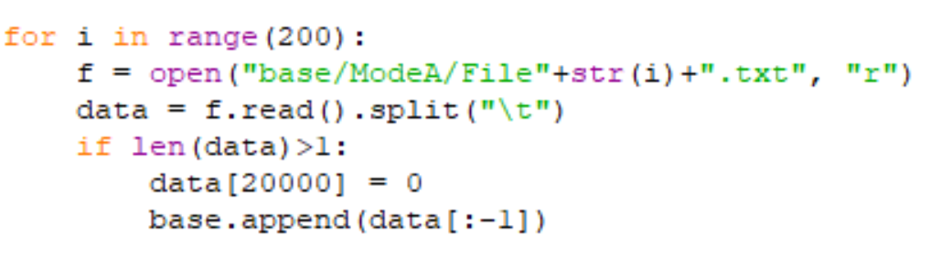

Then I applied Fourier transform on the data and applied PCA on the data.

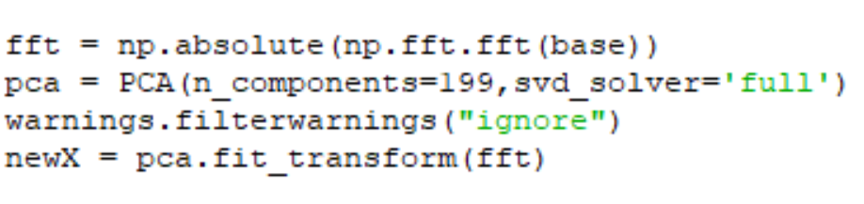

Then I called Reachdistance function, local reachability distance function and LOF function. Here I am setting the reachability distance as 10.

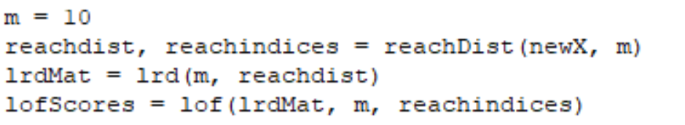

In reachability distance I found the indices and distances between the points.

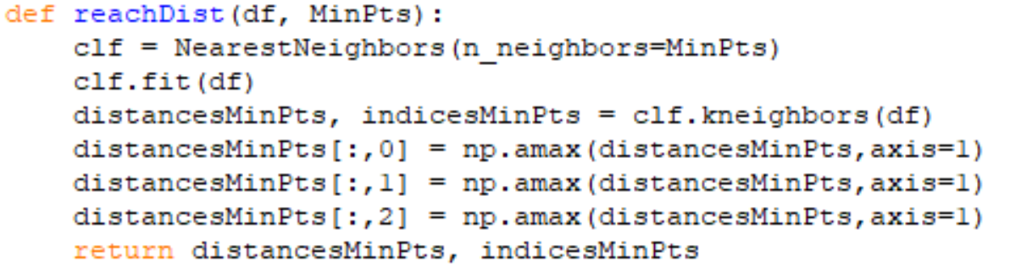

In local reachability density I am finding the LRD matrix based on the formula given in the slides.

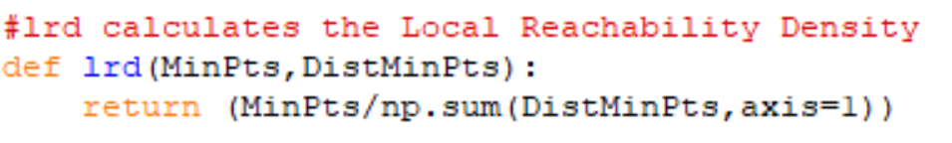

Later I am applying LOF on the LRD matrix and indices

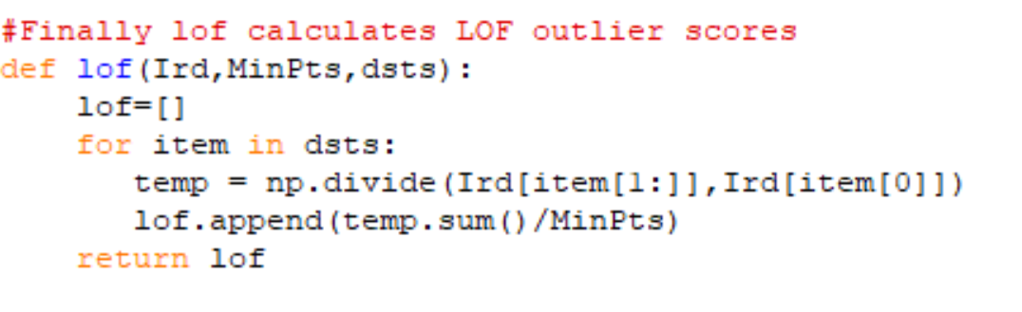

Now the LOFscores of the training data is taken alpha and now we need to work on the test data. I tested the algorithm on ModeM data.

I am reading the test data and applying Fourier transform and PCA on the data, then doing the same three operations on it.

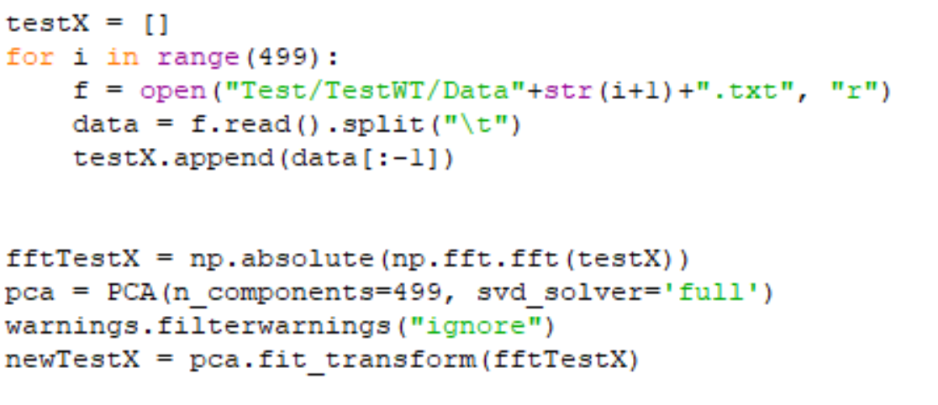

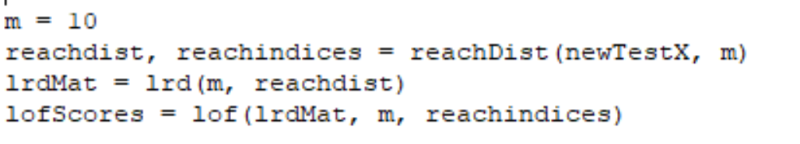

My next step is to find the strangeness using LOF for the StrOUD algorithm and writing the values to the result file.

