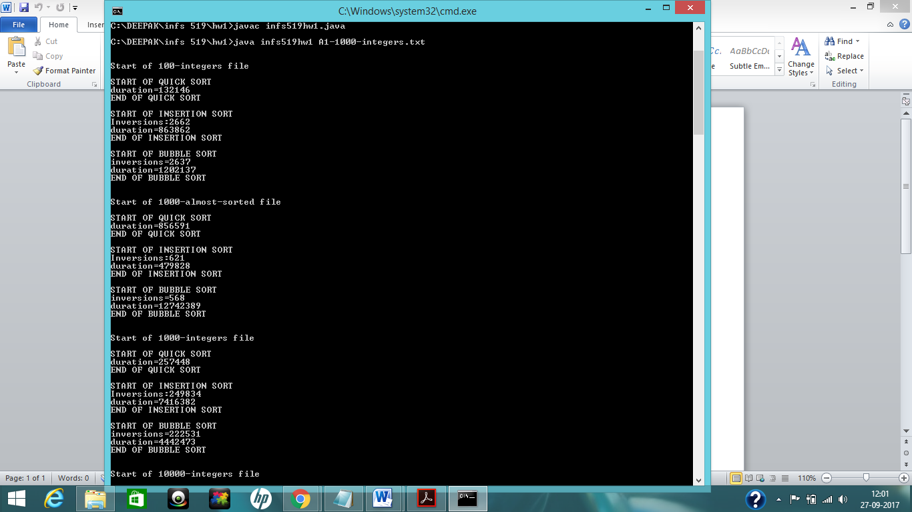

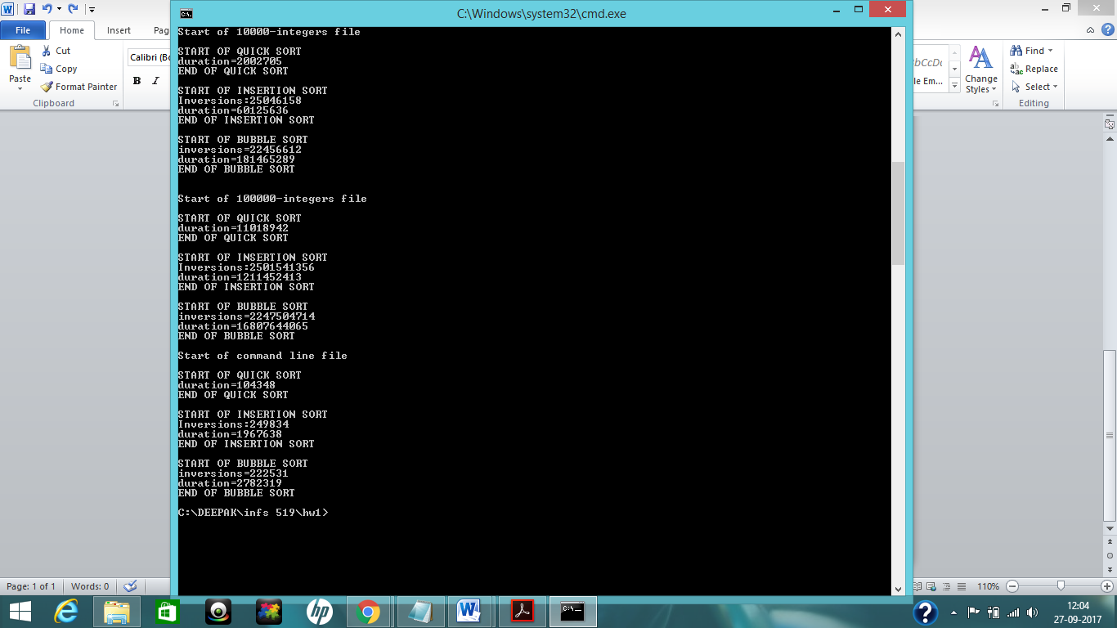

Since the duration varies little from execution to execution, the values in the table and in the screenshot may vary little as a took the screenshot of another execution. However there isn’t vast difference between them.