**Deen Dayal Upadhyaya College University of Delhi**



ARTIFICIAL INTELLIGENCE

NEP PRACTICALS

Course: Bsc (Hons) Computer Science

Semester: 6

UPC: 32341601

Submitted To: Submitted By:

**Dr. Anuja Soni Anupam Jena**

**(21HCS4119)**

1. Write a program in Prolog to implement TowerOfHanoi(N) where N represents the number of disks.

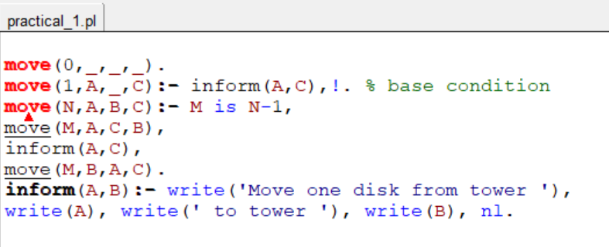

**Output:**

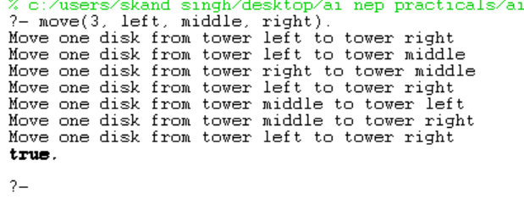

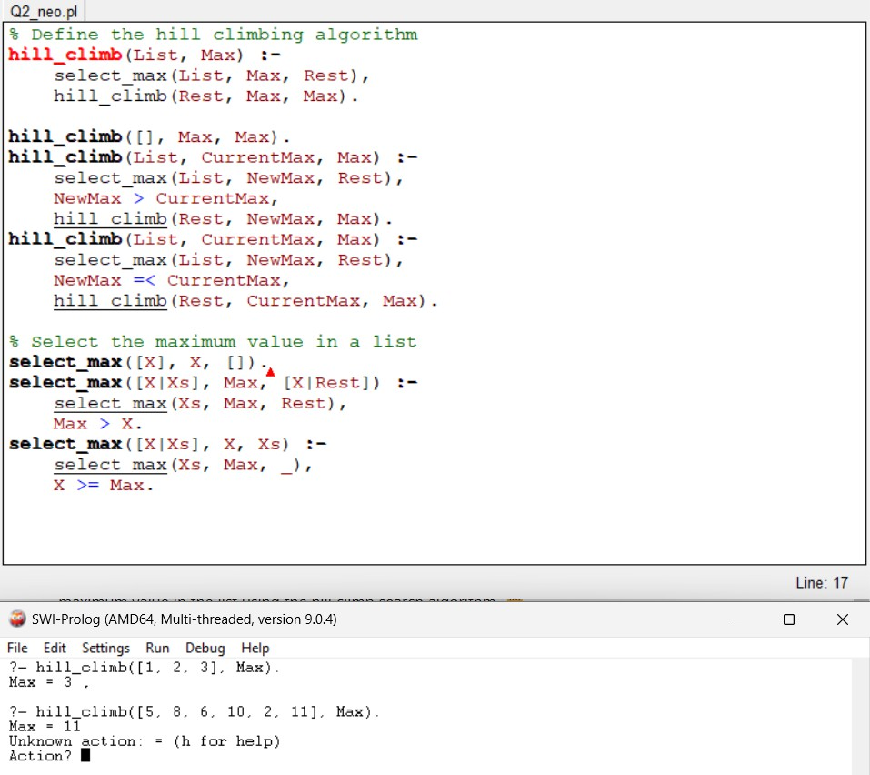2. Write a program to implement the Hill climbing search algorithm in Prolog.

**Output:**

3. Write a program to implement the Best first search algorithm in Prolog.

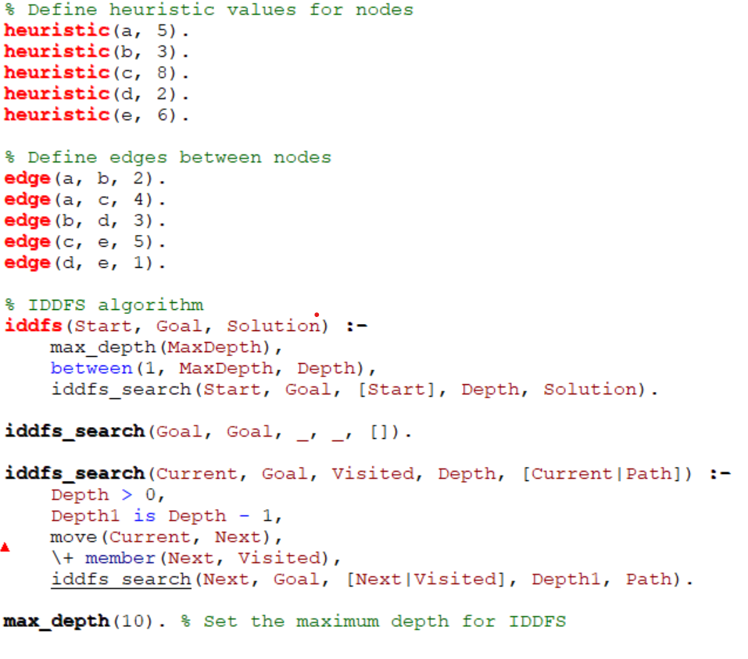

**Output:**

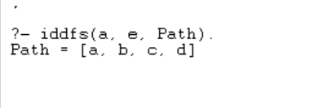

4. Write a program to implement A* search algorithm in Prolog.

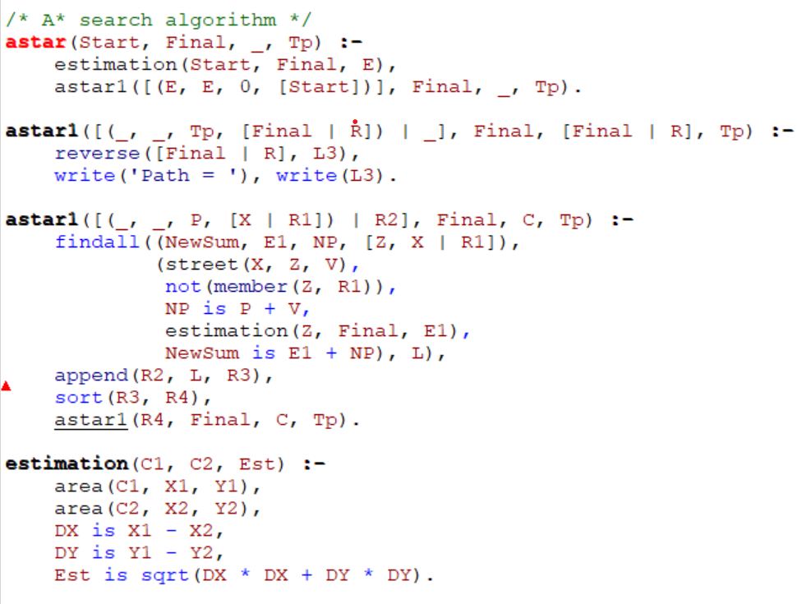

**Output:**

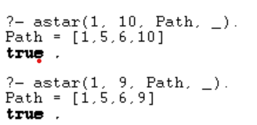

5. Write a program to implement the min-max search algorithm in Prolog.

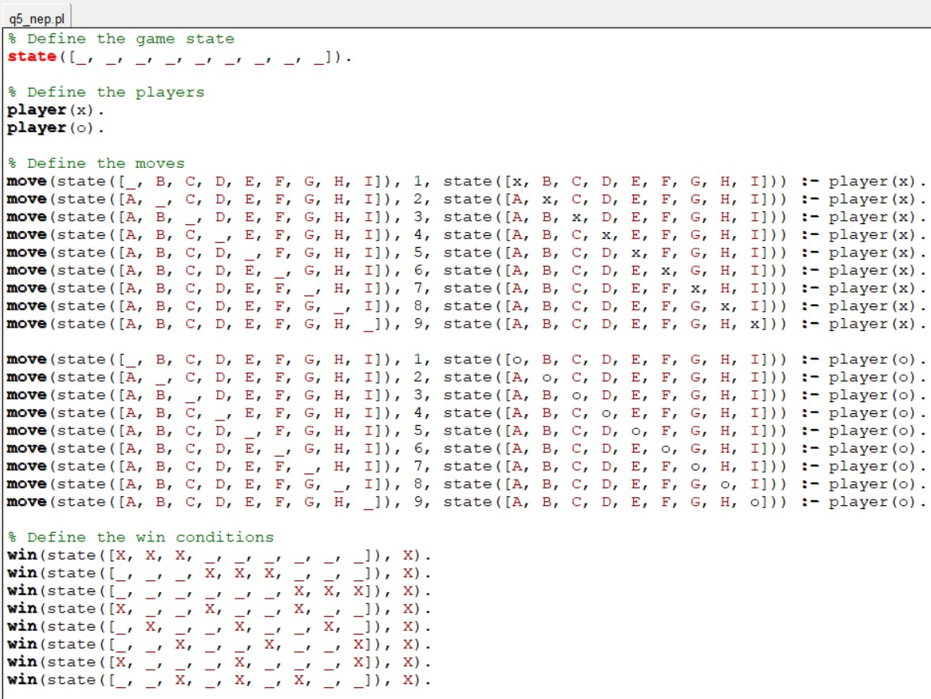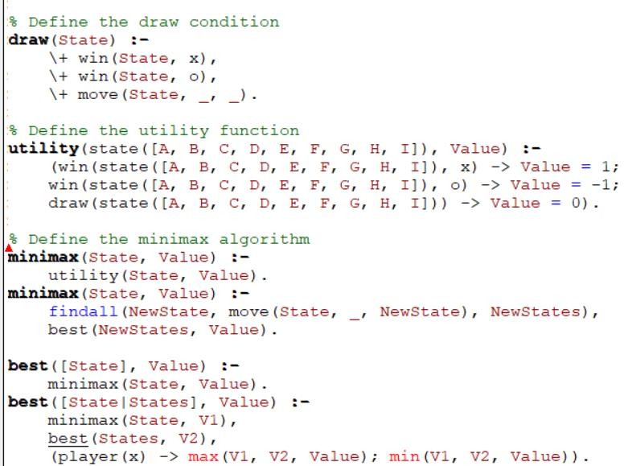

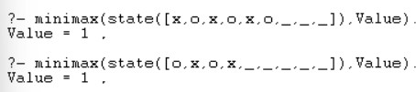**Output:**

6. Write a program to solve the Water-Jug Problem in Prolog.

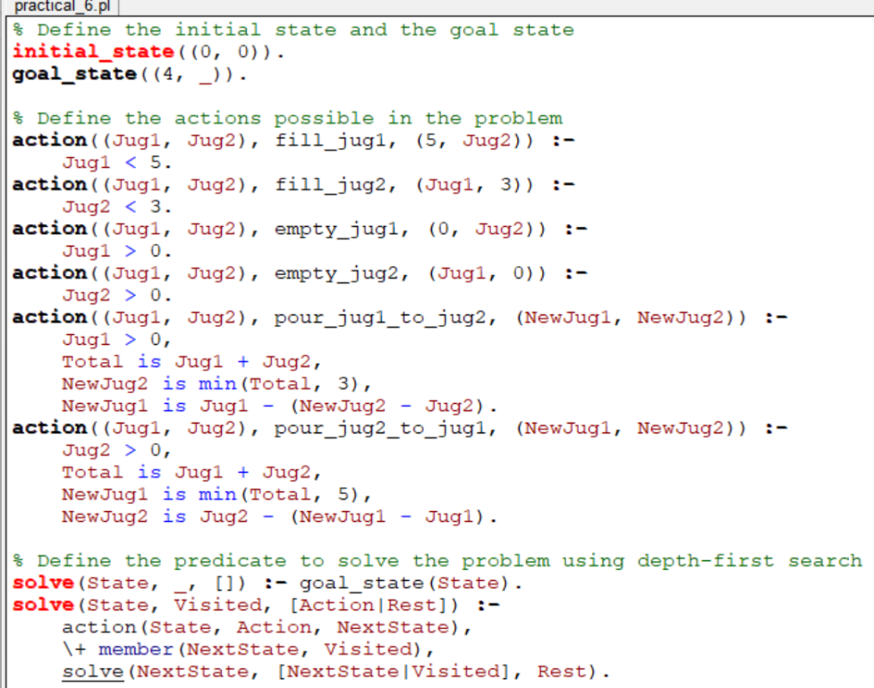

**Output:**



7. Implement sudoku problem (minimum 9X9 size) using constraint satisfaction in Prolog.

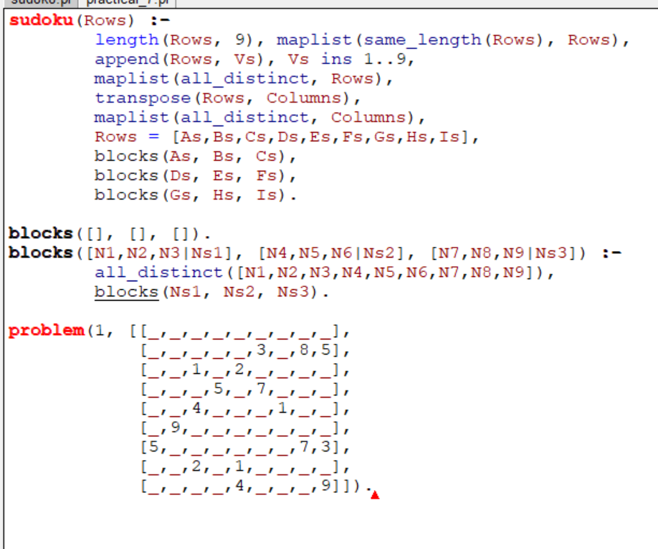

**Output:**



8. Write a Prolog program to implement the family tree and demonstrate the family relationship.

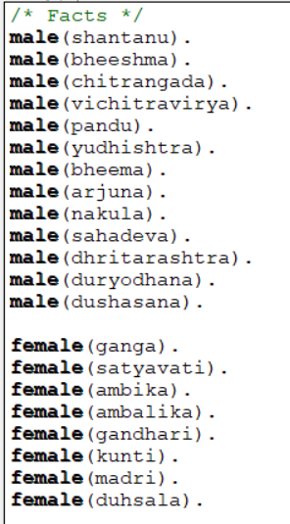 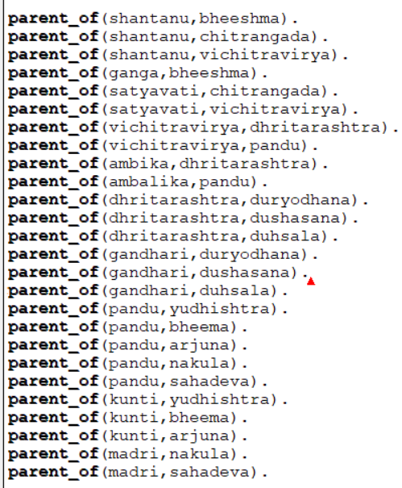

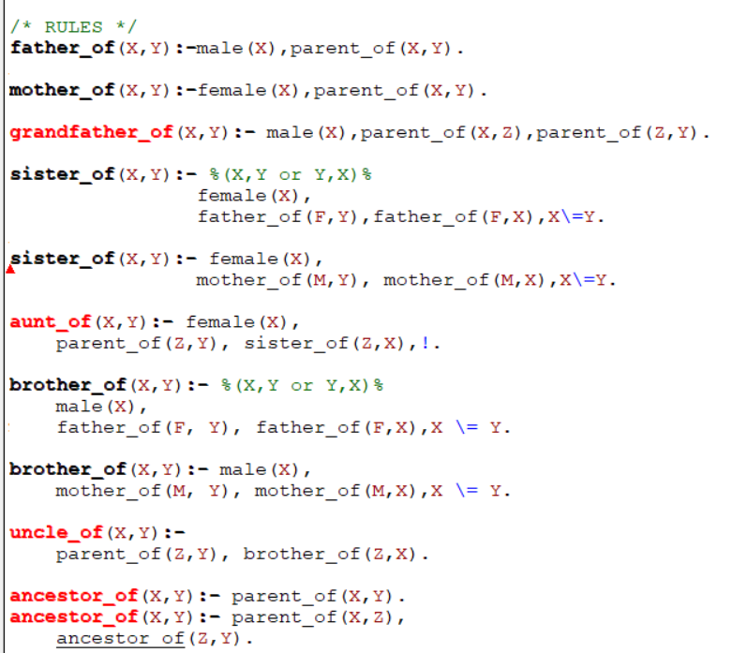

**Output:**

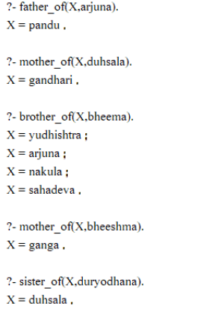

9. Write a Prolog program to implement knowledge representation using frames with appropriate examples.

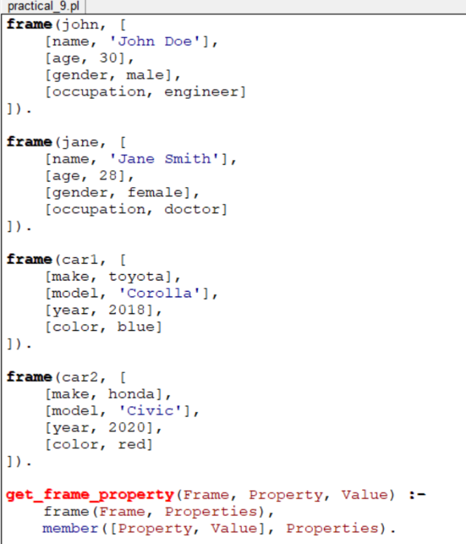

**Output:**

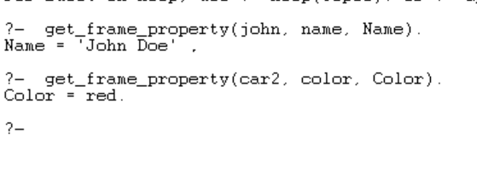

10. Write a Prolog program to implement conc (L1, L2, L3) where appended with L1 to get the resulted list L3.

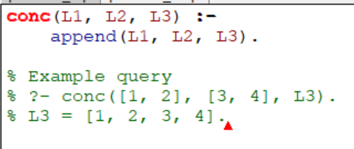

**Output:**

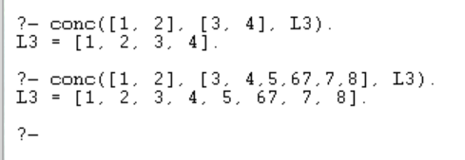

11. Write a Prolog program to implement reverse (L, R) where List L is original and List R is reversed list.

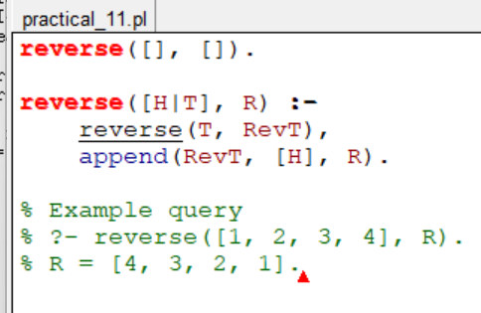

**Output:**

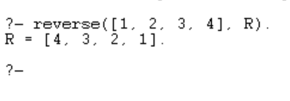

12. Write a Prolog program to generate a parse tree of a given sentence in English language assuming the grammar required for parsing.

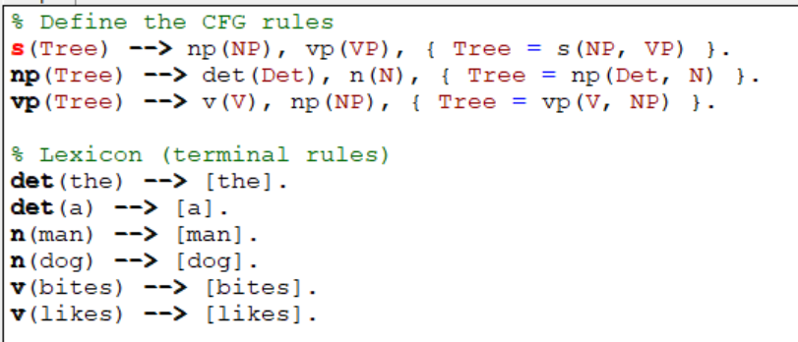

**Output:**

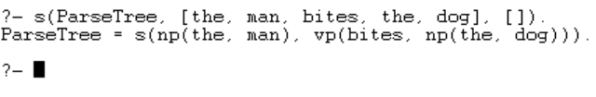

13. Write a Prolog program to recognize context free grammar a^nb^n.

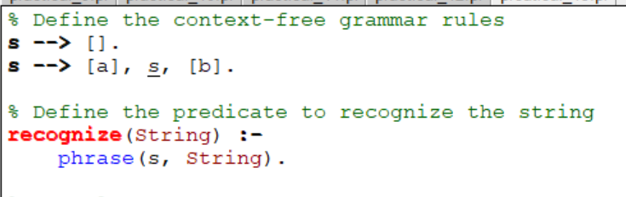

**Output:**

