HTML/CSS Exercise
Ques1: How are inline and block elements different from each other?
Solution:
Inline-elements:
An inline element does not start on a new line and only takes up as much width as necessary.Examples of inline elements are as follows:<span>, <a>, <img>, <button>
Code-Snippet:-
<label for="Product" class="label-heading">Product:
<span class="red_assestric">*</span>
</label><br/>

Block-level-elements:
A block-level element always starts on a new line and takes up the full width available.Examples of block level elements are: <div>, <footer>, <form>, <main> ,<nav>
Code-Snippet:
<div>
<h2>Heading</h2>
<p>We cover the entire gamut of product engineering including user experience design, web and mobile application development, cloud, devOps, big data, testing and infrastructure managed services to transform businesses digitally.</p>
<p> At TO THE NEW, design led engineering is at the core of our offerings. Some of the cutting-edge technologies, frameworks and platforms we work on include MEAN, Grails, IoT, Blockchain, Bootstrap, AEM, Drupal, Hadoop, AWS, React, Ionic, Roku, iOS, and Android.</p>
</div>
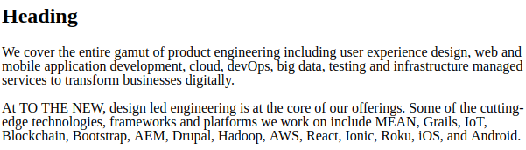
Code-Snippet:
Ques2: Explain the difference between visibility:hidden and display:none
Solution:
Visibility:Hidden
The visibility property specifies whether or not an element is visible and the Hidden elements take up space on the page.
Code-Snippet:
<h1>Visibility</h1>
<h2 style="visibility:visible">Heading is visible</h2>
<h2 style="visibility:hidden">Heading is hidden</h2>
<p>Space is left on Top</p>
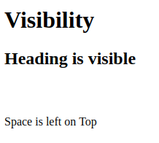

Display:none:
The display property specifies if/how an element is displayed. Display:none; is commonly used with JavaScript to hide and show elements without deleting and recreating them.i.e it doesn’t preserve the space
Code-Snippet:
<h1>Display</h1>
<h2 style="display:none">hidden heading</h2>
<h2 >heading above to this is hidden</h2>
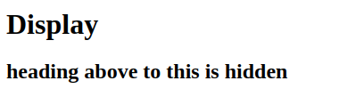

Ques3: Explain the clear and float properties.
Solution:
The CSS float specifies how an element should float. It is used for positioning and formatting content e.g. let an image float left to the text in a container.The CSS clear property specifies what elements can float beside the cleared element and on which side.This property specifies what elements can float beside the cleared element and on which side.
Code-Snippet of float:
<div><button type="submit" style="float:right">Submit</button></div>

Ques4: explain difference between absolute, relative,fixed and static.
Solution:
Position:static:
Static positioned elements are not affected by the top, bottom, left, and right properties. An element with positin:static is not positioned in any special way; it is always positioned according to the normal flow of the page:
Code-Snippet:
<div style="position:static; border:1px solid black">
This div element has position: static;
</div>
Position:relative:
An element with position:relative; is positioned relative to its normal position.Setting the top, right, bottom, and left properties of a relatively-positioned element will cause it to be adjusted away from its normal position. Other content will not be adjusted to fit into any gap left by the element.
Code:Snippet:
<div style="position:relative; left:30px; border:1px solid black">
position: relative;
</div>
Position:fixed:
An element with position:fixed; is positioned relative to the viewport, which means it always stays in the same place even if the page is scrolled. The top, right, bottom, and left properties are used to position the element.A fixed element does not leave a gap in the page where it would normally have been located.
Code-Snippet:
<h2>position: fixed;</h2>
<p>An element with position: fixed; is positioned relative to the viewport, which means it always stays in the same place even if the page is scrolled:</p>
<div style="position: fixed; bottom: 0;right: 0;width: 300px; border: 1px solid black;">
This div element has position: fixed;
</div>
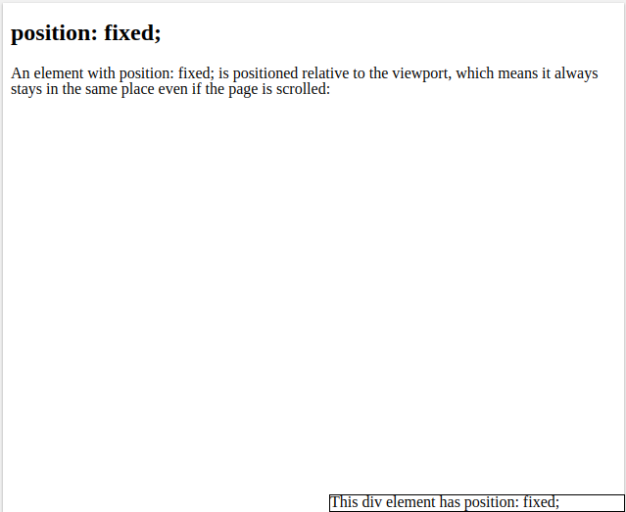
Position:absolute:
An element with position:absolute is positioned relative to the nearest positioned ancestor (instead of positioned relative to the viewport, like fixed). However; if an absolute positioned element has no positioned ancestors, it uses the document body, and moves along with page scrolling.
Code-Snippet:
<h2>position: absolute;</h2>
<p>An element with position: absolute; is positioned relative to the nearest positioned ancestor</p>
<div style="position: relative;width: 400px;height: 200px;border: 1px solid black;">div element has position: relative;
<div style="position: absolute;top: 80px;right: 0;width: 200px;height: 100px;border: 1px solid black;">div element has position: absolute;</div>
</div>
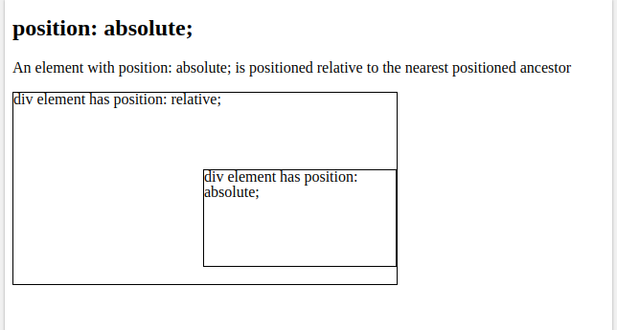

Ques5: Write the HTML code to create a table in which there are 4 columns( ID , Employee Name, Designation, Department) and at least 6 rows. Also do some styling to it.
Solution:
Added in git repository
Ques6: Why do we use meta tags?
Solution:
Metadata is data (information) about data.The <meta> tag provides metadata about the HTML document. Metadata will not be displayed on the page, but will be machine parsable.Meta elements are typically used to specify page description, keywords, author of the document, last modified, and other metadata.The metadata can be used by browsers (how to display content or reload page), search engines (keywords), or other web services.HTML5 introduced a method to let web designers take control over the viewport .
Code-Snippet:
<head>
<meta charset="UTF-8">
<meta name="description" content="About HTML">
<meta name="keywords" content="HTML,CSS">
<meta name="author" content="ToTheNew">
<meta name="viewport" content="width=device-width, initial-scale=1.0">
</head>

Ques7: Explain box model.
Solution:
All HTML elements can be considered as boxes. In CSS, the term “box Model" is used when talking about design and layout. The CSS box Model is essentially a box that wraps around every HTML element. It consists of: margins, borders, padding, and the actual content.
All HTML elements can be considered as boxes. In CSS, the term "box model" is used when talking about design and layout.The CSS box model is essentially a box that wraps around every HTML element. It consists of: margins, borders, padding, and the actual content.
Different Parts of box model are as follows:-
1.Content- The content of the box, where text and images appear.2.Padding- Clears an area around the content. The padding is transparent.3.Border- A border that goes around the padding and content.4.Margin- Clears an area outside the border. The margin is transparent
Code-Snippet:
<h2>TO THE NEW</h2>
<p>TO THE NEW is a premium digital technology company that provides end-to-end Product Engineering and Digital Transformation services to Fortune 500 companies and Silicon Valley startups across the globe..</p>
<div Style="background-color: grey;width: 300px;border: 3px solid black;padding: 50px;margin: 20px;">We cover the entire gamut of product engineering including user experience design, web & mobile application development, cloud, devOps, big data, testing and infrastructure managed services to transform businesses digitally. At TO THE NEW, design led engineering is at the core of our offerings. Some of the cutting-edge technologies, frameworks and platforms we work on include MEAN, Grails, IoT, Blockchain, Bootstrap, AEM, Drupal, Hadoop, AWS, React, Ionic, Roku, iOS, and Android.</div>

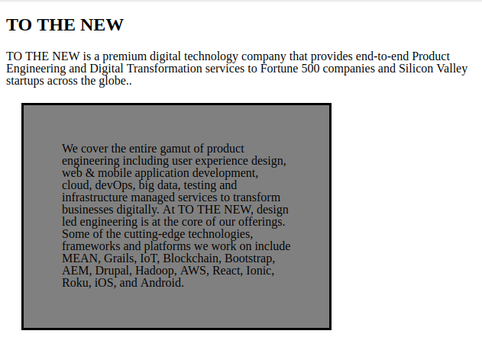
Ques8: What are the different types of CSS Selectors?
Solution:
Different types of selectors in CSS.
- CSS Element Selector
- CSS Id Selector
- CSS Class Selector
- CSS Universal Selector
- CSS Group Selector

Ques9: Define Doctype.
Solution:
The <!DOCTYPE> declaration must be the very first thing in your HTML document, before the <html> tag.The <!DOCTYPE> declaration is not an HTML tag; it is an instruction to the web browser about what version of HTML the page is written in.In HTML 4.01, the <!DOCTYPE> declaration refers to a DTD, because HTML 4.01 was based on SGML. The DTD specifies the rules for the markup language, so that the browsers render the content correctly.HTML5 is not based on SGML, and therefore does not require a reference to a DTD.

Ques10: Explain 5 HTML5 semantic tags.
Solution:
A semantic element clearly describes its meaning to both the browser and the developer.Examples of non-sementicelements:<div> ,<span>- Tells nothing about its content.Examples of sementicelements:<form><table>and<article>- Clearly defines its content.
HTML5 offers new semantic elements to define different parts of a web page:
1. <article>
2. <aside>
3. <details>
4. <figcaption>
5. <figure>
6. <footer>
7. <header>
8. <main>
9. <mark>
10. <nav>
11. <section>
12. <summary>
13. <time>

Ques11: Create HTML for web-page.jpg (check resources, highest weightage for answers)
Solution:
added in git repository
Ques12: Create HTML for form.png (check resources, highest weightage for answers)
Solution:
Added in git repository

