**NAME:DEEPAKKANNAN M**

**727721EUIT026**

**IT-A**

**DAY5:**

**CLASS EXERCISE 1:**

**ECLIPSE CODE:**

package com.selenium.test2.selenium1;

import java.util.List;

import org.openqa.selenium.Alert;

import org.openqa.selenium.By;

import org.openqa.selenium.JavascriptExecutor;

import org.openqa.selenium.Keys;

import org.openqa.selenium.WebDriver;

import org.openqa.selenium.WebElement;

import org.openqa.selenium.chrome.ChromeDriver;

import org.openqa.selenium.chrome.ChromeOptions;

import org.openqa.selenium.edge.EdgeDriver;

import org.openqa.selenium.firefox.FirefoxDriver;

import org.openqa.selenium.interactions.Actions;

//import org.openqa.selenium.edge.EdgeDriver;

import org.openqa.selenium.support.ui.Select;

import io.github.bonigarcia.wdm.WebDriverManager;

/**

* Hello world!

*

*/

public class App

{

public static void main( String[] args ) throws InterruptedException

{

WebDriverManager.*chromedriver*().setup();

WebDriver driver;

ChromeOptions co = new ChromeOptions();

co.addArguments("--remote-allow-origins=*");

driver=new ChromeDriver(co);

driver.get("https://demoqa.com/droppable/");

driver.manage().window().maximize();

//creating Elements for drag and drop

// WebElement drag=driver.findElement(By.id("draggable"));

// WebElement drop=driver.findElement(By.id("droppable"));

WebElement drag=driver.findElement(By.*id*("draggable"));

WebElement drop=driver.findElement(By.*id*("droppable"));

Actions act=new Actions(driver);

act.dragAndDrop(drag, drop).build().perform();

}

}

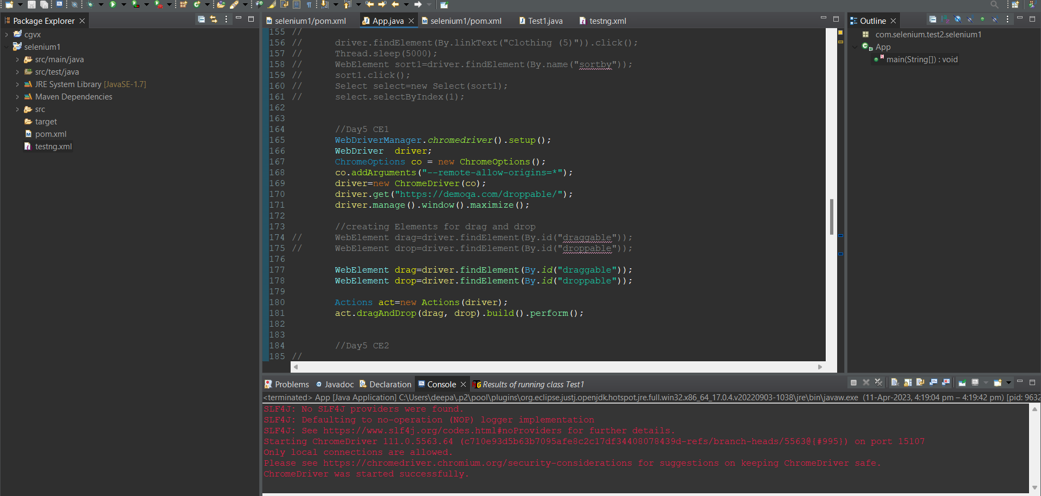

**OUTPUT:**

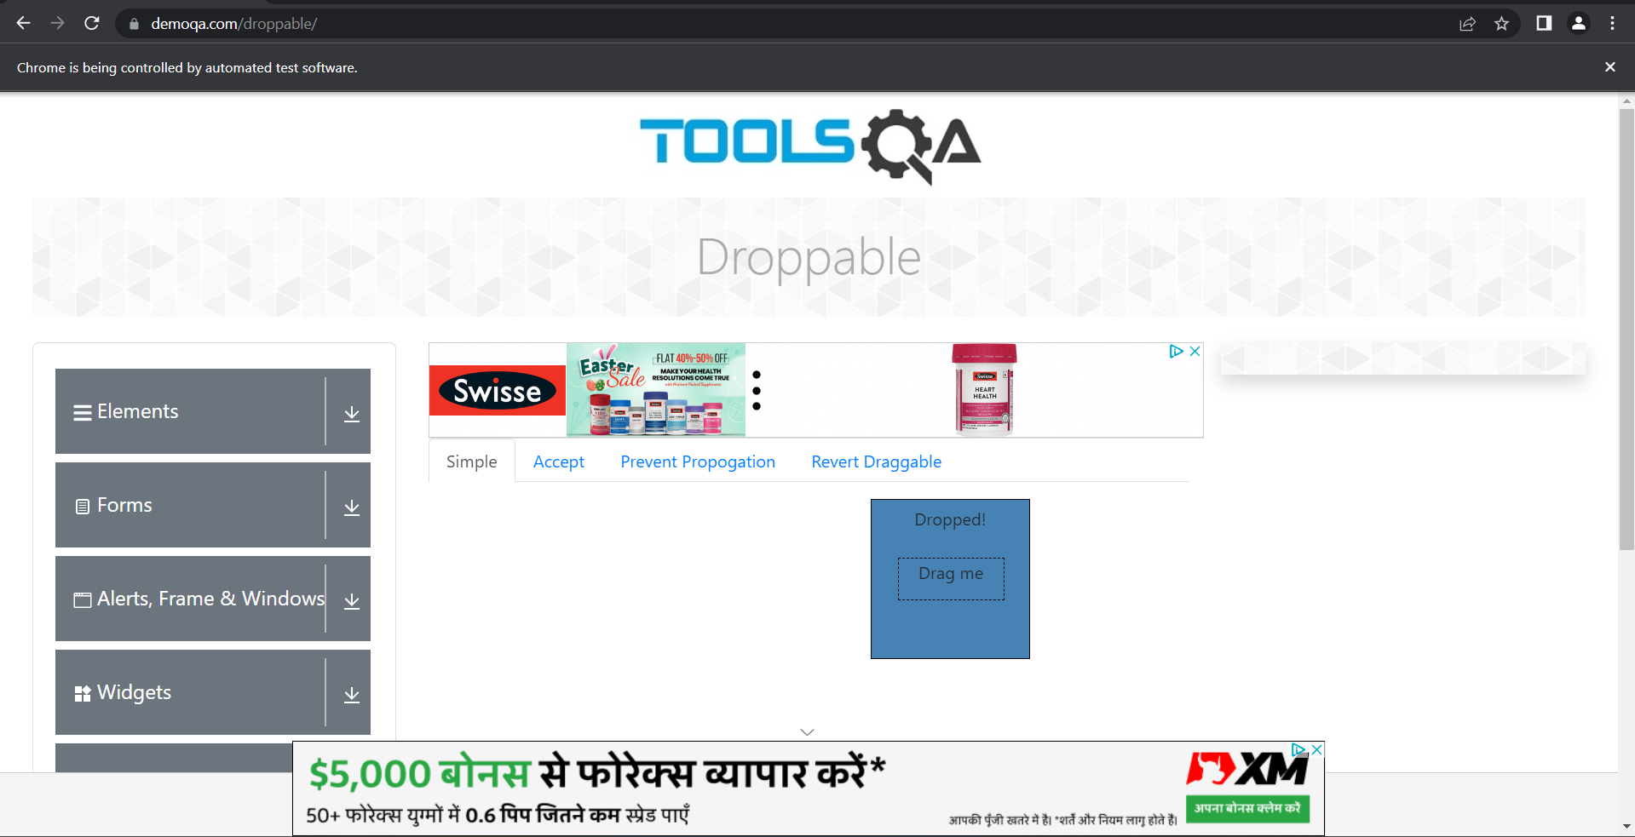

**CLASS EXERCISE 2:**

**CODE FOR ECLIPSE:**

package com.selenium.test2.selenium1;

import java.util.List;

import org.openqa.selenium.Alert;

import org.openqa.selenium.By;

import org.openqa.selenium.JavascriptExecutor;

import org.openqa.selenium.Keys;

import org.openqa.selenium.WebDriver;

import org.openqa.selenium.WebElement;

import org.openqa.selenium.chrome.ChromeDriver;

import org.openqa.selenium.chrome.ChromeOptions;

import org.openqa.selenium.edge.EdgeDriver;

import org.openqa.selenium.firefox.FirefoxDriver;

import org.openqa.selenium.interactions.Actions;

//import org.openqa.selenium.edge.EdgeDriver;

import org.openqa.selenium.support.ui.Select;

import io.github.bonigarcia.wdm.WebDriverManager;

/**

* Hello world!

*

*/

public class App

{

public static void main( String[] args ) throws InterruptedException

{

// **TODO** Auto-generated method stub

WebDriverManager.*chromedriver*().setup();

WebDriver driver;

ChromeOptions co = new ChromeOptions();

co.addArguments("--remote-allow-origins=*");

driver=new ChromeDriver(co);

driver.get("https://jqueryui.com/droppable/");

driver.switchTo().frame(0);

WebElement drag1=driver.findElement(By.*id*("draggable"));

Actions act=new Actions(driver);

WebElement drop1=driver.findElement(By.*id*("droppable"));

act.dragAndDrop(drag1, drop1).build().perform();

}

}

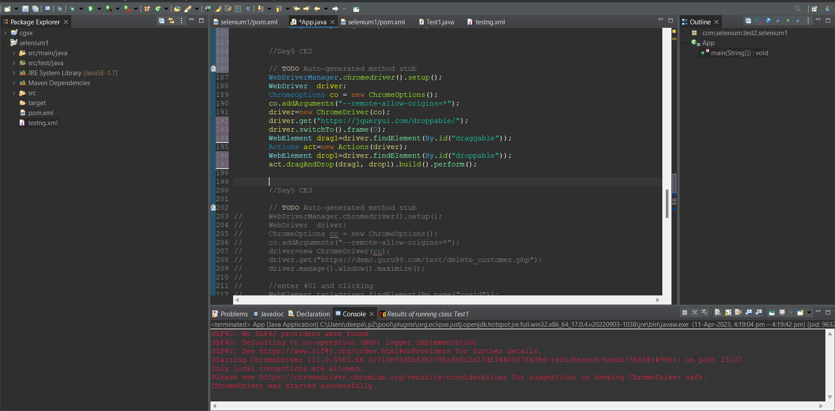

**OUTPUT:**

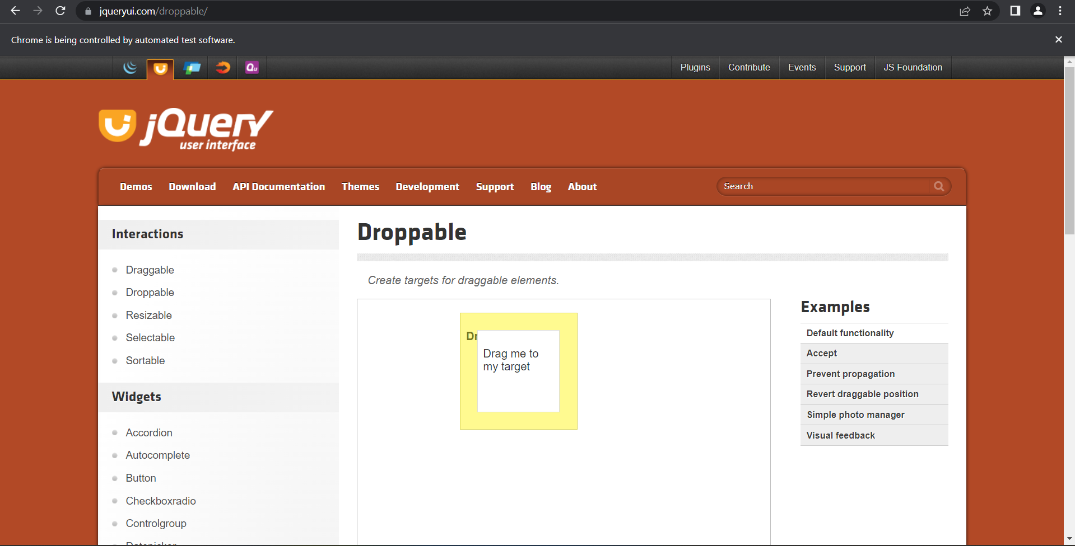

**CLASS EXERCISE 3**

**ECLIPSE CODE:**

package com.selenium.test2.selenium1;

import java.util.List;

import org.openqa.selenium.Alert;

import org.openqa.selenium.By;

import org.openqa.selenium.JavascriptExecutor;

import org.openqa.selenium.Keys;

import org.openqa.selenium.WebDriver;

import org.openqa.selenium.WebElement;

import org.openqa.selenium.chrome.ChromeDriver;

import org.openqa.selenium.chrome.ChromeOptions;

import org.openqa.selenium.edge.EdgeDriver;

import org.openqa.selenium.firefox.FirefoxDriver;

import org.openqa.selenium.interactions.Actions;

//import org.openqa.selenium.edge.EdgeDriver;

import org.openqa.selenium.support.ui.Select;

import io.github.bonigarcia.wdm.WebDriverManager;

/**

* Hello world!

*

*/

public class App

{

public static void main( String[] args ) throws InterruptedException

{

WebDriverManager.*chromedriver*().setup();

WebDriver driver;

ChromeOptions co = new ChromeOptions();

co.addArguments("--remote-allow-origins=*");

driver=new ChromeDriver(co);

driver.get("https://demo.guru99.com/test/delete_customer.php");

driver.manage().window().maximize();

//enter 401 and clicking

WebElement txt1=driver.findElement(By.*name*("cusid"));

txt1.sendKeys("401");

driver.findElement(By.*name*("submit")).click();

//handling alert boxes

Alert alt=driver.switchTo().alert();

Thread.*sleep*(4000);

alt.dismiss();

txt1.clear();

txt1.sendKeys("402");

driver.findElement(By.*name*("submit")).click();

alt.accept();

Alert alt2=driver.switchTo().alert();

String txt=alt2.getText();

alt2.accept();

System.***out***.println(txt);

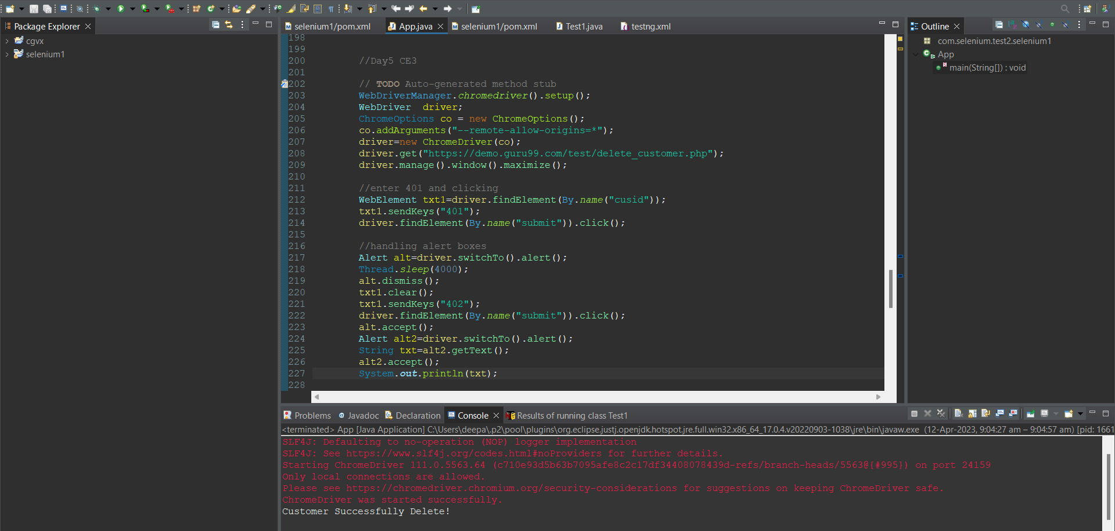

**OUTPUT:**

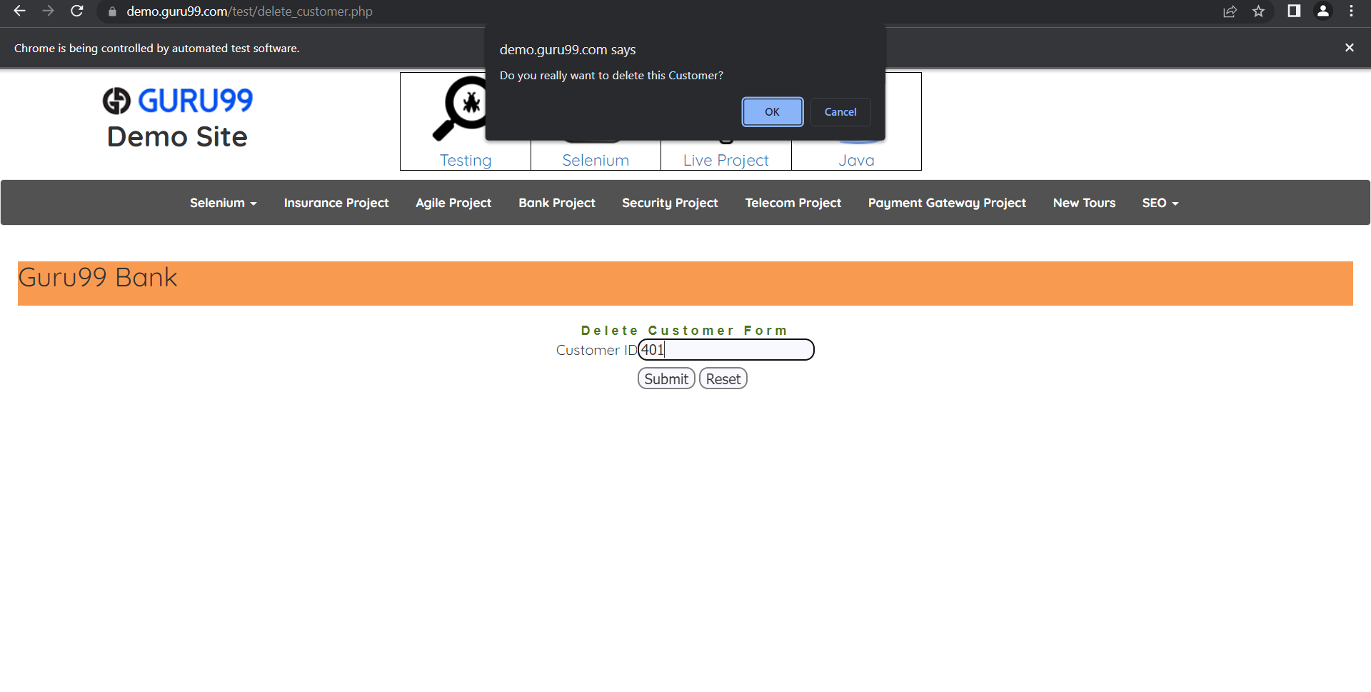

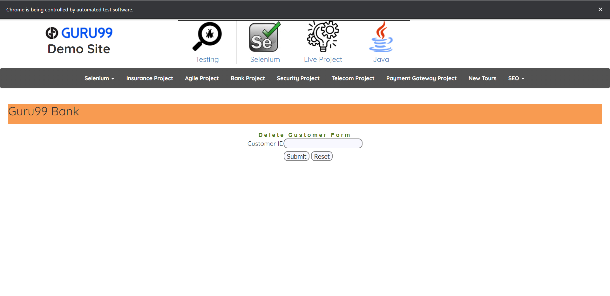

**CLASS EXERCISE 4:**

**ECLIPSE CODE:**

package com.selenium.test2.selenium1;

import java.util.List;

import org.openqa.selenium.Alert;

import org.openqa.selenium.By;

import org.openqa.selenium.JavascriptExecutor;

import org.openqa.selenium.Keys;

import org.openqa.selenium.WebDriver;

import org.openqa.selenium.WebElement;

import org.openqa.selenium.chrome.ChromeDriver;

import org.openqa.selenium.chrome.ChromeOptions;

import org.openqa.selenium.edge.EdgeDriver;

import org.openqa.selenium.firefox.FirefoxDriver;

import org.openqa.selenium.interactions.Actions;

//import org.openqa.selenium.edge.EdgeDriver;

import org.openqa.selenium.support.ui.Select;

import io.github.bonigarcia.wdm.WebDriverManager;

/**

* Hello world!

*

*/

public class App

{

public static void main( String[] args ) throws InterruptedException

{

WebDriverManager.*edgedriver*().setup();

WebDriver driver = new EdgeDriver();

driver.manage().window().maximize();

driver.get("https://www.abhibus.com/bus-ticket-booking");

//selecting and entering source

WebElement d=driver.findElement(By.*xpath*("//*[@id=\"source\"]"));

d.sendKeys("Coimbatore");

//selecting and entering destination

driver.findElement(By.*xpath*("//*[@id=\"destination\"]")).sendKeys("Chennai");

//Datepicker

WebElement dp=driver.findElement(By.*xpath*("//*[@id=\"datepicker1\"]"));

JavascriptExecutor js=(JavascriptExecutor) driver;

js.executeScript("arguments[0].setAttribute('value', '04/10/2023')", dp);

}

}

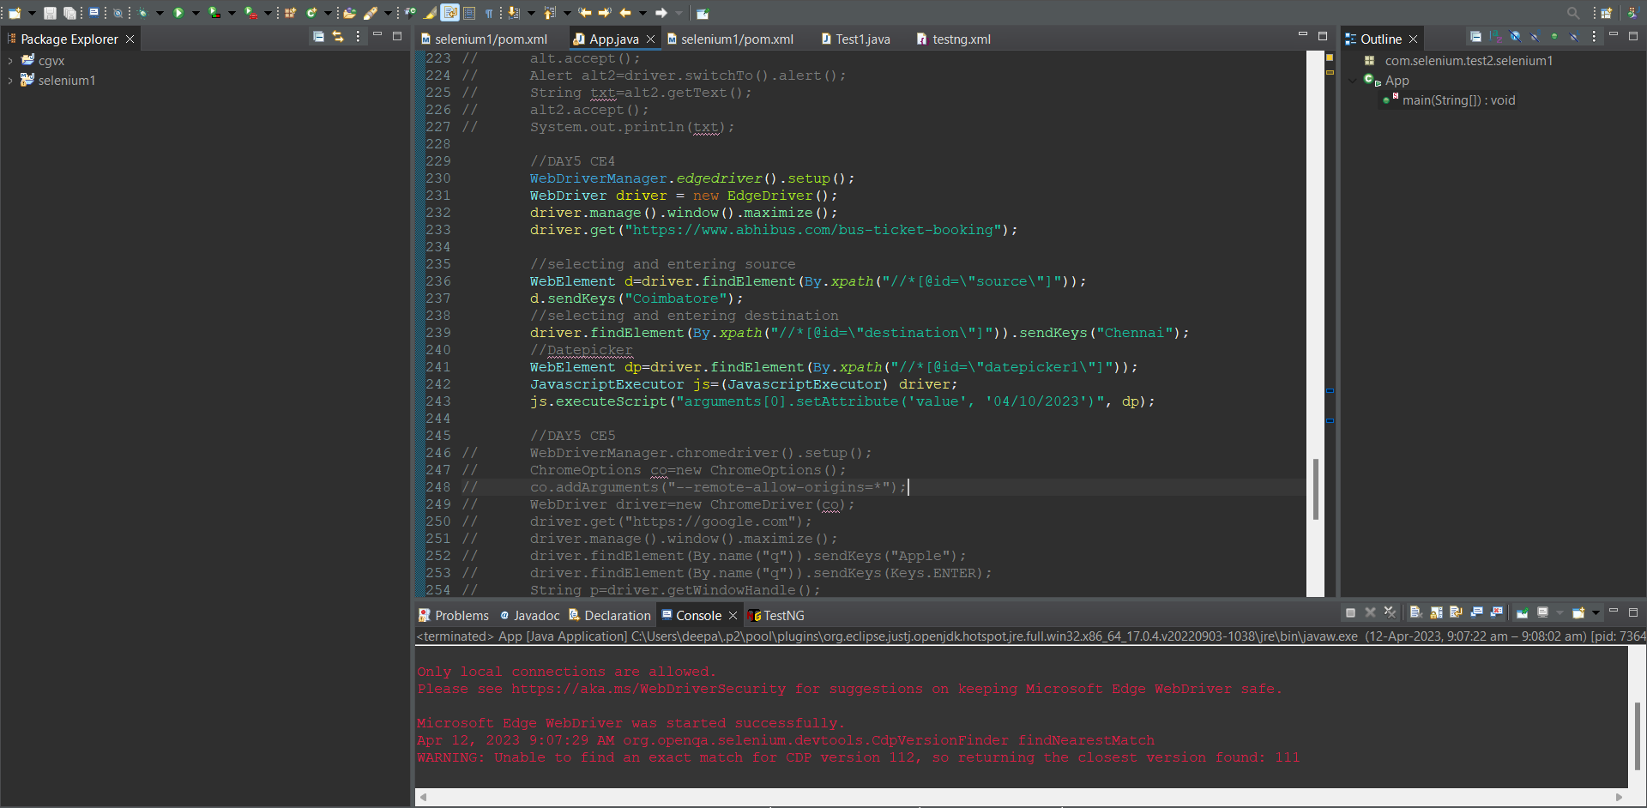

**OUTPUT:**

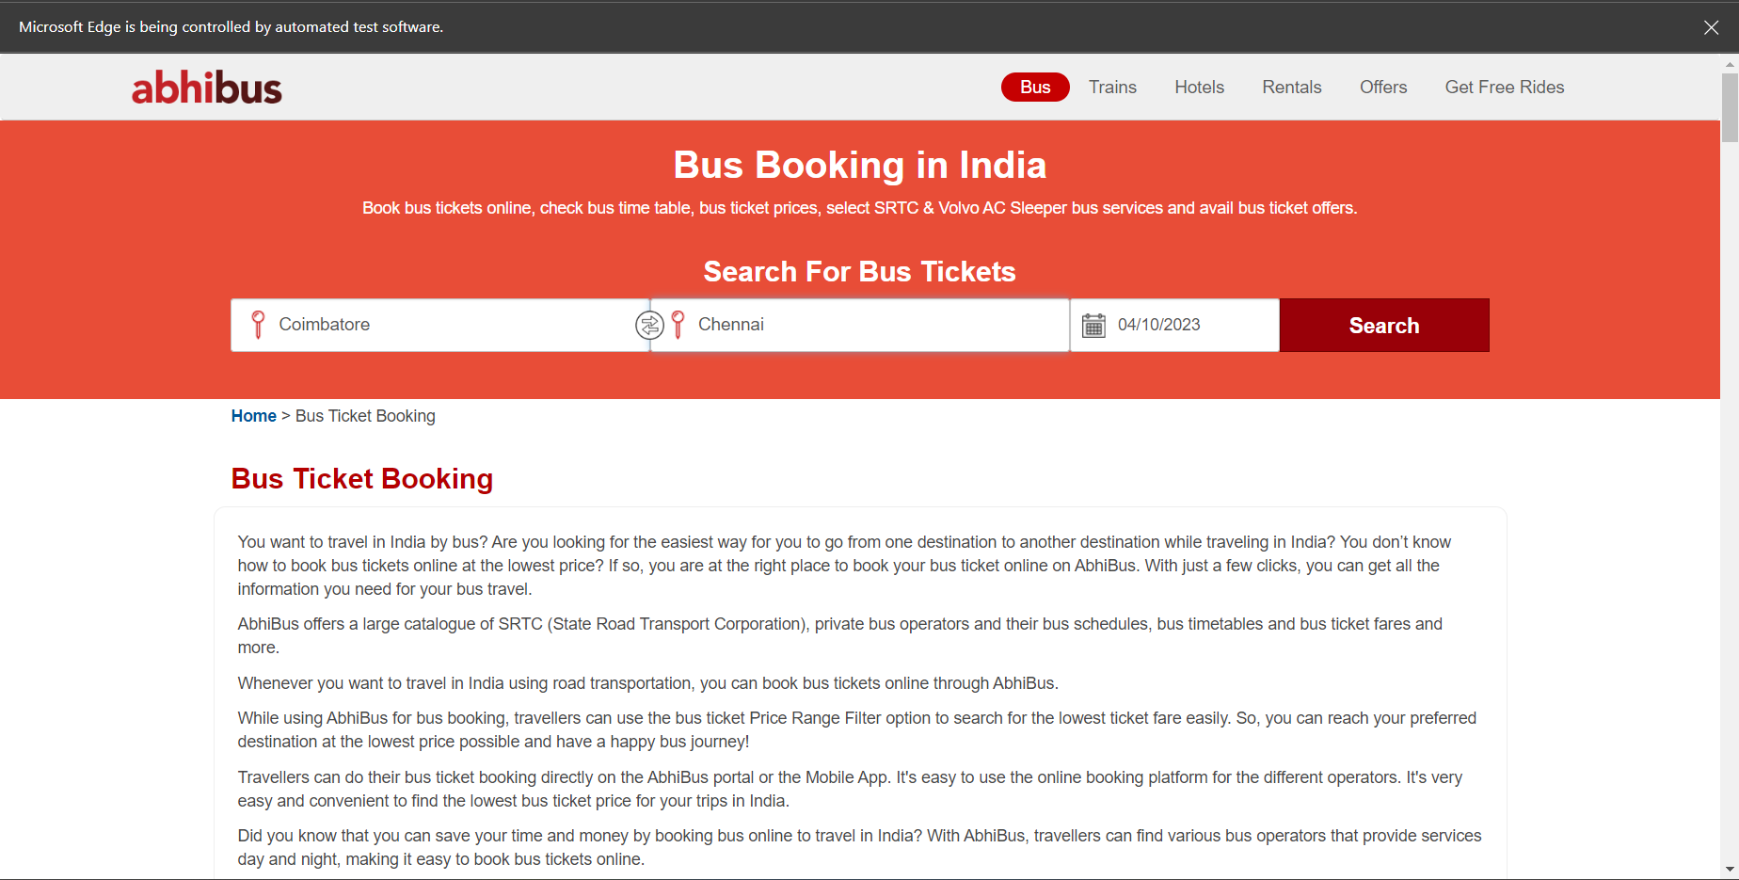

**CLASS EXERCISE 5:**

**ECLIPSE CODE:**

package com.selenium.test2.selenium1;

import java.util.List;

import org.openqa.selenium.Alert;

import org.openqa.selenium.By;

import org.openqa.selenium.JavascriptExecutor;

import org.openqa.selenium.Keys;

import org.openqa.selenium.WebDriver;

import org.openqa.selenium.WebElement;

import org.openqa.selenium.chrome.ChromeDriver;

import org.openqa.selenium.chrome.ChromeOptions;

import org.openqa.selenium.edge.EdgeDriver;

import org.openqa.selenium.firefox.FirefoxDriver;

import org.openqa.selenium.interactions.Actions;

//import org.openqa.selenium.edge.EdgeDriver;

import org.openqa.selenium.support.ui.Select;

import io.github.bonigarcia.wdm.WebDriverManager;

/**

* Hello world!

*

*/

public class App

{

public static void main( String[] args ) throws InterruptedException

{

WebDriverManager.*chromedriver*().setup();

ChromeOptions co=new ChromeOptions();

co.addArguments("--remote-allow-origins=*");

WebDriver driver=new ChromeDriver(co);

driver.get("https://google.com");

driver.manage().window().maximize();

driver.findElement(By.*name*("q")).sendKeys("Apple");

driver.findElement(By.*name*("q")).sendKeys(*Keys*.***ENTER***);

String p=driver.getWindowHandle();

System.***out***.println(p);

String t=driver.getTitle();

System.***out***.println(t);

//edge

WebDriverManager.*edgedriver*().setup();

WebDriver driver1=new EdgeDriver();

driver1.get("https://google.com");

driver1.manage().window().maximize();

driver1.findElement(By.*name*("q")).sendKeys("Selenium");

driver1.findElement(By.*name*("q")).sendKeys(*Keys*.***ENTER***);

String p1=driver1.getWindowHandle();

System.***out***.println(p1);

String t1=driver1.getTitle();

System.***out***.println(t1);

//Firefox

WebDriverManager.*firefoxdriver*();

WebDriver driver2=new FirefoxDriver();

driver2.get("https://google.com");

driver2.manage().window().maximize();

driver2.findElement(By.*name*("q")).sendKeys("Cucumber");

driver2.findElement(By.*name*("q")).sendKeys(*Keys*.***ENTER***);

String p2=driver2.getWindowHandle();

System.***out***.println(p2);

String t2=driver2.getTitle();

System.***out***.println(t2);

}

}

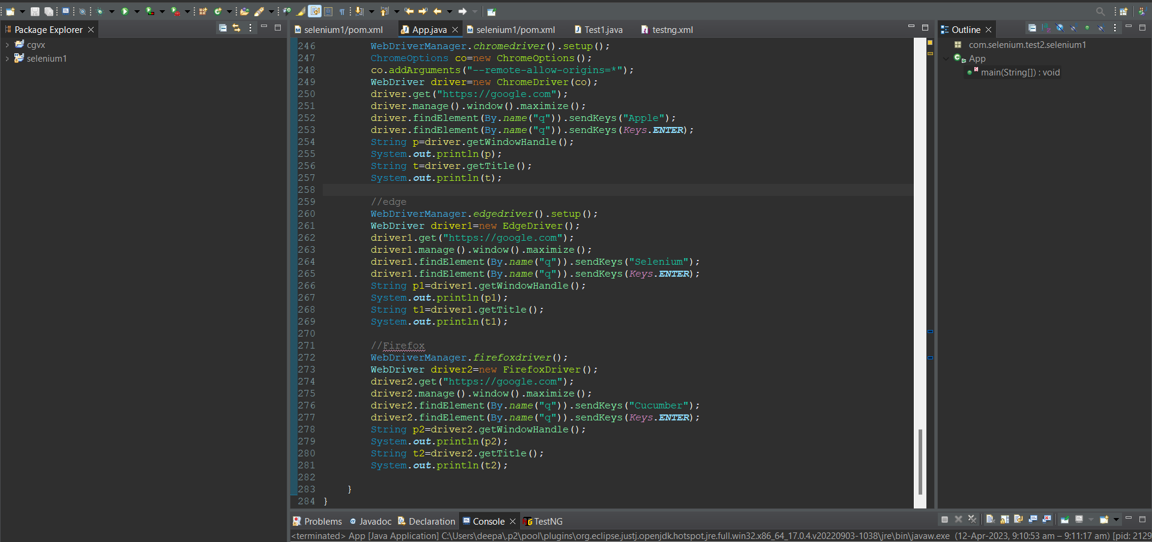

**OUTPUT:**

**CHROME:**

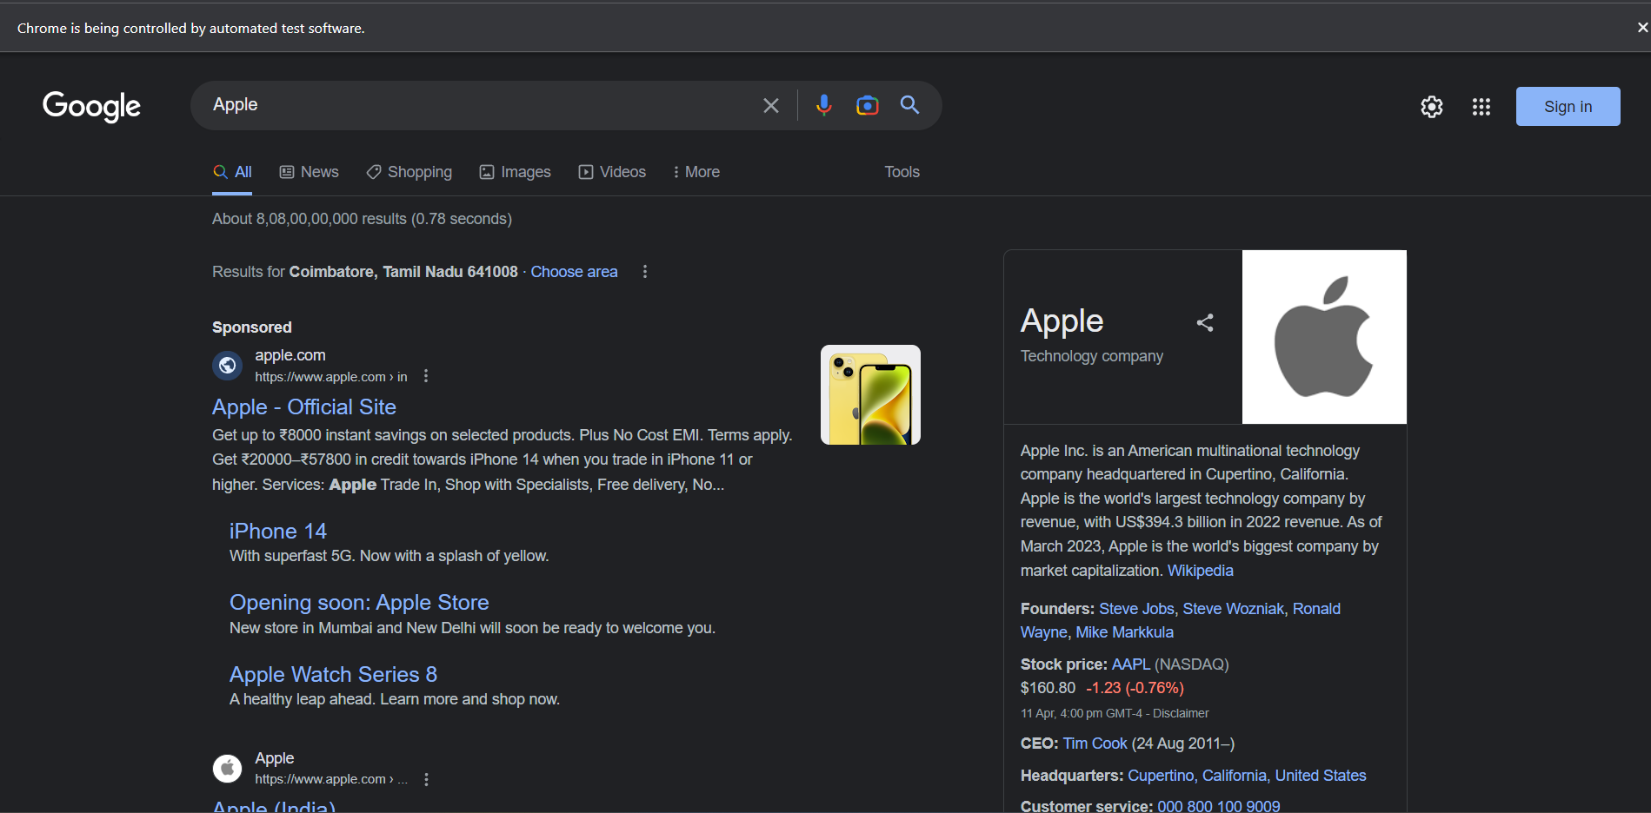



**EDGE:**

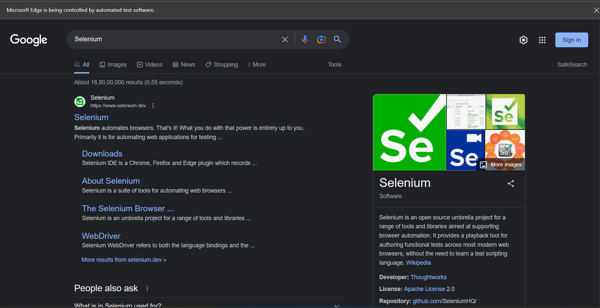



**FIREFOX:**

