**NAME:DEEPAKKANNAN M**

**REG.NO:727721EUIT026**

**CLASS:IT-A**

**DAY 3:**

**CLASS EXERCISE 1**

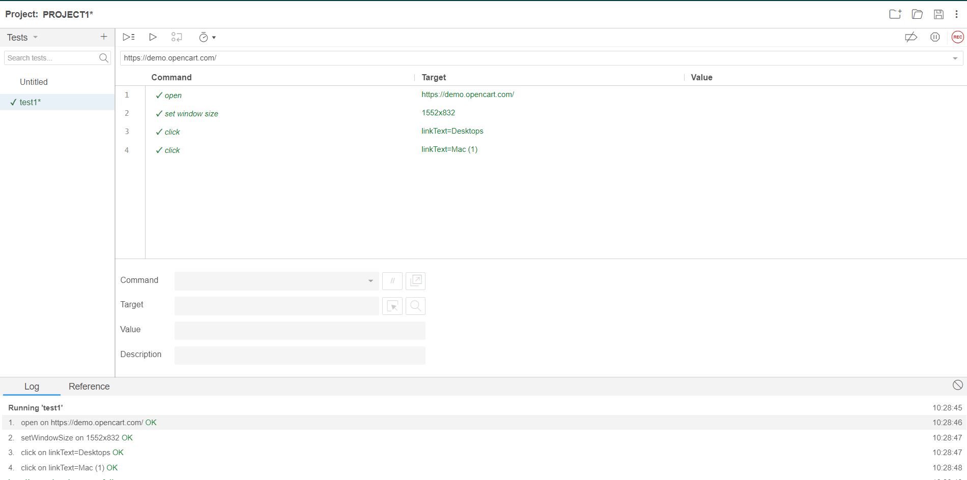

**CLASS EXERCISE 2:**

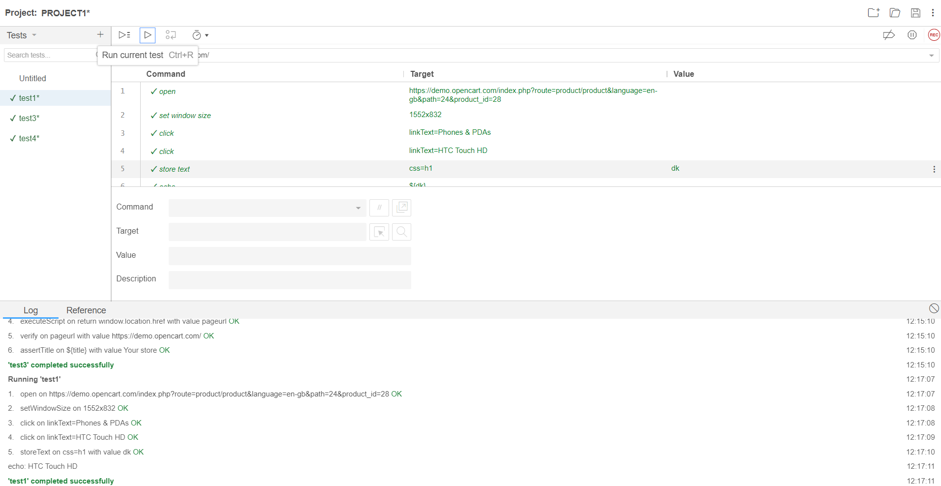

**CLASS EXERCISE 3:**

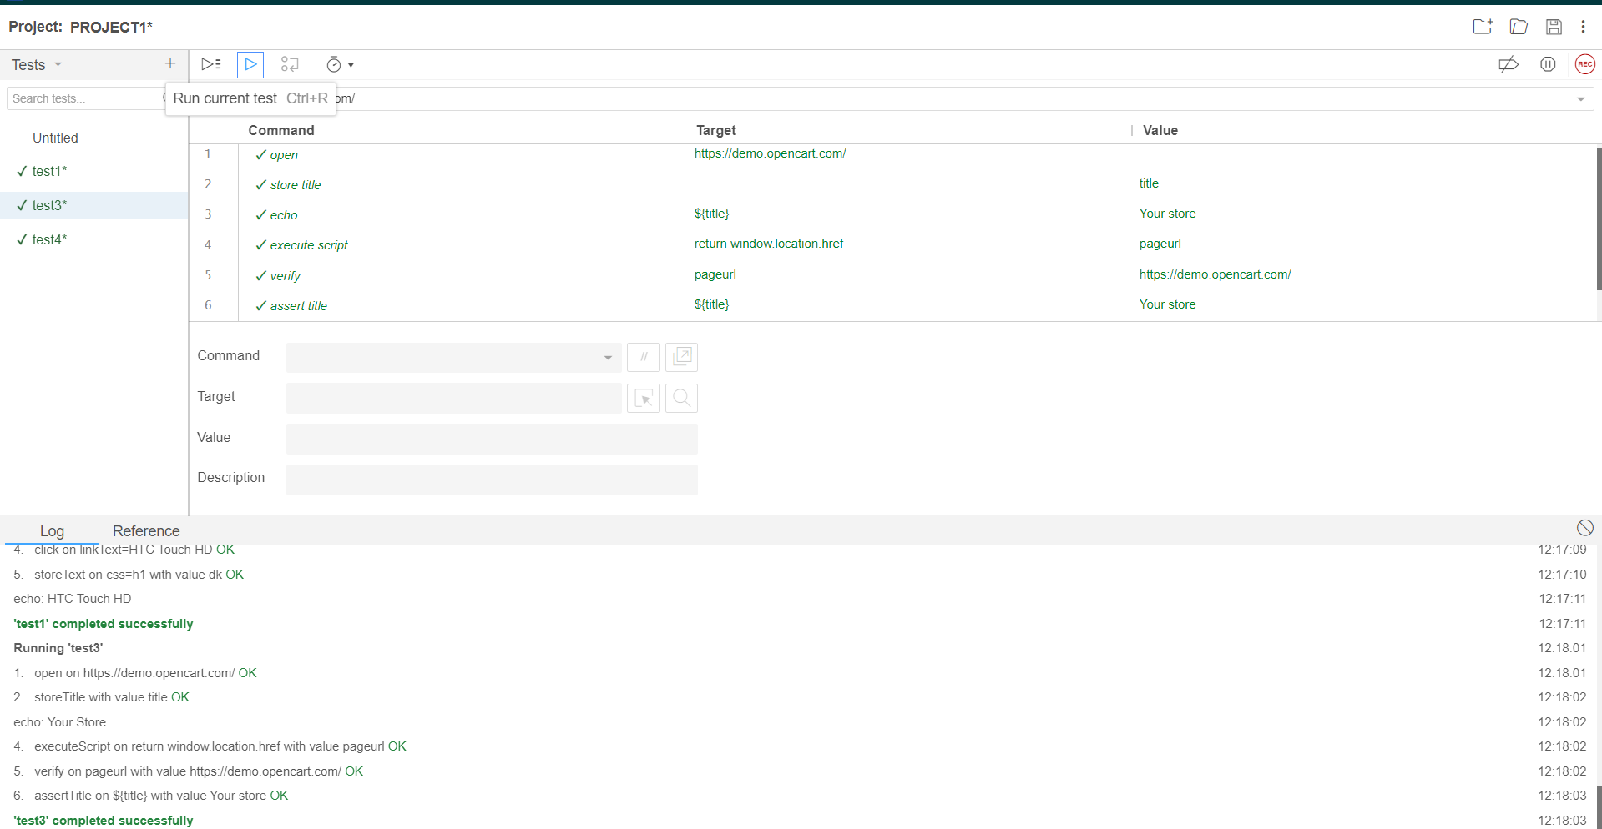

**CLASS EXERCISE 4:**

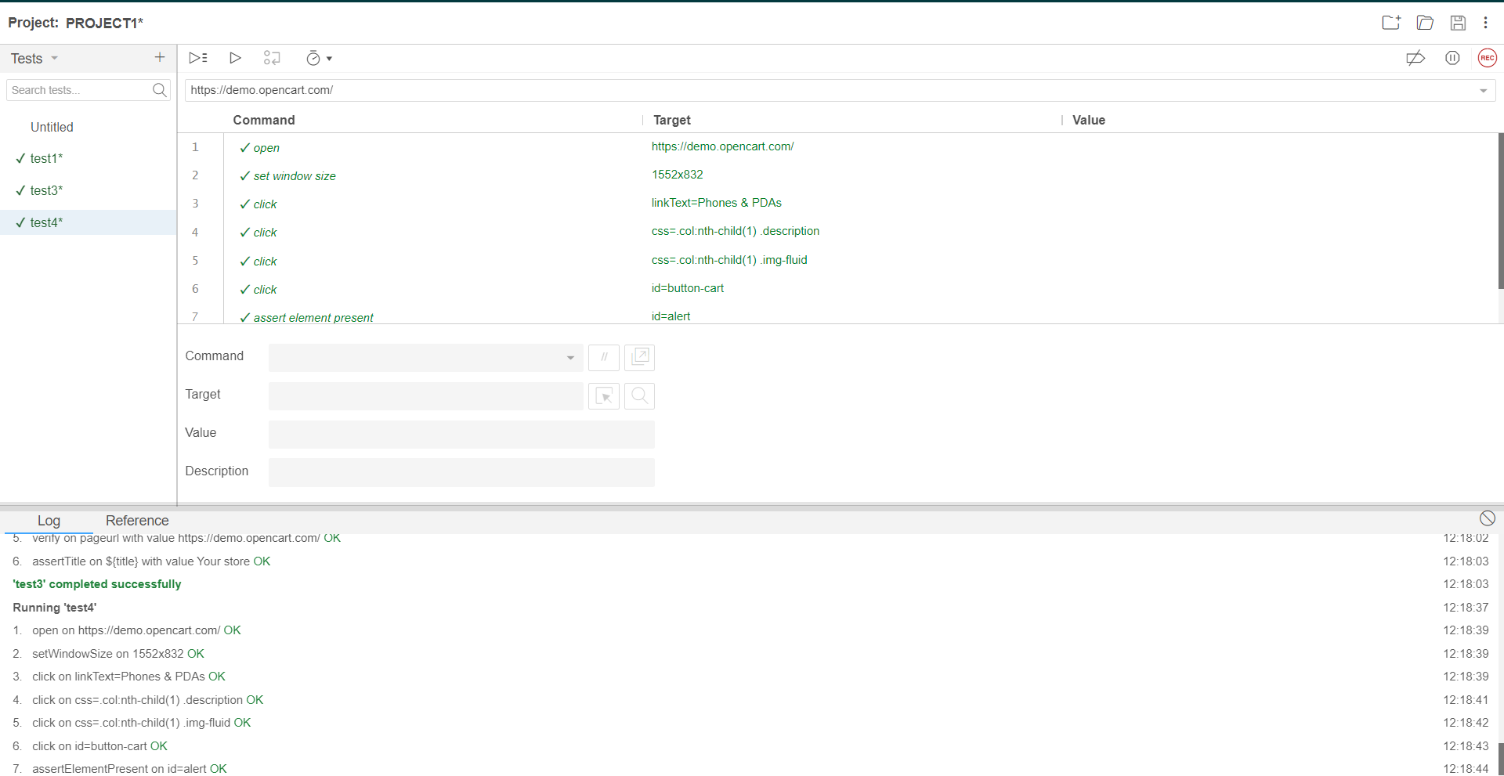

**CLASS EXERCISE 5:**

