**Introduction**

Created a login page with 2 fields (Username and Password) And a login button which will navigate to Home Screen Home Screen Contains Username and logout button

**Functionality:**

* · When the user login, it fetch username from login screen and show it in Home Screen.
* · When users close the app user credentials must be stored in local storage. So when reopening the app user don't need to relogin.
* · Password field can take only numbers and have maximum length of 10 digits and username like abcd.1234@gmail.com
* · By clicking on the logout button, it must be located to another screen.

**GetX for navigation.**

**Sharedpreferences for local storage**

**User interface**

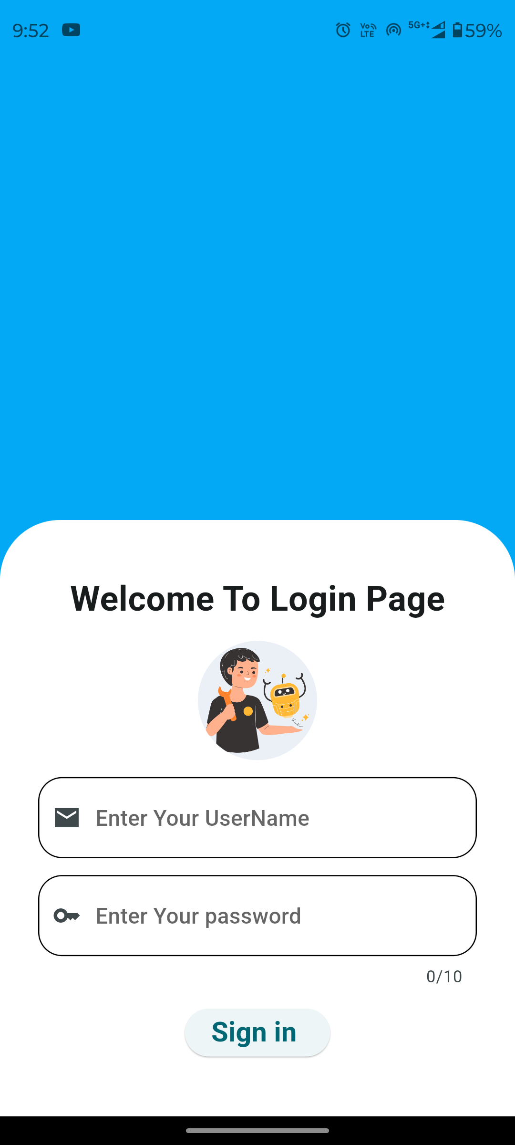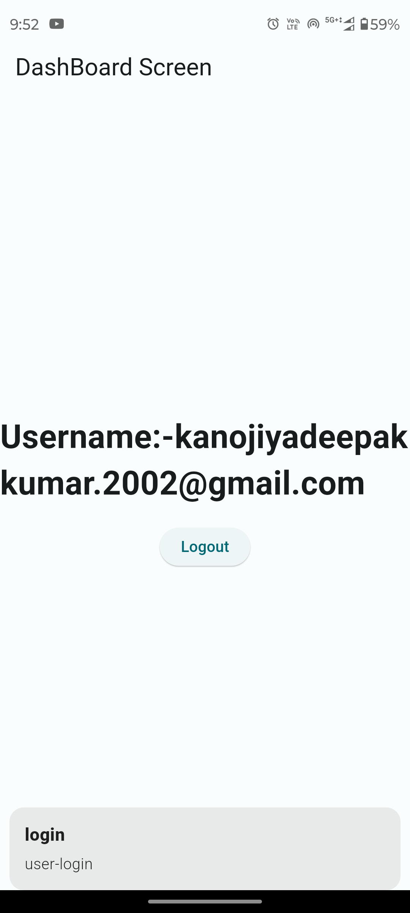

DashBoard

LoginPage