

## VISVESVARAYA TECHNOLOGICAL UNIVERSITY

### BELAGAVI, KARNATAKA

**INTERNSHIP TRAINING REPORT**

**ON**

WEB APPLICATION DEVELOPMENT

***A report submitted in the partial fulfillment of the requirements for the award of the degree of***

***Bachelor of Engineering in***

***Information Science & Engineering***

***Submitted by***

## Deepak K 1SG17IS027

### DEPARTMENT OF INFORMATION SCIENCE & ENGINEERING

**SAPTHAGIRI COLLEGE OF ENGINEERING**

**Bengaluru-57**

**2020-21**

SAPTHAGIRI COLLEGE OF ENGINEERING

### 14/5, Chikkasandra, Hesaraghatta Main Road, Bengaluru-560057

[*AFFILIATED TO VIVSVESWARAYA TECHNOLOGICAL UNIVERSITY, BELAGAVI*]



### Department of Information Science & Engineering

**CERTIFICATE**

Certified that the Internship work entitled **WEB APPLICATION DEVELOPMENT** carried out by **Deepak K [1SG17IS027]** bonafide student of 8th semester, Department of **Information Science & Engineering**, Sapthagiri College of Engineering, Bengaluru in partial fulfillment of the award of **Bachelor of Engineering** in **Information Science & Engineering** of the **Visvesvaraya Technological University,** Belagavi during the year 2020-21. It is certified that all corrections/suggestions indicated for Internal Assessment have been incorporated in the Report deposited in the departmental library. The Internship report has been approved as it satisfies the academic requirements in respect of Internship work prescribed for the said Degree.

Prof. Gayathri R

**Signature of the Coordinator**

Dr. H R Ranganatha

**Signature of the HOD**

Dr. H Ramakrishna

**Signature of the Principal**

**Name of the Examiner**

1. ……………………………………

2. ……………………………………

**Signature of the Examiner with date**

1. ………………………..

2. …………………………

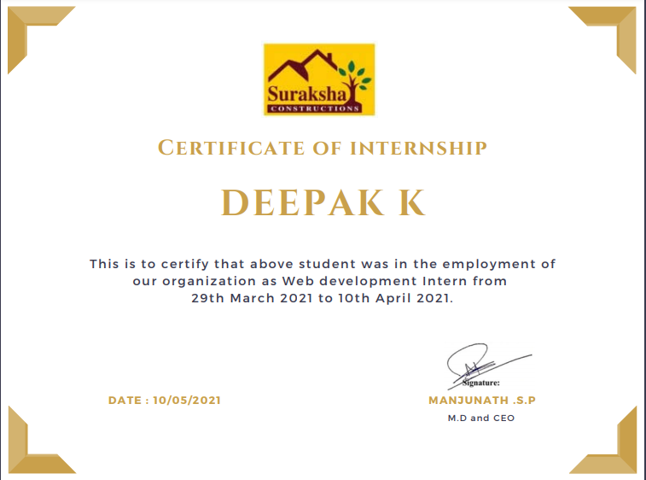

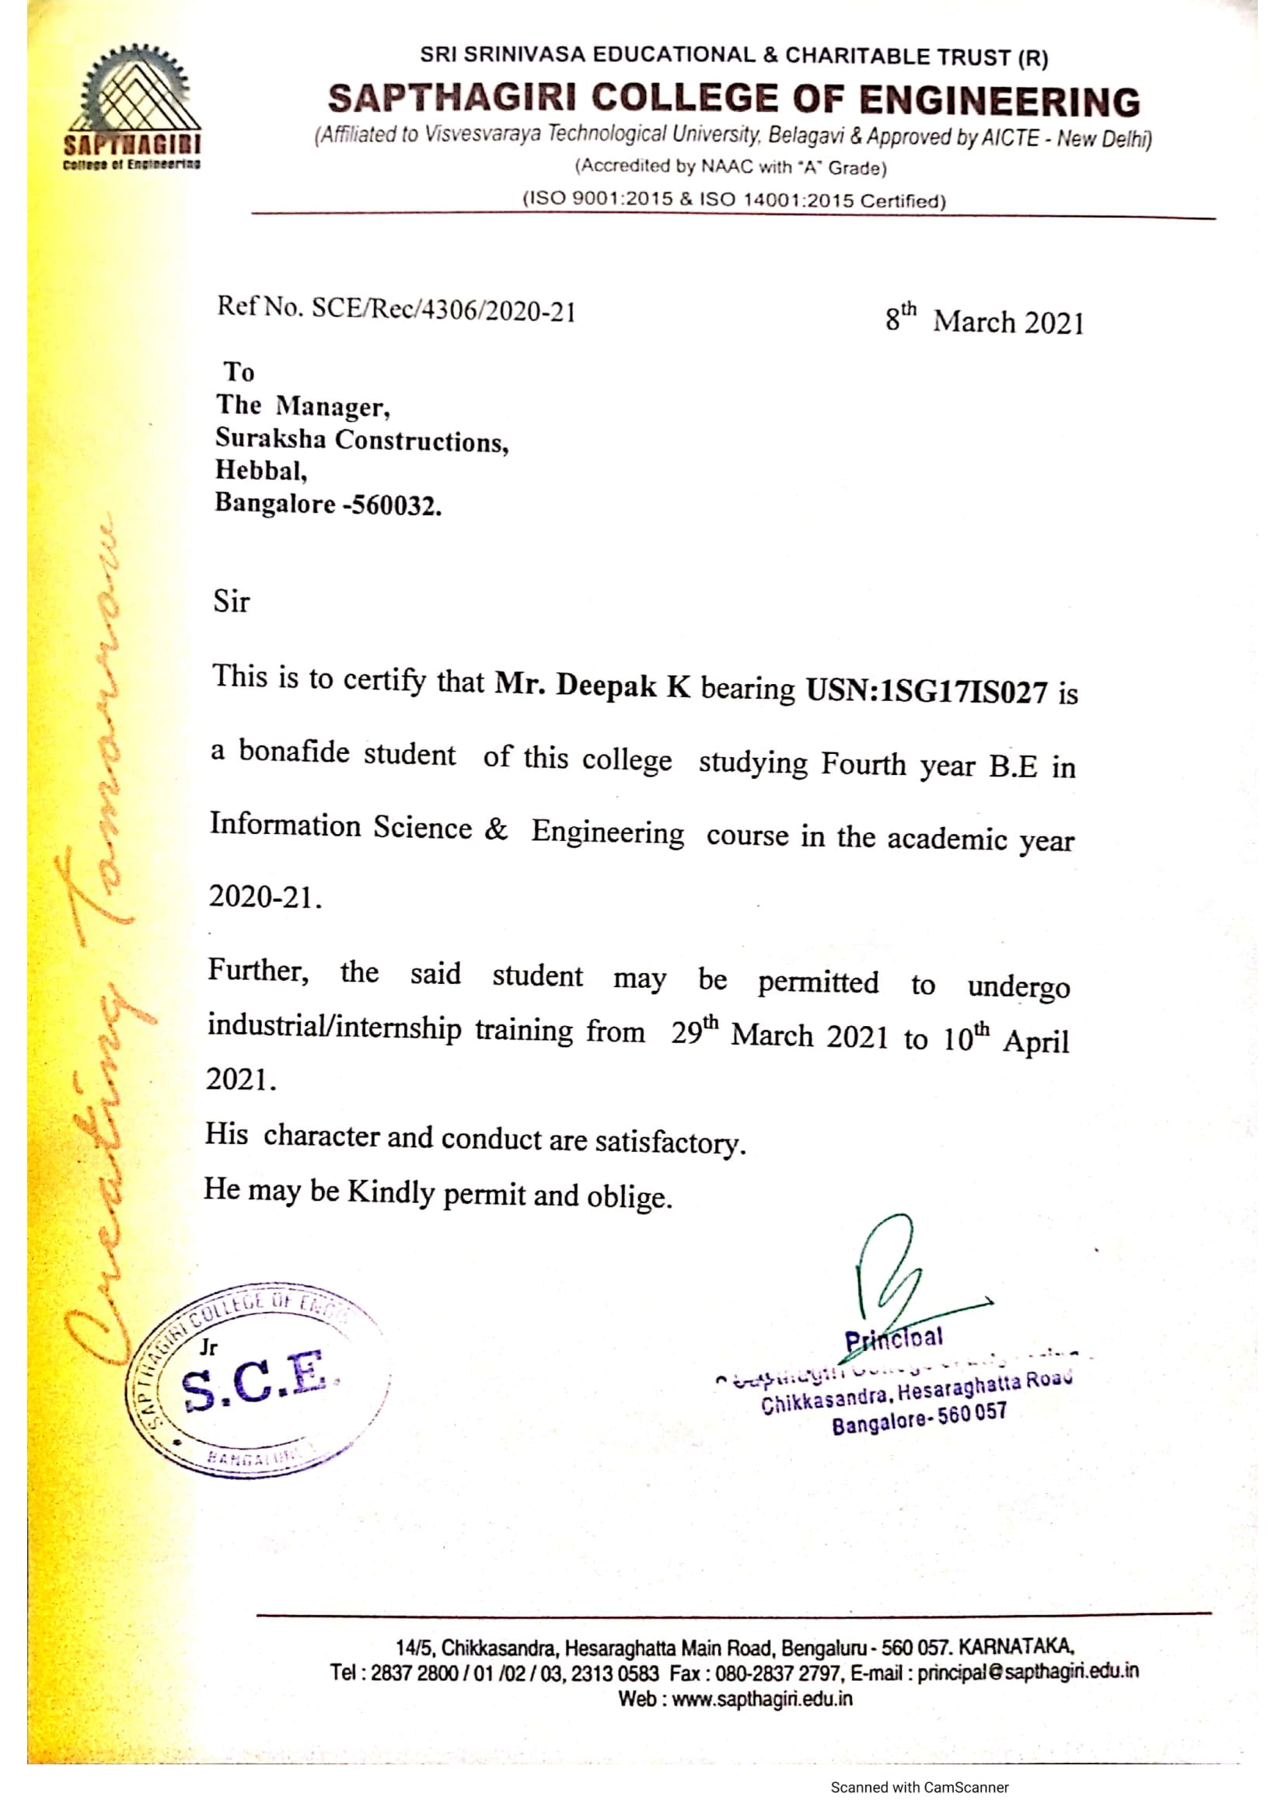

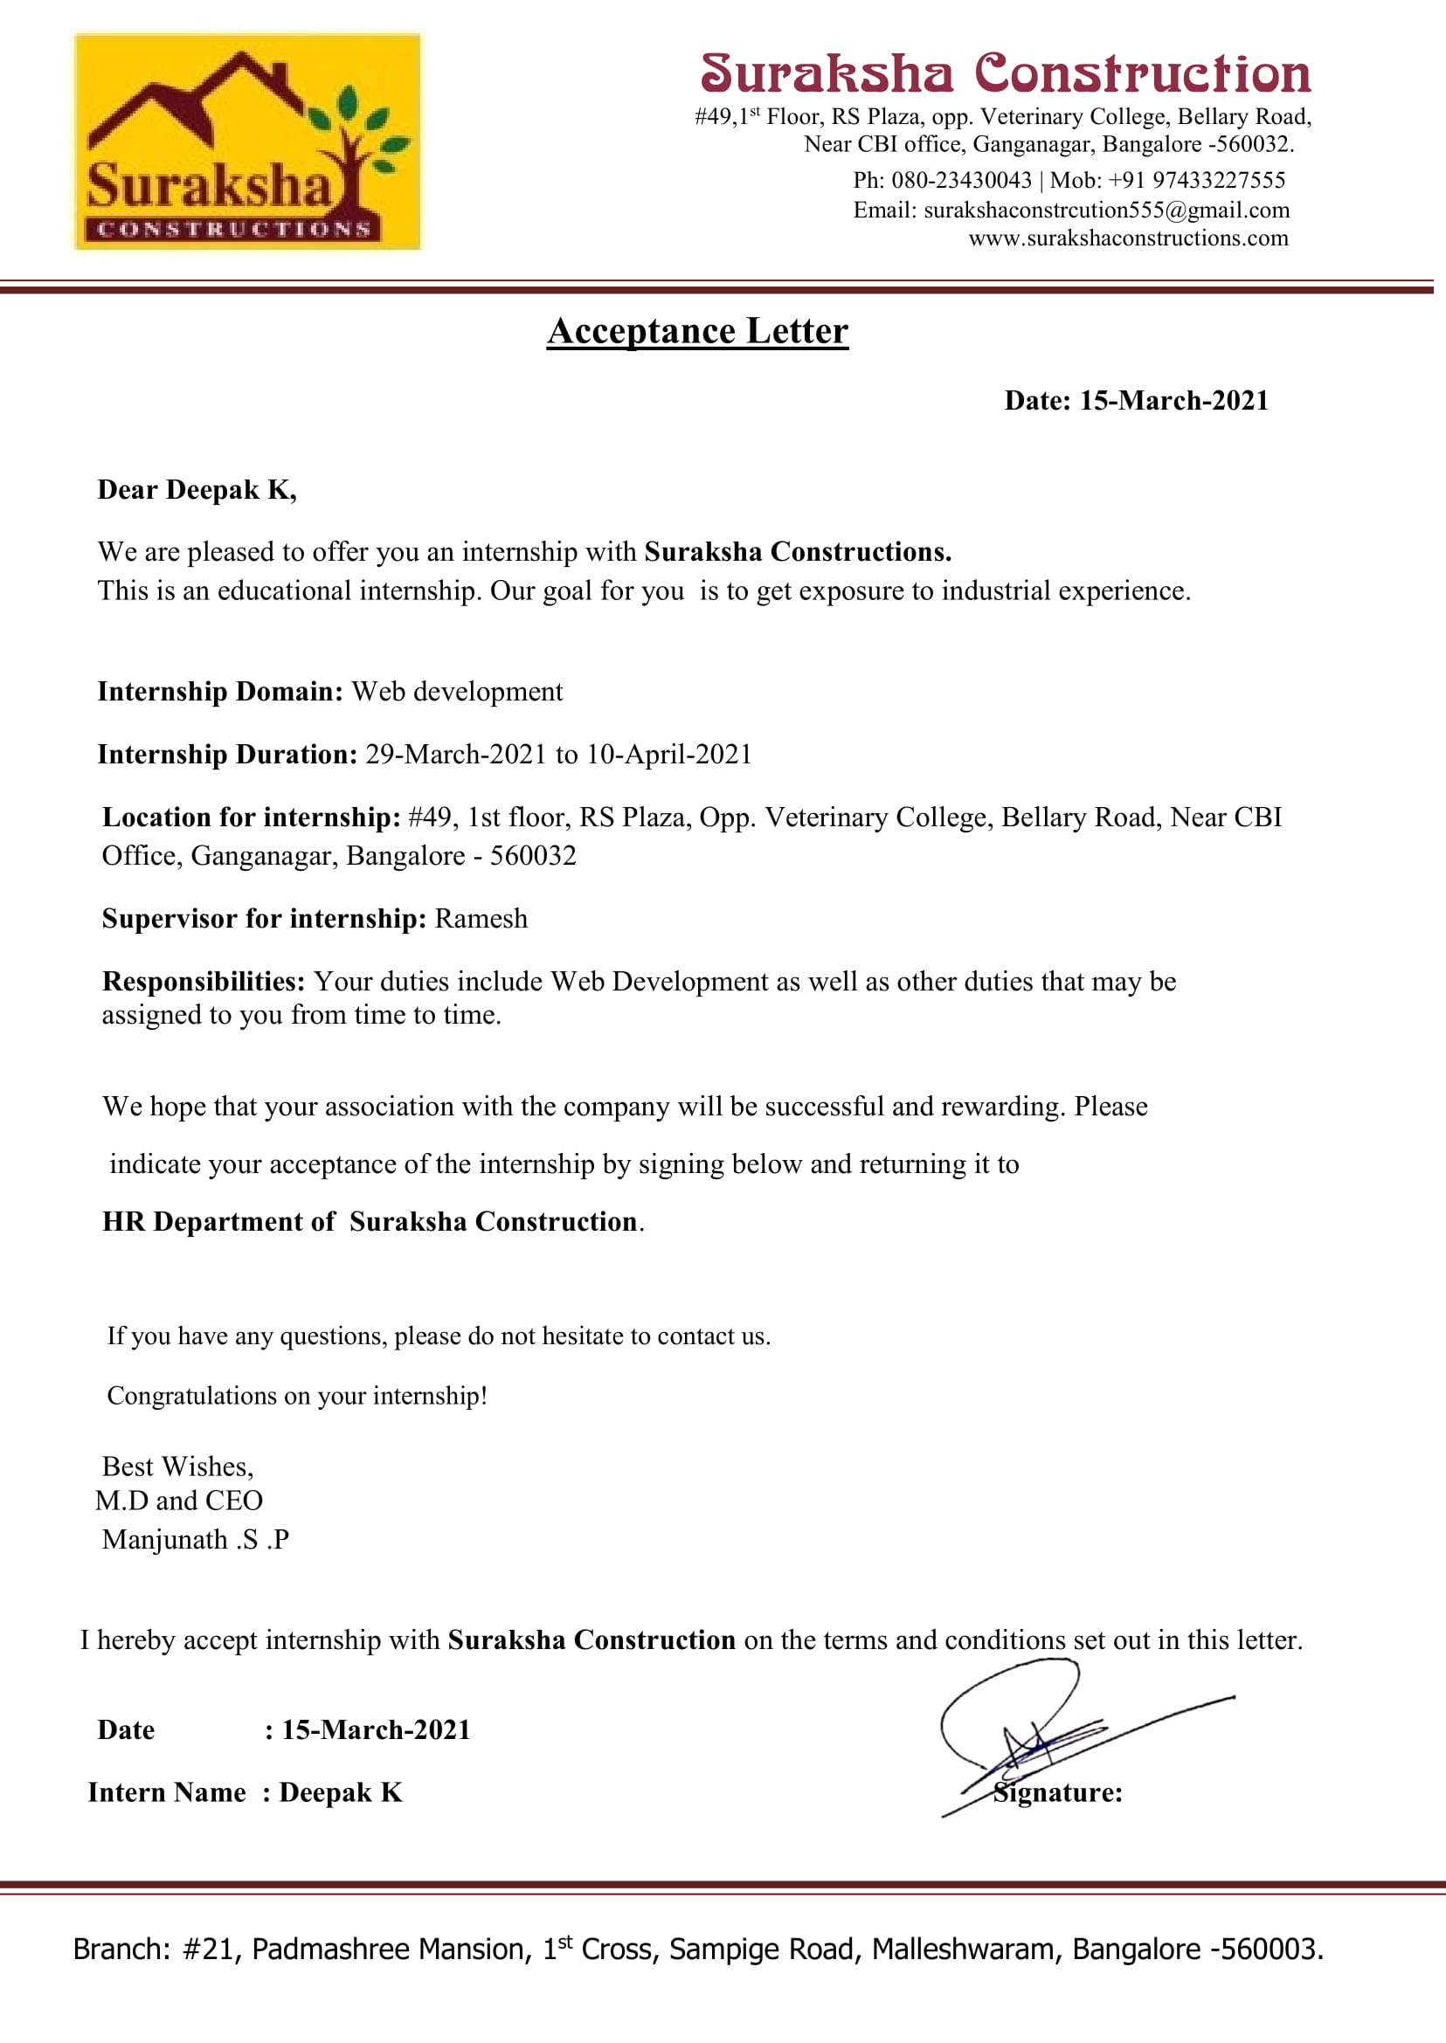

# ABSTRACT

Web application development is the process and practice of developing web applications. There is a consensus that the processes involved are extensions of standard software engineering processes. Considering this, along with its unique characteristics, popular frameworks used include the spiral approach and business-oriented approach to application development, among other models that address the requirements for an iterative process. Just as with a traditional desktop application, web applications have varying levels of risk. A personal home page is much less risky than, for example, a stock trading website. For some projects [security](https://en.wikipedia.org/wiki/Computer_security), [software bugs](https://en.wikipedia.org/wiki/Software_bug), etc. are major issues. If time to market, or technical complexity is a concern, [documentation](https://en.wikipedia.org/wiki/Software_documentation), [test](https://en.wikipedia.org/wiki/Test_plan) [planning](https://en.wikipedia.org/wiki/Test_plan), [change control](https://en.wikipedia.org/wiki/Change_control), [requirements analysis](https://en.wikipedia.org/wiki/Requirements_analysis), [architectural description](https://en.wikipedia.org/wiki/Software_architecture) and formal design and construction practices can mitigate risk. This encourages to use automation tools like docker for shipment purpose and Jenkins to build continuous integration and deployment to reduce manual intervention during development of product.

## ACKNOWLEDGEMENT

Any achievement doesn’t depend solely on the individual efforts but on the guidance, encouragement and cooperation of intellectuals, elders and friends. A number of personalities have helped us. I would like to take this opportunity to thank all of them.

I would like to express our sincere gratitude to **Dr. H Ramakrishna,** Principal, S. C. E., Bengaluru, for his help and inspiration during the tenure of the course.

I extend warm thanks to **Dr. H R Ranganatha**, H.O.D., Dept. of I.S.E., S.C.E., Bengaluru, for his constant encouragement, motivation and guidance.

I am also thankful to Internship training coordinators **Prof. Gayathri R.**, Assistant Professors, Dept. of I.S.E., S.C.E., Bengaluru, for their valuable coordination and support.

I would like to thank my guide **Prof. Asha P N,** Assistant Professor, Dept. of I.S.E., S.C.E., Bengaluru, for her timely advice, constructive suggestions and regular assistance in the Internship training work.

Wholeheartedly I would like to thank the faculty members and staff of the Department of I.S.E., S.C.E., for their valuable time and expertise.

I would like to extend our heartfelt gratitude to our parents and to all our friends for their cooperation and motivation.

### DEEPAK K(1SG17IS027)

**TABLE OF CONTENTS**

|  |  |  |
| --- | --- | --- |
| **Chapter**  **number** | **Details** | **Page**  **number** |
| **1** | **COMPANY PROFILE** | 1 |
|  | 1.1 Introduction About The Company | 1 |
|  | 1.2 Overview Of The Organization | 2 |

1. TASK PERFORMED 3
   1. Learning Experiences 3
   2. Knowledge Acquired 4
   3. Skills Learned 6
   4. The Most Challenging Task Performed 6
   5. Problem Identified 7
2. REFLECTIONS 8
   1. Solutions 8
3. CONCLUSION 10

**LIST OF FIGURES**

**Figure no**

3.1.1

### Name of the figure

Automated CI/CD pipeline using Jenkins

### Page no

8

## CHAPTER 1

**COMPANY PROFILE**

* 1. **Introduction About The Company**

Suraksha Constructions is construction company headquartered in [Bangalore, Karnataka](https://en.wikipedia.org/wiki/Bangalore%2C_Karnataka). It was founded in May 2010 by Mr. Manjunath. S. P. He is current CEO of the company.

The Suraksha Constructions company was launched for a limited services till August, 2015, then extended to outside of Bangalore region with more services.

The company was established itself as a premier EPC & LSTK Service Provider with front-end engineering capabilities. Company is in leading EPC and Infrastructure public limited company listed on NSE and BSE Stock Exchanges in India. Company strongly entrenched with proven domain knowledge, experience and credentials

The company raised an undisclosed amount in seed funding from Angel Investors during initial years. This was followed expanding company to various branches across Karnataka.

Suraksha constructions company also has a technical team to reach clients digitally through websites and mobile app. To start this initiative website and app are getting build which becomes a single platform to show all their services to customers and clarify their quieries and make the company get into higher position in the market by implementing technology to their traditional work

## Overview Of The Organization

Suraksha Constructions company renders expertise Architectural design services for both . residential & commercial Project of any competence and Magnitude on Pan India basis. Our

reverse engineering module is best configured for maximization & optimization of space along

with economization of project. The company offer an Integrated & comprehensive Interior

design & design to build solutions. We carry  vast experience, expertise & skill sects with high

degree of professional etiquette to design your dream home or a State of art  office spaces for

project par excellence on pan India basis.

The company render one stop solution for design and design-to-build services under

turnkey project management for all kinds of residential  and commercial construction.

Project are undertaken on Engineering, Procurement & Contracting (EPC) Module and as well

as on Project Management Consultation(PMC) module for project of any competence &

magnitude, PAN INDIA.

## CHAPTER 2

**TASK PERFORMED**

## Learning Experiences

I was an intern at Suraksha Constructions. I was assigned to the tech team where I worked with the team to provide the backend support for the website, and also I helped in developing the web services. Every day was a new learning experience for me. The exposure to the industrial technologies was new. The day began with the daily meeting in which the tasks were assigned. The task was not only to write the code for the product, but also a principle had to be followed to keep the code neat and clean. The future improvements of the product should have been easy and simple with minimal coupling.

I had the opportunity to learn from the industry experts in that field. I had to make a decision every day on the set of tasks which had to be accomplished by the day so that I was in schedule to complete the task.

I came to know how the web works more deeply as I built web services which could handle the clients made requests asynchronously without the interruptions of the service.

I was able to learn from the documentation about website and its working and tools and components used behind to develop provided by them. I was fascinated to learn how the automation tools are used to build the website backend with less human involvement to develop the website.

The main part of my learning experience is that whenever I had to learn something new I had to look through the documentation of a particular tool or a component. By doing this I learnt one major thing that how documentation is an important aspect of software development. If there is no proper documentation for the software then the other person looking through the documentation is unable to understand the usage

## Knowledge Acquired

The knowledge acquired from the internship program was to setting up Continuous Integration (CI) and Continuous Deployment (CD) Pipeline of application using Jenkins, Git, Docker.

Continuous Integration (CI) and Continuous Delivery (CD) is rapidly becoming an integral part of software development process as it makes our monotonous and repetitive tasks a little less grindy. Continuous Integration (CI) is a project development practice where developers integrate code into a shared repository frequently. Each Integration is then verified by an automated build that allows the team to detect problems in an early stage. Continuous delivery (CD) is a software engineering approach in which teams produce software in short cycles, ensuring that the software can be reliably released at any time and, when releasing the software, doing so manually. It aims at building, testing, and releasing   
software with greater speed and frequency.

Docker is a tool designed to make it easier to create, deploy, and run applications by using containers. Containers allow a developer to package up an application with all of the parts it needs, such as libraries and other dependencies, and deploy it as one package. By doing so, thanks to the container, the developer can rest assured that the application will run on any other Linux machine regardless of any customized settings that machine might have that could differ from the machine used for writing and testing the code.

GitHub is a code hosting platform for version control and collaboration. It lets us and others work together on projects from anywhere.

## Skills Learned

The Skills Learned from this internship program was a deeper knowledge of Jenkins,

Docker, GitHub and Python. Jenkins is an open-source automation tool written in Java with plugins built for Continuous Integration purposes. Jenkins is used to build and test our software projects continuously making it easier for developers to integrate changes to the project, and making it easier for users to obtain a fresh build. It also allows us to continuously deliver our software by integrating with a large number of testing and deployment technologies.

Docker is a platform which packages an application and all its dependencies together in the form of containers. This containerization aspect ensures that the application works in any environment. Containerization is a type of Virtualization which brings virtualization to the operating system level. While Virtualization brings abstraction to the hardware, Containerization brings abstraction to the operating system. Python is [dynamically typed](https://en.wikipedia.org/wiki/Dynamic_programming_language) and [garbage-collected](https://en.wikipedia.org/wiki/Garbage_collection_(computer_science)). It supports multiple [programming](https://en.wikipedia.org/wiki/Programming_paradigms) [paradigms](https://en.wikipedia.org/wiki/Programming_paradigms), including [procedural](https://en.wikipedia.org/wiki/Procedural_programming), object-oriented, and [functional programming](https://en.wikipedia.org/wiki/Functional_programming). Python is often described as a "batteries included" language due to its comprehensive [standard library](https://en.wikipedia.org/wiki/Standard_library).

Python was conceived in the late 1980s as a successor to the [ABC language](https://en.wikipedia.org/wiki/ABC_(programming_language)). Python 2.0, released in 2000, introduced features like [list comprehensions](https://en.wikipedia.org/wiki/List_comprehension) and a [garbage](https://en.wikipedia.org/wiki/Garbage_collection_(computer_science)) [collection](https://en.wikipedia.org/wiki/Garbage_collection_(computer_science)) system capable of collecting [reference cycles](https://en.wikipedia.org/wiki/Reference_cycle). Python 3.0, released in 2008, was a major revision of the language that is not completely [backward-compatible](https://en.wikipedia.org/wiki/Backward_compatibility), and much Python 2 code does not run unmodified on Python 3.

## The Most Challenging Task Performed

The Most Challenging Task Performed throughout this internship program was setting up a docker for deployment and integrating it with GitHub.

GitHub is a highly used software that is typically used for version control. It is helpful when more than just one person is working on a project. Say for example, a software developer team wants to build a website and everyone has to update their codes simultaneously while working on the project. In this case, GitHub helps them to build a centralized repository where everyone can upload, edit, and manage the code files. Some updates have to be documented, others are designed so that they can be "interrogated" to determine supported functionality. Since other components/systems rely only on the docker the system that provides the files can (ideally) change its internal details "behind" that Website without affecting its users.

Today, with the rise of implementation of continuous integration, every log of recent updates done by different developers are maintained and ensuring the proper developed application goes for deployment

GitHub has various advantages but many people often have a doubt as to why not use Dropbox or any cloud based system. Let me take the same example forward to answer this question. Say more than two software developers are working on the same file and they want to update it simultaneously. Unfortunately, the person who save the file first will get precedence over the others. While in GitHub, this is not the case. GitHub document the changes and reflect them in an organized manner to avoid any chaos between any of the files uploaded.  
Therefore using GitHub centralized repository, it avoids all the confusion and working on the same code becomes very easy.

## Problem Identified

The Problem Identified was the application did not provide the customer with the query received confirmation mail response immediately. Rather it would take a couple of hours to a couple of days to provide them with the confirmation mail of query received.

The delay of delivering this confirmation mail made a bad impression on the customer. So in order to reduce the wait time and make the user experience much better we had to come up with a solution.

The main reason behind the time consumption was that the query submission made by customer need to reach admin mail and he use to check mail and write a return mail as confirmation mail to the user.

Since this process needs manual intervention by admin to keep checking mail for query by customers and write immediate response. His major time was invested on it and sometimes replying bulk confirmation emails was stress task.

On other end Customer was unsure if his query has been reached to company and waited for response. This above problem was identified of involvement of human work and needed to be automated. This automation should ensure to reduce the time invested on replying goes down and customer gets confirmation mail immediately.

## CHAPTER 3

**REFLECTIONS**

## Solutions

So in order to reduce the waiting time for the customer, and manual intervention on admin side. we came up with the idea of having a automated CI/CD pipeline system. In which once customer submits a query in mail, It auto triggers the Jenkins and pulls the query from website and push to GitHub for log maintain and trigger a auto reply mail to the respective mail as confirmation. Also notifies the admin about new query received.

By doing this, we can reduce the waiting time of customers from a couple of hours to a couple of minutes. This improves the customer satisfaction.

By using Jenkins we can store the queries in GitHub and have an automated CI/CD pipeline

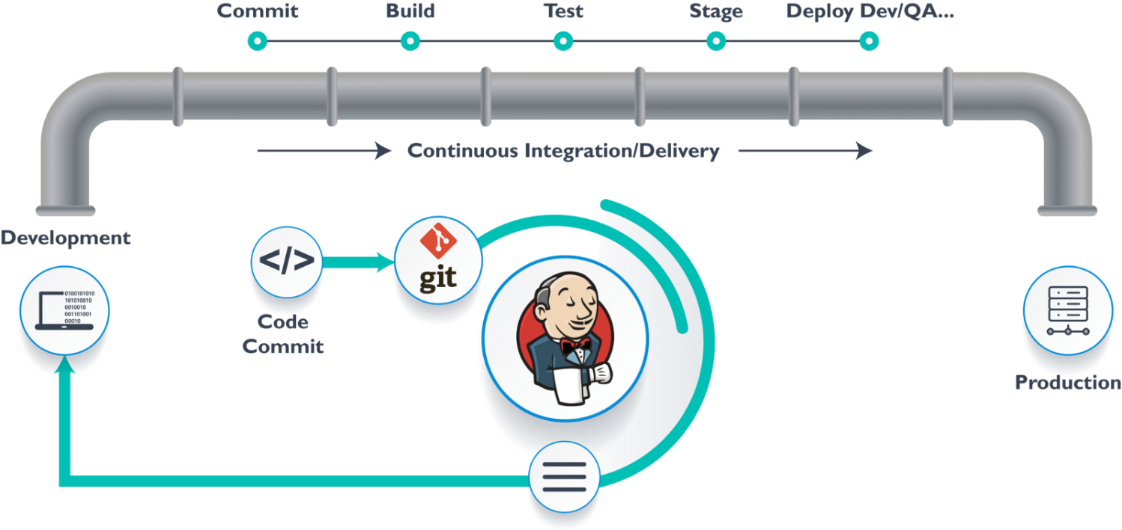

Fig 3.1.1:Automated CI/CD Pipeline using Jenkins

## CHAPTER 4

**CONCLUSION**

From this internship program, we came to this conclusion that it helped me in both the ways which are Improved the knowledge of Python, Jenkins and Docker.

We got to know about python that it is Open source and community development, easy to learn, User-friendly data structures, High-level language, dynamically typed language (No need to mention data type based on the value assigned, it takes data type), Object oriented language, Portable and Interactive and Portable across Operating systems. Applications are GUI based desktop applications (Games, Scientific Applications), Web frameworks and applications and Enterprise and Business applications.

We got to know about Jenkins, Docker and GitHub plays vital part in backend of web development and become part of DevOps Technology. It is used to automate the development of desktop and mobile applications, big data processing, embedded systems, and so on.   
In 2020, 88% of global organizations had adopted DevOps and has been leading the automation in faster pace.

# REFERENCE

[1] [www.google.com](http://www.google.com)

[2] [www.youtube.com](http://www.youtube.com)

[3] [www.geeksforgeeks.com](http://www.geeksforgeeks.com)

[4] [www.stackoverflow.com](http://www.stackoverflow.com)

[5] [www.github.com](http://www.github.com)

[6] [www.wikipedia.com](http://www.wikipedia.com)

# ATTENDANCE REPORT

|  |  |  |
| --- | --- | --- |
| **SL.NO** | **DATE** | **STATUS** |
| 1 | 29 MAR | PRESENT |
| 2 | 30 MAR | PRESENT |
| 3 | 31 MAR | PRESENT |
| 4 | 1 APR | PRESENT |
| 5 | 2 APR | PRESENT |
| 6 | 3 APR | PRESENT |
| 7 | 4 APR | PRESENT |
| 8 | 5 APR | PRESENT |
| 9 | 6 APR | PRESENT |
| 10 | 7 APR | PRESENT |
| 11 | 8 APR | PRESENT |
| 12 | 9 APR | PRESENT |
| 13 | 10 APR | PRESENT |