End-to-End Local MLOps Pipeline
Heart Disease Risk Prediction (UCI)

MLOps Assignment I (S1-25_AIMLCZG523)
Group 114 • 28 Dec 2025

Stack: MLflow • FastAPI • Docker • Minikube (Kubernetes) • Prometheus/Grafana • GitHub Actions

Repository: https://github.com/deepakkt/bitsaiml-mlops-group-114
One-command evaluator: make verify

Concise 10-page DOCX report (condensed from the full submission PDF).

Ravindra Babu Katiki | 2024AB05286 | 100%
Deepak Kumaran | 2024AB05107 | 100%
Degala Venkatesh | 2023AC05236 | 100%
Hemant Dyavarkonda | 2024AB05109 | 100%
Ashish Kumar | 2024AB05110 | 100%

1. Executive Summary
2. Requirement Coverage (At-a-Glance)
3. System Architecture
4. Data Acquisition, Preprocessing, and EDA
5. Feature Engineering and Model Development
6. Experiment Tracking and Packaging
7. Serving API and Observability
8. CI/CD and Automated Testing
9. Containerization, Deployment, and Monitoring
10. End-to-End Verification and Next Steps
Appendix A. Repository Structure and Key Commands
Appendix B. Deployment and Monitoring Evidence (Screenshots)

1. Executive Summary
This submission implements an end-to-end, production-style MLOps workflow for a heart disease risk classifier. It covers dataset acquisition and EDA, model training and selection, MLflow-based experiment tracking, reproducible packaging, API serving, containerization, Kubernetes deployment, and monitoring.
Delivered capabilities:
- Reproducible dataset pipeline with metadata (timestamp + SHA-256); 297 clean rows used for training.
- Model comparison (Dummy, Logistic Regression, Random Forest) with cross-validation; best model selected by ROC-AUC.
- MLflow logging for parameters, metrics, plots, and exported model artifacts.
- FastAPI inference service with health checks, JSON logging, and Prometheus metrics.
- Docker image + Minikube deployment with probes and 2 replicas; Prometheus/Grafana monitoring.

2. Requirement Coverage (At-a-Glance)
Requirement | Implementation / evidence
1. Data acquisition + EDA | scripts/download_data.py; src/heart/eda.py; report/figures/
2. Features + models | src/heart/features.py; src/heart/train.py (Pipelines + GridSearchCV)
3. Experiment tracking | MLflow (./mlruns); artifacts/training_summary.json; plots + models
4. Packaging | artifacts/model (MLflow export); requirements.txt
5. CI/CD + tests | .github/workflows/ci.yml; ruff; pytest (tests/)
6. Containerization | docker/Dockerfile; make docker-build/docker-run
7. Deployment | k8s/manifests/; make k8s-up/k8s-deploy; port-forward checks
8. Monitoring + logging | FastAPI JSON logs; /metrics; ServiceMonitor + kube-prometheus-stack
9. Documentation | This report + full PDF submission; repo README/Makefile

3. System Architecture
The pipeline is designed for reproducibility and quick evaluation. A single command (make verify) can run setup, lint/tests, data preparation, training with MLflow logging, Docker smoke tests, Minikube deployment, and monitoring checks.
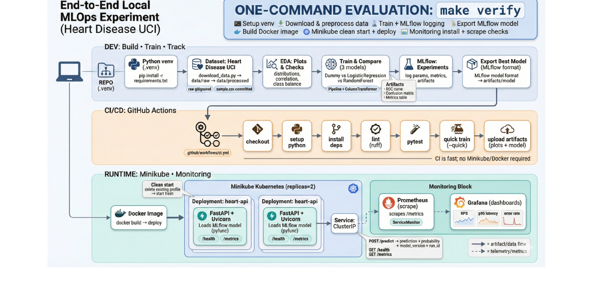
Figure 1. High-level architecture and data/telemetry flow.
Core components:
- Data & EDA: deterministic cleaning and report figures.
- Training: consistent preprocessing (ColumnTransformer) + model selection.
- Tracking: MLflow local store logs runs, metrics, plots, and exported models.
- Serving: FastAPI /health, /predict, /metrics with structured logs.
- Runtime: Docker (local), Kubernetes (Minikube) with probes and replicas.
- Monitoring: Prometheus scrape + Grafana dashboards.

4. Data Acquisition, Preprocessing, and EDA
Dataset: Heart Disease UCI (binary classification). The original multi-level target is binarized as target = 1 if severity > 0 else 0.
Raw / clean records | 303 / 297
Download timestamp (UTC) | 2025-12-28T11:18:50.923323+00:00
SHA-256 checksum (raw CSV) | fbd8e872af527dd3544a47b5…
Source | https://archive.ics.uci.edu/ml/datasets/Heart+Disease
Preprocessing steps:
- Schema normalization and numeric coercion; invalid tokens converted to missing values.
- Rows with missing values dropped after coercion to produce a clean training frame.
- Reproducibility metadata persisted to data/raw/metadata.json.
EDA figures (make eda) summarize class balance, feature distributions, correlations, and missingness after cleaning.
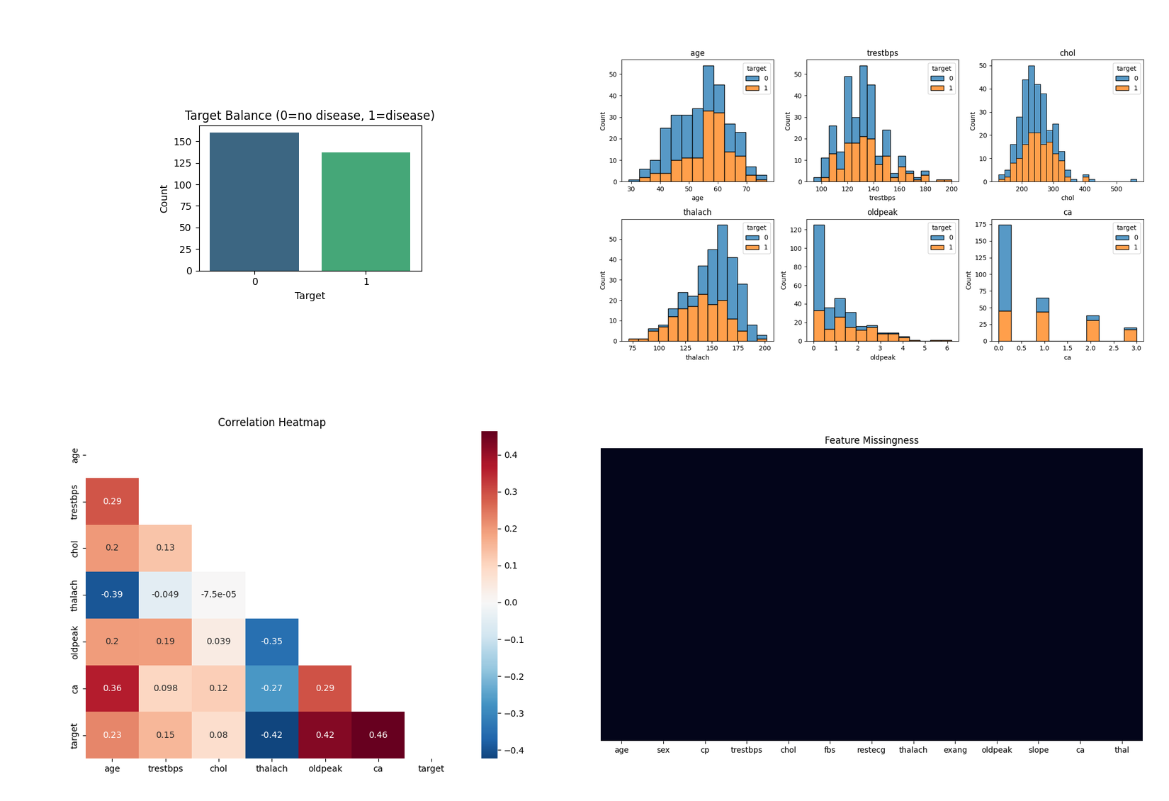
Figure 2. EDA summary: class balance, numeric distributions, correlation heatmap, and missingness heatmap.
Selected EDA observations:
- Class balance is reasonably even (positives ~46%).
- Numeric signals with stronger association include ca and oldpeak (positive) and thalach (negative).
- Processed dataset contains no missing values (after cleaning).

5. Feature Engineering and Model Development
Training uses a single sklearn Pipeline that combines preprocessing and the estimator to avoid training-serving skew.
Features:
- Numeric: age, trestbps, chol, thalach, oldpeak, ca
- Categorical/ordinal: sex, cp, fbs, restecg, exang, slope, thal
Preprocessing:
- Numeric: median imputation + standard scaling.
- Categorical: most-frequent imputation + one-hot encoding (handle_unknown=ignore).
Models compared:
- DummyClassifier baseline
- Logistic Regression (GridSearchCV tuned; primary metric ROC-AUC)
- Random Forest (GridSearchCV tuned; primary metric ROC-AUC)
Model | Best CV ROC-AUC | Test ROC-AUC | Accuracy | Precision | Recall
dummy | 0.500 | 0.500 | 0.533 | 0.000 | 0.000
log_reg | 0.896 | 0.953 | 0.867 | 0.885 | 0.821
random_forest | 0.894 | 0.936 | 0.817 | 0.840 | 0.750
Selected model: log_reg (run_id=ecd7b01bf3cf4e44a1241e6764766477). Hold-out ROC-AUC=0.953, Accuracy=0.867.

6. Experiment Tracking and Packaging
MLflow tracks each run (file:./mlruns), logging parameters, metrics, plots (ROC + confusion matrix), and the model.
- Run summaries: artifacts/training_summary.json
- Best model export: artifacts/model (MLflow model format + metadata.json)
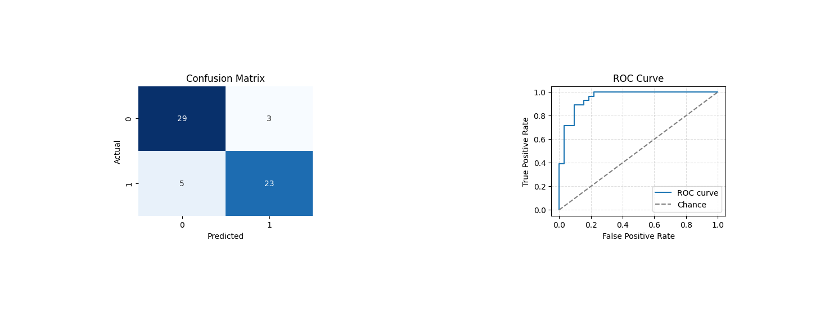
Figure 3. Best model (log_reg) plots: confusion matrix and ROC curve.

7. Serving API and Observability
The best model is served via FastAPI (Uvicorn). The service loads the MLflow export from artifacts/model (or via MODEL_PATH) and provides prediction plus observability endpoints.
Endpoints:
- GET /health: liveness/readiness, includes model_loaded and run_id.
- POST /predict: JSON request with 13 features; returns prediction and probability.
- GET /metrics: Prometheus metrics (request count, latency histogram, errors).
Example invocation:
curl http://localhost:8000/health
curl -X POST -H "Content-Type: application/json" -d @data/sample/request.json http://localhost:8000/predict
Logs & metrics:
- Structured JSON logs with request_id and latency; X-Request-ID returned to clients.
- Metrics include heart_api_requests_total, latency histogram buckets, and heart_api_errors_total.

8. CI/CD and Automated Testing
GitHub Actions runs linting (ruff), unit tests (pytest), and a quick training run that logs to MLflow and uploads artifacts.
- Workflow file: .github/workflows/ci.yml
- Artifacts uploaded: artifacts/** and mlruns/**
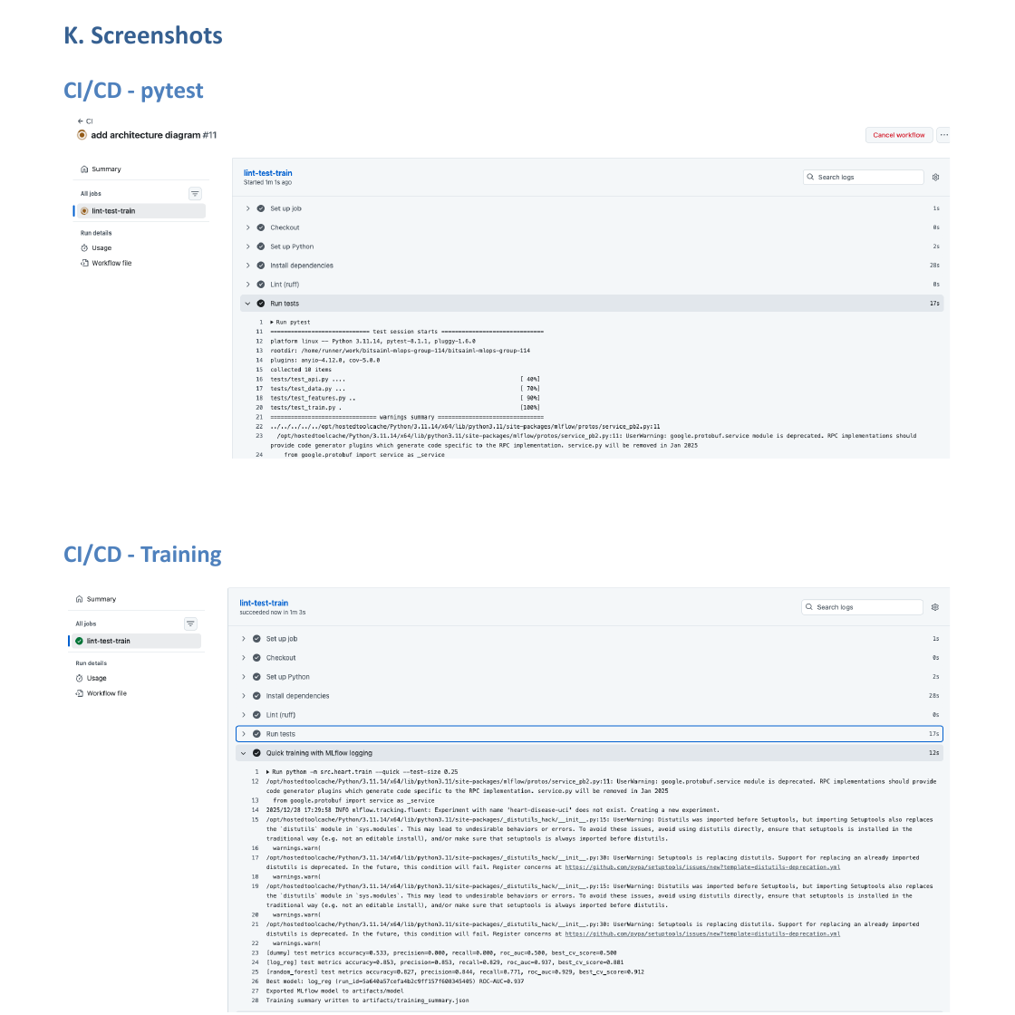
Figure 4. CI workflow evidence (pytest + quick training).

9. Containerization, Deployment, and Monitoring
Serving is packaged in a Docker image (docker/Dockerfile) and deployed to Minikube using Kubernetes manifests (k8s/manifests). The deployment uses 2 replicas and /health probes. Monitoring is installed via Helm (kube-prometheus-stack) and scrapes /metrics using a ServiceMonitor.
Key commands:
make train
make docker-build && make docker-run && make smoke-test
make k8s-up && make k8s-deploy && make k8s-smoke
make monitor-up && make monitor-check
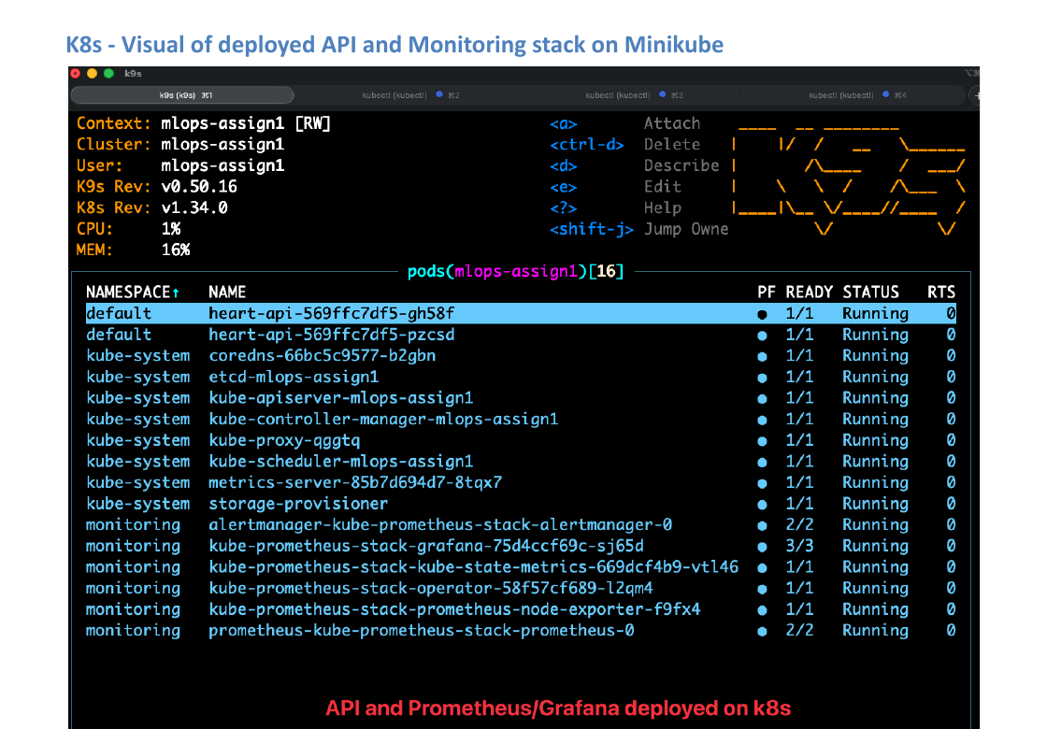
Figure 5. Minikube snapshot: API pods and monitoring stack.

10. End-to-End Verification and Next Steps
make verify orchestrates the full flow from a clean environment: setup, lint/tests, data, training, Docker smoke test, Minikube deployment + smoke test, monitoring scrape check, and teardown.
Optional flags:
- VERIFY_SKIP_MONITORING=1 (skip Prometheus/Grafana install if resources are tight).
Recommended improvements:
- Add gated model promotion (e.g., MLflow Model Registry + metric thresholds).
- Strengthen lineage (log git commit SHA and dataset checksum as MLflow tags; consider DVC).
- Production hardening: Ingress + autoscaling + auth/rate limits + load testing.
Source of truth: https://github.com/deepakkt/bitsaiml-mlops-group-114

Appendix A. Repository Structure and Key Commands
Repository layout (high-level):
.
├─ src/heart/ # data prep, features, training, evaluation, API
├─ scripts/ # bootstrap, data download, smoke tests, Prometheus target check
├─ artifacts/ # training summaries, plots, exported MLflow model
├─ docker/ # Dockerfile for serving
├─ k8s/ # Minikube scripts, manifests, monitoring install/uninstall
├─ tests/ # pytest unit tests
└─ .github/workflows/ci.yml # GitHub Actions CI pipeline
Evaluator shortcuts (Makefile):
- make data • make eda • make train
- make api • make docker-build • make docker-run • make smoke-test
- make k8s-up • make k8s-deploy • make k8s-smoke
- make monitor-up • make monitor-check • make verify

Appendix B. Deployment and Monitoring Evidence (Screenshots)
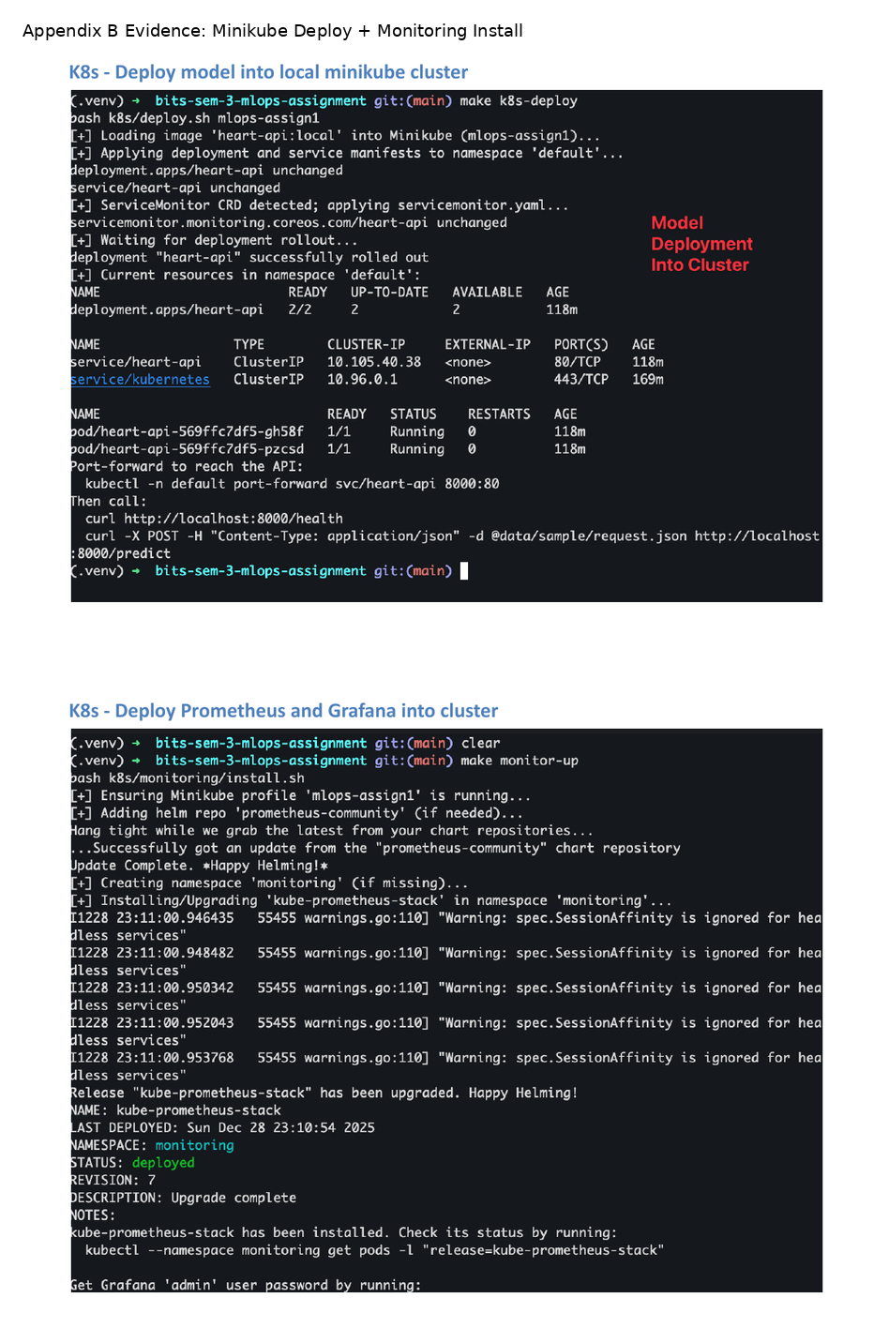
Figure B1. Minikube deployment and kube-prometheus-stack installation evidence.

